Finding the fingerprint and genetic variance for a number of phenotypically similar Date palm cultivars
Ahmed Yousef Lafta Hzaa* - Aqeel Hadi Abdulwahid Al_Amiry
Department of Horticulture, College of Agricultural, University of Basrah, Iraq.
*Corresponding author’s Email: ahmed.lafta@uobasrah.edu.iq, Phone: +9647702681501

Summary
The study was conducted in order to determine the genetic fingerprint for a number of phenotypically similar date palm cultivars Phoenix dactylifera L. The study included eight cultivars (six of them each one contain two strains with different fruit color and rest two cultivars, each cultivar have three different strains) this cultrvarce are similarty in all other charachtarastics and give same name between farmers which are scattered in several regions of southern and central Iraq. Six of SSR primers were used i this study. The results showed the presence of polymorphic alleles between cultivars and the same alleles among some of the studied strains. The number of alleles reached 150, and the number of alleles ranged between 1 and 4 alleles in the genetic locus. The results of the molecular analysis of the primers show that the Halawi red strain gave nine alleles of different molecular weights than the Halawi yellow strain, while the Barhi red strain gave four alleles different from the Barhi yellow strain and the Shouethi yellow strain gave five different alleles in molecular weight from the Shouethi red strain. Five alleles appeared in the Maktum red strain, but this alleles did not appear in the Maktum yellow strain. As for as the Jawzi red strain, it gave three alleles similar to the Jawzi yellow strain out of a total of eight alleles for each of them. The results of the primers also showed that the alleles produced by the cultivars Brim yellow strain and the Brim white strain were identical, which means that they are one cultivar, while the Brim red strain showed a difference in all alleles resulting from it with the yellow strain and white strain, as well as the same result gave Khadrawi Basrah strain and the Khadrawi Karbala same alleles in the number and molecular weight, while the Khadrawi Maysan was differed from them.
Keyward: Date palm, fingerprint, SSR, similarity cultivars
Introduction :
The date palm, Phoenix dactylifera L., is considered one of the main fruit trees in the The Arabian Peninsula, and an important source of food, It is a holy tree at the Arab people. It belongs to the Arecaceae family, and it is one of the most important plant families for human benefit after the Graminaceae family, because it contains important economic types. One of the most widespread plants of this family in Iraq is the date palm, as it is considered one of the most important fruit trees at the local level due to its suitability for growth in most Iraqi regions, and its cultivation extends from Mandali in the east, Tikrit in the north, and Al-Faw in the south (Al-Bakr, 1972).
There are about 5,000 cultivars of date palms as well as other seed strains scattered in different parts of the world, but every date producing country has only a small number of the main commercial cultivars that are nurtured and cared for and their dates are exported to all parts of the world (Abul-Soad et al., 2017).
Previously, farmers relied on choosing cultivars grown from seeds that are characterized by the quality of their fruits, and then they are vegetatively propagated by offshoot, and in this way the desired cultivars were preserved, while the cultivars multiplication from seeds resulted in a great diversity in cultivars as a result of the nature of cross-pollination and genetic isolation (Peyron, 2000 ). Many researchers pointed out the difficulty of distinguishing date palm cultivars by their phenotypic characteristics and without the presence of fruits, becous the vegetative growth characteristics are affected by the surrounding environmental conditions and service processes (Sedra et al., 1998).
DNA fingerprinting is an effective method for date palm cultivar identification, genetic diversity estimation and phylogenetic tree analysis, and in recent years, the DNA fingerprinting indicator technique has become increasingly important for distinguishing closely related taxa. Molecular indicators such as Simple Sequences Repeate (SSR) have proven to be a very powerful tool in plant diversity analysis because they are not only site-specific but also possess a high degree of polymorphism, fulfilling most of the requirements to achieve accurate analysis of date palm fingerprints (Khanam et al., 2012). The (SSR) technique is also considered one of the very important and widespread molecular indicators currently, and it is used in the identification of cultivars, genetic mapping and to detect genetic diversity (Yusuf et al., 2015).
at the study by Racchi et al., (2014) on Genetic characterization of 18 date palm cultivars using 16 SSR primers, noted total bands was 110 with average of 6.88 bands for each initiator, showed 28 bands are unique and specific to some cultivars. The average polymorphism rate ranged from 81%.
in other study Characterization of 12 Tunisian date palm cultivars was carried out using nine primers of SSR that produced 39 amplified bands and the number of bands for each allel ranged from 3 to 5 bands, and the amplified band sizes ranged between (117-300) base pairs (Metoui et al., 2017).
The SSR markers used in a study by (Jamil et al., 2020) succeeded in distinguishing 12 out of 13 Pakistani date palm cultivars, while the Halawi cultivar was identified using a two-step method for DNA-level identification Nuclear.
Due to the presence of a number of date palm strains that are similar in names and have become famous, it was necessary to establish a rule through which these forms of naming could be resolved, especially as they were named after well-known cultivars. Therefor must be found a standard reference capable of establishing the genetic identity of a variety on the basis of DNA fingerprints. Moreover, finding the genetic relationship to determine the genetic convergence and divergence between the studied strains for improvement and production of new selected cultivars.
Materials and methods:
The study was carried out during the 2020 growth season to aim of identifying and diagnosing the genetic fingerprint of some phenotypically similar date palm cultivars spread in several regions of southern and central Iraq using SSR indicators. 18 strains were used in this study (eight cultivars) six of them each one contain two strains with different fruit color and rest two cultivars, each cultivar have three different strains (Table 1). The work was carried out in the Laboratory of Date palm and Genetic Engineering and - Department of Horticulture and Landscaping - College of Agriculture - University Basra.
The plant samples were collected from the fresh and white leaves close to the shoot tip. The leaves were washed several times with sterile distilled water, to clean them of dust and plankton, then wiped it with a medical cotton dipped in alcohol at a concentration of 70% for sterilization, then it was cut into small pieces (1 cm2). ) Using clean, sterile sharp scissors, the pieces placed in ceramic mortar then the Liquid Nitrogen was added to it, the samples were ground well until they turned into a white powder, the powder was kept in a sample container with a volume of 10 milliliters.
DNA was extracted by CTAB method, as mentioned by (Doyle. 1991). and (Aitchitt et al.,1993) DNA quality and quantity were estimated using a Nano Drop ND-2000 spectrophotometer (THERMO SCIENTIFIC, USA) at 260nm and purity was checked by the A260/A280 ratio.
Six primers for SSR markers produced by BIONEER were used, Table (2) shows the primers, their sequences, sources, MT temperature for each primer, and GC ratio.
The following SSR-PCR program was used: one cycle of 5 minutes at 95°C for the initial denaturation of the DNA strand, followed by 35 replication cycles including each cycle: 30 seconds at 95°C for the template denaturation and 45 seconds at 49°, then 57°C for binding of primers to template DNA and 1 minute at 72°C for elongation of bound primers with one final cycle of 72°C for 7 minutes as the final cycle of final elongation.
Data analysis :
Using the Gel Analyzer 2010a digital documentation program to allocate and identify the DNA bands resulting from the polymerase chain reaction (PCR), based on the DNA Ladder 100 bp volume guide produced by Promega company, then the results were transmitted to the Excel program for statistical processing, extracting the results from them and calculating the number of Similar and different alleles (Fazekas et al., 2014 ؛ Abou-Elwafa, 2018).
The results were analyzed according to the pre-prepared tables using Power Marker version 3.25 software and STRUCTURE version 2.3 software.

Table (1) Cultivars under study
code | Cultivar name | Cultivar location | Cultivar Coordinates
H 1 | Halawi yellow | Basra - Abi Khasib | Lat: N 30˚. 47654  Lon: E 47˚. 88210
H 2 | Halawi red | Basra - Abi Khasib | Lat: N 30˚. 47647  Lon: E 47˚. 88028
B 1 | Barhi yellow | Basra - Mdina | Lat: N 30˚. 99383  Lon: E 47˚. 35735
B 2 | Barhi red | Basra - Mdina | Lat: N 30˚. 99383  Lon: E 47˚. 35735
SH1 | Shouethi yellow | Basra - katiban | Lat: N 30˚. 71244  Lon: E 47˚. 78305
SH2 | Shouethi red | Basra - katiban | Lat: N 30˚. 71244  Lon: E 47˚. 78305
M1 | Maktum yellow | Babylon - Tourist | Lat: N 32˚. 39563  Lon: E 44˚. 53092
M2 | Maktum red | Babylon - Tourist | Lat: N 32˚. 39701  Lon: E 44˚. 59516
J1 | Jawzi yellow | Babylon - Tourist | Lat: N 32˚. 44389  Lon: E 44˚. 47102
J2 | Jawzi red | Babylon - Tourist | Lat: N 32˚. 44405  Lon: E 44˚. 47100
CH1 | Jabjab Basrah | Basra - Shuaiba | Lat: N 30˚. 42284  Lon: E 47˚. 66652
CH2 | Jabjab Karbala | Karbala, Nakheel Hussainiya station | Lat: N 32˚. 68404  Lon: E 44˚. 10017
BR1 | Brim yellow | Basra - Abi Khasib | Lat: N 30˚. 47976  Lon: E 47˚. 88764
BR2 | Brim red | Basra - Mdina | Lat: N 30˚. 99395  Lon: E 47˚. 35807
BR3 | Brim white | Basra - Mdina | Lat: N 30˚. 99383  Lon: E 47˚. 35735
KH1 | Khadrawi Basrah | Basra - Al-Faw | Lat: N 30˚. 18651  Lon: E 48˚. 39694
KH2 | Khadrawi Maysan | Maysan - Maysan research station | Lat: N 31˚. 49227  Lon: E 47˚. 10456
KH3 | Khadrawi Karbala | Karbala, Nakheel Hussainiya station | Lat: N 32˚. 68354  Lon: E 44˚. 10016

Table ( 2 ) Primers characteristics of Technology SSR from the BIONEER company Korea .
Primers | Sequence | Annealing temp  (°C) | GC % | Source
PDCAT6 | F: AATCAGGGAAACCACAGCCA  R : GTTTAAAGCCTTCTCAAGATAGCCTCAG | 53 | 46 | Akkak et al. , (2009)
PDCAT18 | F : CCTAAACCTGAATGAATCAAAGCA  R : ACTAACATAAGGACAGTGCTATGTGATTG | 54 | 38 | Akkak et al. , (2009)
MPDCIR70 | F : CCATTTATCATTCCCTCTCTTG  R: CTTGGTAGCTGCGTTTCTTG | 51.8 | 45 | Billotte et al., (2004)
MPDCIR78 | F : CCCCTCATTAGGATTCTAC  R: GCACGAGAAGGCTTATAGT | 49.3 | 47 | Billotte et al., (2004)
DP157 | F : TGGACAATGACACCCCTTTT  R: GCCCACACAACAACAACCTCTCT | 54.6 | 50 | Elmeer et al .,2011
DP175 | F: ACACACACACACACACACACACC  R : GTGGCTTCTTTTTGGCTGTC | 57.6 | 51 | Elmeer et al .,2011

Results and discussion
The results of the six SSR primers showed there a polymorphism among the strains studied, the number of total alleles was 150 alleles, with an average of 25 alleles for each primer, and the number of alleles ranged between 1 and 5 alleles in the genetic locus, the polymorphic alleles reached 43, with an average of 7.17 alleles for each primers, the six primers proved to be effective In giving the polymorphism between the strains under study, the percentage of the total morphological polymorphism was 100%, which indicates the large genetic differences between the strains. The average expected heterogeneity (He) was 0.250, and the average (PIC) was 0.691 (Table 3). The alleles differed in number and molecular weights, and varied from one primer to another. Some primers were able to identify the known cultivars and distinguish them from the phenotypically similar strains.
Table (3) Descriptive genetic parameters for 6 microsatellite loci analyzed on 18 date palm cultivars.
primers | no total bands | no of bands | Poly  morphism bands | Major.  Allele.  Frquency | Gene  Diversity | Expected  heterozygosity  He | PIC
PDCAT6 | 20 | 6 | 6 | 0.278 | 0.819 | 0.167 | 0.796
PDCAT18 | 27 | 8 | 8 | 0.278 | 0.826 | 0.500 | 0.804
MPDCIR70 | 18 | 3 | 3 | 0.778 | 0.364 | 0.000 | 0.327
MPDCIR78 | 18 | 5 | 5 | 0.333 | 0.722 | 0.000 | 0.672
DP157 | 40 | 13 | 13 | 0.278 | 0.863 | 0.778 | 0.851
DP175 | 27 | 8 | 8 | 0.389 | 0.739 | 0.056 | 0.699
total | 150 | 43 | 43 | 2.334 | 4.333 | 1.501 | 4.148
Mean | 25 | 7.17 | 7.17 | 0.389 | 0.722 | 0.250 | 0.691

primer PDCAT6
produced a number of alleles reached 20 alleles, (Figure 1). The cultivars and their it strains gave alleles different. The primer was able to distinguish between seven cultivars and their it strains that are phenotypically similar to them. The cultivars produced alleles with molecular weights different from the alleles that resulted from their strains. Halawi yellow gave the allele with a size of 170 bp, while the Halawi red strain gave a different allele with a size of 190 bp. The Barhi yellow cultivar and the Barhi red strain also produced two different alleles with a size of (200 bp, 210 bp) respectively. The cultivars (Maktum yellow, Jawzi yellow, and Jabjab Basra) were distinguished from their strains by the presence of allan in each cultivar, as Maktum gave (170 bp, 200 bp), while Jawzi and Jabjab Basra were given (190 bp, 200 bp), while the strains (Maktum red, Jawzi red and Jabjab Karbala) ) each of them produced one allele (210 bp, 220 bp, 220 bp respectively.
The results of the same primer showed that the Brim yellow and the Brim white are the same as they produced the same allele at 220 bp, while the Brim red strain differed from them, which did not give any allele during DNA amplification. The primer was also able to identify the Khadrawi Basra and Khadrawi Karbala strain, as they matched in the size of the resulting allele 230 bp, while the Khadrawi Maysan strain differed from them as it gave the allele of 200 bp. The primer was unable to distinguish between Shouethi yellow cultivar and Shouethi red strain, as it gave a similar allele of 190 bp.
Figure (1) PCR amplification of PDCAT6 in 18 date palm cultivars on 2% agarose gel,
M=100bp plus DNA ladder.
(1. Halawi yellow 2 Halawi red 3. Barhi yellow 4. Barhi red 5. Shouethi yellow 6 Shouethi red
7. Maktum yellow 8. Maktum red 9. Jawzi yellow 10 Jawzi red 11. Jabjab Basrah 12. Jabjab Karbala 13. Brim yellow 14. Brim red 15. Brim white 16.Khadrawi Basrah 17.Khadrawi Maysan 18.Khadrawi Karbala).

Primer PDCAT18
The Primer gaves totaling 27 alleles shows in (Figure 2), as he was able to identify most cultivars and their it strains, which were characterized by the presence of alleles of varying molecular sizes, as in the Halawi red strain that gave the 120 bp allele that did not appear in the cultivar Halawi yellow, as well as the Barhi red strain that produced the allele Its size reached 140 bp. It was not found in the Barhi yellow cultivar, while the Shouethi yellow cultivar was distinguished from the Shouethi red strain by its allele production of 115 bp. The primer was also able to determine the genetic fingerprint of the Maktum yellow cultivar, which gave an allele of 125 bp in size, different from the Maktum red strain, which gave allele reached 150 bp, the cultivar Jawzi yellow and the Jawzi red strain identical in production of the allele reached 140 bp. The same primer was also able to distinguish the Jabjab Basra cultivar from the Jabjab Karbala strain, the primer was able to confirm the conformity of the Brim yellow cultivar with the Brim White strain, while the Brim red differed from them by the appearance of a different allel at 180 bp. Also, Khadrawi Basra and Khadrawi Karbala were identical in producing the same alleles, while Khadrawi Maysan produced a different allele of 125 bp.
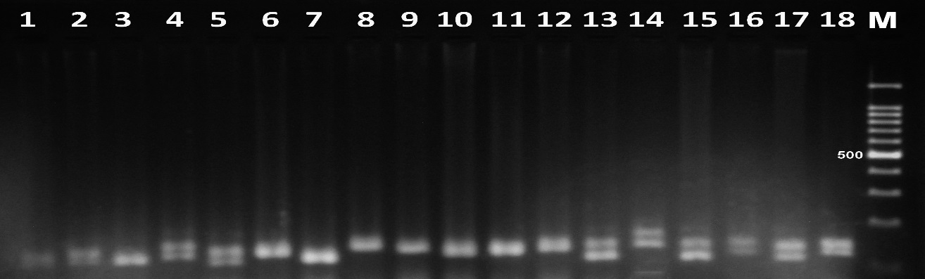
Figure (2) PCR amplification of PDCAT18 in 18 date palm cultivars on 2% agarose gel,
M=100bp plus DNA ladder.

primer mPdCIR70
The total of alleles resulting from the SSR-PCR reaction due to this primer was 18 alleles, with a molecular weight ranging from 170 bp to 200 bp (Table 3). It was able to identify some cultivars such as Halawi, Shuwathi and Maktum, which produced alleles different from their phenotypically similar strains. The primer was also able to distinguish the Brim red strain by producing an allele with a size of 200 bp, while both the Brim yellow and Brim white were identical with the allele of 180 bp in size. As for the rest of the cultivars, they were identical to their strains and did not differ from them (Figure 3).
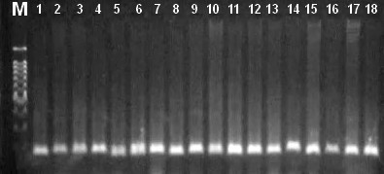
Figure (3) PCR amplification of mPdCIR70 in 18 date palm cultivars on 2% agarose gel,
M=100bp plus DNA ladder.

primer mPdCIR78
The primer mPdCIR78 gave alleles reached 18 alleles, and most of them are of similar in molecular weights at the cultivars and strains except for the two cultivars (Jawzi yellow and Jabjab Basra), each one has produced an allele with a size of 170 bp different from the allele produced by the slates Jawzi red and Jabjab Karbala which is (200 bp, 140 bp) respectively.. The primer was also able to distinguish the Brim red strain with its allele production of 180 bp different from Brim yellow and Brem White, which were similarity in allele production of 150 bp.
Primer DP157
The Primer DP157 succeeded to giving 40 alleles (Figuer 4). It was able to determine the genetic fingerprint of each studied cultivar and distinguish it from the phenotypically similar strains. The Halawi red strain was distinguished by the appear of three alleles, while ther was no allele produced in the Halawi yellow cultivar. The Barhi red strain was also distinguished for Barhi yellow cultivar by allele reached 900 bp, and the this primer was able to identify the two cultivars (Shouethi yellow and Maktum yellow) and distinguish them from the two strains (Shouethi red and Maktum red) by producing each of them alleles reached (330 bp and 200 bp) respectively. The primer DP157 was also able to produce alleles with differenc molecular weights that distinguish between the Jawzi yellow cultivar and his strain Jawzi red, the Jabjab Basra cultivar and the Jabjab Karbala strain. The results of this primer, there were confirmed in genetic match between the Brim yellow cultivars and the Brim white strain wich produced the same three alleles, while no allele appeared in the Brim red strain. Also, a genetic match was obtained between the Khdrawi Basra and the Khdrawi Karbala through their production of two identical alleles (170 bp and 1000 bp) and did not appear in the Khdrawi Maysan strain .
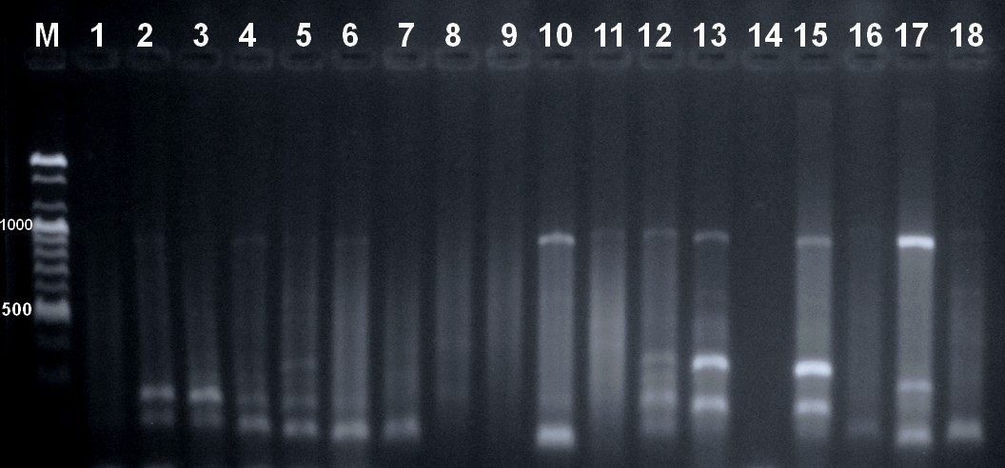
Figure (4) PCR amplification of DP157 in 18 date palm cultivars on 2% agarose gel,
M=100bp plus DNA ladder.

Primer DP175
In this Primer, the results show a number of alleles differenc in numbers and sizes, and their total was 27 alleles (Figur 5). These alleles were able to determine the genetic fingerprint of most of the studied cultivars, the Halawi yellow and the Halawi red strains each produced two different alleles (300 bp and 120 bp) respectively, and the Barhi red strain was characterized by the appearance of the 300 bp allele that did not appear in the Barhi yellow cultivar. The primer was also able to determine the identity of the Shouethi yellow cultivar by producing two alleles of size (320 bp, 170 bp) that differed from the alleles produced by the Shouethi red strain. On the other hand, the same allele appeared in the Maktum yellow cultivar and the Maktum red strain, with a size of 330 bp. As for the Jawzi yellow cultivar, its identity was identified and distinguished from the Jawzi red strain by the appearance of three alleles differ in molecular weights (300 bp, 170 bp, 120 bp). The results of the primer DP175 confirmed the genetic similarity between the Brim yellow cultivar and the Brim White strain, as well as the conformity of the Basra Khadrawi with the Karbala Khadrawi.
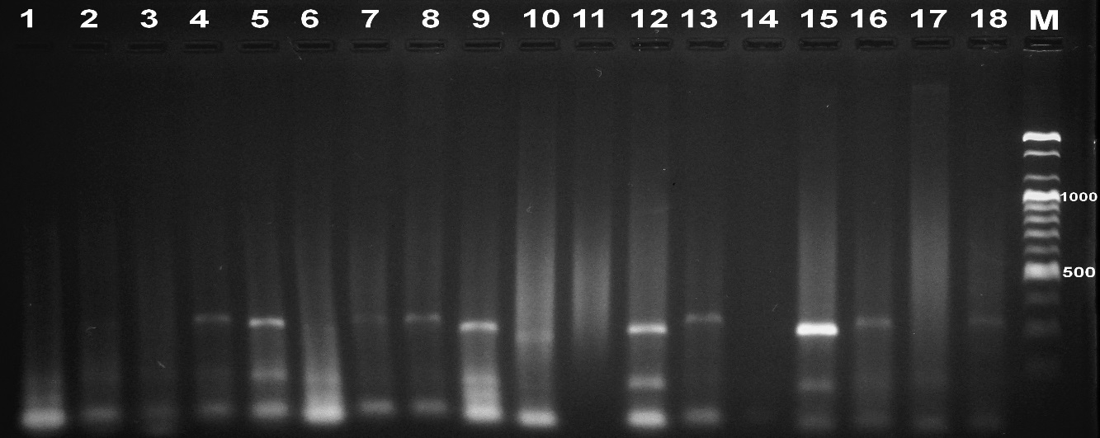
Figure (5) PCR amplification of DP175 in 18 date palm cultivars on 2% agarose gel,
M=100bp plus DNA ladder.

Genetic relationship and construction of a dendrogram
The dendrogram (Fig 1) showed the genetic relationship between the cultivars and their strains under study based on the results of primer amplificationas, number of cultivars appeared that matched each other, such as the two cultivars (Khadrawi Basra and Khadrawi Karbala) and the two cultivars (Brim yellow and Brim White) because of their matching in the number and size of alleles. This indicates their genetic affinity, which indicates the existence of a common genetic material between these cultivars (Vogt et al., 1997).
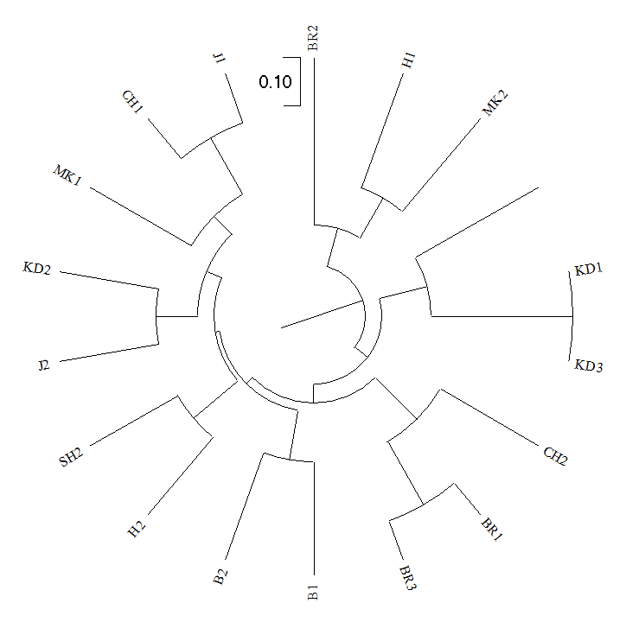
Fig 1. Dendrogram of 18 date palm cultivars generated with data from 6 SSR primers.

Class stratification of the inputs based on ΔK values computed by STRUCTURE HARVESTER revealed six groups as the most likely number of K (Evanno et al. 2005). (Fig. 2) The optimal number of studied taxa in these 18 accessions was determined to be six (Kopt = 6, Fig. 2). The overall stratification was in part in agreement with the dendrogram in Fig. 1. Each vertical line represents a single multilocular genotype. Each color represents the most likely strain from which the partial genotype was derived. Long monochromatic individuals are genetically similar, while polychromatic individuals have mixed genotypes from multiple groups.
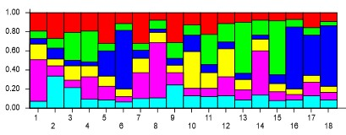
Fig 2. Model-based cluster construction using Bayesian analysis among 18 date palm cultivars based on allelic variants at 6 SSR loci. Six clusters were defined using the Evanno et al. (2005) method..

We conclude from this study that these strains that are phenotypically similar with the well-known cultivars (Khadrawi Basra and Khadrawi Karbala), (Brim yellow and Brim White) are genetically the same, But there was a change in the phenotype due to the environment in which it was grown, as well as the different naming of farmers according to his geographical area. As for the rest of the strains, they are different strains that differ from the genetically known cultivars as a result of genetic mutations, so they must be called by names that differ from the known cultivar.
References
Abou-Elwafa, S. (2018). Identification of associated genes with drought tolerance in barley. Biology Plantarum 62(2), 299-306. https://doi.org/10.1007/s10535-017-0765-0
Abul-Soad, A. A., Jain, S. M. & Jatoi, M. A. (2017).Biodiversity and conservation of date palm. In Biodiversity and conservation of woody plants, 313-353: Springer.
Ahmed, T. A. & Al-Qaradawi, A. Y. (2009). Molecular phylogeny of Qatari date palm genotypes using simple sequence repeats markers. Biotechnology 8(1): 126-131.
Aitchitt, M., Ainsworth, C.C. & Thangavelu, M. (1993). A rapid and efficient method for the extraction of total DNA from mature leaves of the data palm ( Phoenix dactylifera L.). Plant molecular biology reporter, 11(4), 317-319. https://doi.org/10.1007/bf02905332
Akkak, A., Scariot, V., Marinoni, D. T., Boccacci, P., Beltramo, C. & Botta, R. (2009). Development and evaluation of microsatellite markers in Phoenix dactylifera L. and their transferability to other Phoenix species. Biologia Plantarum 53(1): 164-166.
Al-Bakr A., (1972). The Date Palm. Its Past and Present Status. Alani Press, Baghdad:1085pp.
Arabnezhad, H., Bahar, M., Mohammadi, H. R. & Latifian, M. (2012). Development, characterization and use of microsatellite markers for germplasm analysis in date palm (Phoenix dactylifera L.). Scientia Horticulturae 134: 150-156.
Chao,C.T. & Devanand,P.S.(2012). Not all ‘Medjool’ date plants grown in California are the same. Plant Genetic Resources Department of Botany and Plant Sciences, UC Riverside, USA.
.Doyle, J. (1991). DNA protocols for plants. In Molecular techniques in taxonomy , 283-293: Springer.
https://link.springer.com/chapter/10.1007/978-3-642-83962-7_18
Fazekas, M., Madar, A., Sipiczki, M., Miklós, I. & Holb, I.J. (2014). Genetic diversity in Monilinia laxa populations in stone fruit species in Hungary. World Journal of Microbiology and Biotechnology,30(6): 1879-1892. https://link.springer.com/article/10.1007/s11274-014-1613-4

Jamil, S., Shahzad, R., Kanwal, S., Yasmeen, E., Rahman, S. U. & Iqbal, M. Z. (2020). DNA Fingerprinting and Population Structure of Date Palm Varieties Grown in Punjab Pakistan using Simple Sequence Repeat Markers. International Journal of Agriculture and Biology 23(5): 943-950.
Khanam, S., Sham, A., Bennetzen, J. L. & Aly, M. A. (2012). Analysis of molecular marker-based characterization and genetic variation in date palm ('Phoenix dactylifera'L.). Australian Journal of Crop Science 6(8): 1236-1244.
Metoui, M., Essid, A., Ferchichi, A. & Hormaza, J. I. (2017). Tunisian Date Palm (Phoenix Dactylifera L.) Cultivars Characterization Using Simple Sequence Repeats (SSR) Markers. Transylvanian Review 1(4): 4736-4741.
Peyron, G. (2000). Cultiver le palmier-dattier. Editions Quae.
Racchi, M., Bove, A., Turchi, A., Bashir, G., Battaglia, M. & Camussi, A. (2014). Genetic characterization of Libyan date palm resources by microsatellite markers. 3 Biotech 4(1): 21-32.
Sedra, M. H., Lashermes, P., Trouslot, P. & Combes, M.-C. (1998). Identification and genetic diversity analysis of date palm (Phoenix dactylifera L.) varieties from Morocco using RAPD markers. Euphytica 103(1): 75-82.
Vogt, T., Mathieu-Daude, F., Kullmann, F., Welsh, J. & McClelland, M. (1997). Fingerprinting of DNA and RNA using arbitrarily primed PCR. DNA markers: protocols, applications and overviews: 55-74.
Yusuf, A., Culham, A., Aljuhani, W., Ataga, C., Hamza, A., Odewale, J. & Enaberue, L. (2015). Genetic diversity of Nigerian date palm (Phoenix dactylifera) germplasm based on microsatellite markers. International Journal of Bio-Science and Bio-Technology 7(1): 121-132.

