Application of exogenous salicylic acid induces resistance in pakchoi (Brassica campestris ssp. chinensis Makino) against Plasmodiophora brassicae
Running title: Salicylic acid induces clubroot in pakchoi
Hongfang Zhu#, Xiaofeng Li #, Dandan Xi, Lu Gao, Zhaohui Zhang, Yuying Zhu *
Horticulture Research Institute, Shanghai Academy of Agricultural Sciences, Shanghai, China;
Shanghai Key Lab of Protected Horticultural Technology, Shanghai, China
# These authors contributed equally to this work.
*Corresponding authors: yy5@saas.sh.cn ( Yuying Zhu )
Abstract
Salicylic acid (SA) is a plant hormone that plays critical roles in defense against diseases. To investigate the mechanism of SA-induced resistance against clubroot, we analyzed the effect of SA on growth of clubroot-sensitive plants, alteration of antioxidative system, and related gene expression. A clubroot-sensitive pakchoi cultivar, xinxiaqing, was treated with P. brassicae and/or 0.6 mM exogenous SA. Results revealed that clubroot significantly affected pakchoi growth and enhanced reactive oxygen species (ROS) contents and membrane lipid peroxidation. After 0.6 mM exogenous SA treatment, both clubroot incidence rate and disease index were decreased in inoculated plants. Exogenous SA also increased the activities of superoxide dismutase (SOD), ascorbic acid-peroxidase (APX), catalase (CAT), and glutathione reductase (GR). Additionally, the production rate of malondialdehyde (MDA), hydrogen peroxide (H₂O₂), and superoxide anion (O₂· –) was inhibited by SA. The expression levels of genes, encoding antioxidant enzymes ,were decreased in group Inoculation+SA plants. Collectively, we conclude that 0.6 mM SA contributes to induce plant resistance to clubroot by increasing activities of antioxidant enzymes, abilities of osmotic regulation, and ROS scavenging to decrease clubroot-induced damage in pakchoi.
Key words: exogenous SA, pakchoi, clubroot, resistance induction, antioxidant system

Introduction
Clubroot is a worldwide soil-born disease that is caused by Plasmodiophora brassicae Woron (P. brassicae) infection (Howard et al., 2010). P. brassicae can infect over 100 Brassica species, including Brassica napus L., Brassica rapa pekinesis, Brassica oleracea L., and Brassica rapa L., resulting in great economic loss. The life cycle of P. brassicae is mainly composed of primary phase taking place in root hairs and secondary phase taking place in cortical and stele cells (Ingram and Tommerup, 1972; Lemarié et al., 2015). In recent years, damage of clubroot becomes more and more serious. According to the statistics, clubroot incident area had already up to 4666.7 hm² only in Shanghai (China) in 2017 (supplied by Shanghai Agricultural Technology Extension Service Center). To successfully control clubroot, many researches pay much attention to control clubroot, such as chemical control, crop rotation, and genetic control (Howard et al., 2010).
To overcome pathogen infections, plants have developed a defense system comprising of pathogen-associated molecular patterns (PAMP)-triggered immunity (PTI) and resistance (R) proteins associated pathogen effector-triggered immunity (ETI) (Jones and Dangl, 2006; An and Mou, 2011). Following activated PTI or ETI, the mobile signals, produced in local infected tissues, moves to distal tissues, activating systemic acquired resistance (SAR) (An and Mou, 2011). SA is a small phenol in plants and well-studied as a signal molecular during plant immunity response, although it also plays essential roles in in cellular signal transduction, plant growth and development, and abiotic stress (Morris et al., 2000; Vlot et al., 2009; Spormann et al., 2019)
Oxidative stress acts as a result of various stresses, including biotic stress. The primary reason for oxidative stress is excessive accumulation of reactive oxygen species (ROS), produced during aerobic metabolism and damage plant cells (Sunkar et al., 2003; Apel and Hirt, 2004). To avoid ROS damage, plants evolved two systems comprising of non -enzymatic and enzymatic ROS scavenging mechanisms (Apel and Hirt, 2004). The involved enzymes mainly include superoxide dismutase (SOD), ascorbic acid-peroxidase (APX), glutathione peroxidase (GPX), catalase (CAT), and glutathione reductase (GR) (Apel and Hirt, 2004). Overproduction of ROS, beyond plant scavenging ability, further results in plant hypersensitive reaction (HR) and damages to cells. Ozone (O₃) and superoxide anion (O₂· – ) are reported to be accumulated in an Arabidopsis mutant, radical-induced cell death 1 (rcd1), resulting in cell death (Overmyer et al., 2000). Contrarily, overexpression of chloroplast SOD in chloroplast enhanced plant resistance to oxidative stress (Allen, 1995).
Numerous evidences have revealed that SA is an effective strategy to inhibit clubroot disease. It has been hypothesized that SA can be converted to biologically inactive methyl salicylate by P. brassicae (Ludwig-Müller et al., 2015). Exogenous SA was reported to suppress clubroot in Arabidopsis (Agarwal et al., 2011). Similar results were also observed in broccoli (B. oleracea), Arabidopsis Bur-0 accession(Lovelock et al., 2013; Lemarié et al., 2015). Additionally, SA related genes were differentiated expressed in B.rapa ssp. Chinensis inoculated with P. brassicae (Chu et al., 2014). However, the mechanism of SA repress clubroot still remains unclear.
Researches have established that exogenous SA induced resistance to abiotic and biotic stresses, possibly through regulating ROS metabolism. Plants treated with SA increased APX and GR activity against temperature stress (Wang and Li, 2006). Application of benzothiadiazole S-methyl ester (BTH), a SA analog, induced wheat defense-related genes overexpression in wheat (Pasquer et al., 2005). Moreover, SA application induced PR-proteins in Solanum melongene L. against Verticillium dahlia Kleb (Mahesh et al., 2017). SA was also found to induce rubber tree against Phytophthora palmivora through increasing CAT, peroxidase (POD), and phenylalanine ammonialyase (PAL) activities (Deenamo et al., 2018). The latest study revealed that SA application enhanced two tomato cultivars resistance to Tomato yellow leaf curl virus (TYLCV) by increasing POD and APX activities (Li et al., 2019). A recent research showed that exogenous SA decreased clubroot symptoms in two Arabidopsis accessions (Lemarié et al., 2015). Conversely, degradation of endogenous SA enhanced Ralstonia solanacearum virulence in tobacco (Lowe-Power et al., 2016). Moreover all these researches suggested that SA-mediated increased clubroot resistance may depend on ROS pathway in pakchoi.
At present, there are a few of pakchoi cultivars resistance to clubroot and most cultivars exhibit susceptibility to clubroot, which bring challenges to growers and breeders. Our previous researches have revealed 0.6 mM SA have best effectivity to control clubroot (Zhu et al., 2017). However, the underlying molecular mechanism was not clear. In this study, we found that pakchoi exhibited increased clubroot resistance after exogenous SA, consistent with the previous result (Zhu et al., 2017). ROS contents, antioxidant enzyme activities, and related gene expression were altered after SA treatment. We demonstrated that exogenous SA treatment increases antioxidant enzyme activities to scavenge over-produced ROS level, resulting in increased clubroot resistance.

Materials and Methods
Plant Materials
Xinxiaqing, a pakchoi cultivar and mainly grew in Shanghai, was used for analysis and supplied by Protected Horticultural Research Institute, Shanghai Academy of Agricultural Science (SAAS). The P. brassicae (physiological race 7) was isolated from infected roots grew in Hongyang Farm in Qingpu District, Shanghai (Zhu et al., 2019).

P. brassicae and SA treatment
P. brassicae infected pakchoi roots with galls were harvested from fields and stored at -20 ºC until required. Diseased roots were homogenated and mixed with sterilized soil, keeping with 2×10⁸ spores per gram soil with hemocytometer. Pakchoi seeds were sowed on soil (group Control) or mixed soil with root homogenate (group Inoculation) in growth chamber, which was set to 28±1ºC day/20±1ºC night and 12 h light / 12 nigh. Water content of two kind soils was 60%. Ten days after germination (DAG), seedlings (group Control and group Inoculation) were treated with water or 0.6 mM SA (group Control+SA or group Inoculation+SA, SA was diluted in ethanol/water) with one time every day for four days. Forty DAG, plants were used to calculate disease index and disease incidence rate. The third leaf was collected for RNA extraction, ROS content measurement, soluble protein content measurement, proline content measurement, and antioxidant enzyme activities.

Disease discovery
Disease symptoms were discovered at forty DAG. Clubroot grading was described previously (Huang et al., 2012). Grade 0：no symptoms; Grade 1: very small galls in lateral roots or primary roots, which do not affect main root growth ; Grade 3: a few of galls are found obviously in primary roots and gall size is 2-3 times than transection of basal part of stem; Grade 5: severe galls are found in lateral roots and primary roots, gall size is over 4 times than transection of basal part of stem, which affect plant growth (Huang et al., 2012).
Disease incidence rate (DIR) = (number of disease plants/total number of plants) X 100%
Disease index (DI)=∑(disease grade X number of disease plants per grade) X 100 / (total number of plants)
Induced resistance index (IRI) =｛(DI of inoculated plants- DI of inoculated plants with exogenous SA) / DI of inoculated plants｝X100%。

Measurement of proline content and soluble protein
Proline content was measured according to the method of Funck et al. (Funck et al., 2008). Proline was extracted with sulfosalicylic acid, followed by acidic ninhydrin reagent. The mixture was extracted with toluene. The tolune supernatant was used to detect A₅₂₀. Standard curves from 0 to 10 mM proline treated in the same way was made to calculate proline content. Soluble protein content was detected using Coomassie Brilliant Blue G-250 (Bradford, 1976).

Measurement of ROS content
Malondialdehyde (MDA) content represents the damage of ROS to membrane lipids and was measured with thiobarbituric acid (TBA) method previously described (Jiang and Zhang, 2001). H₂O₂ content was measured by monitoring the absorbance of titanium–peroxide complex at 415nm described by Brennan and Frenkel (1977). O₂· – content was measured as described by Jang and Jiang and Zhang (2001). In presence of O₂· –, nitrite is finally synthesized from hydroxylamine. A standard curve of NO₂ ⁻ was used to calculate O₂· – content.

Measurement of antioxidant enzyme activities
SOD activity was measured with nitro blue tetrazolium (NBT) according to the method of Jiang and Zhang (Jiang and Zhang, 2001). One unit SOD activity was determined to cause 50% inhibition of the reduction of NBT at 560 nm. CAT and APX activity was measured with the method of Jiang and Zhang (Jiang and Zhang, 2001). The reaction buffer, containing 50 mM potassium phosphate buffer (pH7.0), 10 mM H₂O₂, and enzyme extract, was used to detect the absorbance at 240 nm for measuring CAT activity. APX enzyme extract was added to reaction buffer containing 50mM potassium phosphate buffer (pH7.0), 0.5 mM ascorbate (ASC), 0.1 mM H₂O₂. The decrease of APX activity in A₂₉₀ for 1 min was measured in the mixed solution at 25ºC. GR activity was measured with the oxidation of NADPH at 340 nm (Jiang and Zhang, 2001). The absorbance at 340 nm without NADPH was used to make corrections.

RNA extraction and Gene expression
To detect expression levels of SOD, CAT, APX, and GR, total RNA was extracted with RNAiso plus and tested by Nanodrop 2000 (Thermo Scientific). Then cDNA was synthesized with HiScript II Q RT SuperMix for qPCR(+gDNA wiper) (Vazyme), after which qRT-PCR was performed with QuantiFast ® SYBR® Green PCR Kit (Qiagen). Fluorescence was detected by LightCycler® 480 II (Roche). Gene expression level was calculated by 2^{—ΔΔCt} method. Actin was used as reference gene. All primers used were listed in Supplementary Table 1.

Results
The effects of SA on induced-clutroot-resistance and growth of pakchoi
To explore whether SA increases pakchoi resistance to clubroot, seedlings having one leaf and one bud were treated with 0.6mM SA or water. Within Group Control, there was no galls occurred in roots (Figure 1). Plant height, maximum leaf area, and fresh weight did not changed with SA application (Table 1). Within Group Inoculation, abnormal root system occurred with large galls without SA (Figure 1). DIR and DI of Group Inoculation were up to 66.15% and 36.16% , respectively (Tabel 1). Plant height, maximum leaf area, and fresh weight on the ground were reduced by 27.40%, 39.26%, and 58.61%, respectively compared with those of Group Control (Table 1). However, after 0.6 mM SA treatment for four days, DIR and DI were only up to 25.51% and 13.45% compared to those of Group Control. DIR was reduced by 61.42% compared to that of Group Inoculation, and DI was reduced by 62.80%. Additionally, Plant height, maximum leaf area, and shoot fresh weight on the ground were only reduce by 17.22%, 19.42%, and 21.48% (Table 1). These data revealed that exogenous SA effectively released the inhibition of clubroot on pakchoi growth.

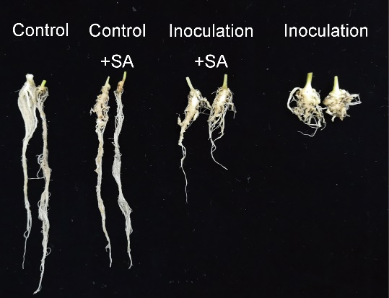
Figure 1 Forty-day old plant roots of group Control, Control+SA, Inoculation+SA, and Inoculation. SA concentration was 0.6 mM with four-day continuous treatment.

Table 1 Effect of SA on the inducted-resistance and growth of pakchoi under P. brassicae.
Group | DIR(%) | DI(%) | IRI (%) | Plant height  (cm) | Maximum leaf area (cm²) | Shoot fresh weight (g)
Control | - | - | - | 13.65±0.51ª | 25.65±0.11 ª | 6.33±0.07 ª
Inoculation | 66.15±1.07ª | 36.16±2.03ª | - | 9.91±0.12 ^{c} | 15.58±0.13 ^{c} | 2.62±0.02 ^{c}
Control+SA | - | - | - | 13.30±0.41ª | 24.47±0.21ª | 6.21±0.03 ª
Inoculation+SA | 25.51±2.43^{b} | 13.45±0.05^{b} | 61.21±0.017 | 11.30±0.46 ^{b} | 20.67±0.20 ^{b} | 4.97±0.11 ^{b}

Group Control or Control + SA: ten-day-old seedlings sowed in soil treated with water or 0.6mM SA, respectively; group Inoculation or Inoculation+SA: ten-day-old seedlings sowed in mixed soil (with P. brassicae) treated with water or 0.6 mM SA, respectively. The calculation of DIR and DI were presented in methods. DIR: disease incidence rate; DI: disease index. Data shown represent mean ± SD (n > 190 ). Different letters indicate significance (Tukey’s HSD test, P < 0.05).

Effect of SA on proline and soluble protein contents in pakchoi
AS plant resistance to stresses can be expressed by proline and soluble protein levels, therefore, we detected the proline and soluble protein contents after SA application in P. brassicae – inoculated pakchoi. Soluble protein contents of group Inoculation were 7.21 mg.g⁻¹ FW in leaves and 3.55 mg.g⁻¹ FW in roots (Figure 2A). Proline contents were 20.72 mg.g⁻¹ FW in leaves and 15.94 mg.g⁻¹ FW in roots (Figure 2B). After 0.6 mM SA application, both soluble protein and proline contents were increased. Soluble protein contents were up to 9.56 mg.g⁻¹ FW in leaves and 6.43 mg.g⁻¹ FW in roots (Figure 2A). Proline contents were increased to 30.74 mg.g⁻¹ FW in leaves and 20.61 mg.g⁻¹ FW in roots (Figure 2B). These results showed that P. brassicae inoculation reduced soluble protein and proline contents while SA increased soluble protein and proline contents in P. brassicae-infected pakchoi.

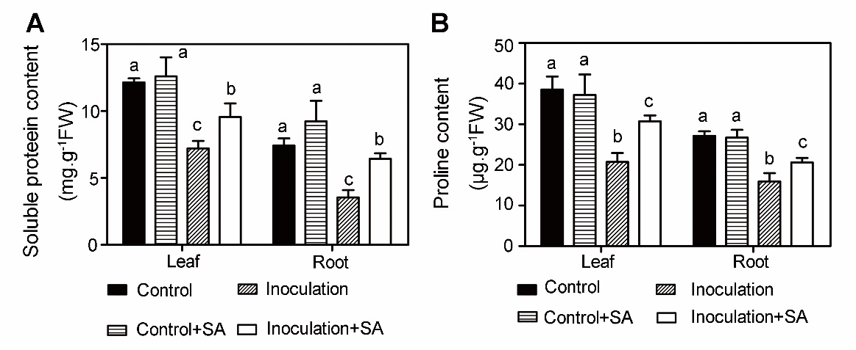
Figure 2. Soluble protein and proline contents in pakchoi. Soluble protein (A) and proline contents (B) in leaves and roots were presented. The third leaves were harvested for analysis. Data shown represent mean ± SD (n = 3). Different letters indicate significance (Tukey’s HSD test, P < 0.05).

Effect of SA on ROS and MDA contents in P. brassicae-inoculated pakchoi
When suffer from biotic or abiotic stresses, plants will produce more ROS further leading to oxidative stress to cells. Accumulation of ROS causes cell membrane lipid peroxidation and cell death (Sunkar et al., 2003). MDA is a byproduct of membrane lipid peroxidation and its content reflects the degree of membrane lipid peroxidation (Sunkar et al., 2003). Firstly, we detected ROS content expressed by H₂O₂ and O₂· – contents in plants. In group Control, H₂O₂ contents were 8.25 μmol.g⁻¹ FW in leaves and 12.13 μmol.g⁻¹ FW in roots (Figure 3A). O₂· – levels were 3.09 μmol.g⁻¹ FW in leaves and 6.71 μmol.g⁻¹ FW in roots (Figure 3B). MDA contents were 2.69 μmol.g⁻¹ FW in leaves and 3.73 μmol.g⁻¹ FW in roots (Figure 3C). However, ROS and MDA contents of group Inoculation were distinctly increased. H₂O₂, O₂· –, and MDA contents were up to in 13.72 μmol.g⁻¹ FW and 20.94 μmol.g⁻¹ FW , 4.20 μmol.g⁻¹ FW and 12.43 μmol.g⁻¹ FW , and 5.23 μmol.g⁻¹ FW and 5.87 μmol.g⁻¹ FW, in leaves and roots, respectively (Figure 3). With SA application, H₂O₂, O₂· – , and MDA contents of group Inoculation+SA were reduced to 11.06 μmol.g⁻¹ FW and 16.28 μmol.g⁻¹ FW, 3.54 μmol.g⁻¹ FW and 9.48 μmol.g⁻¹ FW, and 4.53μmol.g⁻¹ FW and 4.78, in leaves and roots, respectively (Figure 3). These data revealed that P. brassicae inoculation significantly promoted ROS and MDA production and exogenous SA application inhibited ROS and MDA production to protect plants.
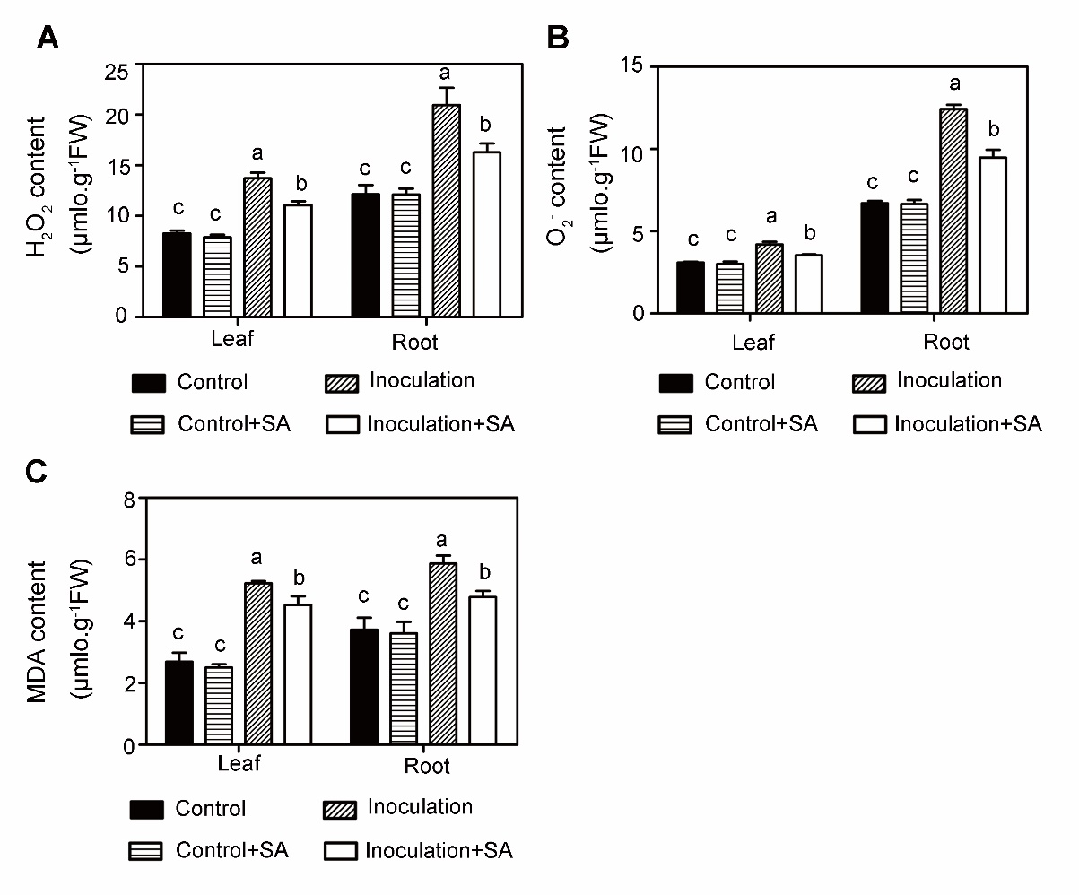
Figure 3 SA effect on ROS and MDA contents in pakchoi. H₂O₂ (A), O₂· – (B), and MDA (C) contents in pakchoi were measured among four groups. Forty-day old leaves or roots were harvested for analysis, respectively. Methods were detailed described in Materials and Methods. Data shown represent average ± SD. Different letters indicate significance (Tukey’s HSD test, P < 0.05).

Effect of SA on antioxidant enzymes activities
To response to stress, plants continuously adjust to their metabolism to adapt to environment, including increased activities of antioxidant enzymes to scavenge over produced ROS. Between groups without inoculation, SA treatment did not change SOD and GR activities but increased APX activities both in leaves and roots (Figure 4). In group Inoculation, SOD activities were 233.62 U.g⁻¹ FW in leaves and 194.74 U.g⁻¹ FW in roots, CAT activities were 61.53 U.g⁻¹ FW in leaves and 108.13 U.g⁻¹ FW in roots, APX were 1.66 U.g⁻¹ FW in leaves and 1.41 U.g⁻¹ FW in roots, and GR were 1.46 U.g⁻¹ FW in leaves and 0.53 U.g⁻¹ FW in roots (Figure 4). However, treated with 0.6 mM SA after inoculation, SOD activities were up to 277.82 U.g⁻¹ FW in leaves, 226.09 U.g⁻¹FW in roots, CAT were up to 83.80 U.g⁻¹FW and 161.84 U.g⁻¹FW, and GR were up to 1.94 U.g⁻¹FW and 0.97 U.g⁻¹FW, respectively (Figure 4). APX activity was up to 1.95 U.g⁻¹FW in leaves but did not change in root compared to that of group Inoculation (Figure 4). Increased antioxidant enzyme activities contributes to scavenging ROS and protect plants. These data revealed that SA induced plants resistance to clubroot through antioxidant system.
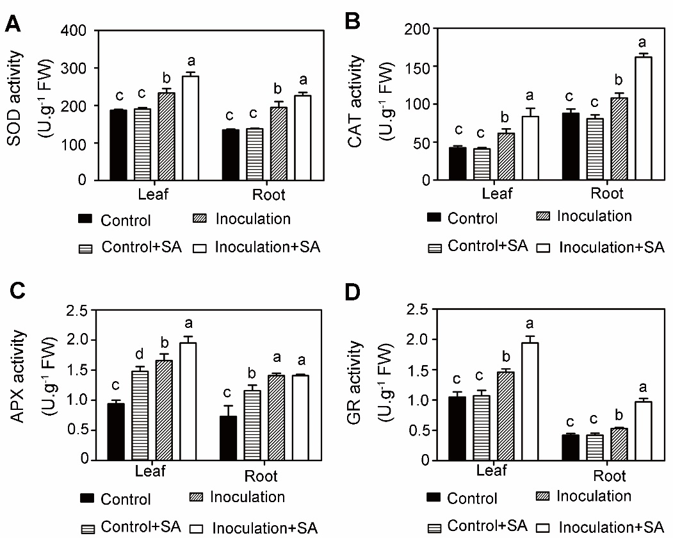

Figure 4 Antioxidant enzyme activities in pakchoi. SOD (A) , CAT (B) , APX (C) , and GR (D) activities in pakchoi were measured among four groups at 40 DAG. Data shown represent average ± SD (n = 3). Different letters indicate significance (Tukey’s HSD test, P < 0.05).

Effect of SA on antioxidant gene expression
Since activities of antioxidant enzymes in pakchoi were altered after inoculation and SA application, we further detected antioxidant genes expression levels to analysis potential mechanism of SA – induced clubroot resistance in pakchoi. qRT-PCR analysis revealed that exogenous SA did not alter SOD,CAT, APX, and GR expression levels both in leaves and roots without inoculation (Figure 5). Compared to group Control, significantly increased gene expression levels were observed in group Inoculation (Figure 5). When plants of group Inoculation were treated with SA, SOD, CAT, APX, and GR expression levels were increased significantly compared to that of plants of group Inoculation (Figure 5). These data revealed that exogenous SA promoted antioxidant enzyme biosynthesis through upregulating related genes expression, resulting in increased clubroot resistance.

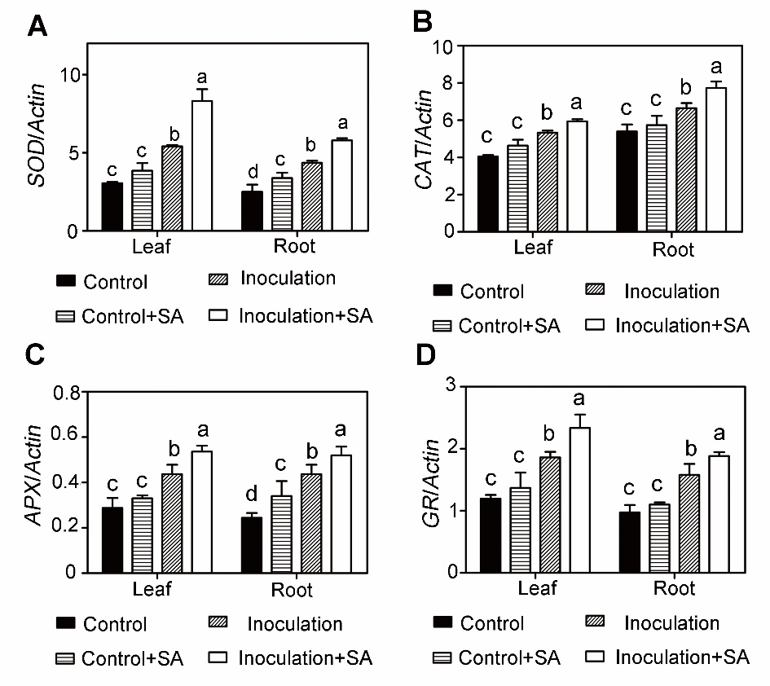

Figure 5 Relative gene expression levels in roots and leaves. SOD (A), CAT (B), APX (C), and GR (D) expression levels in different groups were detected. Data shown represent average ± SD (n = 3). Different letters represent significance (one-way anova, P < 0.05).

Discussion
SA , as a plant hormone, has been established to promote plant growth and development, induce resistance to temperature and disease stresses. Exogenous SA has been verified to be beneficial in plant growth against abiotic and biotic stresses (Mabood and Smith, 2007). SA induces plant resistance to virus, fungi, and bacteria infection, which has been verified in tobacco and wheat (Pasquer et al., 2005; Lowe-Power et al., 2016). In this study, inoculation with P. brassicae impacted plant height, maximum leaf area, and fresh weight. Our previous study revealed that different concentrations of exogenous SA application have different effects on clubroot incidence in pakchoi (Zhu et al., 2017). Clubroot incidence rate of plants treated with 0.6 mM SA was lower than that of plants treated with 0.2 mM, 0.4 mM or 0.8 mM SA (Zhu et al., 2017). This suggests that 0.6 mM exogenous SA may work best in controlling clubroot. Hence, we employed 0.6 mM exogenous SA, after inoculation, leading to decreased plant DIR, increased resistance to clubroot, and promoted plant growth (Figure 1 and Table 1).
Under normal conditions, the production and scavenging of cellular ROS keep dynamic balance. When plants suffer from stresses, the balance is broken and ROS are accumulated, resulted from production rate is higher than scavenging rate by antioxidant enzymes. Our study revealed that exogenous SA inhibited the production rate of H₂O₂ and O₂· –, as well as MDA content. ROS scavenging mainly depends on antioxidant enzymes and antioxidants. SOD, CAT, GR, and APX are key antioxidant enzymes required for ROS scavenging and preventing membrane peroxidation. These four enzymes increased their activities with SA application in plants inoculated with P. brassicae (Figure 4). SOD converts O₂· – into H₂O₂ (Apel and Hirt, 2004). The decreased O₂· – might result from enhanced SOD activity induced by exogenous SA (Figure 3B and Figure 4A). Moreover, SA treatment also inhibited the generation of H₂O₂ both in leaves and roots, which was consistent with the enhancement of CAT and APX activities (Figure 3A and Figure 4B,C). Ascorbic acid-glutathione (AsA-GSH) system comprises AsA, GR, and APX, converting H₂O₂ to H₂O and MDA (Apel and Hirt, 2004). It has been established that SA can stimulate AsA-GSH cycle to increase the efficiency of antioxidants. Our study revealed that APX and GR activities were increased, leading to decreased H₂O₂ and MDA contents (Figure 3A, C and Figure 4C,D).
The secondary phase of P. brassicae lifecycle is associated with cell division and cell elongation, leading to gall formation (Lemarié et al., 2015). Auxin is an essential hormone that plays key roles in root development, including gall formation(Ludwig-Müller, 2014). Auxin level, as well as the expression of hormone - related genes, was changed after inoculation with P. brassicae in B.napus (Prerostova et al., 2018). Previous research showed many pathogens positively regulate auxin biosynthesis or modulate auxin signaling to make hosts more susceptible to infection (Kidd et al., 2011; Kazan and Lyons, 2014). In Arabidopsis, it has been stablished that SA or its analogue treatment represses auxin level and signaling (Wang et al., 2007). Therefore, we hypothesized that the exogenous SA treatment may also affect auxin biosynthesis and signaling, thus decreasing P. brassicae infection abilities and increasing plant resistance to infection, which is deserved to be further studied.

Conclusions
Collectively, we conclude that P. brassicae-infected pakchoi over products ROS and MDA, resulting in membrane lipid peroxidation, and damaging cell structures and functions. Exogenous SA significantly increases gene expression levels and antioxidant enzyme activities to decrease ROS contents and reduce or prevent membrane lipid peroxidation, leading to increased clubroot resistance in pakchoi.

Acknowledgements
This work was supported by the Shanghai Municipal Agricultural Commission: 8-1-2014 and 03-2-2018. The funders had no role in study design, data collection and analysis, decision to publish, or preparation of the manuscript.

Conflict of interest
All authors declare that they have no conflict of interest.

References
Agarwal, A., Kaul, V., Faggian, R., Rookes, J.E., Ludwig-Müller, J., and Cahill, D.M, 2011. Analysis of global host gene expression during the primary phase of the Arabidopsis thaliana–Plasmodiophora brassicae interaction. Funct Plant Biol., 38: 462.
Allen, R.D., 1995. Dissection of oxidative stress tolerance using transgenic plants. Plant Physiol., 107: 1049-1054.
An, C., and Mou, Z., 2011. Salicylic acid and its function in plant immunity. J Integr Plant Biol., 53: 412-428.
Apel, K., and Hirt, H., 2004. Reactive oxygen species: metabolism, oxidative stress, and signal transduction. Annu Rev Plant Biol., 55: 373-399.
Bradford, M.M., 1976. A rapid and sensitive method for the quantitation quantities microgram principle of protein-dye binding. Anal Biochem., 72: 248-254.
Brennan, T., and Frenkel, C., 1977. Involvement of hydrogen peroxide in the regulation of senescence in pear. Plant Physiol., 59:411-416.
Chu, M., Song, T., Falk, K.C., Zhang, X., Liu, X., Chang, A., Lahlali, R., McGregor, L., Gossen, B.D., Peng, G., and Yu, F., (2014). Fine mapping of Rcr1 and analyses of its effect on transcriptome patterns during infection by Plasmodiophora brassicae. BMC Genomics., 15: 1166.
Deenamo, N., Kuyyogsuy, A., Khompatara, K., Chanwun, T., Ekchaweng, K., and Churngchow, N., 2018. Salicylic acid induces resistance in rubber tree against phytophthora palmivora. Int J Mol Sci., 19: 1883.
Funck, D., Stadelhofer, B., and Koch, W., 2008. Ornithine-δ-aminotransferase is essential for Arginine Catabolism but not for Proline Biosynthesis. BMC Plant Biol., 8: 40.
Howard, R.J., Strelkov, S.E., and Harding, M.W., (2010). Clubroot of cruciferous crops - new perspectives on an old disease. Can J Plant Pathol., 32: 43-57.
Huang, R., Huang, R., Hua, J., Liang, Y., Shao, J., and Shao JY., 2012. Study on inoculation methods and condition of clubroot in Brassica rapa chinensis. Chinese Agricultural Science Bulletin., 28: 252-255.
Ingram, D., and Tommerup, I., 1972. The life history of Plasmodiophora brassicae Woron. P Roy Soc Lond., 180: 103-112.
Jiang, M., and Zhang, J., 2001. Effect of abscisic acid on active oxygen species, antioxidative defence system and oxidative damage in leaves of maize seedlings. Plant & cell physiol., 42:1265-1273.
Jones, J.D.G., and Dangl, J.L., 2006. The plant immune system. Nature, 444: 323-329.
Kazan, K., and Lyons, R., 2014. Intervention of phytohormone pathways by pathogen effectors. Plant Cell, 26: 2285-2309.
Kidd, B.N., Kadoo, N.Y., Dombrecht, B., Tekeoğlu, M., Gardiner, D.M., Thatcher, L.F., Aitken, E.A.B., Schenk, P.M., Manners, J.M., and Kazan, K., 2011. Auxin signaling and transport promote susceptibility to the root-infecting fungal pathogen fusarium oxysporum in Arabidopsis. Mol Plant Microbe In., 24: 733-748.
Lemarié, S., Robert-Seilaniantz, A., Lariagon, C., Lemoine, J., Marnet, N., Jubault, M., Manzanares-Dauleux, M.J., and Gravot, A., 2015. Both the jasmonic acid and the salicylic acid pathways contribute to resistance to the biotrophic clubroot agent Plasmodiophora brassicae in Arabidopsis. Plant Cell Physiol., v127.
Li, T., Huang, Y., Xu, Z., Wang, F., and Xiong, A., 2019. Salicylic acid-induced differential resistance to the tomato yellow leaf curl virus among resistant and susceptible tomato cultivars. BMC Plant Biol., 19.
Lovelock, D.A., Donald, C.E., Conlan, X.A., and Cahill, D.M., 2013. Salicylic acid suppression of clubroot in broccoli (Brassicae oleracea var. italica) caused by the obligate biotroph Plasmodiophora brassicae. Australas Plant Path., 42: 141-153.
Lowe-Power, T.M., Jacobs, J.M., Ailloud, F., Fochs, B., Prior, P., and Allen, C., 2016. Degradation of the plant defense signal salicylic acid protects Ralstonia solanacearum from toxicity and enhances virulence on tobacco. mBIO., 7: e616-e656.
Ludwig-Müller, J., 2014. Auxin homeostasis, signaling, and interaction with other growth hormones during the clubroot disease of Brassicaceae. Plant Signal & Bahav., 9: e28593.
Ludwig-Müller, J., Jülke, S., Geiß, K., Richter, F., Mithöfer, A., Šola, I., Rusak, G., Keenan, S., and Bulman, S., 2015. A novel methyltransferase from the intracellular pathogen Plasmodiophora brassicae methylates salicylic acid. Mol Plant Pathol., 16: 349-364.
Mabood, F., and Smith, D., 2007. The role of salicylates in Rhizobium-legume symbiosis and abiotic stresses in higher plants. Salicylic Acid- A Plant Hormone,151-162.
Mahesh, H.M., Murali, M., Anup Chandra Pal, M., Melvin, P., and Sharada, M.S., 2017. Salicylic acid seed priming instigates defense mechanism by inducing PR-Proteins in Solanum melongena L. upon infection with Verticillium dahliae Kleb. Plant Physiol Bioch., 117: 12-23.
Morris, K., Mackerness, S.A.H., Page, T., John, C.F., Murphy, A.M., Carr, J.P., and Buchanan Wollaston, V., 2000. Salicylic acid has a role in regulating gene expression during leaf senescence. Plant J., 23: 677-685.
Overmyer, K., Tuominen, H., Kettunen, R., Betz, C., Langebartels, C., Sandermann, H., and Kangasja Rvi, J., 2000. Ozone-sensitive Arabidopsis rcd1 mutant reveals opposite roles for ethylene and jasmonate signaling pathways in regulating superoxide-dependent cell death. Plant Cell, 12: 1849-1862.
Pasquer, F., Isidore, E., Zarn, J., and Keller, B., 2005. Specific patterns of changes in wheat gene expression after treatment with three antifungal compounds. Plant Mol Biol., 57: 693-707.
Prerostova, S., Dobrev, P., Konradyova, V., Knirsch, V., Gaudinova, A., Kramna, B., Kazda, J., Ludwig-Müller, J., and Vankova, R., 2018. Hormonal responses to Plasmodiophora brassicae infection in Brassica napus Cultivars differing in their pathogen resistance. Int J Mol Sci., 19: 4024.
Spormann, S., Soares, C., and Fidalgo, F., 2019. Salicylic acid alleviates glyphosate-induced oxidative stress in Hordeum vulgare L. J Environ Manage., 241: 226-234.
Sunkar, R., Bartels, D., and Kirch, H., 2003. Overexpression of a stress-inducible aldehyde dehydrogenase gene from Arabidopsis thaliana in transgenic plants improves stress tolerance. Plant J., 35: 452-464.
Vlot, A.C., Dempsey, D.A., and Klessig, D.F., 2009. Salicylic acid, a multifaceted hormone to combat disease. Annu Rev Phytopathol., 47: 177-206.
Wang, D., Pajerowska-Mukhtar, K., Culler, A.H., and Dong, X. (2007). Salicylic Acid Inhibits Pathogen Growth in Plants through Repression of the Auxin Signaling Pathway. CURR BIOL 17, 1784-1790.
Wang, L., and Li, S., 2006,. Salicylic acid-induced heat or cold tolerance in relation to Ca2+ homeostasis and antioxidant systems in young grape plants. Plant Sci., 170: 685-694.
Zhu, H., Zhai, W., Li, X., and Zhu, Y., 2019. Two QTLs controlling Clubroot resistance identified from bulked segregant sequencing in pakchoi (Brassica campestris ssp. chinensis Makino). Sci Rep-UK., 9: 1-9.
Zhu, H., Gao, Q., Li, X., Liu, J., Zhai, W., Xing, S., and Zhu, Y., 2017. Effect of exogenous salicylic acid on seedling growth and clubroot disease (Plasmodiphora brassicae) in Pak-choi (Brassica campestris ssp. chinensis Makino). Acta Botanica Boreal-Occidentalla Sinica., 37: 297-306.

