Running Title: Association of ACE Gene with Inflammatory Disorders

Ace Gene and its Associations with Inflammation or Inflammatory Disorders

Iqra Riasat^{1†}, Naveed Iqbal Soomro^{1*†}, Amna Noor¹, Javed Iqbal², Syeda Marriam Bakhtiar1*
1. Genetic and Molecular Genetic Research group, Department of Bioinformatics and Biosciences, Capital University of Science and Technology, Islamabad, Pakistan
2. Deputy District Health Office, Rawalpindi.

* For correspondence: naveediqbalsoomro1@gmail.com; smarriamb@gmail.com
†Contributed equally to this work and are co-first authors

Received _______________; Accepted _______________; Published _______________

Novelty statement
This study aims to determine the frequency and association of ACE gene I/D Polymorphism in the Pakistani population and its distribution among various ethnicities. The cross-sectional study was carried comprising 400 subjects from Rawalpindi, Pakistan. It was observed that ACE gene I/D polymorphism in the population 67.2% was insertion while 32.75% was a deletion. The prevalence of diabetes was observed at 14% no significant association was observed with ACE gene Polymorphism. Prevalence of obesity was observed 54% no significant association was observed with ACE gene Polymorphism. The prevalence of cardiovascular disorder was observed at 35% in our selected population and there was no significant association observed with ACE gene Polymorphism. The prevalence of the psychiatric disorders that were observed 55%, association with ACE gene polymorphism was not significant.

Abstract
Angiotensin I-converting enzyme (ACE) gene as part of the renin-angiotensin system (RAS) that is involved in the regulation of the blood pressure levels, the maintenance of body fluids and salts. ACE is a potent vasoconstrictor of the RAS and is a vasodilator of a kallikrein-kinin system that has major implications in the process of inflammation. Inflammation is part of the body's defense mechanism; however, chronic inflammation is referred to as slow, long-term inflammation lasting for prolonged periods of several months to years. ACE I/D polymorphism is seen to be associated with many inflammatory diseases. This study aims to determine the frequency and association of I/D Polymorphism in the Pakistani population and its distribution among various ethnicities. The objectives are to determine the frequency of I/D in various ethnicities and to determine the association of I/D polymorphism with inflammatory diseases. The cross-sectional study was carried comprising 400 subjects. Anthropometric measurements were taken, body mass index was calculated. Diabetes was assessed by measuring blood sugar levels. Cardiovascular disease condition was assessed by measuring blood pressure and lipid profiling. Psychiatric disorder of subjects was assessed by asking questions related to standard indicators of anxiety and depression. The biochemical analyzer was used for complete reactive protein and lipid profiling. I/D polymorphism was identified through genetic screening via PCR. Statistical analysis was done to observe associations and chi-square values and odds ratios were calculated. For ACE gene I/D polymorphism in the population 67.2% was insertion while 32.75% was a deletion. The prevalence of diabetes was observed at 14% no significant association was observed with ACE gene Polymorphism. Prevalence of obesity was observed 54% no significant association was observed with ACE gene Polymorphism. The prevalence of Cardiovascular disorder was observed at 35% in our selected population and there was no significant association observed with ACE gene Polymorphism. The prevalence of the psychiatric disorders that were observed 55%, association with ACE gene polymorphism was not significant. We found that deletion increases genetic susceptibility towards obesity, cardiovascular disorders, diabetes, and psychiatric disorders. However, this is a preliminary study and the results need to be confirmed in a larger cohort.

Keywords: Ace gene, Inflammation, Diabetes, Obesity, CVD, Polymorphism

Introduction
The first genetic element that is shown to impact human physical performance is the Angiotensin I-converting enzyme (ACE) gene (Bilchick et al., 2019). The enzyme was discovered by Leonard T. Skeggs Jr. in 1956 (Dorer et al., 1970). The instructions for the formation of an angiotensin-converting enzyme that can cut proteins is given by the ACE gene. This enzyme is a part of the renin-angiotensin system (RAS) that is involved in the regulation of blood pressure levels and the maintenance of body fluids and salts (Savoia et al., 2011). This enzyme can cut angiotensin I at a specific location and convert it into another protein called angiotensin II. This enzyme causes vasoconstriction which increases blood pressure. The gene encodes an enzyme that converts angiotensin I into an angiotensin II that is a more physiologically active peptide and is more effective vasopressin and an aldosterone-stimulating peptide that controls blood pressure and controls fluid-electrolyte balance. The ACE gene is located on chromosome no 17. It has 26 exons and 25 introns. The size of the ACE gene is 27546bp (Gribouval et al., 2005). Polymorphism in a gene is said to occur if more than one allele occupies that gene’s locus within a population. Along with having more than one allele at a specific locus, the occurrence of this allele has a rate of at least 1% in a population. The most important polymorphism in the ACE gene is insertion/deletion polymorphism which occurred at intron 16 of the gene on chromosome 17q23 (Okamoto et al., 2002).
As ACE is a potent vasoconstrictor of the RAS and it also inactivates the bradykinin and it is a vasodilator of a kallikrein-kinin system that has major implications in the process of inflammation. According to some studies, ACE can modulate the cutaneous neurogenic inflammations (Hyman et al., 2006). Reports have also shown the Associations between the I/D polymorphism of the ACE gene in intron 16 and autoimmune diseases (Lehmann et al., 2005).
Inflammation is part of the body's defense mechanism to recognize and remove harmful stimuli and begin the healing process. Chronic inflammation, however, is referred to as slow, long-term inflammation lasting for prolonged periods of several months to years. In general, the extent and effects of chronic inflammation vary with the cause of the injury and the ability of the body to repair and overcome the damage (Viitanen et al., 2001a). Chronic inflammation can result from the failure of eliminating the agent causing acute inflammation, exposure to a low level of a particular irritant or foreign materials over a long period, autoimmune disorders, or recurrent episodes of acute inflammation. Worldwide, 3 of 5 people die due to chronic inflammatory diseases like stroke, chronic respiratory diseases, cardiovascular disorders, cancer, obesity, and diabetes, making inflammation the most significant cause of death in the world (Porcelli, 2018).
Clear evidence is present that shows that there is an association between cardiovascular diseases and chronic renal diseases with coagulation disorders, inflammation, endothelial dysfunctions, and fibrosis. There are different markers of the inflammation and fibrinolytic system that includes D-dimmers and C-reactive proteins (CRP). They play an important role in the pathogenesis of renal and cardiovascular disorders. In atherosclerosis and coronary heart diseases, elevated levels of CRP are considered an important risk factor. The smallest fibrin degradation product is D-dimmer. Increased blood coagulation activation and fibrinolytic action pathway are reflected by the plasma levels of D-dimers. By the consideration of the fibrogenic markers that include the transforming growth factors β1 (TGF-β1) that is a multifunctional cytokine and is considered as a key driver of fibrosis. It works as the regulator of cell proliferation and the formation of collagen in renal and cardiovascular diseases. Another potent regulator of fibrinolysis known as plasminogen activator inhibitor 1(PAI-1) is also being involved in some physio-pathological processes. Its functions or expressions can cause deleterious outcomes depending upon the disease (Chábová, 2018).
Some of the previous studies also show the interactions between ACE I/D polymorphic, fibrinolytic cascade, and RAS (Bilchick et al., 2019). From this, it can be hypothesized that there may be any associations between the elevated levels of plasma and inflammation. During the RAS system when Angiotensin I is being converted into Angiotensin II, ACE is formed that is also involved in the formation of the Bradykinin that plays important role in the degeneration and also in the inhibitory pathways of Angiotensin II. Angiotensin II also forms the AT1 Receptor and the AT2 Receptor. AT1 receptor plays an important role in growth inhibition, salt re-absorption, oxidative stress, and apoptosis. Apart from these, it is also involved in the vasoconstriction that leads towards CVD, Lipogenesis that leads towards obesity, reduced insulin sensitivity that leads towards diabetes and the most important is cytokines (chemokines) that are involved in the inflammation. The AT2 receptor is also produced through Angiotensin II that involved in vasodilation and increased insulin sensitivity. (Lines ending with a perpendicular segment represent inhibitory pathways). All the major mechanisms in which the Ace gene is involved and how it led towards the inflammatory disorders is given below in Figure 1.
ACE I/D polymorphism is seen to be associated with many inflammatory diseases in which mostly researches have been done on vitiligo, aggressive periodontitis, asthma, pancreatitis, metabolic syndrome in elderly Slovaks, myocardial infarction, and obesity (Bilchick et al., 2019; Gribouval et al., 2005; Lehmann et al., 2005; Scholzen et al., 2003; Viitanen et al., 2001a, 2001b). Insertion/deletion polymorphism of the ACE gene does not influence the gene structure but it affects the function of the gene (Gribouval et al., 2005; Manning et al., 2003; Schmidt et al., 2007). I/D polymorphism is reported to be associated with various diseases and disorders. This study aims to determine the frequency and association of I/D Polymorphism in the Pakistani population and its distribution among various ethnicities to determine the frequency of I/D in various ethnicities and to determine the association of I/D polymorphism with inflammatory diseases (Sun et al., 2009).
Figure 1: The process of the RAS system and its action.

Material and Methods

Subjects and Clinical data
The cross-sectional study was carried out from 2018 to 2019 at several regions of district Rawalpindi, Pakistan. Inclusion criteria were complete age range 18 to 101 years, with no visible physical and mental disability, no pregnancy, Exclusion criteria were the age range below 18 and above 80 years, physically and mentally unfit or disabled persons, having pregnancy in case of female subjects. Socio-demographic information of participants having “a similar socioeconomic status, judged by work type and level of instruction was collected on properly designed data acquisition form. Informed consent was obtained from all participants.

Sample Size
The sample size was calculated by using a formula (Reshetnikov et al., 2015)
$$Sample Size=\frac{Z^{2}*P(1-p)/e^{2}}{Z^{2}*P(1-p)/e^{2}N}$$
Where N is the size of the population, e is the margin error and Z is the z-score of the number of standard deviations. An estimated sample size of 382 subjects was calculated using the above formula with a 5% margin, 95% level of confidence, and 1.96 z-score. In this study, 400 total samples were collected.

Evaluation of Obesity
Standing height and body weight were recorded without shoes with light clothing for all subjects. BMI was calculated as weight divided by height squared. Normal weight, overweight, and obesity were defined as BMI <24, 24-30, >30 Kg/m2 respectively (Schmidt et al., 2009)

Evaluation of Diabetes
Diabetes was assessed by measuring blood sugar levels using Microlab 400 ELI Tech Group Reagents. Type II Diabetes Mellitus was defined as random plasma glucose of 200mg/dl or greater (Yang et al., 2020).

Evaluation of Cardiovascular disorders
Cardiovascular disease condition was defined as participants having systolic blood pressure (SBP) > 140 mmHg and/or diastolic blood pressure (DBP) >90 mmHg. Questions were asked via questionnaire from subjects to assess information about the CVD condition of the subject (Bilchick et al., 2019).

Evaluation of Psychiatric Disorders
Psychiatric disorder of subjects was assessed by asking questions related to standard indicators of anxiety and depression. A psychiatric disorder was defined as if the subject complains about feeling nervous, restless or tense, having a sense of impending danger, panic or doom, having an increased heart rate, breathing rapidly (hyperventilation), sweating, trembling, feeling weak or tired, trouble concentrating or thinking about anything other than the present worry, having trouble sleeping, experiencing gastrointestinal (GI) problems, having difficulty controlling worry, having the urge to avoid things that trigger anxiety (Qu et al., 2020).

Clinical Examination
Anthropometric measurements were taken that include personal details of subjects, which include age, gender, ethnicity, family history, disease history, lifestyle with a special focus on dietary habits and use of medicinal procedures.

Biochemical Analysis
The biochemical analysis was performed to identify any discrepancy or deviations from standard level indicating the presence of disease. The biochemical analyzer was used for CRP (complete reactive protein) and lipid profiling. Prepared samples were analyzed to measure total cholesterol and blood glucose levels by Microlab 400 with ELI Tech Group reagents. For the detection of the CRP in blood reagents, C-reactive protein detection was done. The appearance of visible agglutination under artificial light indicated the presence of CRP in serum samples.

Genetic Screening
Genetic screening was used to identify the presence of Polymorphism at the DNA level which was or could be associated with the disease. I/D polymorphism was identified through genetic screening. During the genetic screening, simple PCR was run on the extracted DNA from the collected blood samples by the simple organic method. The size of the products of PCR was 190bp for the deletion and it was 390bp for the insertion polymorphism (Sun et al., 2009). Primers were designed by using a tool called Primer3. The primers for the insertion/deletion polymorphism were
FORWARD 5-CTGGAGACCACTCCCATCCTTTCT-3
REVERSE 5-GATGTGGCCATCACATTCGTCAGAT-3.

Statistical Analysis
Statistical analysis through the SPSS v 25.0 was done to find out and verify associations and chi-square ratios and their odds ratios were found out. For the odd ratios, the confidence level was 95% and lower and upper values were found out from which we find out the average values of the odds ratios. Results were presented in the form of a percentage, p-value, and odds ratio. The p-value of <0.05 was marked as significant for association studies.

Results

Population Characteristics and Metabolic Measures
A total of 381 samples were collected for the study, out of which the percentage of both genders is almost equal (50%). All the respondents were divided into 3 age groups that include teens age (18, 19), young adults that include (20 to 35), and then adults all above (35 above). Table 1 is showing the percentages of all the respondents according to which out of 381 7% were teenagers, 16% of subjects were young adults and 77% were young adults.

Status of I/D Polymorphism
The percentage of I/D polymorphism of the ACE gene in the population of 381 samples was 67.2% is insertion while they remain 32.75% is the deletion based on PCR results (Figure 2: (A)).

Diabetes association with I/D Polymorphism
The prevalence of diabetes was observed at 14% and its association with the insertion is noted as 20% with 0.878 p-values and OR of 0.979. It shows more association with deletion as of 80% with a p-value of 0.877 and 1.046 OR. But their p-values do not show any significance because they are greater than 0.05 (Figure 2: (B)).

Obesity association with I/D Polymorphism
Prevalence of obesity as shown in Figure 2: (C) according to which 54% people are obese and they are classified into 3 classes, obese class1, obese class 2 and obese class 3 according to the WHO’s classification of BMI in Asian people. According to this 30%, people are categorized into obese class 1 who shows more association with insertion with the 63.5 % and p-value of 1.251 while with the deletion it has 36.5% with a p-value of 0.081. 15% of people categorized into obese class 1 have 62.5% association with insertion having a p-value of 0.852 and 37% association with deletion with a p-value of 1.261. Obese Class 3 has 9% of people who also show more association with the insertion having 71.4% with a p-value of 1.933 and 28.6% with deletion having 1.140 p-values. All these p-values present no significant association between the I/D polymorphism and the obese people (Table 2).

CVD association with I/D Polymorphism
The prevalence of cardiovascular disorder was observed at 35% in our selected population. Its association with insertion is 68.7% with 0-808 p-values (OR 1.022) and with the deletion it has 31.25% with p-values of 0.718 (0.955). These p-values also have no significant value Figure 2: (D).

Psychiatric Disorders association with I/D Polymorphism
The prevalence of psychiatric disorders was 55 %. Their association with the insertion is 49% and 51% with the deletion. Their p-values and OR with the insertion are 0.285 and 0.911 while with the deletion it is 0.286 and 1.210. All these p-values show no significant importance (Figure:2 (E)).
Table 2: Various variables with their prevalence and their associations with the I/D polymorphism
Worldwide frequencies of I/D with obesity are 67.25% and 32.75% (Abraham et al., 2015), diabetes has 48.6% and 39.6% (Abraham et al., 2015; Flegal et al., 2016; Ward et al., 2016), CVD has 40% and 77% (Savoia et al., 2011), and psychiatric disorders have 40% and 41.0% respectively (Reshetnikov et al., 2015). The results of our research are presented in Figure 2.
Figure 2: (A) is showing the percentage of I/D polymorphism in the population. (B) is showing the prevalence of diabetes. Prevalence of obesity is shown in (C), (D) is showing the prevalence of Cardiovascular disorder. (E) is showing the prevalence of psychiatric disorders.

Discussion
In the Rawalpindi region prevalence of obesity is 54%. According to WHO BMI classification criteria 6% of subjects were underweight (BMI >18), 40% of individuals were normal weight (BMI >18 to 24.9) 28% were overweight (BMI >25 to 29.9), 15% of subjects were categorized as Obese Class I as there BMI was above 25, 8% subjects were under Obese Class II and 3% were categorized under Obese class III as there BMI was greater than 40. All the individuals having BMI greater than 30 were considered Obese and the prevalence of obesity was observed 54% in subjects of the Rawalpindi region. The prevalence of obesity according to research 39% of adults were overweight and 13% were obese (Hyman et al., 2006). The prevalence that was found out from our research is 28% are overweight and 26% are obese. Females have more obese because of their lifestyle and daily habits. Pregnancy is one of the major causes of obesity is seen in Pakistani women because during that time their eating habits change completely and rest becomes the major part of their routine and they didn’t go for exercise that causes more obesity in females. Cardiovascular diseases overall make 32.5% of the population worldwide (Flegal et al., 2013) and our research results make 35% of the population that have CVD. The overall prevalence of diabetes was 9.9% in the US population in 2015 (Abraham et al., 2015; Flegal et al., 2016; Prina et al., 2015; Reshetnikov et al., 2015) but in our research, it is found to be 14%. This situation can be alarming because by comparing with the US population our prevalence of the disease is about 5% more so precautionary measures are needed to be taken to control this situation.
The overall prevalence of psychiatric disorders in the world is 32.9% (Abraham et al., 2015; Flegal et al., 2016) and our research shows that anxiety has 55% in the Rawalpindi population. The prevalence of psychiatric disorders is also very high that means that we have to check which are causing these problems in our population before it goes out of control. ACE gene and its associations with the inflammatory disorders remain controversial because in some regions it shows high associations while in the other ethnicities, it can be seen that the ACE gene and its any polymorphism (ID, II, DD) does not show any association with any inflammatory disorders. But in most of the cases, it is seen that it is present in the conditions. So, it can be concluded that these associations can be dependent on the ethnicities because their association ratios vary from one ethnicity to the other ethnicity.
All these diseases show associations with the I/D polymorphism of the ACE gene but their p-values are non-significant which means that there is no link between the inflammatory disorders and the I/D polymorphism. There are some studies according to which there is no reason through which we can predict that there is no association between the inflammation and the ACE genotype. Some studies like polycystic ovary disease (Marushchak1 et al., 2020) and spontaneous miscarriages (Rasha et al., 2020) do not find an association between them.
Conclusion
We conducted a study to find out the prevalence and associations of some inflammatory diseases that majorly include obesity, diabetes, CVD, and psychiatric disorders. An estimated sample size of 381 subjects was calculated using the formula with a 5% margin, 95% level of confidence, and 1.96 z-score. Samples were collected by the random sampling methods with some exclusion criteria that were people with some major physical abnormalities or injuries and pregnant women. For this study genetic screening and data analysis were performed. The percentage for the insertion was 67.3% and for the deletion, it was 32.6%. From these values, we find out the associations of this polymorphism with all the diseases like obesity, diabetes, CVD, and psychiatric disorders.
According to the odds ratios, diabetes and psychiatric disorders show high exposure association with deletion while cardiovascular disorders show higher exposure associated with the insertion. All the other values are indicating the low exposure association. As the rate of all the inflammatory disorders is notably high in this population which means that there is something else that is causing these inflammatory disorders that can be genetic, environmental, or epigenetic. In conclusion, we find that Deletion increases genetic susceptibility towards obesity, cardiovascular disorders, diabetes, and psychiatric disorders. However, this is a preliminary study and the results need to be confirmed in a larger cohort.
Acknowledgement
We gratefully acknowledge and thank full to Dr. Sohail Ijaz Awan MS THQ hospital Kahuta, Dr. Javed Iqbal Soomro M.O THQ hospital Kahuta, Dr. Javed’s Clinic, and Saeed Pharmacy for organizing free medical camps and for helping us to collect samples and data.
Contribution
Miss Iqra Riasat and Miss Amna Noor planned the experiments, executed the study and interpreted the results. Mr. Naveed Iqbal Soomro made the write up and statistically analyzed the data and made illustrations. Dr Javed Iqbal helped in collection of data arranged free medical camps and supervised in collection of samples. Dr Syeda Marriam Bakhtiar supervised the project.

Ethics statement
All individuals signed informed consent before their enrollment in the study stating that their data could be used in future medical research. Also, the study was planned according to the ethical guidelines provided by the ethical committee of the Capital University of Science and Technology, Islamabad.

References
Abraham, T. M., Pencina, K. M., Pencina, M. J., & Fox, C. S. (2015). Trends in diabetes incidence: The framingham heart study. Diabetes Care, 38(3), 482–487. https://doi.org/10.2337/dc14-1432
Bilchick, K., Kothari, H., Narayan, A., Garmey, J., Omar, A., Capaldo, B., & McNamara, C. (2019). Cardiac resynchronization therapy reduces expression of inflammation-promoting genes related to interleukin-1β in heart failure. Cardiovascular Research, 1311–1322. https://doi.org/10.1093/cvr/cvz232
Chábová, V. Č. (2018). Immunity and hypertension. In Aktuality v Nefrologii (Vol. 24, Issue 4). https://doi.org/10.1111/apha.13487
Dorer, F. E., Skeggs, L. T., Kahn, J. R., Lentz, K. E., & Levine, M. (1970). Angiotensin converting enzyme: Method of assay and partial purification. Analytical Biochemistry, 33(1), 102–113. https://doi.org/10.1016/0003-2697(70)90443-4
Flegal, K. M., Kit, B. K., Orpana, H., & Graubard, B. I. (2013). Association of all-cause mortality with overweight and obesity using standard body mass index categories a systematic review and meta-analysis. In JAMA - Journal of the American Medical Association (Vol. 309, Issue 1, pp. 71–82). https://doi.org/10.1001/jama.2012.113905
Flegal, K. M., Kruszon-Moran, D., Carroll, M. D., Fryar, C. D., & Ogden, C. L. (2016). Trends in obesity among adults in the United States, 2005 to 2014. In JAMA - Journal of the American Medical Association (Vol. 315, Issue 21, pp. 2284–2291). https://doi.org/10.1001/jama.2016.6458
Gribouval, O., Gonzales, M., Neuhaus, T., Aziza, J., Bieth, E., Laurent, N., Bouton, J. M., Feuillet, F., Makni, S., Amar, H. Ben, Laube, G., Delezoide, A. L., Bouvier, R., Dijoud, F., Ollagnon-Roman, E., Roume, J., Joubert, M., Antignac, C., & Gubler, M. C. (2005). Mutations in genes in the renin-angiotensin system are associated with autosomal recessive renal tubular dysgenesis. Nature Genetics, 37(9), 964–968. https://doi.org/10.1038/ng1623
Hyman, S. E., Malenka, R. C., & Nestler, E. J. (2006). Neural mechanisms of addiction: The role of reward-related learning and memory. In Annual Review of Neuroscience (Vol. 29, pp. 565–598). https://doi.org/10.1146/annurev.neuro.29.051605.113009
Lehmann, D. J., Cortina-Borja, M., Warden, D. R., Smith, A. D., Sleegers, K., Prince, J. A., Van Duijn, C. M., & Kehoe, P. G. (2005). Large meta-analysis establishes the ACE insertion-deletion polymorphism as a marker of Alzheimer’s disease. American Journal of Epidemiology, 162(4), 305–317. https://doi.org/10.1093/aje/kwi202
Manning, M. W., Cassis, L. A., & Daugherty, A. (2003). Differential effects of doxycycline, a broad-spectrum matrix metalloproteinase inhibitor, on angiotensin II-induced atherosclerosis and abdominal aortic aneurysms. Arteriosclerosis, Thrombosis, and Vascular Biology, 23(3), 483–488. https://doi.org/10.1161/01.ATV.0000058404.92759.32
Marushchak1, M., Maksiv2, K., & , Inna Krynytska3, M. K. (2020). The role of insertion-deletion polymorphism of the ACE gene in development of arterial hypertension in patients with chronic obstructive pulmonary disease. Bangladesh Journal of Medical Science, 19(03), 543–551. https://doi.org/https://doi.org/10.3329/bjms.v19i3.45873
Okamoto, Y., Kihara, S., Ouchi, N., Nishida, M., Arita, Y., Kumada, M., Ohashi, K., Sakai, N., Shimomura, I., Kobayashi, H., Terasaka, N., Inaba, T., Funahashi, T., & Matsuzawa, Y. (2002). Adiponectin reduces atherosclerosis in apolipoprotein E-deficient mice. Circulation, 106(22), 2767–2770. https://doi.org/10.1161/01.CIR.0000042707.50032.19
Porcelli, E. G. (2018). Chronic inflammation. In Journal of the American Dental Association (Vol. 149, Issue 9, pp. 750–751). https://doi.org/10.1016/j.adaj.2018.07.009
Prina, A. M., Cosco, T. D., Dening, T., Beekman, A., Brayne, C., & Huisman, M. (2015). The association between depressive symptoms in the community, non-psychiatric hospital admission and hospital outcomes: A systematic review. In Journal of Psychosomatic Research (Vol. 78, Issue 1, pp. 25–33). https://doi.org/10.1016/j.jpsychores.2014.11.002
Qu, Z., Ma, X., Huang, S., Hao, X., Li, D., Feng, K., & Wang, W. (2020). SIRT2 inhibits oxidative stress and inflammatory response in diabetic osteoarthritis. 2855–2864.
Rasha, F., Kahathuduwa, C., Ramalingam, L., Hernandez, A., Moussa, H., & Moustaid-Moussa, N. (2020). Combined effects of eicosapentaenoic acid and adipocyte renin–angiotensin system inhibition on breast cancer cell inflammation and migration. Cancers, 12(1), 1–17. https://doi.org/10.3390/cancers12010220
Reshetnikov, E. A., Akulova, L. Y., Dobrodomova, I. S., Dvornyk, V. Y., Polonikov, A. V., & Churnosov, M. I. (2015). The insertion-deletion polymorphism of the ACE gene is associated with increased blood pressure in women at the end of pregnancy. JRAAS - Journal of the Renin-Angiotensin-Aldosterone System, 16(3), 623–632. https://doi.org/10.1177/1470320313501217
Savoia, C., D’Agostino, M., Lauri, F., & Volpe, M. (2011). Angiotensin type 2 receptor in hypertensive cardiovascular disease. Current Opinion in Nephrology and Hypertension, 20(2), 125–132. https://doi.org/10.1097/MNH.0b013e3283437fcd
Schmidt, U., Lee, S., Beecham, J., Perkins, S., Treasure, J., Yi, I., Winn, S., Robinson, P., Murphy, R., Keville, S., Johnson-Sabine, E., Jenkins, M., Frost, S., Dodge, L., Berelowitz, M., & Eisler, I. (2007). A randomized controlled trial of family therapy and cognitive behavior therapy guided self-care for adolescents with bulimia nervosa and related disorders. American Journal of Psychiatry, 164(4), 591–598. https://doi.org/10.1176/ajp.2007.164.4.591
Schmidt, U., Lee, S., Beecham, J., Perkins, S., Treasure, J., Yi, I., Winn, S., Robinson, P., Murphy, R., Keville, S., Johnson-Sabine, E., Jenkins, M., Frost, S., Dodge, L., Berelowitz, M., & Eisler, I. (2009). A Randomized Controlled Trial of Family Therapy and Cognitive Behavior Therapy Guided Self-Care for Adolescents With Bulimia Nervosa and Related Disorders. FOCUS, 7(4), 512–521. https://doi.org/10.1176/foc.7.4.foc512
Scholzen, T. E., Ständer, S., Riemann, H., Brzoska, T., & Luger, T. A. (2003). Modulation of Cutaneous Inflammation by Angiotensin-Converting Enzyme. The Journal of Immunology, 170(7), 3866–3873. https://doi.org/10.4049/jimmunol.170.7.3866
Sun, J., Fan, H., Che, Y., Cao, Y., Wu, X., Sun, H. X., Liang, F., Yi, L., & Wang, Y. (2009). Association between ACE gene I/D polymorphisms and hyperandrogenism in women with polycystic ovary syndrome (PCOS) and controls. BMC Medical Genetics, 10. https://doi.org/10.1186/1471-2350-10-64
Viitanen, L., Pihlajamäki, J., Halonen, P., Lehtonen, M., Kareinen, A., Lehto, S., & Laakso, M. (2001a). Association of angiotensin converting enzyme and plasminogen activator inhibitor-1 promoter gene polymorphisms with features of the insulin resistance syndrome in patients with premature coronary heart disease. In Atherosclerosis (Vol. 157). www.elsevier.com/locate/atherosclerosis
Viitanen, L., Pihlajamäki, J., Halonen, P., Lehtonen, M., Kareinen, A., Lehto, S., & Laakso, M. (2001b). Association of angiotensin converting enzyme and plasminogen activator inhibitor-1 promoter gene polymorphisms with features of the insulin resistance syndrome in patients with premature coronary heart disease. Atherosclerosis, 157(1), 57–64. https://doi.org/10.1016/S0021-9150(00)00705-X
Ward, B. W., Clarke, T. C., Nugent, C. N., & Schiller, J. S. (2016). Early Release of Selected Estimates Based on Data From the 2015 National Health Interview Survey (05/2016). National Health Interview Survey Early Release Program, 1–120. http://citeseerx.ist.psu.edu/viewdoc/download?doi=10.1.1.696.7183&rep=rep1&type=pdf
Yang, Y., He, X., Cheng, R., Chen, Q., Shan, C., Chen, L., & Ma, J. xing. (2020). Diabetes-induced upregulation of kallistatin levels exacerbates diabetic nephropathy via RAS activation. FASEB Journal, March, 1–14. https://doi.org/10.1096/fj.201903149R

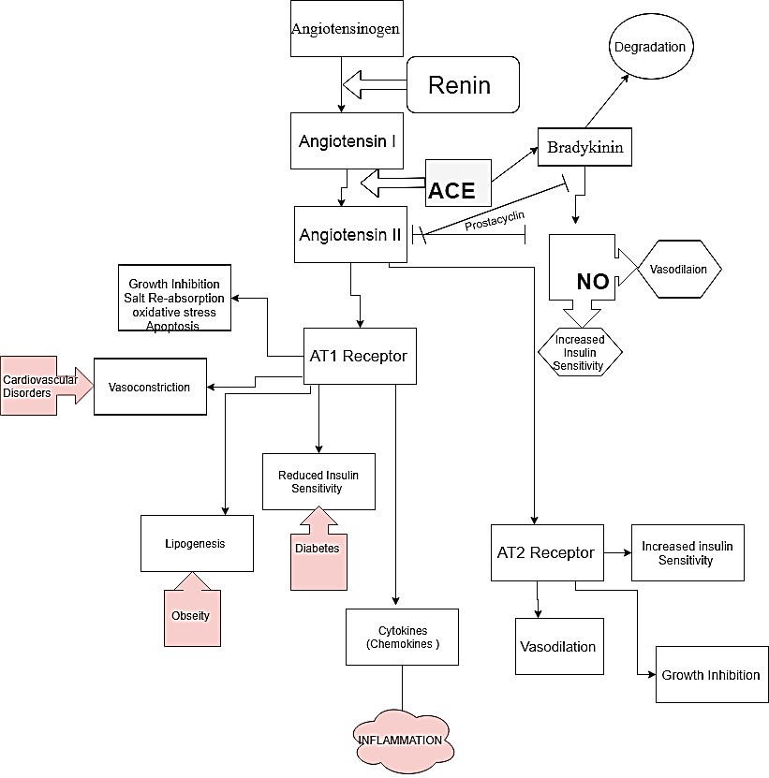
Figure 1: The process of the RAS system and its action.
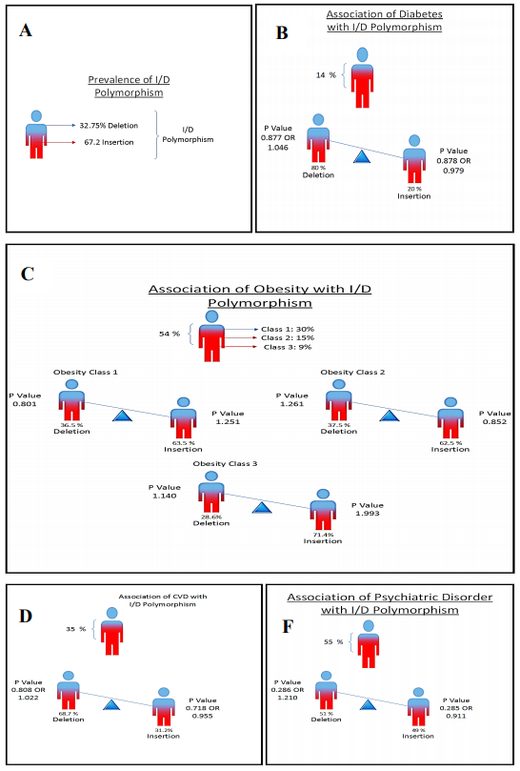
Figure 2: (A) is showing the percentage of I/D polymorphism in the population. (B) is showing the prevalence of diabetes. Prevalence of obesity is shown in (C), (D) is showing the prevalence of Cardiovascular disorder. (E) is showing the prevalence of psychiatric disorders.

Table 1: Percentages of Gender and Ages of all the respondents included in this research project.
Variables Category frequency or  Distribution |  |  | Insertion | Deletion
Gender | Male | 50% | 74% | 26%
 | Female | 50% | 74% | 26%
Age | Young | 7% | 10% | 30%
 | Young adults | 16% | 24% | 49%
 | Adults | 77% | 67% | 33%
* Data collected through questionnaire
** BMI is classified according to the WHO’s recommendation of BMI classification for the Asian population

Table 2: Various variables with their prevalence and their associations with the I/D polymorphism
Variables | Category | Frequency distribution | Insertion | Deletion | P-value | Odd ratio
Obesity * (obese 54%) | Obesity class I | 30% | 63.5% | 36.5% | 1.251 (for insertion)  0.801 (for deletion) | 0.020 (for insertion)  0.167 (for deletion)
 | Obesity class II | 15% | 62.5% | 37.5% | 0.852 (for insertion)  1.261(for deletion) | 0.164 (for insertion)  0.212 (for deletion)
 | Obesity class III | 9% | 71.4% | 28.6% | 1.933 (for insertion)  1.140 (for deletion) | 0.236 (for insertion)  0.156 (for deletion)
Diabetes ** | Diabetic | 14% | 20% | 80% | 0.875 (for insertion)  0.877 (for deletion) | 0.979 (for insertion)  1.046 (for deletion)
Cardiovascular disorders *** | CVD | 35% | 68.75% | 31.25% | 0.808 (for insertion)  0.718 (for deletion) | 1.022 (for insertion)  0.955 (for deletion)
Psychiatric disorders **** | Anxiety | 55% | 49% | 51% | 0.285 (for insertion)  0.286 (for deletion) | 0.911 (for insertion)  - (for deletion)

List of abbreviations
ACE Angiotensin Converting Enzyme
RAS Renin-angiotensin system
I/D Insertion/Deletion
CVD Cardiovascular Disorders
PCR Polymerase chain reaction
BMI Body mass index

