Running title: Molecular Authentication of Commercially Cultivated Coffee

Molecular Authentication of Commercially Cultivated Coffee (Coffea spp.) in the Philippines

Arleen Panaligan ^{1,2*}, Miriam Baltazar^{2,3} and Grecebio Jonathan Alejandro^{1,4}
¹The Graduate School, University of Santo Tomas, España, 1015 Manila, Philippines
²Department of Biological Sciences, Cavite State University, Indang, 4122 Cavite, Philippines
³National Coffee Research, Development and Extension Center, Cavite State University, Indang, 4122 Cavite, Philippines
⁴College of Science and Research Centre for the Natural and Applied Sciences, University of Santo Tomas, España, 1015 Manila, Philippines.
* For correspondence: acpanaligan@cvsu.edu.ph
Received _______________; Accepted _______________; Published _______________

Novelty statement

DNA barcoding using ITS and matK has not been used to molecularly authenticate commercially cultivated coffee. The results of this study show the potential of DNA barcodes to authenticate coffee species with overlapping characters as well as planting materials even at the seedling stage. This method of authentication will benefit the coffee industry and coffee growers for large-scale plantations.

Abstract

Accurate identification of commercially cultivated coffee species is necessary since the cup quality may be attributed to the kind of species. At seedling stage, it is difficult to discriminate Coffea species. Even at the matured stage, some morphological characters have been observed to be overlapping. To complement the traditional method of morphology-based identification, DNA barcoding using nuclear ribosomal internal transcribe spacer (ITS) and maturase K (matK) regions was performed. Both markers had 100% amplification and sequencing success rates. Although ITS had lower resolution in Coffea species, it efficiently discriminated Coffea arabica and Coffea liberica. The matK barcode discriminated all the species. Findings revealed that matK was an efficient barcode over ITS for commercially cultivated Coffea species by generating the highest rate of both universality and discrimination power. DNA barcoding as a method of authentication will benefit the coffee industry and coffee growers for large-scale plantations. © 2020 Friends Science Publishers

Keywords: Coffea arabica; Coffea canephora; Coffea liberica; DNA barcode; ITS; matK

Introduction

Coffee trees belong to the genus Coffea L. subgenus Coffea under Rubiaceae family and composed of 124 species (Davis et al. 2019). In the Philippines, there are three commercially cultivated species, namely Coffea arabica L., Coffea canephora Pierre ex A. Froehner and and Coffea liberica W. Bull ex Hiern (Figure 1). Excelsa and liberica are varieties of Coffea liberica. Generally, the fruits of var. liberica are bigger, more tapered at the base, have thicker and more leathery pericarp than that of var. excelsa (Bridson 1988; Davis et al. 2006). The first two species are of high commercial value (Maluf et al. 2005; N’diaye et al. 2005, Davis et al. 2019). Coffea arabica is tetraploid (2n=4x=44) and self-fertile while the other two species are diploid (2n=22) and self-incompatible (Davis et al. 2006; Clarindo and Carvalho 2008).
Planting materials such as seedlings need accurate identification since the market value of coffee depends on the cup quality which may be attributed to the species. Consumers tend to choose Coffea arabica (locally known as Arabica) because of its better flavor and rich aroma. Coffea canephora (locally known as Robusta) is more bitter and has higher caffeine content than Coffea arabica (Lecolier et al. 2009) while Coffea liberica (locally known as Kapeng Barako) contains low caffeine (N’diaye et al. 2005) and has a strong flavor. Between var. excelsa and var. liberica, the latter is more bitter (Bridson 1988).
Morphology-based identification is the usual method of identifying plants including coffee. However, it is difficult to discriminate Coffea species at seedling stage. Generally, distinct characteristics of Coffea species can be observed at maturity but they still possess overlapping characters. Since phenotypes are highly affected by the environment, morphological characterization may lead to inconsistent data (Hebert et al. 2003). An efficient marker is then necessary to authenticate coffee planting materials. DNA barcoding is a molecular technique of using short, standardized DNA sequences to identify species in which bioinformatics plays an important role (Hebert et al. 2003). It can be used to identify plants irrespective to life stages (Ali et al. 2014). It also complements traditional taxonomy which is based on morphological characters (Hajibabaei et al. 2007).
The Consortium for the Barcode of Life (CBOL) Plant Working Group (2009) recommended ribulose-bisphosphate carboxylase (rbcL) and maturase K (matK) as core barcodes. Although rbcL is highly universal, it has a low discriminating power (CBOL Plant Working Group 2009). Between the two core barcodes, matK was used in this study because of its greater species discrimination even up to the species level (CBOL Plant Working Group 2009). The nuclear ribosomal internal transcribe spacer (ITS) was added to matK as suggested by the China Plant BOL Group (2011). The ITS and matK, non-coding and coding regions, respectively, were used to assess possible barcodes to authenticate commercially cultivated Coffea species in the Philippines. Hence, this study aimed to evaluate the PCR success rate, sequencing success rate, and discriminatory power of ITS and matK regions for commercially cultivated Coffea species.

Materials and methods

Sample collection and preservation

Twenty-four (24) samples representing three commercially cultivated Coffea species, namely Coffea arabica (6 samples), Coffea canephora (9 samples) and Coffea liberica (9 samples) were collected from private and government coffee grower institutions in the Philippines. Leaf samples were stored in bags with silica gel. Herbarium vouchers were made and deposited at the University of Santo Tomas Herbarium (USTH). The coffee samples labelled by the coffee growers as ‘arabica’ were coded as A, ‘robusta’ as C, ‘liberica’ as L and ‘excelsa’ as LE.

Amplification of the candidate DNA barcodes

Silica gel dried leaves of each Coffea samples were crushed separately into fine powder and DNA samples were extracted following the protocol of Dneasy Plant Minikit (Qiagen, Hilden, Germany). Using universal primer pairs (Table 1), the ITS and matK regions were amplified with a total volume of 25 μL per reaction. The PCR mixture contained 19.45 μL water, 2.5 μL 10x reaction buffer, 0.5 μL 50 mM MgCl₂, 0.4 μL 10 mM dNTP, 0.5 μL 10 μM forward and reverse primers, 0.15 μL 5u/ μL Taq DNA polymerase (Vivantis) and 1.0 μL DNA. The PCR amplification was performed using a T100 Thermal Cycler (Bio Rad) as follows: initial denaturation at 97°C for 90 s followed by 35 cycles of 95°C for 30 s, 55°C for 20 s (ITS) or 50°C for 20 s (matK), 72°C for 1 min, followed by final extension at 72°C for 10 min (Li et al. 2012).
One percent (1%) agarose solution containing Gel red stain (Vivantis) in 1x TAE buffer was used for electrophoresis. The sizes of the PCR products were determined using 100 bp plus ladder (Vivantis) and the gel images were obtained using Vilber Lourmat gel documentation system. The PCR products were purified using QIA-quick Purification Kit (Qiagen, Germany) and sent to Macrogen Inc., Seoul, South Korea for bidirectional DNA sequencing.

Sequence analyses

The consensus sequences were edited and assembled using Codon Code Aligner v.4.1.1 (Codon Code Co., Centerville, MA, USA). Basic Local Alignment Search Tool (BLAST) was used to gather homologous sequences from the National Center for Biotechnology Information (NCBI) GenBank Database and Multiple Sequence Alignment was performed using MEGA 7 (Kumar et al. 2016). Neighbor-Joining (NJ) was constructed in MEGA 7 using 1000 bootstrap replicates.
The discriminatory power of ITS and matK markers were evaluated using genetic distance-based method. Pairwise distances of these markers were computed using Kimura–2–parameter (K2P) model (Kimura 1980). This was performed using MEGA 7 software (Kumar et al. 2016) to determine the genetic variation within species (intraspecific genetic distance) and between species (interspecific genetic distance). The Wilcoxon two–sample test was performed using SPSS software (version 20.0; SPSS Inc., Chicago, USA) to evaluate if there is a significant difference between the interspecific and intraspecific divergences.

Results

PCR success rate, sequencing success rate and discriminatory power

Table 2 summarizes the Coffea samples used in this study and their accessions. A total of 48 sequences were newly generated in this study from ITS and matK markers (Table 2). The non-coding ITS and coding matK regions were 100% amplified and sequenced (Table 3). The sequence characteristics from multiple sequence alignment of the two candidate barcodes are presented in Table 3. Interspecific distances of ITS and matK were higher than their intraspecific distances. Barcode matK had higher discriminatory power than ITS (Figures 2 and 3).

Discussion

The universality of the DNA barcodes was assessed by getting the percentage of PCR success and sequencing success. A single dark band on agarose gel and obtaining a consensus sequence indicated successful PCR amplification and DNA sequencing.
Amplification and sequencing of ITS became a problem in studies on medicinal plants and Arecaceae (Chen et al. 2010; Yang et al. 2012). Difficulty in amplification and sequencing of matK was also observed in some studies (Chen et al. 2010; Dong et al. 2012). In this study, the non-coding ITS and coding matK regions were 100% amplified and sequenced, which means that these two barcodes are universal for Coffea species. The high universality of ITS was found congruent with the findings in Selaginellaceae and Salvia (Gu et al. 2013; Wang et al. 2013) and matK in Arecaceae, Ardisia and Philippine Leea (Yang et al. 2012; Liu et al. 2013; Cabelin and Alejandro, 2015).
The discriminatory power of ITS and matK was evaluated using Kimura two-parameter distance and tree-building methods. If the interspecific distance is significantly higher than its intraspecific distance, the discrimination is considered successful (CBOL Plant Working Group 2009). Using Wilcoxon two-sample test, the interspecific divergences of the candidate DNA barcodes were significantly higher than their intraspecific distances (p ˂ 0.001). This indicates that these candidate barcodes have a potential to discriminate Coffea at the species level.
A species is considered resolved if all individuals of that species form a monophyletic clade (Kuzmina et al. 2012). The ITS region was considered efficient in discriminating species in Selaginellaceae and Gentianaceae (Gu et al. 2013; Zhang et al. 2016). The low discriminatory power of ITS has previously been reported in Ardisia (Liu et al. 2013). Out of the twenty-four coffee samples belonging to the three different species, two members of the Coffea canephora interclustered with Coffea arabica (Figure 2). However, not all species have to be distinguished for a DNA barcode to be considered effective (Lahaye et al. 2008). The ambiguity of the taxon will necessitate further analysis and checking of its identity. Some species would be better resolved by other DNA regions (Fazekas et al. 2008). In the present study, the maturase K region had higher percentage of resolved monophyletic taxa than ITS (Figure 3). The result was in agreement with other studies in sedges and fig cultivars (Starr et al. 2009; Castro et al. 2015). This result contradicts the report that matK had low species resolution in Gentianaceae (Zhang et al. 2016).
In the Philippines, there are four known coffee varieties and these are ‘arabica’, ‘robusta’, ‘liberica’, and ‘excelsa’ (Figure 1) corresponding to Coffea arabica, Coffea canephora, Coffea liberica and Coffea excelsa, respectively. However, there were reports that ‘liberica’ and ‘excelsa’ belong to a single species that is Coffea liberica. ‘Liberica’ refers to Coffea liberica var. liberica from West Africa and ‘excelsa’ to Coffea liberica var. dewevrei from Central Africa (Charrier and Berthaud 1985; Davis et al. 2006). The NJ trees for ITS and matK showed that the locally known Kapeng Barako which refers to ‘liberica’ and ‘excelsa’ grouped in a single clade (Figures 2 and 3), that may indicate that they are of the same species.

Conclusion

Although ITS had lower discriminatory power in Coffea, it efficiently discriminated Coffea arabica and Coffea liberica. Considering the ease of amplification and sequencing, ITS is a satisfactory DNA barcode for these two species. The matK region was able to discriminate the three Coffea species, indicating that this DNA barcode is efficient for authentication of commercially cultivated coffee at the species level.

Acknowledgements

The authors would like to thank Research Centre for Natural & Applied Sciences (RCNAS) of the University of Santo Tomas and Cavite State University for providing the laboratory facilities. The first author is grateful to DOST-PCIEERRD and NMNH, Paris, France for the sponsorship to training; Commission on Higher Education-Faculty Development Program (CHED-FDP) for the study grant; and DOST-PCAARRD for the dissertation grant.

Author contributions

AC conceptualized and designed the study, performed the experiment, analyzed and interpreted the results, wrote and revised the manuscript. MB and GJA edited and approved the manuscript.

References

Ali MA, G Gyulai, N Hidvegi, B Kerti, FM Al Hemaid, AK Pandey, J Lee (2014). The changing epitome of species identification–DNA barcoding. Saudi J Biol Sci 21: 204–231
Anthony F, MC Combes, C Astorga, B Bertrand (2002). The origin of cultivated Coffea arabica L. varieties revealed by AFLP and SSR markers. Theor Appl Genet 104: 894–900
Bridson DM (1988). Coffea. Flora of tropical East Africa, Rubiaceae, pp:706–709. Rotterdam: Balkema
Cabelin VL, PJ Santor, GJD Alejandro (2015). Evaluation of DNA barcoding efficiency of cpDNA barcodes in selected Philippine Leea L. (Vitaceae). Acta Bot Gall: Bot Lett 1–8
Castro C, A Hernandez, L Alvarado, D Flores (2015). DNA barcodes in fig cultivars (Ficus carica L.) using ITS regions of ribosomal DNA, the psbA-trnH spacer and the matK coding sequences. Am J Plant Sci 6: 95–102
CBOL Plant Working Group (2009). A DNA barcode for land plants. PNAS USA 6 (31): 12974–12797
Charrier A, J Berthaud (1985). Coffee: botany, biochemistry and production of beans and beverage, pp:13–47. In: Clifford MN, Willson KC, editors. London & Sydney: Croom Helm
Chen S, H Yao, J Han, C Liu, J Song, Y Shi Zhu, X Ma, T Gao, X Pang, K Luo, Y Li, X Li, X Jia, Y Lin, C Leon (2010). Validation of the ITS2 region as a novel DNA barcode for identifying medicinal plant species. PLoS One 5(1): 1–8
China Plant BOL Group (2011). Comparative analysis of a large dataset indicates that internal transcribed spacer (ITS) should be incorporated into the core barcode for seed plants. PNAS 108(49): 19641–19646
Clarindo WR, CR Carvalho (2008). First Coffea arabica karyogram showing that this species is a true allotetraploid. Plant Syst Evol 274: 237–241
Davis AP, R Govaerts, DM Bridson, P Stoffelen (2006). An annotated taxonomic conspectus of the genus Coffea (Rubiaceae). Bot J Linn Soc 152: 465–512
Davis AP, H Chadburn, J Moat, R O’Sullivan, S Hargreaves, EN Lughadha (2019). High extinction risk for wild coffee species and implications for coffee sector sustainability. Sci Adv 5: 1–9
Dong W, J Liu, J Yu, L Wang, S Zhou (2012). Highly variable chloroplast markers for evaluating plant phylogeny at low taxonomic levels and for DNA barcoding. PLoS One 7 (4): 1–9
Fazekas AJ, KS Burgess, PR Kesanakurti, SW Graham, SG Newsmaster, BC Husband, DM Percy, M Hajibabaei, SC Barett (2008). Multiple multilocus DNA barcodes from the plastid genome discriminate plant species equally well. PLoS One 3 (7): 1–12
Gu W, J Song , Y Cao Y, Q Sun Q, H Yao, Q Wu, J Chao, J Zhou, W Xue, J Duan (2013). Application of the ITS2 region for barcoding medical plants of Selaginellaceae in Pteridophyta. PLoS One 8 (6): 1–8
Hajibabaei M, GA Singer, PD Hebert, DA Hickey (2007). DNA barcoding: how it complements taxonomy, molecular phylogenetics and population genetics. Trends Genet 23 (4): 167–172
Hebert PD, A Cywinska, S Ball, JR De Waard (2003). Biological identifications through DNA barcodes. R Soc 313–321
Kathurima WC, GM Jenji, SM Muhoho, R Bouglanger, BM Gichimu, EK Gichuru (2012). Genetic diversity among commercial coffee varieties, advanced selections and museum collections in Kenya using molecular markers. Int J Biodivers Conserv 4 (2): 39–46
Kimura M (1980). A simple method for estimating evolutionary rates of base substitutions through comparative studies of nucleotide sequences. J Mol Evol 16(2): 111–120
Korir NK, J Han, L Shangguan, C Wang, E Kayesh, Y Zhang, J Fang (2012). Plant variety and cultivar identification: advances and prospects. Crit Rev Biotechnol 1–15
Kumar S, G Stecher, K Tamura (2016). MEGA 7: Molecular evolutionary genetics analysis version 7.0 for bigger datasets. BMC Ecol 33(7): 1870–1874
Kuzmina ML, KL Johnson, HR Barron, PD Hebert (2012). Identification of the vascular plants of Churchill, Manitoba, using a DNA barcode library. BMC Ecol 12(25): 1–11
Lahaye R, M Van Der Bank, D Bogarin, J Warner, F Pupulin, G Gigot, O Maurin, S Duthoit, TG Barraclough, V Savolainen (2008). DNA barcoding the floras of biodiversity hotspots. PNAS 105(8): 2923–2928
Lecolier A, P Besse, A Charrier, TN Tchakaloff, M Noirot (2009). Unraveling the origin of Coffea arabica ‘Buorbon pointy’ from La Reunion: a historical and scientific perspective. Euphytica 1–11
Li M, K Au, H Lam, L Cheng, R Jiang, P But, P Shaw (2012). Identification of Baiying (Herba Solani Lyrati) commodity and its toxic substitute Xungufeng (Herba Aristolochiae Mollissimae) using DNA barcoding and chemical profiling techniques. Food Chem 135: 1653–1658
Liu Y, K Wang, Z Liu, K Lou, S Chen, K Chen (2013). Identification of medical plants of 24 Ardisia species from China using the matK genetic marker. Pharmacogn Mag 9 (36): 331–337
Maluf MP, M Silvestrini, L Ruggiero, OG Filho, CA Colombo (2005). Genetic diversity of cultivated Coffea arabica inbred lines assesed by RAPD, AFLP, and SSR marker systems. Sci Agric 62(4): 366–373
N’diaye A, V Poncet, J Louarn, S Hamon, M Noirot (2005). Genetic differentiation between Coffea liberica var. liberica and C. liberica var. dewevrei and comparison with C. canephora. Plant Syst Evol 253: 95–104
Starr JR, RF Naczi, BN Chouinard (2009). Plant DNA barcodes and species resolution in sedges (Carex, Cyperaceae). Mol Ecol Resour 9(1): 151–163
Wang M, H Zhao, L Wang, T Wang, R Yang, X Wang, Y Zhou, C Ding, L Zhang (2013). Potential use of DNA barcoding for the identification of Salvia based on cpDNA and nrDNA sequences. Gene 528(2): 206–215
White TJ, T Bruns, T, S Lee, J Taylor (1990). Amplification and direct sequencing of fungal ribosomal RNA genes for phylogenetics. PCR protocols: a guide to methods and applications, pp: 315–322. New York: Academic Press, Inc
Yang HQ, YR Dong, ZJ Gu, N Liang, JB Yang (2012). A preliminary assessment of matK, rbcL and trnH-psbA as DNA barcodes for Calamus (Arecaceae) species in China with a note on ITS. Ann Bot Fenn 49: 319–330
Zhang D, B Jiang, L Duan, N Zhou (2016). Internal transcribed spacer (ITS), an ideal DNA barcode for species discrimination in Crawfurdia Wall (Gentianaceae). Afr J Tradit Complement Altern Med 13(16): 101–106

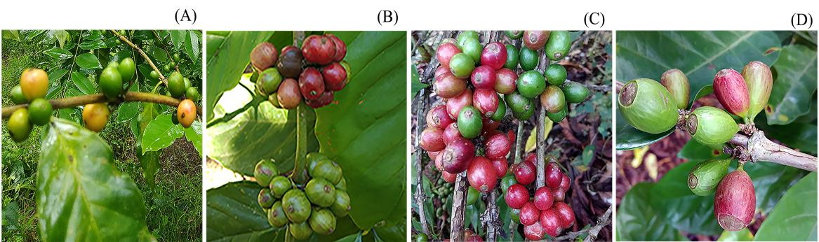
Fig. 1: Field photographs of Coffea: (A) Coffea arabica (arabica); (B) Coffea canephora (robusta);
(C) Coffea liberica (excelsa); (D) Coffea liberica (liberica) (Photograph: A.C. Panaligan)

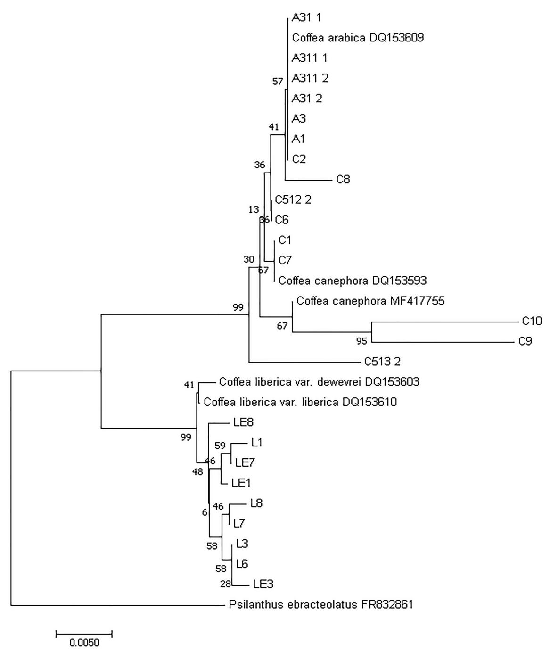

Fig. 2: Neighbor-joining tree inferred using Kimura two-parameter distances of ITS. Numbers on nodes are bootstrap support (BS) values. A = Coffea arabica; C = Coffea canephora; L = Coffea liberica (liberica); LE = Coffea liberica (excelsa)

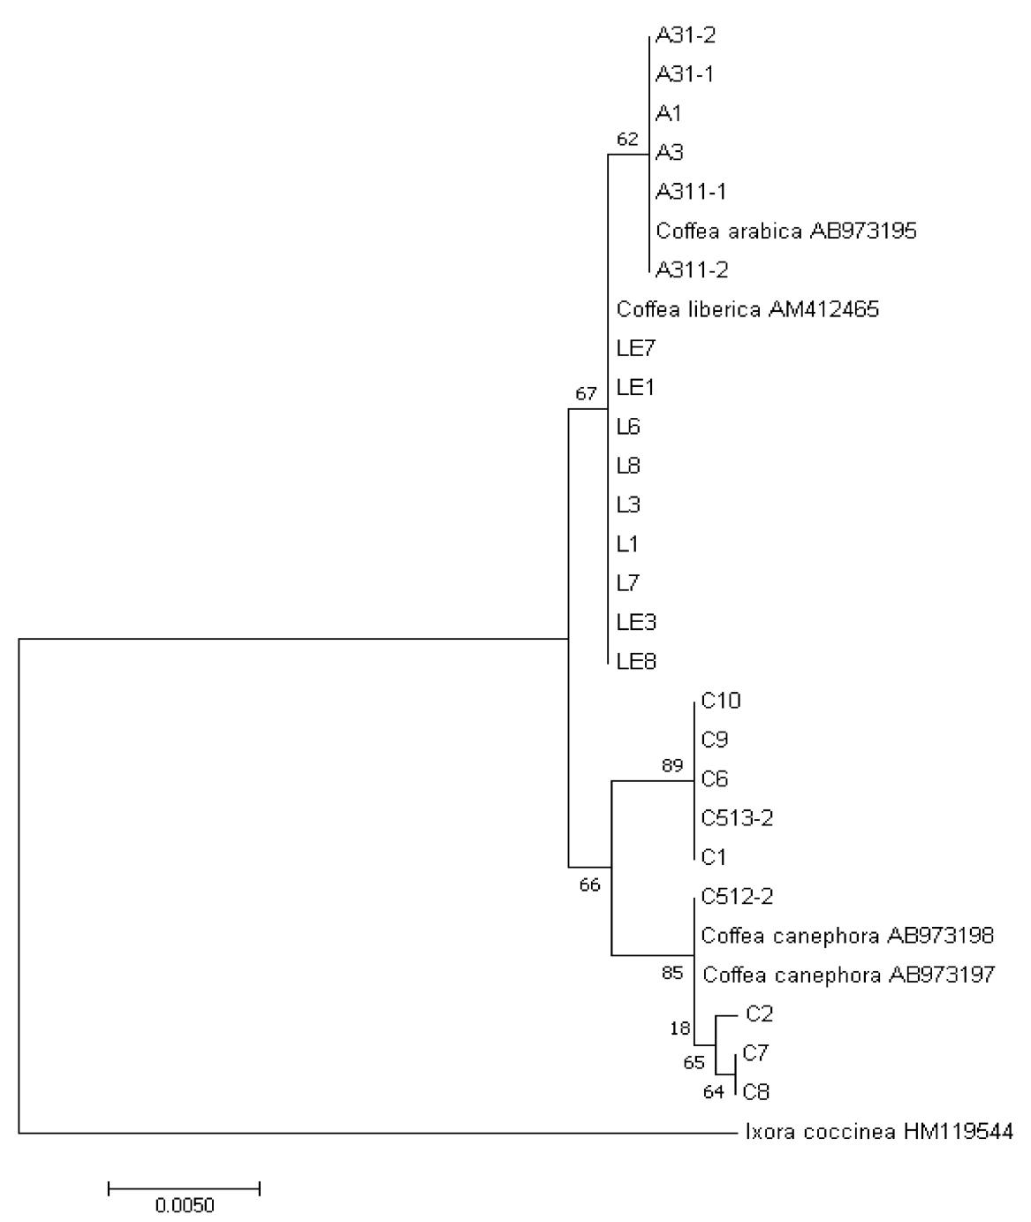

Fig. 3: Neighbor-joining tree inferred using Kimura two-parameter distance of matK. Numbers on nodes are bootstrap support (BS) values. A = Coffea arabica; C = Coffea canephora; L = Coffea liberica (liberica); LE = Coffea liberica (excelsa)

Table 1: Universal primers of the two candidate barcodes
Barcode | Primer | Primer sequence (5’–3’) | Reference
ITS | ITS5 | GGAAGTAAAAGTCGTAACAAGG | White et al. 1990
 | ITS4 | TCCTCCGCTTATTGATATGC
matK | 3F_Kim f | CGTACAGTACTTTTGTGTTTACGAG | CBOL-PWG 2009
 | 1R_Kim r | ACCCAGTCCATCTGGAAATCTTGGTTC
ITS = internal transcribe spacer; matK = maturase K

Table 2: List of Coffea species used in the study and their accessions

Species | Place of origin/ collection place | Code | USTH  accession | GenBank accession
 |  |  |  | ITS | matK
C. arabica | Indang, Cavite | A1 | 014856 | MK611791 | MK722268
C. arabica | Indang, Cavite | A3 | 014857 | MK611792 | MK722267
C. arabica | Ampasit, La Trinidad, Benguet | A31-1 | 014858 | MK615726 | MK722270
C. arabica | Ampasit, La Trinidad, Benguet | A31-2 | 014859 | MK615727 | MK722269
C. arabica | BSU, La Trinidad, Benguet | A311-1 | 014860 | MK615728 | MK722266
C. arabica | BSU, La Trinidad, Benguet | A311-2 | 014861 | MK615729 | MK722265
C. arabica | Mascarenes / Nicaragua – |  | – | DQ153609 | AB973195
C. canephora | Indang, Cavite | C1 | 014862 | MK615730 | MK722259
C. canephora | Indang, Cavite | C2 | 014863 | MK615731 | MK855097
C. canephora | Alfonso, Cavite | C6 | 014864 | MK615732 | MK722261
C. canephora | Alfonso, Cavite | C7 | 014865 | MK615733 | MK722260
C. canephora | Indang, Cavite | C8 | 014866 | MK615734 | MK722264
C. canephora | Indang, Cavite | C9 | 014867 | MK615735 | MK722263
C. canephora | Indang, Cavite | C10 | 014868 | MK615736 | MK722262
C. canephora | NOMIARC, Bukidnon | C512-2 | 014869 | MK615737 | MK722258
C. canephora | NOMIARC, Bukidnon | C513-2 | 014870 | MK615738 | MK855098
C. canephora | Cameroon/ Vietnam | – | – | DQ153593 | AB973198
C. canephora | Mexico/ Indonesia | – | – | MF417755 | AB973197
C. liberica | Indang, Cavite | L1 | 014871 | MK615739 | MK722250
C. liberica | Indang, Cavite | L3 | 014872 | MK615740 | MK722249
C. liberica | Alfonso, Cavite | L6 | 014873 | MK615741 | MK722253
C. liberica | Silang, Cavite | L7 | 014874 | MK615742 | MK722252
C. liberica | Alfonso, Cavite | L8 | 014875 | MK615743 | MK722251
C. liberica | Indang, Cavite | LE1 | 014876 | MK615744 | MK722255
C. liberica | Indang, Cavite | LE3 | 014877 | MK615745 | MK722254
C. liberica | Alfonso, Cavite | LE7 | 014878 | MK615746 | MK722257
C. liberica | Silang, Cavite | LE8 | 014879 | MK615747 | MK722256
C. liberica var. dewevrei | Central African Republic – |  | – | DQ153603
C. liberica var. liberica | Congo/ not indicated – |  | – | DQ153610 | AM412465
USTH = University of Santo Tomas Herbarium; ITS = internal transcribe spacer; matK = maturase K

Table 3: Sequence characteristics from multiple sequence alignment of the two candidate barcodes

Characteristics | ITS | matK
Number of samples | 24 | 24
PCR success (%) | 100 | 100
Sequencing success (%) | 100 | 100
Aligned sequence length (bp) | 711 | 846
Mean Interspecific K2P distances | 0.024 ± 0.006 | 0.005 ± 0.002
Mean Intraspecific K2P distances | 0.007 ± 0.002 | 0.002 ± 0.001
K2P = Kimura–2–parameter; ITS = internal transcribe spacer; matK = maturase K

