Original Research Article
Running title: Identification of any correlation between gene promoter of fertility marker (Tyrosine Kinase) and semen quality

Tyrosine Kinase Gene Polymorphisms Associate with Fresh Semen Quality from Dairy Bull Friesian Holstein

Tatik Hernawati^{1*}, Yudit Oktanella², Shahnaz Audya Dhaneswari³, Rimayanti⁴, Aulanni’am⁵

^{1,4*}Department of Veterinary Reproduction, Faculty of Veterinary Medicine, Airlangga University, Surabaya, East Java, Indonesia
^{2,3}Department of Veterinary Reproduction, Faculty of Veterinary Medicine, Brawijaya University, Malang East Java, Indonesia
⁵Department of Chemistry, Faculty of Mathematics and Natural Sciences, Brawijaya University, Malang East Java, Indonesia

Corresponding author: yuditoktanella@gmail.com
Novelty statement
Tyrosine kinase (TEK) is an enzyme, a subclass of protein kinase that can transfer a phosphate group from ATP to a protein in a cell. It functions as an "on" or "off" switch in many cellular functions, including spermatozoa. These protein molecules found in the spermatozoa plasma membrane and function to recognize ZP3 and play a role in signal transduction that will produce auto-phosphorylation. It has been suspected that the promoter gene of TEK is related to the fertility of bulls, which possibly affect the quality of sperm.
ABSTRACT
This research aims to identify polymorphisms in TEK genes to identify any related possibility to fresh semen quality of FH bull using the PCR method. A total of 14 samples of bull’s whole blood were collected and also the quality of each bull’s fresh semen. DNA amplification was carried out using primer Forward (TEK_F) 5'-TAGATTGTCGCTTGCCTGGG-3 'and Reverse (TEK_R) 5'-CCTGTGCCGACAGGTTTACT-3'. Analysis of the DNA sequence results was carried out using BioEdit and NCBI BLAST software. The results showed that of the 7 samples producing 262 bp and found polymorphisms in the TEK gene sequence in 23 gene bank databases. In the analysis of the relationship between the motility of individual spermatozoa with mutations, r count> r table (0.806> 0.754) or significance value <5% significance level (0.029 <0.050). In the analysis of the relationship between semen concentration and mutation, r count> r table (0.897> 0.754) or significance level <5% significance level (0.006 <0.050) is obtained.

Keywords: whole-blood, Tyrosine Kinase gene, polymorphism, semen quality, Friesian Holstein bull

INTRODUCTION
The success of artificial insemination (IB) is determined by several factors (Oliveira et al., 2012), one of which is the quality of the fresh semen. The appearance of livestock production depends on genetic potential and environmental influences. An effective method of bull selection becomes crucial to maintain livestock genetics that can respond to the livestock environment. Current evaluation in improving the quality of the bull’s performance is done by examining semen quality as an indicator of fertility. Several studies indicate that there is a strong correlation between specific glycoproteins from seminal fluid with sperm quality, such as osteopontin (), tyrosine kinase (), bovine ..... Therefore, these findings have been developed into another comprehensive yet molecular-based studies by approaching proteomic analysis to determine the bull’s performance. Besides, evaluation of bull’s performance can also be seen from the pedigree, namely the selection based on the reputation shown by the cow's ancestors concerned, but a bloodline or offspring of a good individual does not always mean that valuable traits will be inherited through the artificial breeding system.
Various efforts have been made by the government to encourage an increase in the population of dairy cattle, providing high-quality frozen semen and increasing productivity (both quality and quantity). The zuriat test is a test to find out the genetic potential of male candidates through the milk production of female offspring (Daughter Cow / DC) and is carried out to produce superior male seedlings that have adapted to agro-climate conditions in Indonesia (Directorate of Livestock Breeding 2012). The zuriat test is carried out in several stages and requires a relatively long time of ± 7 years and is relatively expensive (Directorate of Animal Breeding, 2015)
To complete the evaluation of the quality of spermatozoa, a molecular examination needs to be carried out, bearing in mind that in the seminal plasma there are some biomarkers that can be used to diagnose semen fertility. If the genes that influence the spermatozoa quality phenotype have been revealed, the purpose of a selection system of high-quality bull’s performance can be done early.
As technology develops in the field of molecular genetics, selection can be done more quickly and accurately. Selection can be done at the DNA level by assessing the diversity of certain genes related to the quality of fresh semen of males.
Tyrosine kinase is a subgroup of the protein kinase class (Muhaiminrifai, 2011). Tyrosine kinase is a spermatozoa plasma membrane protein, functions as a mediator between spermatozoa and egg cells, and plays a role in signal transduction that will produce autophosphorylation.
Phosphorylation de-phosphorylation processes are likely the most important post-translational cascades of mature mammalian spermatozoa. Any dysregulation will affect the sperm motility and capacitation process (Urner and Sakkas, 2003). An elevation of carbonylation of the kinases and phosphatases may lead to abnormal phosphorylation/de-phosphorylation of spermatozoa proteins. During capacitation, the PKA regulatory subunit binds to the AKAP proteins, promoting an increase in tyrosine phosphorylation of sperm proteins by the indirect activation of tyrosine kinases. Lowering activity of tyrosine phosphorylation in sperm will cause an improper capacitation process, leading to lower quality of ejaculated sperm (Pereira et al., 2015).
Endogenous tyrosine kinase concentrations in semen plasma can also trigger hyperactivity and increase spermatozoa motility. Tyrosine kinase activity is capable of assisting spermatogenesis, epididymal maturation, spermatozoa capacitation, acrosome exositism, and assisting fusion between sperm-oocyte and membrane interaction (Ijiri et al., 2012). Until now, it is suspected that the promoter gene polymorphism of TEK is related to the fertility of bulls, which directly affect the quality of fresh semen. Furthermore, Ijiri et al, (2012) suggested that there was a decrease/increase in TEK expression with the quality of fresh semen in various species in mammals and amphibians.
Materials and methods
Materials
Geneaid™ DNA Isolation Kit, nuclease free water, primer forward (TEK_F) 5'-TAGATTGTCGCTTGCCTGGG-3’ and reverse (TEK_R) 5'-CCTGTGCCGACAGG TTTACT-3’, PCR Master Mix (Promega), DNA ladder 100 bp and 1 kb, agarosa, ethanol absolute, TBE buffer Bio Rad®, gel red nucleic acid (Biotium).
Sample collection
As much as fourteen blood-samples were obtained from selected bulls of Friesian Holstein. Blood collection from the coccygeal (tail) vein was performed during samples collection. 3-5 mL of blood volume was taken from each bull and put inside venoject tube containing EDTA.
DNA extraction
Total genome was extracted from the blood sample using the Geneaid™ DNA Isolation Kit. There are three main steps in DNA isolation, namely destruction of cell walls or lysis, separation of DNA from solid materials such as cellulose and proteins, and DNA purification (Ardiana, 2009).

Quantification of total genome
DNA amplification and sequencing
Polymerase chain reaction (PCR) amplifications for the pooled DNA were performed in a final reaction volume of 25 μL consisting of 50 ng genomic DNA, 1 μL of 10pmol each primer, 12,5 µL PCR mix, nuclease free water into 25 μL. The PCR protocol was 2 min at 94°C for initial denaturation followed by 35 cycles at 94°C for 30 s, 52,5 °C for 30 s, 72°C for 1 min and a final extension at 72°C for 7 min for all the primer pairs.
PCR product of the TEK gene sequencing was carried out in two directions namely by using a primer of TEK_F 10 pmol and TEK_R 10 pmol to analyze nucleotide sequences of each samples. The sequence results consist of electroforegrams containing adenine, thymine, guanine, and cytosine content containing DNA fragments that have been labeled by ddNTPs.
Statistical analysis
Data obtained then carried out in a qualitative discussion by describing the differences in the DNA of TEK genes between individual bulls. Analysis of any polymorphism is carried out by aligning DNA sequences from samples to NCBI GeneBank database: NM 173964.2. The alignment uses the ClustalW multiple alignment algorithm in the BioEdit software. Bivariate Pearson correlation analysis was used to identify any correlation of the polymorphism with fresh semen quality.
RESULTS AND DISCUSSION
DNA Isolation
Total DNA isolated from 14 bulls (Bos taurus) of Friesian Holstein using whole-blood samples which were carried out by the Geneaid ™ DNA Mini Kit protocol. The total DNA templates were tested quantitatively using a Nano-200 Micro-nucleic acid spectrophotometer machine on 260 nm and 280 nm wavelengths (Table 1). The total DNA from the isolation was then used for the process of amplification of TEK genes from bulls by PCR technique to determine the sequences of TEK genes from several bulls, so as to determine the presence of TEK promoter gene polymorphisms in dairy bulls, and their relationship to the level of spermatozoa fertility, which is indicated by the quality of FH dairy cow spermatozoa from fresh semen and post-thawing.
DNA concentrations can be calculated accurately through the absorption of ultraviolet light spectrophotometry (Siswanto, et al., 2016). New England Biolabs (2018) recommends that the concentration used in running PCR be 0.2 ng / µL for relatively short target DNA. The results of DNA isolations showed good concentration for amplification process because it was more than 0.2 ng / µL.
The results of total DNA isolation were also tested quality by using agarose 1% electrophoresis obtained a total DNA band with fragment size> 10,000 bp which can be seen in Figure 1.

Amplification of TEK Genes by PCR Method
TEK gene amplification was carried out to multiply TEK gene fragments before sequencing so that it could be used to determine the TEK sequences of FH bulls. The primers used to amplify the TEK gene were taken from genebank with the sequence number NM_1739642 and were designed using the Primer3plus program. A pair of primers used to perform TEK gene amplification in PFH cattle are shown in Table 2. The PCR program used can be seen in Table 3.

The amplification process for approximately 90 minutes produces a product which was then passed through a qualitative agarose electrophoresis test of 2%. Electrophoresis results can be seen in Figure 2.
The desired target band of PCR products using designed primers designed is 302 bp. The results of visualization on the PCR product showed a ribbon with a 302 bp fragment size according to the target based on the primary design. Specific PCR products as shown in Figure 2 later be continued to sequence procedure.
Unfortunately, of the 14 samples that were examined, only 7 samples were successfully obtained. Blast analysis from remained samples (n=7) have good query coverage, namely A and F by 99%, and samples B, C, D, E, G by 98% and ident 98.85% for samples A and F, and 99.61% for samples B, C, D, and G, while sample E has an ident of 99.22%. This result is following Wiley (2011), that sequences with Query cover and ident in the range of 95% are of good quality for analysis.
Analysis of TEK gene sequences
Sequencing results from the 7 samples produced 262 bp and found several differences in DNA sequences (Table 5). Analyzing data using the BioEdit® software, there are 23 gene bank databases showing mutations (Table 6).

Based on the analysis of correlation between motility of individual spermatozoa (Table 7) with mutations, r count> r table (0.806> 0.754) or significance value <5% significance level (0.029 <0.050) suggested that there was a significant relationship between the motility of individual spermatozoa with mutations. Analysis of the relationship between cement concentration and mutation, r count> r table (0.897> 0.754) or significance value <significant level 5% (0.006 <0.050) is concluded that there is a significant relationship between cement concentration and mutation. The negative correlation coefficient indicates that the relationship between the concentration of cement and mutations is not unidirectional, meaning that the higher the concentration of cement, the mutation will decrease, conversely the lower the concentration of cement, the mutation will increase.
The results of a comparison between gene sequences with individual motility data of spermatozoa and semen concentrations per sample (Table 8) were obtained in samples that experienced a higher level of deletion in samples C and G showed lower motility and concentration. This is consistent with the statement of Nakada (2006) that the level of deletion is proportional to the level of decreased sperm motility and semen concentration.
Bovine seminal plasma proteins and its analogs are a family of structurally related proteins characterized by the presence of tandem fibronectin domains. Proteins in seminal plasma family have high varieties of molecular mass, ranging from (12-100 kDa). Bovine seminal plasma contains glycoprotein substances and it has been believed that the glycoprotein concentration determines the quality of fresh semen. Sperm binding proteins have been categorized based on its energy, structural and other functional proteins. As the name implies, these proteins play a vital role in sperm binding to the oviductal epithelium and formation of the oviductal sperm reservoir (Dar et al., 2018). Following figure (Figure 3) illustrate the sequences changes in spermatozoa responsible for the sperm’s activity.
The sperm motility is activated by the phosphorylation of protein kinase-A (PKA) substrates in a media containing HCO3 − and Ca2 + sources. Simultaneously, incubation of spermatozoa either in-vivo (female reproductive tract) or in-vitro (in a specialized media) for extended period of time increased the tyrosine phosphorylation, responsible for the capacitation, the acrosome reaction, and changes in the motility pattern known as hyper activation. On the other hand, inhibition of Phosphordiesterase (PDE) has been increased cAMP levels, subsequently affects sperm motility. Sperm physiological function, survival rate and successful fertilization are influenced by the proteins/glycoproteins concentration in the seminal plasma.
The tyrosine kinase-associated PR (PR2) is responsible for the effect of progesterone on the hyperactive motility and acrosome reaction. Progesterone also increases the membrane fluidity of human sperm plasma membrane, which is an important event in sperm capacitation and tyrosine phosphorylation (Naz and Rajesh, 2004).
The negative correlation coefficient indicates that the relationship that occurs between the motility of individual spermatozoa with mutations is not unidirectional, meaning that the motility percentage of individual spermatozoa could be either possibly or impossibly affected by the number of mutations in tyrosine kinase gene promoter. Nevertheless, according to gene sequences evaluation, samples which experienced mutation -deletion- in samples C and G showed lower motility and concentration. This is consistent with the statement of Nakada (2006) that the level of nucleotide deletion is proportional to the level of decreased sperm motility and semen concentration.
Conclusion
Based on the results of research and discussion that has been submitted, it can be concluded that:
1. There is a difference in the DNA sequence / polymorphism of the Tyrosine kinase (TEK) gene in PFH cows ie (c.4018T> C), (c.3821A> T), (c.3832C> G), (c.3831G> -), (c.4079T> -).
2. Tyrosine kinase gene polymorphisms affect the quality of fresh semen of PFH cattle, with the level of deletion proportional to the level of decreased sperm motility and semen concentration.

References
Aisah, I., K. Edi, C. Ema, dan U. Nurul. 2015. Representasi Mutasi Kode Genetik Standar Berdasarkan Basa Nukleotida. Jurnal Matematika Integratif. Volume 11. No.1 pp. 25-34.
Ardiana, D.W. 2009. Teknik isolasi DNA genom tanaman pepaya dan jeruk menggunakan modifikasi buffer CTAB. Buletin Teknik Pertanian 14:12- 16
Fatchiyah, E.L., S. Arumingtyas, Widyarti dan S. Rahayu. 2011. Biologi molekuler prinsip dasar analisis. Jakarta: Penerbit Erlangga.
Kartini, A.R. 2012. Karakterisasi Molekular Padi Transgenik dengan Beberapa Metode Isolasi DNA. Departemen Biokimia. FMIPA. IPB.
Madden, Tom. 2003. The BLAST Sequence Analysis Tool : The NCBI handbook. The National Laboratory Medicine. USA.
Morales P. and M. Llanos. 1996. Interaction of Human Spermatozoa with The Zona Pellucida of Oocyte: Development of The Acrosome Reaction. Frontiers in Bioscience 1:August 1:d149-160
Nakada, K. 2006. Mitochondria Related Male Infertility. PNAS 103(41):15148-53.
Rajesh K Naz, Preeti B Rajesh. 2004. Role of tyrosine phosphorylation in sperm capacitation / acrosome reaction. Reprod Biol Endocrinol. 2004; 2: 75. Published online 2004 Nov 9. doi: 10.1186/1477-7827-2-75
New England Biolabs. 2018. PCR Troubleshooting Guide. https://www.neb. com/tools-and-resources/troubleshooting-guides/pcr-troubleshooting-guide. [20 Juni 2019]
Y Oktanella, A Firmawati, VF Hendrawan, D Wulansari. 2017. Comparison Between Oviduct Fluid Protein a nd Oviductal Epithelia Cell As Supplements In Capacitation Media To Improve Sheep's Spermatozoa Quality. International Journal of ChemTech Research 10 (4), 565-571
Siswanto, J.E., B. Tiara, P. Evira, V.P. Lidya dan Y. Luluk. 2016. Isolasi DNA pada Sampel Darah Tepi dan Swab Buccal Pada Bayi Penderita ROP: Perbandingan Hasil Uji Konsentrasi dan Indeks Kemurnian. Sari Pediatri. 18 :4.
Wiley. E. O. and S.L Bruce. 2011. Phylognetics: Theory and Practise of Pylogenetic Systematics: Second Edition. Wiley-Blackwell., USA.
Oliveira LZ, de Arruda RP, de Andrade AFC, Celeghini ECC, dos Santos RM, Beletti ME, et al. 2012. Assessment of field fertility and several in vitro sperm characteristics following the use of different Angus sires in a timed-AI program with suckled Nelore cows. Livest Sci 2012; 146:38–46. https://doi.org/10.1016/j. livsci.2012.02.018
Urner F, Sakkas D. Protein phosphorylation in mammalian spermatozoa. Reproduction 2003. https://doi.org/10.1530/rep.0.1250017
Pereira R, Sa´ R, Barros A, Sousa M. Major regulatory mechanisms involved in sperm motility. Asian J Androl 2015; 19:5–14. https://doi.org/10.4103/1008-682X.167716 PMID: 26680031
Hernawati, T., Oktanella, Y., Mulyati, S., & Suprayogi, T. W. (2019). Correlation between Osteopontin Promoter Gene and Fresh Semen Quality in Friesian Holstein Dairy Cows. Research Journal of Pharmacy and Technology, 12(4), 1677-1682.
Mohammad Rayees Dar, Mahendra Singh, Rachana Sharma, Sunita Thakur, Aasif Ahmad Sheikh and Showkat Ahmad Bhat, 2018. Bovine Fertility as Regulated by Sperm Binding Proteins: A Review. Asian Journal of Animal and Veterinary Advances, 13: 6-13.

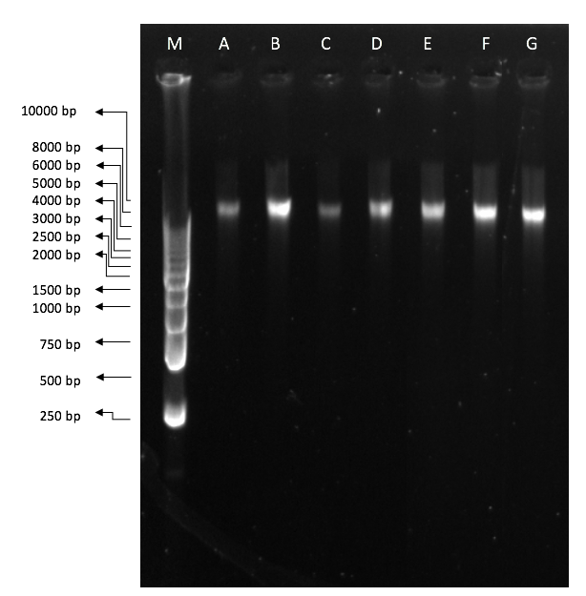
Figure 1. Total DNA Electrophoresis Results in 1% agarose. M:marker; A-F: sampel code

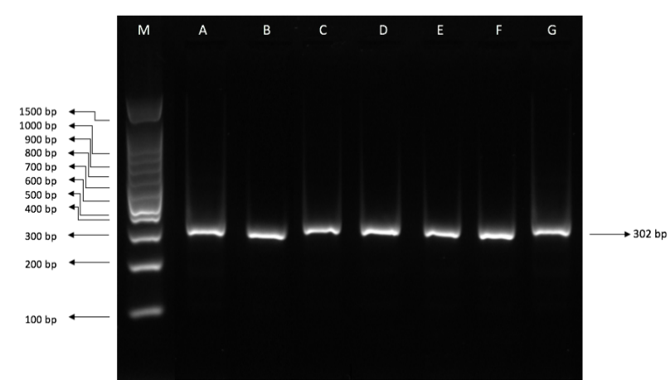

Figure 2. Electrophoresis results for PCR products 2% agarose concentration

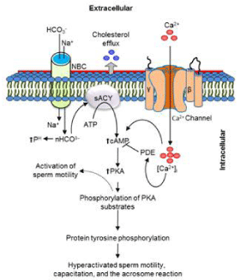

Figure 3: Molecular mechanism changes in spermatozoa responsible for the motility activation capacitation, and the acrosome reaction (Rahman and Pang, 2016).

Table 1. Total DNA Concentration and Purity of FH bulls
No | Sample | Concentration  (ng/ μL) | Purity (260/280)
1 | A | 20.36 | 1.39
2 | B | 20.15 | 1.44
3 | C | 17.75 | 1.51
4 | D | 16.55 | 1.01
5 | E | 21.63 | 1.06
6 | F | 62.80 | 1.72
7 | G | 14.46 | 0.96
8 | H | 10.06 | 1.01
9 | I | 8.9 | 1.06
10 | J | 18.2 | 0.98
11 | K | 12.3 | 1.19
12 | L | 19.12 | 1.06
13 | M | 3.84 | 1.56
14 | N | 4.56 | 1.24

Table 2. Primary Oligonucleotide Sequence of FH bulls TEK
Primer | Oligonucleotide Sequence
Forward  (TEK_F) | 5’- TAGATTGTCGCTTGCCTGGG -3’
Reverse  (TEK_R) | 5’- CCTGTGCCGACAGGTTTACT -3’

Table 3. PCR Programs for Amplification of of FH bulls TEK
Steps | Time | Temperature
Predenaturation | 3 m | 94ºC
Denaturation | 30 s | 94ºC
Annealing | 30 s | 52,5ºC
Extension | 1 m | 72ºC
Post Extension | 7 m | 72ºC

Table 5. TEK gene after being aligned with TEK from genebank with the sequence number NM_1739642
No | Sample | Target band | Query Coverage | Ident
1 | A | 273 | 99% | 98.85%
2 | B | 265 | 98% | 99.61%
3 | C | 286 | 98% | 99.61%
4 | D | 280 | 98% | 99.61%
5 | E | 271 | 98% | 99.22%
6 | F | 265 | 99% | 98.85%
7 | G | 296 | 98% | 99.61%

Table 6. Type of mutation from sample’s sequence

Code | Type of mutation | n | Mutation location | n
A | transition | 1 | (c.4018T>C) | 3
 | transversion | 1 | (c.3821A>T)
 | deletion | 1 | (c.4079T>-)
B | transition | - | - | 3
 | transversion | 2 | (c.3821A>T) (c.3832C>G)
 | deletion | 1 | (c.4079T>-)
C | transition | - | - | 4
 | transversion | 2 | (c.3821A>T) (c.3832C>G)
 | deletion | 2 | (c.3831G>-)  (c.4079T>-)
D | transition | - | - | 3
 | transversion | 1 | (c.3821A>T)
 | deletion | 2 | (c.3831G>-)  (c.4079T>-)
E | transition | - | - | 3
 | transversion | 2 | (c.3821A>T) (c.3832C>G)
 | deletion | 1 | (c.4079T>-)
F | transition | 1 | (c.4018T>C) | 3
 | transversion | 1 | (c.3821A>T)
 | deletion | 1 | (c.4079T>-)
G | transition | 1 | (c.4018T>C) | 4
 | transversion | 1 | (c.3821A>T)
 | deletion | 2 | (c.3831G>)  (c.4079T>-)
 |  |  | Total mutations | 23

Table 7. Results of Comparison between Characteristics of Mutations with Semen Quality

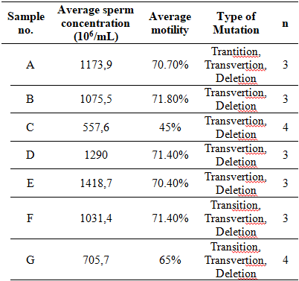

Table 8. Results of Pearson Correlation Analysis
 |  | Mutation
Motility | Pearson Correlation | -,806*
 | Sig. (2-tailed) | ,029
 | N | 7
Sperm Concentration | Pearson Correlation | -,897**
 | Sig. (2-tailed) | ,006
 | N | 7
* Correlation is significant at the 0.05 level (2-tailed).
** Correlation is significant at the 0.01 level (2-tailed).

