Running title: Geoinformatics
Geostatistic Approach in Early Warning the Potential Risk of Rice Brown Plant Hopper Occurrence (Nilaparvata lugens Stål.)

Vo Quang Minh¹* †, Ho Van Chien^{2 †}, Truong Chi Quang^{1 †}
¹Department of Land Management, College of Environment and Natural Resources, Cantho University, Vietnam
²Southern Regional Plant Protection Center, PPD, MARD, Vietnam
*For corresponding author: Email: vqminh@ctu.edu.vn
†Contributed equally to this work and are co- authors
Received _______________; Accepted _______________; Published _______________

Novelty statement The geostatistics tool recommends demonstrating the method in predicting the Brown Plant Hopper (BPH) to analyze and manipulate the spatial differences of rice BPH. The success of the result suggests future application in early warning of pests and diseases.

Abstract

The spatial relationships between climate and Brown Plant Hopper (BPH) transmission investigate using data collected from 120 different study areas (Trung An village, Thot Not District, Cantho City, Vietnam. A Geographic Information System (GIS) and geostatistic technique monitor the spatial relationship between crops and climatic variables. A Global Positioning System (GPS) uses to receive the spatial data location of the location. There was a relationship between climatic and cultural practice factors that affected to occurrence and density of the brown planthopper. Climatic evidence suggests that rainfall, maximum and minimum temperature, and relative humidity are causal aspects of the BPH prevalence. Therefore, the model can be used to predict the occurrence and spatial distribution, which can use for early warning of the occurrence of brown planthopper. However, the accuracy of the prediction would depend on the factors that affected to brown planthopper.

Keywords: Interpolation; Kgriging; Semivariogram; BHP; Pest, Disease

Introduction

The complexity of biological phenomena involved in the pest and environment interaction, coupled with the massive volume of scientific information available for analysis, has made it extremely difficult to reconcile risk posed by a pest to an environment (Andrewartha, H.G., and Birch, L.C. (1984). Birch, L.C. 1984). Nevertheless, the probability of an event estimated by multivariate regression analysis is helpful because such models can handle massive quantities of information into workable and meaningful predictive results rigorously and scientifically. Furthermore, the output can readily display in a GIS format to communicate better the results of models, which proved the valuable tool in data management and manipulation used to predict brown plant hopper's density (Erhard John Dobesberger, 2002).
The climatic variables interact with plants with diverse mechanisms and directly affect tissue and organ-specific photosynthetic allocation. Consequently, such climate changes profoundly affect the population dynamics and insect pests status (Woiwod, I. P. 1997). These effects could either be direct, through the influence of weather on the insect's physiology and behavior (Merrill, R. et al., 2008; Parmesan, C. et al., 2003; Samways. MJ 2005), or may mediate by host plants, competitors, or natural enemies (Bale, J.S. et al., 2002; and Harrington, R., et al., 2001). In addition, the impacts include changes in phenology, distribution, and community composition of the ecosystem that finally leads to the extinction of species (Walther, GR. et al., 2002).
Remote sensing (RS), Global Positioning Systems (GPS), Geographic Information Systems (GIS), and others technologies are tools, which can assist farmers in maximizing area-wide pest management's economic and environmental benefits through precision agriculture (Huang Y. et al., 2008). Crop-pest interactions will change significantly with climate change leading to an impact on pest distribution. Through the analysis, the control strategy precisely introduces to a specific field, where be highly infected, and the rest of place may not need to present a control method practically. Pest and diseases occurrence is strongly dependent upon climatic conditions as temperature and humidity. Any changes in them can significantly alter their population, which ultimately results in yield loss. When combined with a spatially comprehensive database and GIS, simple agroclimatic indices are an inexpensive and rapid mapping altered crop potential. Modeling the risk of pest establishment based on multivariate techniques is feasible and provides appropriate decision support in pest risk assessment (Bale, J.S. et al., 2002).
The GIS and geostatistics tools apply to approach the method in predicting the BPH to analyze the spatial differences among the study area. The method used to determine major climatic factors at experimental conditions of rice production, affecting the occurrence and density of rice BPH, and adopted as diagnostic factors for early warning. GIS tools are used to analyze and manipulated the spatial distribution of rice BPH. In addition, it served as an initial stage in developing a methodology for other pests and diseases. The success of the approach will suggest for future application.

Materials and Methods

The study used the data collected from 120 sites in Cantho city, Vietnam, at ten days intervals for the Winter-Spring crop season (WS) of 2003-2004 on pest enemy, rice cultivation techniques, climatic factors, as a testing data set for approaching the method in predicting the BPH. It represented intensive rice cultivation areas, where pests and diseases often occurred and damaged rice cultivation.
The Rice BPH density in sampling quadrate was collected and calculated as follows:
Quadrate size = 0.5m X 0.5m = 0.25m².
Select 5 quadrates randomized in a rice field, counting all of BPH in a quadrate.
Total of brown planthoppers collected in five quadrates
Rice planthopper density/m² = ------------------------------------------------- x 4
5
The correlated factors among climatic, crop practices, the density of rice BPH selected for regression analysis and prediction model development.
Brown planthopper (Number/m²) = A. x₁ + B x₂ + C. x₃ +…+ Z.x_{n}
In which: A, B, C,..Z ; Constants, x₁, …x_{n} : Effected factors
Variogram and spatial variation of predicted and actual BPH factors interpolated, using GIS and geospatial analysis tools (Ming Li, Yimin Zhao, 2014; and Erhard John Dobesberger, 2002). A variogram is half of the variance sum of the increment that is the regionalized variables Z(x) at the x and x + h. The standard theoretical variogram fits the function mode, including the spherical, exponential, power, and logarithmic function models. The variogram of variables recommends from selected theoretical models. Variogram eigenvalues explant the spatial variation of the reservoir parameters in Figure 2. The geometry of Figure 2 shows that the variogram value increases as the distance increases near the origin. The so-called variation range means that the variogram value stabilizes and no longer increases near the extreme importance when the space is more than a specific range and is often called the "variable range." The extreme value corresponding to the ordinate is often called the partial sill (c + c₀), and the constant nugget c₀ refers to the variogram value at the origin.
Besides, Kriging is an interpolation method used that makes predictions at unsampled locations using a linear combination of observations at nearby sampled locations. The effect of each observation on the kriging prediction base on several factors: 1) its geographical proximity to the unsampled location, 2) the spatial arrangement of all observations (i.e., data configuration, such as clustering of observations in oversampled areas), and 3) the pattern of spatial correlation of the data. The development of kriging models is meaningful only when data are spatially correlated (Goovaerts, P., 2019). The kriging estimate, denoted z*(u₀), is a specific linear combination of the five observations:
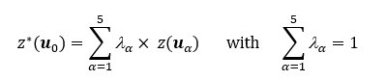

Results and Discussion

The data of 6 periods, at ten days intervals, were collected. Liner correlation and regression of rice BPH density and climatic conditions, cultural practice analyzed. Based on the regression equation, the density of the brown planthopper was predicted and used for interpolation and spatial delineation of the predicted brown planthopper. Besides, the actual distribution compares to density predicted together with standard deviation analysis. Among those periods, period 2nd and all rice crop seasons select for interpretation and delineation of the results.

Correlation between brown hopper density with related effect factors

Among those parameters calculated from 120 observation sites for the 2nd period, only five parameters positively correlated with BPH density, even though some factors had less significance, as shown in Table 2. Other parameters had a litter of no correlation. Thus, it can be affected by several elements to the density of BPH during this period, depending on the cropping periods, climatic factors, cultural practices, etc.
Table 2 also shows the linear correlations of factors correlated with BPH density for all cropping seasons. It shows that most factors positively associated with BPH density, but only pesticide application times had a negative correlation. It means the more times of selective pesticide application, the lower density of the BPH. However, applying broad-spectrum insecticides did not reduce BPH density could be attributed to the insecticide resistance development in BPH and to cause hopper burn and the pesticide application method used by farmers (Mizuki Matsukawa-Nakata et al., 2019). The number of factors that affected the density of the BPH was different for each period. At different periods, rice crops had another state of development and cultural practices, which decide rice's ability to resist pest or pest control to attack the crop.

Regression of Brown hopper with affected factors

Based on the factors that affected the density of the BPH (Table 2), the regression analysis of all involved factors can use to predict the brown planthopper's density. The results showed that the regression equation of predicted BPH density in the 2nd period had a higher determination factor (R² ⁼ 0.66) than all cropping season BPH (R² = 0.41) (Table 3). It can be due to several factors affecting its density or the interaction of some factors, causing the lower R² of all cropping seasons.

Prediction of Brown plant hopper density

BPH is often affected by several factors, including climatic, cultural practices, variety, etc. Since we have known the involved elements and their relation, we can predict their occurrence and density. Therefore, it is beneficial for both local government and farmers to warn the event of hopper for plant protection strategies recommendation, but the prediction accuracy is the major constraint. However, the general trend is beneficial for local government or farmers in an early warning instead of accuracy. Based on this point of view, regression equations and affected parameters to BPH density can predict and use for early warning. Depending on the observations and data collected at 120 locations in different cropping periods, at ten days interval, the predicted; actual density of the BPH and its correlation of 2nd period and cropping season calculated and shown in Figure 3
Figures 3 show the predicted and actual BPH density relationship, closely related to all observed locations at the 2nd period (a) and most cropping season (b). The density of the BPH was different for each of the observation sites. The density of the BPH depending on several factors and can be predicted based on the relation with affected factors as climatic, cultural practices, etc. Even though the expected accuracy does not estimate, it also gives its occurrence trend. Therefore, it can assist the government in recommending early warnings and developing the strategies of crop protection.

Variogram of Brown plant hopper density

Based on the semivariogram from 120 observed locations, the spatial distribution of BPH density was delineated. Then, the kriging method was applied to interpolate the density—the calculation of accuracy assessment and standard data deviation.
Table 4 showing the semivariogram of actual and predicted BPH in the 2nd period all and cropping season. The selection of the exponential variogram model of the 2nd period for interpolation. Both existing and expected density models give nearly the same distance of variation (Ao and A). It was showing that the variation distance of both conditions' density is the same. Especially the R² of predicted density was higher than the actual density, indicating that several factors affected and changed the density of the brown planthopper in the actual condition.
The interpolation maps for the spatial distribution of BPH density were delineated. The prediction is base on the correlation between BPH density factors and the spatial interpolation results of actual BPH density. It shows that the predicted BPH density based on the influencing factors is relatively consistent with the spatial distribution of the actual BPH density (actual R² = 0.438 and predicted R² =0,814). However, the predicted BHP density is lower than that of the actual BPH density. It is because the actual density of BPH is influence by many factors besides the weather, climate, and farming factors.
From the selected semi-variation model, the spatial variation of brown planthopper density is delineated. The interpolated density within the research area was closely related to the actual density variation. Therefore, it can assist in early warning of the occurrence and spatial distribution of BPH. However, it is only used for interpolation since the density has closely correlated with affected factors; otherwise, the interpolated density would be unbelievable.
As the 2nd period, the semivariogram of actual and predicted BPH density for all cropping seasons is calculated and used for interpolation and spatial delineation (Table 4). Its variogram model was Gaussian, the variation distance and R² were different to 2nd periods; this can be due to the difference of factors affected to density and trend of its occurrence. However, this model is used for interpolation for both predicted and actual density at high probability (predicted R² = 0.940, and actual R² = 0.712)
The spatial delineation maps of predicted and actual density of BPH showed in Figure 4. These were also delineated the close relation between prediction and existing conditions. Since this result gave the ability to use the model and method to predict the BPH's density, it also depends on the factors that affected the BPH density.

Conclusion and Suggession

There was a relationship between climatic and cultural practice factors that affected to occurrence and density of the BPH. Therefore, the model can predict the occurrence and spatial distribution and use it for early warning of BPH occurrence. However, the accuracy of the prediction would depend on the factors that affected BPH.
The GIS and geostatistics tools apply as a demonstration for approaching the method in predicting the BPH to analyze and manipulate the spatial differences of rice BPH among the study area. In addition, it served as an initial stage in developing a methodology for other pests and diseases.
The success of the result recommends for future application. More site observations at different cropping stages or ecosystems must observe. Otherwise, crop varieties and cultivation seasons should also include in the model for better accuracy that could officially warn the government and the farmers to reduce pests and disease damage by better crop protection strategies.

References

Andrewartha, H.G., and Birch, L.C. (1984). The ecological web: more on the animal's distribution and abundance. University of Chicago Press, Chicago, USA, pp. 606.
Bale, J.S., Masters, G.J., Hodkinson, I.D., Awmack, C., Bezemer, T.M., Brown, V.K., Butterfield, J., Buse, A., Coulson, J.C., Farrar, J., Good, J.E.G., Harrington, R., Hartley, S., Jones, T.H., Lindroth, R.L., Press, M.C., Symrnioudis, I., Watt, A.D. and Whittaker, J.B. (2002) Herbivory in global climate change research: direct effects of rising temperature on insect herbivores. Global Change Biology, 8, 1-16. https://doi:10.1046/j.1365-2486.2002.00451.x
Department of Plant Protection. (2014). National technical regulation on surveillance method of Rice pests. QCVN 01 - 166: 2014/BNNPTNT. Vietnamese Ministry of Agricultural and Rural Development.
Erhard John Dobesberger. (2002). Multivariate techniques for estimating the risk of pest establishment in new environments. Paper presented to the North American Plant Protection Organization, International Symposium on Pest Risk Analysis held in Puerto Vallarta, Mexico, March 18-21, 2002.
Goovaerts, P. (2019). Kriging Interpolation. The Geographic Information Science & Technology Body of Knowledge (4th Quarter 2019 Edition), John P. Wilson (ed.). https://doi.org/10.22224/gistbok/2019.4.4
Harrington, R., Fleming, R., and Woiwod, I. (2001). Climate change impacts on insect management and conservation in temperate regions: can they be predicted? Agric. For. Entomol., 3: 233-240. https://doi.org/10.1046/j.1461-9555.2001.00120.x
Huang Y., Lan Y., Westbrook J.K., Hoffmann W.C. (2008). Remote Sensing and GIS Applications for Precision Area-Wide Pest Management: Implications for Homeland Security. In: Sui D.Z. (eds) Geospatial Technologies and Homeland Security. The GeoJournal Library, vol 94. Springer, Dordrecht. https://doi.org/10.1007/978-1-4020-8507-9-12
Merrill, R., Gutierrez, D., Lewis, O., Gutie¥rrez. J., Diez, S. and Wilson, R. (2008). Combined effects of climate and biotic interactions on the elevational range of a phytophagous insect. J. Animal Ecol., 77: 145-155. https://doi.org/10.1111/j.1365-2656.2007.01303.x
Ming Li, Yimin Zhao. (2014). Chapter 10: Applicable Scope, Advantages, and Disadvantages of -Major Software Packages. Geophysical Exploration Technology. Applications in Lithological and Stratigraphic Reservoirs, Pages 305-335. https://doi.org/10.1016/B978-0-12-410436-5.00010-1
Mizuki Matsukawa-Nakata, Nguyen Huy Chung, and Youichi Kobori. (2019). Insecticide application and its effect on the density of rice planthoppers: Nilaparvata lugens and Sogatella furcifera in paddy fields in the Vietnamese Red River Delta. J Pestic Sci. 2019 May 20; 44(2): 129–135. https://doi:10.1584/jpestics.D18-080
Parmesan, C., Yohe, G. A. (2003). The globally coherent fingerprint of climate change impacts across natural systems. Nature 421, 37–42 (2003). https://doi.org/10.1038/nature01286
Samways MJ (2005). Insect Diversity Conservation, 342 pp. Cambridge, UK: Cambridge University Press. [The most recent global synthesis of the field of insect conservation]. https://doi.org/10.1017/CBO9780511614163
Walther, GR., Post, E., Convey, P. et al. (2002). Ecological responses to recent climate change. Nature 416, 389–395. https://doi.org/10.1038/416389a
Woiwod, I. P. (1997). Detecting the effects of climate change on Lepidoptera. Journal of Insect Conservation. 1 (3), pp. 149-158. https://doi.org/10.1023/A:1018451613970

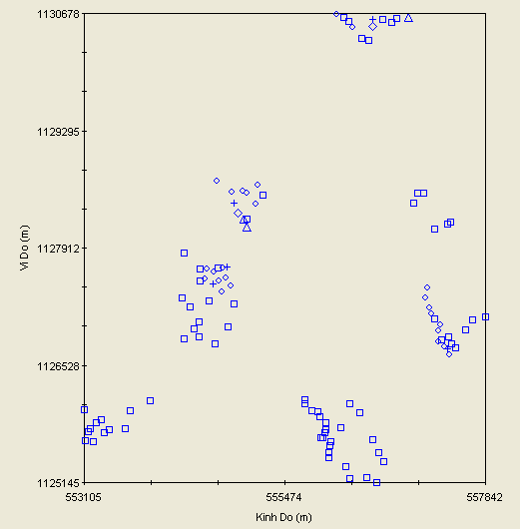
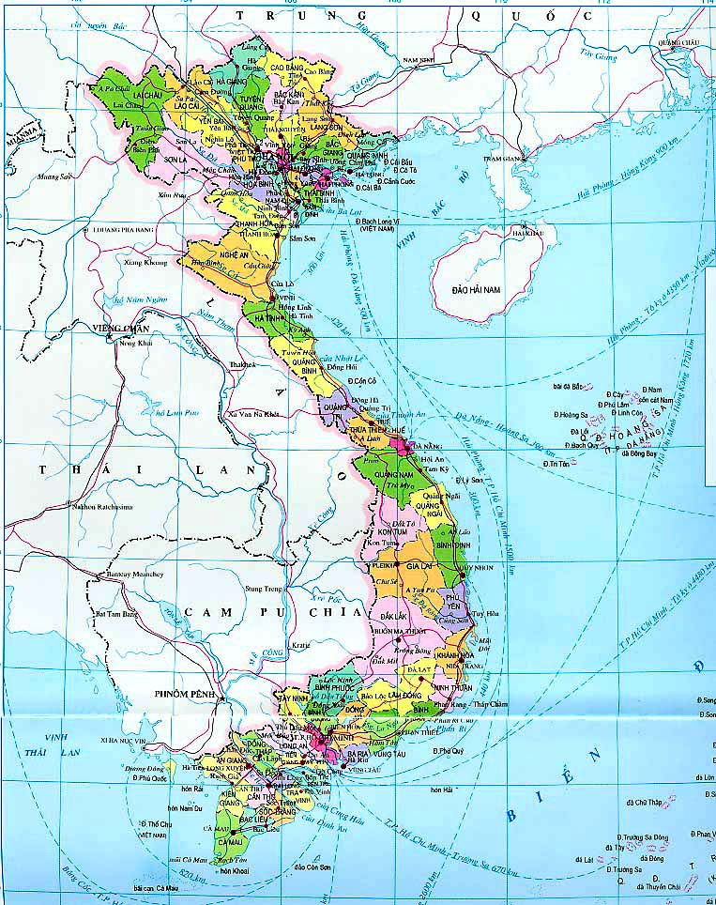
Figure 1: Location of the study sites in the Mekong delta

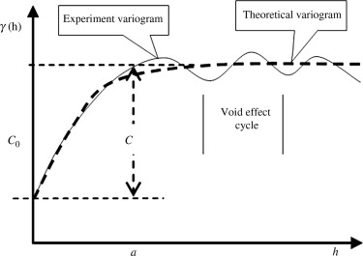
Figure 2. Variogram parameter illustration (Ming Li, Yimin Zhao. (2014).

a)
b)
Figure 3: Correlation between predicted and actual BPH density in the 2nd period (a) and most cropping season (b).

a)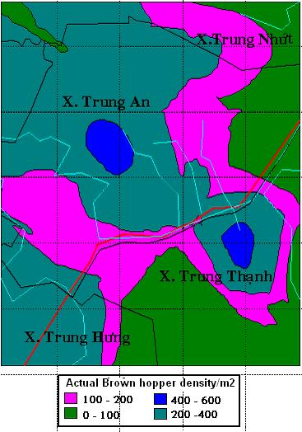
b)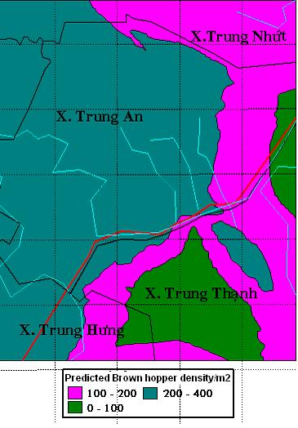
c) 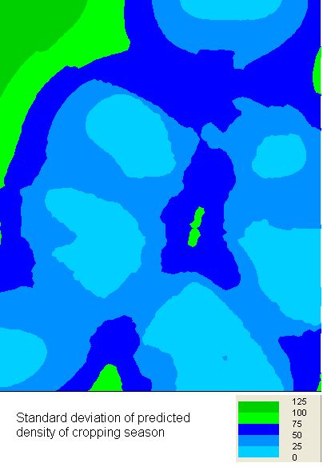
Figure 4: Spatial distribution of predicted (a), actual (b) BPH density, and Standard deviation (c) in Winter-Spring cropping season 2003-2004

Table 1: Rice Brown plant hopper warning levels ( Department of Plant Protection. 2014)
Affected levels | Brown Plant Hopper density (number/m²) | No. of BPH eggs/m²)
Slightly affected | 750 - 1500 | 250 - 500 >
Moderately affected | 1500 - 3000 > | 500 – 1.000
Strongly affected | > 3000 | > 1.000
Completely loss | 70% rice yield loss

Table 2 Linear correlations of affected factors to the density of BPH in 2nd periods and Winter-Spring rice cropping season,
Affected Factors | Brown hopper density/m²
 | 2nd period | DX cropping season
Brown planthopper age | 0.80** | 0.39**
Enemy density/m² | 0.60** | 0.45**
Air temperature (⁰C) | 0.42** | 0.36**
Field water level (cm) | 0.31** | -
Number of leaf /m² | 0.21* | -
Leaf color code | - | 0.24**
Air humidity (%) | - | 0.22**
Times of pesticide used. | - | - 0.32**
n= 118, **: at significant 1%, *: at significant 5%

Table 3: Regression equation of predicticed BPH for 2nd prriod and all season (number/m2)
Predicted BHP density | Regression equation | Determination factor
2nd period | - 200.39 + (173.20 x Brown hopper age) + (1.44 x enemy density) + (6.88 x Air temp.) – (5.53 x Field water level) + (0.01 x Number of leaf/m²). | R² = 0.66
All cropping season | = - 182.66 + (2.12 x enemy density) + (37.84 x Brown hopper age) + (13.70 x Air temperature) + (72.19 x Leaf color code) – (4.88 x Air hum.) – (14.80 x Times of pesticide used). | R²= 0.41

Table 4: Semivariogram of actual and predicted BPH density in 2nd periods and all cropping season (Winter-Spring, 2003-2004)
Brown hopper density (Hopper number/m²) |  | Variogram  Model | C_{o} | C_{o}+C | R² | C/C+C_{o} | A_{o} (m) | A (m)
2nd period | Predicted | Exponential | 13900 | 70800 | 0,814 | 0,804 | 1.257 | 3.771
 | Actual | Exponential | 43800 | 96400 | 0,438 | 0,546 | 1.129 | 3.387
Cropping season | Predicted | Gaussian | 1970 | 18840 | 0,940 | 0,895 | 1.747 | 3.025
 | Actual | Gaussian | 9870 | 34330 | 0,740 | 0,712 | 889 | 1.539
C_{o} : Nugget variance C+C_{o} : Sill
R²: Determination factor C/C+C_{o}: Proportion
A_{o}: Range Parameter A: Range (effective range)

