Running title: Tenderization of Hens Meat Using Agaricus bisporus extract

Utilization of Button Mushroom (Agaricus bisporus) Water Extract as A Culling Hens Meat Tenderizer

Wardah^{1†}, Rini Rahayu Sihmawati¹, Dewi Putri Absiyati², Putri Jauharo Tuhfatul Izzah² and
Tatang Sopandi^{2*}
¹ Study Program of Agroindustry, Vocational Faculty, Universitas 17 Agustus 1945, Surabaya, 60117, Indonesia
² Study Program of Biology, Faculty of Science and Technology, Universitas PGRI Adi Buana, Surabaya, 60234, Indonesia
^{*)}For correspondence: tatang.sopandi@unipasby.ac.id
†⁾Contributed equally to this work and are co-first authors
Received _______________; Accepted _______________; Published _______________

Novelty statement
Button mushrooms are rarely used to tenderize a culling hens meat. This results indicate that the protein content, protease and collagenase enzyme activity between button mushroom fruit body parts differ from one another. We found that the application of whole button mushroom water extract with a concentration of 5% could increase the tenderness and preference for toughness and taste of culling hens meat without affecting pH, WHC, cooking loss, water content, protein and fat, color and aroma.
Abstract
The search for a meat tenderizer that is cheap, easy to obtain, has a short production time, and can be applied in the meat industry is still needed. The present study aims to determine the protein and enzyme content in the water extract of Agaricus bisporus and to explore its use as a meat tenderizer for culling hens. Application of meat tenderization using the soaking method with a completely randomized design, 6 treatments, each treatment repeated 5 times. The treatments consisted of 4 concentrations of water extract of A. bisporus mushroom, namely, 2.5%, 5.0%, 7.5%, and 10%, one positive control treatment using 0.2% papain and one negative control treatment using distilled water. The study's results showed that the fruiting bodies of A. bisporus mushrooms and their parts had different protein content and protease and collagenase activities. The protein content of whole A. bisporus fruiting bodies, parts of volva, pileus, and stipe were 25.51±1.35%, 19.87±1.13%, 18.13±1.12%, and stipe 8.67±1.11% with protease activity of 74.41±1.43 U mL⁻¹, 74.63±1.63 U mL⁻¹, 66.34±1.52 U mL⁻¹, and stipe 51.66±1.26 U mL⁻¹, respectively. Meanwhile, the collagenase enzyme activities were 8.29±2.74 U mL⁻¹, 9.14±1.53 U mL⁻¹, 4.01±1.19 U mL⁻¹, and stipe 2.57±1.18 U mL⁻¹, respectively. This study showed that water extract of A. bisporus mushroom at a concentration of 5% significantly increased tenderness. Furthermore, the water extract did not change pH, WHC, cooking loss, water, protein and fat content, color, and aroma but increased preference for toughness and taste of culling hens meat. This study concluded that A. bisporus mushroom extract has great potential to be used as a meat tenderizer. The dose of using water extract of A. bisporus mushroom for application as a meat tenderizer is recommended at 5%.
Keywords: Agaricus bisporus, culling hens, protease, meat, tenderizer

Introduction
Meat plays an important role not only as a source of food nutrition but also in economies and cultures worldwide. Consumers are very concerned about meat's sensory quality and tenderness. Meat quality is strongly influenced by several factors: muscle composition, collagen content, intramuscular connective tissue structure, and post-slaughter myofibrillar protein degradation. The meat tenderness also depends on the type of muscle, age, factors before and after slaughter, pH, and postmortem temperature (Anderson et al. 2012). Different physical and chemical methods are used to tenderize meat. However, using exogenous protease enzymes as meat tenderizer is a relatively progressive method and is considered efficient for improving meat quality (Rawdkuen et al. 2013).
Protease enzymes can reduce the amount of connective tissue, degrade collagen and elastin in connective tissue to reduce meat hardness (Ryder et al. 2015). Papain and bromelain are protease enzymes of plant origin that are most widely used for meat tenderization (Liu et al. 2008). However, using papain as a meat tenderizer is limited because it can reduce juiciness and cause a bitter taste in meat derived from bitter peptides resulting from proteolytic degradation (Gerelt et al. 2000). Meanwhile, using of bromelain can result in excessive tenderness and a mushy texture (Ha et al. 2014; Nam et al. 2016).
The search for cheap protease enzymes, a short production process, easy to obtain, and can be applied in industry is still being carried out, including from edible mushrooms such as Pleurotus ostreatus (Chung and An 2012), Sarcodon aspratus, Agaricus bisporus, and Lentinula edodes (Lee et al. 2017). Microbial-derived proteases are preferred over plant and animal proteases because of their various characteristics, which are more suitable for biotechnological applications, such as activity over a wide temperature and pH range, thermal stability, and high catalytic activity (Savitha et al. 2022). Most of the proteases from Basidiomycetes fungi are neutral to slightly acidic (Sumantha et al. 2006; Sabotič et al. 2007). White button mushrooms (Agaricus bisporus) are cultivated worldwide and account for 35-45% of total mushroom production (Research and Markets, 2020). Studies on meat tenderizers using A. bisporus have been conducted on beef longissimus dorsi (Lee et al. 2017).
However, studies on poultry meat, primarily culling hens, have yet to be published. Culling hens meat comes from laying hens that are generally rejected at about 96 weeks due to low egg production, around 20-25%. Culling hens meat can be used as a source of animal protein. However, the public's preference for consuming culling hens meat is low because it has a rough, challenging, and juicy texture and a fishy aroma that is only used as chicken soup. Depending on the animals age and specific muscle type, the chemical composition, structure, and amount of connective tissue also affects meat tenderness (Bolumar et al. 2013). Tenderization technology must be applied to increase the tenderness and quality of culling hens meat. This study aims to examine the content of protease and collagenase enzymes in the fruiting bodies of A. bisporus mushrooms and their principal parts. This study also aims to explore water extract from A. bisporus mushroom as a tenderizer in culling hens meat.
Materials and Methods
Determination of Protein Content
The protein content in the water extract of A. bisporus (white button) mushroom was determined using the titrimetric method AOAC (2005). Fresh A. bisporus was obtained from mushroom farmers in Malang, East Java, Indonesia. Fresh A. bisporus mushrooms were cleaned of adhering dirt and then air-dried, and the main components of the mushroom fruiting bodies were separated. Whole A.bisporus mushrooms (250 g), pileus parts (250 g), stipe parts (250 g), and volva parts (250 g) were separately sliced and each mixed with 2.5 L distilled water, crushed in a blender and then put into a mixer constant at 150 rpm at 25°C for 24 hours. The pulverized was filtered with Whatman No.1 filter paper in a vacuum. The filtrate obtained was then concentrated in a rotary evaporator at 60ºC for 2 hours to produce concentrated A. bisporus water extract. The extract was dried in a rack dryer at 60ºC to constant weight. A total of 1 g sample contains an extract of whole A.bisporus mushrooms, pileus, stipe, and volva wrapped in parchment paper. Then had been weighed and put into a 300 mL Kjeldahl flask, plus 1 g of a mixture of selenium (7 g potassium sulfate and 0.8 g cupric sulfate) and 12 mL concentrated sulfuric acid, then digested at 420ºC for 1 hour. After being cooled to room temperature, the Kjeldahl flask containing the digested sample was added to 50 mL of distilled water and 50 mL of 40% sodium hydroxide. The distillate was accommodated in a 250 mL Erlenmeyer flask containing 25 mL of 4% boric acid. The distillation process was stopped when the color of the distillate in the holding Erlenmeyer flask changed from red to green. Then, the distillate was titrated with 0.2 N hydrochloric acid solution until the color changed from green to red.
Determination of Protease Activity
Determination of the protease enzyme activity of the water extract of A. bisporus mushroom was measured using the Cupp-Enyard (2008) method. Briefly, 1 mL of water extract of A. bisporus mushroom was added with 0.65% casein substrate (0.65 g casein in 100 mL of 0.05 M K-phosphate buffer solution at pH 7.5). The mixture was then incubated at 37°C for 10 minutes. Incubation and reaction were stopped by adding 5 mL of 110 mM trichloroacetic acid (TCA) reagent and incubating at 37°C for 30 minutes. The mixture was then centrifuged at 10000 rpm for 10 minutes, and 2 mL of the supernatant was taken. Furthermore, 5 mL of sodium carbonate and 1 mL of Folin Ciocalteau reagent were added to the supernatant filtrate and incubated at 37°C for 30 minutes. The absorbance of the mixture was measured using a spectrophotometer at a wavelength of 660 nm. One unit of enzyme activity was defined as the amount of enzyme required to release 1 mmole of tyrosine on a casein substrate per minute.
Determination of Collagenase Activity
The collagenase enzyme activity of A. bisporus mushroom water extract was determined using Moore and Stein (1954) method described by Park et al. (2002). Briefly, 5 mg collagen was added to 1 mL 50 mM Tris-HCl (pH 7.5) containing 5 mM calcium chloride and 0.1 mL water extract of A. bisporus mushroom. After homogenization, the mixture was incubated at 37ºC for 1 hour. Incubation and reaction were stopped by adding 0.2 mL of 50% trichloroacetic acid (TCA). After being allowed to stand for 10 minutes at room temperature, the mixture was centrifuged at 1800 g for 20 minutes. A total of 0.2 mL of the supernatant was taken and mixed with 1.0 mL of dilute ninhydrin solution, incubated at 100ºC for 20 minutes, then cooled at room temperature. Next, the mixture was diluted with 5 mL 50% 1-propanol, and a spectrometer measured the absorbance at a wavelength of 570 nm. A buffer solution (50 mM Tris-HCl, pH 7.5) containing 5 mM calcium chloride was used instead of the control enzyme solution. The amino acid tyrosine solution was used as the standard curve. One unit (U) of enzyme activity was defined as the amount of enzyme required to hydrolyze 1 mole of collagen substrate per hour.
Preparation of Mushroom Extract
A total of 12.5 kg of fresh whole A. bisporus mushroom that had been cleaned of impurities were air-dried, sliced into small pieces, crushed with a blender, and macerated in 125 L distilled water, stirred in a shaker for 24 hours at a speed of 150 rpm. After maceration, the mixture was filtered, and part of the supernatant was taken. Then evaporated in a rotary evaporator at 60ºC for 2 hours until concentrated. The concentrated A. bisporus mushroom water extract was dried in a rack dryer at 60ºC to constant weight. Furthermore, the concentration of A. bisporus mushroom water extract consisting of 2.5%, 5%, 7.5%, and 10% extract of A. bisporus mushroom in distilled water was made to be used as a meat tenderizer.
Soaking of Meat of Culling Hens
The breast meat of culling hens was obtained from the Wadung Asri Slaughterhouse, Sidoarjo. East Java - Indonesia. The culling hens meat of the Lohmann strain is taken from the same farm and slaughtered at the same time. The culling meat soaking treatment has used the method of Lee et al. (2017). A total of 60 pieces of breast culling hens meat were taken, cleaned, and separated from the skin, fat, and bones. The meat is divided into 6 parts of 10 pieces each, and the first 4 parts are each soaked in 2.5% (CMWE 2.5%), 5% (CMWE 5.0%), 7.5% (CMWE 7.5%), and 10% (CMWE 10.0%) white button mushroom water extract. One part was immersed in 0.2% papain and used as a positive control. The remaining part was soaked in distilled water (CMWE 0%) and used as a negative control. Soaking was done at 4ºC for 48 hours. The meat of culling hens that have been soaked is then observed for tenderness, water holding capacity, cooking loss, pH value, biochemical composition (water, protein, and fat content), and sensory properties of color, taste, toughness, and aroma.
Determination of Meat Tenderness
Meat tenderness was measured according to the method of Hinnergardt and Tuomy (1970) using a penetrometer. A total of 10 g samples of breast culling hens pieces from each treatment were placed on a penetrometer mat with a weight of 100 g. The pointer is set in contact with the sample surface, and the scale shows zero. The penetrometer lever is pressed for 10 sec, then released. Tenderness measurement results in mm 100 g⁻¹ 10 sec⁻¹.
Determination of Cooking Loss
Measurement of cooking loss using the Lee et al. (2017) method. A total of 10 g of meat samples from each treatment were steamed at 80ºC for 15 minutes. Cool the meat and it dry with tissue paper without pressing. The weight of the meat before and after boiling was weighed. The calculation of the cooking loss value is as follows:
Cooking loss (%) = (weight before steaming – weight after steaming) x 100%
Weight before steaming
Determination of Water Holding Capacity
Measurement of water holding capacity (WHC) was carried out using the method of Honikel and Hamm (1994). A total of 2 g of meat samples from each treatment were crushed, and the pulverized product was put into a 20 mL centrifuge tube containing 10 mL of distilled water. The tube was then centrifuged at 3000 rpm for 20 minutes. The supernatant portion was taken, and the volume was measured. WHC calculation:
WHC (%) = (volume before centrifugation – volume of supernatant) x 100%
volume before centrifugation
Determination of pH value
The pH of tenderized meat products was measured using a pH meter previously calibrated using a phosphate buffer solution of 4.0 and 7.0. Meat samples from each treatment were taken as much as 10 g, crushed, and added with 10 mL of distilled water. The minced meat and water were homogenized and measured with a pH meter.
Biochemical composition
The biochemical composition includes water, protein, and fat content of culling meat from each soaking treatment. Determination of the water, protein, and fat content of meat was carried out using the oven method, titrimetric method, and the Babcock method (AOAC, 2005).
Sensory characteristics
Sensory characteristics of chicken meat were carried out by 40 untrained panelists consisting of students and lecturers from the faculty of science and technology, Universitas PGRI Adi Buana, Surabaya. All panelists have a taste threshold of 10% sugar in tea water, do not smoke, and are not color blind. Researchers were asked to rate the preference for meat from each immersion treatment coded and cooked at 71°C. The meat samples were cut into cubes of 2 x 2 cm. Panelists were asked to state their preference for the color, aroma, toughness, and taste of culling hens meat tenderization products based on a 5 point Linkert scale, namely, 1 = very disliked, 2 = disliked, 3 = neutral, 4 = like, and 5 = very liked.
Statistical Analysis
Data from observations of protein content, enzyme activity, tenderness, pH value, cooking loss, water holding capacity, and biochemical composition of culling hens meat tenderization products were analyzed using a one-way analysis of variance at a significance level of 0.05. Tukey's test at a significance level of 0.05 was used to see differences between treatments. The data from the observation of sensory characteristics before the analysis of variance was transformed into log + 0.5 numbers. Statistical analysis was performed using the Statistical Program for Social Science (SPSS) version 22 software.
Results
Protein Content and Enzyme Activity of A. bisporus Water Extract
The measurement results (Figure 1) showed that there was a significant difference (P<0.05) in protein content between the water extract of the main fruiting body of the A. bisporus mushroom. The protein content of the water extract of the volva part (19.87±1.13%) was significantly (P<0.05) higher than pileus (18.13±1.12%) and stipe (8.67±1.11%), but significantly (P<0.05) lower than the whole fruiting bodies (25.51±1.35%). Meanwhile, the protein content of the pileus was significantly (P<0.05) higher than the stipe part.
Figure 1 also shows a significant difference (P<0.05) in the activity of the protease and collagenase enzymes between the water extracts of the main parts of the fruiting bodies of the A. bisporus mushrooms. The protease enzyme activity of the volva part (74.63±1.63 U mL⁻¹) was significantly (P<0.05) higher than pileus (66.34±1.52 U mL⁻¹) and stipe (51.66±1.26 U mL⁻¹), but not significantly different (P>0.05) compared to whole fruiting bodies (74.41±1.43 U mL⁻¹). Collagenase enzyme activity in the volva part (9.14±1.53 U mL⁻¹) was significantly (P<0.05) higher than pileus (4.01±1.19 U mL⁻¹) and stipe (2.57±1.18 U mL⁻¹), but not significantly different (P>0 0.05) compared with whole fruiting bodies (8.29±2.74 U mL⁻¹). Meanwhile, the collagenase enzyme activity of pileus was significantly (P<0.05) higher than stipe.
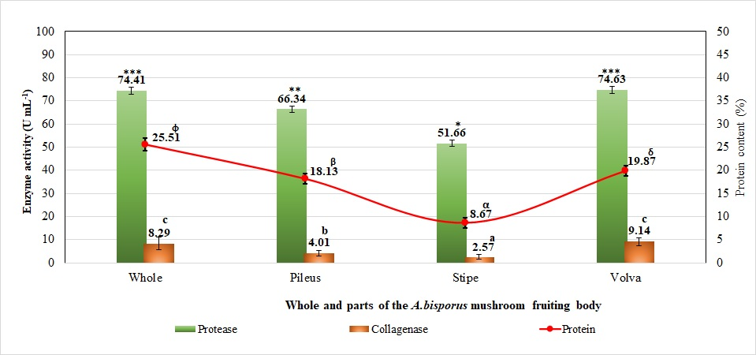
Figure 1. Protein content and activity of protease and collagenase enzymes in the fruiting body of A. bisporus mushroom and its parts. The mean value with standard deviation (error bar) and given a different notation showed a significant difference (P<0.05).

Tenderness and pH Value of Meat Tenderization Products
The results of the tenderness measurement (Figure 2) showed that soaking culling hens meat in the water extract of the A. bisporus mushroom has a significant effect (P<0.05) on the tenderness. The tenderness of culling hens meat at CMWE 10% (102.75±2.23 mm 100 g⁻¹ 10 sec⁻¹) was significantly higher (P<0.05) compared to CMWE 7.5% (84.25±2.44 mm 100 g⁻¹ 10 sec⁻¹), CMWE 5% (78.75±2.72 mm 100 g⁻¹ 10 sec⁻¹), CMWE 2.5% (68.25±1.33 mm 100 g⁻¹ 10 sec⁻¹) and CMWE 0% (62.75±2.22 mm 100 g⁻¹ 10 sec⁻¹), but not significantly different (P>0.05) compared to 0.2% papain (99.25±3.64 mm 100 g⁻¹ 10 sec⁻¹). The tenderness of culling hens meat at CMWE 7.5% was significantly (P<0.05) higher than CMWE 5%, CMWE 2.5%, and CMWE 0%. The tenderness of culling hens meat at CMWE 5% was significantly (P<0.05) higher than CMWE 2.5% and CMWE 0%. The tenderness of the meat in the CMWE 2.5% was significantly (P<0.05) higher than in CMWE 0%.
Figure 2 also shows that soaking culling hens meat in water extract of A. bisporus mushroom has no significant effect (P>0.05) on the pH of the meat. There was no significant difference (P>0.05) between the pH of culling hens meat on papain 0.2% (6.20±0.09 mm 100 g⁻¹ 10 sec⁻¹), CMWE 0.0% (6.15±0.06 mm 100 g⁻¹ 10 sec⁻¹), CMWE 2.5% (6.15±0.07 mm 100 g⁻¹ 10 sec⁻¹), CMWE 5.0% (6.13±0.07 mm 100 g⁻¹ 10 sec⁻¹), CMWE 7.5% (6.12±0.11 mm 100 g⁻¹ 10 sec⁻¹) and CMWE 10% (5.95±0.19 mm 100 g⁻¹ 10 sec⁻¹).
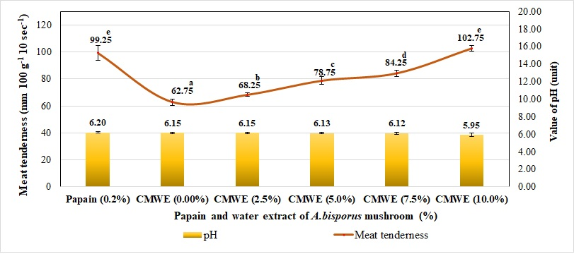
Figure 2. Tenderness and pH of culling hens meat soaked in papain and several concentrations of water extract of A. bisporus mushroom. The mean and standard deviation values (error bars) which were given different notations showed significant differences (P<0.05).

Water Holding Capacity and Cooking Loss of Meat Tenderization Products
The results of the measurement of water holding capacity (Figure 3) showed that soaking of culling hens meat in the water extract of A. bisporus mushroom had a significant effect (P<0.05) on the water holding capacity (WHC). WHC of culling hens meat at CMWE 0.0% (32.90±0.74%) was significantly (P<0.05) lower than WHC at papain 0.2% (43.68±1.79%), CMWE 7.5% (37.878±1.59%) and CMWE 10% (39.04±2.265%), but not significantly different (P>0.05) compared to CMWE 2.5% (34.48±0.49%) and CMWE 5% (37.06±3.05%). WHC of culling hens meat at CMWE 2.5% was significantly (P<0.05) lower than WHC at papain 0.2% and CMWE 10%, but not significantly different (P>0.05) with CMWE 5% and CMWE 7.5%. WHC of culling hens meat at CMWE 5% and CMWE 7.5% was not significantly different (P>0.05) with CMWE 10% and CMWE 10%, but was significantly (P<0.05) higher than papain 0.02%.
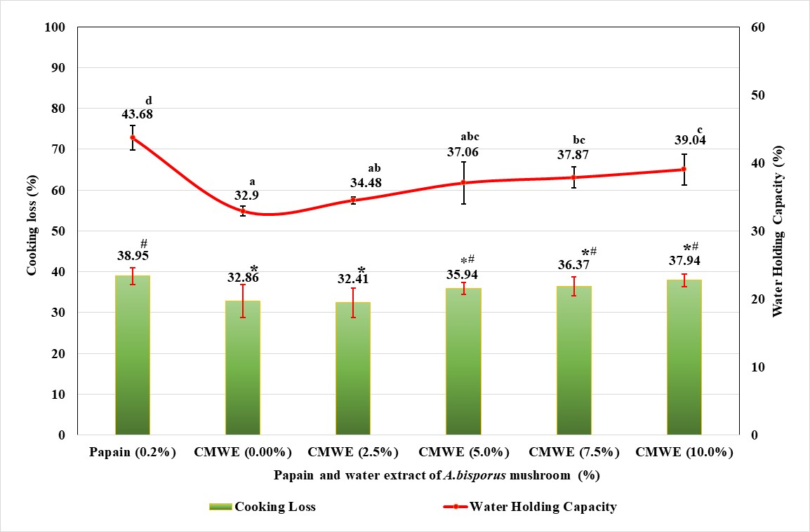
Figure 3. Water holding capacity and cooking loss of culling hens meat soaked in papain and some concentrations of A. bisporus mushroom water extract. The mean and standard deviation values (error bars) which were given different notations showed significant differences (P<0.05).

Figure 3 also shows that soaking culling hens meat in water extract of A. bisporus mushroom has a significant (P<0.05) effect on cooking loss. Cooking loss culling hens at CMWE 0.0% (32.86±3.99%) was not significantly different (P>0.05) with CMWE 2.5% (32.41±3.61%), CMWE 5% (35.94±1.45%), CMWE 7.5% (36.37±2.34 %), and CMWE 10% (37.94±1.53%), but significantly (P<0.05) lower than papain 0.2% (38.95±2.04%). There was no significant difference (P>0.05) between cooking loss in papain 0.2% and CMWE 5%, CMWE 7.5%, and CMWE 10%.
Biochemical Composition of Meat Tenderization Products
The results of the measurement of water content (Figure 4) showed that soaking culling hens meat in the water extract of A. bisporus mushroom has no significant effect (P>0.05) on the water content. There was no significant difference (P>0.05) between the water content of culling hens meat soaked in water extract of A. bisporus mushroom and 0.2% papain.
Figure 4 shows that the protein content of culling hens meat in papain 0.2% (21.41±0.75%), CMWE 0.0% (22.53±0.65%) and CMWE 2.5% (21.65±0.61%) was significantly (P<0.05) higher than the content of culling hens meat protein in CMWE 10% (19.67±0.86%), but not significantly different (P>0.05) compared to CMWE 5% (20.47±0.54%) and CMWE 7.5% (19.86±0.73%). There was no significant difference (P>0.05) in protein content of culling hens meat in CMWE 5.0%, CMWE 7.5%, and CMWE 10%.
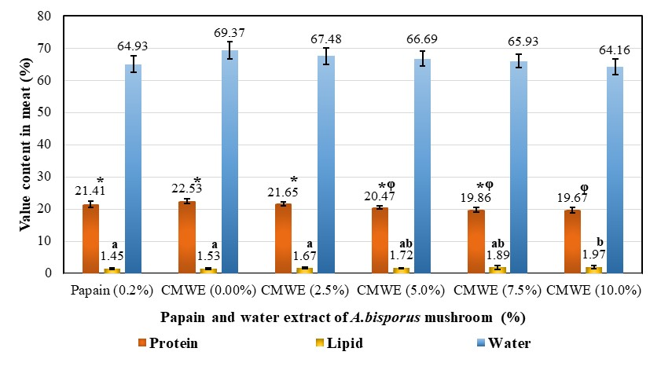
Figure 4. Biochemical composition of culling hens meat soaked in papain and some concentrations of water extract of A. bisporus mushroom. The mean and standard deviation values (error bars) which were given different notations showed significant differences (P<0.05).
Figure 4 also shows that the fat content of culling hens meat was significantly (P<0.05) affected by the soaking of the water extract of A. bisporus mushroom. The fat content of culling hens meat in CMWE 0.0% (1.53±0.24%) was not significantly different (P>0.05) compared to papain 0.2% (1.45±0.29%), CMWE 2.5% (1.67±0.19%), CMWE 5% (1.72 ±0.15%), and CMWE 7.5% (1.89±0.39%), but significantly (P<0.05) lower than CMWE 10% (1.97±0.26%). There was no significant difference (P>0.05) in fat content of culling hens meat between CMWE 2.5%, CMWE 5%, CMWE 7.5%, CMWE 10%, and papain 0.2%.
Sensory Characteristic of Meat Tenderization Products
The results of the panelists assessment (Figure 5) showed that soaking culling hens meat in the water extract of A. bisporus mushroom has no significant effect (P>0.05) on the sensory characteristics of color and aroma. The color and aroma of culling hens meat soaked in water extract of A. bisporus mushroom were included in the category favored by the panelists (panelists score more than 4). However, the results of this study showed that soaking culling hens meat in water extract of A. bisporus mushroom has a significant effect (P<0.05) on the taste and toughness of the meat. The taste and toughness of the meat that was not soaked in papain or water extract of A. bisporus mushroom were included in the neutral category according to the panelists' assessment.
The taste of culling hens meat at CMWE 0% was significantly (P<0.05) lower than that of papain 0.2%, CMWE 2.5%, CMWE 5%, CMWE 7.5%, and CMWE 10%. The taste of culling hens meat in papain 0.2% was significantly (P<0.05) lower than CMWE 5%, CMWE 7.5%, and CMWE 10%, but not significantly different (P>0.05) compared to CMWE 2.5%. There was no significant difference (P>0.05) between the taste of culling hens meat at 5% CMWE, 7.5% CMWE, and 10% CMWE.
The study also showed that soaking culling hens meat in the water extract of A. bisporus mushroom has a significant effect (P<0.05) on the toughness of the meat. The toughness of culling hens meat at CMWE 0% was significantly (P<0.05) lower than papain 0.2%, CMWE 2.5%, CMWE 5%, CMWE 7.5%, and CMWE 10%. The toughness of culling hens meat in CMWE 2.5% was significantly (P<0.05) lower than CMWE 5% but not significantly different (P>0.05) with papain 0.2%, CMWE 7.5%, and CMWE 10%. The toughness of culling hens meat at 5% CMWE was significantly (P<0.05) higher than that of papain 0.2%, but not significantly different (P>0.05) compared to CMWE at 7.5% and CMWE at 10%.
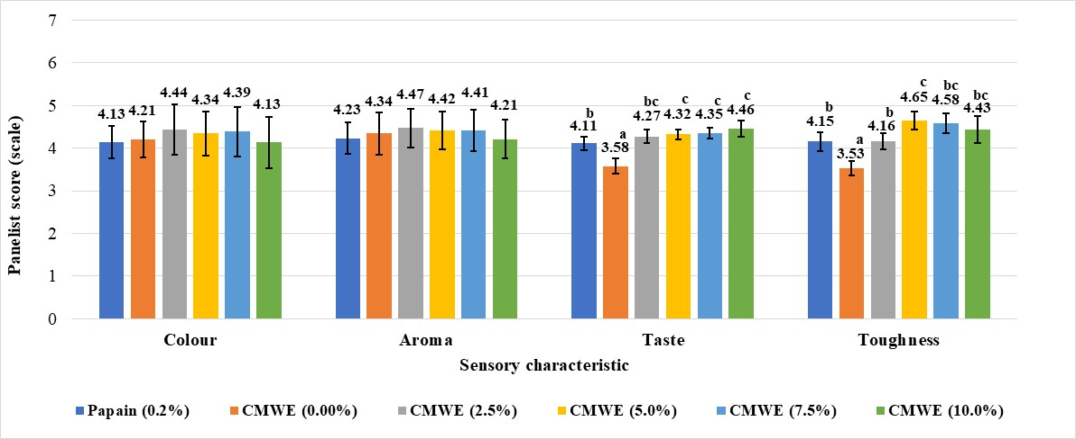
Figure 5. Panelists assessment of the sensory characteristics of color, aroma, taste, and toughness of culling hens meat soaked in papain and some concentrations of A. bisporus mushroom water extract. The mean and standard deviation values (error bars) which were given different notations showed significant differences (P<0.05).

Discussion
The present study proves that the fruiting body of the A. bisporus mushroom and its parts contain protein. The protein content of the water extract of A. bisporus mushroom in this study was included in the range of protein content of A. bisporus that had been reported by several researchers. Usman et al. (2021) have reported that the crude protein content of A. bisporus is around 19-38% based on the dry weight. Variations in the protein content of A. bisporus have also been reported by several researchers. Mohiuddin et al. (2015) have reported the protein content of the mushroom A. bisporus around 17.7–24.7%, and Ahlavat et al. (2016) have reported 29.1%. Protein content variations of A. bisporus were thought to be due to differences or variations in the nutrient composition of the substrate. Sebaaly et al. (2019) have reported that the nutritional composition of A. bisporus mushroom is influenced by the type of substrate.
The present study indicates that the fruiting bodies of A. bisporus mushrooms contain protease and collagenase enzymes. Similarly, Inácio et al. (2015) have reported that the mushroom A. bisporus can produce protease enzymes. The protease activity of the water extract of A. bisporus mushroom in this study was higher than that reported by Lee et al. (2017), which is 0.160 U mL⁻¹. The difference level of activity in protease enzyme is thought to be caused by differences in the nutrient composition of the substrate. Several researchers have reported that the protease enzyme activity of A. bisporus (Savoie, 1998), Schizophyllum commune (Johnston et al. 2000), and Pleurotus sapidus (Zorn et al. 2005) is affected by the availability of nitrogen in the substrate.
The present study indicated significant differences in protein content and protease and collagenase activity between water extracts of the main fruiting body of A. bisporus mushrooms. The highest protein content, protease, and collagenase activity were found in the volva part, followed by the pileus, and the lowest in the stipe part. Differences in protein content and activity of protease and collagenase enzymes between fruiting body parts of A. bisporus mushrooms are thought to be due to differences in physiological functions between fruiting body parts for growth and reproduction. Zied et al. (2017) reported that differences in the mycochemical composition of the morphological parts of mushrooms were related to the physiological stage of maturity. Sakinah et al. (2019) stated that mushroom volva functions in the absorption and storage of nutrients. Zhou et al. (2019) suggested that the stipe is a stem or stalk that supports mushroom pileus, which consists of sterile hyphae tissue and is considered an intermediary for spore dispersal. Inácio et al. (2015) stated that proteases play an essential role in physiological processes such as germination and sporulation. Several researchers have reported the protein content between the fruiting parts of the A. bisporus mushroom, but the protein content in the volva part has not been reported. Nasiri et al. (2013) reported that the protein content of the pileus part of the A. bisporus (33.65%) was higher than that of the stipe part (19.01%). Valchev (2020) reported that the total content of amino acids and essential amino acids in the pileus part of the A. bisporus was 139.22 mg kg⁻¹ and 54.59 mg kg⁻¹, respectively, higher than the stipe part, which was 47.80 mg kg⁻¹ and 39.49 mg kg⁻¹, respectively. Golak-Siwulska et al. (2018) reported that the chitin content in the pileus part (6.68%) was lower than in the stipe part (7.25%). Zhuang and Sun (2011) reported that the quality and protein content of the volva part of the mushroom Dictyophora rubrovolvata (26.74%) was higher than that of the pileus (15.55%).
The present study indicated that water extract of A. bisporus with a minimum concentration of 2.5% could tenderize culling hens' meat. The tenderness of culling hens' meat increased with the increase in the concentration of the water extract of A. bisporus mushroom. However, achieving the same tenderness as 0.2% papain requires a 10% concentration. The present is in line with Lee et al. (2017), who reported that the use of water extract of A. bisporus with a concentration of 5% reduced the hardness of beef longissimus dorsi. The ability of the water extract of A. bisporus mushroom to tenderize meat is thought to be due to the activity of protease and collagenase enzymes. Those enzymes in the water extract of A. bisporus mushroom can degrade protein and collagen. The data on the tenderness of culling hens meat soaked in water extract of A. bisporus mushroom confirmed that water extract of A. bisporus mushroom produced protease and collagenase enzymes. Some researchers have also reported the effect of using mushroom water extract on tenderness and tissue degradation in meat. Kim et al. (2015) reported that an water extract of Sarcodon aspratus can tenderize meat. Due to the degradation of many myosin chains in myofibrillar proteins in beef, longissimus dorsi. The protease enzyme can hydrolyze peptide bonds and collagenase degrades collagen fibers in meat (Pal and Suresh 2016; Sprangers and Everts, 2019). Kemp and Parr (2012) suggested that meat tenderness generally depends on connective tissue, sarcomere length, and the degree of muscle proteolytic degradation. Gelse et al. (2003) reported that in old cattle, the formation of more substantial and more complex collagen crosslinks in connective tissue was increased; proteolytic enzymes can degrade the connective tissue, which consists of 80% collagen, to soften the meat. Santos et al. (2020) reported that proteolytic enzymes could degrade myofibrillar protein and collagen in meat and cause an increase in tenderness.
Several researchers have also reported the effect of using mushroom body parts on meat tenderness. Chung and An (2012) reported that proteases in powder and extracts of whole and pileus of oyster mushrooms (Pleurotus ostreatus) with a concentration of 20-30% could reduce hardness and increase the amino nitrogen content of beef and pork. Barido and Lee (2021) reported that soaking meat in the extract of the mushroom Cordyceps militaris increased the protein solubility and myofibrillar fragmentation index of chicken breast.
The present study indicated that using a water extract of A. bisporus mushroom could tenderize meat without causing changes in pH. However, there was a tendency to decrease the pH of culling hens' meat and increase the concentration of A. bisporus mushroom water extract to 10% extract concentration. The pH of culling hens meat soaked in A. bisporus mushroom water extract was not different from meat without soaking in water extract A. bisporus. Protein hydrolysis by protease enzymes from water extract of A. bisporos mushroom into small molecular units such as amino acids was not high enough to lower the pH of meat. This study is in line with Lee et al. (2017), who reported that the use of water extract of A. bisporus as a meat tenderizer very little affected the pH of beef longissimus dorsi.
The present study showed that soaking culling hens meat in water extract of A. bisporus mushroom at concentrations of 2.5% and 5% had no effect on meat WHC, but at high concentrations (7.5% and 10%) increased meat WHC. This study is in line with Lee et al. (2017), who reported that the use of water extract of A. bisporus mushroom with a concentration of 5% did not affect the WHC of beef longissimus dorsi. The same thing was also reported by Kim et al. (2015), who reported that the water extract of S. aspratus mushroom with a concentration of 2% did not affect WHC longissimus dorsi.
Controversial research results regarding the effect of using enzymes from plants as meat tenderizers on WHC have been reported. Some researchers report that meat tenderizing enzymes can reduce WHC, some have no effect, and others can increase WHC. Maqsood et al. (2018) reported that using enzymes bromelain, ficin, or papain reduced the WHC of camel meat. Gokoglu et al. (2017) reported that using bromelain and papain solutions did not increase the WHC of squid (Loligo vulgaris). Doneva et al. (2018) reported that soaking rabbit meat in papain, ginger extract, and kiwifruit extract for 48 hours increased WHC. Naveena et al. (2004) reported that ginger homogenate for 48 hours increased the WHC of buffalo meat. Variations in the effect of using meat tenderizing enzymes on WHC are thought to be caused by several factors. The factors are differences in muscle structure and enzyme type, duration, and method of tenderization. The results of our study support the hypothesis of Doneva et al. (2018), which reported that an increase in WHC meat could occur due to an increase in reactive protein groups that can bind water after partial enzymatic hydrolysis.
This study showed that soaking culling hens meat in water extract of A. bisporus mushroom up to a concentration of 10% did not affect cooking loss. This study is in line with Lee et al. (2017), who reported that the water extract of A. bisporus with a concentration of 5% did not affect the cooking loss of beef longissimus dorsi. As in WHC, several researchers have reported the controversial effects of using meat tenderizing enzymes on cooking loss. Kadıoğlu et al. (2019) reported that soaking a layer of chicken meat in pineapple juice increased cooking loss. Nadzirah et al. (2016) reported that using bromelain powder from pineapple increased the cooking loss of steak round cuts. However, Woinue et al. (2021) reported that the bromelain enzyme from pineapple peel extract did not affect the cooking loss of mutton thigh meat.
The present study showed that soaking culling hens meat in water extract of A. bisporus mushroom had no effect on water content, decreased protein, and increased meat fat content. In this study, using a water extract of A. bisporus mushroom as a meat tenderizer with a concentration of 10% can reduce the protein content of culling hens meat by about 2.86%. This decrease in protein content is thought to occur due to protein hydrolysis by protease enzymes to produce amino acids or low molecular weight compounds. Ketnawa et al. (2011) reported that the decrease in the protein content of meat with the use of protease enzymes as tenderizers occurred due to the degradation of protein or collagen structures into hydroxyproline and resulted in protein fragments with shorter peptide chains. The decrease in protein content increased along with the increase in proteolytic activity. Several researchers have reported a decrease in protein content due to meat tenderizing enzymes. Barido and Lee (2021) reported that proteases from extracts of the C.militaris at high concentrations reduced the total protein content of chicken breast.
The present study showed that using water extract from A. bisporus mushroom as a meat tenderizer with a concentration of 10% increased the fat content of culling hens' meat by about 0.44%. The increase in fat content is thought to be due to fat emulsion, the formation of new fatty acid compositions, and free fatty acids from the work of protease and collagenase enzymes contained in the water extract of A. bisporus mushroom. In addition, it is suspected that the fat derived from the water extract of the A. bisporus mushroom was absorbed in the meat. Wang et al. (2019) reported that hydrolysis by protease enzymes will decompose the combination of protein and fat and release fat.
The present study indicated that the color and aroma of culling hens meat soaked in water extract of A. bisporus mushroom was included in the preferred category at all concentrations used. This study also indicated that the taste of culling hens meat at a concentration of 5-10% water extract of A. bisporus mushroom was preferable to a concentration of 2.5% water extract of A. bisporus mushroom and 0.2% papain. The toughness of culling hens meat at a concentration of 5% water extract of A. bisporus mushroom was preferred compared to that without soaking in A. bisporus mushroom water extract and 0.2% papain. The increase in taste preference and toughness of culling hens meat soaked in 5% water extract of A. bisporus mushroom was thought to be due to changes in the protein and fat content of the meat, the formation of new components, or the addition of flavor components derived from the A. bisporus mushroom. Barido and Lee (2021) reported that the use of C. militaris mushroom extract as a meat tenderizer was due to an increase in inosinic acid content. Lee et al. (2017) reported that the use of water extract of A. bisporus mushroom with a concentration of 5% increased the preference for flavor but did not affect the color and juiciness of beef longissimus dorsi.
Conclusion
The present study concluded that the fruiting body of the mushroom A. bisporus and its parts could produce protease and collagenase enzymes. The activity of the two enzymes had different activities in each part of the fruiting body, and the highest activity was found in the volva. A. bisporus mushroom has excellent potential to be used as a meat tenderizer. The effect of using mushroom water extract as a meat tenderizer is influenced by concentration. The minimum concentration of A. bisporus mushroom water extract required to tenderize culling hens meat is 2.5% and an optimum of 5% without affecting pH, WHC, cooking loss, protein, fat content, and preferred sensory characteristics.
Acknowledgments
All authors would like to thank Universitas 17 Agustus 1945, Surabaya for funding this research and publication. The authors also thank the Biology Study Program, Faculty of Science and Technology, Universitas PGRI Adi Buana, Surabaya for providing laboratory facilities for research.
Author Contributions
W and TS planned, coordinated the research, collected data, prepared and made up the articles. RRS, DPA and PJTI collected data, statistically analyzed the data and made illustrations.
Conflict of Interest
All authors declare that there is no conflict of interest in writing articles, financing and personal beliefs.
Data Availability
All research data is available and can be requested from the correspondent authors.
Ethics Approval
Ethics approval is not applied to this article.
References
Ahlavat OP, Manikandan K, M. Singh (2016). Proximate composition of different mushroom varieties and effect of UV light, exposure on vitamin D content in Agaricus bisporus and Volvariella volvacea. Mushroom Res 25(1):1-7
Anderson MJ, Lonergan SM, Fedler CA, Prusa KJ, Binning JM, E Huff-Lonergan (2012). Profile of biochemical traits influencing tenderness of muscles from the beef round. Meat Sci 91(3):247–254
AOAC (2005). Official Methods of Analysis of Association of Official Analytical Chemists. 18th Edition, Washington, DC. 2005.
Barido FH, S.K. Lee (2021). Tenderness-related index and proteolytic enzyms response to the marination of spent hen breast by a protease extracted from Cordyceps militaris mushroom. Anim Biosci 34(11):1859-1869
Bolumar T, Enneking M, Toepfl S, V. Heinz (2013). New developments in shockwave technology intended for meat tenderization: Opportunities and challenges. A review. Meat Sci 95:931–939
Chung KM, HJ An (2012). Effect of oyster mushrooms on meat tenderization. J Korean Soc Food Sci Nutr 41(6):829-833.
Cupp-Enyard C (2008). Sigma’s non-specific protease activity assay-casein as a substrate. J Vis Exp 19(19):899
Doneva M, Nacheva I, Dyankova S, Metodieva P, D Miteva (2018). Application of plant proteolytic enzymes for tenderization of rabbit meat. Biotechnol Anim Husb 34(2):229-238
Gelse K, Pöschl E, T Aigner (2003). Collagens-structure, function, and biosynthesis. Adv Drug Deliv Rev 55(12):1531–1546
Gerelt B, Ikeuchi Y, A Suzuki (2000). Meat tenderization by proteolytic enzymes after osmotic dehydration. Meat Sci 56(3):311-318
Gokoglu N, Yerlikaya P, Ucak I, H Yatmaz (2017). Effect of bromelain and papain enzymes addition on physicochemical and textural properties of squid (Loligo vulgaris). J Food Meas Charact 11(1):347-353

Golak-Siwulska I, Kałużewicz A, Wdowienko S, Luiza D, S Krzysztof (2018). Nutritional value and health-promoting properties of Agaricus bisporus (Lange) Imbach. Herba Pol 64(4):71-81
Ha M, Bekhit AED, A Carne (2014). Effects of L-and iso-ascorbic acid on meat proteinhydrolyzing activity of four commercial plants and three microbial protease preparations. Food Chem 149:1-9
Hinnergardt LC, JM Tuomy (1970). A penetrometer test to measure meat tenderness. J Food Sci 35(3):312-315
Honikel KO, R Hamm (1994). Measurement of water-holding capacity and juiciness, In: Pearson, A.M., Dutson, T.R. (eds) Quality Attributes and their Measurement in Meat, Poultry and Fish Products. Adv Meat Res vol 9. Springer, Boston, MA
Inǎcio FD, Ferreira RO, Araujo CAV, Brugnari T, Castoldi R, Peralta RM, CGM de Souza (2015). Protease of wood rot fungi with emphasis on the genus Pleurotus. Biomed Res Int 2015:290161
Johnston JM, Ramos ER, Bilbrey RE, Gathman AC, WW Lilly (2000). Characterization of ScPrI, a small serine protease, from mycelia of Schizophyllum commune. Mycol Res 04(6):726–731
Kadıoğlu P, Karakaya M, Unal K, AS Babaoğlu (2019). Technological and textural properties of spent chicken breast, drumstick and thigh meats as affected by marinating with pineapple fruit juice. Br Poult Sci 60(4):381–387
Kemp CM, T Parr (2012). Advances in apoptotic mediated proteolysis in meat tenderization. Meat Sci 92(3):252–259
Ketnawa S, Chaiwut P, S Rawdkuen (2012). Aqueous two-phase extraction of bromelain from pineapple peels (‘Phu Lae’ cultv.) and its biochemical properties. Food Sci Biotechnol 20:1219-1226
Kim HK, Lee SH, YC Ryu (2015).Tenderization of Bovine Longissimus Dorsi Muscle using Water Extract from Sarcodon aspratus. Korean J Food Sci Anim Resour 35(4):533-540
Lee KH, Kim HK, Kim SH, Kim KH, Choi CM, Jin HH, Lee SJ, YC Ryu (2017). Effects of mushroom extract on textural properties and muscle protein degradation of bovine longissimus dorsi muscle. Biosci Biotechnol Biochem 81(3):558–564
Liu FY, Liao JS, Qi JR, PF Tang (2008). The industry development of papain and bromelain. Sci Technol Food Ind 7:091
Maqsood S, Manheem K, Gani A, A Abushelaibi (2018). Degradation of myofibrillar, sarcoplasmic and connective tissue proteins by plant proteolytic enzymes and their impact on camel meat ternderness. J Food Sci Technol 55(9):3427-3638
Mohiuddin KM, Alam M, Arefin T, I Ahmed (2015). Assessment of nutritional composition and heavy metal content in some edible mushroom varieties collected from different areas of Bangladesh. Asian J Med Biol Res 1(3):495–501
Nadzirah KZ, Zainal S, Noriham A, I Normah (2016). Application of bromelain powder produced from pineapple crowns in tenderising beef round cuts. Int Food Res J 23(4):1590–1599
Nam SH, Walsh MK, Kim SH, KY Yang (2016). Identification and functional characterization of cysteine protease from nine pear cultivars (Pyrus pyrifolia). Int J Food Prop 19(7):1631-1644
Nasiri F, Ghiassi TB, Bassiri AR, Hoseini SE, M Aminafshar (2013). Comparative study on the main chemical composition of button mushroom’s (Agaricus bisporus) cap and stipe. J Food Biosci Technol 3:41–48
Naveena BM, Mendiratta SK, ASR Anjaneyulu (2004). Tenderization of buffalo meat using plant proteases from Cucumis trigonus Roxb (Kachri) and Zingiber officinale roscoe (Ginger rhizome). Meat Sci 68(3):363-369
Pal GK, PV Suresh (2016). Microbial collagenases: chellenges and prospects in production and potential applications in food and nutrition. RSC adv 6(40):33763-33780
Park PJ, Lee SH, Byun HG, Kim SH, SK Kim (2002). Purification and Characterization of a Collagenase from the Mackarel Scomber japonicus. J Biochem Mol Biol 35(6):576-582
Rawdkuen S, Jaimakreu M, S Benjakul (2012). Physicochemical properties and tenderness of meat samples using proteolytic extract from Calotropis procera latex. Food Chem 136(2):909–916
Research and Markets (2020). Global mushroom cultivation industry (2020 to 2025)-Economic viability of mushroom cultivation and trade by developing countries presents opportunites. https://www.researchandmarkets.com/r/mbvgp9
Ryder K, Ha M, Bekhit AED, A Carne (2015). Characterisation of novel fungal and bacterial protease preparations and evaluation of their ability to hydrolyse meat myofibrillar and connective tissue proteins. Food Chem 172:197–206
Sabotič J, Trček T, Popovič T, J Brzin (2007). Basidiomycetes harbour a hidden treasure of proteolytic diversity. J Biotechnol 128(2):297-307
Sakinah N, Misran MJA, Mahmud TMM, S Abdullah (2019). A review: Production and postharvest management of Volvariella volvacea. Int Food Res J 26(2):367-376
Santos DI, Fraqueza MJ, Pissarra H, Saraiva JA, Vicente AA, MM Margarida (2020). Optimazation of the effect of pineapple by-products enhanced in bromelain by hydrostatic pressure on the texture and overall quality of silverside beef cut. Foods 9(12):1752
Savitha S, Sadhasivam S, Swaminathan K, FH Lin (2022). Fungal protease: Production, purification and compatibility with laundry detergents and their wash performance. J Taiwan Inst Chem Eng 42(2):298-303
Savoie JM (1998). Changes in enzyme activities during early growth of the edible mushroom, Agaricus bisporus, in compost. Mycol Res 102(9):1113-1118
Sebaaly Z, Assadi F, Sassine YN, N Shaban (2019). Substrate types effect on nutritional composition of button mushroom (Agaricus bisporus). Agric For 65(1):73-80
Sprangers S, V Everts (2017). Review;Molecular pathways of cell-mediated degradation of fibrillar collagen. Matrix Biol 75(76):190-200
Sumantha A, Larroche C, A Pandey (2006). Microbiology and industrial biotechnology of food-grade proteases: a perspective. Food Technol Biotechnol 44(2):211–220
Usman M, Murtaza G, A Ditta (2021). Nutritional, Medicinal, and Cosmetic Value of Bioactive Compounds in Button Mushroom (Agaricus bisporus). A Review Appl Sci 11(13):5943
Valchev N (2020). Nutritional and amino acid content of stem and cap of Agaricus bisporus, Bulgaria. Bulg J Agric Sci 26 (Suppl. 1):192-201
Wang L, Yang F, Rong Y, Yuang Y, Ding Y, Shi W, Z Wang (2019). Effects of different proteases enzymatic extraction on the lipid yield and quality of Antarctic krill oil. Food Sci Nutr 7(7):2224-2230
Woinue Y, Chaurasiya RS, R Sharma (2021). Meat tenderization using bromelain enzyme extracted from pineapple waste. Food Res 5(2):363-370
Zhou J, Kang L, Liu C, Niu X, Wang X, Liu H, Zhang W, Liu Z, Latgé JP, S Yuan (2019). Chitinases play a key role in the stipe cell wall extension in the mushroom Coprinopsis cinerea. Appl Environ Microbiol 85(15):e00532-19
Zhuang Y, L Sun (2011). Nutritional charecteristics of proteins from volva and pileus in cultivated mushroom Dictyophora rubrovolvata. Int J Food Sci Nutr 62(4):392-396
Zied DC, Pardo JE, Tomaz RS, Miasaki CT, A Pardo-Giménez (2017). Mycochemical characterization of Agaricus subrufescens considering their morphological and physiological stage of maturity on the traceability process. Bio Med Res Int 2017
Zorn H, Peters T, Nimtz M, R Berger (2005). The secretome of Pleurotus sapidus. Proteomics 5(18):4832–4838

