Manuscript type: Original Research Article
Title: Loop-Mediated Isothermal Amplification Assay is more sensitive than PCR assays for detecting of Colletotrichum gloeosporioides on Litchi
Running Title: Detection of Colletotrichum gloeosporioides by PCR and LAMP
Authors: Guanghui Kong¹, Tinglu Li^{1, 3}, Weixiong Huang¹, Minhui Li¹, Pinggen Xi^{1, 2, *}, Tom Hsiang⁴, Zide Jiang¹
^{1.} Department of Plant Pathology/Guangdong Province Key Laboratory of Microbial Signals and Disease Control, South China Agricultural University, Guangzhou, 510642, China
^{2.} Maoming Branch, Guangdong Laboratory for Lingnan Modern Agriculture
^{3.} Forest Resources Conservation Center of Guangdong Province
^{4.} School of Environmental Sciences, University of Guelph, Guelph, ON, N1G 2W1, Canada
For correspondence: Pinggen Xi, xpg@scau.edu.cn.
# These authors contribute equally to this study.
Novelty statement (4-5 points):
- This study reported the LAMP procedure for Colletotrichum gloeosporioides on litchi.
- The optimized LAMP procedure is sensitive than nested PCR and conventional PCR.
- This method could specifically detect C. gloeosporioides.
- This procedure could detect C. gloeosporioides from plant tissues and soils.
Abstract:
Litchi is an important tropical and subtropical fruit, and anthracnose caused by Colletotrichum gloeosporioides is a most common and destructive diseases of litchi, which caused numerous yield loss every year. Here, the loop-mediated isothermal amplification (LAMP) method was developed for detecting C. gloeosporioides on litchi. The LAMP method could detect 100 fg genomic DNA of C. gloeosporioides by targeting the glutamine synthetase (GS) sequences in a 25 μL reaction. The sensitivity is 10 and 10⁴-fold higher than nested PCR and conventional PCR, respectively. Further, we also found the LAMP procedure is sufficient for detecting C. gloeosporioides in litchi tissues and soils. Therefore, LAMP method is a useful tool for detecting this pathogen in the field.

Keywords: Colletotrichum gloeosporioides; LAMP; PCR; nested PCR; detection of pathogen
INTRODUCTION
Litchi (or lychee; Litchi chinensis) is an important tropical and subtropical fruit because of its delicious taste and commercial value (Jiang et al. 2017). The annual yield of litchi is about 3.5 million tons in the world (Kong et al. 2019; Kong et al. 2020). Litchi anthracnose is a common and destructive disease of litchi during production and post-harvest (Anderson et al. 2013), which is caused by Colletotrichum gloeosporioides. C. gloeosporioides infects litchi fruits, flowers, shoots and leaves; however, it is difficult to distinguish anthracnose with other common litchi diseases at the early stage of infection. Therefore, the early diagnosis of C. gloeosporioides is necessary to identify this pathogen from soil or plant tissues in time. That is also necessary for proper selection of disease control measures.
Nucleic acid-based methods, such as conventional PCR, could be used to detect of known plant pathogens by amplifying the targeting DNA sequence (Chung et al. 2010). But, conventional PCR and nested PCR always spend several hours each time and require technical support and special equipment, therefore a simple and rapid detection method is preferred (Li et al. 2016). The LAMP assay is a rapider detection method comparing to PCR assays, LAMP assay utilizes two pairs of primers to amplify the target sequence using Bst DNA polymerase, which possesses strand-displacing activity (Notomi et al. 2000), so the LMAP reaction is finished at isothermal condition and thermal cycler is not needed (Nagamine et al. 2002). The products of LAMP assays could be visualized by gel electrophoresis, real-time detection equipment, SYBR Green I, hydroxynaphthol blue (HNB) or calcein (Tomita et al. 2008; Goto et al. 2009; Bekele et al. 2011). Comparing with conventional PCR and nested PCR, LAMP assays are more convenient for rapid detection of pathogens in the field (Shen et al. 2016; Kong et al. 2021).
The LAMP method has been used for detecting various plant pathogens, such as bacteria (Liu et al. 2013), fungi (Manjunatha et al. 2018), oomycetes (Khan et al. 2017), nematodes (Peng et al. 2017) and viruses (Zhang et al. 2018). Litchi anthracnose disease caused by C. gloeosporioides is a most common and destructive disease of litchi. However, there are no reports for LAMP detection of C. gloeosporioides on litchi. Here, the conventional PCR, nested PCR and LAMP procedures were developed for detecting C. gloeosporioides, and found that the LAMP procedure could detected the DNA of C. gloeosporioides from plant tissues and soils, indicating that the LAMP procedure is suitable for detection of this pathogen in the field.
Materials and Methods
Strains and DNA sxtraction
The C. gloeosporioides isolate was from diseased litchi fruits in Guangzhou, Guangdong Province, China. Other plant pathogen strains are maintained in this lab and listed in Table 1. The isolates were maintained on potato dextrose agar medium (Kong et al. 2021). In this study, the total DNA of all strains was extracted by Fungal DNA kit. Total soil DNA was extracted from litchi orchard soil by the FastDNA^{tm} SPIN Kit.
Primer design
This study designed the C. gloeosporioides LAMP primers by PrimerExplorer V4 software (http://primerexplorer.jp/e/). The LAMP primers were designed based on glutamine synthetase (GS) gene sequence (GenBank accession: JX010086.1). Forward inner primer (FIP) is made up of the F1c and F2 sequences, B1c and B2 sequences form reverse inner primer (BIP) (Fig. 1; Table 2). The primers for PCR assays were designed based on ITS (GenBank accession JX010275.1) (Table 2).
LAMP reaction
Each 25μL LAMP reaction contains 2.5 μL of 10× Isothermal Amplification Buffer Ⅱ, 1.4 mM dNTP each, 0.2 μM of primers F3 and B3, 1.6 μM of each primers FIP and BIP and 8 U of Bst DNA polymerase. The LAMP reactions were performed separately in water baths at 62-67°C for 60 min to evaluate the optimal temperature. SYBR Green I was used to stain products of LAMP reactions. SYBR Green I was bought from DingGuo (Beijing, China) and Bst DNA polymerase was from NEB (UK).
LAMP Specificity
Several plant pathogens were subjected to the specificity analyses of this LAMP assay including Peronophythora litchii, Phytophthora melonis, Pythium aphanidermatum, Alternaria alternata, Geotrichum candidum, Pestalotiopsis sp., and Phomopsis guiyuan. The genomic DNA of these strains was extracted and subjected to LAMP assays. The LAMP reactions were incubated in 64°C water bath for 1 hour, then visualized by SYBR Green I.
Conventional PCR and nested PCR assays
The conventional PCR assays were performed as previously described with specific primers (ITSF and ITSR) (Kong et al., 2021). The amplification cycles for C. gloeosporioides initiated with denaturation 5 minutes at 94°C, followed by 35 cycles of three steps (1, denaturation 30 seconds at 94°C; 2, annealing 30 seconds at 63°C; 3, extension 1 minutes at 72°C) and finalized with 7 minutes extension at 72°C.
Nested PCR include two rounds of ampliﬁcations. Primer pairs, ITSF/ITSR and nITSF/nITSR were used in the first and second round, respectively (Table 2). The product of first round amplification was used as template in second round. All of these PCR reaction products subjected to run a 1 % agarose gel, then the gel was visualized Goldenview staining (DingGuo, Beijing, China) and ultraviolet (UV) light.
Detection of C. gloeosporioides from infected litchi tissues
The litchi leaves were inoculated with C. gloeosporioides. After 2 days the total DNA of infected leaves were extracted and subjected to the LAMP assays. Healthy litchi leaves were used as negative control.
Field presumed pathogen-infected fruits were from the orchards in South China Agricultural University (SCAU), where litchi anthracnose happened in the past year. Total DNA of these litchi fruits was extracted and subjected to LAMP assays.

Results
Optimization of LAMP assay
To investigate the optimized LAMP procedure, the LAMP assays were performed at 6 different temperatures (62, 63, 64, 65, 66, and 67 °C), the LAMP reaction showed highest efficiency at 64°C (Fig. 2). The color of LAMP reaction mixtures changes from orange to green, when the target sequence is amplified, or the color remains orange. LAMP assays were also performed with a series of Mg²⁺ concentrations, and our results showed that the optimal concentration of Mg²⁺ is 6 mM in this study (Fig. 3).
The LAMP assay specifically detected C. gloeosporioides
The specificity of this LAMP procedure is tested with several plant pathogens including Peronophythora litchii, Phytophthora melonis, Pythium aphanidermatum, Alternaria alternata, Geotrichum candidum, Pestalotiopsis sp., and Phomopsis guiyuan (Table 1). the LAMP assays performed with genomic DNA of these pathogens, then visualized by SYBR I Green staining. The reaction showed positive results, when the template DNA was extracted from C. gloeosporioides (Fig. 4), indicating the LAMP assays specifically detected C. gloeosporioides.
Sensitivitiy of LAMP is higher than conventional PCR and nested PCR
The sensitivities of conventional PCR, nested PCR and LAMP were evaluated by a series of concentrations of C. gloeosporioides genomic DNA. LAMP assays successfully detected 100 fg DNA of C. gloeosporioides in 25 μL reaction volume (Fig. 5A), while the detection limits of conventional PCR and nested PCR assays are 1 ng and 1pg genomic DNA of C. gloeosporioides respectively (Figs. 5B and 5C).
The LAMP method detected C. gloeosporioides from plant tissues
To investigate whether the LAMP assay is useful for plant tissues, we extracted DNA from infected plant tissues and used as templates. Considering anthracnose and downy blight are the two main diseases of litchi (Kao and Leu, 1980; Kong et al., 2021), the DNA was extracted from the litchi leaves 2 days after inoculating with C. gloeosporioides or both of C. gloeosporioides and Peronophythora litchii (the cause agent of litchi downy blight). Only the LAMP assays with leaves inoculated with C. gloeosporioides showed positive reactions, while the healthy plant leaves showed negative result (Fig. 6).
We also performed the LAMP assay with field samples. The presumed C. gloeosporioides-infected fruit samples were from the litchi orchard where anthracnose occurred in last year. The total DNA of six litchi fruits were extracted and subjected to the LAMP assays. Three of these samples showed positive results, healthy plant tissue was used as negative control and showed negative result (Fig. 7). These results indicated this procedure could also detect the pathogen from field samples.
Detection of C. gloeosporioides from field soils
In this study, we found anthracnose happened in a litchi orchard extracted in SCAU, so we collected soil samples in this orchard and extracted the DNA of these soil samples. The soil samples of the citrus orchard where anthracnose didn’t take place were used as control. The LAMP assays detected C. gloeosporioides from the soils of litchi orchard and didn’t detect this pathogen from the soil of citrus orchard (Fig. 8), indicating that the LAMP assay is capable of detecting of C. gloeosporioides from soils.
Discussion
Litchi anthracnose caused by C. gloeosporioides occurs annually in most Chinese litchi growing regions (Anderson et al. 2013). Previous study found that LAMP assay could detect C. gloeosporioides on soybean (Wang et al. 2017). Here, the optimized LAMP procedure was developed for detection of C. gloeosporioides on litchi, and found that this procedure is more sensitive than nested PCR and conventional PCR methods. It’s also useful for detection of C. gloeosporioides from litchi tissues and litchi orchard soils. This study is the first report using LAMP for detection of C. gloeosporioides on litchi.
Our study showed that different temperature and Mg²⁺ concentration dramatically affected the efficiency of the LAMP assays, and optimized the LMAP procedure for detection of C. gloeosporioides on lychee.
In this study, the LAMP procedure could detect 100 fg DNA (Fig. 6), the LAMP method was more sensitive than conventional PCR and nested PCR methods, which was consistent with previous studies that LAMP assays are more sensitive than conventional PCR assays (Zhang et al. 2013; Manjunatha et al. 2018). In this study, nested PCR is also more sensitive than conventional PCR, however the nested always spend several hours and need special equipment including a thermocycler, indicating nested PCR can be used in the lab, but not suitable for rapid detection in the field.
In this study, total DNA extracted from mycelia, litchi tissues and soils were used as template in LAMP assays, the LAMP detected the presence of C. gloeosporioides in all of these samples, indicating this procedure is not only suitable for purified DNA but also diseased plant tissues and soil samples. Combining with previous study on LAMP assays of Pythium species (Feng et al. 2018), these results indicate LAMP procedures are also sufficient for the detecting C. gloeosporioides from soils.
Conclusion
This study developed the optimized procedures for detecting C. gloeosporioides by LAMP method. This LAMP method could specifically detect the pathogen and is more sensitive than conventional PCR and nested PCR. The LAMP assay is sufficient for detecting C. gloeosporioides from litchi leaves, fruits and soils. Therefore, the LAMP assay would be useful for rapid diagnosis of litchi anthracnose.

Acknowlegements
This research was supported by grants to G.K. from the National Natural Science Foundation of China (31701771) and P.X. from Modern Agricultural Technology System of Guangdong Province (2020KJ123).
Author Contributions
Guanghui Kong, and Pinggen Xi designed the experiment and analyzed the data, Guanghui Kong, Tinglu Li, Weixiong Huang performed the experiments. Guanghui Kong, Zide Jiang, Minhui Li, Pinggen Xi, Tom Hsiang wrote the manuscript.

Table 1 Isolates used in this study
Table 2 Primers for detection of Colletotrichum gloeosporioides

Figure Legends
Fig. 1. The LAMP primers used in this study. Partial sequence of the C. gloeosporioides GS gene, and the location of LAMP primers (CgF3, CgB3, CgF2, CgF1c, CgB2 and CgB1c) targeting the sequence of C. gloeosporioides GS gene.

Fig. 2. Optimization of LAMP reaction temperature. Assessment was based on SYBR Green I visualization of color change. Different temperatures as follows: 1, 62°C; 2, 63°C; 3, 64°C; 4, 65°C; 5, 66°C; 6, 67°C; 7, double distilled water as negative control. The same results were obtained in three independent repeats.

Fig. 3. Optimization of Mg²⁺ concentration. Assessment based on SYBR Green I visualization of color change for (A) C. gloeosporioides. Different concentration of Mg²⁺ as follows: 1, 2 mM; 2, 4 mM; 3, 6 mM; 4, 8 mM; 5, 10 mM; 6, 12 mM; 7, 14 mM; 8, 16 mM; 9, double distilled water as negative control. Genomic DNA of C. gloeosporioides used as template. These experiments were repeated at least three times each.

Fig. 4. Specificity of LAMP detection of C. gloeosporioides. Assessment based on SYBR Green I visualization of color change. 1, C. gloeosporioides; 2, Peronophythora litchii; 3, Phomopsis longanae; 4, Pestalotiopsis sp.; 5, Alternaria alternata; 6, Phytophthora melonis; 7, Pythium aphanidermatum; 8, Geotrichum candidum; 9, Litchi; 10, double distilled water as control. The same results were obtained in three independent repeats.

Fig. 5. Sensitivity of LAMP, nested PCR and conventional PCR for detection C. gloeosporioides genomic DNA. (A) Detection by LAMP with SYBR Green I staining; (B) nested PCR and (C) conventional PCR analyzed on gel electrophoresis. Sensitivity of these assays were evaluated using serially diluted genomic DNA as follows: 1, 10² ng; 2, 10 ng; 3, 1 ng; 4, 10⁻¹ ng; 5, 10⁻² ng; 6, 10⁻³ ng; 7, 10⁻⁴ ng; 8, 10⁻⁵ ng; 9, 10⁻⁶ ng; 10, negative control. M, DL 2000 DNA marker. These experiments were repeated three times.

Fig. 6. LAMP detection of C. gloeosporioides from infected tissues. LAMP assays were inspected by adding SYBR Green I dye. LAMP detection with C. gloeosporioides GS primers. 1, purified genomic DNA of C. gloeosporioides (positive control); 2 and 3, DNA from leaves inoculate with C. gloeosporioides; 4 and 5, DNA from leaves inoculate with P. litchii and C. gloeosporioides simultaneously, 6, DNA from healthy litchi leaves; 7, negative control. These experiments were performed at least three times each.

Fig. 7. LAMP detection of C. gloeosporioides from field fruits. LAMP reactions were inspected by adding SYBR Green I dye. LAMP detection with C. gloeosporioides GS primers. 1-6, DNA extracted from field fruits; 7, purified genomic DNA of C. gloeosporioides; 8, negative control. These experiments were performed at least three times each.

Fig. 8. LAMP detection of C. gloeosporioides from soil. LAMP reactions were inspected by adding SYBR Green I dye. LAMP detection with C. gloeosporioides GS primers. 1-3, DNA extracted from litchi orchard soil; 4-6, DNA extracted from citrus orchard soil, 7, purified genomic DNA of C. gloeosporioides; 8, negative control. These experiments were performed at least three times each.

References
Anderson JM, Aitken EAB, Dann EK, Coates LM (2013). Morphological and molecular diversity of Colletotrichum spp. causing pepper spot and anthracnose of lychee (Litchi chinensis) in Australia. Plant Pathology 62:279-288.
Bekele B, Hodgetts J, Tomlinson J, Boonham N, Nikolic P, Swarbrick P, Dickinson M (2011). Use of a real-time LAMP isothermal assay for detecting 16SrII and XII phytoplasmas in fruit and weeds of the Ethiopian Rift Valley. Plant Pathology 60:345-355.
Chung WH, Chung WC, Peng MT, Yang HR, Huang JW (2010) Specific detection of benzimidazole resistance in Colletotrichum gloeosporioides from fruit crops by PCR-RFLP. New Biotechnology 27:17-24.
Cooke AW, Coates LM (2002) Pepper spot: A preharvest disease of lychee caused by Colletotrichum gloeosporioides. Australasian Plant Pathology 31:303-304.
Feng WZ, Nukaya A, Satou M, Fukuta N, Ishiguro Y, Suga H, Kageyama K, (2018) Use of LAMP Detection to Identify Potential Contamination Sources of Plant-Pathogenic Pythium Species in Hydroponic Culture Systems of Tomato and Eustoma. Plant Disease 102:1357-1364.
Goto M, Honda E, Ogura A, Nomoto A, Hanaki K (2009) Colorimetric detection of loop-mediated isothermal amplification reaction by using hydroxy naphthol blue. Biotechniques 46:167-172.
Jiang L, Ye W, Situ J, Chen Y, Yang X, Kong G, Liu Y, Tinashe RJ, Xi P, Wang Y, Jiang Z (2016) A Puf RNA-binding protein encoding gene PlM90 regulates the sexual and asexual life stages of the litchi downy blight pathogen Peronophythora litchii. Fungal Genetetic and Biology 98:39-45.
Kao CW, Leu LS (1980) Sporangium germination of Peronophythora litchii, the causal organism of litchi downy blight. Mycologia 72:737–748.
Khan MR, Li BJ, Jiang Y, Weng QY, Chen QH (2017) Evaluation of Different PCR-Based Assays and LAMP Method for Rapid Detection of Phytophthora infestans by Targeting the Ypt1 Gene. Frontiers in Microbiology 8:1920.
Kong GH, Wan L, Deng YZ, Yang WS, Li W, Jiang LQ, Situ JJ, Xi PG, Li MH, Jiang ZD (2019) Pectin acetylesterase PAE5 is associated with the virulence of plant pathogenic oomycete Peronophythora litchii. Physiological and Molecular Plant Pathology 106:16-22.
Kong G, Chen Y, Deng Y, Feng D, Jiang L, Wan L, Li M, Jiang, Z; Xi P (2020) The Basic Leucine Zipper Transcription Factor PlBZP32 Associated with the Oxidative Stress Response Is Critical for Pathogenicity of the Lychee Downy Blight Oomycete Peronophythora litchii. mSphere 5(3):e00261-20.
Kong G, Li T, Huang W, Li, M, Shen W, Jiang, L, Hsiang T, Jiang Z, Xi P (2021) Detection of Peronophythora litchii on lychee by loop-mediated isothermal amplification assay. Crop Protection 139(2021):105370.
Liu J, Xu LP, Guo JL, Chen RK, Grisham M, Que YX (2013). Development of Loop-Mediated Isothermal Amplification for Detection of Leifsonia xyli subsp xyli in Sugarcane. Biomed Research International 2013:357692.
Manjunatha C, Sharma S, Kulshreshtha D, Gupta S, Singh K, Bhardwaj SC, Aggarwal R (2018). Rapid detection of Puccinia triticina causing leaf rust of wheat by PCR and loop mediated isothermal amplification. PLoS One 13:e0196409.
Nagamine K, Hase T, Notomi T (2002) Accelerated reaction by loop-mediated isothermal amplification using loop primers. Molecular and Cellular Probes 16:223-229,.
Notomi T, Okayama H, Masubuchi H, Yonekawa T, Watanabe K, Amino N, Hase T (2000). Loop-mediated isothermal amplification of DNA. Nucleic Acids Research 28:E63.
Peng, H., Long, H. B., Huang, W. K., Liu, J., Cui, J. K., Kong, LA, Hu XQ, Gu JF, Peng DL (2017) Rapid, simple and direct detection of Meloidogyne hapla from infected root galls using loop-mediated isothermal amplification combined with FTA technology. Scientific Reports 7:44853.
Shen W, Xu G, Sun L, Zhang L, Jiang Z (2016) Development of a loop-mediated isothermal amplification assay for rapid and sensitive detection of Sporisorium scitamineum in sugarcane. Annals of Applied Biology 168:321-327.
Tang ZH, Wang HC, Hou YP, Zhang SP, Wang JX, Zhou MG (2011) Baseline and differential sensitivity to mandipropamid among isolates of Peronophythora litchii, the causal agent of downy blight on litchi. Crop Protection 30:354-359.
Tomita N, Mori Y, Kanda H, Notomi T (2008) Loop-mediated isothermal amplification (LAMP) of gene sequences and simple visual detection of products. Nature Protocols 3:877-882.
Wang S, Ye W, Tian Q, Dong S, Zheng X (2017) Rapid detection of Colletotrichum gloeosporioides using a loop-mediated isothermal amplification assay Australasian Plant Pathol. 46:493–498.
Zhang JX, Borth W, Lin B, Melzer M, Shen HF, Pu X, Sun DY, Nelson S, Hu, J (2018) Multiplex detection of three banana viruses by reverse transcription loop-mediated isothermal amplification (RT-LAMP). Tropical Plant Pathology 43:543-551.

Tables
Table 1. Isolates used in this study.
Species | Host | Geographic origin
Peronophythora litchii | Lychee | Guangzhou, Guangdong, China
Colletotrichum gloeosporioides | Lychee | Guangzhou, Guangdong, China
Phytophthora melonis | Cucumber | Guangzhou,Guangdong, China
Pythium aphanidematum | Cucumber | Guangzhou, Guangdong, China
Phomopsis longanae | Lychee | Guangzhou, Guangdong, China
Pestalotiopsis sp. | Lychee | Guangzhou, Guangdong, China
Alternaria alternata | Lychee | Guangzhou, Guangdong, China
Geotrichum candidum | Lychee | Guangzhou, Guangdong, China

Table 2. Primers for detecting of Colletotrichum gloeosporioides.
Primer type | Primer name | Sequence (5’-3’)
LAMP | F3 | GCTGGGCTTCTGGTTATTGC
LAMP | B3 | GCCAACCGGCAAAAAGGATG
LAMP | FIP | ATCAGCCAGGTGGGGTGGG-GCTGCTGGCTGACAGGA
LAMP | BIP | GCCTCCAGCTGCAGGGTTCAA-GCGGACAAAGACGCCTCTA
Conventional PCR | ITSF | TCCGTAGGTGAACCTGCGG
Conventional PCR | ITSR | TCCTCCGCTTATTGATATGC
Nested PCR | nITSF | GGCCTCCCGCCTCCGGGCGGG
Nested PCR | nITSR | ACCTTTGAGGGCCTACATCAG

Figures
Figure 1
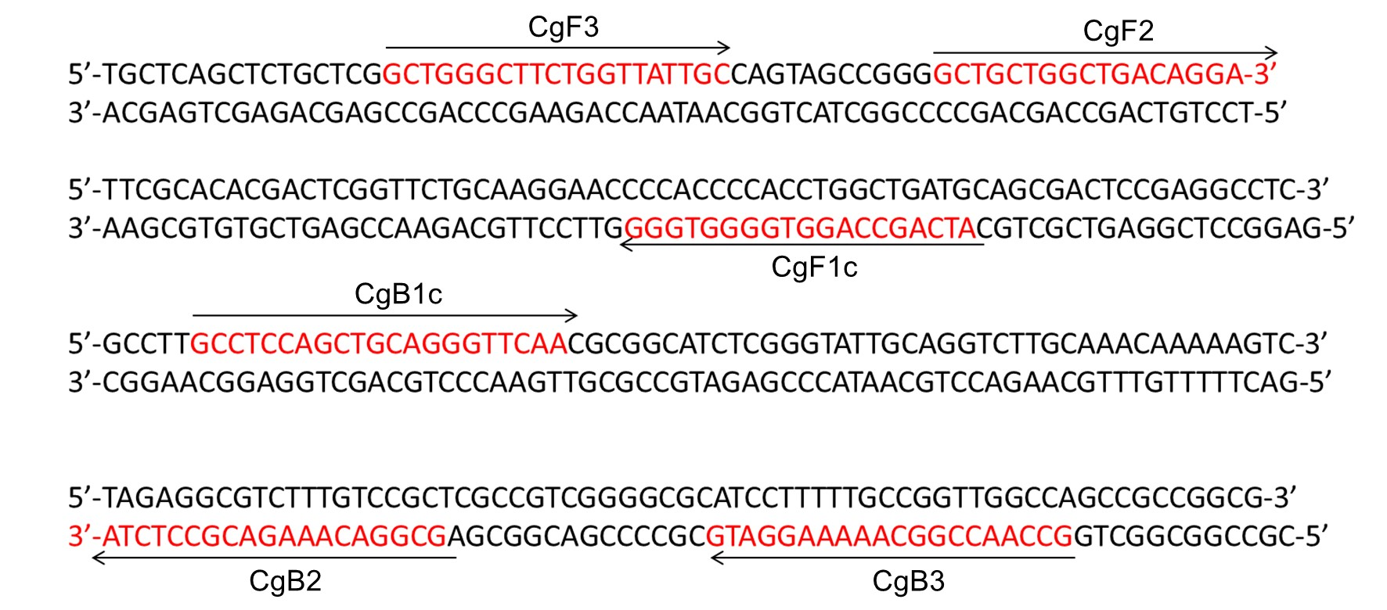Figure 2
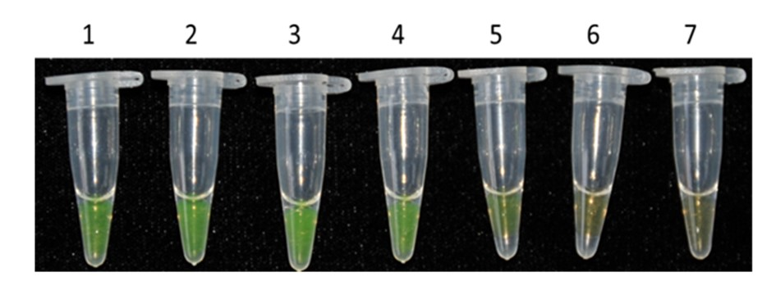

Figure 3
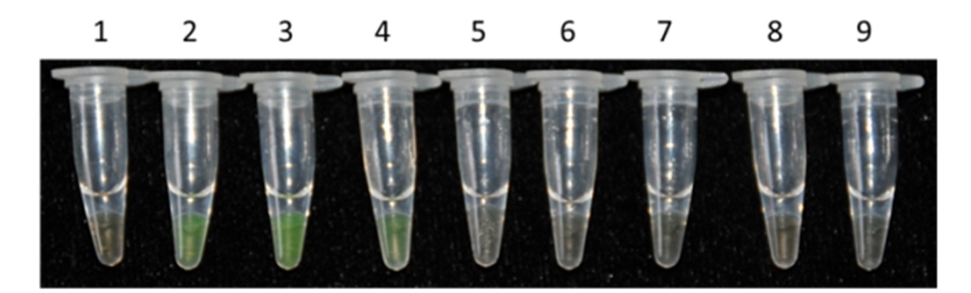

Figure 4
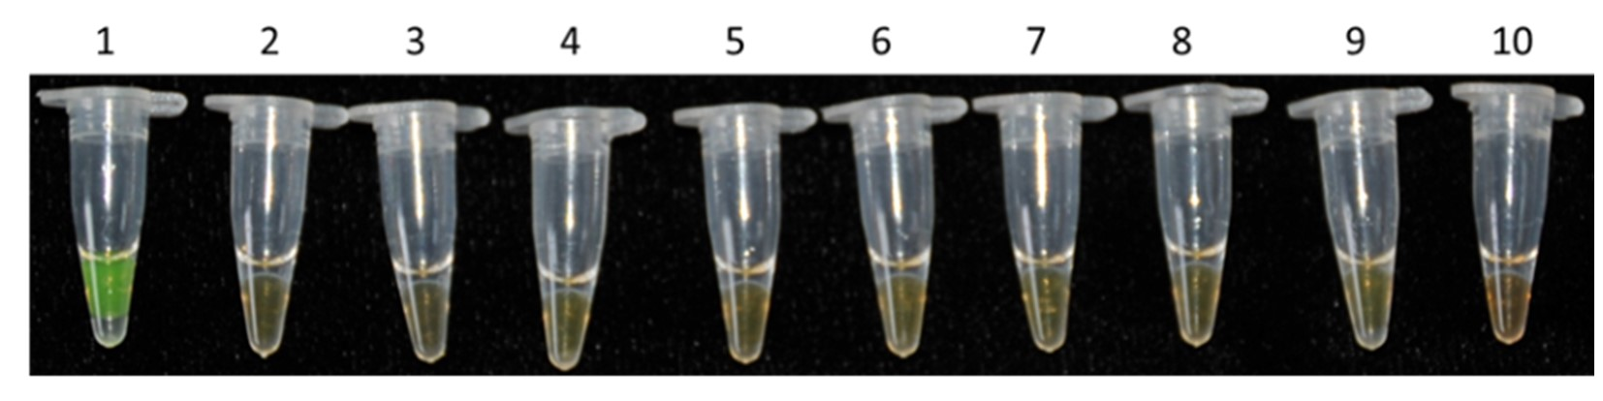
Figure 5
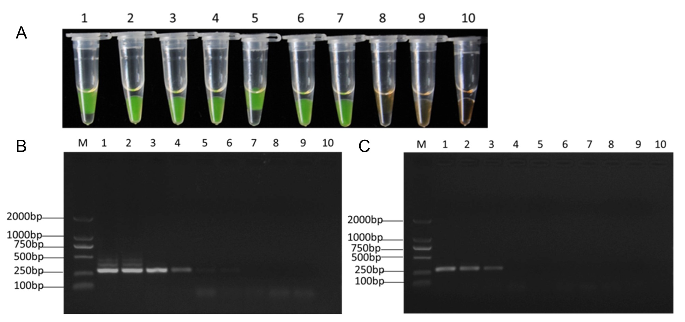

Figure 6
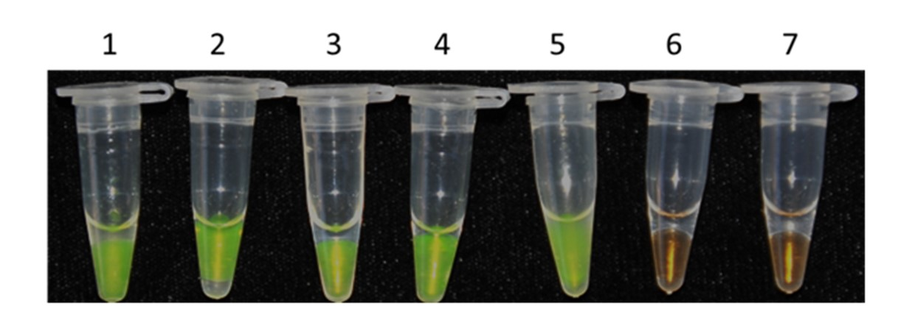

Figure 7
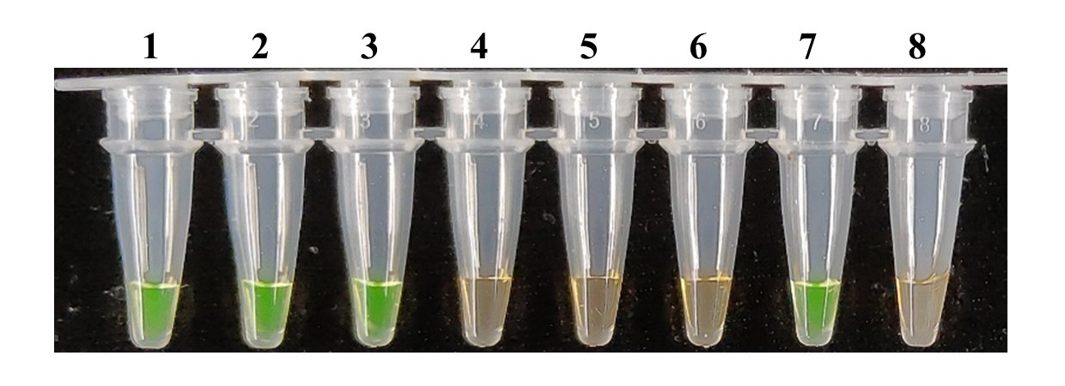
Figure 8


