RUNNING TITLE: IMPROVE GROWTH AND DEVELOPMENT OF PLANTS USING NANOPARTICLE
APPLICATIONS OF VARIOUS NANOPARTICLE TO IMPROVE GROWTH AND DEVELOPMENT IN DIFFERENT PLANTS: A REVIEW
Narmeen Ayesha ¹, Hina Nazir¹, Muhammad Mutie Un Nabi* ¹, Muhammad Raza ², Shoaib Ahmad^{3,} Qadar Khan ³, Usama Ahmad Khan ⁴, Ali Hassan⁵
- (Department of Botany, University of Agriculture, Faisalabad)
- (School of biochemistry and Biotechnology, University of the punjab)
- (Center for plant sciences and biodiversity, University of Swat)
- (Department of Botany, Ghazi University, City Campus, Dera Ghazi Khan)
- (Department of Plant Breeding and Genetics, University of Agriculture, Faisalabad)

NOVELTY STATEMENT:
Unleashing the future of agriculture with nanoparticles: where tiny particles make a big impact on plant growth and productivity. These result show that applications of various nanoparticle such as Aluminum, Aluminum oxides, Zinc, carbon nanotubes, silver, iron and iron oxides helps in improving plants growth and development and also show beneficial effect for reducing biotic and abiotic stress on plants.
ABSTRACT:
Nanotechnology is a highly sophisticated and fast advancing domain of scientific and technological research. The main focus of this field is to create new and unique nanomaterials by comprehending and manipulating matter at the nanoscale. Nanotechnology is a cutting-edge discipline of the 21st century. The majority of nano-materials are recognized for their ability to promote plant development. This work purportedly elucidates the crucial function of nanoparticles in plants. This review focuses on the impact of nanoparticles on the growth, blooming, and seed production of plants. Recent studies on the impact of nanoparticles on different plants crops have shown that they promote enhanced seed germination and growth.
Keywords: Nanotechnology, nanoparticles, transfer, agricultural industry, nutrients, growth, flowering

- INTRODUCTION:
Several scientific disciplines widely use the prefix nano to denote tiny things and processes. The terms included are nanoscience, nanotechnology, nanorobots, nanomagnets, nanoelectronics, nanoencapsulation, and others (Buzea et al., 2007). We use the prefix "nano" to refer to organisms or processes that are extremely small, often measuring nanometers.
Nanoscience is a scientific field that investigates the characteristics of matter at the nanoscale, with a specific emphasis on the distinct properties shown by solid-state materials due to their size (Mulvaney, 2015). Nanotechnology studies the creation, manipulation, and use of materials with sizes ranging from 1 to 100nm, known as nanomaterials (Hasan, 2015). Nanoparticles, as defined by the International Organisation for Standardisation (ISO), are nano-objects that have all their exterior dimensions at the nanoscale. If there is a large difference in size, usually more than three times, it may be more appropriate to use terms like nanofibers or nanoplates instead of the term NPs2. Nanoparticles (NPs) may exhibit many morphologies, and dimensions. They may have many shapes, like conical, spherical, tubular, spiral, hollow core, etc., or they can be irregular (Ealia and Saravanakumar, 2017). Nanoparticles (NPs) size from 1 to 100 nanometers. We often refer to nanoparticles (NPs) as atom clusters when their size drops to less than 1 nm. Nanoparticles (NPs) may exist in two forms: either as individual particles or as clusters of particles (Machado et al., 2015).
Nanoparticles (NPs) may either have a homogeneous structure or consist of several layers. In the latter scenario, the layers often consist of:
- The outermost layer is often composed of diverse tiny metal ions, molecules, polymers or surfactants.
- The layer consists of a chemically distinct substance from the core layer.
- The central component of the NP is referred to as the core layer, as described by Khan and Saeed (2019).

Properties of nanoparticles:
- Smaller size
- Having larger surface area
- Slow release
- Increased surface area to volume ratio
- Nanoparticles are extremely small, allowing them to easily penetrate plant and animal cells. This characteristic is critical for nanotechnologists to achieve targeted product delivery at the cellular level, giving nanotechnology an advantage over conventional methods.
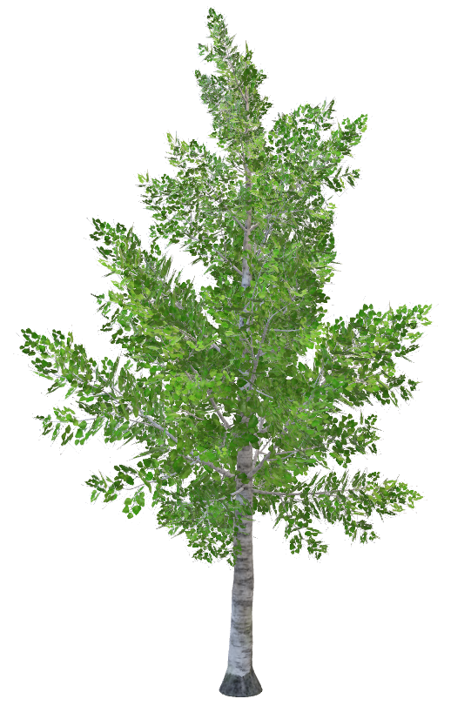
Nanoparticles possess a high specific surface area (SA) relative to their volume, resulting in a considerable number of atoms being located on their surfaces. This property improves nanoparticle reactivity. The increased surface area to volume ratio results in enhanced reactivity and improved ability to penetrate soil and plants (Tarafdar et al., 2015). see Figure 1.
Soil Applications
Energy routes of Soil-mixed NPs:
- Lenticles
- Root Hairs
- Exudates
- Mucilage
Foliar Application
Energy routes of aerosol NPs:
- Hydathodes
- Stomata
- Cuticle
- Lenticles

Phloem Transport
Biochemical Impacts:
- Lycopene
- Chlorophyll
- Biomass
Xylem Transport
Physiological Impacts:
- Flower development
- Stem development
- Root development
- Germination and Fruits development

Figure 1. The Impact of soil and foliar application on plants
- IMPACT OF NANOPARTICLES ON PLANTS:
Following are some Nanoparticles and their impact on the lants are mentioned below
  - ALUMINUM AND ALUMINUM OXIDES NANOPARTICLES:
Aluminium is the 3rd most abundant metal in the earth's crust, behind oxygen and silicon. Nevertheless, Al is not essential in biological systems, and so far, no scientific evidence has substantiated its role in any biological processes inside living creatures, which continues to be a biochemical mystery. Al interactions in soils are very complicated, and researchers still don't fully understand them. This could be because soils contain a wide range of organometallic and multinucleated complexes, as well as other ions (Chauhan et al., 2021). Aluminium in most soils is present in the form of non-toxic aluminium silicates and oxides. Roots of plant are showing to these forms of aluminium and do not experience any harmful effects (Buchanan et al., 2015). Nevertheless, as the soil pH drops below 5, it promotes the solubility of aluminium into monomeric forms such as AlOH²⁺, Al³⁺, AlOH²⁺, and AlOH⁴⁺. Out of these forms, the trivalent form (Al³⁺) has the greatest harmful effect on plant development and production. This is because it triggers several hazardous reactions associated with aluminium in most plants (Silva et al., 2020).
In recent decades, various studies have shown the impact of aluminium (Al) on the development and productivity of various plant species (Singh et al., 2017). In general, the majority of this research has documented the harmful effects of aluminium (Al) on plants and the mechanisms by which plants tolerate their toxicity (Fang et al., 2020). However, a small number of studies have also found positive effects of aluminium on plant development (Muhammad et al., 2019). In recent years, a number of crop species have demonstrated considerable genetic diversity in aluminium tolerance and unique sustainable methods. This is due to the significance cultivation of crop in acid soils in agriculture (Kochian et al., 2015).
  - ALUMINUM EFFECT ON PLANT GROWTH:
Plants that thrive in acidic soils, native species, and Al hyperaccumulators frequently exhibit the phenomenon of Al-induced plant growth enhancement (Sun et al., 2020). Obligate hyper-accumulators are plant species that only thrive on soils containing high concentrations of metals and are incapable of survival in the absence of a specific metal. On the other hand, facultative hyperaccumulators have the ability to develop and live in soils regardless of whether a certain metal is present or not. There aren't many plant species for which growth studies on Al have been done, so using these two groups to describe Al hyperaccumulators might not give clear results (Schmitt et al., 2016).
2.2 FOR BIOTIC AND ABIOTIC STRESS:
While Al has been shown to have positive effects on both biotic and abiotic stressors, studies on its favourable effects have mostly concentrated on stimulating plant growth and improving nutrient absorption. According to reports, Al helps plants become more resilient to biotic stressors like viruses and herbivores as well as abiotic stressors, including ion toxicity and nutrient shortages (Bojórquez-Quintal et al., 2017). It has been proposed that Aluminium buildup in leaf tissues creates a sensory barrier that prevents female insects from ovipositing, therefore lowering the number of grubs, even if the exact mechanism behind this defence reaction is unclear. In plant pathological investigations, Al inhibits the vegetative development and germination of blast rot pathogen (Thielaviopsis basicola Ferraris) spores. Similar to this, Al increased resistance to the pathogen that causes potato late blight (Phytophthora infestans) by preventing mycelia and sporangia growth and triggering defensive mechanisms in vulnerable potato plants (Arasimowicz-Jelonek et al., 2014). Localised ROS accumulation (H₂O₂) in roots and systemic activation of nitric oxide and salicylic acid-dependent pathways in leaves were characteristics of this protective mechanism. These showed correlations with protein activity and gene expression linked to pathogens (Arasimowicz-Jelonek et al., 2014). Yang et al. (2016) showed in hydroponic experiments that tea plants exposed to fluoride (F) had a growth inhibition effect on both shoots and roots; however, the addition of aluminium neutralised the toxicity of F by generating an Al-F complex, which in turn stimulated the development of tea plants. Furthermore, Al has been shown to enhance Phosphorus absorption in plants, and Phosphorus deficiency is a significant problem in acidic soils (Li et al., 2016a). The Al treatment increased the amount of Low-P-responsive proteins in the leaves of citrus (Citrus sinensis), and it also increased the expression of genes in maize that protect the plant from not getting enough inorganic P (Maron et al., 2008). These proteins include ribonucleases, phosphoenolpyruvate carboxylase, purple acid phosphatases, pyrophosphatases, and glycerophosphodiester phosphodiesterase. (Li et al., 2016).
  - ALUMINUM OXIDE:
The most significant impact on tobacco (Nicotiana tabacum) development of root and growth appeared to be a statistically significant reduction in root length as NP concentration rose. The average root length of tobacco seedlings three weeks’ old was dramatically reduced as the concentration of NPs increased. The number of leaves per seedling drastically decreased as the concentrations of NPs rose. 3 weeks old tobacco seedling leaves have adverse effects on their yield and development due to aluminium oxide nanoparticles. As exposure to NPs increased, the average biomass of three-week-old tobacco seedlings dropped. Al₂O₃ NPs adversely affect the growth and development of tobacco seedlings (Caitlin et al., 2012). When Triticum aestivum (wheat) was treated with 50 and 1000 mg/L of nano-scale alumina, it grew much longer. In the 200 and 500 mg/L treatment instances, the length of the roots was measured somewhat shorter than the control, but the roots' development seemed to be inhibited, and their absorption of aluminium exceeded that of the other doses. For every treatment, the percentage of germination of the seeds was almost 90%. Root lengths were somewhat shorter in the 200 and 500 mg/L treatments than in the control, but they were much longer in the presence of 50 or 1000 mg/L NPs. According to Ali et al. (2012), there was no discernible increase or decrease in shoot length or dry biomass as a result of nanoscale alumina.
- CARBON NANOTUBES:
Iijima made the inaugural discovery in the field of carbon nanotubes, or CNTs, using transmission electron microscopy. A range of beginning materials, including boron and molybdenum, can produce these two-dimensional, nanoscale nanotubes, but carbon yields the most functionally varied form of the material. Concentric graphite cylinders (CNTs) close at both ends due to the presence of five-membered rings. These nanotubes may be single-walled (SWNTs) with just the tubule and no graphite layers or multi-walled (MWNTs) with a core tubule of nanometric diameter encircled by graphite layers (Rao et al., 2004). More length-to-diameter ratios—up to 132,000,000:1—have been achieved in nanotube construction than in any other material. According to Harris & Harris (2009), the nanotubes have an outside diameter of around 2.5 to 30 nm and a length ranging from a few tens of nm to several μm. The remarkable features of these cylindrical carbon molecules are useful in the domains of material science and technology, electronics, optics, and nanotechnology. Various sectors have studied the use of carbon nanotubes in recent years. Devices such as conducting composites, electrodes, photovoltaic sensors, transistors, and supercapacitors utilize carbon nanotubes in the electrical sector.

3.1. EFFECT OF CNTS ON PLANTS GROWTH:
We assessed the effects of MWCNTs on germination and seedling growth in Brassica juncae and Phaseolus mungo. They both displayed 100% germinations, proving that MWCNTs are not dangerous (Mondal et al., 2011). According to Godake et al. (2010), B. Juncae seedlings exhibited a significant increase in vegetative biomass at various CNT concentrations, specifically a 1.5-fold increase at 20 µg/ml CNT concentration. Additionally, root length was inspired up to 138%, 202%, and 135% with CNT concentrations of 10µg/ml, 20µg/ml, and 40µg/ml, respectively. Figure 2 displays the applications of carbon nanotubes.

Figure 2. Application of Carbon Nanotubes
  - ZEA MAYS
The roots of Zea mays (Figure 3) differ depending on the kind of tissue. According to Yan et al. (2013), SWCNT treatment promotes the formation of seminal roots while inhibiting the growth of root hair. MWCNTs improve maize germination at low concentrations by enhancing water supply (Tiwari et al., 2014). Bean sprouts grow both stimulated and inhibited by CNTs at concentrations of 100 and 1200 µg/mL, respectively. Therefore, even at low concentrations, it is inhibitory in a dose-dependent manner while also changing the pH of water (Li et al., 2014). In Ficus carica, SWCNTs, at low concentrations increase root and stem length and growth (Flores et al., 2013).
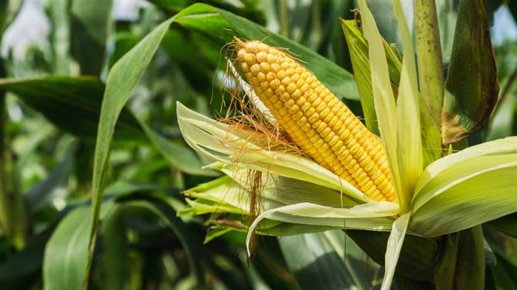
Figure 3. Corn (Zea mays)
  - BT-COTTON
Multi-walled carbon nanotubes (MWCNTs) help hybrid Bt-cotton Figure 4 seedlings grow both in the lab and in real life. While in vivo observations revealed a significant increase in plant height and number of leaves, along with a 2.8-fold increase in the number of bolls per plant and 1.85 a fold increase in boll size at a concentration of 100µg/ml, the seeds exposed to MWCNTs in vitro showed the highest root and shoot length at a concentration of 60µg/ml. These findings increased the yield of the Bt-cotton plant (Nalwade and Neharkar, 2013).
Figure 4. Genetically modified Bt-Cotton
  - CASTOR PLANT
MWCNTs maximum increased the percentage of seed germination in Ricinus communis L. (castor plant) (Figure 5) at doses of 50 and 100 µg/ml. Maximum values were observed for the length of the radical and seedling, number of rootlets, vigour of the seedlings, wet weight, and dry weight at a 100µg/ml concentration of MWCNTs (Fathi et al., 2017).
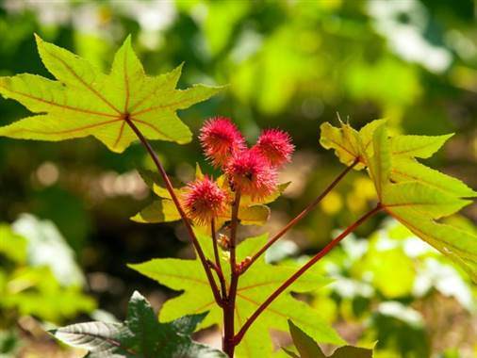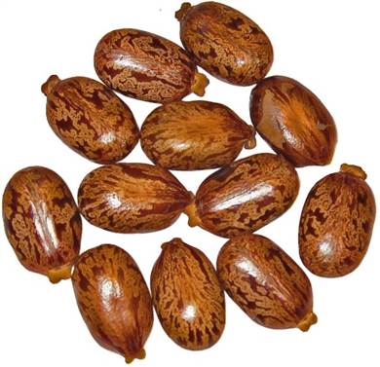
Figure 5. Castor plant and its seeds
  - ARABIDOPSIS THALIANA
Arabidopsis thaliana figure 6 mesophyll cells exhibited dual-phase regulation when exposed to single-walled carbon nanotubes. At concentrations of less than or equal to 50 µg/ml, SWCNTs induced the growth of trichome clusters on the surface of plant cells. But when SWCNTs are present in amounts higher than 50 µg/ml, they cause bad things to happen, like more reactive oxygen species (ROS) being made, green leaves turning yellow, protoplasts changing shape, and protoplast cells dying or necrosis (Yuan et al., 2011).
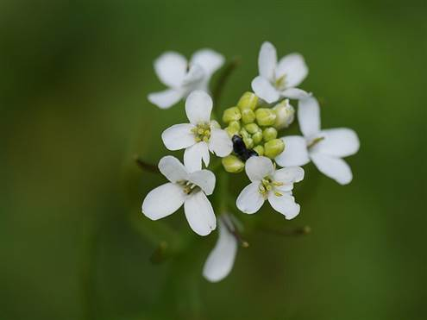
Figure 6. Arabidopsis thaliana
  - DODONAEA VISCOSA
When exposed to multi-walled carbon nanotubes (MWCNTs), Dodonaea viscosa L., also known as hopbush. Multi-walled carbon nanotubes (MWCNTs) had a big positive effect on seed germination and other growth traits when there was a lot of drought stress, as Yousefi et al. (2017) showed. Water extracts from calyces showed a significant rise in bioactive components. Unprocessed plants yielded a mere four bioactive chemicals (Al-Rekaby, 2018).
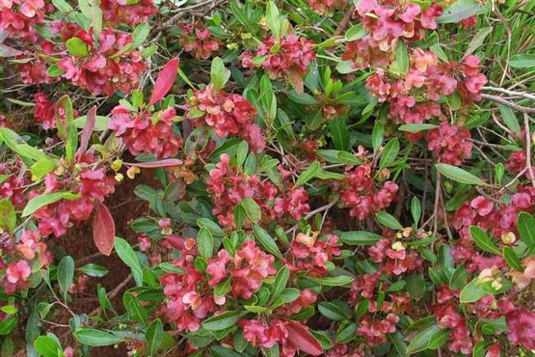
Figure 7. Hopbush (Dodonaea viscose)
- COPPER NANOPARTICLES:
Copper is ubiquitously present in plant tissues and serves as an essential element for development, playing a crucial role in several physiological processes (Chibber et al., 2013) According to reports, the average amount of copper (Cu) found in 1 kilogramme of dry plant tissue is roughly 10 milligrammes. While it has had a transformative impact on several sectors, it has also had harmful impacts on biological organisms. However, this feature also indicates that Cu may be potentially hazardous. Cu ions have the ability to catalyse the creation of free radicals (Ivask et al., 2010), generate oxidative stress (Valko et al., 2005), and transform them into genotoxic compounds (Ahamed et al., 2010). Cu nanoparticles exhibit a brownish-black powder form and undergo reduction upon exposure to hydrogen or carbon monoxide. This reduction process poses risks to human health and is harmful to aquatic organisms.
  - WHEAT
Low amounts of CuO NP solution helped wheat grow and produce more in soil, hydroponic, and in vitro systems (Yasmeen et al., 2018). Ibrahim et al. (2022) observed that the concentration of CuO NPs influenced the growth of wheat in vitro. In contrast, another study has shown that increased quantities of CuO may impede the development of wheat (Kacziba et al., 2023). When grown in soil, the presence of CuO NPs at a concentration of 50 mg/kg had no impact on the growth characteristics of wheat (Guan et al., 2020). Conversely, greater concentrations (10, 30, and 300 mg/kg) did demonstrate an inhibitory effect (Adams et al., 2017).
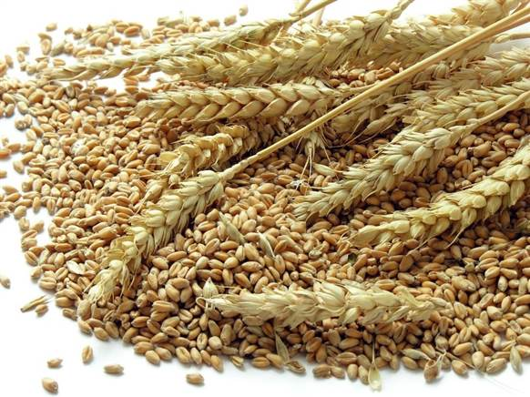
Figure 8. Wheat
  - BARLEY
The study by Kadri et al. (2022) showed that adding CuO NPs to in vitro growth tests made seed germination and seedling development better. Still, soil studies showed that higher levels of slightly smaller CuO NPs made plants grow much less quickly (Fedorenko et al., 2021). Joko et al. (2021) conducted a soil investigation and found that the presence of CuO NPs at a concentration of 300 mg/kg initially reduced barley biomass over a one-week period
4.3 LETTUCE
In a different study, spraying 20 mg of CuO NPs on L. sativa (Figure 9) plants increased their dry weight and number of leaves. Irrigating the plants with CuO NPs also increased the amount of macro- and microelements in their roots (Kohatsu et al., 2021). On the other hand, foliar spraying with higher concentrations of CuO NPs considerably reduced lettuce growth and altered its oxidative state (Xiong et al., 2021). To sum up, the concentration and method of application have an impact on how CuO NPs affect lettuce growth. This shows that CuO NPs have effects on the oxidative state and lettuce growth that depend on the concentration and method of application.
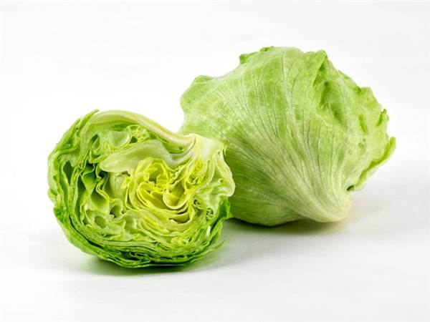
Figure 9. Lettuce (Lactuca sativa L.)
  - MUNG BEAN
The mung bean (Vigna radiata L.), according to the very few pieces of data that are currently available, seems to be relatively susceptible to exposure to CuO NP (Subpiramaniyam et al., 2021). Only at high concentrations did copper oxide nanoparticles limit shoot biomass, but they also promoted lipid peroxidation and lignification and inhibited root development across a broad range of concentrations in vitro (Gopalakrishnan Nair et al., 2014).
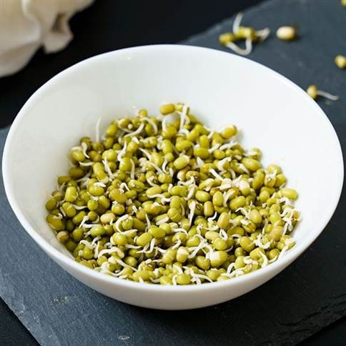
Figure 10. Mung bean (Vigna radiata L.)
  - CUCUMBER
In cucumber (Cucumis sativus L.), the CuO NP treatment significantly reduced root development and seed germination (Figure 11). In addition, compared to the control group, this therapy altered the pattern of protein expression (Moon et al., 2014). In the same way, CuO NPs stopped white mustard (Sinapis alba L.) seeds from germinating and then their roots from growing longer in a lab experiment (Landa et al., 2016). Furthermore, lucerne (Medicago sativa L.) plants cultivated hydroponically and treated with copper oxide nanoparticles exhibited a significant decrease in root elongation. Hong et al. (2015) observed an elevation in ascorbate peroxidase activity and a corresponding downregulation of catalase.
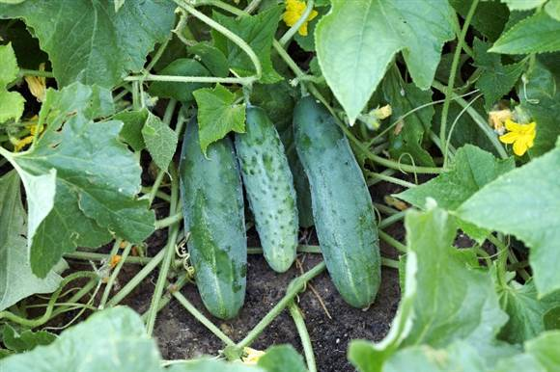
Figure 11. Cucumber (Cucumis sativus L.)
  - SOYBEAN
Research on the reaction of soybeans (Glycine max L.) to CuO NPs is scarce, and the available findings are inconsistent. CuO NP reduced soybean root development under hydroponic settings in a concentration- and exposure-time-dependent manner, causing oxidative stress and elevated Cu levels (Liu et al., 2021). An in vitro investigation of the filter paper showed that modest amounts of CuO exposure improved soybean root growth. However, the development of both roots and shoots was markedly reduced as the concentration rose (Adhikari et al., 2012).
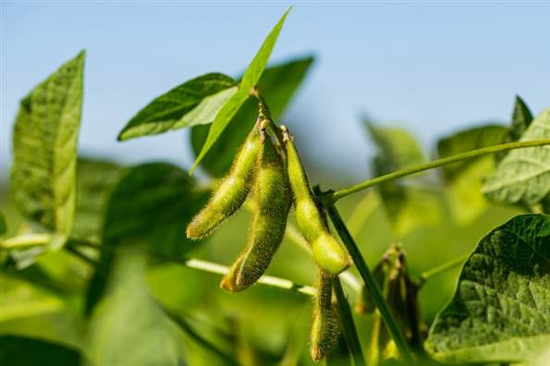
Figure 12. Soybean (Glycine max L.)
- ZINC OXIDES NANOPARTICLES:
Because of their special physical and chemical properties, zinc oxide nanoparticles, or ZnO-NPs, are one of the metal oxide nanomaterials and a useful and adaptable inorganic molecule. (Agnieszka and Jesionowski, 2014). Foods extensively produce and use zinc oxide nanoparticles, or ZnO-NPs, as a zinc nutrient in a variety of commercial and additive products, including batteries, ferrites, fire retardants, plastics, glass, ointments, lubricants, adhesives, sealants, pigments, and sunscreens (Eixenberger et al., 2017).
Notably, studies have shown that zinc is an essential mineral for all living organisms. The authors Nandhini et al. (2019) highlighted the advantages of zinc oxide nanoparticles (ZnO-NPs) for the germination and growth of pearl millet in addition to the increased activity of enzymes involved in plant defense, including lipoxygenase, phenylalanine, polyphenol oxidase, ammonia-lyase, and peroxidase. Furthermore, ZnO-NPs had a favourable effect on the generation of chlorophyll pigment from wheat and maize plants. Singh et al. studied how ZnO-NP improved the physical, nutritional, and quantitative features of wheat (Triticum aestivum L.) and maize (Zea mays L.). These also included the overall amount of protein, carbohydrates, and oil (Singh et al., 2018).
Fertiliser application rates are highly accumulating in worldwide agriculture to boost crop growth and productivity, particularly in food crops (Xiao et al., 2019). Numerous studies have shown that ZnO-NPs may boost food crop productivity, variety, and healthy growth. ZnO-NPs have been successfully proven and recommended for usage as a foliar fertiliser in addition to a soil Zn fertiliser by several studies (Singh et al., 2018). Because of their unique properties, ZnO-NPs have been suggested as an essential micronutrient and are meant to operate as a cofactor for the mobilisation and activation of nutritional enzymes (Raliya et al., 2015).
- IRON NANOPARTICLES:
Wheat (Triticum aestivum) showed a higher percentage of germination after soaking in iron nanoparticles and incubating in distilled water. When iron nanoparticles were used, the germination percentage increased after soaking, but the NPs had no effect on the incubation period. Soaking seeds in NPs and then incubating them in distilled water resulted in a significant decrease in root development; however, soaking seeds in distilled water and then incubating them in NPs solution led to an increase in root growth. Iron NPs significantly increased the development of the shoots after soaking them in NPs and incubating them in distilled water. Iron therapy led to an even greater rise in growth compared to the control. severe loss of vigour in seedlings when they are soaked in iron nanoparticles and kept in distilled water (Farhat et al., 2015).
- SILVER NANOPARTICLES:
AgNPs are unique and have a wide variety of uses, especially in plant biotechnology and agriculture. They have been shown to function as safe and efficient nanopesticides and fertilisers while also improving plant growth, photosynthetic efficiency, and seed germination. Their capacity to ward off dangerous microbes and provide a more secure and hygienic atmosphere makes them advantageous in these sectors (Khan et al., 2019). AgNPs demonstrate wastewater treatment and the use of electronic devices by acting as photochemical and excellent electric conductors. In agricultural settings, it promotes fungicides, plant development, and fruit ripening (Mahendran et al., 2019). Fertilisers are generally necessary to promote plant growth and development. Unfortunately, a number of processes, including photolysis, breakdown, hydrolysis, and leaching, prevent the majority of fertilisers from reaching plant bodies. Therefore, it is crucial to manipulate innovative nanomaterials and applications of nanotechnology in order to prevent the loss of nutrients during fertilisation and boost crop output. In addition to being beneficial for crops, nano-fertilisers—also referred to as nano-encapsulated nutrients—also have the ability to regulate the release of chemical fertilisers, release nutrients only when needed, manage plant development, and increase target activity (Salama et al., 2022).

  - FOR SEED GERMINATION:
In one of the most important stages of plant establishment in agriculture, seed germination is crucial to crop quality (Acharya et al., 2020). AgNPs have the ability to integrate with seed coats and aid in water absorption into seeds, thereby facilitating starch metabolism and germination. In order to improve starch metabolism and rice-aged seeds, it is also used as a nanopriming agent. One of AgNPs' priming objectives is to control the expression of aquaporin genes, which promote water and H₂O₂ diffusion. In order to improve rice-aged seed germination, AgNPs were synthesised in an environmentally friendly manner, utilising kaffir lime leaf extract as a nanopriming agent. When compared to traditional hydropriming, AgNO₃ priming, and unprimed control, the performance of seedling vigour and germination has been noticeably improved when photosynthesized AgNPs (5 and 10 ppm) are applied to rice-aged seeds. According to Mahakhham et al. (2017), nanopriming is also linked to increased α-amylase activity, which results in a larger soluble sugar content that supports the development of seedlings. We used Bacillus subtilis spizizenni to create the extracellular AgNPs. After applying 1 mM AgNPs, bajra (Pennisetum glaucum) seedlings showed remarkable results in terms of improved seed germination in only three days. A one-way variance statistical analysis revealed a significant improvement in plumule and radicle length compared to control Bajra seeds (Sable et al., 208). AgNPs were used in research to monitor salt stress in lentil seedlings. Exposure to AgNPs improved seedling development and lentil seed germination. Furthermore, at concentrations of 10 μg/mL AgNPs, the germination percentage for lentils rose, along with the mean germination time for lentil plants, germination characteristics, and drought tolerance. In drought-stressed circumstances, AgNPs administered at a concentration of 10 μg/mL were reported to increase lentil seed germination (Hojjat, 2016).
  - FOR PLANT GROWTH
Agriculture uses AgNPs as antiviral, antibacterial, and antifungal agents. It promotes plant growth and metabolism while extending the shelf life of fruits, leaves, flowers, and vegetables. Many parameters, including composition, particle size, concentration, functionalization, exposure duration, plant species, and many more, influence how different plants react to AgNP treatments. AgNPs at various concentrations (0, 5, 10, and 20 mg/L) were utilised in research. The administration of the new bio stimulants at a concentration of 5 mg/L improved root growth. (Guzman-B et al., 2021). Exogenous application of AgNPs impacted plant development in various ways. According to Mirzajani et al. (2013), Oryza sativa showed improved root development when treated with 30 μg/mL AgNPs; however, root growth was terminated at 60 μg/mL. An experimental investigation examined the impact of AgNPs on the mean germination times, rates, percentages, root lengths, and dry/fresh weight of seedlings of the 3 spices. We used various concentrations of AgNPs, including 0.05, 0.1, 0.5, 1, 1.5, 2, and 2.5 mg/L, to examine the germination of seeds. In terms of assessed growth characteristics and germination percentage, three species have shown different dose responses to AgNPs. AgNPs have increased germination rates (Almutairi and Alharbi, 2015).

- AUTHOR CONTRIBUTION STATEMENT

All authors contributed to the study's conception and design. Author Muhammad Mutie Un Nabi was responsible for creating the study and writing the protocol. Muhammad Mutie Un Nabi and Narmeen Ayesha handled the preparation of the materials, data collection, and analysis. Muhammad Mutie Un Nabi wrote the first draft of the manuscript, and Hina Nazir provided feedback on earlier iterations. Authors Muhammad Raza, Shoaib Ahmad, Qadar Khan the literature searches and contributed a lot to Strategies Portion. The final part of the manuscript is Hinder Hunger written by Usama Ahmad Khan and Qadar Khan. Ali Hassan was in charge of managing the references and citations. All authors read and approved the final manuscript.

- CONFLICT OF INTEREST STATEMENT
There is not a conflict of interest disclosed by the author. The paper has not been sent to another journal for publication.

- ETHICS APPROVAL
Not applicable

REFERENCES:

Acharya P, GK Jayaprakasha, KM Crosby, JL Jifon, BS Patil (2020). Nanoparticle-mediated seed priming improves germination, growth, yield, and quality of watermelons (Citrullus lanatus) at multi-locations in Texas, Sci. Rep. https://doi.org/10.1038/s41598-020-61696-7.
Adams J, M Wright, H Wagner, J Valiente, D Britt, A Anderson (2017). Cu from dissolution of CuO nanoparticles signals changes in root morphology. Plant Physiol Biochem. 110:108–117. doi: 10.1016/j.plaphy.2016.08.005.
Adhikari T, S Kundu, AK Biswas, JC Tarafdar, AS Rao (2012). Effect of copper oxide nano particle on seed germination of selected crops. J Agr Sci Technol. A. 2(6A):815.
Agnieszka KR, T Jesionowski (2014). Zinc Oxide—From Synthesis to Application: A Review. Materials 7, 2833–2881.
Ahamed M, MA Siddiqui, MJ Akhtar, I Ahmad, AB Pant, HA Alhadlaq (2010). Genotoxic potential of copper oxide nanoparticles in human lung epithelial cells. Biochemical and Biophysical Research Communications, 396, 578–583.
Ali RM, R Fatemeh, J Vahidreza (2012). Effects of alumina nanoparticles on morphological properties and antioxidant system of Triticum aestivum. Iranian J. of Plant Physiol. 3(1): 595-603.
Almutairi Z, A Alharbi (2015). Effect of silver nanoparticles on seed germination of crop plants, J. Adv. Agric. 4 280–285, https://doi.org/10.24297/jaa. v4i1.4295.
Al-Rekaby LS (2018). Influence of multiwalled carbon nanotubes and biostimulators on growth and content of bioactive constituents of karkade (Hibiscus sabdariffa L.). Journal of Botany 1: 1-11.
Arasimowicz-Jelonek M, J Floryszak-Wieczorek, K Drzewiecka, J Chmielowska-Bąk, D Abramowski, K Izbiańska (2014). Aluminum induces cross−resistance of potato to phytophthora infestans. Planta 239, 679–694. doi: 10.1007/S00425-013-2008-8
Bojórquez-Quintal E, C Escalante-Magaña, I Echevarría-Machado, M Martínez-Estévez (2017). Aluminum, a friend or foe of higher plants in acid soils. Front. Plant Sci. 8, 1767. doi: 10.3389/fpls.2017.01767
Buchanan BB, W Gruissem, RL Jones (2015). Biochemistry and molecular biology of plants (West Sussex, UK: John wiley & sons).
Buzea C, II Pacheco, K Robbie (2007). Nanomaterials and nanoparticles: sources and toxicity. Bio interphases. 2(4):MR17–71.
Caitlin EB, A Jordan, BM William, Z Baohong (2012). Effects of aluminum oxide nanoparticles on the growth, development, and microRNA expression of tobacco (Nicotiana tabacum). PLoS One, 2012; 7(5): e34783.
Chauhan DK, V Yadav, M Vaculik, W Gassmann, S Pike, N Arif (2021). Aluminum toxicity and aluminum stress-induced physiological tolerance responses in higher plants. Crit. Rev. Biotechnol. 41, 715–730. doi: 10.1080/07388551.2021.1874282
Chibber S, SA Ansari, R Satar (2013). New vision to CuO, ZnO, and TiO₂ nanoparticles: their outcome and effects. Journal of Nanoparticle Research, 15, 1–13.
Ealia SAM, MP Saravanakumar (2017). A review on the classification, Characterisation, synthesis of nanoparticles and their application. In: IOP Conference Series: Materials Science and Engineering. IOP. p. 32019.
Eixenberger JE, CB Anders, RJ Hermann, RJ Brown, KM Reddy, A Punnoose, DG Wingett, (2017). Rapid Dissolution of ZnO Nanoparticles Induced by Biological Buffers Significantly Impacts Cytotoxicity. Chem. Res. Toxicol. 30, 1641–1651.
Fang K, P Xie, Q Zhang, Y Xing, Q Cao, L Qin (2020). Aluminum toxicity-induced pollen tube growth inhibition in apple (Malus domestica) is mediated by interrupting calcium dynamics and modification of cell wall components. Environ. Exp. Bot. 171, 103928. doi: 10.1016/j.envexpbot.2019.103928
Farhat Y, R Abdul, MN Iqbal, MZ Hafiz (2015). Effect of silver, copper and iron nanoparticles on wheat germination. Int J Biosci. 6(4): 112–117.
Fathi Z, RAK Nejad, H Mahmood Zadeh, TN Satari (2017). Investigating of a wide range of concentrations of multi-walled carbon nanotubes on germination and growth of castor seeds (Ricinus communis L.). Journal of Plant Protection Research.
Fedorenko AG, TM Minkina, NP Chernikova, GM Fedorenko, SS Mandzhieva, VD Rajput, AV Soldatov (2021). The toxic effect of CuO of different dispersion degrees on the structure and ultrastructure of spring barley cells (Hordeum sativum distichum). Environ Geochem Health. 43:1673–1687. doi:10.1007/s10653-020-00530-5.
Flores D, JS Chaves, R Chacón, A Schmidt (2013). A novel technique using SWCNTs to enhanced development and root growth of fig plants (Ficus carica). In: Technical Proceedings of the NSTI Nanotechnology Conference and Expo (NSTI Nanotech’13. 3: 167-170.
Ghodake G, YD Seo, D Park, DS Lee (2010). Phytotoxicity of carbon nanotubes assessed by Brassica juncea and Phaseolus mungo. Journal of Nanoelectronics and Optoelectronics 5(2): 157-160.
Gopalakrishnan Nair PM, SH Kim, IM Chung (2014). Copper oxide nanoparticle toxicity in mung bean (Vigna radiata L.) seedlings: physiological and molecular level responses of in vitro grown plants. Acta Physiol Plant. 36:2947–2958. doi:10.1007/s11738-014-1667-9.
Guan X, X Gao, A Avellan, E Spielman-Sun, J Xu, S Laughton, GV Lowry (2020). CuO nanoparticles alter the rhizospheric bacterial community and local nitrogen cycling for wheat grown in a calcareous soil. Environ Sci Technol. 54(14):8699–8709. doi: 10.1021/acs.est.0c00036.
Guzman-B ´ aez GA, ´ LI Trejo-T´ellez, SM Ramírez-Olvera, J Salinas-Ruíz, JJ Bello-Bello, G Alc´ antar-Gonz´ alez, JV Hidalgo-Contreras, FC Gomez-Merino (2021) ´ Silver nanoparticles increase nitrogen, phosphorus, and potassium concentrations in leaves and stimulate root length and number of roots in tomato seedlings in a hormetic manner, Dose Response 1–15, https://doi.org/10.1177/15593258211044576.
Harris PJ, PJF Harris (2009). Carbon Nanotube Science: Synthesis, Properties and Applications. Cambridge university press.
Hasan S (2015). A review on nanoparticles: their synthesis and types. Res J Recent Sci. 2277:2502.
Hojjat SSS (2016). The Effect of silver nanoparticle on lentil Seed Germination under drought stress, Int. J. Farming Allied Sci. 208–212.
Hong J, CM Rico, L Zhao, AS Adeleye, AA Keller, JR Peralta-Videa, JL Gardea-Torresdey (2015). Toxic effects of copper-based nanoparticles or compounds to lettuce (Lactuca sativa) and alfalfa (Medicago sativa). Env Sci: Proc Impacts. 17(1):177–185. doi:10.1039/C4EM00551A.
Ibrahim AS, GA Ali, A Hassanein, AM Attia, ER Marzouk (2022). Toxicity and uptake of CuO nanoparticles: evaluation of an emerging nanofertilizer on wheat (Triticum aestivum L.) plant. Sustainability. 14(9):4914. doi:10.3390/su14094914.
Ivask A, O Bondarenko, N Jepihhina, A Kahru (2010). Profiling of the reactive oxygen species related ecotoxicity of CuO, ZnO, TiO2, silver and fullerene nanoparticles using a set of recombinant luminescent Escherichia coli strains: differentiating the impact of particles and solubilised metals. Analytical and Bioanalytical Chemistry, 398, 701–716.
Jośko I, M Kusiak, B Xing, P Oleszczuk (2021). Combined effect of nano-CuO and nano-ZnO in plant-related system: from bioavailability in soil to transcriptional regulation of metal homeostasis in barley. J Hazard Mater. 416:126230. doi: 10.1016/j.jhazmat.2021.126230.
Kacziba B, A Szierer, E Mészáros, A Rónavári, Z Kónya, G Feigl (2023). Exploration the homeostasis of signaling molecules in monocotyledonous crops with different CuO nanoparticle tolerance. Plant Stress. 7:100145. doi: 10.1016/j.stress.2023.100145.
Kadri O, I Karmous, O Kharbech, H Arfaoui, A Chaoui (2022). Cu and CuO nanoparticles affected the germination and the growth of barley (Hordeum vulgare L.) seedling. Bull Environ Contam Toxicol. 108(3):585–593. doi:10.1007/s00128-021-03425-y.
Khan AU, M Khan, MM Khan (2019) Antifungal and antibacterial assay by silver nanoparticles synthesized from aqueous leaf extract of Trigonella foenumgraecum, Bio nanoscience 9 597–602, https://doi.org/10.1007/s12668-019-00643-x.
Khan I, K Saeed, I Khan (2019). Nanoparticles: properties, applications and toxicities. Arab J Chem. 12(7):908–31.
Kochian LV, MA Piñeros, J Liu, JV Magalhaes (2015). Plant adaptation to acid soils: the molecular basis for crop aluminum resistance. Annu. Rev. Plant Biol. 66, 571–598. doi: 10.1146/annurev-arplant-043014-114822
Kohatsu MY, MT Pelegrino, LR Monteiro, BM Freire, RM Pereira, P Fincheira, CN Lange (2021). Comparison of foliar spray and soil irrigation of biogenic CuO nanoparticles (NPs) on elemental uptake and accumulation in lettuce. Env Sci Pollut Res. 28:16350–16367. doi:10.1007/s11356-020-12169-x.
Landa P, T Cyrusova, J Jerabkova, O Drabek, T Vanek, R Podlipna (2016). Effect of metal oxides on plant germination: phytotoxicity of nanoparticles, bulk materials, and metal ions. Water Air Soil Pollut. 227:1–10. doi:10.1007/s11270-016-3156-9.
Li X, Y Li, M Qu, H Xiao, Y Feng, J Liu (2016). Cell wall pectin and its methyl-esterification in transition zone determine Al resistance in cultivars of pea (Pisum sativum). Front. Plant Sci. 7, 39. doi: 10.3389/fpls.2016.00039
Li X, Z Zhou, D Lu, X Dong, M Xu, L Wei, Y Zhang (2014). The effect of pristine carbon-based nanomaterial on the growth of green gram sprouts and pH of water. Nanoscale Research Letters 9: 1-6.
Liu C, Y Yu, H Liu, H Xin (2021). Effect of different copper oxide particles on cell division and related genes of soybean roots. Plant Physiol Biochem. 163:205–214. doi: 10.1016/j.plaphy.2021.03.051.
Machado S, JG Pacheco, HPA Nouws, JT Albergaria, C Delerue-Matos (2015). Characterization of green zero-valent iron nanoparticles produced with tree leaf extracts. Sci Total Environ. 533:76–81.
Mahakham W, AK Sarmah, S Maensiri, P Theerakulpisut (2017). Nanopriming technology for enhancing germination and starch metabolism of aged rice seeds using photosynthesized silver nanoparticles, Sci. Rep. 7 1–21, https://doi.org/10.1038/s41598-017-08669-5.
Mahendran D, N Geetha, P Venkatachalam (2019). Role of silver nitrate and silver nanoparticles on tissue culture medium and enhanced the plant growth and development, in: Vitr. Plant Breed. Towar. Nov. Agron. Trait. Biot. Abiotic Stress Toler., Springer Singapore, pp. 59–74, https://doi.org/10.1007/978- 981-32-9824-8_4.
Maron LG, M Kirst, C Mao, MJ Milner, M Menossi, LV Kochian (2008). Transcriptional profiling of aluminum toxicity and tolerance responses in maize roots. New Phytol. 179, 116–128. doi: 10.1111/j.1469-8137.2008. 02440.x
Mirzajani F, H Askari, S Hamzelou, M Farzaneh, A Ghassempour (2013). Effect of silver nanoparticles on Oryza sativa L. And its rhizosphere bacteria, Ecotoxicol. Environ. Saf. 88 48–54, https://doi.org/10.1016/j.ecoenv.2012.10.018.
Mondal A, R Basu, S Das, P Nandy (2011). Beneficial role of carbon nanotubes on mustard plant growth: an agricultural prospect. Journal of Nanoparticle Research 13: 4519-4528.
Moon YS, ES Park, TO Kim, HS Lee, SE Lee (2014). SELDI-TOF MS-based discovery of a biomarker in Cucumis sativus seeds exposed to CuO nanoparticles. Environ Toxicol Pharmacol. 38(3):922–931. doi: 10.1016/j.etap.2014.10.002.
Muhammad N, G Zvobgo, GP Zhang (2019). A review: The beneficial effects and possible mechanisms of aluminum on plant growth in acidic soil. J. Integr. Agric. 18, 1518–1528. doi: 10.1016/S2095-3119(18)61991-4
Mulvaney P (2015). Nanoscience vs nanotechnology—defning the field. ACS Nano. https://doi.org/10.1021/acsnano.5b01418.
Nalwade AR, SB Neharkar (2013). Carbon nanotubes enhance the growth and yield of hybrid Bt cotton Var. ACH-177-2. International Journal of Advanced Science and Technology 3: 840-846.
Nandhini M, S Rajini, A Udayashankar, S Niranjana, OS Lund, H Shetty, H Prakash (2019). Biofabricated Zinc Oxide Nanoparticles as an Eco-Friendly Alternative for Growth Promotion and Management of Downy Mildew of Pearl Millet. Crop. Prot. 2019, 121, 103–112.
Raliya R, R Nair, S Chavalmane, WN Wang, P Biswas (2015). Mechanistic Evaluation of Translocation and Physiological Impact of Titanium Dioxide and Zinc Oxide Nanoparticles on the Tomato (Solanum lycopersicum L.) Plant. Metallomics 7, 1584–1594.
Rao CN, A Müller, K Cheetham (2004). The Chemistry of Nanomaterials: Synthesis, Properties and Applications. Weinheim: Wiley-VCH Verlag, GmbH and Co., KGaA.
Sable SV, S Ranade, S Joshi (2018). Role of AgNPs in the enhancement of seed germination and its effect on plumule and radicle length of Pennisetum glaucum, IET Nanobiotechnol. 12 922–926, https://doi.org/10.1049/iet-nbt.2017.0304.
Salama DM, ME Abd El-Aziz, EA Shaaban, SA Osman, MS Abd El-Wahed (2022). The impact of nanofertilizer on agro-morphological criteria, yield, and genomic stability of common bean (Phaseolus vulgaris L.), Sci. Rep. 12 1–15, https://doi.org/10.1038/s41598-022-21834-9.
Schmitt M, T Watanabe, S Jansen (2016). The effects of aluminum on plant growth in a temperate and deciduous aluminum accumulating species. AoB Plants 8, plw065. doi: 10.1093/AOBPLA/PLW065
Silva TF, BG Ferreira, RMD Isaias, SS Alexandre, MGC Franca (2020). Immunocytochemistry and density functional theory evidence the competition of aluminum and calcium for pectin binding in urochloa decumbens roots. Plant Physiol. Biochem. 153, 64–71. doi: 10.1016/j.plaphy.2020.05.015
Singh A, NB Singh, S Afzal, T Singh, I Hussain (2018). Zinc Oxide Nanoparticles: A Review of Their Biological Synthesis, Antimicrobial Activity, Uptake, Translocation and Biotransformation in Plants. J. Mater. Sci. 53, 185–201.
Singh S, DK Tripathi, S Singh, S Sharma, NK Dubey, DK Chauhan (2017). Toxicity of aluminum on various levels of plant cells and organism: a review. Environ. Exp. Bot. 137, 177–193. doi: 10.1016/j.envexpbot.2017.01.005
Subpiramaniyam S, SC Hong, PI Yi, SH Jang, JM Suh, ES Jung, LH Cho (2021). Influence of sawdust addition on the toxic effects of cadmium and copper oxide nanoparticles on Vigna radiata seeds. Environ Pollut. 289:117311. doi: 10.1016/j.envpol.2021.117311.
Sun LL, MS Zhang, XM Liu, QZ Mao, C Shi, LV Kochian (2020). Aluminum is essential for root growth and development of tea plants (Camellia sinensis). J. Integr. Plant Biol. 62, 984–997. doi: 10.1111/jipb.12942
Tarafdar JC (2015). “Nanotechnology in soil science”. Soil Science: An Introduction., Chapter: Nanotechnology in Soil Science 775-807
Tiwari DK, N Dasgupta-Schubert, LM Villaseñor Cendejas, J Villegas, L Carreto Montoya, SE Borjas García (2014). Interfacing carbon nanotubes (CNT) with plants: enhancement of growth, water and ionic nutrient uptake in maize (Zea mays) and implications for nanoagriculture. Applied Nanoscience 4: 577-591.
Valko M, H Morris, MT Cronin, (2005). Metals, toxicity and oxidative stress. Current Medicinal Chemistry, 12, 1161–1208.
Xiao L, S Wang, D Yang, Z Zou, J Li (2019). Physiological Effects of MgO and ZnO Nanoparticles on the Citrus Maxima. J. Wuhan Univ. Technol. 34, 243–253.
Xiong T, T Zhang, Y Xian, Z Kang, S Zhang, C Dumat, S Li (2021). Foliar uptake, biotransformation, and impact of CuO nanoparticles in Lactuca sativa L. var. ramose Hort. Environ Geochem Health. 43:423–439. doi:10.1007/s10653-020-00734-9.
Yan S, L Zhao, H Li, Q Zhang, J Tan, M Huang, S He, L Li (2013). Single-walled carbon nanotubes selectively influence maize root tissue development accompanied by the change in the related gene expression. Journal of Hazardous Materials 246: 110-118.
Yasmeen F, NI Raja, N Ilyas, S Komatsu (2018). Quantitative proteomic analysis of shoot in stress tolerant wheat varieties on copper nanoparticle exposure. Pl Mol Bio Rep. 36:326–340. doi:10.1007/s11105-018-1082-2.
Yousefi S, D Kartoolinejad, R Naghdi (2017). Effects of priming with multi-walled carbon nanotubes on seed physiological characteristics of Hopbush (Dodonaea viscosa L.) under drought stress. International Journal of Environmental Studies 74(4): 528-539.
Yuan H, S Hu, P Huang, H Song, K Wang, J Ruan, R He, D Cui (2011). Single walled carbon nanotubes exhibit dual-phase regulation to exposed Arabidopsis mesophyll cells. Nanoscale Res Letters 6: 1-9.

