Study Theory of Reasoned Action (TRA) On The Intention Of Consuming Organic Vegetables (Study Case In The Bengkulu Province, Indonesia)

Ridha Rizki Novanda
¹Department of Socio-Economic Agriculture, Faculty of Agriculture, University of Bengkulu, Bengkulu, Indonesia

Abstract
People are motivated to eat organic rather than non-organic vegetables by the growing trend of healthy living. This is because organic crops are considered better for consumption because they do not contain as much pesticide residue as non-organic crops. Therefore, the opportunity to establish an organic vegetable business in the city of Bengkulu has excellent potential. In this regard, it is essential to analyze how the intention to consume organic vegetables in Bengkulu city. The study of the intention to consume organic vegetables in Bengkulu city can be related to the reaction action theory. This study aims to identify the factors that influence the intention to consume organic vegetables in the city of Bengkulu using the Theory Of Reasoned Action. This study was conducted in January 2020 and took place in Bengkulu Region. This research involved 100 respondents who were chosen using an unintended form of sampling. The number of respondents selected as many as 100 individuals; this number follows the needs of the research method. In order to examine the factors that affect the intention to consume organic vegetables, this research uses reaction-action theory. The analysis method used is partial Least Square with the help of the PLS 3 Pro smart software. Based on the research results, it was found that attitude and subjective norms had a significant effect on the formation of an intention to consume organic vegetables. Respondents agree that attitudes can affect the intention to consume organic vegetables with a P-Value of 0.000. Meanwhile, the subjective norm affects the intention to consume organic vegetables with a P-Value of 0.016. The results of this study indicate that the TRA study strongly supports research involving intentions.
Keywords: Intention, Organic, Vegetable, Theory of Reasoned Action
JEL Classification: L26

INTRODUCTION
People are motivated to eat organic rather than non-organic vegetables by the growing trend of healthy living. This is because organic crops are considered better for consumption because they do not contain as much pesticide residue as non-organic crops. Organic vegetables are healthy products for consumption and are friendly to the environment because organic vegetables do not use chemicals in their cultivation (Alamsyah, 2018). In addition to taste, it is often said that organic vegetables have higher levels of antioxidants, vitamin C, iron, and zinc than non-organic vegetables. Organic vegetables are about the same as non-organic vegetables, but the application of fertilizer is the difference. Since organic vegetables have important ingredients that are safe and do not affect the environment, they can thus produce balanced, highly nutritious foods.
Awareness of the dangers posed by synthetic chemicals in agriculture has made organic farming attracting attention at both the producer and consumer levels. Indonesian people realize the importance of living healthy by consuming organic vegetables (Priambodo & Najib, 2016). Most consumers will choose food safe for health and environmentally friendly, thus encouraging increased demand for organic products (Khorniawati, 2014; Priastuti, Suroso, & Najib, 2016). This healthy lifestyle requires assurance that agricultural products must-have attributes that are safe for consumption, high in nutrition, and environmentally friendly. Another important finding is that the determinants of organic vegetable purchases among customers are the positive attitude towards organic goods, safety, health, environmental issues, and the degree of confidence in organic characteristics (Slamet, Nakayasu, & Bai, 2016). While consumers emphasize the importance of health values, they are mostly unaware of the agrochemical risks associated with vegetable consumption. organic vegetables are the best solution (Probst, Aigelsperger, & Hauser, 2010; Probst, Houedjofonon, Ayerakwa, & Haas, 2012).
Some people choose organic vegetables in their food components for various reasons. However, the primary motivation for consumers to choose organic products is the impact of organic products on health (Devi & Hartono, 2016; Suardika, Ambarawati, & Sukaatmadja, 2014). The willingness of consumers to pay high prices for healthy vegetables is positively affected by family income, familiarity, differential cognition, knowledge of safety, nutritional health, packaging, confidence in labels and online shopping experience, but spending on family food, price levels, volatility in prices (Zhang et al., 2018). In addition, consumers are now interested in buying more environmentally friendly plants in containers (Iqbal, 2015; Yue et al., 2011).
Similarly, the town of Bengkulu, where the healthy living movement has also started to reach the city of Bengkulu. The growing interest in buying organic vegetables has resulted in the increasing business of organic vegetables in Bengkulu. This condition is supported by creating organic communities that focus on obtaining organic vegetables for their lives. The opportunity to establish an organic vegetable business in the city of Bengkulu has excellent potential. In order to increase the supply of organic vegetables, it is necessary to increase access to organic vegetables. Access to organic food is an important determinant of the probability of a household buying organic food (Dimitri & Dettmann, 2012).
In this regard, it is essential to analyze how the intention to consume organic vegetables in Bengkulu city. Fishbein & Ajzen (1975) proposed the concept of intention, which defines a person's subjective possibility to perform a particular behavior. Thus, the individual's intention to do something is a function of the attitude towards the embodiment of behavior and norms that influence the manifestation of behavior. So that the study of the intention to consume organic vegetables in Bengkulu city can be related to the reaction action theory.
Theory of Reasoned Action is a theory that explains human behavior. This theory is structured using the basic assumption that humans consciously and consider all available information (Mahyarni, 2013). This theory provides a model that has potential benefits for predicting intention to consume organic vegetables based on individual normative and attitude beliefs (Southey, 2011). In the activation of attitudes and actions, the reasoned action perspective is consistent with evidence for automatic processes and the finding that attitudes will differ with the context in which they are expressed (Ajzen & Fishbein, 2000). A key application of the theory of reasoned action is behavioral intention prediction, which includes both attitude and behavior prediction. The subsequent separation of behavioral intention from behavior allows for the limiting factor on the influence of attitude (Ajzen, I., & Fishbein, 1980). In the TRA application, the intention to behave measures the relative strength of a person's intention to perform a behavior. Attitude consists of beliefs about the consequences of performing the behavior multiplied by the assessment of those consequences. Subjective norms are seen as a combination of the perceived expectations of the relevant individual or group to fulfill these expectations (Hosseini, Gharlipour Gharghani, Mansoori, Aghamolaei, & Mohammadi Nasrabadi, 2015).
Reasoned action theory (TRA) shows that attitude and subjective norms are essential for persuasive communication. This study assesses how to apply TRA, its construction, and other relevant factors to predict behavioral intentions and beliefs and change behavioral tendencies (Nguyen et al., 2018). According to Mahyarni (2013), the Theory Of Reasoned Action is a theory that explains human behavior. This theory is structured using the basic assumption that humans behave consciously and consider all available information. Reasoned action theory (Ajzen, 2011) provides a model that has potential benefits for predicting intentions to perform behavior based on individual attitudinal and normative beliefs. Two elements of reasoned action data can be described using the principle of structural equation modeling: structural components that link theoretical variables to each other and components of measurement that describe theoretical constructs. In addition, a three-step analytical approach is described: analyzing the proximal determinants of intention to conduct a behavior, analyzing the underlying beliefs, and performing segmentation analysis for purposes of intervention design (Bleakley & Hennessy, 2012). Finally, this study identifies problems when effect and causal indicators are present in one analysis and concludes that the two types of indicators can be combined in data analysis based on a reasoned approach to action.
Based on the description above, the purpose of this study is to identify the factors that influence the intention to consume organic vegetables in the city of Bengkulu using the Theory Of Reasoned Action. Theory Of Reasoned Action can be an appropriate analytical tool in this research. so that it can accurately identify the factors that influence the consumption of organic vegetables in the city of Bengkulu

RESEARCH METHOD
This study was conducted in January 2020 and took place in Bengkulu Region. This research involved 100 respondents who were chosen using an unintended form of sampling. Therefore, as many as 100 individuals were selected by the number of respondents; this number follows the needs of the research method. In order to examine the factors that affect the intention to consume organic vegetables, this research uses reaction-action theory.
The analysis method used is partial Least Square with the help of the PLS 3 Pro smart software. Partial Least Square (PLS) is a powerful analysis method because of the lack of dependence on measurement scales (e.g., measurements requiring interval or ratio scales), sample size, and distribution of residuals. Reflexive or formative types can form indicators on PLS. (Sholiha & Salamah, 2015), model evaluation in PLS includes two stages, namely evaluation of measurement models and evaluation of structural models.
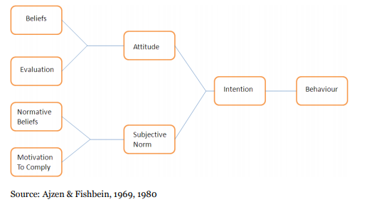

Figure 1. TRA model

Figure 1. TRA Model
Hypothesis
Based on this, the hypotheses formulated in the TRA are:
H1: Attitude has a significant effect on The Intention Of Consuming Organic Vegetables In The Bengkulu City
H2: Subjective norm has a significant effect on The Intention Of Consuming Organic Vegetables In The Bengkulu City

In this study, PLS was conducted to confirm the planned Theory of Reasoned Action to analyze The Intention Of Consuming Organic Vegetables In The Bengkulu City. The following describes the parameters that will be tested in this study:

Table 1. An explanation for the PLS model
Latent Variable | Manifest Variable
- ATB  (Attitude toward the behavior) | ATB₁  ATB₂  ATB₃  ATB₄  ATB₅  ATB₆  ATB₇  ATB₈  ATB₉ | Freshness of vegetables  Quality  Price  Size  Lifestyle  Taste  Health  Cleanliness  Belief
- SN  (Subjective norm) | SN₁  SN₂  SN₃ | Children Hope  Relative Hope  The expectations of the life partner
- I  (The Intention Of Consuming Organic Vegetables In The Bengkulu City) | I₁  I₂  I₃ | The Intention Of Consuming Organic Vegetables every day  The Intention Of Consuming Organic Vegetables every week  The Intention Of Consuming Organic Vegetables every month

RESULT AND DISCUSSION

Characteristics of respondent
The majority of respondents, comprising 45 percent of all respondents, are between 37 and 53. The majority of respondents, or 33% of all respondents, have four family members. The number of family members is proportional to the quantity of vegetables purchased by consumers. Meanwhile, barely one in every ten people has family members at home, accounting for only 1.00 percent of the population. This demonstrates that the larger the household, the greater the requirement for organic vegetables. Housewife is the most common occupation, accounting for 48% of the population. Compared to other professions, homemakers have more free time to buy organic veggies, while women entrepreneurs make up only 7% of the workforce.
Model Compatibility Test
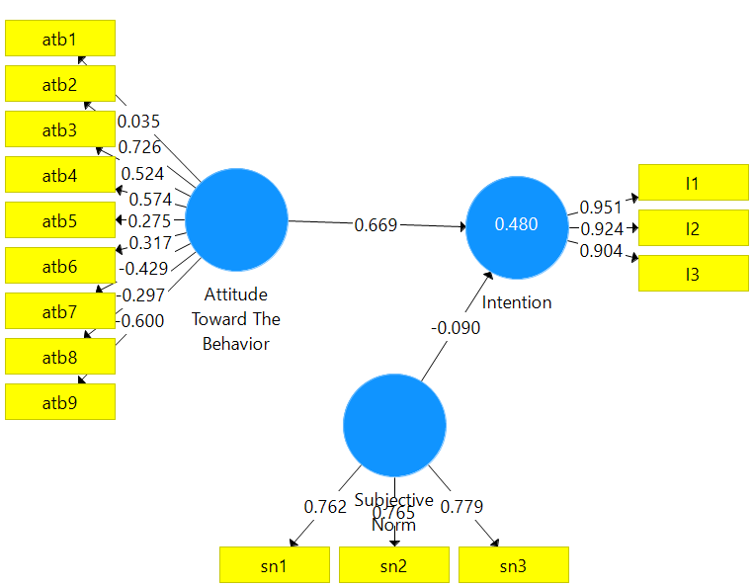

Figure 1. Path diagram with initial loading factor

The loading factor value is an individual reflective measure with a standard of 0.7 (Ghozali, 2017). So that the manifest variable whose value is below 0.7 must be excluded from the model. After the issuance of several manifest variables, a model path diagram is obtained, as shown in Figure 3. The path diagram has removed variables that are not fit in the model. Maintaining an unfit variable will invalidate the model.

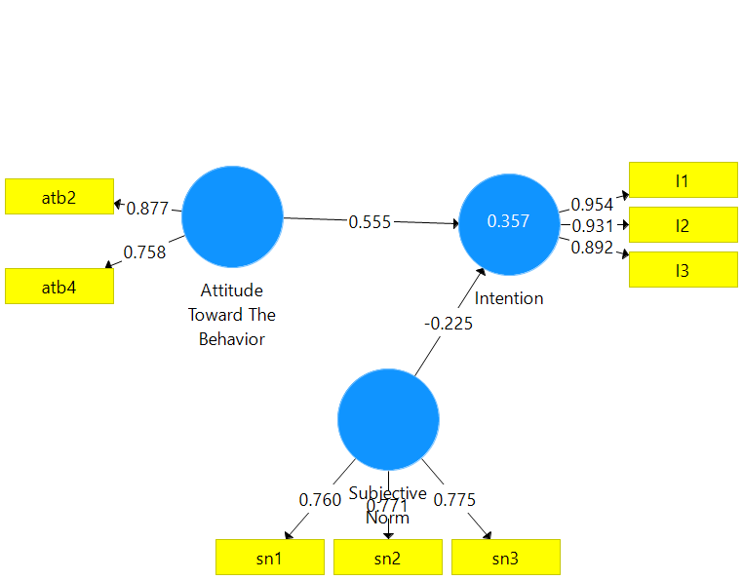

Figure 2. Path diagram with final loading factor

Validity Construct is assessed based on the Average Variance Extracted (AVE). In this study, the AVE value of each construct was above 0.5. Therefore, there was no convergent validity problem in the model being tested. Therefore, the entire model is declared valid. Construct reliability is assessed based on composite reliability to measure internal consistency, and the value must be above 0.6. Based on table 2, the overall composite reliability measurement results are above the 0.6 or real value. This means that the data is consistent and able to explain the model.

Table 2. Average Variance Extracted (AVE) Value
Latent variable | Croch alpa | rho_A | Composite reliability | AVE
ATB | 0.520 | 0.551 | 0.803 | 0.672
SN | 0.917 | 0.928 | 0.948 | 0.858
I | 0.656 | 0.658 | 0.813 | 0.591
Description: : AVE > 0.5 = Valid
Composite Reabiity > 0,6 = Realible

Inner model evaluation can be done to calculate the GoF (Goodness of fit) value. The Golf value is 0.502 and is included in the large category, which means that the model is fit and suitable for use. Coefficient evaluation is to assess the relationship between latent variables in the model. Based on the results of data processing, ATB has a positive relationship with intention. Meanwhile, SN has a negative relationship with Intention (Table 3).

Table 3 Evaluation of Coefficients
The relationship between variables | Coefficient | Relationship
ATB -> I | 0.555 | Positive
SN -> I | -0.225 | Negative

Based on the data processing results, it was found that ATB had a significant effect on the intention with a P-value of 0.000. On the other hand, SN significantly affects the intention with a P-value of 0.016 (Table 7).

Table 4 Hypothesis test
 | Standard D | T Statistics | P Values | Notes
ATB->I | 0.077 | 7.215 | 0.000 | significant
SN->I | 0.093 | 2.412 | 0.016 | significant
Notes: P-value<0.05 = significant

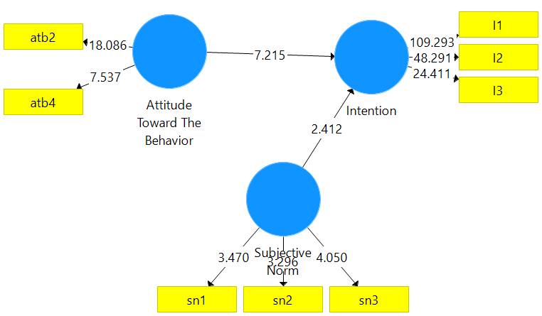

Figure 3. T-Test

Study Theory of Reasoned Action (TRA) On The Intention Of Consuming Organic Vegetables In The Bengkulu City

In this study, in-depth research was conducted on consuming organic vegetables with the Theory of Reasoned Action (TRA) approach. Fishbein and Ajzen (1980) stated that a person's intention to carry out a behavior determines whether the behavior will be carried out or not. The intention to do or not to do a specific intention is influenced by two essential determinants: attitude (attitude towards behavior) and social influence, namely subjective norms. Theory of Reasoned Action (TRA) focuses on factors influencing intention, namely attitude and subjective norms. Attitude and subjective norm are the closest factors in shaping the intention.
Based on the research results, it was found that attitude and subjective norms had a significant effect on the formation of an intention to consume organic vegetables. Respondents agree that attitudes can affect the intention to consume organic vegetables with a P-Value of 0.000. Meanwhile, the subjective norm affects the intention to consume organic vegetables with a P-Value of 0.016. The results of this study indicate that the TRA study strongly supports research involving intentions. The next discussion will be how attitudes and subjective norms can influence intention.
1. Attitude towards behavior affect the intention to consume organic vegetables
Based on the measurement results, it was found that attitude towards behavior had a significant effect on the intention to consume organic vegetables with a P-value of 0.000. This proves that TRA is a suitable theory in research on the intention to consume organic vegetables. Attitude towards behavior is explained by two indicators, namely Quality and Size.

Figure 4. Attitude towards behavior affect the intention to consume organic vegetables

Based on figure 5, quality is the most significant indicator influencing the intention to consume organic vegetables with a loading factor value of 0.877. Respondents stated that quality is what they are most looking for in organic vegetables. There is a perception that organic vegetables are of higher quality than non-organic vegetables. According to (Waskito, Ananto, & Reza, 2014), organic food is considered more nutritious than other conventional foods, and organic foods can increase endurance. Quality indicators are a benchmark for someone to pay for organic vegetables at a higher price compared to non-organic vegetables (Pramono & Prabawani, 2017). Organic vegetable purchasing decisions are significantly influenced by quality (Hurriyati, 2010; Widyastuti, 2018). In a global market with an increasingly high level of competition, quality is defined strategically as something that can meet consumer wants or needs (meeting customers' needs) (Anom Yuarini, Satriawan, & Oka Suardi, 2015). So that in selling organic vegetables, quality is what determines the consumer's intention to buy them.
Apart from quality, the size indicator also greatly influences the intention to consume organic vegetables. Based on the research results, it was found that the size of the organic vegetables had a loading factor value of 0.758. This shows that the perception of the size of organic vegetables is something that consumers are looking forward to. The more the availability of organic vegetables, the higher the intention.

2. Subjective norm affects the intention to consume organic vegetables
Based on the measurement results, the Subjective norm had a significant effect on the intention to consume organic vegetables with a P-value of 0.016. This proves that TRA is a suitable theory in research on the intention to consume organic vegetables. Subjective norm is explained by three indicators, namely Children Hope, Relative Hope, and
The expectations of the life partner.

Figure 5. Subjective Norm affect the intention to consume organic vegetables

Fulfilling children's desires is a consideration that can clarify subjective norms and influence patterns of vegetable consumption. For food eaten at home, children have their taste. In choosing vegetables at home, the power of kids is very dominant. In order to grow and develop children, eating vegetables is a priority. Thus, the child's preferences about the type of vegetables would have a direct impact on a mother's decision to consume vegetables at home. Based on the study findings, Subjective Norm has a positive correlation with The Children's hope. This indicates that the decision to consume organic vegetables is connected to the aspirations of children.
The second measure that can describe the Subjective norm is the satisfaction of local relatives' desires. Relative hope's effect will determine the purpose of consuming organic vegetables. The majority of respondents agreed that the decision to consume organic vegetables was highly motivated by Relative Hope. Neighbors are a part of partnerships. The habits of the neighbors in purchasing vegetables impact the decision to consume these vegetables.
The most dominant factor in describing the subjective norm is to satisfy the life partner's desire to consume organic vegetables. A participant who is in a household is a life partner. Meanwhile, respondents determine which vegetables are based on these standards to eat at home. The life partner's perceptions of the vegetables to be eaten have a huge influence on consuming organic vegetables in a household. Life partners have a more powerful impact on family decision-making, in the conventional view.

CONCLUSION
Based on the research results, it was found that attitude and subjective norms had a significant effect on the formation of an intention to consume organic vegetables. Respondents agree that attitudes can affect the intention to consume organic vegetables with a P-Value of 0.000. Meanwhile, the subjective norm affects the intention to consume organic vegetables with a P-Value of 0.016. The results of this study indicate that the TRA study strongly supports research involving intentions. In the TRA application, the intention to behave measures the relative strength of a person's intention to perform a behavior. Attitude consists of beliefs about the consequences of performing a behavior multiplied by an assessment of those consequences. Subjective norms are seen as a combination of the perceived expectations of the relevant individual or group to consume organic vegetables.

REFERENCES
Ajzen, I., & Fishbein, M. (1980). Understanding attitudes and predicting social behavior. New Jersey: Prentice-Hall. Englewood Cliffs.
Ajzen, I. (2011). The theory of planned behavior: Reactions and reflections. Psychology and Health. https://doi.org/10.1080/08870446.2011.613995
Ajzen, I., & Fishbein, M. (2000). Attitudes and the Attitude-Behavior Relation: Reasoned and Automatic Processes. European Review of Social Psychology, 11(1), 1–33. https://doi.org/10.1080/14792779943000116
Alamsyah, D. P. (2018). Meningkatkan Minat Beli Konsumen Pada Produk Ramah Lingkungan Melalui Dukungan Lokasi Konsumen. Jurnal Kajian Ilmiah, 18(1). https://doi.org/10.31599/jki.v18i1.195
Anom Yuarini, D., Satriawan, I., & Oka Suardi, I. (2015). Strategi Peningkatan Kualitas Produk Sayuran Segar Organik pada CV. Golden Leaf Farm Bali. Jurnal Manajemen Agribisnis, 3(2), 26297.
Bleakley, A., & Hennessy, M. (2012). The quantitative analysis of reasoned action theory. Annals of the American Academy of Political and Social Science. https://doi.org/10.1177/0002716211424265
Devi, S. R. M., & Hartono, G. (2016). Faktor-Faktor Yang Mempengaruhi Keputusan Konsumen Dalam Membeli Sayuran Organik. Agric, 27(1), 60. https://doi.org/10.24246/agric.2015.v27.i1.p60-67
Dimitri, C., & Dettmann, R. L. (2012). Organic food consumers: what do we know about them? British Food Journal, 114(8), 1157–1183. https://doi.org/10.1108/00070701211252101
Fishbein, M., & Ajzen, I. (1975). Strategies of Change: Active Participation. Belief, Attitude, Intention, and Behavior: An Introduction to Theory and Research.
Ghozali, I. (2017). Model Persamaan Struktural. Konsep dan Aplikasi Dengan Program AMOS 24.0. Update Bayesian SEM. In Model Persamaan Struktural. Konsep dan Aplikasi Dengan Program AMOS 24. Update Bayesian SEM. https://doi.org/10.1016/j.ando.2009.02.007
Hosseini, Z., Gharlipour Gharghani, Z., Mansoori, A., Aghamolaei, T., & Mohammadi Nasrabadi, M. (2015). Application of the theory of reasoned action to promoting breakfast consumption. Medical Journal of the Islamic Republic of Iran.
Hurriyati, R. (2010). Penerapan Model Strategi Pemasaran Usaha Kecil Berbasis Web 2.0 sebagai upaya dalam Meningkatkan Daya Saing Indutri Kecil (Penerapan Model pada Indutri Kecil Strategis di Kota Bandung). Fakultas Pendidikan Manajemen Bisnis Universitas Pendidikan Indonesia, (229), 1–25.
Iqbal, M. (2015). Consumer Behaviour of Organic Food: A Developing Country Perspective. International Journal of Marketing and Business Communication. https://doi.org/10.21863/ijmbc/2015.4.4.024
Khorniawati, M. (2014). Produk Pertanian Organik Di Indonesia: Tinjauan Atas Preferensi Konsumen Indonesia Terhadap Produk Pertanian Organik Lokal. Journal of Chemical Information and Modeling, 8(2), 171–182. https://doi.org/10.1017/CBO9781107415324.004
Mahyarni. (2013). Sebuah Kajian Historis tentang Perilaku. Jurnal El-Riyasah, 4(1), 13–23. Retrieved from http://ejournal.uin-suska.ac.id/index.php/elriyasah/article/view/17/13
Nguyen, Q. A., Hens, L., MacAlister, C., Johnson, L., Lebel, B., Tan, S. B., … Lebel, L. (2018). Theory of reasoned action as a framework for communicating climate risk: A case study of schoolchildren in the Mekong Delta in Vietnam. Sustainability (Switzerland), 10(6), 1–14. https://doi.org/10.3390/su10062019
Pramono, F., & Prabawani, B. (2017). Analisis Faktor-Faktor Preferensi Konsumen Yang Mempengaruhi Keputusan Pembelian Sayuran Organik (Studi Kasus : Pelanggan Super Indo Semarang). Jurnal Ilmu Administrasi Bisnis, 6(4), 21–30.
Priambodo, L. H., & Najib, M. (2016). Analisis Kesediaan Membayar (Willingness to Pay) Sayuran Organik dan Faktor-Faktor yang Mempengaruhinya. Jurnal Manajemen Dan Organisasi, 5(1), 1. https://doi.org/10.29244/jmo.v5i1.12125
Priastuti, D., Suroso, A. I., & Najib, M. (2016). Analisis Strategi Peningkatan Daya Saing Sayuran Organik. Jurnal Manajemen Dan Organisasi, 5(3), 258. https://doi.org/10.29244/jmo.v5i3.12177
Probst, L., Aigelsperger, L., & Hauser, M. (2010). Consumer Attitudes towards Vegetable Attributes: Potential Buyers of Pesticide-Free Vegetables in Accra and Kumasi, Ghana. Ecology of Food and Nutrition, 49(3), 228–245. https://doi.org/10.1080/03670241003766055
Probst, L., Houedjofonon, E., Ayerakwa, H. M., & Haas, R. (2012). Will they buy it? The potential for marketing organic vegetables in the food vending sector to strengthen vegetable safety: A choice experiment study in three West African cities. Food Policy. https://doi.org/10.1016/j.foodpol.2012.02.014
Sholiha, E. U. N., & Salamah, M. (2015). Structural Equation Modeling-Partial Least Square untuk Pemodelan Derajat Kesehatan Kabupaten/Kota di Jawa Timur (Studi Kasus Data Indeks Pembangunan Kesehatan Masyarakat Jawa Timur 2013). Jurnal Sains Dan Seni ITS, 4(2), 169–174.
Slamet, A., Nakayasu, A., & Bai, H. (2016). The Determinants of Organic Vegetable Purchasing in Jabodetabek Region, Indonesia. Foods, 5(4), 85. https://doi.org/10.3390/foods5040085
Southey, G. (2011). The Theories of Reasoned Action and Planned Behaviour Applied to Business Decisions: A Selective Annotated Bibliography. Journal of New Business Ideas & Trends, 9(1), 8.
Suardika, I., Ambarawati, I., & Sukaatmadja, I. (2014). Analisis Perilaku Konsumen terhadap Keputusan Pembelian Sayur Organik CV Golden Leaf Farm Bali. Jurnal Manajemen Agribisnis, 2(1), 26274.
Waskito, D., Ananto, M., & Reza, A. (2014). Persepsi Konsumen Terhadap Makanan Organik Di Yogyakarta. Pelita - Jurnal Penelitian Mahasiswa UNY, 9(01), 36–48.
Widyastuti, P. (2018). Kualitas dan Harga sebagai Variabel Terpenting pada Keputusan Pembelian Sayuran Organik. Ekspektra : Jurnal Bisnis Dan Manajemen, 2(1), 17. https://doi.org/10.25139/ekt.v2i1.675
Yue, C., Dennis, J. H., Behe, B. K., Hall, C. R., Campbell, B. L., & Lopez, R. G. (2011). Investigating Consumer Preference for Organic, Local, or Sustainable Plants. HortScience, 46(4), 610–615. https://doi.org/10.21273/HORTSCI.46.4.610
Zhang, B., Fu, Z., Huang, J., Wang, J., Xu, S., & Zhang, L. (2018). Consumers’ perceptions, purchase intention, and willingness to pay a premium price for safe vegetables: A case study of Beijing, China. Journal of Cleaner Production. https://doi.org/10.1016/j.jclepro.2018.06.273

