First report of Botrytis cinerea on saffron corms in Morocco
Samah Ourras¹, M’hammed Elouark¹, Ismail El Aymani¹, Najoua Mouden², Mohamed Chliyeh¹, Karima Selmaoui¹, Soukaina Msairi³, Rachid Benkirane¹, Abdelaziz El Alaoui¹, Amina Ouazzani Touhami¹, Allal Douira¹
¹ Laboratory of Plant, Animal and Agro-Industry Productions, Botany, Biotechnology and Plant Protection Team, Faculty of Sciences, Ibn Tofail University, Kenitra, Morocco
² Laboratory of Molecular Chemistry and Environmental Molecules, Multidisciplinary Faculty of Nador-Mohammed 1er University Oujda, Morocco
³ National Agency of Medicinal and Aromatic Plants, Taounate, Morocco

*Corresponding Author: samah.ourras@uit.ac.ma

Abstract
During the prospecting survey conducted by farmers in Taznakht and Taliouine, the main areas of Crocus sativus cultivation in Morocco, diseased Crocus bulb samples showing discoloration and irregular necrotic lesions were collected. Following the isolation test, morphological aspects and cultural characteristics of fungal colonies performed have revealed the presence of Botrytis cinerea. The identity of the B. cinerea isolate was complemented by means of the internal transcribed spacer sequence whose fungal culture was under accession number OM980236. Additionally, B. cinerea isolate was confirmed to be pathogenic on Crocus sativus corms by inducing rot symptoms. To the best of our knowledge, B. cinerea has not been reported in Morocco, this is the first report of this species, isolated from corms in Morocco.
Keywords: Botrytis cinerea, Crocus sativus, saffron, pathogenic agent, Morocco.

Introduction
Botrytis cinerea, is species of special interest on account of its peculiar relations to the phenomena both of saprophytism and parasitism. Botrytis cinerea is a polyphagous fungal pathogen causing gray mold disease in more than 230 host plants (Jarvis, 1980). Nonetheless, its presence in Morocco among the mycoflora related to Crocus sativus has not been reported. Saffron cultivation is confined to two southwestern areas: Taliouine (province of Taroudant) and Taznakht (province of Ouarzazate) of Morocco, renowned for its high-quality characteristics saffron on a national and international scale (Aboudrare et al., 2014).
At the border of saprophytism and parasitism, the fungus Botrytis cinerea, a ubiquitous plant pathogen, responsible for grey mould, is a microorganism, polyphagous which causes enormous damage in agriculture (Kadri et al., 2014). The disease caused by this pathogen is economically formidable and important because this fungus attacks more than 230 plant species (Jarvis, 1980).
Saffron cultivation is practiced in two areas of southern Morocco, Taliouine (Taroudante province) and Taznakht (Ouarzazate province), renowned for their high quality saffron on a national and international scale (Aboudrare et al., 2014). Surveys, in July 2020, in the area of Taliouine, near the farmers, allowed to isolate Botrytis cinerea, among a diversified fungal complex, from the corms of saffron presenting the necrotic lesions. In Morocco, this fungal species has not been cited among the mycoflora related to Crocus sativus (Ben Tata et al., 2017; El Aymani et al., 2019). In this study, the pathogenicity of Botrytis cinerea towards saffron was studied.
Materials and Methods
On 20 July, during prospecting surveys conducted by farmers in Taliouine, three sets of saffron corms were formed according to disease symptoms observed on each. Corms of the first one displayed irregular, brown to dark brownish lesions with variable size. The second and third ones contained respectively visible discolored spots with chlorotic halo or apparently healthy. Symptomatic or asymptomatic corms were cut in fragments 1cm long, surface sterilized for 1min using 5% sodium hypochlorite solution, rinsed in sterile distilled water several times, and then plated on PSA medium (200g potato, 20 g sucrose, 15 g Agar-agar, 1000 ml distilled water), amended with 0,5 mg/l of chloramphenicol or on water agar (15 g d’Agar-agar, 1000 ml distilled water) at 22-25°C for 7 days. Colonies having white to gray fluffy mycelia formed after an incubation period of 7 days at 24°C. The cultures were incubated for one week under 16h photoperiod at 25°C.
Results
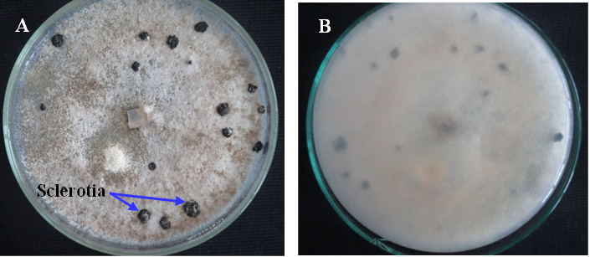
6% of obtained fungal colonies from corms with small spots, had initially white appearance but developed gray fluffy mycelia after an incubation period of 7 days at 25°C (Figure1), producing tree-like conidiophores (Figure 2A,B), with elliptical conidia, measuring 7.7 to 11 μm long and 5.9 to 9 μm wide (n= 200) (Figure 2C,D). The isolate incubated at 24 ± 2°C for 20 days, produced blackish, spherical to irregular microsclerotia.

Fig.1 Morphology of cultural characteristics of 21-day-old colony appearance of B. cinerea (A) upper side, (B) reverse side on potato sucrose agar (PSA) showing abundant aerial mycelia and black sclerotia with different size.

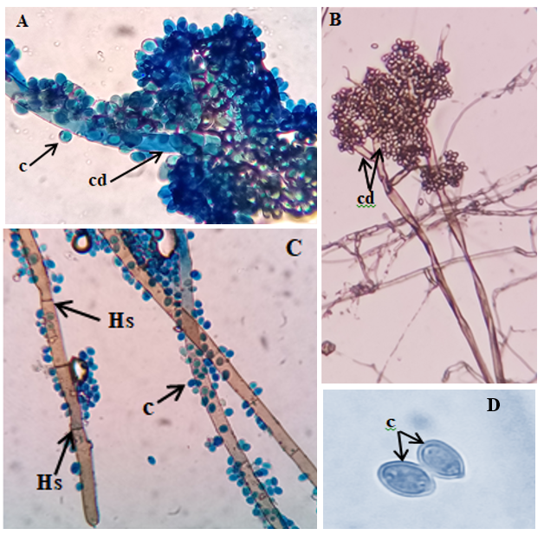
Fig.2 Microscopic characteristics of fructifications and hyphae of B. cinerea isolate. A-B, Conidiophores bearing clusters of conidia (cd); C, hyphae with the septum (Hs); D, unicellular conidia (c) at 400x magnification. Mounting liquid: cotton blue and water (E).

Discussion
This description is almost consistent with those reported for B. cinerea (Ellis, 1971). Following the morphological detection method, fungal genomic rDNA of B. cinerea isolate was extracted using the described method by Murray and Thompson (Murray et al., 1980; Doyle et al., 1987).
The internal transcribed spacer (ITS) sequence region of rDNA was amplified using universal primers ITS1 and ITS4 (White et al., 1990) and then sequenced. Based on the sequence comparison, the resultant ITS sequence matched well to B. cinerea with a similarity of 100%. It was deposited in GenBank at accession (OM980236).
The pathogenicity test was conducted by inoculating agar plug (5 mm) onto the leaves of saffron plants (Hmouni et al., 2005; 2006 and Mouria et al., 2013). Leaves collected from 3 month-old saffron plants were surface sterilized, rinsed three times then placed in 90 mm Petri dishes which contained beforehand two sterilized slides and were consistently moistened by sterilized distilled water to maintain continuous wet conditions. Prior to inoculation, the upper and lower surfaces of leaves were disinfected in 75% alcohol, rinsed with sterile water, and air dried. Colonized agar discs were prepared from a fresh colony and put onto each leaf that had been wounded with a sterile needle (two sites per leaf). Controls were inoculated with PSA discs only.
Healthy saffron corms were prepared for inoculation in the same manner as leaves. Onto the surface of each wounded corm, two mycelial agar plugs removed from the margin of culture plate of B. cinerea isolate were placed at each point site of inoculation. They were then placed on Petri dishes containing 3 sterilized filter paper discs moistened with sterilized water and kept at room temperature 25°C in darkness for 7 days incubation period. Control wounded corms were inoculated with PSA plug only. Brownish lesions covered by abundant greyish mycelium, of 0.66 to 4.7 cm dimension were developed on leaves (Figure 3A, B) and corms (Figure 3C) after 7 days of inoculation. No symptoms were observed on control leaves and corms.
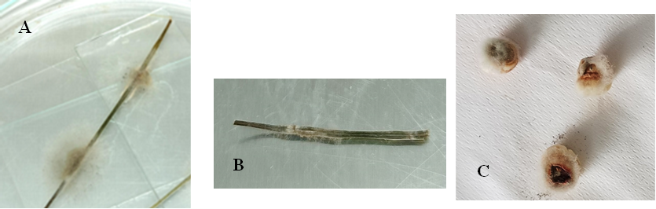

Fig.3 Leaf and saffron corm lesions with diffusing greyish aerial mycelium induced by B. cinerea 7 days postinoculation upon corms (C) and detached leaves (A, B).

The sporulating ability of tested B. cinerea isolate was noted on leaves and corms. This indicates, that once installed in the saffron fields B. cinerea can produce a secondary inoculum on the leaves and spread to healthy ones and so participate in the progression of the disease during the vegetative phase of the plant. The original isolate was successfully recovered from lesions of either leaves or corms with similar colony features even sclerotial development. Such a result is fulfilling Koch's postulates. To the best of our knowledge, this is the first report of Botrytis cinerea, isolated from corms in Morocco. This species has been previously cited in Italy among fungal complex associated with saffron (Belfiori et al., 2021). In Morocco, Botrytis cinerea was pointed out upon various plant species such as, Pyrus mamorensis (Sellal et al., 2013), Hibiscus rosa-sinensis L. and Acalypha wilkesiana J. Mueller (Meddah et al., 2006), strawberry (Fragaria ananassa L.) (Mouden et al., 2013), Catharanthus roseus (Kadri et al. 2014), tomato and cucumber (Mouria et al., 2013), apples in storage (Mounir et al., 2007).

Conclusion
The use of infected corms would probably lead to an increase in the population of B. cinerea, which could be a threat to the saffron culture over the course of time. The danger of such a species does not seem immediate, but its presence at the soil level, on newly formed bulbs and on all parts of the plants should be carefully monitored. Also, supplementary studies are necessary to determine the presence of this pathogen in the saffron fields of Morocco and the impact of corm attack as the propagating material of saffron plants.

Acknowledgments
This study was conducted under the research project of the 2nd PMA 2020/11, entitled ‘Elaboration d’un produit biofertilisant et biopesticide, à base de champignons endophytes, adapté à la protection et l’amélioration de la productivité du safran au Maroc’ financed by ‘Agence Nationale des Plantes Médicinales et Aromatique’ et l’Université Ibn Tofail, Kénitra, Morocco’

References:
- Aboudrare, A., Aden, A.H., Lybbert, T.J. (2014). Importance Socio-économique du Safran pour les Ménages des Zones de Montagne de la Région de Taliouine-Taznakht au Maroc. Revue Marocaine des Sciences Agronomiques et Vétérinaires, 2(1), 5-14.
- Belfiori, B., Rubini, A., Riccioni, C. (2021). Diversity of Endophytic and Pathogenic Fungi of Saffron (Crocus sativus) Plants from Cultivation Sites in Italy. Diversity, 13(11), 535.
- Bentata, F., Lage, M., Bakhy, K., Ibrahimi, M., Jbair, A., El Aissami, A., Kissayi, K.H., Labhilili, M. (2017). Sanitary assessment of saffron corms and soil from Great Moroccan production areas: Taliouine and Taznakht. ActaHortic. 1184, 263-266.
- Doyle, J.J., Doyle, J.L. (1987). A rapid DNA isolation procedure for small quantities of fresh leaf tissue (No. RESEARCH).
- El Aymani, I., Qostal, S., Mouden, N., Selmaoui, K., Ouazzani, T.A., Benkirane, R., Douira, A. (2019). Fungi associated with saffron (Crocus sativus) in Morocco. Plant Cell Biotechnol.Mol. Biol, 20, 1180–1188.
- Ellis, M.B. (1971). Dematiaceous Hyphomycetes. Commonwealth Mycological Insti-tute, Kew, England.
- Hmouni, A., Douira, A., Mouria, A. (2006). Biological Control of Tomato Grey Mould with Compost Water Extracts," Trichoderma" sp., and" Gliocladium" sp. Biological Control of Tomato Grey Mould with Compost Water Extracts," Trichoderma" sp., and" Gliocladium" sp., 1000-1007.
- Hmouni, A., Mouria, A. Douira, A. (2005). Etude de la réceptivité des feuilles de tomate à Botrytis cinerea, agent causal de la pourriture grise, ne relation avec l’activité antagoniste de quelques isolats de Trichoderma et de Gliocladium.. Journal AL AIWAMIA, vol. 2, n° 3, pp. 33-46.
- Jarvis, W.R. (1980). Epidemiology. Pages: 219-250 In: Coley-Smith J. R. et al. (eds.). The biology of Botrytis, Academic Press, New York.
- Kadri, O., Tauhami, A.O., Benkirane, R., Douira, A. (2014). Pouvoir pathogène de Botrytis cinerea sur Catharanthus roseus à différents stades végétatifs. Journal of Applied Biosciences, 76, 6338-6351.
- Meddah, N., Ouazzani, T.A., Benkirane, R., Douira, A. (2006). Caractérisation de la mycoflore pathogène d’Hibiscus rosa-sinensis L. et d’Acalypha wilkesiana J. Mueller de la ville de Kénitra (Maroc). Bulletin de l’Institut Scientifique, Rabat, section Sciences de la Vie, 28, 7-11.
- Mouden, N., Benkirane, R., Touhami, A.O., Douira, A. (2013). Mycoflore de quelques variétés du fraisier (Fragaria ananassa L.), cultivées dans la région du Gharb et le Loukkos (Maroc). Journal of Applied Biosciences, 61, 4490-4514.
- Mounir, R., Durieux, A., Bodo, E., Allard, C, Simon, J.P., Achbani, E.H., El-Jaafari, S., Douira, A., Jijakli, M.H. (2007). Production, formulation and antagonistic activity of the biocontrol like-yeast Aureobasidium pullulans against Penicillium expansum. Biotechnol Lett., 29(4):553-9.
- Mouria, B., Ouazzani, T.A., Douira, A. (2013). Effet du compost et de Trichoderma harzianum sur la suppression de la verticilliose de la tomate. Journal of Applied Biosciences, 70, 5531-5543.
- Mouria, B., Ouazzani, T.A., Mouria, A., Douira, A. (2013). Mise en évidence d’une variation intra spécifique chez Botrytis cinerea et lutte biologique in vitro par l’extrait de compost. Journal of Applied Biosciences, 64, 4797-4812.
- Murray, M.G., Thompson, W. (1980). Rapid isolation of high molecular weight plant DNA. Nucleic acids research, 8(19), 4321-4326.
- Sellal, Z., Dahmani, J., Benkirane, R., Ouazzani, T.A. Douira, A. (2013). Pathogenic Capacity of Botrytis cinerea on Leaves of Pyrus mamorensis, an Endemic Tree of Mamora Forest in Morocco. Atlas Journal of Biology, 2(2), 125-129.
- White, T.M., Bruns, T., Lee, S., Taylor, J. (1990). Amplification and direct sequencing of fungal ribosomal RNA for phylogenetics. In: Innis, M.A., Gelfand, D.H., Sninsky, J.J., White, T.J. (Eds.), PCR protocols: a guide to methods and applications. Academic Press, San Diego, CA, pp. 315–321.

