Running title: Improving Seed Viability Test of Grammatophyllum speciosum Using Direct and Indirect Methods

Improved Assessment of Seed Viability and Germination of Grammatophyllum speciosum Blume for Long-term Ex-situ Conservation

Dwi Murti Puspitaningtyas 1†, Ratna Yuniati 2†, Elizabeth Handini 1†, Popi Aprilianti 1†, Anom Bowolaksono2† and Surya Diantina 1†*
¹Research Center for Plant Conservation, Botanic Gardens, and Forestry, Research Organization of Natural Science and Environment, National Research and Innovation Agency (BRIN), Bogor, West Java, Indonesia
²Department of Biology, Faculty of Mathematics and Natural Sciences, University of Indonesia, Jakarta, Indonesia
³Department of Agronomy, University of Agriculture, Faisalabad 38040, Pakistan
*For correspondence: suryadiantina@gmail.com/ surya.diantina@brin.go.id
†Contributed equally to this work
Received ; Accepted ; Published

Novelty statement

The successful orchid seed germination depends mainly on its viability and the medium used for germination. The effectiveness of four different media and three different drying periods on Grammatophyllum speciosum Blume orchid seed germination prior to storage at -20°C for one year showed modified KC or VW media as the best seed germination and plantlet development. Three days’ desiccation treatment was successful in maintaining germination and viability after one year of storage. Tetrazolium chloride (TTC) seed viability test with six preconditioning treatments found that pre-conditioning with 10% and 5% Clorox followed by 10% sucrose prior to immersion in 1% TTC for 18 hours could be recommended to seed TTC viability assessment on this orchid seed, may recommend as a fast-tracking strategy to assess G. speciosum seed viability, combined with seed germination to support this species ex-situ conservation in seed banking storage.

Abstract

Orchid seed banking is the most convenient conservation method due to their small but abundant size in one pod. The purposes of this study were to determine the best in vitro seed germination medium for G. speciosum and to assess the seed viability in storage using direct (germination) and indirect (TTC test) methods. Four different basal media were used for in vitro seed germination in this study: (1) modified Knudson C, (2) modified Vacin and Went, and modified leaf fertilizers (3) Hyponex, and (4) Growmore. The results indicated that mature seeds of G. speciosum were germinated and developed well on all asymbiotic media tested, especially on VW and KC media. Seeds were dried in a desiccator for 3, 6, or 9 days before germination and storage. We found the best seed germination was achieved by drying the seeds in a desiccator for 3 days while longer drying in a desiccator reduced seed germination, similar to one year of storage. The seed viability test of G. speciosum was carried out by Triphenyl Tetrazolium Chloride (TTC) test with a concentration of 0.1% or 1% TTC, either with or without sucrose or Clorox pre-condition treatments. Preconditioning with 10% and 5% Clorox followed by 10% sucrose before immersion in 1% TTC for 18 hours produced the highest seed viability. This study is a practical conservation approach for orchid seed banking, by providing a fast-tracking seed viability status using TTC test before actual seed germination on in vitro growth.

Keywords: Asymbiotic seed germination, Desiccation, Dry storage, Triphenyl Tetrazolium Chloride test

Introduction

The Grammatophyllum genus contains twelve species, including Grammatophyllum speciosum Blume. G. speciosum is a beautiful orchid species that is also known as a giant orchid. This epiphytic orchid has a large clumping of flowers and cylindrical stems up to 3 m long or longer, 5 cm thick with many strap leaves, growing on the branches of big trees (Figure 1a-c). This species is native to Indo-China to W. Malesia, from Laos, Myanmar, Thailand, Vietnam, Malaya, Sumatra, Borneo, Java, Sulawesi, Philippines to Papua New Guinea (Plants of the World Online, 2023).
Since all orchid species are listed as Appendix II on CITES, their long-term storage is crucial for the conservation of natural genetic diversity, and the convenience of seed banking is allowed due to their minute size of hundreds to millions of seeds in one capsule can easily be stored in small volumes (Swartz and Dixon, 2017).
Seed quality assessment in banking is very important to support the ex-situ conservation of orchids. Fresh seed viability and germination were checked to collect information on initial status. Germination tests should be conducted regularly to monitor changes in seed storability and to provide an indication of when accessions should be renewed by making fresh collections. Most orchid seeds are orthodox thus longevity can be extended by storage at both low moisture content and temperature (Seaton et al., 2013; Merritt et al., 2014). Seaton et al., 2018) and Hosomi et al. (2012) reported the successful storability of orchid seed in conventional seed banks at -20°C storage is highty determined by initial fresh seed quality. Further research is needed to determine the effectiveness of the seed viability test compared with seed germination on G. Speciosum after seed bank storage.
The success of orchid seed germination depends on seed viability and the medium used for germination. There are two methods to test seed viability, direct and indirect methods. Assessment of seed germination on in vitro medium is considered as direct method to test seed viability. In contrast, the indirect method is done by testing the metabolic activity of the seeds with the help of chemicals such as triphenyl tetrazolium chloride (TTC) (Hosomi et al., 2011, 2012; Srivastava et al., 2015), fluorescein diacetate (FDA) (Srivastava et al., 2015) or Evans Blue (EB) test (Pradhan et al., 2022).
The tetrazolium test has been widely used to determine seed quality including orchids (Hosomi et al., 2011, 2012; França-Neto and Krzyzanowski, 2019) by determining the respiratory activity in the cells. Specific seed preconditioning and staining techniques in orchid seeds are applied to accelerate diffusion of TTC (2,3,5 triphenyl tetrazolium chloride) in the cells, such as preconditioning with sucrose for Cattleya species (Hosomi et al., 2011, 2012), pre-treatment by scarification with sodium hypochlorite (NaOCl) (Dowling and Jusaitis, 2012; Bae et al., 2013), or vacuum suction (Diantina et al., 2020), thus developed a strong red coloration. Moreover, other conditions such as concentration and duration of TTC were also important (Hosomi et al., 2011, 2012; Mercado et al., 2020a, 2020b).
The purposes of this study were to assess the best in vitro seed germination medium of Grammatophyllum speciosum Blume and seed germination after one year of storage at -20°C seed banking. Seed viability after storage was also determined using the TTC test. In order to establish a protocol for the viability test procedure for G. speciosum, the effectiveness of preconditioning treatment on TTC staining in G. speciosum seeds was also observed.

Materials and Methods

Experimental details and treatments

Experimental material: Flowers of Grammatophyllum speciosum were obtained from orchid collections in the Bogor Botanic Garden, Indonesia, and cross-pollinated. Mature pods were harvested at 9 months after pollination, as yellowish-green and cracked pods. The pods were stored at room temperature on filter paper (Salazar and Gelvez, 2015) for 48 hours or until the natural dehiscence of the pods. Based on the observation, the fruit of G. speciosum was a rounded-elongated, oval-like capsule, measuring about 11–14 cm long, ± 5–6.5 cm in diameter (Figure 2 A-C.). The weight of the pods was about 63–76 grams. The seeds were elongated elliptical with a pale yellow-brown color, 0.4-0.7 mm long and ± 0.2–0.25 mm wide. The seed length between 500–900 µm was classified as medium size seed (Barthlott et al., 2014). The seeds do not have endosperm and contain a globular-shaped embryo (Figure 2 C.).
Treatments: The germination and viability study was conducted at the Tissue Culture Laboratory in Bogor Botanic Gardens. Seed drying begins with removing the seeds from the dehiscence pods. Seeds were placed on Petri dishes and sieved to remove any remaining debris. Seeds were dried in a desiccator over silica gel and treated for 3, 6, and 9 days to reduce the moisture content of the seeds. Seeds’ eRH was collected with a data logger (Gemini Tinytag view 2, TV-4505, UK). A longer period (3 to 9 days) of seed drying over silica gel in a desiccator resulted in the reduction of seeds relative humidity from 54.6 to 50.6% eRH (Table 1), but not statistically different.
Seeds for the germination experiment were tested for initial/fresh germination in several media. Unused seeds were kept in small vial containers and labeled. Several seed vials were put together in a larger storage jar which is hermetically sealed and stored in the freezer at -20°C (Seaton et al., 2018). The stored seeds were tested for germination after one year of storage.

Seed sterilization and germination

After drying over silica gel for 3, 6, and 9 days, seeds of G. speciosum were tested for initial germination on several asymbiotic seed germination media below. Seed sterilization was carried out before sowing on the germination media. Seeds were soaked in 10% Clorox solution (0.525% NaOCl, Bayclin) for 10 minutes, followed by soaking in 5% (0.2625% NaOCl, Bayclin) solution for 5 minutes and rinse with sterile distilled water three times. In the third rinse, seeds were sown onto four germination media. A total of 100-200 seeds are sown for each petri dish, with three replications of each treatment.

Asymbiotic seed germination media

Four different basal media were used in this study (Puspitaningtyas and Handini, 2014): (1) KC (modified Knudson C with the addition of 150 g/l bean sprout extract and 150 ml/l coconut water, (2) VW (modified Vacin and Went with the addition of 100 g/l bean sprouts extract, 100 g/l tomatoes extract and 150 ml/l coconut water), (3) HS (modified Hyponex leaf fertilizer 25:5:20 (N:P:K) with the addition of 2 g/l peptone and 40 g/l potatoes), and (4) GS (modified Growmore leaf fertilizer 32:10:10 (N:P:K) with similar additional ingredients as for HS). All the media were supplemented with 2 % (w/v) sugar, 1 g/l activated charcoal, and solidified with 0.8 % (w/v) agar. The pH of the media was adjusted to 5.6–5.8 with 1 N NaOH or HCl to adjust.
Based on the results of the fresh seed germination, the seed germination experiment after one year of storage was applied only on two modified KC and VW media.

Seed viability using tetrazolium test

The seed viability test with TTC staining was assessed after one year of storage in a freezer at −20°C. The seed material was desiccated seeds for three days before storage. There were six treatments of TTC procedures with two types of preconditions: (1) with 10% Clorox solution (0.525% NaOCl, Bayclin) for 10 minutes, followed by soaking in 5% (0.2625% NaOCl, Bayclin) solution for 5 minutes, and rinsing with distilled water three times and (2) precondition with 10% sucrose for 18 hours, as indicated in Table 2.
The seed viability was then observed under a binocular microscope (Olympus U-TV0.5XC-3 5 H 12344, Japan, 40 × magnification). Red and pink-stained seeds were considered viable, while white-stained seeds as non-viable; seeds without embryos were considered empty seeds and discarded from evaluation (Hosomi et al., 2017). Three replicates per treatment were evaluated.

Observation

Seed germination and viability were observed at 8 weeks after sowing. Seed germination was initiated by the rupture of the seed coat and embryo enlargement to produce a protocorm. The lack of further development of the embryo was considered as a non-germinated seed. The seeds were counted for the total of germinated and non-germinated, with the germination percentage calculated as below:
Seed germination (%) = | Total number of germinated seeds | × 100%
 | Total number of seeds observed (±100-200 seeds)
Seed viability was observed under a microscope and pink to red-stained seeds were considered viable and calculated as follows:
Seed viability (%) = | Total number of pink to red stained seeds | × 100%
 | Total number of seeds observed (±100-200 seeds)

Statistical analysis
Data were analyzed for variance (ANOVA) using IBM SPSS statistic 22 and significant results were statistically compared with Duncan's Multiple Range Test (DMRT, α=0.05) for seed germination or Tukey’s Honestly Significant Difference Test (HSD, α=0.05) for seed viability test.

Results

Assessment of the seed asymbiotic germination media

Germination of fresh seeds: A germination test of fresh seeds (after drying) was conducted. Seeds of G. speciosum were able to germinate on all four different media: KC, VW, HS, and GS, supplemented with organic nutrients in this study ((Figure 3). We observed the greenish-globular-shaped early protocorms, followed by the initiation of rhizoids and apical buds after 8 weeks of sowing.
The best combination of germination media and drying time was found on VW media after seed drying for 3 days (74.8%), but germination declined on this media after 9 days of seed drying. Overall, seed germination after desiccation for 3 days gave a good result and no significant difference between VW, KC, and HS media, while the lowest germination was found on GS media.
Seed germination and development of protocorm-like bodies (PLB) of G. speciosum on the four media are shown in Figure 4. The best PLB performance indicated by green and bigger embryos with plenty of rhizoids was found in VW and KC media, compared with GS or HS media. GS and HS basal media were plant fertilizers for shoot multiplication, containing high nitrogen resources with the ratio of N:P:K was 32:10:10 (GS) and 25:5:20 (HS). Since PLBs development was found best on VW and KC media (Figure 4), KC and VW media were selected to be used for the next seed germination test after one year of storage in the freezer at -20°C.

Seed germination after one year of storage: Seed germination of G. speciosum after one year of storage was done on VW and KC media. There was no significant difference between both media and storage time nor interactions between observed parameters. Duration of drying on both storage times showed desiccation for three days maintained the highest seed germination both before and after one-year storage, compared with six or nine days of desiccation (Table 3).

Seed viability using improvement method on Tetrazolium (TTC) test

We also conducted indirect seed viability tests after one year of storage of G. speciosum (drying for three days before storage), which were done on six combination treatments. The purpose of the pre-soaking treatment in NaOCl was to crack the seed coat and accelerate the TTC imbibition into the embryo. Meanwhile, the pre-condition of sucrose immersion strengthened the coloring of the embryos. The TTC test has been successfully used to estimate orchid seeds' viability. Also, the seed viability test using the TTC method allowed fast and simple procedures to predict viability, compared with the germination test which takes a longer time to allow the counting of germinated seeds.
The result showed that pre-conditioning with Clorox followed by sucrose before immersion in 1% TTC for 18 hours (T4) showed the best staining quality and produced the highest seed viability but was not statistically different with other treatments except T3 (without sucrose precondition). (Figure 5 and Figure 6).
Comparison of seed viability (TTC test) and in vitro seed germination after one year of storage in this study showed no significant difference with the highest percentage of the red-stained embryo being 73.57 ± 5.15 and the highest germination being 72,98 ± 9,08. Thus, both methods of direct and indirect can be used to assess the seed viability of G. speciosum.

Discussion

Seed germination occurred after the imbibition process. Viable seeds were swollen and germination started with embryo enlargement (stage 1), followed by cracking of the testa or seed coats (stage 2) before development of proto-meristem (Diantina et al., 2020). Embryo development in orchid seed germination has also been reported by Udomdee et al. (2014) and Samala et al. (2014). KC and VW were tissue culture basal media, known to have richer macro and micronutrients compared with HS and GS media (Puspitaningtyas and Handini, 2014). Observation on the embryo development stage was made referring to Diantina et al. (2020) and showed that most germinated embryos from KC and VW media reached stages 2 and 3 (initiation of proto meristem, rhizoid, and primordia shoots), while most germinated seeds on GS and HS media still at stage 2 development. Therefore, G. speciosum may require high macronutrients and micronutrients to support germination and development. While some orchid species, ie. terrestrial orchids require simpler nutrient composition (Diantina, et al., 2020; Nadarajan et al., 2011).
Many orchid species are considered to have orthodox seed behavior, as their longevity can be extended by reducing seed moisture content and storing them at low temperatures, under routine seed bank conditions (Seaton and Pritchard, 2011; Seaton et al., 2013; Merritt et al., 2014). Desiccating seeds over silica gel caused a reduction in the relative humidity (eRH) of seeds from 54% to 50% after three to nine days in the desiccator. After one year of storage, we found a 10% decrease in G. speciosum seed germination. Therefore, we consider G. speciosum seeds to have semi-orthodox or intermediate behavior that was tolerant to desiccation and freezing during storage, with a slight reduction in germination. To confirm this type of behavior, a longer seed storability test should be applied to G. speciosum.
Drying orchid seed to a suitable moisture content is important to maintain seed lifespan. Seed drying will reduce moisture content and determine the success of germination during a certain storage duration (Yuniarti and Nurhasybi, 2015). On the other hand, over-drying may be detrimental since some orchids were known to have either intermediate or recalcitrant seed behavior (Machado-Neto and Custodio, 2005). Therefore, although this species can germinate well after one year of storage, a routine test should be conducted for maintenance in seed banks.
In this study, a low concentration of 0.1% TTC succeeded in red-staining the embryo as reduction of TTC only happened on viable seeds by cellular respiration, while dead tissue remains in its original color. A low concentration of 0.1% TTC is recommended if the exposure time is longer than 12 hours (Hosomi et al., 2011). We found no significant difference between 0.1% TTC (4 days) and 1% TTC (18 hours) in the percentage of seed viability results (Figure 5). Furthermore, preconditioning with 1% NaClO for 10 minutes was adequate to scarify the seed coat and improve seed staining (Mercado et al., 2019; Hosomi et al., 2017).
According to Hosomi et al. (2011) pre-conditioning in 10% sucrose solution improved the development of seed staining. When seeds are immersed in a colorless solution of tetrazolium, TTC penetrates the seed tissue which interferes reduction process of living cells and staining intensity indicates the viability of the tissue, so viable seeds will be colored red. Moreover, compared with the germination test that requires at least 35 days to reach embryo development, the TTC test is more efficient since requires only three days to complete (1 day for pre-conditioning, 1 day for seed staining, and 1 day for counting red-stained embryos).
This study aligns with findings by Mercado et al. (2019) that the highest viability percentages were obtained by staining the Epidendrum barbaricum seeds using TTC after pre-conditioning with both 1% sodium hypochlorite (NaOCl) and 10% sucrose. Meanwhile, improper selection of scarification methods for breaking dormancy and inappropriate selection of asymbiotic media can affect evaluation results and interpretation of seed quality (Dowling and Jusaitis, 2012; Popova et al., 2016; Magrini and De Vitis, 2016).

Conclusion

In this paper, it can be concluded that a simple method to support the conservation of mature seeds of G. speciosum in low-temperature storage (-20 °C) is applicable by drying seeds over silica gel in a desiccator for three days before storage. The results indicated that mature seeds of G. speciosum were able to germinate well on a nutrient medium, either modified VW or KC media, after one year of storage. Indirect seed viability test of G. speciosum can be carried out by TTC test with the concentration of either 0.1% or 1% TTC at a certain immersion time and pre-condition with clorox and sucrose may improve red staining quality.
This research supports the ex-situ conservation of orchid seed in conventional seed banks and fast-tracking seed viability by TTC test, especially for G. speciosum. However, more studies in various species and genera levels, media compositions, and TTC precondition treatments are still needed to optimize orchid seed banking and conservation protocol.

Acknowledgements

We would like to thank to Research Center for Plant Conservation, Botanic Gardens, and Forestry-National Research and Innovation Agency for providing the infrastructure and tissue-culture laboratory to carry out this research. Authors appreciate Hugh W. Pritchard, Philip Seaton, and Tim Marks, for initiating the Orchid Seed Stores for Sustainable Use (OSSSU) project from 2007 to 2010, and also to Millennium Seed Bank Partnership (MSBP) and the Royal Botanic Gardens, Kew.

Author Contributions

All authors are main contributors and have made an equal contribution to the research process to published writings. All authors reviewed the manuscript. All authors read and approved the final manuscript.

Conflict of Interest

All authors declare no conflict of interest

Data Availability

Data presented in this study will be available on a fair request to the corresponding author

Ethics Approval

Not applicable to this paper

References

Bae KH, MS Ko, MH Lee, NY Kim, JM Song, G Song (2013). Effects of NaOCl treatment on in vitro germination of seeds of a rare endemic plant, Oreorchis coreana Finet. J Plant Biotechnol 40:43-48.
Barthlott W, B Große-Veldmann, N Korotkova (2014). Orchid Seed Diversity: A Scanning Electron Microscopy Survey. Turland NJ. (ed.). Botanic Garden and Botanical Museum Berlin-Dahlem. 239p.
Custódio CC, TR Marks, HW Pritchard, ST Hosomi, NB Machado-Neto (2016). Improved tetrazolium viability testing in orchid seeds with a thick carapace (Dactylorhiza fuchsii) or dark seed coat (Vanda curvifolia). Seed Sci Tech 44(1):1-12. DOI: 10.15258/sst.2016.44.1.17
Diantina S, S Kartikaningrum, AC McCormick, J Millner, C McGill1, HW Pritchard, J Nadarajan (2020). Comparative in vitro seed germination and seedling development in tropical and temperate epiphytic and temperate terrestrial orchids. Plant Cell, Tissue Org Cult 143:619–633. https://doi.org/10.1007/s11240-020-01947-7
Dowling N, M Jusaitis (2012). Asymbiotic in vitro germination and seed quality assessment of Australian terrestrial orchids. Aust J Bot 60:592–601. DOI: 10.1071/BT12133
França-Neto JB, FC Krzyzanowski (2019). Tetrazolium: an important test for physiological seed quality evaluation. J Seed Sci 41(3): 359-366. DOI: 10.1590/2317-1545v41n3223104
Hosomi ST, RB Santos, CC Custódio, PT Seaton, TR Marks, NB Machado-Neto (2011). Pre-conditioning Cattleya seeds to improve the efficacy of the tetrazolium test for viability. Seed Sci Tech 39:178-189. DOI: 10.15258/sst.2011.39.1.15
Hosomi ST, CC Custódio, PT Seaton, TR Marks, NB Machado-Neto (2012). Improved assessment of viability and germination of Cattleya (Orchidaceae) seeds following storage. In Vitro Cellular & Developmental Biology - Plant Plant 48: 127–136. DOI: 10.1007/s11627-011-9404-1
Hosomi ST, TB de Souza, CC Custódio, NB Machado-Neto (2017). Refining the tetrazolium test for evaluation of Cattleya labiata and C. tigrina seeds viability. Aust J Crop Sci 11(10):1320-1326. DOI: 10.21475/ajcs.17.11.10.pne606
Machado-Neto NB, CC Custódio (2005). Orchid Conservation through Seed Banking: Ins and Outs. Selbyana, 26 (1/2), 229–235. http://www.jstor.org/stable/41760193
Magrini S, M De Vitis (2016). Impacts of scarification methods and nitrogen source on seeds germination in the genus Limodorum. Plant Biosystems, 151:419– 428. DOI: 10.1080/11263504.2016.1179698
Mercado SAS, EAB Delgado, JDQ Caleño (2019). Pre-treatment effect on the tetrazolium test on Epidendrum barbaricum Hágsater & Dodson seeds. Acta Agron 68 (4): 306-311. DOI: 10.15446/acag.v68n4.79619
Mercado SAS, JDQ Caleño, LYM Rozo (2020a). Improvement of the methodology of the Tetrazolium test using different pretreatments in seeds of the genus Epidendrum (Orchidaceae). J Seed Sci 42:1-8 e202042013. DOI: 10.1590/ 2317-1545v42231028
Mercado SAS, JDQ Caleño, JPR Suárez (2020b). Optimization of the Tetrazolium test in three species of orchids of the Andean forest. Aust J Crop Sci 14:822–829. DOI: 10.21475/ajcs.20.14.05.p2276
Merritt DJ, FR Hay, ND Swarts, KD Sommerville, KW Dixon (2014). Ex-situ conservation and cryopreservation of orchid germplasm. Intl J Plant Sci 175:46–58. DOI: 10.1086/673370
Nadarajan J, S Wood, TR Marks, PT Seaton, HW Pritchard (2011). Nutritional requirements for in vitro seed germination of 12 terrestrıal, lithophytic and epiphytic orchids. J Trop For Science 23(2): 204-212. https://www.jstor.org/stable/23616921
Nadarajan J, HW Pritchard (2014). Biophysical characteristics of successful oilseed embryo cryoprotection and cryopreservation using vacuum infiltration vitrification: an innovation in plant cell preservation. PLoS ONE 9; Article e96169. DOI: 10.1371/journal.pone.0096169
Popova E, HH Kim, PK Saxena, F Engelmann, HW Pritchard (2016). Frozen beauty: the cryobiotechnology of orchid diversity. Biotechnol Adv 34:380–403. DOI: 10.1016/j.biotechadv.2016.01.001
Pradhan N, X Fan, F Martini, H Chen, H Liu, J Gao, UM Goodale (2022). Seed viability testing for research and conservation of epiphytic and terrestrial orchids. Bot Stud 63(1):1-14. DOI: 10.1186/s40529-022-00333-0
Puspitaningtyas DM, E Handini (2014). Orchid seeds storage of Coelogyne spp. for ex-situ conservation. Buletin Kebun Raya 17(2):101-111. ISSN 0125-961X. https://publikasikr.lipi.go.id/index.php/buletin/article/view/83. [Indonesian]
Puspitaningtyas DM, E Handini (2020). Ex-situ conservation of Cymbidium finlaysonianum by seed storage. Biodiversitas 21(8):3519-3524. DOI: 10.13057/biodiv/d210813
Puspitaningtyas DM, E Handini (2021). Seed germination evaluation of Phalaenopsis amabilis in various media for long-term conservation. Biodiversitas Vol.22 (11):5231-5238. DOI: 10.13057/biodiv/d221162
Salazar SAM, JDM Gélvez (2015). Determining the viability of orchid seeds using the Tetrazolio and Carmín Índigo tests. Revista de ciencias 19:59-69. http://www.scielo.org.co/scielo.php?script=sci_ arttext&pid=S0121-19352015000200004
Samala S, S Te-chato, S Yenchon, K Thammasiri (2014). Protocorm-like body proliferation of Grammatophyllum speciosum through asymbiotic seed germination. ScienceAsia 40:379–383. DOI: 10.2306/scienceasia1513-1874.2014.40.379
Seaton PT, HW Pritchard (2011). Orchid seed stores for sustainable use: a model for future seed-banking activities. Lankesteriana 11:349-353. DOI:10.15517/lank.v11i3.18290
Seaton PT, JP Kendon, HW Pritchard, DM Puspitaningtyas, TR Marks (2013). Orchid Conservation: The Next Ten Years. Lankesteriana 13(1–2):93–101. DOI: 10.15517/lank.v0i0.11545
Seaton PT, ST Hosomi, CC Custódio, TR Marks, NB Machado-Neto, HW Pritchard (2018). Orchid seed and pollen: A toolkit for long-term storage, viability assessment and conservation. In: Chapter 4: Orchid propagation: from laboratories to greenhouses -methods and protocols. Lee Y-I, EC-T Yeung (eds.) Springer Protocols Handbooks. DOI: 10.1007/978-1-4939-7771-0_4
Sopalun K, K Thammasiri, K Ishikawa (2010). Micropropagation of the Thai orchid Grammatophyllum speciosum Blume. Plant Cell, Tissue Org Cult 101:143–50. DOI:10.1007/s11240-010-9671-2
Srivastava D, MC Gayatri, SK Sarangi (2015). In vitro seed germination and plant regeneration of an epiphytic orchid Aerides ringens (Lindl.) Fischer. Ind J Biotechnol 14:574-580. http://eprints-bangaloreuniversity.in/6885/1/IJBT%2014(4)%20574-580.pdf.
Swartz ND, KW Dixon (2017). Conservation methods for terrestrial orchids. J. Ross Publishing, Plantation, FL, USA, pp 235.
Udomdee W, P Wen, S Chin, F Chen (2014). Effect of storage temperature on seed viability and in vitro germination of nobile Dendrobium hybrids. Thai Agricultural Research Journal, 32(2):201–217. DOI:10.14456/thaidoa-agres.2014.9
Yuniarti N, Nurhasybi (2015). Viability and Biochemical Content Changes in Seed Storage of Jabon Putih (Anthocephalus cadamba (Roxb) Miq.). Jurnal Manajemen Hutan Tropika 21(2): 92-98. DOI: 10.7226/jtfm.21.2.92

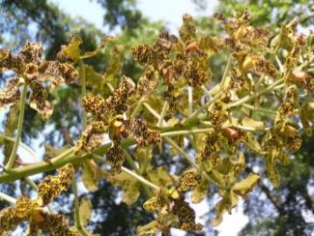 | 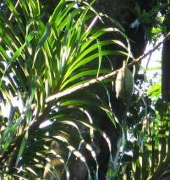 | 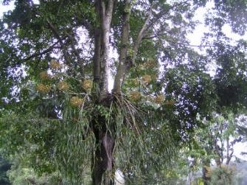
A | B | C

Figure 1. The plant morphology of Grammatophyllum speciosum Blume. (A) the inflorescences, (B) fruit/pod, (C) and growth habit of Grammatophyllum speciosum Blume

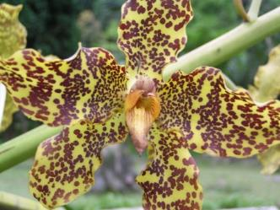 | 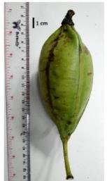 | 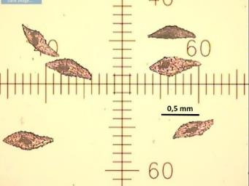
(A) | (B) | (C)

Figure 2. Flowers, fruit pod and orchid seeds of Grammatophyllum speciosum Blume: (A) Flowers; (B) Fruit/pod, Bar = 1 cm; (C) Seeds, magnified 40 ×, Bar = 0.5 mm

Figure 3. Fresh seed germination percentage of Grammatophyllum speciosum on some germination media and desiccation time. The mean ± SD followed by different letters indicates a significant difference according to Duncan's test at a significance level α = 0.05

Media | Duration of drying time in a desiccator
 | 3 days | 6 days | 9 days
GS | 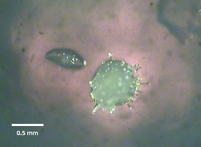 | 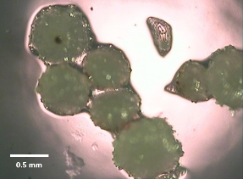 | 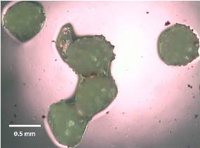
HS | 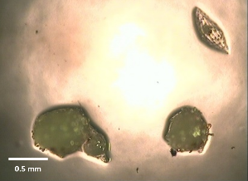 | 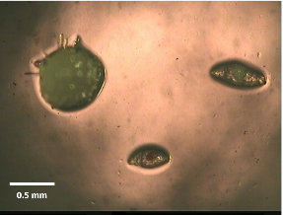 | 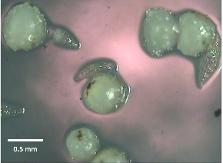
VW | 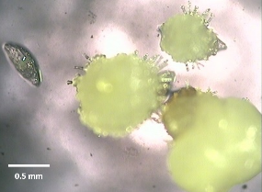 | 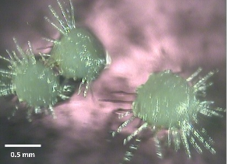 | 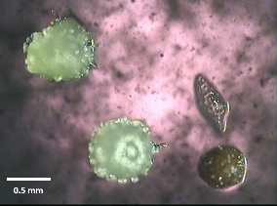
KC | 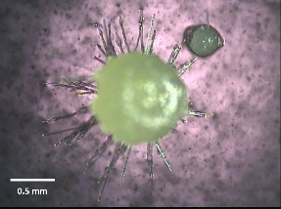 | 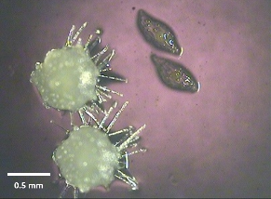 | 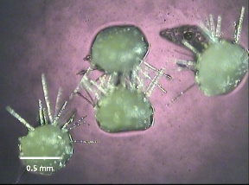

Figure 4. PLBs development of Grammatophyllum speciosum on four germination media and desiccation treatments, observed at 8 weeks after sowing, magnified 40×, bar = 0.5 mm.

Figure 5. Seed viability (%) of orchid seeds with TTC test: (1) seeds were directly soaked in 1% TTC; (2) precondition in sucrose + 1% TTC; (3) precondition in clorox + 1% TTC; (4) precondition in clorox + sucrose + 1% TTC; (5) seeds were directly soaked in 0.1% TTC; (6) precondition in clorox + 0.1% TTC. The mean ± SD followed by different letters indicates a significant difference according to Tukey B^{a,b} test at a significance level α = 0.05.

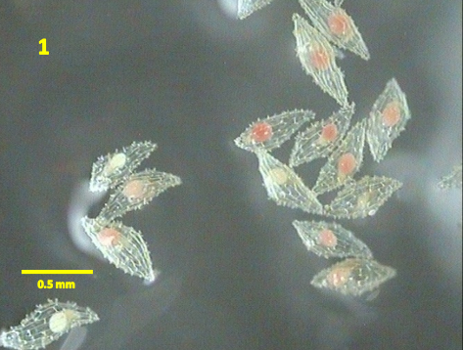 | 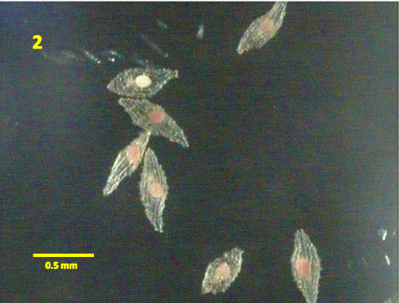
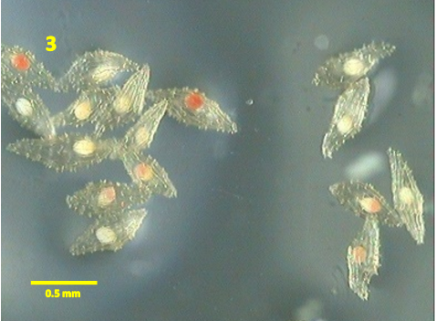 | 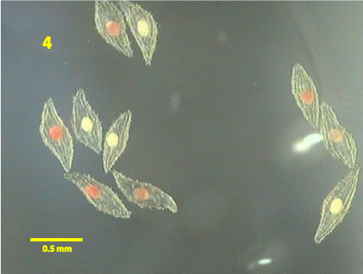
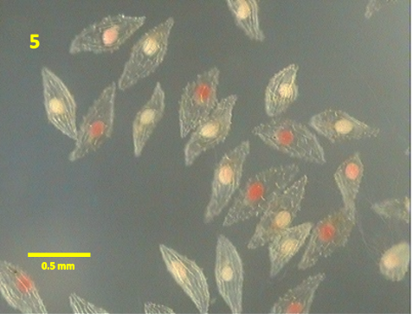 | 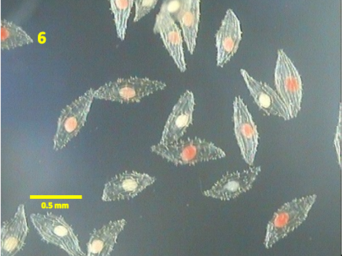
Figure 6. Effect of pre-condition treatments for red-staining of Grammatophyllum speciosum seeds in TTC test: (1) seeds were directly soaked in 1% TTC; (2) precondition in sucrose + 1% TTC; (3) precondition in clorox + 1% TTC; (4) precondition in clorox + sucrose + 1% TTC; (5) seeds were directly soaked in 0.1% TTC; (6) precondition in clorox + 0.1% TTC. All pictures were magnified 40×, Bar = 0.5 mm.

Table 1. Seed relative humidity (RH) percentage after drying

Duration in desiccator (days) | eRH (%)
3 | 54.60 ± 1.31
6 | 52.83 ± 1.58
9 | 50.57 ± 3.11

Table 2. Improved seed viability treatments

Treatment code | Clorox precondition | Sucrose precondition | TTC (w/v)
T1 | - | - | 1%, 18 hours
T2 | - | + | 1%, 18 hours
T3 | + | - | 1%, 18 hours
T4 | + | + | 1%, 18 hours
T5 | - | - | 0.1%, 4 days
T6 | + | - | 0.1%, 4 days

Table 3. Seed germination of Grammatophyllum speciosum before and after storage with some drying time in a desiccator.

Storage time (years) | Germination (%)
 | Duration of drying time in a desiccator
 | 3 days | 6 days | 9 days
Fresh (0) | 73.41 ± 5.20 a | 61.13 ± 4.53 b | 60.20 ± 8.32 b
Stored (1) | 72.42 ± 5.97 a | 63.11 ± 8.19 b | 63.73 ± 2.45 b
Note: The mean ± SD followed by different letters in the same row indicates a significant difference according to Duncan's test at significance level α = 0.05

Plants of the World Online (2023). Grammatophyllum speciosum Blume. Webasite https://powo.science.kew.org/taxon/urn:lsid:ipni.org:names:636310-1. [access on 10-August-2023]

