Agro Automation-Unmanned Smart Farming for the Improvement of Agriculture Based on Internet of Things (IoT)
Dr. Mohamed Junaid K.A^{1*}, Dr. Sukhi Y², Dr. Anita S³
^{1*}Principal, Electronics and Communication Engineering, R.M.K. Engineering College Kavaraipettai, Tamil Nadu, India
^{1*}Email: mohamedjka1205@gmail.com
²Professor, Department of Electrical and Electronics Engineering, R.M.K. Engineering College, Kavaraipettai, Tamil Nadu, India
³Associate Professor, Department of Electrical and Electronics, R.M.K. Engineering College, Gummidipoondi, Kavaraipettai, Tamil Nadu, India

Abstract
This paper is especially offers with low fee smart irrigation for agriculture land based on IoT. Irrigation of agricultural land the usage of manual technique is time consuming and tedious. Farming is one of the maximum crucial occupations in India. Especially our villages stay through farming. In order to offer way to this tedious process, it's stimulated for designing a smart machine that no longer simplifies the irrigation process, however additionally makes it extra efficient. The farmland’s homes are measured the usage of sensors and they may be all multiplexed through Node MCU microcontroller. The collected statistics is processed through the microcontroller itself, and dispatched to the cloud server. The cloud server acts as a bridge and sends statistics to the cell phone. The valve actuates with the cause acquired from the sign dispatched through the cell phone. When it’s actuated, the water valve is opened to the area. This make certain higher performance and additionally effects in good sized water saving. Hardware setup turned into advanced and examined inside the crop land. The advantages acquired in terms of yield and man power are considerable to the farmers.
Keywords: Agriculture, automation, drip irrigation, water usage, IoT, soil moisture, temperature, humidity.

1.Introduction
Modernization of agriculture is essential due to the fact it is intently associated with agriculture civilization. Agriculture is straight forward to the soil circumstance (Avunduk et al 2021) i.e., the soil need to be appropriate for agriculture. The knowledge approximately the soil circumstance is wanted for plant growth. Soil need to have the traits required like water garage capacity, vitamins for the boom of plant. Good agriculture (Ghoashy et al 2020) offers precise quality, constant meals deliver to the nation. The growth in populace gets sufficient meals and could now no longer starve because of the improvement with inside the agricultural fields. Agriculture acts as a supply of task advent for the developing populace. It additionally contributes gross home product (GDP) of the nation. This is focus on agricultural improvement, which will increase the GDP of the nation. Normally, farmers use traditional farming approach to irrigate crop fields inside the villages. This approach may be carried out in regions wherein water is to be hard plenty. Generally, the controllers are used to deliver water at normal periods all through the day. This is accomplished primarily based on preceding knowledge approximately the water availability and crop subject. This approach cannot offer an answer for the agriculture lands. This isn't always normal due to the fact farmers cannot continually depend upon the rain and herbal water sources. Excess rain damages the plants and because of much less rain the plants dies off. The success received on relying at the water utilization for the plant growth. The well deliberated water management (Miter et al 2020;Panday et al 2020;Dutta et al 2020) to the crop can enhance manufacturing. The water shortage in a place may be adjusted to a point with the aid of using the water delivery system. The facts approximately the scenario of the farmer land to be communicated to the worried person. Water deliver to the land need to be adjusted primarily based totally on soil, crop, water availability, and climate conditions. Precision irrigation (Ghobashy et al 2020)approach can offer earnings to the crop manufacturing because of its capability for distinctive plant.
Agriculture is the driving force for the improvement of civilizations. The growth in populace creates a sizable deficiency inside the food. In manner to fulfill this demand to growth the crops yield in step with rectangular kilometer. Technology is critical criterion for enhancing crop yields inside the improvement of crop production (Youzhi et al 20200). One of the foremost worries of USA is to lessen the variety of farmers, day via way of means of day. As in step with the latest report, most effective 21% of the United States of America’s populace is stated to take agriculture as number one occupation. This does concur that majority of the humans with agricultural heritage now no longer choose to take agriculture as a profession (Becker-Reshef et al 2020). This is because of the decrease pay grade than different occupations and especially because of the IT revolution. As the variety of individuals who soak up agriculture is reducing at an alarming rate, it's far centered to growth the variety via way of means of bringing state-of-the-art innovation primarily based totally on engineering technologies, which makes the paintings less complicated and greater green than ever before (Jiang et al 2020) The purpose is to automate particular responsibilities of farming via way of means of sensing numerous parameters and analyzing the facts received from the sensors . By placing limits for every parameter, farmers want no longer fear, because the sensors installation are continuously monitored. Therefore, if a positive parameter like humidity is going past the limits, that’s while the farmers gets notified and so they'll want to take care (Bronson et al 2020).
Water is the principle for cultivation of plant inside the farmers land. There is studies in the correct manage of water and upgrades in water storage. In order to put in force this sensors like plant viability sensor, soil moisture sensor, plant protection tracking the usage of camera, manage of irrigation water deliver are performed inside the fields. In the present day state of affairs Internet of Things (Milteretal 2020) performs a crucial position inside the agricultural applications. As according to the record of Aspirant World on June 30, 2020 concerning clever agriculture, the cultivation takes area in 20% of the land, which contributes 40% of the overall international’s meals deliver. In agriculture, water is one of the principal assets for the manufacturing of crop yields (Meena et al 2020). When the quantity of water utilization is greater than the desired quantity, it can result in detrimental impact at the soil. In order to plant crop manufacturing inside the proposed land, it's far essential to defend and enhance the herbal assets, mainly water (Dutta et al 2020). This will plant the crop manufacturing and meals deliver on a normal basis. This guarantees right techniques to put in force water saving inside the international the usage of modernization techniques. This calls for development inside the performance and versatility of the water transport (Liu et al 2020;Liu et al 220;Jang et al 020;Li et al 2020;Peng et al 219). By enhancing the performance of the water deliver, the quantity of water utilized by the plant is increased. The plant in the flexibility of water transport offers water to the person at the precise charge inside the preferred time for the desired time duration (Roy t al 2019;Arata et al 2020;ck et al 2020). In this regard the automation of water degree manages is implemented. In the existing state of affairs maximum of the irrigation water manage is performed manually. The studies and trends require the layout of automated irrigation controllers Liu et al 2020)for plant cultivation. Various controllers are used for water manage and manage algorithms for water regulators. These controllers have a few obstacles in the course of operation. The layout of those controllers is hard for realistic applications (ray et al 2020). Organization of the work is shown in fig 1.
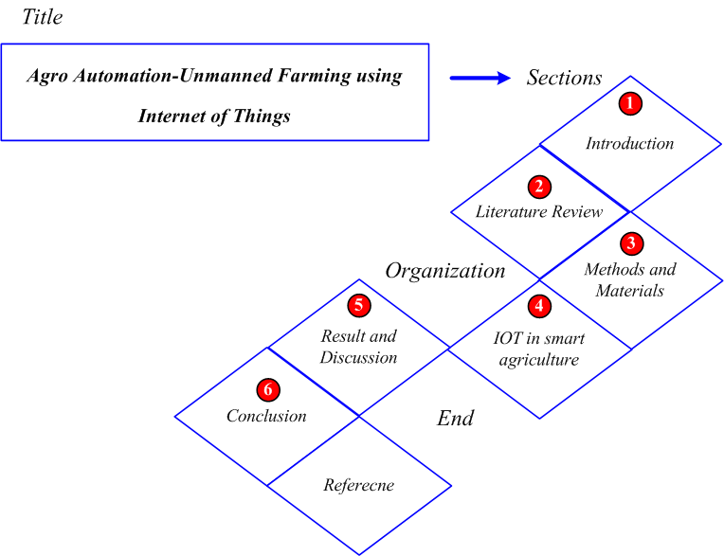
Fig 1: Organization of the work
To conquer those demerits of IoT primarily based on the total structures, it will provide higher solutions and extra advantages. The kind of PI decentralized controllers for irrigation reason below guide operation is hard to tune. To conquer the hazards of PI controllers, predictive controllers are used with robust behavior that is similarly changed the use of adaptive controllers.
2. Recent research work: a brief review
There was a variety of research work in the literature that relied on robots to remove landmines at low cost for the purpose of humane demining utilizing verity of techniques and features. Some of them reviewed as below,
Q. P. Ha et al. (2009) have presented the robotic autonomous system (RAS) development brought a novel horizon onthe construction's earth-moving process. The use of RAS technology in the military has grown in popularity. Ground-based forces are routinely asked for earthmoving tasks as part of military operations, which may be partially or totally helped by the use of RAS technologies. There have been rapid improvements in military construction automation utilizing higher-mobility ground based on platforms, human-machine, machine-machine interfaces, tele operation, control schemes, data transferschemes, machine perception, manipulation capabilities, advances in networked robotics, cyber physical schemes. M.Gheisarnejadet al (2019) have suggestedadaptive neural-fuzzy interface system (ANFIS) supervised by a single input interval type-2 fuzzy logic control (SI-IT2-FLC) to monitorthe speed of the 2-wheeled mobile robot (WMR). The suggestedmethod, a novel supervised controller can handle inherent non-linearities, uncertainties, exterior disruptions in scheme mode. The kinematic controller, which was classified using the robot's kinematic model, and the dynamic controller, which was constructed using the physical features on robot dynamics, was used to build the robot control in two phases.
Wanliet al. (2018) have exhibited a motion control system that allowsa mobile robot pass through selected waypoints in order to reconstructorbital motion. Initially, the parameterized trajectory optimization methodwas executed to make a curvature-continuous trajectory from waypoints, withlocation,speed demands were given as equalcontrols. To lower the computational burden, virtual locations were introduced to reduce oscillation, and the full execution time of the entire trajectory was chosen as the optimization parameter. An equivalency transformation was offered for the feedback controller design to transfer the error system into an affine form, which was advantageous. H. Jiang et al. (2019) was exhibited a new passively-actively convertible mobile robot that can navigate unstructured terrain. When stability and traction are enhanced, the robot's locomotion system may radically modify its posture to suit difficult terrain conditions by adopting a revolutionary adjustable side frame.With a balance-rocker system, the suggested robot can passively adapt to changing terrain conditions, ensuring that all 4 wheels may make contact with the ground. This robot can alter its ground clearance and balance its body. Principles and configurations were the 2 mechanisms given. The kinematics of the robot in active and passive modes composed of position as well as posture, were described utilizing a mathematical model for an effective design, control of the locomotion system. The forward, inverse solutions for the robot were calculated. V.Vjayakumar et al. (2019) was exhibited a robotics tasks were categorizedbased on common robotics applications, application-specific blocks abstracting particular actions. A factory worker with no programming competency canwrite robot programs by mixing these components utilizing a Graphical User Interface. A simulation solution was established to visualize, analyze, enhance robotic workflow before deploying. An autonomous mobile robot was combined with LBR to enhanced re-configurability, productivity. The system as an entire was controlled utilizing an event-driven distributed control system. Lastly, the system's capabilities were assessed utilizing Industries 4.0 design principles, prospective future research topics were addressed in order to further develop the system. T.Tsurutaet al (2019) was presented an automated mobile robotic schemetodesign free access floors. Drawing grid-pattern lines whose intersections (making the places of future pedestal bases) can be automatically marked by the suggested system, which contains a mobile robot with a device and laser positioning unit at its center, is required for the building of such sites. When the laser positioning unit precisely moves a line laser along a chosenpath, measures the distance to a projected item, cross marks were made on floor by controlling the marking method. The marking robot would follow thelaser to apredeterminedposition. W. Zhenget al (2019) was exhibited the adaptive robust finite-time bioinspired neurodynamics control (ARFBNC) for a class of mobile robots with unmeasurable angular speed,numerous time-varying bounded disturbances. The faultscheme of mobile robot was decayedin2sub schemesin term of aschemes mode. Two subsystems were designed with state feedback control rules, disturbance feed-forward compensators.The ARFBNC system is made up of 2 subsystems, state feedback control laws. The stability criteria in the form of linear matrix inequalities (LMIs) were established using the Lyapunov–Krasovskii functional.In contrast to previous studies, the un-measurable angular speed, various time-varying bounded disturbances were effectively approximated.
2.1. Background of the research work
A review of the recent research work displaysa landmine defusing robot for the purpose of humanitarian demining.The main objective of most research on landmine defusing robot is to detect the mines without the loss of human life. Such disturbances mainly occur during the Deming process. Many controllers were actualized for the landmines defusing system such as adaptive neural-fuzzy interface system (ANFIS) controller; adaptive robust finite-time bio-inspired neurodynamics control (ARFBNC), linear matrix inequalities (LMIs) etc. The ANFIS is used for the purpose of velocity tracking task in the mobile robot. Also it has more complexity. Although the above techniques are used for the detection of landmines, the complexity of the algorithm is very high due to increased number of samples required. In related works, few controllers are presented to detect the mines and manage the cost of mobile robot; the above-mentioned limitations have inspired to do this research work.

3. Modelling of automation-unmanned farming based on iot
There is a water scarcity for irrigation in lots ofcomponents of the sector. There can be wastage of water in the irrigation of lands if the water isn't always used efficiently. This ends inadvice water saving techniques for irrigation. Water saving irrigation techniques is being carried outglobal to offer sustainable agricultural manufacturing. One of the brand newtechniques of water saving generation is the exchange partial root irrigation technique. In this technique of plant increase, 1/2 offacet of the plant is provided with water in the first flip of water deliver to the plant. In the subsequentflip, different1/2 offacet of the plant root is watered. This technique of watering the plant root as an opportunity produces abscises acid in theroots that is taken to the shoots. This reduces the openings in the stem part, which ends up inrestrained transpiration and extra wastage of water consumption. This technique reduces the quantity of water used for irrigation approximately 30% to 50%. But this irrigation technique does now no longerlessen the nice of the yield compared with the traditionaltechnique of irrigation. The different new generation for plant irrigation is drip irrigation. This technique is utilized indiversecomponents of the sector and this technique improves the performance of the water utilization and giveshighernice yield. By combing the drip irrigation and exchange partial root irrigation, exchangepartial root-sector drip irrigation technique is carried out. But exchange partial root irrigation and exchange partial drip irrigation techniques did now no longersupplywhole lot variationsin the water utilization. So it's been concluded to put in forcetraditional drip irrigation for developingflorato supply yield. In case of exchange partial root irrigation, a number of the elements affecting crop manufacturing are soil water content, threshold values for water to begin irrigation, crop yield, nice, and water use performance are considered. It has been anticipated that plant increasethe use of pot testconfirmed a badmanufacturing. It is calculated that the lower in yield with the aid of usingpercent is round 22%. Therefore, it's faressential to take a look at the decrease soil water threshold for flora to make use a technique for plant increasewith the intention toenhance the water usageperformance. Therefore, significance has to accept for the decrease soil water threshold and the crop yield. Low soil water threshold values for developingspecialflora, the anticipatednice of the yield and the irrigation water use performance are studied. The final results of the take a look atfurnished a sturdy theoretical help and the idea for extragreen water control system.

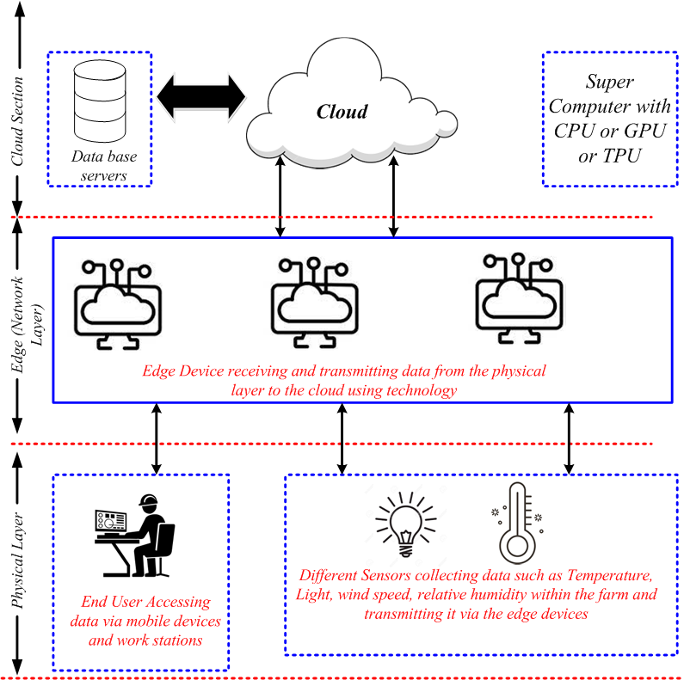
Fig 2: IoT cloud based smart farming
Agriculture is one of the principal sources of earning. It produces a wonderful effect on economy. Therefore a higher improvement in the area of crop developing is essential. In India, irrigation manipulate is finished through guide methods. This guide technique can't preserve the right situations properly. This guide can't deliver most suitable crop yield. This may be furnished most effective with appropriate temperature and moisture situations. A module is evolved for measuring the crop area parameters the use of air temperature sensor, soil temperature sensor, soil moisture sensor and soil humidity sensor. The diverse parameter values acquired from the sensor are processed in the microcontroller through evaluating with the edge values saved in the microcontroller. The values are dispatched to the person through IoT. If the parameter values are in the threshold values, then the parameter values are received from the sensors constantly and the statistics is dispatched to the person. When the parameter values are out of doors the edge range, then notification is dispatched to the farmer to take the essential action. Farmers can view the facts anywhere. This manipulate device may be tailored in which there may be shortage of water is present. This manipulate device is extra green in lots of places. The law of water and the use of computerized manipulates will bring about accelerated productiveness with much less guide work. This technique makes use of arduinouno board to get hold of enter from the sensors. The statistics received from the sensors are dispatched to the cloud thru GSM sim. Using this setup statistics acquisition is applied. The gadgets used on this technique are strength green and cheap. The average device is value powerful and robust. The respond from the farmer is sensed the use of raspberry pi, that's the primary a part of the communiqué and coding is finished the use of python programming. The micro controllers get hold of the farmer’s instructions from the raspberry pi. In this situation ZigBee protocol is used for the communiqué purpose. In this situation routers are used to attach the quit gadgets. The proposed device makes use of drip irrigation to water the plants, which leads to higher water utilization for the crop land. This device may be applied for small in addition to massive vicinity crop lands. The valve beginning and remaining is finished the use of a microcontroller on the farmers command to permit the float of water in the crop land. The whole device has each hardware and software. The evolved hardware is applied in the okra area the use of drip irrigation.
All soil and the atmospheric situations in the agricultural lands are sensed through the farmers themselves through journeying the farming lands. Farmers are used to live in the farmlands to defend their plants towards sure animals and birds inflicting harm. Water passing gadget in the fields is completed manually through the people or farmers. All soil and atmospheric situations in agricultural lands are sensed through the sensors in the farmlands and data is exceeded to the farmer’s cellular app thru IoT from anywhere. Cloud related Camera in the discipline presents stay pictures of it thru the app. Water passing is actuated through solenoid valves the use of IoT era may be managed from cellular app itself from anywhere. Agro automation is a fixed up evolved for farmers to test the parameter price variety of limits to offer higher harvesting. The evolved gadget offers intimation to the farmer concerning the soil situation. The evolved gadget is greater appropriate for Indian farmers despite the fact that they're now no longer literate. In the evolved gadget soil parameters including moisture content material of the soil, pH price, temperature and humidity of air are measured the use of sensors. The measured values are as compared with the right values of the crop. The distinction among the right price and the real price measured notification is ship to the farmer thru the clever cellular phone. This facilitates the farmer to determine upon the on/off situation of the water delivery system. The data approximately the agro automation to the villagers helped loads to enhance the pleasant of grain and additionally a extensive kind of grains for cultivation. IoT presents a critical answer in the agricultural industry. These industries assist the human beings of round 10 billion in the earth through 2050. With the advent of IoT primarily based totally systems, green use of water and fertilizer produces multiplied yield. The plant of plant changed into completed in a farmland in Kavaraipettai village of Thiruvallur District, Tamilnadu, India from Sep 2019 to March 2020. The common air temperature changed into 32.6 degree C, relative humidity 72%. While developing the crop the temperature of the sphere various among 28˚C and 34˚C.
4. Modelling of iot in smart agriculture
As shown in Figure 2, the IoT is a sensible, promising generation that gives unconventional and realistic sources in variety of areas, including smart cities, smart homes, visitors manipulate, healthcare, smart agriculture, etc. In the rural field, IoT generation has made enormous improvement in agricultural control. This generation permits all agricultural system and is to be related to make the suitable selection in irrigation and fertilizer supply. The smart structures decorate the accuracy performance of system that tracking plant or even elevating livestock. Wireless sensor networks (WSNs) are utilized to gather information from special sensing system. Furthermore, cloud offerings also are important to be incorporated with IoT to investigate, manner the faraway information that helps selection-making to put in force the great decisions. Smart farm control calls for the usage of ICT, floor sensors, and manipulate structures hooked up on robots, independent vehicles, and different automatic system. The achievement of smart structures relies upon on high-pace internet, superior cell system, satellites to deliver (pix, positioning).
According to the Food, Agriculture Organization (FAO 2017), approximately 20–40% of plants are misplaced yearly because of pests and sicknesses and due to loss of appropriate tracking of the country of the crop. Therefore, the usage of sensors, smart structures lets in tracking of climate factors, fertility status, and additionally figuring out the precise quantity of fertilizers essential for crop growth.
4.1. Smart Sensing for Agriculture
Sensors are liable for measuring, tracking entire elements in smart scheme; e.g., soil fitness tracking has unique sensors which include vitamins contents, phosphate contents, soil moisture, compaction,etc. The smart irrigation system includes several sensors for tracking water levels, irrigation efficiency, weather sensors, etc. Automated Wireless smart Sensors is shown in fig 3.
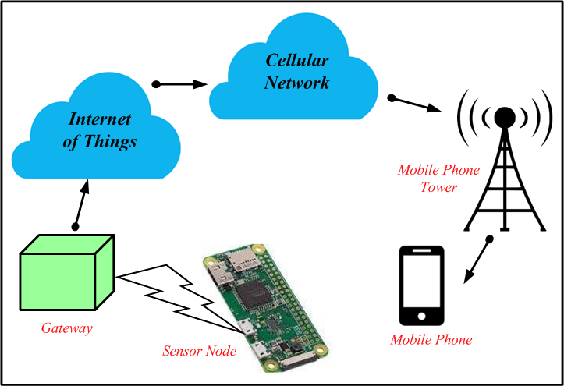
Fig 3: Automated Wireless smart Sensors
The sensors can measure and reveal the modifications in soil and yield properties and neighborhood climate on-farm sites. So, the sensors can collect the unique statistics for use for the evaluation of the farm statutes and for creating an appropriate decision. These smart sensors reveal the version in soil, crop, cattle health, in addition, make contributions to decorate the rural product in phrases of amount and quality. The preferred sensors utilized in smart farming networks are soil moisture sensors that use to degree the alternate in soil moisture, soil temperature used to degree the reveal the temperature in soil, air temperature, soil pH value, humidity, N, P, K sensors, etc.
4.2. Application of IoT in Smart Farming
Smart systems are situatedmostly with IoT, as it denotes the backbone in all smart applications; the most essential applications of IoT smart farming are as follow:
4.2.1. IoT Based for Drones
Drones had utilized commercially in agriculture because an early 1980 s in constrained usage, however with improvement of communiqué generation, multiplied usage of IoT, the usage of unmanned plane takes very significant.
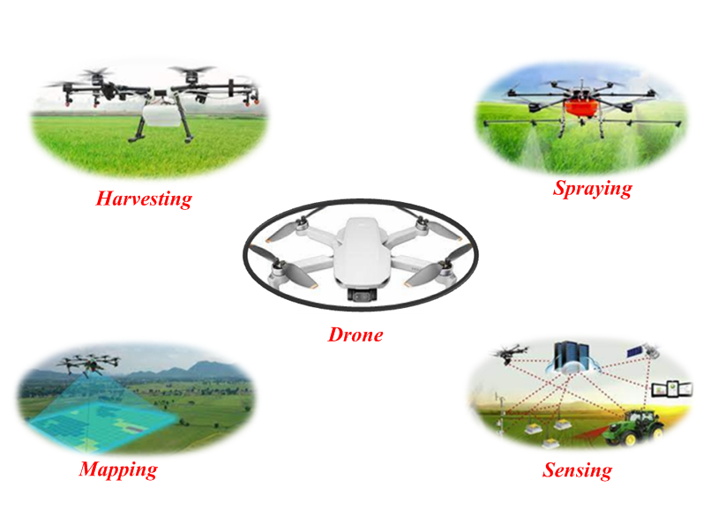
Fig 4: Usage of agricultural (Harvesting, Spraying, Mapping, Sensing)
It can carry outvariouscapabilities that causeenhancing agricultural practices. Examples of drone operations are irrigation, tracking crop health, planting, crop spraying, crop inspection, soil analysis.

4.2.2. IoT Agricultural Robot
The agricultural robotic is a robotic used in lots of agricultural practices. IoT has contributed to the improvement of robots to be finished more than one agricultural activity, in which robots can carry out many capabilities rather than humans. In the United States and Europe and many nations in Asia, they prolonged to using such cutting-edge generation in agriculture, in which robots have stepped forward agriculture efficiency, as they decreased working charges and decreased working time.
5. Impact Of Climate To Smart Farming
Compared to soil heat storage, the energy factors consumed during photosynthesis are factors that affect surface flow and soil advection (Zheng et al 2019). From this study, higher surface heat flux appears to be proportional to a thinner, well-watered canopy with regular advection. The limitation of this study is that the data used were collected in a short period of time. Long-term recorded datasets would have provided much better results and robust assessments and analyses. If you had collected records at the beginning of the planting season, collecting records early would have yielded better research results. Their study shows that shorter day lengths and lower daily minimum temperatures can cause leaf aging processes. It is used to determine leaf color and tanning data that indicate the impact of climate change on carbon cycle, but does not explain the rate of change in vegetation color over a day or over a period of time.
5.1. Cloud-Based IoT Smart Farming
ICT technology can enhance the extent of interplay (Bayrkdar et al 2020) among the small-scale farmers and the farming professional tremendously. It may be inferred from their studies that the Geo Farmer answer can assist the farmers proportion with each the favorable reviews and demanding situations they encountered in the farm (Meier et al 2020). It has been determined that the Geo Farmer answer additionally supplied Interactive Voice Response (IVR) capabilities permitting the farmers to have voice conversations with the facilitators thru their clever phones. This has helped them to offer a higher rationalization of the final results of the expert recommendation they obtained from the farming professionals specifically in regions in which net connectivity may be very limited. It is observed that the answer supplied a professional to the farmer, farmer-to-farmer interplay which helped records sharing, information collection, and assessment process.
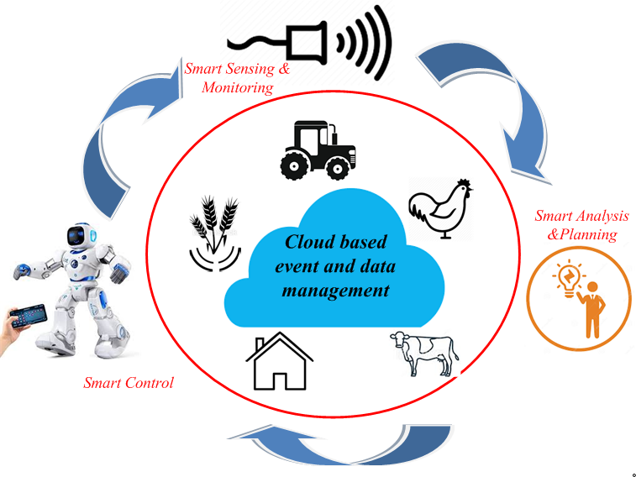
Fig 5:Structure ofSmart Farming Cycle
The limitations in their studies is that the solution cannot display the farmers’ attitudes and practices closer to the Geo Farmer which gives room for in addition research in the studies. The involvement of customers with very little ICT capabilities has created a mission for those classes of customers. IoTs may be used to adjust the outlet of valves for actuators hooked up for the irrigation device to keep away from water strain to the crops. It may be deduced from their studies that farmers are knowledgeable remotely of the soil water situation through textual content message saving time of tour in the farm, making the farming device an automatic one and offers particular measurable water situation of the soil at the farm. This will assist the disorder in the soil because of immoderate watering of the soil. The limitations of this work are that the software evolved cannot degree the day by day water of the plant.
5.2. Functional Block Diagram of Sensors with Aaduino Uno
IoT module calls for DC voltage for its operation. It is derived from the EB deliver. EB deliver voltage is 230 volts AC deliver. This voltage is stepping right all the way down to 7 volts based on the use of step down transformer. Then it's far transformed into DC voltage the use of bridge rectifier. The variable DC voltage is filtered the use of LC clear out elements. Then it expenses the battery. Battery is used to deliver strength to the modules. IoT is used to manipulate the water circulate the crop discipline. The information of the crop discipline is examining the use of sensors. The information is dispatched to the cloud the use of arduinouno and coffee price ESP wifi microchip. This consists of the transmission manage protocol and the net protocol. This is used to switch information from sensor to the farmers. The information is dispatched with excessive accuracy. The sensors used to degree the information are the humidity sensor and the temperature sensor. The information acquired from the sensor is represented graphically for evaluation purpose. This information may be analyzed in which ever with the aid of using the farmers. Humidity is the ratio of the moisture content material at an area to maximum quantity of moisture for the required air temperature. Generally humidity sensor is used to discover the moisture content material in air and its temperature the use of substrates with electrodes. The humidity sensor output values are information with 40bits, which has each decimal values and vital values. In those sensors, unmarried bus communicates the sign and synchronizes the information among sensor and microcontroller unit. These sensors are positioned in a blanketed area. Humidity sensor measures humidity with accuracy in the variety of 20% to 80%.
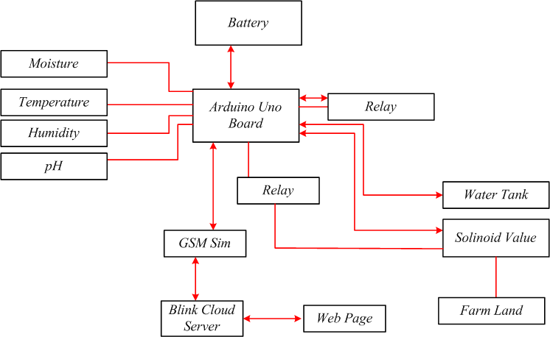
Fig 6: Functional Block Diagram of Sensors with Aaduino Uno
The air temperature is measured the use of thermistor and the water content material of the soil is measured the use of the humidity sensor. In those sensors the analog information is transformed into virtual form. It is simple to apply those sensors. These sensors take 2sec time c program language period to gather the information. After the information collection, information mining algorithms and strategies are used to provide statistics approximately the cultivation. K-approach clustering is used to method the senor information. In the clustering method, information from the sensor is grouped as comparable gadgets. The comparable gadgets are categorised into diverse groups. This could be very beneficial whilst adjustments are accomplished. It is a vector quantization approach. This approach makes use of sign processing for the evaluation. The enter information required for the evaluation is acquired from the sensors that are transformed into the use of system gaining knowledge of technique. Here programming is accomplished the use of python language. The limits for the crop subject are taken as a centroid of the cluster. The output from the cluster is primarily based totally at the class of information. The output is dispatched to the net page. The information may be visible in the cellular Smartphone the use of android app. The required movement may be taken the use of the information acquired in the cellular Smartphone.
The sensors are linked to the IoT module. The sensor alerts are acquired through the arduinouno board. Arduinouno board has microcontroller, Electrically Erasable Programmable Read Only Memory and Static Random Access Memory. The microcontroller has analogue to virtual converter. ADC has thirteen virtual pins and six analogue pins. The reminiscence in the microcontroller allows saving the statistics even supposing the strength deliver to the micro controller is disconnected. Voltage regulator 7805 continues a consistent output voltage for the operation of the microcontroller. The temperature and the moisture content material is measured the usage of DHT11. LM293 is used to degree the soil moisture as analog value. The output of this sensor is hooked up to the microcontroller and saved in the reminiscence unit. It is ship to the registered cell Smartphone through cloud. Once the sign is acquired in the cell Smartphone, the selection is taken through the farmer concerning the popularity of the solenoid valve. If the farmer desires to spark off the solenoid valve, the farmer has to press “ON” in the cell Smartphone. When the farmer activates the valve thru the cell Smartphone, the sign is ship to the microcontroller the usage of the cloud server. The proposed device has a faucet that's on open situation usually. The water usually reaches the solenoid valve position. The water is furnished to the plant life handiest while the solenoid opens and lets in the water to flow. Solenoids are utilized in automation purpose, which converts electric electricity to mechanical electricity. A coil is wound across the magnetic cloth to supply an electromagnet. This is an electrically operated device. Solenoid valve is commonly used to open/near water pipes to manipulate the quantity of water flowing into the field.The hardware setup working and practicality of the project was evaluated. The project hardware is setup in a metallic enclosure to protect the hardware from extreme temperatures, protect hardware from the water, prevent dust in the hardware, and prevent third person access to the hardware. The Soil Moisture Sensor is the only remote sensor in the model. This sensor is isolated from the rest of the hardware and placed in the field. This sensor is very essential for the core process of the model. This sensor sends vital field data to the microprocessor, and it is also said to withstand temperature levels. The solenoid valve is one of the most important components of the model; the valve opens and closes according to the tripping of the relay.
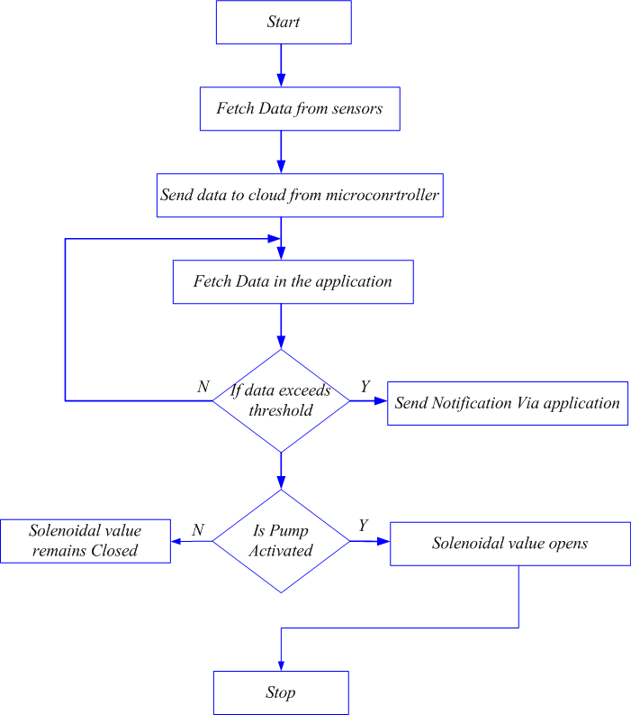
Fig 7:Flowchart of the process for sensor data and Solenoid valve operation with NodeMCU
The tripping of relay is take care with the aid of using the microcontroller, and overall, the go with the drift of water is managed. The dripper in the subject additionally has same significance as one of the fundamental goals whilst growing the version is water control. Drippers are a great answer for water control as they constantly permit water in drops. So addition of a drip irrigation device isn't any brainer for this project. The cell utility created the use of the Blynk platform can manipulate and sensing element’s output will be derived. The app indicates the crucial statistics of the subject, whilst additionally offering the choice to permit water in on every occasion there's a water scarcity notification, which is likewise thrown in the app. The algorithms are coded as consistent with Microcontroller Programming languages and needful instructions are used. All hardware additives are unit examined and managed the use of appropriate codes and instructions for the respective sensors. Bugs in the Software element are rectified. Reliable paintings of the hardware software program integration are ensured.
BLYNK App is evolved for interfacing the use of IoT. Remote managing of the hardware may be accomplished with clever Smartphone the use of Blynk server. This is an open supply server used to messages among the clever cellular Smartphone and the hardware the use of microcontroller. Devices even in the variety of hundreds may be related to it. Blynk server may even be released on a Raspberry Pi. The saved records may be dispatched server and displayed the use of this App. There are blynk library commands, which might be used to run the procedure and talk with the server. ARDUINO IDE is software program used to edit, assemble and add this system at the arduino device. This is open supply software program. Arduino Integrated Development Environment is used to jot down application for the characteristic of gadgets related in the system. This may be very likeminded software program. Functions like debugging this system then enhancing and compilation are accomplished on Java platform. This may be utilized in working structures like Lunux, MAC machine, home windows easily. Compilation the use of this software program is straightforward and the understanding to jot down this system may be learnt easily. Software library of Arduino IDE has not unusual place enter and output procedures. USB port is used to attach the Arduino board to the pc. Now the Arduino IDE is hooked up to the pc thru USB. There are one of a kind arduino modules present in the market. Each module has a microcontroller. Arduino code is written in the IDE with the aid of using the person is modified to a file. Editor is used to jot down the code and the compiler is used to assemble the code after which add it to the arduino module. This is uploaded into the microcontroller and finished after which sends to the sensors and valve. One of the principle reasons of the challenge is water management.
6. Experimental Setup
During the conduction of experimentation and assessment of values from the place, manure is brought in the land. The way brought to the sector is urea, calcium high-quality phosphate, potassium sulphate. On 10thDec 2019, 10 rows of okra is planted in a place of 400m2 place with uniform hole of 1m in width sensible and duration sensible among flowers. The quantity of water utilization for plant is managed primarily based totally at the message acquired in the cell phone. The delivery of water for okra plant is completed the use of drip irrigation method. The irrigation is completed for 30 instances with a time hole of about 2 days and the technique ended on 18thFeb 2020. The water deliver machine has a huge tank of 20000litres of water. The water is fed from the tank via a tap that is on circumstance all of the time. The foremost water deliver machine from the faucet is fed via a pipeline as much as the solenoid valve. The water could be provided to the flowers simplest if the valve is opened. There are 10 rows of water deliver traces through the five bends in the top give up and five bends in the decrease ends. A 2cm complete length is made in the 1inch drip pipe at a distance of 1m. The drip pipe is placed at a distance of 5cm far from the plant. Soil moisture is measured the use of the soil sensor positioned in the subject at a distance of 3cm far from the plant. The water content material in the soil for 0.15m is measured. When the water content material reaches 80% subject capacity, irrigation need to be commenced and it's going to prevent while it reaches 95% subject capacity. The irrigation calculation is primarily based on the posted paper. In case of plant boom the water required for extraordinary levels of the plant varies with the plant kind for cultivation. The irrigation pipes are operated manually for the duration of the change partial drip irrigation method. Initially the water is authorized in a single facet of flowers after which it's far opened in the different facet.The crop land for the irrigation and yield turned into a floor region of 20m. Generally the irrigation techniques like overhead sprinkler, flood kind are the maximum green techniques for green water utilization. When those techniques are used for water deliver to plants, there's needless water wastage. The water wastage is resulting from a fungus that develops because of the over moisture in the soil. It may be very important to preserve water via agro automation. It is in the end viable for the farmland. As according to the literature evaluate water used for irrigation from the water assets of the sector is round 85%. Due to the growth in international population, this percent of water utilization for irrigation can also additionally growth. For this reason, it's miles important to make use of the water correctly based on the usage of technology.

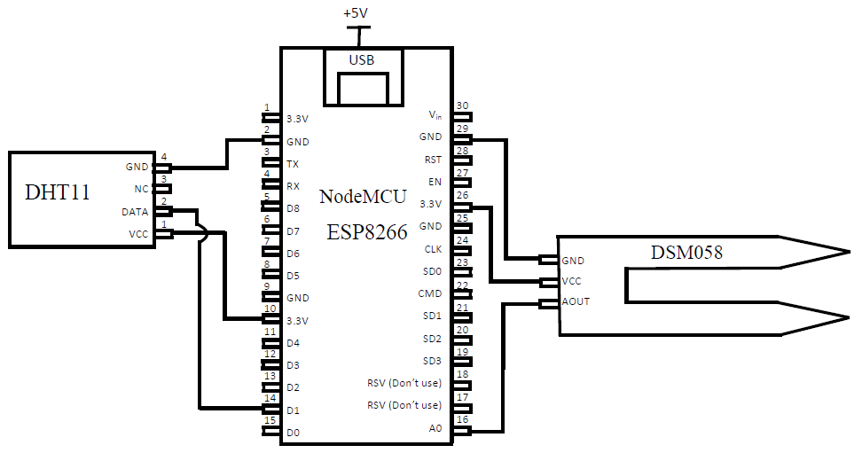
Fig 8: Connection of Sensors with Node MCU
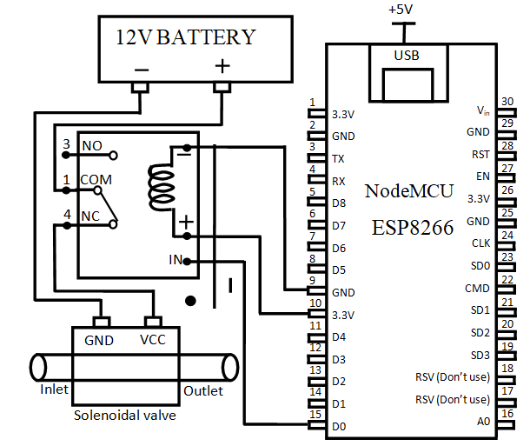
Fig 9: Connection of Relay and Solenoid Valve with NodeMCU
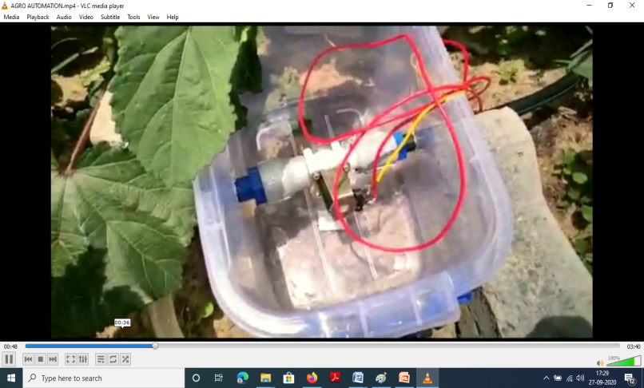
Fig 10: Solenoid valve connected to the primary water source
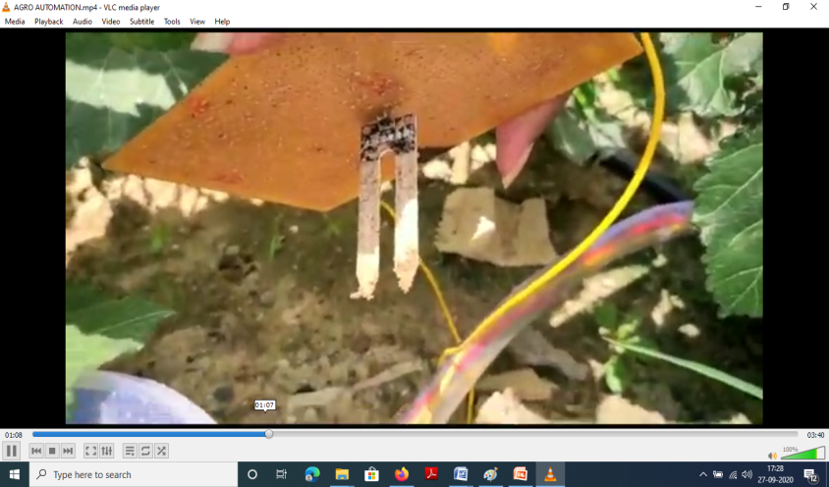
Fig 11: Moisture sensor connected directly in the field
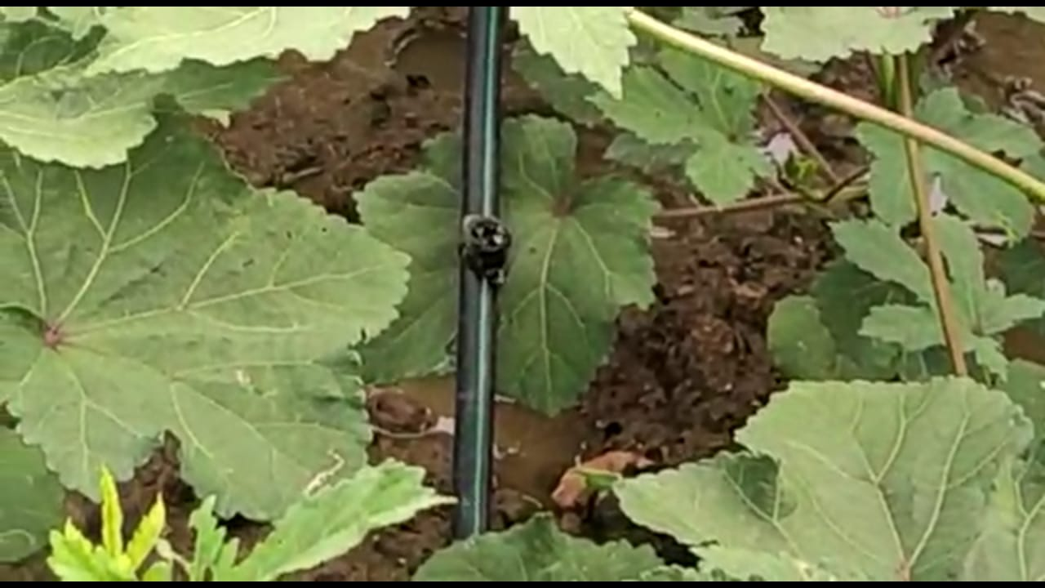
Fig 12: Drip water management in the field
The water is applied for irrigation after the provision of water is monitored the usage of remarks manage techniques and sensors. Cloud computing allows to shop and method the information associated with the irrigation parameters like temperature and soil moisture. IoT is used to obtain the information from the fields and the user. IoT primarily based totally agro automation is used to govern the quantity of water via clever Smartphone and to screen the situation of the plants. In order to supply higher yield from the crop the usage of agro automation, the gadget has 3 distinct modules. Fig 7 shows the connection of the sensors with the NodeMCU. The moisture sensor DSM058 and humidity and temperature sensor DHT11 are connected to NodeMCU. Fig 8 shows the connection of the Relay and Solenoid Valve with NodeMCU. The input/output pin of the NodeMCU is connected to the control input pin of the relay.The hardware setup operating and its overall performance is being justified. The hardware setup is sealed inside metal enclosure to shield the hardware from severe temperatures, to shield hardware from the water, save you dirt in the hardware, and save you 1/3 individual get admission to the hardware. The Soil Moisture Sensor is the most effective far flung sensor version and it's miles separated from enclosure. The transmission of discipline information is through the sensor and microprocessor is signed. Depending upon it the microcontroller sends a command sign to relay. The solenoid valve’s action/inactivity is validated thru tripping of relay. The dripper is taken into consideration as principal objectives; as it offers a super answer for water control as they continually permit water in drops. Fig 9 indicates the solenoid valves related to the number one water supply in the discipline. Fig 10 indicates the moisture sensor positioned related without delay in the discipline in the farmland in which crop became planted. Fig 11 indicates the water control carried out the use of drippers in the dripper pipes, in order that extra water wasted may be minimized.
6.1. Sensor Data of smart mobile phone
The cell software created the use of the Blynk platform that offers water on every occasion there may be a water scarcity notification, which is likewise thrown in the app. An App is designed the use of a 3rd celebration cloud source, named Blynk for its function. The algorithms are coded as in line with Microcontroller Programming languages and needful instructions are used. All hardware additives are unit examined and managed the use of appropriate codes and instructions for the respective sensors. Bugs in the Software element are rectified. Reliable running of hardware software program integration is ensured. Fig 12 shows the sensor data shown in the smart mobile phone. The notification received in the smart mobile phone, which is available with the farmers help them to know the condition of the farmland even though they away from the crop field. BLYNK App is developed for interfacing IoT with mobile phone. This is an open source server used to messages between the smart mobile phone and the hardware using microcontroller. Even possibility of thousands of device can connect at a time in it. Blynk server can even be launched on a Raspberry Pi.
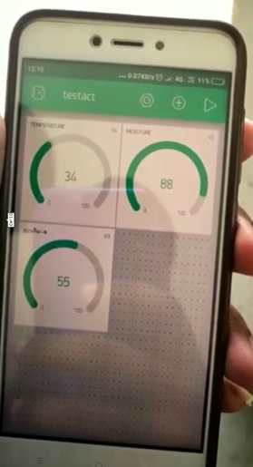
Fig 13: Sensor Data shown in Smart Mobile Phone
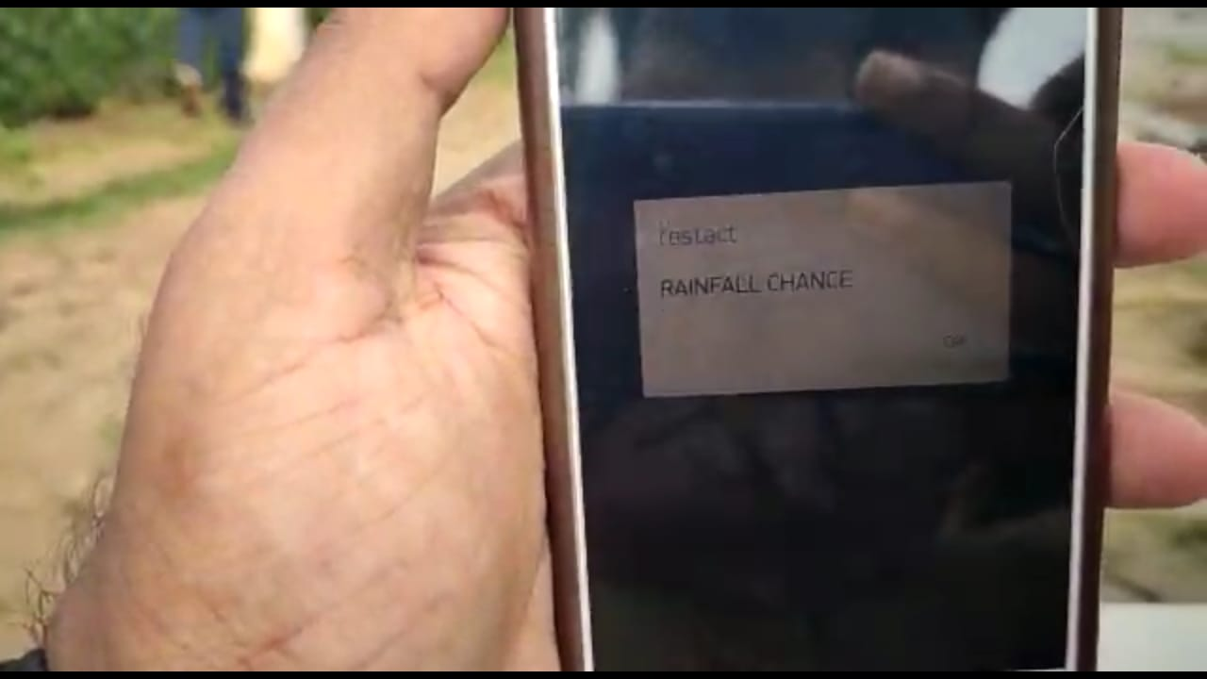
Fig 14: Notification received in the mobile
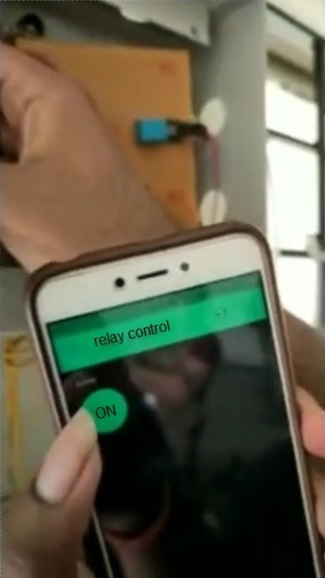
Fig 15: Relay control using Mobile phone
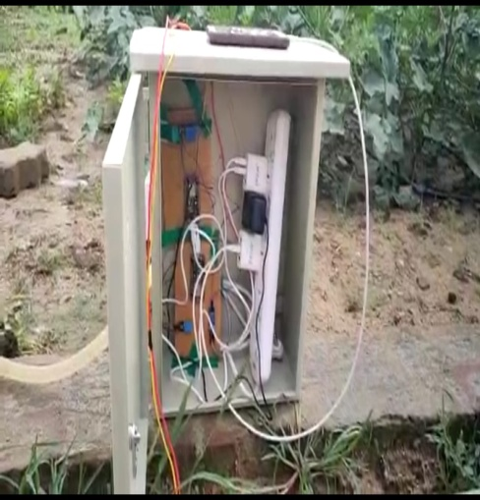
Fig 16: Microcontroller module enclosed in metal box
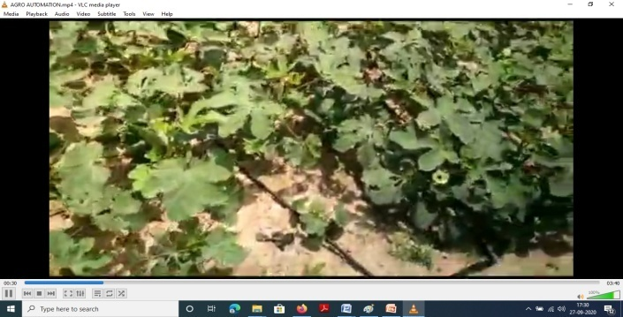
Fig 17: Crop field where drippers and sensors were implemented
The saved statistics may be displayed based on the use of this App. There are blynk library instructions which can be used to allow the verbal exchange with the method and the server. ARDUINO IDE software program lets in modifying, compiling and importing this system in the arduino; those are depending on editor preference and relying upon this system dumped in it, the characteristic of gadgets is established. Functions like debugging this system then modifying and compilation are accomplished on Java platform. This may be utilized in running structures like Lunux, MAC machine, home windows easily. Compilation the use of this software program is straightforward and the information to put in writing this system may be learnt easily. The supply code written in C language for the automation method is covered as annexure. USB port is used to attach Arduino board to laptop. Now the Arduino IDE is hooked up to the laptop via USB. One of the primary reasons of the paper is water management. Fig 13 suggests the notification acquired in the cell at some point of the rainfall condition. This will assist the farmers now no longer to replace at the motor for the sector watering. Fig 14 suggests the operation of the relay manage the usage of Mobile phone. This suggests that the farmers can open the valve in the cropland and the usage of cell from anywhere. Fig 15 shows the microcontroller module enclosed in the metal box. The setup placed in the field area helps to get the air temperature and the humidity level of the cropland. Fig 16 shows the crop field provided with drippers and sensors. It can be noted that the land production yield has increased with proper supply of water to the land. This reduces the total cost spend for production of crop yield.
7. Result And Discussion
To deal with the developing shortage of water, the proposed paintings implements a dripping water system, which has simplest advantages that the farmers supplying higher approach of irrigation, additionally guarantees that pH stability of the soil is maintained. Based on information accrued because 1990, it's been discovered that there's a reducing fashion discovered in the according to capita water availability in India. Exploitation of groundwater aside from discount in water exceptional and exploitation of aquifers in maximum growing nations has caused the modern-day sit
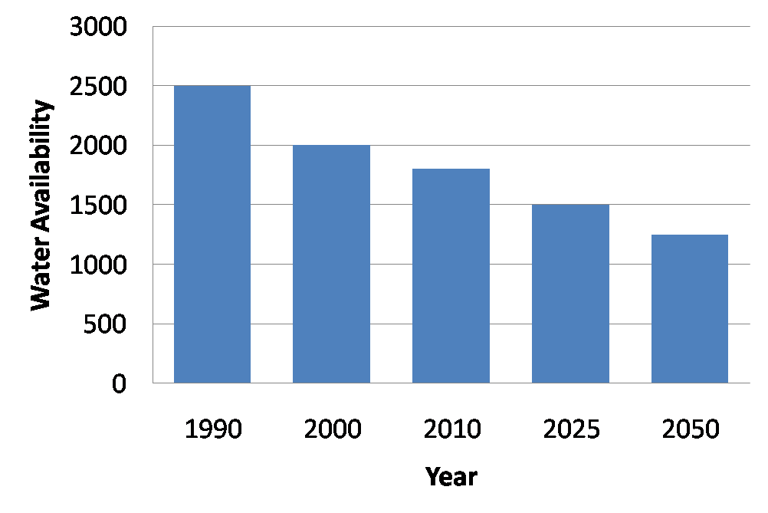
Fig 18: Water per Capita Availability
Fig 18 offers a quick view of water availability in step with capita (in quintals) has reduced steadily. According to the prediction factor, it's far visible via way of 2020 the supply of water could have reduced many fold whilst in comparison to its availability in 1990. In fact, there is lots of stress on automating the irrigation gadget in a greater green and clever manner. The 3 sensor used: moisture sensor, temperature sensor and humidity sensor play a important position in supplying the diverse parametric values to the farmer by using cloud interface with the registered mobile. The primary contribution of inspiration is using dripping gadget to manipulate the soil moisture content material of the sphere and plants via way of correctly utilizing the sensors to observe, reveal and ship suitable facts to the farmer. Soil moisture sensors are used to estimate the extent of water in the soil. Two parameters are set as limits to function of hallmark to signify the subsequent parameters:
(i) Need for moisture in the soil (at 80%)
(ii) Enough moisture content in the soil (at 95%)
The soil moisture sensor used on this mission is DSM058, which is selected particularly due to its interfacing with the Arduino UNO and it's far much less expensive. First the parameters which might be sensed with the aid of using the sensors are dispatched to the Arduino for comparison. A pre-described database is fed into the gadget which units the higher and decrease certain values of resistance towards which the measured values are compared. On comparison, whilst the values are observed to be decrease or better than the pre-described bounds, it'll be conveyed to the farmer the usage of the cloud platform, sending a message to the registered cellular phone. On seeing the message, the farmer can now manipulate the solenoid price the usage of a relay manipulates. The most useful variety for the desired quantity of water and sensors is defined in the desk below (Table 1).
Table1: Ideal Value Pre-fixed in Arduino
Sensor Name | Ideal Range | Water Needed
Temperature Sensor | 400-800 Ω | 600-800 mm
Moisture Sensor | 300-700 Ω
Humidity Sensor | 250-500 Ω

Table 2: Cost of Drip Irrigation Vs Regular Irrigation
Parameters of Cost | Regular Irrigation | Drip Irrigation
Cost of Labour | Rs.12,350 | Rs.7,580
Cost of Cultural Operations | Rs.2000 | Rs.2000
Cost of pesticides | Rs.500 | Rs.500
Cost of harvesting | Rs.3,000 | Rs.3,000
Cost of marketing | Rs.1,000 | Rs.1,000
Total Cost | Rs. 18,850 | Rs.14,080

A whole report of the farming fee concerned is proven in the desk below (Table 2). This discount in fee rate from 18,850 to 14,080 will bring about a benefit of Rs. 4,770 for the farmers and contributed through the discount in fee of human labour. It has been analyzed and located that in the time of developing okra, the quantity of employees concerned in watering the plant life become decreased from 18 to 7 because the farmer can manage the technique of watering with the useful resource of the registered cell phone. Water and electricity productiveness is observed to be greater successfully applied while drip irrigation is adopted. The water utilization is observed to be 64 Kg/m3 while drip farming is used compared to 49 Kg/m3 of water that is in any other case utilized in normal irrigation technique. This will make certain that the farmer advantages economically through decreased labour fee and energy consumption. Moreover, the proposed is likewise clean to recognize through farmers and agricultures.
8. Conclusion
This paper offers with the implementation of crop land irrigation based on the way of commencing and remaining the solenoid valve as consistent with the use of a smart cell phone. The machine proposed on this paper is low value and works at the circumstance of soil moisture and soil temperature. This machine is an IoT primarily based totally android cell software to irrigate the land for crop yield. This machine enables the farmers to have most desirable usage of water with accuracy and affordability. The gain of this approach is the most conservation of water. This is a smart installation to offer most yield to the farmers. In this paper the presentation of Arduino UNO primarily based totally water feeding for crop subject the use of cell accessibility is visually defined with drip irrigation. Drip irrigation enables to acquire higher water control process. The proposed computerized water irrigation machine is extra green and budget friendly because the value for set up is low. Due to the implementation of agro automation with unmanned IoT farming, the existing younger era becomes fanatic clever farmers interested by agriculture and additionally set off in generating higher yield with much less expenditure to carry out agriculture.
References
Arata, L., Fabrizi, E. and Sckokai, P., 2020. A worldwide analysis of trend in crop yields and yield variability: Evidence from FAO data. Economic Modelling, 90, pp.190-208.
Avunduk, E., Copur, H., Tolouei, S., Tumac, D., Balci, C., Bilgin, N. and Shaterpour–Mamaghani, A., 2021. Possibility of using torvane shear testing device for soil conditioning optimization. Tunnelling and Underground Space Technology, 107, p.103665.
Barickman, T.C., Ku, K.M. and Sams, C.E., 2020. Differing precision irrigation thresholds for kale (Brassica oleracea L. var. acephala) induces changes in physiological performance, metabolites, and yield. Environmental and Experimental Botany, 180, p.104253.
Bayrakdar, M.E., 2020. Enhancing sensor network sustainability with fuzzy logic based node placement approach for agricultural monitoring. Computers and Electronics in Agriculture, 174, p.105461.
Becker-Reshef, I., Justice, C., Barker, B., Humber, M., Rembold, F., Bonifacio, R., Zappacosta, M., Budde, M., Magadzire, T., Shitote, C. and Pound, J., 2020. Strengthening agricultural decisions in countries at risk of food insecurity: The GEOGLAM Crop Monitor for Early Warning. Remote Sensing of Environment, 237, p.111553.
Bonfante, A., Monaco, E., Manna, P., De Mascellis, R., Basile, A., Buonanno, M., Cantilena, G., Esposito, A., Tedeschi, A., De Michele, C. and Belfiore, O., 2019. LCIS DSS—An irrigation supporting system for water use efficiency improvement in precision agriculture: A maize case study. Agricultural Systems, 176, p.102646.
Chen, A., Orlov-Levin, V. and Meron, M., 2019. Applying high-resolution visible-channel aerial imaging of crop canopy to precision irrigation management. Agricultural water management, 216, pp.196-205.
Choudhary, M., Panday, S.C., Meena, V.S., Singh, S., Yadav, R.P., Pattanayak, A., Mahanta, D., Bisht, J.K. and Stanley, J., 2020. Long-term tillage and irrigation management practices: Strategies to enhance crop and water productivity under rice-wheat rotation of Indian mid-Himalayan Region. Agricultural Water Management, 232, p.106067.
Dammer, K.H., Thöle, H., Volk, T. and Hau, B., 2009. Variable-rate fungicide spraying in real time by combining a plant cover sensor and a decision support system. Precision agriculture, 10(5), pp.431-442.
dos Santos, U.J.L., Pessin, G., da Costa, C.A. and da Rosa Righi, R., 2019. AgriPrediction: A proactive internet of things model to anticipate problems and improve production in agricultural crops. Computers and electronics in agriculture, 161, pp.202-213.
Dutta, S.K., Laing, A.M., Kumar, S., Gathala, M.K., Singh, A.K., Gaydon, D.S. and Poulton, P.J.A.W.M., 2020. Improved water management practices improve cropping system profitability and smallholder farmers’ incomes. Agricultural Water Management, 242, p.106411.
Eck, M.A., Murray, A.R., Ward, A.R. and Konrad, C.E., 2020. Influence of growing season temperature and precipitation anomalies on crop yield in the southeastern United States. Agricultural and Forest Meteorology, 291, p.108053.
Fang, L. and Zhang, L., 2020. Does the trading of water rights encourage technology improvement and agricultural water conservation?. Agricultural Water Management, 233, p.106097.
Ghobashy, M.M., Abd El-Wahab, H., Ismail, M.A., Naser, A.M., Abdelhai, F., El-Damhougy, B.K., Nady, N., Meganid, A.S. and Alkhursani, S.A., 2020. Characterization of Starch-based three components of gamma-ray cross-linked hydrogels to be used as a soil conditioner. Materials Science and Engineering: B, 260, p.114645.
Gu, W., Cai, S., Hu, Y., Zhang, H. and Chen, H., 2019. Trajectory planning and tracking control of a ground mobile robot: A reconstruction approach towards space vehicle. ISA transactions, 87, pp.116-128.
Ha, Q.P., Yen, L. and Balaguer, C., 2019. Robotic autonomous systems for earthmoving in military applications. Automation in Construction, 107, p.102934.
Haghverdi, A., Singh, A., Sapkota, A., Reiter, M. and Ghodsi, S., 2021. Developing irrigation water conservation strategies for hybrid bermudagrass using an evapotranspiration-based smart irrigation controller in inland southern California. Agricultural Water Management, 245, p.106586.
Jaiswal, S. and Ballal, M.S., 2020. Fuzzy inference based irrigation controller for agricultural demand side management. Computers and Electronics in Agriculture, 175, p.105537.
Jiang, H., Xu, G., Zeng, W. and Gao, F., 2019. Design and kinematic modeling of a passively-actively transformable mobile robot. Mechanism and Machine Theory, 142, p.103591.
Jiang, L., Guo, S., Wang, G., Kan, S. and Jiang, H., 2020. Changes in agricultural land requirements for food provision in China 2003–2011: A comparison between urban and rural residents. Science of the Total Environment, 725, p.138293.
Lajoie-O'Malley, A., Bronson, K., van der Burg, S. and Klerkx, L., 2020. The future (s) of digital agriculture and sustainable food systems: An analysis of high-level policy documents. Ecosystem Services, 45, p.101183.
Lake, J.A., Kisielewski, P., Hammond, P. and Marques, F., 2019. Sustainable soil improvement and water use in agriculture: CCU enabling technologies afford an innovative approach. Journal of CO2 Utilization, 32, pp.21-30.
Li, Y., Song, D., Dang, P., Wei, L., Qin, X. and Siddique, K.H., 2020. Combined ditch buried straw return technology in a ridge–furrow plastic film mulch system: Implications for crop yield and soil organic matter dynamics. Soil and Tillage Research, 199, p.104596.
Li, Z., Fontanier, C. and Dunn, B.L., 2020. Physiological response of potted sunflower (Helianthus annuus L.) to precision irrigation and fertilizer. Scientia Horticulturae, 270, p.109417.
Liu, D., Mishra, A.K. and Ray, D.K., 2020. Sensitivity of global major crop yields to climate variables: A non-parametric elasticity analysis. Science of the Total Environment, 748, p.141431.
Liu, Y. and Song, W., 2020. Modelling crop yield, water consumption, and water use efficiency for sustainable agroecosystem management. Journal of Cleaner Production, 253, p.119940.
Meier, J., Mauser, W., Hank, T. and Bach, H., 2020. Assessments on the impact of high-resolution-sensor pixel sizes for common agricultural policy and smart farming services in European regions. Computers and electronics in agriculture, 169, p.105205.
Mitter, H., Techen, A.K., Sinabell, F., Helming, K., Schmid, E., Bodirsky, B.L., Holman, I., Kok, K., Lehtonen, H., Leip, A. and Le Mouël, C., 2020. Shared socio-economic pathways for European agriculture and food systems: the Eur-Agri-SSPs. Global Environmental Change, 65, p.102159.
Nair, V.V., Kuhn, D. and Hummel, V., 2019. Development of an easy teaching and simulation solution for an autonomous mobile robot system. Procedia manufacturing, 31, pp.270-276.
Peng, Y., Xiao, Y., Fu, Z., Dong, Y., Zheng, Y., Yan, H. and Li, X., 2019. Precision irrigation perspectives on the sustainable water-saving of field crop production in China: Water demand prediction and irrigation scheme optimization. Journal of cleaner production, 230, pp.365-377.
Roy, P.C., Guber, A., Abouali, M., Nejadhashemi, A.P., Deb, K. and Smucker, A.J., 2019. Crop yield simulation optimization using precision irrigation and subsurface water retention technology. Environmental Modelling & Software, 119, pp.433-444.
Sinha, A., Shrivastava, G. and Kumar, P., 2019. Architecting user-centric internet of things for smart agriculture. Sustainable Computing: Informatics and Systems, 23, pp.88-102.
Torres, A.B., da Rocha, A.R., da Silva, T.L.C., de Souza, J.N. and Gondim, R.S., 2020. Multilevel data fusion for the internet of things in smart agriculture. Computers and electronics in agriculture, 171, p.105309.
Tsuruta, T., Miura, K. and Miyaguchi, M., 2019. Mobile robot for marking free access floors at construction sites. Automation in Construction, 107, p.102912.
Wang, C., Liu, X., Yang, X., Hu, F., Jiang, A. and Yang, C., 2018. Trajectory tracking of an omni-directional wheeled mobile robot using a model predictive control strategy. Applied Sciences, 8(2), p.231.
Xiao, L., Zhao, R. and Zhang, X., 2020. Crop cleaner production improvement potential under conservation agriculture in China: A meta-analysis. Journal of Cleaner Production, 269, p.122262.
Yang, Z., Ding, Y., Hao, K. and Cai, X., 2019. An adaptive immune algorithm for service-oriented agricultural Internet of Things. Neurocomputing, 344, pp.3-12.
Youzhi, W., Jincheng, W., Shiqiang, S., Pinhua, R., Runkai, W., Shihui, L., Liqi, X. and Feng, Z., 2020. Preparation and application properties of sustainable gelatin/chitosan soil conditioner microspheres. International Journal of Biological Macromolecules, 159, pp.685-695.
Zhao, Y., Liu, L., Xie, C., Wang, R., Wang, F., Bu, Y. and Zhang, S., 2020. An effective automatic system deployed in agricultural Internet of Things using Multi-Context Fusion Network towards crop disease recognition in the wild. Applied Soft Computing, 89, p.106128.
Zheng, W., Wang, H., Zhang, Z. and Wang, H., 2019. Adaptive robust finite-time control of mobile robot systems with unmeasurable angular velocity via bioinspired neurodynamics approach. Engineering Applications of Artificial Intelligence, 82, pp.330-344.

