Selection of stable reference genes for quantitative real-time PCR in Paeonia ostii leaves under different drought stress
(Running title: housekeeping genes selection of oil peony)

Cong Xu†, Yuting Luan†, Xiaoxiao Wang†, Daqiu Zhao†, Jun Tao†,‡,*

† College of Horticulture and Plant Protection, Yangzhou University, Yangzhou 225009, China
‡ Joint International Research Laboratory of Agriculture and Agri-Product Safety, the Ministry of Education of China, Yangzhou University, Yangzhou 225009, China

Cong Xu
- mail: xucong97@126.com
Yuting Luan
E-mail: luanyuting96@163.com
Xiaoxiao Wang
E-mail: 2402287168@qq.com
Daqiu Zhao
E-mail: dqzhao@yzu.edu.cn
*Corresponding author.
Jun Tao
E-mail: taojun@yzu.edu.cn

Novelty statement
- Screen stable internal reference genes based on high-throughput sequencing
- The first research on internal reference gene in Paeonia ostii under abiotic stress
- Comprehensive analysis of suitable housekeeping gene based on three public algorithms
- Provides stable reference gene and a reliable combination of housekeeping gene for precise gene expression level analysis in Paeonia ostii under drought stress

Abstract
In the present gene expression level analysis, the definition of relatively stable expressed internal reference genes is essential in both traditional blotting quantification and modern data quantitative strategy, and appropriate internal reference genes can accurately standardize the express abundance of target genes, so as to avoid serious experimental errors. In this research, the expression profiles of ten candidate genes, ACT1, ACT2, GAPDH, eIF1, eIF2, α-TUB, β-TUB, TBP, RNA Pol II and RP II, were calculated for suitable reference genes selection in the leaves of Paeonia ostii under different drought stress. Data was processed by the ΔCt method, geNorm, NormFinder and BestKeeper programs, and then a comprehensive analysis result revealed that ACT1 and RNA Pol II were the most stable genes and eIF2 was the least stable gene. In addition, geNorm program provided the optimal choice of two reference genes combination, RNA Pol II and β-TUB, for qRT-PCR normalization in P. ostii subjected to different drought stress. Our research provided convenience for gene expression analysis in P. ostii under drought stress and promoted research of effective methods to alleviate P. ostii drought stress in the future.
Keywords: Paeonia ostii; Reference gene; qRT-PCR; Drought stress

Introduction
The gene expression level analysis has been widely used in different areas and species (Liu et al. 2014; Li et al. 2013; Yu et al. 2016; Tan et al. 2017; Dong et al. 2019; Chen et al. 2019) in order to screen key genes or specific regulatory mechanism. Quantitative real-time PCR (qRT-PCR) is predominant and has been commonly applied due to its accuracy, good specificity and high throughput at mRNA level (Heid et al. 1996; Ginzinger 2002). In order to acquire precise experimental results, the expression levels of target genes to be tested must be corrected with reliable internal reference genes (housekeeping genes) (Richards et al. 2002; Vandesompele et al. 2002; Bustin 2009). Some traditional housekeeping genes have been usually used as reference genes due to their stable expressions in previous studies, such as actin (ACT), glyceraldehyde-3-phosphate dehydrogenase (GAPDH), 18S rRNA, elongation factors 1α (EF-1α), ubiquitin (UBQ), α-tubulin (α-TUB) and β-tubulin (β-TUB) (Aoki et al. 2000; Zhang et al. 2014). Theoretically, these traditional reference genes maintain the most basic cellular activities and their expression levels are not affected by the external environments. However, many researches showed that the common housekeeping genes presented different expression modes in different conditions (Vandesompele et al. 2002; Bustin 2009; Mou et al. 2015; Wang et al. 2019; Yang et al. 2020). Using unstable internal reference genes may have great impacts on the target gene expression level analysis and cause erroneous experimental results. Therefore, it is critically important to chose relatively stable housekeeping genes according to the certain experimental conditions before their use in qRT-PCR normalization.
Paeonia ostii is a famous traditional ornamental flower in China, which is internationally popular due to its large, showy and fragrance flower. Studies have proved its oil seed enriched a large amount of α-linolenic acid (ALA), which was good for human health. Additionally, as an emerging woody oil crop, it has a lot of advantages such as strong adaption and low planting investment for large-scale cultivation promotion in many areas (Peng et al. 2019b). However, as a common abiotic stress, drought stress greatly restricts the ornamental characteristics and economic values of P. ostii, especially in arid areas (Ma et al. 2018). Therefore, it is urgent to find feasible ways to alleviate the damage of P. ostii causing by drought stress. At present, there are few literatures on P. ostii internal reference gene selection, some scholars have studied the reference genes selection of P. ostii in different tissues or across different developmental stages (Li et al. 2016; Li et al. 2019a). However, there is no literature report on internal reference genes screening under drought conditions in P. ostii. Thus, when clarifying the underlying molecular mechanism of P. ostii drought stress and finding effective mitigation routes, there is a lack of stable internal reference genes.
In this study, we selected 10 commonly used candidate reference genes, and used ΔCt method, geNorm, NormFinder and BestKeeper to test their expression stability under different drought stress degrees in P. ostii. The identified internal reference genes provide valuable information for further qRT-PCR analysis and drought stress alleviation methods of P. ostii.

Materials and methods
Plant materials and drought treatment
The three-year-old potted seedlings of P. ostii were used as plant materials. P. ostii were with uniform growth condition, and cultivated in the same experimental environment with regular agronomic practices. Before drought treatment, watering was normally conducted at 17:00 in three consecutive days. These plants were then divided into three groups of 12 plants in each group and subjected to natural drought treatment. The materials that were not subjected to drought treatment were used as control group. The leaves were randomly collected after the drought treatment on the 4th, 8th, and 12th day from each treatment group. Simultaneously, the leaves were collected from 2 to 4 pairs of leaves from top to bottom, and then were quickly frozen in liquid nitrogen and store at -80 ℃ until RNA extraction and further analysis.
RNA extraction and cDNA synthesis
Total RNA was extracted using TRIzol reagent (Invitrogen, USA) and genomic DNA was removed using DNase I (Takara, Japan). The RNA integrity was analyzed by 1.0% agarose gels, and the RNA purity was assessed using BioPhotometer D30 (Eppendorf AG, Hamburg, Germany). Only qualified RNA samples (260/280 ratio ranged from 1.8 to 2.0; 260/280 ratio > 2.0) could be used for subsequent experiments. The first-strand cDNA was synthesized using PrimeScript RT reagent Kit (Takara, Dalian, China).
Candidate gene selection and primer design
The following 10 potential genes were selected for this study including ACT, GAPDH, eukaryotic translation initiation factor (eIF), α-TUB, β-TUB, TATA-box binding protein (TBP), RNA polymerase II (RNA Pol II) and RNA polymerase II transcription factor (RP II). These sequences were obtained from the RNA-seq data with accession number SRP161474. All of these candidate genes were chosen for their essential functions in maintaining the most basic cellular activities. Using the Primer Premier 5 software, we designed qRT-PCR primers for each of the 10 reference genes from P. ostii. The specific sequence of each primer was shown in Table 1 and the design standard rules were as follows: the amplification product length ranged from 100 bp to 200 bp; primer length ranged from 18 bp to 22 bp; melting temperature (TM) ranged from 45 ℃ to 55 ℃; GC content ranged from 40% to 60%. Additionally, we used the mixed cDNA sample of each sample as cDNA template, and the diluted cDNA template was used to calculate PCR efficiency (E) and correlation coefficients (R²). Finally, the amplified products of each reference genes were visualized on 1.0% agarose gels.
Cloning of candidate reference genes
For visualization, the PCR products of cDNA of the 10 candidate genes were purified from agarose gels using Agarose Gel DNA Recovery Kit (Qingke, Beijing, China), and then purified DNA products were ligated with the pMD18-T simple Vector (Qingke, Beijing, China). Recombinant vectors were transformed into DH5α chemically competent cells (Qingke, Beijing, China), and positive recombinant clones were sequenced by Qingke Biotechnology Co., Ltd.
qRT-PCR analysis
qRT-PCR reactions were conducted with a BIO-RAD PCR CFX96 system (Bio-Rad, USA). The candidate genes were amplified by qRT-PCR from four different drought stress using SYBR Premix Ex Taq (Takara, Dalian, China). The volume of the amplifications was 25.0 μL, containing 12.5 µL 2 × SYBR Premix Ex Taq, 2 µL cDNA template, 2 µL each gene-specific primer (10 μM) and 8.5 µL ddH2O, and the reactions without cDNA were generated as the negative controls simultaneously. The qRT-PCR system was as follows: 95 ℃ for 30 s, followed by 40 cycles of 5 s at 95 ℃, 30 s at 55 ℃, and 30 s at 72 ℃. Each reaction was conducted in triplicate.
Data analysis
The Data were processed by Bio-Rad CFX Manager software. Four different methods based on statistical algorithms including ΔCt method, geNorm (Vandesompele et al. 2002), NormFinder (Andersen et al. 2004) and BestKeeper (Pfaffl et al. 2004) were used to evaluate candidate reference genes’ expression stability and availability in various treatments. The ΔCt method has the ability to calculate each gene’s ΔCt value and standard deviation (SD) based on the relative pair-wise comparisons. The lower the SD value, the smaller the change in gene expression, and the higher the stability of expression. The calculated results are used for ranking. The geNorm program define the stable genes by calculating the expression stability value (M) of each gene. The final criterion identified genes with the lowest M value as the most appropriate reference gene. geNorm can also calculate the pair-wise variation (Vn/Vn+1) as to define the optimal numbers of reference genes. The NormFinder’s reference gene definition principles are consistent with geNorm which are based on the variance between samples. The BestKeeper program generates the pair-wise correlation coefficient (r), coefficient of variation (CV) and standard deviation (SD) by comparing Ct values of each selected reference gene. The r values, CV values, and SD values determine the stable genes. The selected gene with the higher r value, lower CV value and SD value is more stable, conversely, it has the lower stability.
Results
Validation of PCR assays
The primers of all candidate genes were designed based on the gene sequences obtained from P. ostii RNA-seq data (Zhao et al. 2019). The fragment length of PCR amplifications ranged from 104 to 199 (Fig. 1), then the PCR amplification results were verified by sequencing, and the sequencing results were consistent with the original RNA-seq results. In addition, quality analysis result of each primer showed that the melting curve of each candidate gene showed a single sharp peak, indicating good specificity (Fig. 2). The PCR efficiencies (E) of the 10 candidate reference genes ranged from 92.1% to 108.4% and the correlation coefficients (R²) varied from 0.9826 to 0.9999 (Table 1).
Expression analysis of 10 candidate reference genes using ΔCt method
To assess the gene expression stability of 10 candidate genes, we calculated the mRNA expression levels of different genes under different drought stress. The average Ct values of ranged from 25.30 to 29.85 in various drought environments (Fig. 3 and Table 2). Among them, RNA Pol II had the smallest average Ct value, followed by α-TUB, ACT1, TBP, eIF2, β-TUB, eIF1, GAPDH, RP II and ACT2. Using the ΔCt method, we gained the SD values of 10 candidate genes based on the Ct values, and the analysis results determined the stability order of 10 candidate genes as follows: ACT1 > β-TUB > RNA Pol II > GAPDH > ACT2 > α-TUB > eIF1 > TBP > RP II > eIF2.
Expression analysis of 10 candidate reference genes using geNorm program
The analysis results of the geNorm program indicated that the M values of the 10 candidate genes were all less than 1.5. geNorm ranked the stability of 10 candidate genes as follows: RNA Pol II ≥ β-TUB > TBP > ACT1 > α-TUB > eIF1 > GAPDH > RP II > ACT2 > eIF2 (Fig. 4a).
Expression analysis of 10 candidate reference genes using NormFinder program
The analysis results of the NormFinder program indicated that the order of 10 candidate reference genes is: TBP > RNA Pol II > β-TUB > ACT1 > α-TUB > eIF1 > GAPDH > RP II > ACT2 > eIF2 (Fig. 4b).
Expression analysis of 10 candidate reference genes using BestKeeper program
According to the analysis results of the BestKeeper program, BestKeeper combined the r value, CV value, and SD value, and ranked the stability of reference genes as follows: ACT1 > TBP > GAPDH > RNA Pol II > β-TUB > RP II > α-TUB > ACT2 > eIF1 > eIF2.
Comprehensive analysis of the expression stability of 10 candidate reference genes
The four algorithms as above were based on their respective algorithms to sort the 10 candidate reference genes, but the sorting results caused by each algorithm were somewhat different. Generally, the results of geNorm and NormFinder were roughly the same, while the results of ΔCt method and BestKeeper were very similar. Therefore, we conducted a comprehensive analysis of the four sorting results in order to normalize this rank. Based on the comprehensive analysis, the re-rank order of the 10 candidate gene stability was: ACT1 ≥ RNA Pol II > β-TUB > TBP > GAPDH > α-TUB > eIF1 > RP II ≥ ACT2 > eIF2 (Table 3).
Optimal numbers of reference genes for qRT-PCR normalization
The threshold of 0.15 was proposed by geNorm as to determine optimal reference gene numbers, and if V_{n}/V_{n+1} value < 0.15, the number of optimal reference genes is n; in contrast, the optimal reference gene number is n+1. In this study, V_{2/3} value was 0.085 in various drought stress (Fig. 5), which indicated that the RNA Pol II and β-TUB were the optimal combination for accurate qRT-PCR analysis in P. ostii.

Discussion
Compared with conventional quantitative methods, qRT-PCR was superior in high sensitivity and good specificity, which makes qRT-PCR the most important tool for precise gene expression levels. However, studies have shown that no gene express in the same abundance under any conditions, and a single gene may have different expression levels in different tissues, growth stages, and experimental treatments (Bustin 2002; Bowen et al. 2014; Li et al. 2017). Therefore, it is critically necessary to screen the relatively stable expression internal reference genes according to specific experimental treatments before qRT-PCR.
At present, with the wide application of qRT-PCR in many areas (An 2018) such as molecular biology (Pabuayon et al. 2016), modern medicine (Gebeh et al. 2012; Sahoo et al. 2019), food detection (Ding et al. 2020) and environmental monitoring (Chen et al. 2020), some evaluation methods for judging gene stability such as ΔCt method, geNorm, NormFinder and BestKeeper have gradually emerged simultaneously, which improved the efficiency of gene stability analysis and suitable reference genes selection. However, the results of each algorithm are different because of the unique algorithm of each program. Therefore, a comprehensive analysis needs to be synthesized according to the analysis results of each statistical algorithm.
P. ostii is a traditional famous flower in China, and its related research is very rich from multiple levels, such as antioxidant activity research (Zhang et al. 2016), seed dormancy (Xue et al. 2015), oil resource promotion (Li et al. 2015), ornamental traits regulation (Gao et al. 2015), growth and ecological adaptation resistance (Peng et al. 2019a). In recent years, as the medicinal value and economic benefits of P. ostii have become increasingly prominent, the planting scale has expanded in many areas. However, in arid and semi-arid areas, due to the lack of water resources, the use of P. ostii and the orderly development of P. ostii industry has been greatly restricted. Therefore, many scholars have conducted numerous drought-related researches on P. ostii, such as water physiology (Fang et al. 2020), cell membrane system (Li et al. 2019b), osmotic system (Li et al. 2014), photosynthetic mechanism (Fang et al. 2020), etc.
In our previous research, some relevant indicators used to clarify the damage extent of drought stress to P. ostii were measured, and we have tried to find ways to alleviate drought stress on P. ostii (Zhao et al. 2020; Zhang et al. 2019). At the same time, with the development of transcriptome sequencing, the research on drought stress has been gradually advanced and deepened from the physiological level to the molecular level (Guo et al. 2018; Qu et al. 2019). Therefore, it is essential to verify the expression of key genes involved in P. ostii drought stress.
To data, the evaluation of internal reference gene in P. ostii is only reported in the different tissues across different developmental stages without environmental stresses (Li et al. 2016; Li et al. 2019), and the most two stable reference genes were identified in P. ostii flowers, indicating that it is essential to chose reference genes in different cultivars, even they are the same species (Li et al. 2016). Based on the special experimental needs to solve corresponding scientific problems, some scholars screened the reference genes under different abiotic stresses such as plant hormone stress (Qu et al. 2019), light stress (Wan et al. 2019), cold or high temperature stress (Li et al. 2019c; Yu et al. 2020), salt stress (Ma et al. 2020), etc. Similarly, due to the high industrial values of P. ostii, the research on P. ostii drought stress and its mitigation methods is also very significant. In deep, screening the key genes, explaining the key mechanism of drought stress requires suitable reference genes which can correct the expression levels of drought-related genes.
Leaf is the main organ of plants for photosynthesis and transpiration, and also the most sensitive part to drought stress (Otto et al. 2017). Drought stress can cause leaf wilting and withering, reducing the leaf water content in P. ostii. In the drought research of plants, leaves are often measured for drought-related physical and chemical indicators to measure the drought degree of the overall plant. Therefore, in this study, we used leaves as experimental materials to screen the stable internal reference genes of P. ostii under different drought conditions as to provide reference and help for P. ostii drought research.
In this study, we evaluated the expression stability of 10 commonly used internal reference genes of P. ostii under different drought stresses. After a comprehensive evaluation by ΔCt method, geNorm program, NormFinder program and BestKeeper program, ACT1 and RNA Pol II were identified as the most stable genes, and they could be used as internal reference genes under drought stress in P. ostii. Simultaneously, ACT1 had a moderate to high expression abundance, which could be used to quantify genes with moderate to high expression levels, while RNA Pol II had a high expression abundance among these ten candidate genes which could be used for high expression target genes normalization. MIQE guideline for qPCR methods suggested that there is no perfect gene which is constantly expressed regardless of the external environment under any conditions (Bustin et al. 2009). Additionally, the optimal numbers of reference genes were evaluated by geNorm program, and the results showed that using two genes as internal reference corrections was more reliable than using one gene. Therefore, a combination of two internal reference genes (RNA Pol II and β-TUB) could be used for qRT-PCR analysis under drought conditions. This study provided convenience for qRT-PCR analysis, and also provided useful reference data for screening key genes to alleviate drought stress of P. ostii in the future.
Conclusions
Here, we evaluated 10 candidate reference genes in the leaves of P. ostii under different drought stress, including ACT1, ACT2, GAPDH, eIF1, eIF2, α-TUB, β-TUB, TBP, RNA Pol II and RP II. The final comprehensive ranking results analyzed by four algorithms recommended that ACT1 and RNA Pol II were the most stable reference genes, and could be used to relatively quantify the expression levels of target genes. geNorm program defined RNA Pol II and β-TUB as the best combination for qRT-PCR normalization in P. ostii exposed to drought conditions. Our research facilitated the expression analysis of target genes in P. ostii under drought stress, and also promoted the establishment of optional internal reference gene library in P. ostii.

Acknowledgments
This work was supported by the National Key R&D Program of China (2018YFD1000405), and Jiangsu Modern Agricultural Industrial Technology System (JATS[2020]436).

Authors’ contributions
J.T. and D.Z. designed the experiments. C.X., Y.L., and X.W. performed the experiments. C.X., Y.L. and X.W. analyzed the data, wrote and revised the manuscript. All authors have carefully read and approved the final manuscript.

References
An GL (2018) The principle and application of real-time fluorescent quantitative PCR. China Mod Educational Equipment 301: 19–21
Andersen CL, Jensen JL, Ørntoft TF (2004) Normalization of real-time quantitative reverse transcription-PCR data: a model-based variance estimation approach to identify genes suited for normalization, applied to bladder and colon cancer data sets. Cancer Res 64: 5245–5250
Aoki T, Naka H, Katagiri T, Hirono I (2000) Cloning and characterization of glyceraldehyde-3-phosphate dehydrogenase cDNA of Japanese flounder Paralichthys olivaceus†. Fisheries Sci 66: 737–742
Bowen J, Ireland HS, Crowhurst R, Luo Z, Watson AE, Foster T, Gapper N, Giovanonni JJ, Mattheis JP, Watkins C, et al. (2014) Selection of low-variance expressed Malus x domestica (apple) genes for use as quantitative PCR reference genes (housekeepers). Tree Genetics & Genomes 10(3): 751–759
Bustin SA (2002) Quantification of mRNA using real-time reverse transcription PCR (RT-PCR): trends and problems. J Mol Endocrinology 29: 23–39
Bustin SA, Benes V, Garson JA, Hellemans J, Huggett J, Kubista M, Mueller R, Nolan T, Pfaffl MW, Shipley GL, et al. (2009) The MIQE guidelines: minimum information for publication of quantitative real-time PCR experiments. Clin Chem 55(4): 611–622
Chen CB, Wu JY, Hua QZ, Tel-Zur N, Xie FF, Zhang ZK, Chen JY, Zhang R, Hu GB, Zhao JT, et al. (2019) Identification of reliable reference genes for quantitative real-time PCR normalization in pitaya. Plant Methods 15: 70
Chen GX, Lu ZX, Li KX, Wang JW, Wang GA (2020) Effect of real-time quantitative PCR on abundance of nitrifying bacteria in different processes under temperature changes. Water Purification Technol 39(1): 106–109,226
Ding BQ, Liu SN (2020) Application of real-time quantitative PCR technology in rapid food detection. Sci and Technol of Food Industry
Dong ZD, Chen PS, Zhang N, Huang SK, Zhang HR, Wang SR, Li XY, Guo YS, Wang ZD (2019) Evaluation of reference genes for quantitative real-time PCR analysis of gene expression in Hainan medaka (Oryzias curvinotus). Gene Reports 14: 94–99
Fang ZW, Wang XX, Zhang XY, Zhao DQ, Tao J (2020) Effects of fulvic acid on the photosynthetic and physiological characteristics of Paeonia ostii under drought stress. Plant Signal Behav 15(7): 1774714
Gao LX, Yang HX, Liu HF, Yang J, Hu YH (2015) Extensive transcriptome changes underlying the flower color intensity variation in Paeonia ostii. Front Plant Sci 6: 1205
Gebeh AK, Marczylo EL, Amoako AA, Willets JM, Konje JC (2012) Variation in stability of endogenous reference genes in fallopian tubes and endometrium from healthy and ectopic pregnant women. Int J Mol Sci 13(3): 2810–2826
Ginzinger DG (2002) Gene quantification using real-time quantitative PCR: an emerging technology hits the mainstream. Exp Hematol 30: 503–512
Guo LL, Guo DL, Yin WL, Hou XG (2018) Tolerance strategies revealed in tree peony (Paeonia suffruticosa; Paeoniaceae) ecotypes differentially adapted to desiccation. Appl Plant Sci 6(10): e01191
Heid CA,Stevens J, Livak KJ, Williams PM (1996) Real time quantitative PCR. Genome Methods 6(10): 986–994
Li CQ, Hu LZ, Wang XQ, Liu HZ, Tian HH, Wang JS (2019a) Selection of reliable reference genes for gene expression analysis in seeds at different developmental stages and across various tissues in Paeonia ostii. Mol Biol Rep 46(6): 6003-6011
Li H, Ni DH, Duan YB, Chen Y, Li J, Song FS, Li L, Wei PC, Yang JB (2013) Quantitative detection of the rice false smut pathogen Ustilaginoidea virens by real-time PCR. Genet Mol Res 12(4): 6433–6441
Li J, Han JG, Hu YH, Yang J (2016) Selection of reference genes for quantitative real-time PCR during flower development in tree peony (Paeonia suffruticosa Andr.). Front Plant Sci 7: 516
Li JT, Han XP, Wang C, Qi W, Zhang WZ, Tang L, Zhao XT (2017) Validation of suitable reference genes for RT-qPCR data in Achyranthes bidentata blume under different experimental conditions. Front Plant Sci 8: 776
Li JX, Zhang Y, Bi JT, Yang Y (2019b) Study on drought resistance of three varieties of oil peony. J Anhui Agric Sci 47(21): 124–128
Li QY, Li ZL, Lu MX, Cao SS and Du YZ (2019c) Selection of valid reference genes for quantitative real-time PCR in Cotesia chilonis (Hymenoptera: Braconidae) exposed to different temperatures. PLoS One 14(12): e0226139
Li SS, Yuan RY, Chen LG, Wang LS, Hao XH, Wang LJ, Zheng XC, Du H (2015) Systematic qualitative and quantitative assessment of fatty acids in the seeds of 60 tree peony (Paeonia section Moutan DC.) cultivars by GC-MS. Food Chem 173: 133–140
Liu MC, Yao BJ, Zhang H, Guo HY, Hu DY, Wang Q, Zhao Y (2014) Identification of novel reference genes using sika deer antler transcriptome expression data and their validation for quantitative gene expression analysis. Genes & Genomics 36(5): 573-582
Ma L, Wu JY, Qi WL, Coulter JA, Fang Y, Li XC, Liu LJ, Jin JJ, Niu ZX, Yue JL, et al. (2020) Screening and verification of reference genes for analysis of gene expression in winter rapeseed (Brassica rapa L.) under abiotic stress. PLoS One 15(9): e0236577
Ma Y, Li JX, Zhang Y, Zhang G (2018) Research progress on drought resistance in Paeonia suffruticosa. J Anhui Agric Sci 46(13): 27–29,32
Mou SL, Zhang XW, Miao JL, Zheng Z, Xu D, Ye NH (2015) Reference genes for gene expression normalization in Chlamydomonas sp. ICE-L by quantitative real-time RT-PCR. J Plant Biochem Biotechnol 24(3): 276–282
Otto MSG, Francisco JG, Gonsalez BT, de Almeida Calvo L, de Mattos EM, de Almeida M, de Andrade Moral R, Demétrio CGB, Stape JL, de Oliveira RF (2017) Changes in γ-aminobutyric acid concentration, gas exchange, and leaf anatomy in Eucalyptus clones under drought stress and rewatering. Acta Physiologiae Plantarum 39(9)
Pabuayon IM, Yamamoto N, Trinidad JL, Longkumer T, Raorane ML, Kohli A (2016) Reference genes for accurate gene expression analyses across different tissues, developmental stages and genotypes in rice for drought tolerance. Rice 9(1): 32
Peng LP, Cheng FY, Hu XG, Mao JF, Xu XX, Zhong Y, Li SY, Xian HL (2019a) Modelling environmentally suitable areas for the potential introduction and cultivation of the emerging oil crop Paeonia ostii in China. Sci Rep 9(1): 3213
Peng LP, Men SQ, Liu ZA, Tong NN, Imran M, Shu QY (2019b) Fatty acid composition, phytochemistry, antioxidant activity on seed coat and kernel of Paeonia ostii from main geographic production areas. Foods 9(1): 30
Pfaffl MW, Tichopad A, Prgomet C, Neuvians TP (2004) Determination of stable housekeeping genes, differentially regulated target genes and sample integrity: BestKeeper - Excel-based tool using pair-wise correlations. Biotechnol Lett 26(6): 509–515
Qu RJ, Miao YJ, Cui YJ, Cao YW, Zhou Y, Tang XQ, Yang J, Wang FQ (2019) Selection of reference genes for the quantitative real-time PCR normalization of gene expression in Isatis indigotica fortune. BMC Mol Biol 20(1): 9
Richards MP, Poch SM (2002) Quantitative analysis of gene expression by reverse transcription polymerase chain reaction and capillary electrophoresis with laser-induced fluorescence detection. Mole Biotechnol 21(1): 19–37
Sahoo PK, Parida S, Mohapatra A and Mohanty J (2019) Selection of candidate reference genes for RT-qPCR analysis in Argulus siamensis and their validation through screening of drugs and drug targets. Sci Rep 9(1): 18365
Tan Y, Zhou XR, Pang BP (2017) Reference gene selection and evaluation for expression analysis using qRT-PCR in Galeruca daurica (Joannis). Bull Entomol Res 107(3): 359–368
Vandesompele J, De Preter K, Pattyn F, Poppe B, Van Roy N, De Paepe A, Speleman F (2002) Accurate normalization of real-time quantitative RT-PCR data by geometric averaging of multiple internal control genes. Genome Biol 3: 1–12
Wan YL, Hong AY, Zhang YX, Liu Y (2019) Selection and validation of reference genes of Paeonia lactiflora in growth development and light stress. Physiol Mol Biol Plants 25(4): 1097–1105
Wang XW, Wu ZJ, Bao WQ, Hu HY, Chen M, Chai TY, Wang H (2019) Identification and evaluation of reference genes for quantitative real-time PCR analysis in Polygonum cuspidatum based on transcriptome data. BMC Plant Biol 19(1): 498
Xue JQ, Wang SL, Zhang P, Zhu FY, Ren XX, Liu CJ, Zhang XX (2015) On the role of physiological substances, abscisic acid and its biosynthetic genes in seed maturation and dormancy of tree peony (Paeonia ostii ‘Feng Dan’). Sci Horticulturae 182: 92–101
Yang XJ, Zheng HL, Liu YY, Li HW, Jiang YH, Lin LB, Deng XY, Zhang QL (2020) Selection of reference genes for quantitative real-time PCR in Aquatica leii (Coleoptera: Lampyridae) under five different experimental conditions. Front Physiol 11: 555233
Yu JJ, Su Y, Sun JY, Liu JR, Li ZY, Zhang BH (2020) Selection of stable reference genes for gene expression analysis in sweet potato (Ipomoea batatas L.). Mol Cell Probes 53: 101610
Yu SH, Yang P, Sun T, Qi Q, Wang XQ, Xu DL, Chen XM (2016) Identification and evaluation of reference genes in the Chinese white wax scale insect Ericerus pela. Springerplus 5(1): 791
Zhang HF, Li XF, Wu K, Wang MK, Liu P, Wang XS, Deng RX (2016) Antioxidant activities and chemical constituents of flavonoids from the flower of Paeonia ostii. Molecules 22(5): 1–15
Zhang XY, Fang ZW, Liu HN, Zhao DQ, Tao J (2019) Exogenous calcium-induced physiological and biochemical changes in tree peony (Paeonia section Moutan DC.) under drought stress. Photosynthetica 57(4): 904–911
Zhang YF, Zhao LJ, Zeng YL (2014) Selection and application of reference genes for gene expression studies. Plant Physiol J 50(8): 1119–1125
Zhao DQ, Zhang XY, Fang ZW, Wu YQ, Tao J (2019) Physiological and transcriptomic analysis of tree peony (Paeonia section Moutan DC.) in response to drought stress. Forests 10(2): 135
Zhao DQ, Fang ZW, Tang YH, Tao J (2020) Graphene oxide as an effective soil water retention agent can confer drought stress tolerance to Paeonia ostii without toxicity. Environ Sci Technol 54(13): 8269–8279

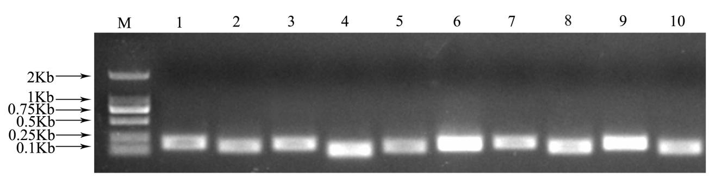Fig. 1 PCR amplification of 10 candidate reference genes of P. ostii
M, 2000 marker; 1, ACT1; 2, ACT2; 3, GAPDH; 4, eIF1; 5, eIF2; 6, α-TUB; 7, β-TUB; 8, TBP; 9, RNA Pol II; 10, RP II
Fig. 2 Melting curves of 10 candidate reference genes of P. ostii

Fig. 3 Comparative expression profiles of 10 candidate reference genes in P. ostii under different drought stress
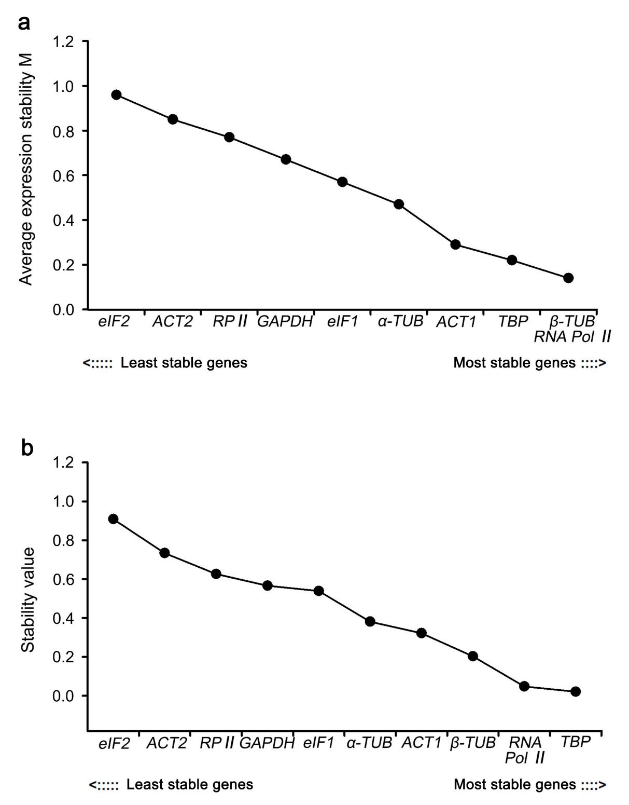
Fig. 4 Expression stability analysis of 10 candidate reference genes in P. ostii by geNorm program (a) and NormFinder program (b)
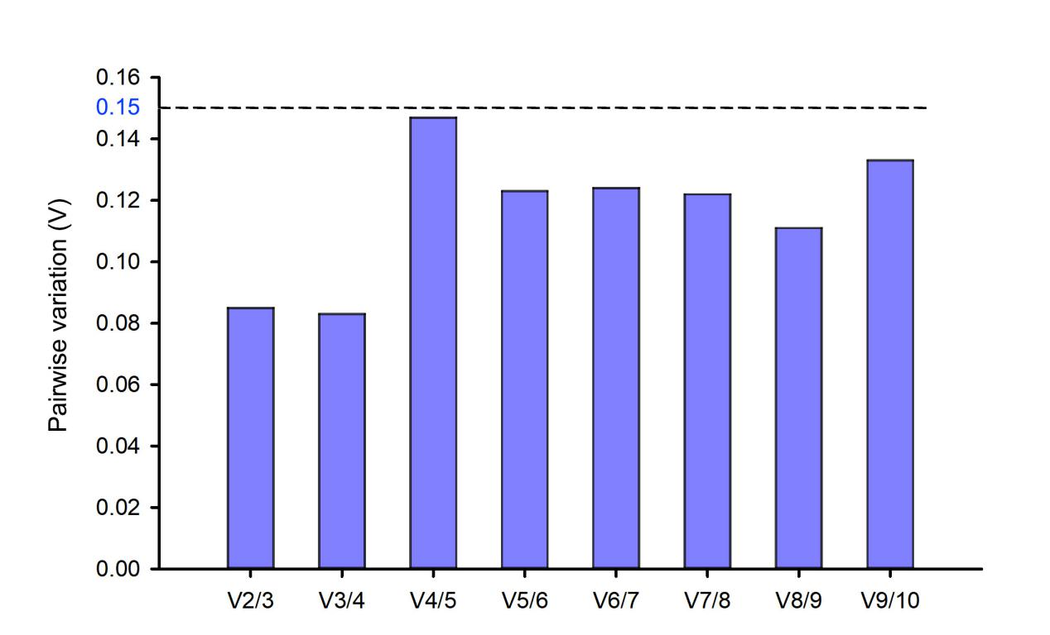Fig. 5 Analysis of the optimal choice of reference gene numbers using geNorm program
Gene symbol | Gene name | Forward primer (5’—3’) | Reverse primer (5’—3’) | Amplicon length(bp) | Amplicon Tm (°C) | E (%) | R²
ACT1 | Actin | CTTCTTGCTACGACATCC | AGCTAAGGTATTGCCACT | 188 | 51.5 | 98.7 | 0.9949
ACT2 | Actin | GCAGAGGGGTATGTTATT | CTTCACTTTGCGAGCTAC | 143 | 51.5 | 99.1 | 0.9874
GAPDH | Glyceraldehyde-3-phosphate dehydrogenase | ATGACCACTGTCCACTCC | TTCCAGTCAACTTCCCAT | 168 | 52.6 | 108.4 | 0.9826
eIF1 | Eukaryotic translation initiation factor | ACGATTACGAAGACAGACC | CAAAGGACTTGACAGAGTC | 104 | 53.0 | 99.0 | 0.9978
eIF2 | Eukaryotic translation initiation factor | GGAAGTGGAAAGGAAGAC | ATCCATAATAGCAGCTCC | 146 | 51.5 | 92.1 | 0.9942
α-TUB | α-Tubulin | CTGGGAACTTTACTGTCTC | TCCTGACTTCATCAATGAC | 178 | 51.9 | 107.7 | 0.9887
β-TUB | β-Tubulin | GTATTACAACGAGGCTTCT | CAGCATCAATCAACTCAG | 199 | 50.6 | 98.7 | 0.9999
TBP | TATA-box binding protein | GTAATGCTGAATACAATCCC | ATACTTCCGTGCTGCTAA | 148 | 50.8 | 99.1 | 0.9891
RNA Pol II | RNA polymerase II | GGTTTGTGACATTTCCTG | ATAGTTTGGTGCATCTCC | 190 | 50.3 | 108.4 | 0.9929
RP II | RNA polymerase II transcription factor | ACGGAGATAGGGTTTGCC | CCCAAAGTTCTTATCGCATT | 135 | 53.1 | 99.0 | 0.9921
Table 1: Primers and PCR efficiencies for P. ostii reference genes.

Table 2: The Ct values of 10 candidate reference genes in P. ostii.
Gene symbol | Average Ct value | SD value | Maximum Ct value - minimum Ct value
ACT1 | 27.20 | 0.20 | 0.69
ACT2 | 29.85 | 0.64 | 2.03
GAPDH | 29.78 | 0.58 | 2.18
eIF1 | 28.99 | 1.01 | 2.97
eIF2 | 27.93 | 1.29 | 3.57
α-TUB | 25.65 | 0.99 | 3.89
β-TUB | 28.65 | 0.39 | 1.09
TBP | 27.53 | 1.02 | 2.42
RNA Pol II | 25.30 | 0.50 | 1.53
RP II | 29.85 | 1.21 | 4.62

Table 3: Ranking of 10 candidate reference genes of P. ostii under drought stress.
Method | 1 | 2 | 3 | 4 | 5 | 6 | 7 | 8 | 9 | 10
ΔCt | ACT1 | β-TUB | RNA Pol II | GAPDH | ACT2 | α-TUB | eIF1 | TBP | RP II | eIF2
geNorm | RNA Pol II / β-TUB |  | TBP | ACT1 | α-TUB | eIF1 | GAPDH | RP II | ACT2 | eIF2
NormFinder | TBP | RNA Pol II | β-TUB | ACT1 | α-TUB | eIF1 | GAPDH | RP II | ACT2 | eIF2
BestKeeper | ACT1 | TBP | GAPDH | RNA Pol II | β-TUB | RP II | α-TUB | ACT2 | eIF1 | eIF2
Final ranking | ACT1/RNA Pol II |  | β-TUB | TBP | GAPDH | α-TUB | eIF1 | RP II / ACT2 |  | eIF2

