Manuscript type: Original Research Article
Running title: Optimizing irrigation threshold for super rice among stages
Agronomic Growth Performance of Super Rice under Water-saving Irrigation Methods with Different Water Control Thresholds in Different Growth Stages

Chengxin Zheng¹, Zhanyu Zhang^{2*}, Shurong Hao^{2*}, Yongchun Pan², Zixin Wang ²
¹College of Water Conservancy and Hydropower Engineering, Hohai University, Nanjing, 210098, P.R. China
²College of Agricultural Engineering, Hohai University, Nanjing, 210098, P.R. China
*For correspondence: zhanyu_hhu@126.com

Novelty statement
A two year experiment was conducted to evaluate the response of the agronomic growth performance, yield and water use of super rice varieties under four different water-saving irrigation regimes with different water controlled thresholds in different growth stages. The results showed that Rainwater-Catching and Controlled Irrigation was the most optimal irrigation regime considering the agronomic growth performance, yield and water saving effect, followed by Controlled Irrigation. Shallow Adjusting Irrigation and Drought Planting with Straw Mulching should be further optimized to achieve the need for water-saving and high-yield. The experimental results will be helpful for the government to formulate irrigation guidelines in southeast China and the results can be transferred to similar environments.

Abstract
Many water-saving techniques have been developed for rice production responding to irrigation water scarcity. Selection of the water-saving methods and the optimum threshold for obtaining maximum benefits of these regimes are largely site-specific depending mainly on soil type, soil texture and the environment. A two year (2017 and 2018) experiment was conducted to evaluate the response of the agronomic growth performance, yield and water use of super rice varieties under different irrigation regimes in Jiangsu, China. The irrigation regimes with different water controlled thresholds in different growth stages were included in the experiment. Treatments included traditional flooding irrigation (FI, as control) and four water-saving irrigation (WSI) regimes: shallow adjusting irrigation (WSI1), rainwater-catching and controlled irrigation (WSI2), controlled irrigation (WSI3), and drought planting with straw mulching (WSI4).The results showed that WSI treatments significantly increased the irrigation water use efficiency by 20.60% to 56.92% than FI. The grain yield of WSI1, WSI2, and WSI3 was significantly increased (6.62%~7.20% for WSI1, 8.21%~12.39% for WSI2, 8.30%~12.91% for WSI3) compared with the control whereas WSI4 decreased the rice yield by 11.69 % ~18.10%. This research implied that WSI2 and WSI3 had the greatest potential for promotion in the lower reaches of the Yangtze River. An optimization in irrigation threshold of WSI1 and WSI4 should be considered to guarantee the overall benefit.

Key words：rice; agronomic growth; water-saving irrigation; yield

Introduction
China has the world’s second largest rice planting area (18.8% of the global rice area) and the highest rice production (28.1% of the global rice production) (Cabangon et al., 2004, Wu et al., 2018).Water plays an essential role in stable agricultural production especially for paddy rice which requires more water than other staple crops such as wheat and maize(Yamaguchi et al., 2019). However, with climate change and increasing water demand as a result of rapid economic development and accelerating urbanization process (Wu et al., 2018, Yan et al., 2015), increasing food production and increasing agricultural water productivity with limited water resources have become a top priority for the agricultural sector (Li et al., 2015, Yamaguchi et al., 2019). There developed several water-saving technologies such as alternate wetting and drying (AWD) and aerobic rice to reduce the demand for water in rice (Bouman, 2007, Sang et al., 2018, Shao et al., 2015). A small portion of water released from rice planting areas can produce huge societal and environmental benefits if the water is used for higher valued uses such as urbanization, industries, or environment (Cabangon et al., 2004). Thus, it is particularly vital to establish water-saving techniques in rice farming. Various water-saving irrigation (WSI) technologies have been applied to achieve higher irrigation water efficiency for rice in China in response to the sever situation of water security (Cabangon et al., 2004, Yang et al., 2018). Alternate Wetting and Drying (AWD), one of the most commonly practiced WSI, is a water-saving procedure for rice growing developed by the International Rice Research Institute (IRRI). In AWD, soil is dried out to some degree between irrigation or precipitation events (Mao, 2000) and in this way paddy fields are only intermittently irrigated in some non-critical periods (Yamaguchi et al., 2019).
The response of rice yield to AWD irrigation is highly variable. Some researchers found that AWD obtained similar or increased grain yield by 9–15% compared to continuously flooded culture (Carrijo et al., 2018, Escasinas et al., 2011, He et al., 2014, Nyamai et al., 2012, Yao et al., 2012). However, reduction in rice yield under AWD has also been reported (Bouman et al., 2001, Xu et al., 2015). The differences in frequency and threshold of the drying cycles of the AWD, soil-hydrological conditions, groundwater table depths, and rice varieties used may all contribute to the contrasting results. The optimum threshold for obtaining maximum benefits of AWD is largely site-specific depending mainly on soil type, soil texture and the environment (Cabangon et al., 2004). There developed several water-saving irrigation regimes in southeast China based on AWD with different water control thresholds(Peng et al., 2011), such as shallow adjusting irrigation, controlled irrigation, rainwater-catching and controlled irrigation and they have different water control threshold during different rice growth stages and the difference between rainwater-catching and controlled irrigation and controlled irrigation is that the former can store more rain in the rain than controlled irrigation(Zheng et al., 2019). Drought planting with straw mulching is a water-saving irrigation regime with high water production efficiency but yield reduction risk which has not been widely used in southern China. Unfortunately，previous studies often focused on a certain type of water-saving irrigation regime. Few researches put these water-saving irrigation regimes together to study their differences in affecting the agronomic growth performance, yield and water use of super rice varieties.
This study was conducted to quantify and compare the agronomic growth dynamic performance rice growth, yield, water use under five different iin southeast China.rrigation methods with different water control thresholds in different growth stages using super rice varieties in southeast China. The experimental results will be helpful for the government to formulate irrigation guidelines in southeast China and the results can be transferred to similar environments.

Materials and Methods

Description of study area and climatic conditions
The study was conducted in specially designed experimental pots at the Key Laboratory of Efficient Irrigation–Drainage and Agricultural Soil–Water Environment in Southern China, Ministry of Education (Nanjing, latitude 31°57′N, longitude 118°50′E, and 144 m above sea level) during the rice growing seasons (May to October) of 2017 and 2018. The study area has a subtropical humid monsoon climate with an average annual temperature of 15.7℃, annual precipitation of 1,021.3 mm, annual evaporation of 900 mm, annual average sunshine hours of 2212.8 hours, and a frost free period of 220 days per year. The soil texture of the experimental site in the plowed layer is loamy clay, with organic matter of 2.40%, total nitrogen of 0.9 g kg⁻¹, available nitrogen of 47.4 mg kg⁻¹, total phosphorus of 33.0 mg kg⁻¹, available phosphorus of 10.4 mg kg⁻¹ and pH of 8.0. The saturated water content of the soil is 38.2% by mass and the soil bulk density is 1.31 g cm⁻³.

Experimental Design
The experiment was laid out in Randomized Complete Block Design, consisting of five treatments with five replications. All treatments were applied to the same pots for both years of the study. Designed pots with a section of 40×40 cm² and a height of 100 cm were used for rice cultivation. The pots with a hydrovalve at the bottom can control water volume precisely. A sand and gravel filter layer with a thickness of 20 cm and soil with a thickness of 60 cm were loaded to each pot from the bottom up. The soil was scraped from the field in the experimental site hierarchically and air-dried. Then the soil was layered and compacted according to the bulk density of the field soil.
Five irrigation regimes with different water controlled thresholds in different growth stages were included in the experiment. Treatments included: Traditional flooding irrigation (FI, as control) and four water-saving irrigation (WSI) regimes: shallow adjusting irrigation (WSI1), rainwater-catching and controlled irrigation (WSI2), controlled irrigation (WSI3), and drought planting with straw mulching (WSI4). Two cm thick semi-decomposed straws were covered on the soil surface of the WSI4 treatment. Different controlled thresholds in different rice growth stages among treatments were presented in Table 1. The rice was irrigated to the upper bound of irrigation when reaching the lower bound of irrigation. The excess rainwater was drained to the maximum storage height of rainfall when the water level exceeded the maximum storage height of rainfall. Water percolation in the field was achieved by controlling the amount of subsurface water drainage. And all treatments were exposed to natural conditions. The temperature and rainfall during the rice growth stage was shown on fig. 1.

Nanjing 5055 and Nanjing 9108, two super rice varieties widely planted locally, were grown in the pots in the year of 2017 and 2018, respectively. Seedlings were sowed on 11 May in 2017 and 20 May in 2018. Plants were transplanted at six hills per pot with two seedlings per hill on 17 June in 2017 and four hills per pot with three seedlings per hill on 22 June in 2018. The harvest date was 27 October in 2017 and 21 October in 2018, respectively. The same fertilizers were applied to all treatments. Local high-yield fertilization method was adopted in this experiment on 2017 and 2018. Total nitrogen (N) fertilization application amount each year converted into applying pure nitrogen was 244 kg/hm², and N:P₂O₅: K₂O=1:0.45:0.8. Nitrogen fertilizer was applied in three times (basal fertilizer: tiller fertilizer: panicle fertilizer = 4:2:4). Phosphate fertilizer was applied once as basal fertilizer, and potassium fertilizer was applied twice (basal fertilizer: tiller fertilizer = 6:4). All basal fertilizers were incorporated in the soil at the last harrowing one day before transplanting. The pots were regularly hand-weeded and pesticides were used to prevent insect and pest damage.

Field measurement and sampling
Time domain reflectometer (TDR) and vertical rulers were used to monitor soil moisture and water depths, respectively. Irrigation water volumes were measured through digital water meters installed on the pipes. Plant height and tiller numbers were measured from one selected hills of each pot and then a total of five hills of the five replicates for each treatment were averaged. The height of plant before heading was the height from soil surface to the highest leaf tip of each hill, and after heading was the height from soil surface to the highest panicle top.
After the crop was harvested, grains and selected hills of rice plants were collected and the root, stem, leaf and panicle of rice plants were separated. The divided plants were first dried at 105 ◦C for 1 h and then dried at 70 ◦C to a constant weight for two days. Five hills of plants per treatment were randomly selected for yield components measurement. Yield components, including effective panicle number per pot, spikelet number per panicle, grain filling percentage, and 1000-grain weight were derived from the five selected hills of rice plants for each treatment. Data were averaged over all sub-samples for each treatment. Irrigation water use efficiency (IWUE) was calculated as grain yield divided by total amount of irrigated water as follows: IWUE = grain yield/ cumulative irrigation water supply.

Statistical analysis
Data were analyzed by one-way ANOVA with least significant difference (LSD) test at the 0.05 probability level. All statistical analyses were performed using standard procedures for a randomized plot design (SPSS 22.0, SPSS Inc., Chicago, USA).

Results

Dynamic variations of rice tillers
Fig. 2 shows the dynamic variation characteristic of tiller numbers in 2017 and 2018. The tillering patterns under the five irrigation regimes during the whole rice growth stage were basically the same, and they all showed the characteristics of rapidly increasing first and then gradually decreasing. However, the WSI treatments obviously delayed the time of reaching the maximum tiller numbers in both years. The maximum tiller numbers were observed 40 days after transplanting under WSI1, WSI2 and WSI3 and 47 days after transplanting under WSI4 in 2017, all after the FI treatment whose maximum tiller number was observed 37 days after transplanting. In 2018, the maximum tiller numbers were observed 37 days after transplanting under FI and WSI3 but 41 days after transplanting under WSI2 and 44 days after transplanting under WSI4. The productive tiller numbers under FI was the lowest among all treatments in both years. Thus, FI had the lowest percentage of productive tillers (79.40% in 2017 and 84.08% in 2018) among all treatments in both years (except WSI4 in 2017 as a result of severe drought in late growth stage).

Dynamic variations of rice plant height
The dynamic variation characteristic of plant height in 2017 and 2018 is showed on Fig. 3. The trend of variation of rice plant height was consistent. The plant height increased rapidly in the early tillering stage and then grew slowly in the middle and late tillering stage when vigorous tillering was happened. The plant height increased most rapidly in jointing-booting stage and reached the highest value in heading-flowering stage. The plant height was less variable and tended to be stable in milky stage and ripening stage, which coincided with the time of reproductive stage.
Rice plants exposed to WSI treatments were significantly shorter than plants receiving continuous water treatments (FI) after tillering stage. Among WSI treatments, the rice plant height of WSI4 was significantly shorter than that of WSI1, WSI2 and WSI3 in both years. The final plant height was significantly higher under FI than that under WSI treatments during both years，as maximum plant height of 90.95 cm in 2017 and 98.68 cm in 2018 was observed under FI. Among the WSI treatments, the final plant height showed an order of WSI1 > WSI2 and WSI3 > WSI4 in both years but the difference between WSI2 and WSI3 did not reach significant levels.

Dry matter yield, grain yield and yield components
Fig. 4 shows the dry matter yield of different parts of the rice plant (root, stem, leaf and panicle) for per pot of each treatment. WSI2 and WSI3 increased the total dry matter yield by 5.31% and 4.87% in 2017 and 4.12% and 4.88% in 2018, respectively, when compared with FI. However, WSI4 decreased the total dry matter yield by 5.12% in 2017 and 3.39% in 2018, respectively. There was no significant difference in the total dry matter yield between WSI1 and FI. WSI treatments significantly increased the dry matter weight of root compared with FI. The dry matter weight of root increased by 10.52% and 13.51% for WSI1, 18.64% and 18.38% for WSI2, 19.43% and 19.12% for WSI3, 26.73% and 22.61% for WSI4 compared with FI in 2017 and 2018, respectively. However, the dry matter weight of stem decreased by 3.38% and 3.72% for WSI1, 4.72% and 5.42% for WSI2, 4.30% and 5.29% for WSI3, 8.93% and 10.55% for WSI4 compared with FI in 2017 and 2018, respectively. WSI4 significantly decreased the dry matter weight of leaf by 7.87% in 2017 and 6.39% in 2018 compared with FI but WSI1, WSI2, WSI3 increased the dry matter weight of leaf by 1.91% and 0.24%, 5.50% and 4.03%, 2.45% and 4.97% in 2017 and 2018, respectively. WSI4 showed the lowest panicle dry matter yield among treatments but WSI1, WSI2 and WSI3 all increased the panicle dry matter yield compared with FI in both years.
The rice yields of the WSI1, WSI2 and WSI3 all increased compared with FI treatment in 2017 and 2018 (Fig. 5). The rice yields increased by 6.62% for WSI1, 8.21% for WSI2, 12.91% for WSI3 in 2017 and 7.20% for WSI1, 12.39% for WSI2, 8.30% for WSI3 in 2018. However, WSI4 decreased the rice yield by 18.10% and 11.69 % compared with FI treatment in 2017 and 2018, respectively. The number of effective panicles was all higher for the WSI1, WSI2, and WSI3 treatment than for the FI treatments in both years. The effective panicle number of WSI4 was significantly lower than FI in 2017 due to severe water deficit and became similar to WSI3 in 2018 as a result of adding more irrigation water.

The percentage of filled grains was 84.23-87.81% in 2017 and 92.39-94.95% in 2018 and there was no significant difference among treatments. This was consistent with the result of Belder et al. (2004) who found that the percentage filled grains was also not significantly affected by water regime. Under different irrigation regimes, the change of spikelet number per panicle and the 1000-grain weight was not completely the same during the two years.

Irrigation and irrigation water use efficiencies
The total irrigation water input during the whole rice growth stage and the irrigation water use efficiency of each treatment are showed on Fig. 6. The total irrigation water input followed an order of FI >WSI1 > WSI3 > WSI2 > WSI4 during both years. The irrigation water application for the whole growing season was 87.23%~87.90% for WSI1, 70.44%~81.87% for WSI2, 73.61%~83.00% for WSI3, 52.89%~60.33% for WSI4 of that applied to FI, respectively, in 2017~2018. The WSI treatments showed significant water saving effect compared with FI treatment. During the two years, WSI treatments significantly increased the irrigation water use efficiency by 18.59% (two-year average, the same below) for WSI1, 40.95% for WSI2, 37.42% for WSI3 and 47.50% for WSI4 than FI, respectively. Although WSI4 has the most significant water-saving effect with the highest irrigation water use efficiency, the rice yield was markedly reduced compared with other treatments.

Discussion
The application of water-saving techniques affects the soil condition of paddy fields and the nutrient cycle in the agro-ecosystem, and thus crop growth and yield (Belder et al., 2004, Ullah et al., 2018). The agronomic growth dynamic performance, rice growth, yield, water use under different irrigation methods with different water control thresholds in different growth stages using super rice varieties was investigated in this study. It can be concluded from the present study that different irrigation regimes does not change the basic rules of rice tillering, but will affect the increase or decrease extent of rice tillers, which will ultimately affect the effective tillering rate. There's a possibility that WSI treatments can delay the time of reaching the maximum tiller numbers, and the drier the water was controlled, the later the maximum tiller number appeared. Wei et al. (2019) studied that the maximum number of tillers usually occurred at the late tillering or jointing stage (approximately 40 days after transplanting) and controlled irrigation with straw returning delayed the peak time of tillers, which was coincident with the results of this experiment. In the present study, WSI inhibited the increase of rice plant height to some extent and the greater the degree of drought, the more obvious the inhibition was. Similar results were worked out in Taihu region of China by Wei et al. (2019) and Shao et al. (2015). The inability of roots to acclimate to the changes of water condition under water-saving irrigation may influence rice growth and thereby, dry matter production (Shao et al., 2015). WSI treatments increased the root dry matter weight but decreased the stem dry matter weight compared with FI in this study. Among the five treatments, the dry matter yield of root under FI showed the lowest ratio to the total dry matter weight, which was only 9.41% in 2017 and 9.72% in 2018 to the total dry matter weight (Fig. 4). However, the ratio was 10.25% to 12.57% under WSI treatments and the WSI4 treatment showed the highest ratio of 12.57% in 2017 and 12.34% in 2018, respectively. The application of water-saving irrigation resulted in the trend of drier soil moisture, and further promoted the plant root system to grow deeper to adapt the situation.
The application of water-saving irrigation resulted in highly variable response of rice yield. Similar or increased grain yield by 9–15% compared with traditional flood irrigation was found by some researchers (Escasinas et al., 2011, He et al., 2014, Yao et al., 2012). However, Bouman et al. (2001) and Xu et al. (2015) reported the reduction in rice yield under water-saving irrigation. In this experiment, we observed an increase of 6.62% to 12.91% of rice yield under WSI1, WSI2 and WSI3 but a yield reduction of 11.69% to 18.10% under WSI4 compared with FI. WSI4 caused severe drought condition in some rice growth stage, which resulted in the heavy yield reduction. The differences in frequency and threshold of the drying cycles of the water-saving irrigation influenced the soil-hydrological conditions and then influenced the growth process of rice, resulting in the change of yield and yield components. WSI2 and WSI3 significantly increased the effective panicle number compared with FI. Cao et al. (2017) and Yang et al. (2003) found that severe water deficit may be the major reason for low yield by decreasing spikelet number, which was identical with our results in 2018. There was no significant difference in 1000-grain weight among treatments. Comprehensive consideration of yield and irrigation water use efficiency, WSI2 and WSI3 showed more appropriate results, indicating great promotion potential in southeast China.

Conclusion
The agronomic growth dynamic performance, rice growth, yield, water use were remarkably affected by the application of water-saving techniques. Different irrigation methods with different water control thresholds in different growth stages were investigated in this study using super rice varieties. In the present study, the WSI treatments obviously delayed the time of reaching the maximum tiller numbers and inhibited the increase of rice plant height to some extent, however, they increased the productive tiller numbers compared with FI in both years. The application of WSI promoted the plant root system to grow deeper to adapt the situation and increased the root dry matter production. WSI1, WSI2, WSI3 could not only save water but also increase the rice yield to some extent (increased by 6.62%~12.91% compared with FI) and WSI2 and WSI3 significantly increased the effective panicle number. The irrigation water use efficiency followed an order of WSI4 > WSI2 > WSI3>WSI1 > FI in both years. Comprehensive consideration of yield and irrigation water use efficiency, WSI2 and WSI3 showed more appropriate results, indicating great promotion potential in southeast China. In summary, the results showed that WSI2 was the most optimal irrigation regime considering yield and water saving effect, followed by WSI3. WSI1 and WSI4 should be further optimized to achieve the need for water-saving and high-yield.

Acknowledgements
The authors acknowledge the financial support from the National Natural Science Foundation of China, Grant No. 51579069 and No. 51879071.

References
Belder, P., B. Bouman, R. Cabangon, L. Guoan, E. Quilang, L. Yuanhua, J. Spiertz, T. Tuong, 2004. Effect of water-saving irrigation on rice yield and water use in typical lowland conditions in Asia, Agric. Water Manag., 65: 193-210
Belder, P., B.A.M. Bouman, R. Cabangon, L. Guoan, E.J.P. Quilang, L. Yuanhua, J.H.J. Spiertz, T.P. Tuong, 2004. Effect of water-saving irrigation on rice yield and water use in typical lowland conditions in Asia, Agric. Water Manag., 65: 193-210
Bouman, B., 2007. A conceptual framework for the improvement of crop water productivity at different spatial scales, Agric. Sys., 93: 43-60
Bouman, B., T.P. Tuong, 2001. Field water management to save water and increase its productivity in irrigated lowland rice, Agric. Water Manag., 49: 11-30
Cabangon, R.J., T.P. Tuong, E.G. Castillo, L.X. Bao, G. Lu, G. Wang, Y. Cui, B.A.M. Bouman, Y. Li, C. Chen, J. Wang, 2004. Effect of irrigation method and N-fertilizer management on rice yield, water productivity and nutrient-use efficiencies in typical lowland rice conditions in China, Paddy and Water Environment, 2: 195-206
Cao, X., C. Zhong, H. Sajid, L. Zhu, J. Zhang, L. Wu, Q. Jin, 2017. Effects of watering regime and nitrogen application rate on the photosynthetic parameters, physiological characteristics, and agronomic traits of rice, Acta Physiol. Plant., 39: 135
Carrijo, D.R., N. Akbar, A.F. Reis, C. Li, A.C. Gaudin, S.J. Parikh, P.G. Green, B.A. Linquist, 2018. Impacts of variable soil drying in alternate wetting and drying rice systems on yields, grain arsenic concentration and soil moisture dynamics, Field Crops Res., 222: 101-110
Escasinas, R.O., O.B. Zamora, 2011. Agronomic response of lowland rice PSB Rc 18 (Oryza sativa L.) to different water, spacing and nutrient management, Philipp J Crop Sci, 36: 37-46
He, H., R. Yang, B. Jia, L. Chen, H. Fan, J. Cui, D. Yang, M. Li, F.-Y. Ma, 2014. Rice Photosynthetic Productivity and PSII Photochemistry under Nonflooded Irrigation, The Scientific World Journal, 2014:
Li, Q., C. Bian, X. Liu, C. Ma, Q. Liu, 2015. Winter wheat grain yield and water use efficiency in wide-precision planting pattern under deficit irrigation in North China Plain, Agric. Water Manag., 153: 71-76
Mao, Z., Water-efficient irrigation regimes of rice in China, the International Rice Research Conference, 31 March-3 April 2000, Los Banos, Philippines, 2000.
Nyamai, M., B. Mati, P. Home, B. Odongo, R. Wanjogu, E. Thuranira, 2012. Improving land and water productivity in basin rice cultivation in Kenya through System of Rice Intensification (SRI), Agricultural Engineering International: CIGR Journal, 14: 1-9
Peng, S.-Z., S.-H. Yang, J.-Z. Xu, Y.-F. Luo, H.-J. Hou, 2011. Nitrogen and phosphorus leaching losses from paddy fields with different water and nitrogen managements, Paddy and Water Environment, 9: 333-342
Sang, H., X. Jiao, S. Wang, W. Guo, M.K. Salahou, K. Liu, 2018. Effects of micro-nano bubble aerated irrigation and nitrogen fertilizer level on tillering, nitrogen uptake and utilization of early rice, Plant, Soil and Environment, 64: 297-302
Shao, G., J. Cui, S.e. Yu, B. Lu, B.J. Brian, J. Ding, D. She, 2015. Impacts of controlled irrigation and drainage on the yield and physiological attributes of rice, Agric. Water Manag., 149: 156-165
Ullah, H., A. Mohammadi, A. Datta, 2018. Growth, yield and water productivity of selected lowland Thai rice varieties under different cultivation methods and alternate wetting and drying irrigation, Ann. Appl. Biol., 173: 302-312
Wei, Q., J. Xu, L. Sun, H. Wang, Y. Lv, Y. Li, F. Hameed, 2019. Effects of straw returning on rice growth and yield under water-saving irrigation, Chilean journal of agricultural research, 79: 66-74
Wu, X.H., W. Wang, X.L. Xie, C.M. Yin, K.J. Xie, 2018. Photosynthetic and yield responses of rice (Oryza sativa L.) to different water management strategies in subtropical China, Photosynthetica, 56: 1031-1038
Xu, Y., J. Ge, S. Tian, S. Li, A.L. Nguy-Robertson, M. Zhan, C. Cao, 2015. Effects of water-saving irrigation practices and drought resistant rice variety on greenhouse gas emissions from a no-till paddy in the central lowlands of China, Sci. Total Environ., 505: 1043-1052
Yamaguchi, T., L.M. Tuan, K. Minamikawa, S. Yokoyama, 2019. Assessment of the relationship between adoption of a knowledge-intensive water-saving technique and irrigation conditions in the Mekong Delta of Vietnam, Agric. Water Manag., 212: 162-171
Yan, T., J. Wang, J. Huang, 2015. Urbanization, agricultural water use, and regional and national crop production in China, Ecol. Model., 318: 226-235
Yang, J., J. Zhang, Z. Wang, L. Liu, Q. Zhu, 2003. Postanthesis water deficits enhance grain filling in two-line hybrid rice, Crop Sci., 43: 2099-2108
Yang, S., Y. Xiao, J. Xu, X. Liu, 2018. Effect of straw return on soil respiration and NEE of paddy fields under water-saving irrigation, PLoS ONE, 13: e0204597
Yao, F., J. Huang, K. Cui, L. Nie, J. Xiang, X. Liu, W. Wu, M. Chen, S. Peng, 2012. Agronomic performance of high-yielding rice variety grown under alternate wetting and drying irrigation, Field Crops Res., 126: 16-22
Zheng, C.X., Z.Y. Zhang, Y.Y. Wu, R. Mwiya, 2019. Response of Vertical Migration and Leaching of Nitrogen in Percolation Water of Paddy Fields under Water-Saving Irrigation and Straw Return Conditions, Water, 11:

Tables and Figures

Table 1: Controlled thresholds in different stages for different irrigation regimes
Stage |  | Re-greening stage | Tillering stage | Jointing - booting  stage | Heading - flowering stage | Milky stage | Ripening stage
FI | 10~30~40 |  | 10~30~100 | 10~40~150 | 10~40~200 | 10~40~200 | Naturally dried
WSI1 | 10~30~40 |  | 90%~20~60 | 90%~30~100 | 100%~30~100 | 80%~30~80 | Naturally dried
WSI2 | 10~30~80 |  | 70%~100%~150 | 70%~100%~200 | 80%~100%~200 | 70%~100%~200 | Naturally dried
WSI3 | 10~30~40 |  | 70%~100%~60 | 70%~100%~80 | 80%~100%~80 | 70%~100%~80 | Naturally dried
WSI4 | 80%~100%~40 |  | 60%~100%~60 | 60%~100%~80 | 60%~100%~80 | 50%~100%~80 | Naturally dried
Note: X~Y~Z denotes that X, Y, Z upper limit of irrigation, the lower limit of irrigation and the maximum storage height of rainfall, respectively. The data with % means the percentage of the saturated water content for the 0~30 cm soil layers. The data without % means the water depths, to mm as a unit. There was a field sunning about five days in late tillering stage.

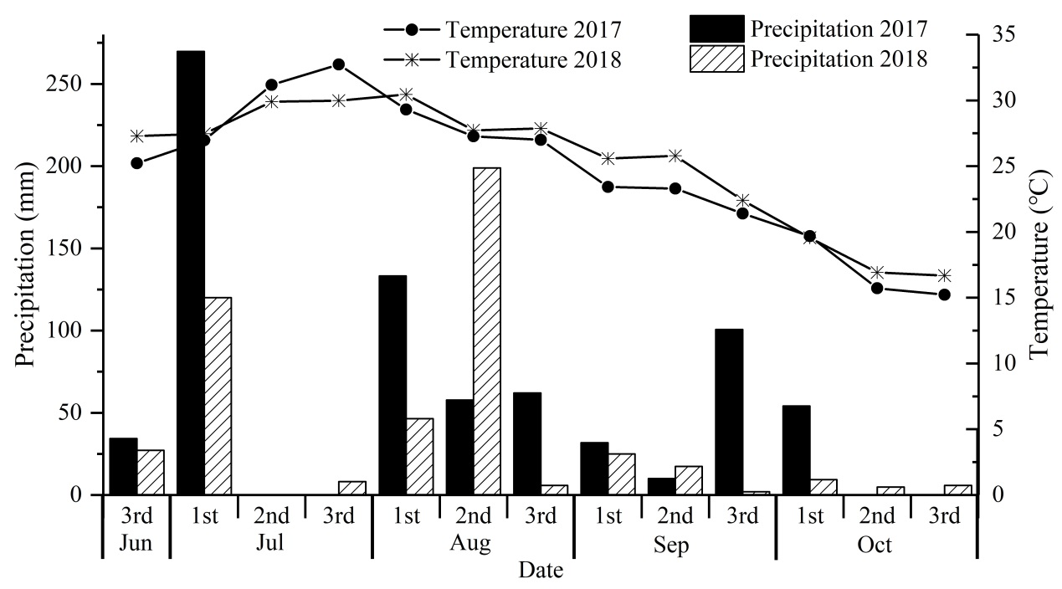
Fig. 1: The temperature and precipitation during the rice growth stage in 2017 and 2018

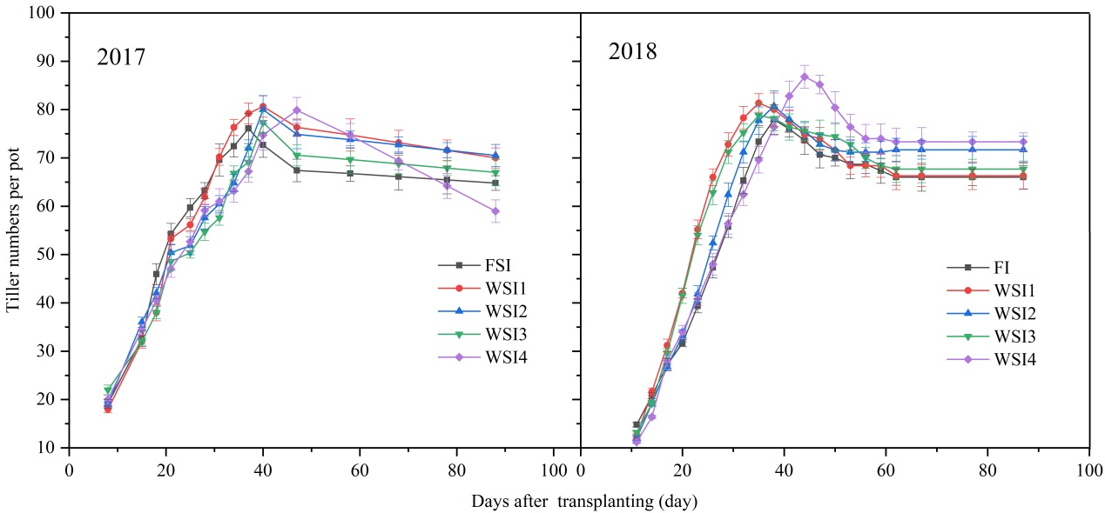
Fig. 2: The variation of the tiller numbers per pot in 2017 and 2018

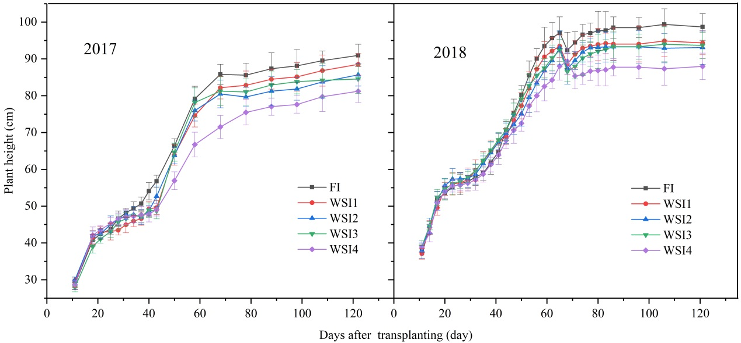
Fig. 3: The variation of the rice plant height in 2017 and 2018

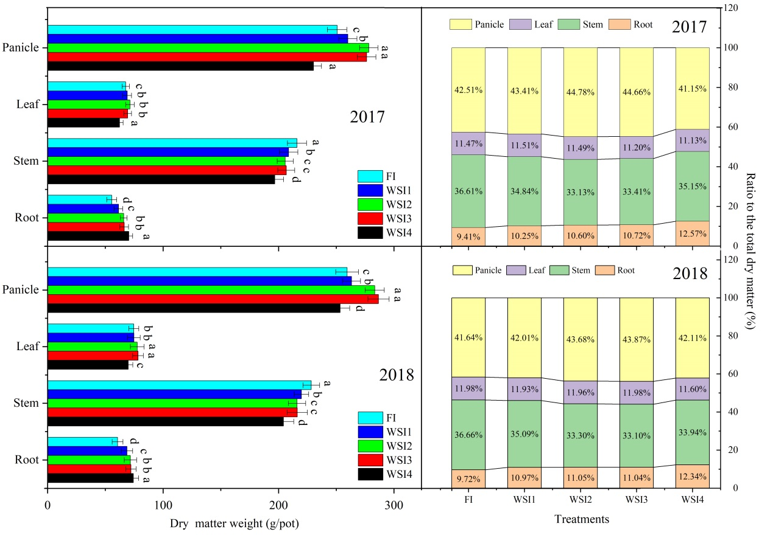
Fig. 4: The dry matter yield of different parts of the rice plant and their ratio to the total dry matter weight in 2017 and 2018

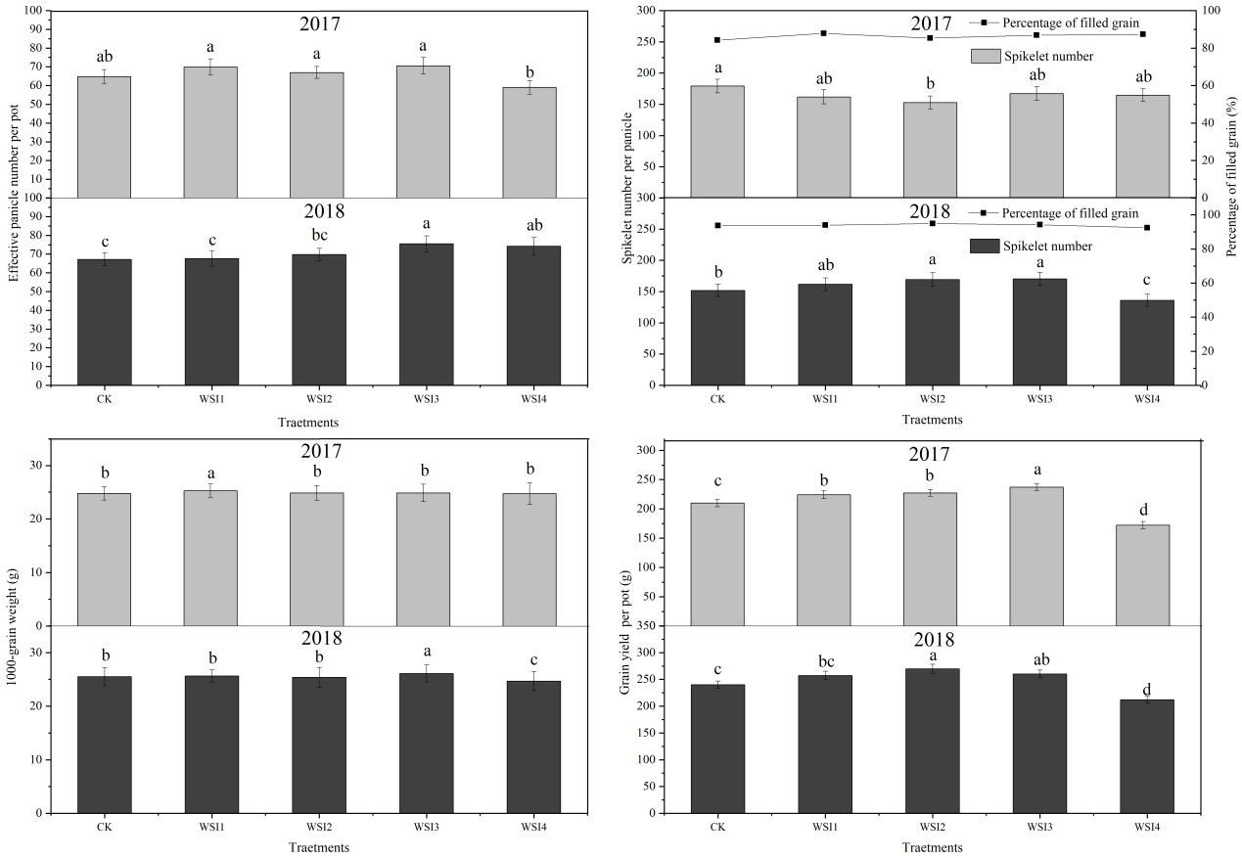
Fig. 5: Grain yield and its components of different irrigation regimes in 2017 and 2018
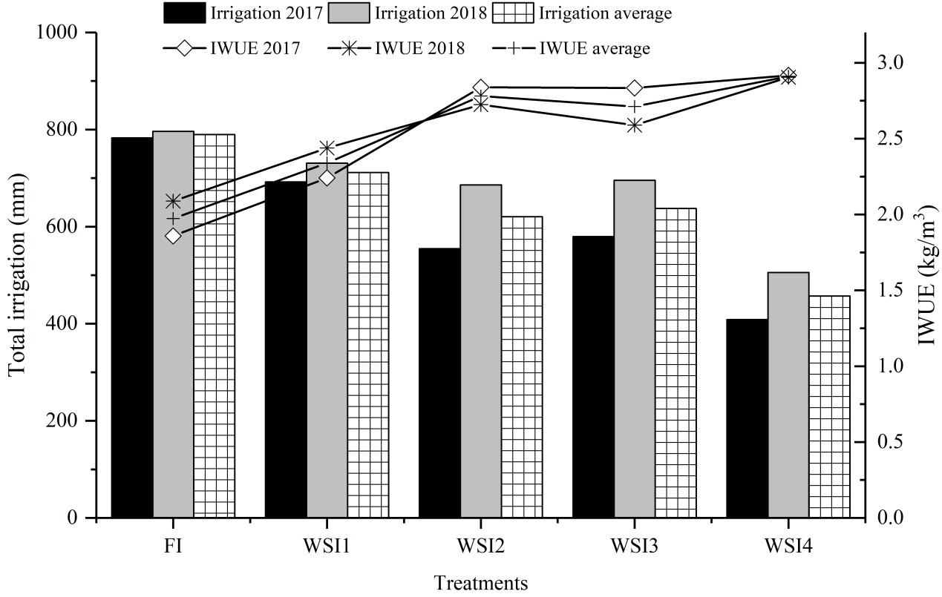
Fig. 6: The total irrigation input and the irrigation water use efficiency of each treatment

