Anti-MRSA efficacy of Amomum tsao-ko essential oil in mice by intragastric administration

Min Qiu^{1,2#}, Mingxiang Gao^{3#}, Fenghui Sun^{1,2}, Nana Long^{1,2}, Cheng Peng⁴*, Min Dai^{1,2}*
(#:MinQiu and Mingxiang Gao contributed equally to this work;*: Min Dai and Cheng Peng are co-corresponding author)

1 Sichuan Provincial Engineering Laboratory for Prevention and Control Technology of Veterinary Drug Residue in Animal-origin Food, Chengdu Medical College, Chengdu, Sichuan 610500, China
2 School of Laboratory Medicine, Chengdu Medical College, Chengdu, Sichuan 610500, PR China
3. School of Basic Medical Sciences, Chengdu Medical College, Chengdu, Sichuan 610500, PR China
4. West China School of Pharmacy Sichuan University, Chengdu, Sichuan 610041, PR China

Abstract Objective: To investigate the anti-MRSA efficacy of Amomum tsao-ko (A. tsao-ko) essential oil in vivo, the oral preventive effect and therapeutic effect were evaluated for anti-MRSA infection in mice. Methods: Firstly, minimal lethal dose (MLD) of MRSA was determined in mice, and the MLD concentration of MRSA was used to make a system infection model in mice by intraperitoneal injection. The effects of preventing and treating MRSA-infected mice were based on the results of oral A. tsao-ko essential oil for three consecutive days. The difference is that the prevention group first receives the drug treatment and then attacks the MRSA, and the treatment is followed by the drug treatment after the challenge of MRSA. On the 7th day, the survival rate was counted for therapeutic effect evaluation. The ED₅₀ of A. tsao-ko oil was calculated by Karber’s method. The concentrations of TNF-α, IL-1β and IL-6 were determined by ELISA kits in the preventive effect group (0.93 g.kg⁻¹.d⁻¹) and the histopathological changes of liver, kidney and lung were observed and recorded. Results: A. tsao-ko essential oil a good anti-MRSA infection effect, and the prevention effect is better. The ED₅₀ of A. tsao-ko essential oil was 0.42 g. kg⁻¹.d⁻¹ and 0.73 g.kg⁻¹.d⁻¹ were used for preventing and treating MRSA infection, respectively. A. tsao-ko essential oil could improve the inflammatory response caused by MRSA infection through regulating and the release of inflammatory factors such as IL-1β, IL-6, and TNF-α. Conclusion: A. tsao-k oessential oil showed strong anti-MRSA efficacy in vivo by intragastric administration, and it is an alternative drug for treating human and animal diseases caused by MRSA.
Key words: MRSA; Amomum tsao-ko essential oil; ED₅₀; Histopathological change
1 Introduction
Methicillin-resistant Staphylococcus aureus (MRSA) was discovered for the first time in 1961 after methicillin was introduced in 1959 (Jevons MP et al., 1961). MRSA, known as "super bacteria", is one of the most important drug-resistant pathogens for nosocomial infections and community-acquired infections. MRSA could cause soft tissue infections, pneumonia, endocarditis and sepsis severe infections. MRSA have induced about 25%-50% of the world's hospital-acquired Staphylococcus aureus infections, which is known as the three major infectious pathogens together with hepatitis B virus and Human Immunodeficiency Virus (BoschT et al., 2015; Malani PN., 2014; Xuhong Y et al., 2014; Frazee BW et al., 2005). With the widespread use of antibiotics, Staphylococcus aureus had shown drug resistance and affected the therapeutic effect of drugs seriously. At present, Vancomycin is the main drug for the treatment of MRSA infections, but the application of vancomycin is subject to certain restrictions, as vancomycin-susceptible bacteria have been continuously reduced and the side effects of itself (Chen LF., 2013; Álvarez R et al., 2016). It is urgent to find new and safe alternative agents for treating MRSA infection. A.tsao-ko Crevostet Lemaire is a perennial herb of the ginger family widely grown in southwestern China. As a food flavor, it can be used as a condiment for cakes, foods, and hotpots. Amomum tsao-ko is usually used to treat a variety of gastrointestinal diseases in China (Rahman MR et al., 2017; Dai Min et al., 2016), and the antibacterial active part of A. tsao-ko was its essential oil (Cui Q et al., 2017; Qiu S et al., 1999).
Compared with antibiotics, Chinese Traditional medicines have many advantages, such as relatively low toxicity, low drug residue, the non-specific antibacterial effect being not easy to produce drug resistance, and the ability to regulate and improve the body's immune capacity (Cui Xin-jie et al., 2017; Tan X et al., 2015; Chen X et al., 2015). Therefore, it is of great potential to develop Chinese Traditional medicine as an antibacterial drug.
The preliminary study has found that A. tsao-ko oil had strong anti-MRSA activity in vitro (Hang Xu et al., 2017). While there were no studies on the effect of A. tsao-ko oil on anti-MRSA infection in vivo. Based on this, this study intends to conduct an in-depth study on the anti-MRSA infection efficacy of A. tsao-ko essential oil in vivo, for laying a foundation for subsequent research on the comprehensive development and utilization of A. tsao-ko.
2 Material and methods
2.1 Bacteria strains
The MRSA standard strain ATCC43300, purchased from the American Type Culture Collection, was deposited in the Sichuan Provincial Experimental Teaching Demonstration Center of Medical Laboratory of Chengdu Medical College.
2.2 Experimental materials
Amomum tsao-ko Crevostet Lemaire was provided by Beijing Tong Ren Tang (batch#: MKBQ1662V). Vancomycin, purchased from Bioengineering (Shanghai) Co., Ltd., was diluted to 30.00 mg/ml with physiological saline. Tween-80 was purchased from Sinopharm Chemical Reagent Co., Ltd., with batch number 20150429. Mucin from porcine stomach was purchased from Sigma Company, with batch No. SLBP2671V. Nutrient Agar was purchased from Beijing AOB Star Biotechnology Co., Ltd., with Batch No.20150810. TNF-α, IL-1β, IL-6 ELISA kits were purchased from Elabscience.
2.3 Animals
Kunming mice, SPF grade, half male and half female (20 ± 2) g, were provided by the Chengdu Institute of Biological Products Co., Ltd. The animal production license number is SCXK (Chuan) 2016-08. Animal experiments were conducted under the principles of good laboratory animal care and performed in compliance with the Animal Ethics Review Committee of Chengdu Medical College, and this committee also approved the experiments.
2.4 Extraction of A. tsao-koessential oil
A. tsao-ko essential oil was extracted by steam distillation method (Qiu S et al., 1999). The density was measured (ρ = 929 mg.ml⁻¹) and stored in brown bottle at 4 ℃ for future use. The essential oil was dissolved with 1% Tween-80 and was diluted to 0.93, 0.65, 0.47, 0.33, 0.17, 1.39, 0.96, 0.68, 0.48 and 0.33 g.ml⁻¹ with physiological saline for using.
2.5 Minimal lethal dose (MLD) of MRSA
ICR Mice (SPF grade) were randomly divided into 6 groups according to body weight (n = 10), 5 experimental groups and one control group, after they adaptive the environment. MRSA was grown in TSA and collected at logarithmic phase. Then bacterial suspension was diluted with physiological saline into different concentrations. After blending with 10% mucin and bacterial suspension half and half, the solution was intraperitoneally injected to mice to made the infection model. The mortality and clinical symptoms were recorded in each group. The smallest bacterial concentration that caused all mice death was recorded as the minimum lethal dose (MLD) of MRSA.
2.6 Anti-MRSA infection efficacy of A. tsao-ko oil
Ninety mices were randomly divided into 9 groups (n = 10) with half of males and females. The groups were blank control group, model control group, solvent control group, positive drug control group, 5 experimental groups, respectively. The blank control group and model control group were given saline by intragastric administration. The solvent control group was given Tween-80 by intragastric administration. The positive control group was given vancomycin by intragastric administration. The different doses of A. tsao-ko essential oil were used for the experimental groups by intragastric administration, once a day for 3 days (Tab.1). Except for the blank group, the mice in the remaining groups were challenged with the MLD of MRSA after administrating on the 3rd day. On the 7th day after challenging, the survival rate was statistically observed for preventive effect evaluation.
To study the therapeutic capacity of A. tsao-ko essential oil, ninety mice were randomly divided into 9 groups as mentioned above, which contained blank control group, model control group, solvent control group, positive drug control group, and five experimental groups. In addition to the blank group, the mice in other groups were intragastrically injected with the MLD dose of MRSA bacterial then different doses of A. tsao-ko essential oil were given intragastrically once daily for 3 days (Tab.2). On the 7th day after the last drug administration, the survival rate was counted for therapeutic effect evaluation.
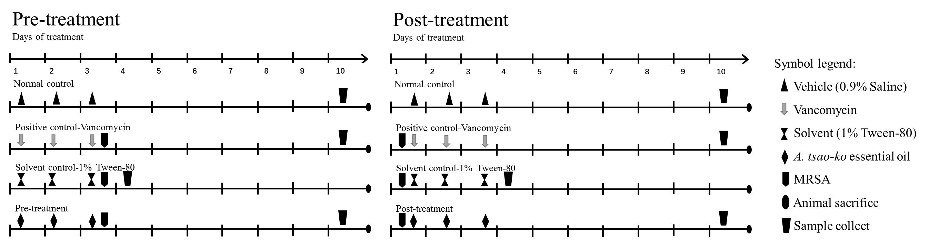
Fig 1. Mice experimental design.
2.7 Effect of A. tsao-ko oil on cytokines
On the 7th day, the serum were collected from one A. tsao-ko essential oil treating group (0.93 g.kg⁻¹.d⁻¹), positive control group (vancomycin group 0.30 g.kg-1.d-1), and blank control group. Model group mice typically died within 24 hours, so blood samples from this group were collected 12 h after infection with MRSA. The levels of TNF-α, IL-1β, and IL-6 were analyzed by ELISA kits.
2.8 Histopathological evaluation
On the 7th day after treatment, the liver, kidney, and lung tissues were sampled in the experiment 1 group (Tab.1). The samples were rinsed with saline and placed in 4% formaldehyde solution. Fresh formaldehyde was used to further fix the samples after 24 hours, and then the sample was embedded in a wax block and cut into 5 μm pieces. The tissue slices were stained with hematoxylin and eosin for microscopic examination. All observations were made manually in a blinded manner using a light microscope with × 5, ×10, ×20, and × 40 objective lenses.
2.9 Statistical Analysis
The 50% effective does (ED₅₀) was calculated by Karber’s method. The statistical analysis of data was carried out by one-way analysis of variance through SPSS software (ver 19.0, SPSS Inc., Chicago, IL, USA), and P＜0.05 or P＜0.01 was considered statistically significant.
3 Results
3.1 Preventive effect of A. tsao-ko essential oil on MRSA in mice
A. tsao-ko essential oil was administered by intragastric administration once a day for 3 days before MLD of MRSA injecting, and then the survival rate was calculated on the 7th day after MRSA infection. As shown in Tab.1, significant anti-infection activity was observed in mice infected with MRSA, and the ED₅₀ of A. tsao-ko essential oil for preventing MRSA infection was 0.42 g.kg⁻¹.d⁻¹. And the survival rate of mice infected with MRSA would increase along with the dose increase of A. tsao-ko oil. When the dose of A. tsao-ko oil increased to 0.93 g.kg⁻¹.d⁻¹, the survival rate of mice infected with MRSA reached to 100%.
Tab. 1 Preventive effect of A. tsao-ko essential oil in mice infected with MRSA
Groups | Drugs | Dose  (g.kg⁻¹.d⁻¹) | No. of animals | No. of survivors | Survival rate (%)
Blank | Saline | - | 10 | 10 | 100
Model | Saline | - | 10 | 0 | 0
Solvent | Tween-80 | 0.005 | 10 | 0 | 0
Positive | Vancomycin | 0.30 | 10 | 10 | 100
Experiment 1 | A. tsao-ko oil | 0.93 | 10 | 10 | 100
Experiment 2 | A. tsao-ko oil | 0.65 | 10 | 8 | 80
Experiment 3 | A. tsao-ko oil | 0.47 | 10 | 6 | 60
Experiment 4 | A. tsao-ko oil | 0.33 | 10 | 3 | 30
Experiment 5 | A. tsao-ko oil | 0.17 | 10 | 0 | 0
3.2 Therapeutical effect of A. tsao-ko essential oil against MRSA in mice
A. tsao-ko essential oil was used to control infection by intragastric administration once a day for 3 days after MRSA infected. A. tsao-ko essential oil significantly shown obvious anti-MRSA efficacy in mice (Tab.2). The ED₅₀ of A. tsao-ko essential oil for treating MRSA infection was 0.73 g.kg⁻¹.d⁻¹. Using high tolerable dose (0.96 and 1.39 g.kg⁻¹.d⁻¹) of A. tsao-ko oil in mice, the survival rate was 60%. Meanwhile, the cure rate was only 10% with 0.33 g.kg⁻¹ A. tsao-ko oil. The anti-MRSA efficacy of A. tsao-ko oil showed more evident as doses increases. Therefore, A. tsao-ko essential oil exhibited significant dose-effect relationship in treating MRSA infection.
Tab.2 Therapeutical effect of A. tsao-ko essential oil in mice infected with MRSA
Groups | Drugs | Dose  (g.kg⁻¹.d⁻¹) | No. of animals | No. of survivors | Survival rate (%)
Blank | Saline | / | 10 | 10 | 100
Model | Saline | / | 10 | 0 | 0
Solvent | Tween-80 | 0.005 | 10 | 0 | 0
Positive | Vancomycin | 0.30 | 10 | 10 | 100
Experiment 1 | A. tsao-kooil | 1.39 | 10 | 6 | 60
Experiment 2 | A. tsao-ko oil | 0.96 | 10 | 6 | 60
Experiment 3 | A. tsao-ko oil | 0.68 | 10 | 5 | 50
Experiment 4 | A. tsao-ko oil | 0.48 | 10 | 3 | 30
Experiment 5 | A. tsao-ko oil | 0.33 | 10 | 1 | 10
3.3 Effect of A. tsao-ko oil on cytokines in mice infected with MRSA
After treatment with A. tsao-ko essential oil, the levels of inflammatory cytokines including IL-1β, IL-6, TNF-α decreased significantly. Except for IL-1β, the levels of IL-6 and INF-α nearly returned to normal levels at the end of experiment. The content of IL-6 decreased from 2065.00 ± 139.40 (the model group) to 58.72 ± 0.36 (the A. tsao-ko group), which showed no significant difference with the blank group (p≥0.05) but significantly different from the model group (P<0.01). The content of INF-α obviously decreased from 76.77 ± 4.61 (the model group) to 30.62 ± 2.81 (the A. tsao-ko group), which showed no significant difference with the blank group (p ≥ 0.05) but significant difference with the model group (P<0.01). The content of IL-1β decreased from 141.00 ± 9.10 (the model group) to 106.70 ± 7.65 (the A. tsao-ko group), which was significantly different from the blank group (P<0.05), but significantly lower than that of the model group (P<0.05). These results showed that A. tsao-ko oil could control MRSA infection in mice through regulating the expression of IL-1β, IL-6 and TNF-α.
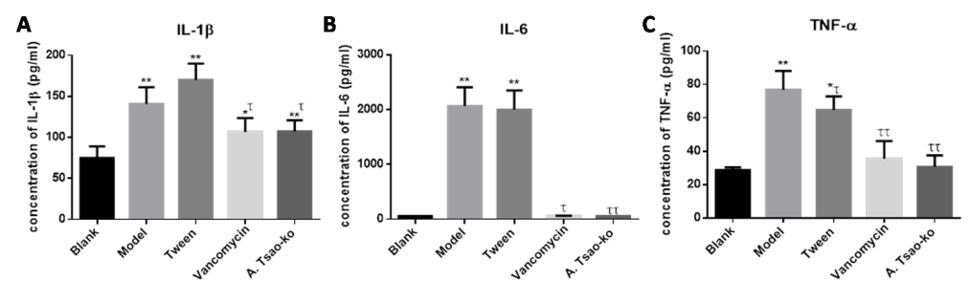
Fig.2 Effects of A.tsao-koon blood cytokines in mice infected with MRSA
Blank: the blank group, Model: the model group, Tween: the Tween-80 group, Vancomycin: the vancomycin group, A.tsao-ko: the preventive group (0.93g.kg⁻¹.d⁻¹); compared with blank group, *p<0.05, **p<0.01; compared with model group, ^{τ}P<0.05, ^{ττ}P<0.01.
3.4 Histopathological changes analysis
After treatment, the lung, liver, and kidney were collected from survival mice, and the histopathological changes of these tissues were observed and recorded. Except for lung, there were no obvious histopathological changes in the liver (Fig.2) and kidney (Fig.3). There had neutrophil infiltration of the lung in the mice infected with MRSA, and A. tsao-ko essential oil could improve the inflammatory response caused by MRSA infection (Fig.4)
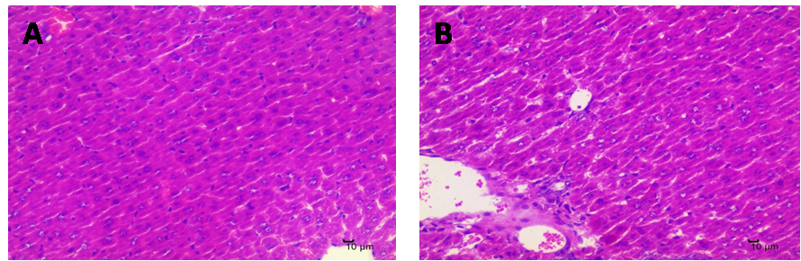
Fig.2 Pathological analysis of liver tissue in mice infected with MRSA
A: the blank group, B: the model group
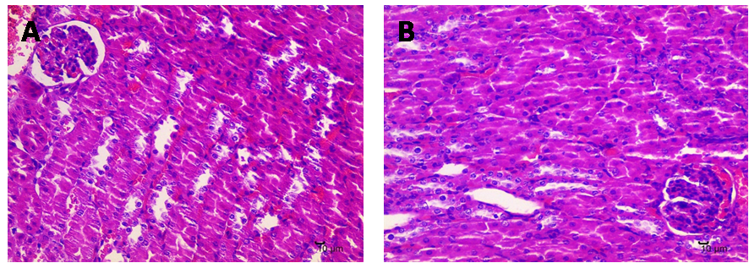
Fig.3 Pathological analysis of kidney in mice infected with MRSA
A: the blank group, B: the model group
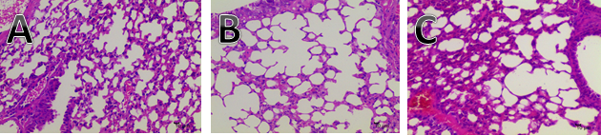
Fig.4 Pathological changes of A.tsao-kooilon the lung tissue in mice infected with MRSA
A: the blank group; B: the model group; C: the preventive administration group (0.93 g.kg⁻¹.d⁻¹A.tsao-k ooil )
4 Discussion
With the extensive use of various clinical antibacterial drugs to obtaining better therapeutic effects, which lead to the emergence of bacterial drug resistance (Howden BP et al., 2013; Giltner CL et al., 2014; Stryjewski ME et al., 2014). The development of new anti-MRSA infectious drugs is imminent. Studies have found that small molecule natural substances have good antibacterial activity. Due to its special pharmacological properties, bacteria are not susceptible to resistance (Qingqing Liu et al., 2011; Yu HH et al., 2005; Liu IX et al., 2000). In addition to the fact that natural medicines are not prone to drug resistance, they also have the effect of anti-oxidation and regulation of immunity (KalyoncuIH et al., 2009; Zhang ZT et al., 2002; Aliberti S et al., 2016). This provides a new idea for the development of antibacterial agents from Chinese traditional medicine. Our previous study showed that A. tsao-ko essential oil had strong anti-MRSA activity in vitro. This study investigated the anti-MRSA activity in vivo of A. tsao-ko essential oil by intragastric administration. MRSA infected mice were administered with A. tsao-ko essential oil prophylactically or therapeutically, while vancomycin was used as positive control drug. The results showed that A. tsao-ko essential oil exhibited stronger preventive effect than therapeutic effect. When the essential oil (0.93 g·kg⁻¹·d⁻¹) was administered intragastrically once a day for 3 days for pre-treatment, the survival rates of mice infected with MRSA could reach to 100.00% (Tab.1), at the same time the ED₅₀ value was 0.42 g.kg⁻¹·d⁻¹. The survival rates of mice infected with MRSA was 60.00% (0.96 and 1.39 g·kg⁻¹·d⁻¹), and the ED₅₀ was 0.73 g.kg⁻¹ when A. tsao-ko essential oil was use for treatment drug.
Pneumonia is one of the most common infectious diseases, and the main pathogenesis is related to MRSA bacterial components interfering with the host immune response, leading to immune dysfunction and inducing the release of a variety of inflammatory factors (Aliberti S et al., 2016). The immune cells release inflammatory cytokines, mainly including IL-1β, IL-6 and TNF-α, which are important inflammatory cytokines in human body and have strong inflammatory activity. As the initiating factor of systemic inflammatory response syndrome (SIRS), IL-1β, IL-6, and TNF-α can directly act on vascular endothelial cells, resulting in a significant increase in their permeation, thereby triggering tissue inflammatory responses and various clinical manifestations. Excessive secretion of pro-inflammatory cytokines leads to tissue damage and even the occurrence and development of sepsis, shock and multiple organ failure (Kim HG et al., 2008; Veleminsky M Jr et al., 2008; Xiaoxia Huang et al., 2017). In this study, MRSA increased the serum levels of IL-1β, IL-6, and TNF-α of mice, indicating that MRSA infection caused the strong inflammatory response of mice. And A. tsao-ko essential oil alleviated the inflammation caused by MRSA by decreasing the levels of IL-1β, IL-6, and TNF-α. There was no obvious pathological change in liver and kidney after infected with MRSA in mice. However, A. tsao-ko essential oil significantly alleviated the pulmonary inflammatory cell infiltration induced by MRSA in mice.
In short, A. tsao-ko essential oil exhibited obvious preventive and therapeutically effect on MRSA infection, and the anti-MRSA mechanism in vivo was related to reduce inflammatory cell infiltration and inflammatory factors release. These results indicated that A. tsao-ko essential oil could be a potential candidate as anti-MRSA agent.
5 Conclusions
The study found that A. tsao-ko essential oil had strong anti-MRSA activity in vivo by oral administration. The preventive effect of A. tsao-ko essential oil against MRSA in vivo was better than that of the therapeutical effect. The ED₅₀ of A. tsao-ko essential oil in preventing and treating MRSA infection was 0.42 g.kg⁻¹.d⁻¹ and 0.73 g.kg⁻¹.d⁻¹, respectively. In addition, A. tsao-ko essential oil could improve the inflammatory response caused by MRSA infection, and its anti-inflammatory activity by reducing inflammatory cell infiltration and inflammatory factors release. Therefore, A. tsao-ko essential oil can be developed as a drug to treating human and animal MRSA infection.
Acknowledgments
This work was supported by the National Natural Science Foundation of China (No. 31970137), the Benefit People Project of Science and Technology of Chengdu Science and Technology Bureau (No.2016-HM01-00362-SF), the Training Program of Innovation and Entrepreneurship for Undergraduate (No.201813705049), the Chunhui Plan of Ministry of Education of China ( No. Z2016120), the Health Commission of Sichuan Province (No.19PJ032).
References
Jevons MP, Rolinson GN, R Knox.Celbenin-resistant staphylococci.Brit Med J, 1961, 1:124-6.
BoschT, Verkade E, M van Luit, et al. Transmission and persistence of livestock-associated methicillin-resistant Staphylococcus aureus among veterinarians and their household members. Appl Environ Microbiol, 2015, 81 (1) : 124-129.
Malani PN. National burden of invasive methicillin-resistant Staphylococcus
aureusinfections.Jama , 2014 , 311 (14) :1438-9
Xuhong Y, Falagas ME, W Dong , et al. In vitro activity of fosfomycin in combination with linezolid against clinical isolates of methicillin-resistant Staphylococcus aureus.Journal of Antibiotics , 2014 , 67 (5) :369-71
Frazee BW, LynJ n, Charlebois ED, et al. High prevalence of methicillin resistant Staphylococcus aureus in emergency department skin and soft tissue infections. Ann Emerg Med, 2005, 45 (3) :311-320.
Chen LF. The changing epidemiology of methicillin resistant Staphylococcus aureus: 50 years of a super bug. Ajic American Journal of Infection Control , 2013 , 41 (5) :448-451
Álvarez R, LE López Cortés, J, Molina, et al. Optimizing the clinical use of vancomycin. Antimicrobial Agents & Chemotherapy , 2016 , 60 (5) :2601
Rahman MR, Lou Z, Yu F, et al. Anti-quorum sensing and anti-biofilm activity of Amomumtsoko (Amommumtsao-koCrevost et Lemarie) on food borne pathogens．Saudi Journal of Biological Sciences , 2017 , 24 (2) :324
Dai Min, Peng Cheng,Sun Fenghui. Anti-infectious efficacy and chemical composition of the essential oil from Amomumtsao-ko. J Tradit Chin Med, 2016, 36(6):799-804.
CuiQ， WangLT，JZ Liu ， et al. Rapid extraction of Amomum tsao-ko essential oil and determination of its chemical composition, antioxidant and antimicrobial activities.. J Chromatogr B Analyt Technol Biomed Life Sci , 2017 , 1061-1062 :364-371
Qiu S, Shou D, Chen L, et al. Pharmacological comparison between volatile oil and water extract. ZhongguoZhong Yao ZaZhi, 1999, 24 (5) :297.
CUI Xin-jie, XIA Jin, SHAO Tie-juan etal. Research Progress in TCM Against Methicillin-resistant Staphylococcus Aureus Biofilms. Chinese Journal of Information on Traditional Chinese Medicine, 2017, 24(02): 132-136.
TanX, YangG,et al.The investigation of inhibiting quorum sensing and methicillin-resistant Staphylococcus aureus biofilm formation from Liriodendron hybrid. Pakistan Journal of Pharmaceutical Sciences,2015,28(3):903-908.
Chen X, Shang F, Meng Y et al. Ethanol extract of Sanguisorba of ficinalisL.inhibits biofilm formation of methicillin resistant Staphylococcus aureus in an ica-dependent manner. Journal of Dairy Science,2015,98(12):8486-8491.
Hang Xu, Nana Long, Lin Lin et al. In Vitro Antibacterial Activity of AmomumTsao-koEssential Oil Against Methicillin-resistant Staphylococcus Aureus. Journal of Chengdu Medical College, 2017, 12(3): 241-246.
Howden BP, Beaume M, Harrison PF, et al. Analysis of the small RNA transcriptional response in multidrug-resistantStaphylococcus aureus after antimicrobial exposure. Antimicrob Agents Chemother, 2013, 57(8): 3864-3874.
Giltner CL, Kelesidis T, Hindler JA, et al. Frequency of susceptibility testing for patients with persistent methicillin resistantStaphylococcus aureusbacteremia.Journal of Clinical Microbiology , 2014 , 52 (1) :357-361
Stryjewski ME, Corey GR. Methicillin-resistantStaphylococcus aureus: an evolving pathogen. Clinical Infectious Diseases, 2014, 58(S1): S10-S19.
Qingqing Liu, GuoyingZuo. Progress in the study of in vitro antibacterial activity of commonly used antibiotics/natural products. China Pharmacy, 2011, 22(37): 3530-3533.
Yu HH，Kim KJ，Cha JD，et al. Antimicrobial activity of berberine alone and in combination with ampicillin or oxacillin against methicillin-resistant staphylococcus aureus. J Med Food，2005，8（4）：454.-461
Liu IX，Durham DG，Michael R，et al. Baicalin synergy with β-lactam antibiotics against methicillin-resistant Staphylococcus aureus and other β-lactam-resistant strains of S.aureus. J Pharm Pharmacol, 2000, 52(3):361.-366
KalyoncuIH，AkbulutM， ÇOklarH.Antioxidant capacity, total phenolics and some chemical properties of semimatured apricot cultivars grown in Malatya, Turkey.World Applied Sciences Journal, 2009 (6) :519-523.
ZhangZT， YunHE，LiuQG, et al. Spectrophotometric determination of antioxidant properties of 20 Chinese herbal medicines in Taibai Mountain. Analysis Laboratory. 2002, 21(2):50-52.
Aliberti S, Reyes LF, Faverio P, et al. Global initiative for meticillin-resistant Staphylococcus aureus pneumonia (GLIMP):an international, observational cohort study. Lancet Infect Dis, 2016, 16 (12) :1364-1376.
Kim HG, Lee SY, Kim NR, et al. Inhibitory effects of Lactobacillus plantarumlipoteichoic acid (LTA) on Staphylococcus aureus LTA-induced tumor necrosis factor-alpha production. J MicrobiolBiotechnol, 2008, 18 (6) :1191-1196.
Veleminsky M Jr, Strrlnsky P, Veleminsky M Sr, et al. Relationship of IL-6, IL-8, TNF and slCAM-1 levels to PROM, pPROM, and the risk of early-onset neonatal sepsis. NeuroEndocrinolLett, 2008, 29 (3) :303-311.
Xiaoxia Huang, Xiayu Yi, XiaoruiHou,et al. Pretreatment of Pam3CSK4 reduces the inflammatory response in the kidney of mice in a systemic infection model of MRSA . Chinese Journal of Immunology, 2017, 33 (10): 1530-1535.

