Running Title: Screening of biofilm and bacteriocin producing bacteria isolated from different water sources

SCREENING FOR BACTERIOCIN PRODUCERS AND BIOFILM FORMERS AMONG BACTERIAL ISOLATES OF WATER SAMPLES FROM HYDERABAD, PAKISTAN

Fariha Ahsan^{1*}, Shaista Bano¹, Mansoor Ali², Khalida Hamid Abbasi³, Arshad Mahmood⁴, Shafiqa Ali⁵, Abdur Rauf⁶, Abdul Hafeez⁷, Muhammad Zahid Aslam⁸, Sisay Ketema⁹, Abdul Rasheed Kaleri¹⁰, Ikram Ullah^{11*}

¹Institute of Microbiology, University of Sindh, Jamshoro 76080, Pakistan

²Department of Food Science and Technology, The University of Agriculture Peshawar, Pakistan
³Barani Agricultural Research Institute, Chakwal 48800, Pakistan
⁴Unit of Soil Science and Plant Nutrients, Brunei Agricultural Research Center, Brunei Darussalam
⁵Department of Earth and Environmental Sciences, National Chung Cheng University, Chiayi 621, Taiwan
⁶Department of Botany, Garden Campus, Abdul Wali Khan University, Mardan, Pakistan
⁷Institute of Hydroponics Agriculture, Pir Mehr Ali Shah Arid Agricultural University, Rawalpindi, Pakistan
⁸Cotton Research Station, Bahawalpur 63100, Pakistan
⁹Department of Public Health, Collage of Health Science, Mizan, Ethiopia
¹⁰ School of Life Science and Engineering, Southwest University of Science and Technology, Mianyang 621010, China
¹¹College of Landscape and Horticulture, Yunnan Agricultural University, Kunming, China
*For Correspondence: ikramkhan1800@gmail.com

Novelty statement
This type of study was done first time in the city of Hyderabad of Province Sindh. In this study it was found that the bacterial isolates of water have capacity to produce biofilm on an abiotic surface. However, the isolated were not capable of bacteriocin production. During random sampling of Schools, Mosques, Bazaar, Hospitals, offices and colleges, it was concluded that the direct line water samples were more contaminated, and high number of E. coli isolates were present. As compared to tank and hand pump water during this research we found that this water has ability of biofilm former. This water is not even treatable by any method like chlorination; filtration etc .and the risk factor is very high.

Abstract
Polluted and contaminated drinking water supplies upgrading general well-being concerns, particularly in urban areas in developing and low assets nation including Pakistan. Microbiologist are now realizing that in natural, clinical, and industrial settings, bacteria often aggregate in biofilm. Biofilm forms when bacteria adhere to surface in moist environments by excreting a slimy, glue-like substance and become more resistant to antibiotics. To comprehend the extent of biofilm related water borne general wellbeing risk credited to drinking water, it is fundamental to decide of biofilm formation of those bacteria which have commonly found in drinking water in planktonic form. Therefore, this study aimed to analyze the capacity of biofilm formation of only E. coli detached from drinking water samples collected during the period of this study. Microbial investigation of water was done by using Millipore Filtration technique. The E. coli isolates were recognized by using conventional biochemical tests. The isolates were tested against a range of commercially available antibiotic discs using Disc-diffusion method introduced by Kirby-Bauer. This helped to determine the resistance pattern of the isolates. The capacity of the indigenous pathogens to form biofilm was assessed using tube adherence method and the Congo red method whereas the investigation of the biofilm formation was done on the basis of the adherence of the biofilm to glass test tube and appearance of black colonies with consistency of dry crystalline, respectively. The validity and accuracy of the methodology was checked with use of control strain (E. coli ATCC 25922). Antibiotic susceptibility testing demonstrated high level of resistance among the E. coli isolates against tested antibiotics. The results of this study showed that 79.5% (n=62) of total samples (n=78) were positive for bacterial growth. Furthermore 16.1% (n=10) isolated bacteria were identified as E. coli and remaining were other bacteria. Screening of the water isolates for bacteriocin producers revealed that none of them can produce bacteriocin while result of biofilm detection assay showed that 60 % of E. coli isolates were having potential of biofilm formation. The results might be helpful for policy making regards drinking water supply.

Keywords: Biofilm; bacteriocin; isolates; drinking water;

Introduction
Polluted and contaminated drinking water supplies enhancing to raise general well-being concerns, particularly in metropolitan region developing and low asset nations including Pakistan. Microbiologist are now realizing that in natural, clinical, and industrial settings, bacteria often aggregate in biofilm. Biofilm forms when bacteria adhere to surface in moist environments by excreting a slimy, glue-like substance and become more resistant to antibiotics. Moreover, water is an essential and vital component of life but safe drinking water is not accessed in many areas of developing countries which cause different type of hazardous disease to health which may cause deaths of many people due to water borne disease. These waters borne diseases are caused by pathogenic microbes present in the drinking water. The range of waterborne diseases and their rigorousness is more in under-developed countries especially in Pakistan where in rural as well as in urban areas the bacteriological contamination of drinking water has long been reported among the most severe domestic problems (Asif et al. 2015; Kazmi et al., 2015; Mohsin et al., 2013; Saddozai et al., 2009; Shar et al., 2010).
Pakistan has a poor water resource management system that has resulted in contaminated drinking water quality, both in rural and urban areas.The situation of polluted drinking water is very bad in all big cities around the Pakistan. Among them Hyderabad is 2nd Largest city of Sindh is Hyderabad, situated nearer to river Indus; Population of city Hyderabad is 1.8 million. Drinking water of Hyderabad is not fit for drinking, it is dangerously contaminated. Different research surveys tell us that 95% of ground water supplies are fiscally contaminated. The mostly1.2 million population of Hyderabad city is affected to contaminated water. Even 7% is the total rural population. A vast amount of untreated water is supplied without treatment and huge quantity of discard is left and burned in the backyard of buildings, streets and side ditched whereby creating polluted conditions and affecting public health. About 57% of the citizens have piped deliver to their homes but in other primarily deprived areas public get water moreover from community taps, hand pumps, wells or pay heavy price to the water vendors. Water quality monitoring is carried out regularly at only a few locations and there is no real water quality monitoring network or information system.
Water contamination is major predicament and problem in context as an effect of industrialization, globalization, population growth and more exaggerated life styles. Contaminated drinking water plays a key function in the spread of water-borne infectious diseases. There are mainly four types of water contaminants; Physical (pH, temperature, aroma, turbidity and color), Chemical (organic and inorganic chemicals), radiological, and Biological (bacteria, viruses and protozoa) contamination (Timothy et al., 2016). Contamination of water becomes matter of concern if the contamination is hazardous to human, animal and plants life. There are many diseases which are transmitted through water. They include protozoal infections such as amoebiasis, giardiasis (Marshall et al., 1997), parasitic infections such as schist-somiasis, taeniasis, ascariasis, enterobiasis (John et al., 2008), bacterial infections includes cholera, typhoid, dysentery, salmonellosis (Momtaz et al., 2013) and viral infections such as Hepatitis A and HIV (Mtapuri-Zinyowera et al., 2014). Various studies have looked at the microbiological quality of water of distinct regions of Pakistan. However, no new investigations have made evaluation of water nature of Hyderabad. This study will consequently be conducted to find out whether the same holds in this environment (Hyderabad). In addition to assessment of microbiological quality of water from Hyderabad, this study will focus on the screening for bacteriocins producer and biofilm formers among E. coli isolates of drinking water sampled from Hyderabad region. As far as bacterial infections are concerned, E. coli is very important in diseases transmitted through consumption of water while a wide range of microorganism has been reported being transported through water. Routine analysis of quality of water at local level is very essential to monitor the risk of transmission water borne diseases (Alqahtani et al., 2015). More specifically, knowing the bacteriological quality of drinking water is very crucial because wide range of pathogenic bacteria usually transmit through this route globally. However, the condition is worst in developing areas. As usual, presence of indicator bacteria such as coliforms indicates the bacteriological contamination (fecal) of water which should not ideally be present on 100 ml of water. It is also important to analyze the pathogen bacteria isolated from water to insight the reason of increasing rate of water borne infection as well as get way to solve the problem of biological contamination of water from its roots. Bacteriocins are protein antibiotic that are produced by bacteria. They act on closely related bacteria and have been reported to be produced by all bacteria lineages. The bacteriocins are a large family of diverse proteins demonstrating different modes of action, microbial targets, size, and immunity mechanisms. The colicins are produced by E. coli and are comprehensively studied type of the bacteriocins; Colicins target E. coli and related species (Cascales et al., 2007). Bacteriocins have been shown to act as anti-competitors thus enabling a strain to invade an establish community of microbes (Lenski and Riley, 2002; Majeed et al., 2011). On the other hand, defensive role of the bacteriocins has been described wherein they seem to antagonize the invasion of other microbial strains/species into an occupied niche of neighboring cells (Kerr et al., 2002). Recently, a new function has been proposed for bacteriocins produced from Gram-positive bacteria where they mediate quorum sensing (Miller and Bassler, 2001). It is probable that whatsoever roles bacteriocins take part in these roles alter as components of the surroundings, both biotic and abiotic, change. Therefore, the present study was designed to screen water isolates for bacteriocins producers as well.
Besides, biofilm is community of microorganisms adhered to an aqueous surface and embedded in a polysaccharide matrix (Stoodley et al., 2002). Biofilm growth is a result of successful attachment and subsequent growth of microorganism on a surface. In an aquatic environment, biofilm is a predominant lifestyle of bacteria. Biofilm may harbor colonies of pathogenic bacteria. The most alarming consequences of biofilm formation includes the presence and further reproduction of both pathogenic and opportunistic pathogens such as E. coli (Beloin et al., 2008), Klebsiella spp. (Vuotto et al., 2014), Pseudomonas spp. (Mulcahy et al., 2014), Mycobacteria spp. (Rose et al., 2015), Campylobacter spp (Brown et al., 2015), Aeromonas spp, Legionella spp, streptococcus mutans (Falsetta et al., 2014) within the Biofilms (Lebeaux et al., 2014). The antibiotic called Bacteriocins is unique from others in a way that it has less killing scale and it is deadly to those microorganisms that are narrowly connected to the producing strains. The toxins produced by the Bacteriocins are found in all main lineages of microorganisms and are also known as generally formed by a few members of the Archaea, recently (Torreblanca et al., 1994).
Inside the biofilm, bacteria can transfer antibiotic resistance to previously sensitive strains of either same or a different species. Upon dispersal of the antibiotic resistant pathogens from their biofilm into domestic drinking water, water borne infections become a challenge because of bacteria have now great resistant towards commonly used antibiotic for particular water borne infections (Kaplan, 2010). Therefore, the present study was designed and conducted to screen water isolates for biofilm forming ability in addition of bacteriocins production with following objectives.
1. Isolation and characterization of bacteria from filtered and non-filtered drinking water samples collected from different taps of different public places.
2. To investigate and detect the antibiotic susceptibility pattern of the all bacterial isolates of water against a range of available antibiotics.
3. To detect pattern of bacteriocins production among the E. coli isolates using qualitative techniques.
4. To detect pattern of biofilm formation among the E. coli isolates using qualitative techniques.

Methodology:
The current research study was carried out at Research laboratory of Institute of Microbiology, University of Sindh, Jamshoro Sindh, Pakistan. The E. coli strains were isolated from drinking total 78 water samples collected from various public places including bazaar, schools, mosques, restaurants, hospitals and hand pumps of Hyderabad district during the period of 6 months September 2013 to February 2014. The E. coli ATCC 25923 was used as control strain in antibiotic sensitivity and biofilm formation assays. Water samples were processed by using milli pore filtration method. All the isolated colonies were sub cultured on a fresh plate. Following identification of the bacteria, the pure cultures were stored for further screening for potential biofilm former and bacteriocins producers, i.e. Millipore Filtration Technique and Pour plate method.
Isolation and identification of bacteria from water samples were done and all the collected water samples were analyzed for the presence of bacteria according to World Health organization (WHO) and Pakistan Standard Guidelines (Athar et al., 2008). Some commercially available media were prepared in the laboratory for routine use according to the instructions given on bottle like MacConkey’s agar, Triple sugar Iron agar, Simmons citrate agar, For the identification and classification of isolated bacteria, Gram staining method were used. Sensitivity of all isolates to various antibiotics was measured by using Kirby Baur Disk Diffusion methods on Muller- Hinton Agar (Oxoid, Basingstoke, UK) (Bauer et al., 1966). The detection of Biofilm formation by the isolates were performed qualitatively by using tube adherence method (Christensen et al., 1982) and tissue culture plate method (Christensen et al., 1985) and also by using Congo Red Agar medium which is a qualitative method. Besides, all pure cultures of E. coli strains isolated from water samples were subjected for stab test and spot test for determination of colicins activity of the isolates test according to (Penfold et al., 2000).

S. No | Name of Antibiotic | Class of Antibiotic
1 | Amikacin (30µg) | Amino-glycoside
2 | Amoxycillin
3 | Cefdodxime | Cephalosporin
4 | Cefotaxime | Cephalosporin
5 | Cefoxitin | Cephalosporin
6 | Chloramphenicol | Amino-glycoside
7 | Ciprofloxacin (5µg) | Quinolone
8 | Erythromycin (15µg) | Macrolide
9 | Kanamycin | Amino-glycoside
10 | Nalidix acid | Quinolone

Table No. 1: Various type of Antibiotic used in Experiment.

Results
Percentage Distribution of Sources of Drinking Water Samples, Water Storage Reservoirs and Filtered versus Non-Filtered Water Samples:
The percentage of the drinking water samples with respect of their collection site are shown in Fig.1 (b). Total 20 samples out of 78 samples were collected from schools. The samples collected from schools are of important value because of the reasons that the water is mainly consumed by the children. Similarly, we tried to collect more number of samples 04, 10 and 30 from hospitals, Mosques and restaurants, respectively, because the water in these places is also consumed by different groups of people rather one particular group. However, we managed to collect less number of water samples from Offices and colleges.
Furthermore, the percentage of the drinking water samples with respect of their storage mode is shown in Fig.1 (b). A total of fifty drinking water samples out of 78 drinking water samples were collected from the site where tanks were used. However, 18 sites used direct supply system while 46 sites where tank were used. We have also collected 14 samples from hand pump which were representing ground water. Among the 78 sites of sampling 08 sites were using filter system for drinking water while at other sites (n=70) water was consumed without any filtration.
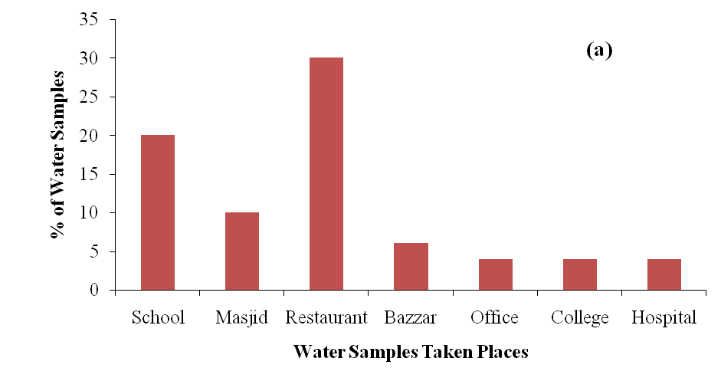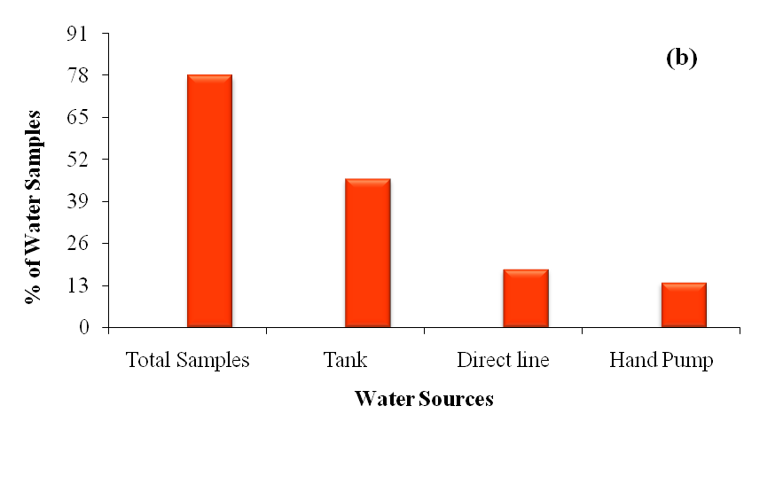
Fig. 1 (a & b): Percentage of Water Samples taken from different Sources

Ratio of Presence of Bacteria in the Drinking Water Samples:
A total of 78 samples were analyzed on nutrient agar and macConkey’s agar for presence of bacteria using milli pore filtration technique. It was found that 79.5% (n= 62) water samples were positive for presence of bacteria while 20.5% (n=16) contained no bacteria as shown in Fig.2. Furthermore, total 20 samples out of 78 samples were collected from schools, It was found that 70% (n= 20) water samples were positive for presence of bacteria while 30% contained no bacteria (Fig 3.6) while, 10 samples out of 78 samples were collected from mosques, It was found that 80% (n= 08) water samples were positive for presence of bacteria while 20% (n= 02) contained no bacteria. Furthermore, Total 30 samples out of 78 samples were collected from Restaurant, It was found that 86.6% (n= 26) water samples were positive for presence of bacteria while 13.4% contained no bacteria (Fig 3.6). We further observed that 66.6% water samples collected from Bazzars showed bacterial growth (Fig 3.6). Total 04 samples out of 78 samples were collected from hospital; it was found that all the water samples were positive for presence of bacteria. The water samples collected from offices, showed 50% positivity (n=02) for presence of bacteria while there is 50% of the water samples contained no bacteria (data not shown).
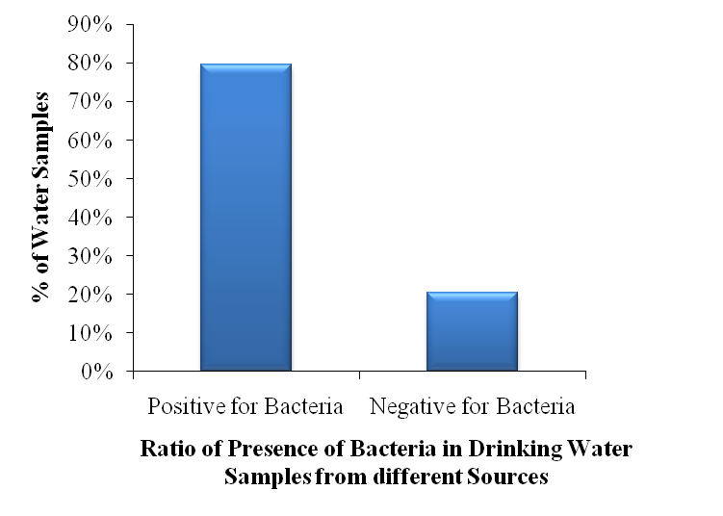
Fig. 2: Ratio of Presence of Bacteria in Drinking Water Samples from different Sources

Bacterial Abundance in the Drinking Water Samples:
A total of 62 samples which showed presence of growth of bacteria were analyzed for load of bacteria by counting colony forming units (CFU) per 100 ml of water. Each CFU represented a viable bacterial cell into the drinking water samples (n=62) of this study. It was found that 14 samples contained less than 106/100ml bacteria however 48 samples contained higher number of bacteria that is = 106/100ml . These results are also shown in Fig. 3.

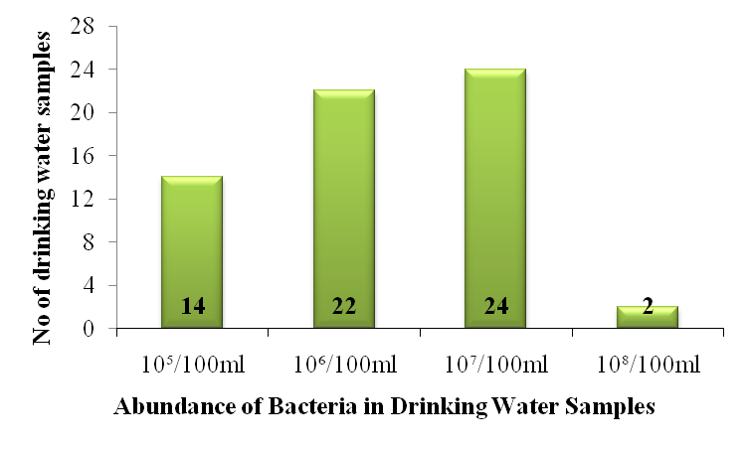
Fig. 3: Abundance of Bacteria in Drinking Water Samples
  - Isolation and Identification of Bacteria found in Drinking Water Samples:
A total of 78 samples were analyses on for presence of gram-negative bacteria using MacConkey’s agar (Fig. 5a). Among the 79.6% (n=62) positive samples drinking water samples, 56.41% (n=44) contained gram negative bacteria, (n=44). However, 23.07% (n=18) of drinking water samples showed presence of other species belonging to gram positive group of bacteria. Furthermore, we observed mixed growth of gram-negative bacteria in 10 samples making the total number of gram negative isolates of water 69.23% (n=54). (See Table No.2)
Total Number of Isolates of Drinking Water Samples (n=72)
Escherichia coli | 10 | 16.66%
Klebsiella spp | 8 | 12.90%
Pseudomonas spp | 18 | 29.03%
Enterobacter spp | 8 | 12.90%
Proteus spp | 10 | 16.66%
Other species of gram positive | 18 | 29.03%

Table No. 2: Percentage Distribution of Bacteria in Drinking Water

  - Percentage Distribution of Bacteria in Drinking Water Samples:
Besides, The biochemical analysis of all isolated gram negative (Fig 3.8) strains (n=44) from the drinking water samples of this study showed that the isolated bacteria belong to Pseudomonas spp, Proteus spp, Enterobacter spp, Klebsiella spp and E. coli. The percentage distribution of the isolated strains is given into the table 03 and pure cultures of some of these isolates are shown in figure 3.8. Pseudomonas spp were commonest bacteria found in drinking water consumed by residence of Hyderabad, Pakistan.
Percentage distribution of bacteria in water samples collected from mosques, schools and restaurants are shown in Fig. 4. It was found that the total water samples from Mosques were 06, among them the percentage distribution of bacteria were as Escherichia coli 33.33% (n=02), Pseudomonas spp 33.33% (n=02), and Proteus spp 33.33% (n=02). Percentage distribution of bacteria isolated from the drinking water samples from schools were as Escherichia coli 16.66% (n=02), among which Proteus spp 33.33% (n=04), Enterobacter spp 33.33% (n=04), and Klebsiella spp 16.66 %(n=02). The total no of water samples collected from Restaurant were 14, among them 8 samples contained mix growth. In the drinking water samples from restaurants, percentage distribution of bacteria were as Pseudomonas spp 45.45 %( n=10), Klebsiella spp 27.27 %( n=06). Escherichia coli 18.18 %( n=04), and Proteus spp 9.09 %( n=02).
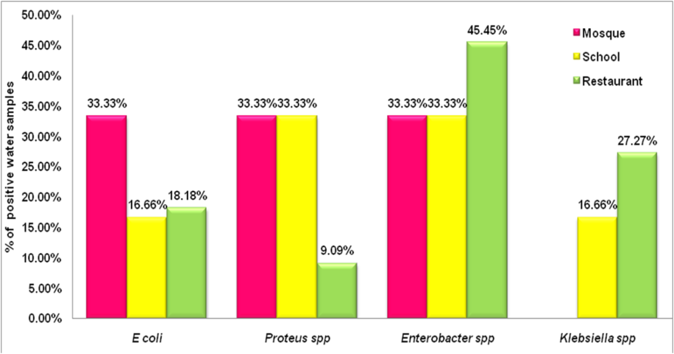
Fig. 4: Percentage Distribution of Bacteria in Drinking Water Collected from Mosques, Schools, and Restaurants

  - Isolation and identification of E. coli isolates of Water and Screening of E. coli isolates for Bacteriocins Production:
E. coli are lactose fermenting bacteria (Flournoy et al., 1990) therefore ability of the isolated bacteria to ferment lactose was considered as a tool to identify the bacteria at first instance. It was mainly observed by pink color of growth on MacConkey’s agar which was further confirmed by using TSI medium tube. Overall 39% of the gram negative bacteria isolated from the drinking water samples were lactose fermenters on MacConkey’s agar (data not shown). Further identification techniques such as TSI and citrate utilization test, motility test and Indole test was performed, which indicated that the 16.1 % of the lactose fermenting gram negative isolates were E. coli.
Besides, All the E. coli isolates of this study were subjected for determination of any antibacterial activity against control strain E. coli 25922. At first instance stab test for bacteriocin activity was performed. Several attempts were made but no isolate showed inhibition of the sensitive test strain of E. coli. Therefore, more sensitive assay for determination of bacteriocin activity; spot test was; was performed which confirmed that the isolated E. coli strains of this study do not produce bacteriocin.
  - Biofilm Formation by E. coli on Congo red Agar (CRA) Plate:
At first instance, all the E. coli isolates of this study were subjected for detection of their biofilm formation ability CRA method. A total of 10 E. coli strains were tested. This results obtained from the CRA method showed that 06 of the total 10 E. coli isolates can produce black growth with crystalline on CRA plate thus they are presumably able to produce biofilm (Freeman et al., 1989) (Fig. 4 ) suggesting that 60% of the E. coli isolates were biofilm formers (Fig. 5a). However, tube adherence method (Christensen et al., 1982) showed that only 4 of these isolates (40%) were able to produce biofilm on glass in test tube (Fig. 5b). All the 04 isolates also were also positive for biofilm formation on CRA methods.
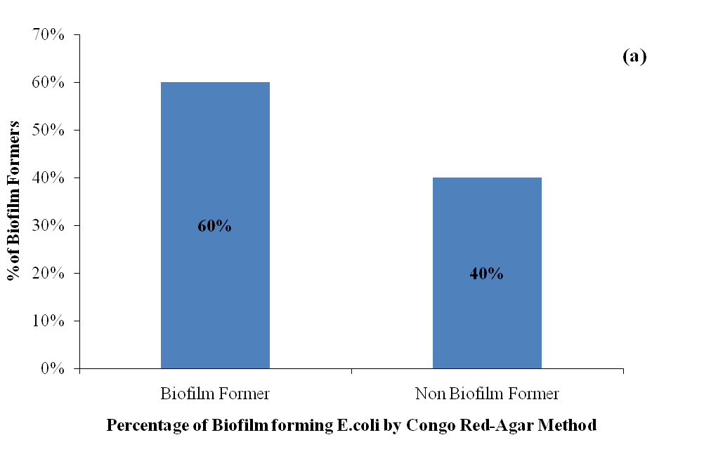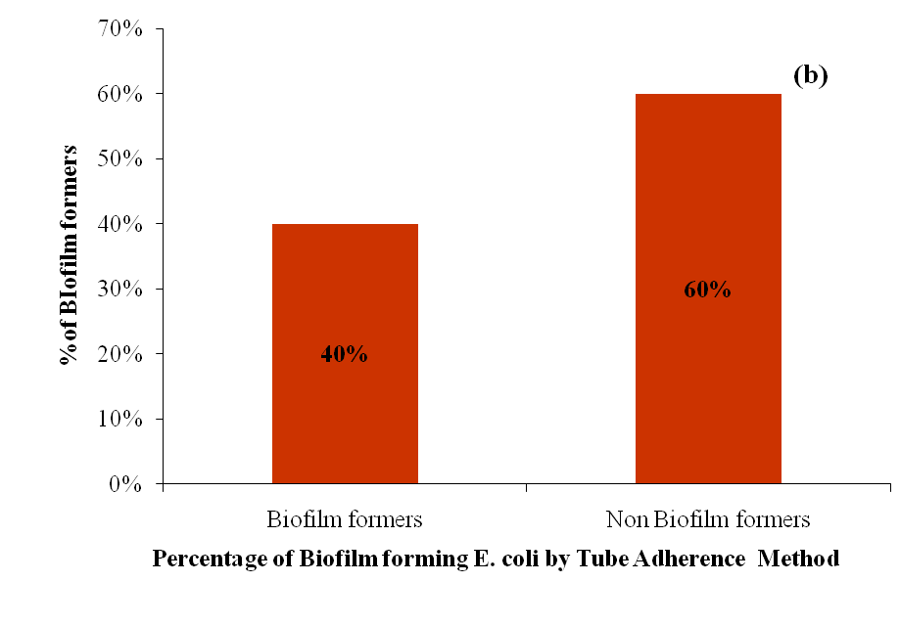
Fig. 5 (a & b): Percentage of Biofilm Forming E. coli by Congo-Red Agar Method (a) and Tube adherence Method (b)
  - Antibiotic Susceptibility Pattern of E. coli isolates:
All the E. coli isolates were subjected to antibiotic sensitivity test which showed that the isolates were resistant to Ampicillin (100%), Cefoxitin (100%), Amoxycillin (80%), Nalidix Acid (60%), Sulphamethaxazole (80%), Penicillin (80%), Cefdodxime (80%) and Erythrosine (80%), Kanamycin (20%), Ciprofloxacin (20%), and Amikacin (20%). The other antibiotic chloramphenicol and Cefotaxime were (100%) effective to E. coli isolates (Fig 6). Furthermore, the antibiotic sensitivity pattern was correlated in capacity of biofilm formation ability. In addition to 100% resistance to Ampicillin and Cefoxitin, the biofilm formers were also highly resistant to Amoxycillin (100%), Penicillin (100%), Cefdodxime (100%), Cefoxitin (100%), Cefotaxime (100%), and Erythromycin (100%).
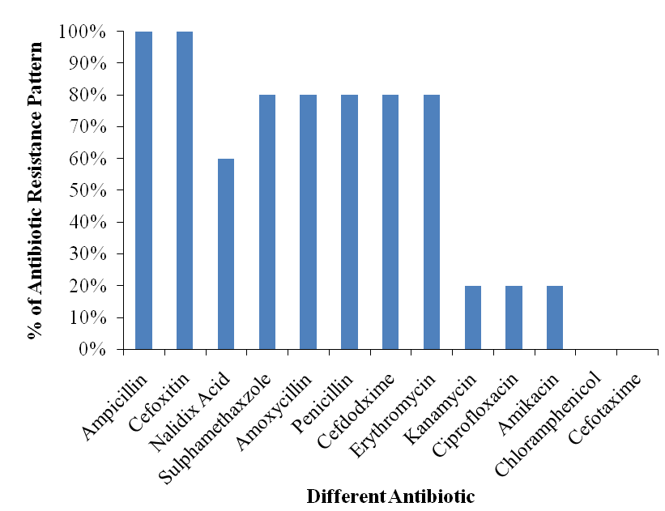
Fig. 6: Antibiotic Susceptibility Pattern of E. coli isolated from Drinking Water Samples

Discussion
According to World Health Organization (WHO), the biological contamination of water is responsible for 80% of human illness in the developing countries. However, this situation is worst in Pakistan (WHO, 1993). Various studies have looked at the microbiological quality of water of distinct regions of Pakistan. However, no new investigations have made evaluation of water nature of Hyderabad. This study will in this manner therefore was conducted to find out whether the same holds in this environment (Hyderabad). We found that the majority of the drinking water sample contained higher number of bacteria that is ≥ 10⁶/100 ml (Fig. 3). Escherichia coli, Klebsiella pneumonia, Proteus and Pseudomonas aeroginosa were commonest pathogen found from drinking water. In addition to assessment of microbiological quality of water from Hyderabad, this study focused on the screening for bacteriocin producer strains and biofilm forming strains of E. coli isolated from drinking water sampled from Hyderabad region. The screening for bacteriocin production was done using stab test and spot test as described previously (Penfold et al., 2000).
The detection of Biofilm formation by the isolates was performed qualitatively by using tube adherence method (Christensen et al., 1982) and tissue culture plate method (Christensen et al., 1985) and Congo red agar medium. While studying the survival of biofilm-associated pathogens (Ica et al., 2012; Murga et al., 2001), previous studies suggest that Biofilms may participate a significant role in the persistence and propagation of fastidious and stress-sensitive organisms in the environment (Parsek and Singh, 2003). Therefore, considerate of the mode of continued existence and development potential of pathogens and fecal indicator organisms in aquatic Biofilms is required for the identification of potential sources of pathogen contamination and continuous development of water treatment strategies especially in developing countries where the risk of waterborne is higher. E. coli has long been used as an indicator of fecal contamination (Leclerc et al., 2001). It has been believed for many years that E. coli can not to live on exterior of a living host or mature in secondary habitats due to a stable exposure to environmental stresses (Ishii and Sadowsky, 2008). In this study the drinking water samples were collected from different public places like 20 samples were collected from School, whereas 4 samples from hospital, 10 samples from Mosque and 30 samples from restaurant.
During this work it was observed that the Quality of Water of Hyderabad city were extremely very poor, the Direct line samples were more contaminated than tank water, more over the direct line water were contaminated with microorganism as well as researcher found biofilm in these samples, whereas the samples from tank were contaminated but if we compared from tank water samples the contamination and microbial burden were low in number, However 18 sites used direct supply system while 46 sites where tank were used. We have also collected 14 samples from hand pump which were representing ground water. In case of direct line samples were higher number of microbial burden like in one direct line sample which is B1 and it were from bazaar of Hyderabad, observed high number of contamination as well as it is strong biofilm former, direct line water is highly contaminated, samples of hand pump were less number of microbial flora, and mostly the samples were no contamination were observed. As we know that in this study the drinking water samples were collected from different public places where the storage mode of water was some time different. A total of fifty drinking water samples out of 78 drinking water samples were collected from the site where tanks were used. However 18 sites used direct supply system while 46 sites where tank were used. We have also collected 14 samples from hand pump which were representing ground water.
In the current research work, we collected some samples of filter water as well as non filter water to know about the difference of filter samples and non filter samples. In this research different techniques were used the first technique which were used by the researcher which is Milli pore filtration technique, A total of 78 samples were analyzed on nutrient agar and MacConkey’s agar for presence of bacteria using Milli pore filtration technique. It was found that 79.5% (n= 62) water samples were positive for presence of bacteria while 20.5% (n=16) contained no bacteria (Fig. 2).
The total abundance of microbes in water samples was also determined in this study. A total of 62 samples which showed presence of growth of bacteria were analyzed for load of bacteria by counting colony forming units (CFU) per 100 ml of water. Each CFU represented a viable bacterial cell into the drinking water samples (n=62) of this study. It was found that 14 samples contained less than 10⁶/100ml bacteria however 48 samples contained higher number of bacteria that is ≥ 10⁶/100ml (Fig 3). We have also found different groups of bacteria in different samples of water, the mostly found the gram negative bacteria using MacConkey’s agar. The isolated bacteria belong to Pseudomonas spp, Proteus spp, Enterobacter spp, Klebsiella spp and E. coli. Pseudomonas spp were commonest bacteria found in drinking water consumed by residence of Hyderabad.
A total of 78 samples were analyzed on for presence of gram negative bacteria using MacConkey’s Agar (Fig. 5a). Among the 79.6% (n=62) positive samples drinking water samples, 56.41% (n=44) contained gram negative bacteria, (n=44). However, 23.07% (n=18) of drinking water samples showed presence of other species belonging to gram positive group of bacteria. Furthermore, we observed mixed growth of gram negative bacteria in 10 samples making the total number of gram negative isolates of water 69.23% (n=54).mostly gram negative bacteria were found in direct line samples which means the direct line water were not treated in any chlorine process or other filtration process, that’s why the large number of population is reported in diarrhea.
In this study, overall 39% of the gram-negative bacteria isolated from the drinking water samples were lactose fermenters. Further identification techniques such as TSI and citrate utilization test, motility test and Indole test was performed, which indicated that the 16.1 % of the lactose fermenting gram negatives isolates of were
We performed the screening of bacteriocin assay; all the E. coli isolates of this study were subjected for determination of any antibacterial activity against control strain E. coli 25922. At first instance stab test for bacteriocin activity was performed. Several attempts were made but no isolate showed inhibition of the sensitive test strain of E. coli. Therefore, more sensitive assay for determination of bacteriocin activity; spot test was performed which confirmed that the isolated E. coli strains of this study do not produce bacteriocin. At first instance, all the E. coli isolates of this study were subjected for detection of their biofilm formation ability CRA (Congo red agar method) method. A total of 10
E. coli strains were tested. This result obtained from the CRA method showed that 06 of the total 10 E. coli isolates can produce black growth with crystalline on CRA plate thus they are presumably able to produce biofilm (Freeman et al., 1989) (Fig. 4) suggesting that 60% of the E. coli isolates were biofilm formers. However, tube adherence method (Christensen et al., 1982) showed that only 4 of these isolates (40%) were able to produce biofilm on glass in test tube. All the 4 isolates also were also positive for biofilm formation on CRA methods. We have also performed antibiotic sensitivity test to know the resistant and sensitive antibiotics in E. coli isolates as well as the biofilm former isolates. All the E. coli isolates were subjected to antibiotic sensitivity test which showed that the isolates were resistant to Ampicillin (100%), Cefoxitin (100%), Amoxycillin (80%), Nalidix Acid (80%), Sulphamethaxazole (80%), Penicillin (80%), Cefdodxime (80%) and Erythrosine (80%), Kanamycin (20%), Ciprofloxacin (20%), and Amikacin (20%). The other antibiotic chloramphenicol and Cefotaxime were (100 %) effective to E. coli isolates.
Furthermore, the antibiotic sensitivity pattern was correlated in capacity of biofilm formation ability. In addition to 100% resistance to Ampicillin and Cefoxitin, the biofilm formers were also highly resistant to Amoxycillin (100%), Penicillin (100%), Cefdodxime (100%), Cefoxitin (100%), Cefotaxime (100%), and Erythromycin (100%).

Conclusion
In this study it was found that the bacterial isolates of water have capacity to produce biofilm on an abiotic surface. However, the isolated were not capable of bacteriocin production. During random sampling of Schools, Mosques, Bazaar, Hospitals, offices and colleges, it was concluded that the direct line water samples were more contaminated, and high number of E. coli isolates were present. As compared to tank and hand pump water. The direct line sample of Bazaar FB1 was very strong biofilm former. The samples obtained from filters were showing presence of very low number or no growth of bacteria. Except those filter samples were contaminated which were not clean properly from years to years. And those filters water samples, which were new and clean properly have no growth of microbes. In tank water samples were less microbial burden were seen, and in hand pump water samples were no growth were seen.
In city of Hyderabad majority places is very risky to supply highly contaminated direct line water and during this research we found that this water has ability of biofilm former. This water is not even treatable by any method like chlorination; filtration etc .and the risk factor is very high. Water supplied was not fit for Human being consumption. Therefore, it is recommended that Government should take serious measurements for water purification at district Hyderabad to ensure human health safety.

References
- Alqahtani, J. M., Asaad, A. M., Ahmed, E. M., and Qureshi, M. A. (2015). Drinking water quality and public health in Southwestern Saudi Arabia: The need for a national monitoring program. Journal of Family & Community Medicine. 22(1), 1924.
- Asif, S., Sajjad, N., Sheikh, A. A., Shahzad, M., Munir, M. T., Umar, W., and Umar, S.(2015). Assessment of water quality for drinking purpose from water coolers of different teaching institutes in Lahore. IOSR Journal of Environmental Science, Toxicology and Food Technology (IOSR-JESTFT) e-ISSN: 2319-2402, p- ISSN: 2319-2399.Volume 9, Issue 2 Ver. I, PP 18-22
- Athar, S. D., Ishtiaq A Qazi, Muhammad A Baig, and Khan, E. A. (2008). National Standards for Drinking Water Quality (NSDWQ). Government of Pakistan. Pakistan Environmental Protection Agency (Ministry of Environment).
- Aziz, J. (2005). Management of source and drinking-water quality in Pakistan. EastMediterr Health J., 11(5-6), 1087-98.
- Azizullah, A., Khattak, M. N. K., Richter, P., and Häder, D.-P. (2011). Water pollution in Pakistan and its impact on public health—a review. Environment International. 37(2), 479-497.
- Bauer, A. W., Kirby, W. M., Sherris, J. C., and Turck, M. (1966). Antibiotic susceptibility testing by a standardized single disk method. Americ. J Clin Pathol. 45(4), 493-6.
- Beloin, C., Roux, A., and Ghigo, J.-M. (2008). Escherichia coli biofilms. Current Topics in Microbiology and Immunology. 322, 249-289.
- Cascales, E., Buchanan, S. K., Duche, D., Kleanthous, C., Lloubes, R., Postle, K., Riley, M., Slatin, S., and Cavard, D. (2007). Colicin biology. Microbiol Mol Biol. Rev.71(1), 158-229.
- Christensen, G. D., Simpson, W. A., Bisno, A. L., and Beachey, E. H. (1982). Adherence of slime-producing strains of Staphylococcus epidermidis to smooth surfaces. Infect Immun 37(1), 318-26.
- Falsetta, M. L., Klein, M. I., Colonne, P. M., Scott-Anne, K., Gregoire, S., Pai, C.H., Gonzalez-Begne, M., Watson, G., Krysan, D. J., Bowen, W. H., and Koo, H. (2014). Symbiotic Relationship between Streptococcus mutans and Candida albicans Synergizes Virulence of Plaque Biofilms In Vivo. Infection and Immunity. 82(5), 1968-1981.
- Flournoy, D. J., Wongpradit, S., and Silberg, S. L. (1990). Facilitating Identification of Lactose-Fermenting Enterobacteriaceae on MacConkey Aga. Proc. Okla. Acad.Sci. 70, 4.
- Freeman, D. J., Falkiner, F. R., and Keane, C. T. (1989). New method for detecting slime production by coagulase negative staphylococci. J. Clin. Pathol. 42(8), 872-4.
- Ica, T., Caner, V., Istanbullu, O., Nguyen, H. D., Ahmed, B., Call, D. R., and Beyenal, H. (2012). Characterization of mono- and mixed-culture Campylobacter jejuni Biofilms. Appl Environ Microbiol. 78(4), 1033-8.
- Ishii, S., and Sadowsky, M. J. (2008). Escherichia coli in the Environment: Implications for Water Quality and Human Health. Microbes Environ. 23(2), 101-8.
- John, R., Ezekiel, M., Philbert, C., and Andrew, A. (2008). Schistosomiasis transmission at high altitude crater lakes in Western Uganda. BMC Infectious Diseases. 8, 110-110.
- Kaplan, J. B. (2010). Biofilm Dispersal: Mechanisms, Clinical Implications, and Potential Therapeutic Uses. J. of Dental Research. 89(3), 205-218.
- Kazmi, M., Hayder, S., Rashid, H., Rustam, M., Sulheri, A. W., and Saeed, A. (2015). Evaluation of Drinking water quality parameters in the areas of East-Lahore Pakistan: A case study. Journal of faculty of engineering & technology 21(3), 41-61.
- Kerr, B., Riley, M. A., Feldman, M. W., and Bohannan, B. J. (2002). Local dispersal promotes biodiversity in a real-life game of rock-paper-scissors. Nature. 418(6894), 171-4.
- Lebeaux, D., Ghigo, J.-M., and Beloin, C. (2014). Biofilm-Related Infections: Bridging the Gap between Clinical Management and Fundamental Aspects of Recalcitrance toward Antibiotics. Microbiology and Molecular Biology Reviews: MMBR 78(3), 510-543.
- Leclerc, H., Mossel, D. A., Edberg, S. C., and Struijk, C. B. (2001). Advances in the bacteriology of the coliform group: their suitability as markers of microbial water safety. Annu Rev Microbiol. 55, 201-34.
- Lenski, R. E., and Riley, M. A. (2002). Chemical warfare from an ecological perspective. Proceedings of the National Academy of Sciences of the United States of America. 99(2), 556-558.
- Majeed, H., Gillor, O., Kerr, B., and Riley, M. A. (2011). Competitive interactions in Escherichia coli populations: the role of bacteriocins. The ISME journal. 5(1), 71-81.
- Marshall, M. M., Naumovitz, D., Ortega, Y., and Sterling, C. R. (1997). Water borne protozoan pathogens. Clinical Microbiology Reviews. 10(1), 67-85.
- Miller, M. B., and Bassler, B. L. (2001). Quorum sensing in bacteria. Annu Rev Microbiol. 55, 165-99.
- Mohsin, M., Safdar, S., Asghar, F., and Jamal, F. (2013). Assessment of drinking water quality and its impact on residents’ health in Bahawalpur City. International Journal of Humanities and Social Science 3(15), 114-128.
- Momtaz, H., Dehkordi, F. S., Rahimi, E., and Asgarifar, A. (2013). Detection of Escherichia coli, Salmonella species, and Vibrio cholerae in tap water and bottled drinking water in Isfahan, Iran. BMC Public Health. 13, 556-556.
- Mtapuri-Zinyowera, S., Ruhanya, V., Midzi, N., Berejena, C., Chin'ombe, N., Nziramasanga, P., Nyandoro, G., and Mduluza, T. (2014). Human parasitic protozoa in drinking water sources in rural Zimbabwe and their link to HIV infection. Germs. 4(4), 86-91.
- Mulcahy, L. R., Isabella, V. M., and Lewis, K. (2014). Pseudomonas aeruginosa biofilms in disease. Microbial ecology. 68(1), 1-12.
- Murga, R., Forster, T. S., Brown, E., Pruckler, J. M., Fields, B. S., and Donlan, R. M. (2001). Role of biofilms in the survival of Legionella pneumophila in a model potable-water system. Microbio. 147 (Pt 11), 3121-6.
- Parsek, M. R., and Singh, P. K. (2003). Bacterial Biofilms: an emerging link to disease pathogenesis. Annu. Rev. Microbiol. 57, 677-701.
- Penfold, C. N., Garinot-Schneider, C., Hemmings, A. M., Moore, G. R., Kleanthous, C., and James, R. (2000). A 76-residue polypeptide of colicin E9 confers receptor specificity and inhibits the growth of vitamin B12-dependent Escherichia coli 113/3 cells. Molecular Microbiology 38(3), 639-649.
- Rose, S. J., Babrak, L. M., and Bermudez, L. E. (2015). Mycobacterium avium Possesses Extracellular DNA that Contributes to Biofilm Formation, Structural Integrity, and Tolerance to Antibiotics. PLoS ONE 10(5), e0128772.
- Saddozai, A. A., Khalil, S., and Hameed, T. (2009). Microbial quality of food snacks and drinking water in Islamabad’s schools and colleges. Pakistan J. Agric. Res. Vol. 22(3-4).
- Shar, A. H., Kazi, Y. F., Kanhar, N. A., Soomro, I. H., Zia, S. M., and Ghumro, P. B. (2010). Drinking water quality in Rohri city, Sindh, Pakistan. Afr J Biotechnol. 9(42), 7102-7107.
- Stoodley, P., Sauer, K., Davies, D. G., and Costerton, J. W. (2002). Biofilms as complex differentiated communities. Annu Rev Microbiol. 56, 187-209.
- Timothy M. Akpomie, Eno O. Ekanem, Mohammed M. Adamu, Janet O. (2016). Akpomie. Computer Modelling of the Concentration of Heavy Metals in Artificial Borings. World Journal of Analytical Chemistry. 4(1):6-10. doi: 10.12691/wjac-4-1-2.
- Torreblanca M, Meseguer I, and A., V. (1994). Production of halocin is a practically universal feature of archael halophilic rods. Lett. Appl. Microbiol. 19(201), 205.
- Vuotto, C., Longo, F., Balice, M. P., Donelli, G., and Varaldo, P. E. (2014). Antibiotic Resistance Related to Biofilm Formation in Klebsiella pneumoniae. Pathogens. 3(3), 743-758.
- WHO. (1993). Guidelines for drinking quality. Geneva: world health organization 1, 1-29.

