Characteristics of Bromelain Enzyme from Queen Variety Pineapple Crown at Different Drying Temperatures

Siti Susanti^{1*}, Heni Rizqiati¹, Yoga Pratama¹, Fahmi Arifan², and Saskia Papa Reza¹
¹Food Technology Division, Department of Agriculture, Faculty of Animal Science and Agriculture, Diponegoro University, Semarang, Indonesia
²Diploma Program of Chemical Engineering, Faculty of Vocational School, Diponegoro University, Semarang, Indonesia

* For correspondence: sitisusanti@live.undip.ac.id
Received ; Accepted ; Published

Novelty statement

Pineapple crown as post-harvest waste is rarely used as source of bromelain enzyme. These results show that at different drying temperature, the characteristic of bromelain enzyme also different. We found that bromelain enzyme from Queen variety pineapple crown has the best characteristics from drying temperature 40°C and precipitated with 60% ammonium sulfate.

Abstract

Pineapple (Ananas comosus (L) Merr) is a plant that contains bromelain enzymes in fruit, leaves, crown, and stem with different amounts. Bromelain is included in the protease enzyme group that can break down the molecular structure of proteins into amino acids. Pineapple crown is one of the waste products from pineapple processing that has not been used optimally. This study aims to utilize Queen pineapple crown waste and determine the characteristics of Queen pineapple crown bromelain enzymes which consist of protein content, unit activity, and specific activity at different drying temperatures. Queen pineapple crowns were dried using a cabinet dryer at temperature of 35 °C, 40 °C, 45 °C, and 50 °C before extraction process. The optimum temperature in the Queen pineapple crowns drying process to produce bromelain with a protein content of 4.41 mg/ml, unit activity 1.36 U/ml, and specific activity 0.31 U/ml was 40ºC, then purified by adding 20%, 40%, 60%, and 80% ammonium sulfate. The optimum concentration of ammonium sulfate used to produce pure bromelain (0.33 U/mg specific activity) from Queen pineapple crowns was 60%.

Keywords: Bromelain enzymes, drying, pineapple crown, protein.

Introduction

Pineapple (Ananas comosus (L) Merr) is a tropical fruit that is widely grown and consumed as a source of vitamins and minerals (Hossain, 2015). Pineapple has several varieties, in Indonesia the most commonly cultivated pineapple varieties are Queen and Cayenne pineapples (Lestari et al., 2020). Queen pineapple is a population that is sufficiently produced so that easy to find in various places where pineapple is sold at very affordable prices (Boonyaritthongchai and Supapvanich, 2017). In addition, Queen pineapples are always available throughout the year because they are not a seasonal fruit (Sibaly and Jeetah, 2017). The high level of public consumption of Queen pineapples results in large amount of crown as post-harvest wastes (Prado and Spinacé, 2019). In 2011 the harvest of Queen pineapples in Indonesia reached 1.5 million tons, 90% of which are Queen pineapples and the remaining 10% are Smooth Cayenne types (M. Syahirman Yusi, 2016). The weight proportion of pineapple crowns is around 35% of the total weight pineapples when harvested (Roha et al., 2013). This means that from the total production of 1.35 million tonnes of pineapples, it is likely that the crown of pineapples will be obtained by weight 472,500 tons. So far, the use of pineapple crowns is still dominated as animal feed and natural fertilizers (Saravanan et al., 2013). Pineapple crowns are rich in organic compounds such as cellulose and proteolytic enzymes (Campos et al., 2020).

Matrials and Methods

Experimental details and treatments

Experimental material: Experiments were performed in the laboratorium of the Department of Agriculture, Diponegoro University, Semarang, Indonesia during July – December 2020. The Queen pineapple crown used in this study was obtained from Rasamala Traditional Market located at Banyumanik, Semarang, Central Java, Indonesia, ammonium sulfate, aquades, BSA (Bovine Serum Albumin), phosphate buffer pH 6,5, natrium citrate buffer, bromelain enzyme (tablet), folin (Folin-Ciocalteau phenol), casein, Lowry reagent, and TCA (tricarboxylic acid) 10%.
Treatments: Fresh pineapple crowns were taken and then selected a good one, cut into small pieces then dried in cabinet dryer with 35 °C, 40 °C, 45 °C, and 50 °C. The dried pineapple crown then crushed using a grinder until smooth then sieved using sieve.

Extraction and Isolation of Crude Bromelain Enzyme

Supernatant extract of bromelain enzymes from Queen variety pineapple crown was carried out with 20 g pineapple crown powder was dissolved in 180 ml of cold sodium citrate buffer pH 6.5 and stirred until homogeneous. The solution then filtered with muslin cloth, the filtrate obtained then centrifuged at 4500 rpm for 25 minutes. The supernatant obtained, crude extract of the bromelain enzyme, stored at -20 °C, then be tested for its characteristics.

Purification of Crude Extract Bromelain Enzyme

Purification was carried out by the modified method referred to (Dutta and Bhattacharyya, 2013b). Ammonium sulfate added to the enzyme solution with concentrations of 20%, 40%, 60%, and 80% and stirred until homogeneous. The mixed solution was then stored for 24 hours at 4°C. The solution obtained was then centrifuged at 3500 rpm for 25 minutes. The precipitate obtained from the centrifugation process is a protein precipitate (bromelain enzyme) dissolved using sodium citrate buffer pH 6.5 then homogenized and dialyzed overnight. The dialysis process was carried out by putting the solution into a dialysis tube, both ends of the tube tied with twist tie and then immersed in a 10 ml buffer solution.

Protein Content

Determination of the protein content was carried out using the modified method (Lowry et al., 1951). The test begins with the making of Standard BSA (Bovine Serum Albumin) at several concentration points, 0.5 ml of BSA mixed with 5 ml of Lowry reagent, then vortexed until homogeneous, then incubated for 10 minutes so that the protein binding reaction occurred by Lowry reagent. Then, 0.5 ml of folin was added to the solution and incubated for 30 minutes. The absorbance of the solution was read with UV-Vis spectrophotometer with wavelength 650 nm and curve of the BSA standard then formed. The next step is to read the absorbance of the sample solution, starting with the sample supernatant of the bromelain enzyme extract, diluted 15 times and took 0.5 ml, added 5 ml of Lowry reagent and then vortex until homogeneous and incubated for 10 minutes. The sample solution was given 0.5 ml of folin and incubated for 30 minutes. The absorbance of the solution was read with UV-Vis spectrophotometer with the same wavelength as BSA. The protein content of the sample was determined by linear regression against the obtained BSA standard curve.

Unit Activity

Determination of the bromelain enzyme activity unit was carried out by referring to the method (Fathimah and Wardani, 2014) with modifications. The test started with 0.5 ml of extract bromelain enzyme after 15 times of dilution mixed with 0.5 ml of 0.5% casein as substrate, and 0.5 ml of phosphate buffer pH 6.5 then the solution incubated in water bath for 20 minutes at 40 °C. 1 ml of 10% TCA was added to stop the reaction and then incubated for 10 minutes at room temperature. Then sample was centrifuged at 5000 rpm for 10 minutes to obtain the supernatant. The absorbance obtained was measured using UV-Vis spectrophotometer at wavelength of 275 nm. The standard solution was prepared in the same way, but the sample tested was replaced with a bromelain solution from bromelain tablet that had been mashed and dissolved with phosphate buffer pH 6.5 then the absorbance was read with a UV-Vis spectrophotometer with a wavelength of 275 nm to calculate the unit of enzyme activity. The enzyme activity was calculated using the formula described by previous studies (Chaurasiya and Hebbar, 2013).

Specific Activity

Specific activity values can be obtained by knowing the protein content (mg/ ml) and unit activity (U/ ml) of the enzyme (Kahiro et al., 2017). The enzyme specific activity is then calculated by dividing the enzyme unit activity by total protein content (Nuraini et al., 2017).

Data Analysis

The data obtained from the test results include data on protein content, enzyme activity unit, and enzyme activity, analyzed descriptively and presented in the form of a bar graph.

Results

Protein Content: Based on Figure 1(a) it can be seen that the highest protein content in the crude extract of bromelain enzyme was 6.01 mg/ ml found at drying temperature of 50 °C, and the lowest protein content was 4.11 mg/ ml at drying temperature of 35 °C. Based on Figure 2(a), it can be seen that the addition of ammonium sulfate with concentration of 80% produces the highest protein content, 2 mg/ ml. Ammonium sulfate with high concentrations could hydrate protein water so that the protein was precipitated.
Unit Activity: Based on Figure 1(b) it can be seen that the optimum temperature of enzyme activity occurs at 40 °C with an activity of 1.36 U/ ml, then at a temperature of 45 to 50 °C the enzyme unit activity decrease. After purification, the highest unit activity was 0.65 U/ ml at the addition of 60% ammonium sulfate (Figure 2(b)).
Specific Activity: Based on Figure 1(c), it can be seen that the highest specific activity of the crude extract of bromelain enzymes from Queen pineapple crown varieties was at drying temperature of 40 °C, 0.31 U/ mg. The high specific activity reflects the high amount of pure bromelain enzyme (Setiasih et al., 2018). After purification, the highest calculation result of specific activity was 0.33 U/ mg protein obtained through purification with 60% ammonium sulfate (Figure 2(c)).

Discussion

Protein Content: The protein content of the crude bromelain enzyme increases along with the incretion of the temperature used, because the increases in temperature can accelerate the enzyme reaction, the reaction speed will continue to increase until it reaches the optimal enzyme temperature. This is in accordance with the opinion of (Bell et al., 2013) which states that the enzyme reaction will continue to increase until it reaches the optimum temperature, if the temperature exceeds the optimum temperature of the enzyme, protein denaturation will occur. The value of high protein content is not always directly proportional to bromelain activity, this could be because of the presence of other proteins besides bromelain enzyme. This is in accordance with the opinion of (Anjum et al., 2011) which states that high protein levels in crude extracts can be caused by the presence of other proteins that participate.
The protein content increased along with the increase in ammonium sulfate concentration, the addition of 80% ammonium sulfate concentration resulted in the highest protein content of 2.00 mg/ml. This is in accordance with the opinion of (Nurhayati et al., 2018) which states that the greater concentration of ammonium sulfate added, the greater its ability to coagulate proteins. The protein content of the bromelain enzyme after purification decreased, before purification the protein content obtained was 4.41 mg/ml, after purification the protein content ranged from 1.14 to 2.00 mg/ml. This is due to the reduced of non-enzyme protein contained in the crude extract of the enzyme. This is in accordance with the opinion of (Chen et al., 2012) which states that the crude extract of the enzyme still contains many other proteins (non-enzyme) that can interfere. Precipitation using ammonium sulfate produces protein that contains a high salt content, it is necessary to do dialysis to remove salts that can interfere with the calculation of protein content. This is in accordance with the opinion of (Nooralabettu, 2014) which states that the use of ammonium sulfate as a protein precipitant produces protein with a high salt content, the salt content in the protein can be removed by dialysis in a buffer solution.
Unit Activity: The highest value of unit activity of enzyme was 1.36 U/ml at 40°C drying temperature, then at a temperature 45 to 50 °C there was a decrease in the unit activity of enzyme. The decrease in enzyme activity can occur because the temperature used exceeds the optimum temperature of the enzyme so that the enzyme undergoes denaturation. This is in accordance with the opinion of (Ren et al., 2011) which states that enzyme activity increases with temperature until it reaches the optimum temperature, if the increasing of temperature continue protein enzyme denaturation will occur. Denaturation is a condition which protein enzymes undergo changes in their structure so that they interfere with enzyme activity. This is in accordance with the opinion of (Guzik et al., 2014) which states that denaturation is the occurrence of modification or changes of the secondary, tertiary structure and phenomena in proteins without any covalent problems. The unit of enzyme activity is a description of the number of enzymes that work. This is in accordance with the opinion of (Dutta and Bhattacharyya, 2013c) which states that the unit activity is a value to see the transformation or change of one substrate molecule per minute under optimal measurement conditions. The activity of the crude extract of the enzyme can be influenced by several factors, including drying, temperature, pH, and the level of fruit maturity. This is in accordance with the opinion of (Poba et al., 2019) which stated that the drying method, temperature, pH, and fruit maturity level could affect the activity of the crude extract of the bromelain enzyme.
The unit activity of enzyme increased with increasing ammonium sulfate concentration up 60%, 0.65 U/ml, then the value of the activity unit decreased. This is in accordance with the statement of (Kumaunang and Kamu, 2011) which stated that the highest bromelain enzyme activity was fractionated with ammonium sulfate at a concentration of 40-60%. The value of the bromelain enzyme activity unit decreased with the use of 80% ammonium sulfate. This is in accordance with the opinion of (Ilyas, 2020) which stated that the enzyme activity unit decreased at a concentration of 80% because at that level of saturation the enzyme activity was not optimal. The decrease in enzyme activity units that occurred with the addition of 80% ammonium sulfate was also supported by (Rozi et al., 2020) which states that the decrease in enzyme activity at a concentration of 80% is thought to be due to the influence of salt ions or a concentration of salt that is too high.
Specific Activity: The specific activity of the bromelain enzyme extract was highest at a temperature of 40 °C, reaching 0.31 U/mg. The specific activity of the enzyme showed the level of purity of the enzyme, the high value of the specific activity shows the amount of bromelain enzyme in the crude extract of the bromelain. This is in accordance with the opinion of (Pratiwi et al., 2014) which states that the higher the specific activity value of the enzyme, the higher the level of purity. The specific activity value was calculated to determine the amount of bromelain enzyme present, with a comparison of protein content with enzyme activity. This is in accordance with the opinion of (Vilanova Neta et al., 2012) which states that the amount of bromelain enzyme present can be determined by calculating the specific activity by dividing the unit value of the enzyme activity by the protein content, which is expressed in units of U/mg.
The highest specific activity was 0.33 U/mg obtained by purification with 60% ammonium sulfate concentration, then decreased at 80% to 0.24 U/mg. This is in accordance with the opinion of (Han et al., 2019) which stated that the highest specific activity of the bromelain enzyme occurred in purification with ammonium sulfate in a concentration range of 40-60%. The value of the specific activity of the enzyme after purification process was greater than that of the crude extract of the bromelain enzyme. This is in accordance with the opinion of (Sundarram and Murthy, 2014) which states that after purification there is an increase in the amount of specific enzyme activity because the amount of impurities has decreased. The specific activity of the enzyme is a measure of purity which value will increase after purification process. This is in accordance with the opinion of (Novák and Havlíček, 2016) which stated that the higher the specific activity of the enzyme, the higher the level of purity of the enzyme.

Conclusion

The research concludes that the drying stage with cabinet dryer at temperature of 40 °C and purification stage with 60% ammonium sulfate concentration gives the best characteristic of bromelain enzyme isolated from Queen variety pineapple crown.

Acknowledgements

This research was funded by the Penelitian Terapan Unggulan Perguruan Tinggi (PTUPT). On this occasion, the author would like to thank the Department Agriculture, for providing lab facilities and constant encouragement to complete this research work successfully.

Author contributions

SS, HR, and FA planned the experiments, SS, HR, YP, and SPR interpreted the results, SS, HR, YP, FA, SPR made the write up, analyzed the data, and made illustrations.
References

Anjum, S. A., Wang, L. C., Farooq, M., Hussain, M., Xue, L. L., Zou, C. M. 2011. Brassinolide application improves the drought tolerance in maize through modulation of enzymatic antioxidants and leaf gas exchange. Journal of Agronomy and Crop Science, 197(3), 177–185. https://doi.org/10.1111/j.1439-037X.2010.00459.x
Bell, C. W., Fricks, B. E., Rocca, J. D., Steinweg, J. M., McMahon, S. K., Wallenstein, M. D. 2013. High-throughput fluorometric measurement of potential soil extracellular enzyme activities. Journal of Visualized Experiments, 81, e50961. https://doi.org/10.3791/50961
Boonyaritthongchai, P., Supapvanich, S. 2017. Effects of methyl jasmonate on physicochemical qualities and internal browning of ‘queen’ pineapple fruit during cold storage. Horticulture, Environment, and Biotechnology, 58(5), 479–487. https://doi.org/10.1007/s13580-017-0362-3
Campos, D. A., Ribeiro, T. B., Teixeira, J. A., Pastrana, L. Pintado, M. M. 2020. Integral valorization of pineapple (Ananas comosus L.) by-products through a green chemistry approach towards added value ingredients. Foods, 9(1), 60. https://doi.org/10.3390/foods9010060
Chaurasiya, R. S., Umesh Hebbar, H. 2013. Extraction of bromelain from pineapple core and purification by RME and precipitation methods. Separation and Purification Technology, 111, 90–97. https://doi.org/10.1016/j.seppur.2013.03.029
Chen, J., Wang, Y., Zhong, Q., Wu, Y., Xia, W. 2012. Purification and characterization of a novel angiotensin-I converting enzyme (ACE) inhibitory peptide derived from enzymatic hydrolysate of grass carp protein. Peptides, 33(1), 52–58. https://doi.org/10.1016/j.peptides.2011.11.006
Dutta, S., Bhattacharyya, D. 2013a. Enzymatic, antimicrobial and toxicity studies of the aqueous extract of Ananas comosus (pineapple) crown leaf. Journal of Ethnopharmacology, 150(2), 451–457.
Dutta, S., Bhattacharyya, D. 2013b. Enzymatic, antimicrobial and toxicity studies of the aqueous extract of Ananas comosus (pineapple) crown leaf. Journal of Ethnopharmacology, 150(2), 451–457. https://doi.org/10.1016/j.jep.2013.08.024
Dutta, S., Bhattacharyya, D. 2013c. Enzymatic, antimicrobial and toxicity studies of the aqueous extract of Ananas comosus (pineapple) crown leaf. Journal of Ethnopharmacology, 150(2), 451–457. https://doi.org/10.1016/j.jep.2013.08.024
Hossain, F. M. 2015. Nutritional Value and medicinal benefits of pineapple. international journal of nutrition and food sciences, 4(1), 84–88.
Fathimah, A. N., Wardani, A. K. 2014. Extraction and characterization of protease enzyme from moringa leaves (Moringa oliefera Lamk.). Jurnal Teknologi Pertanian, 15(3), 191–200.
Guzik, U., Hupert-Kocurek, K., Wojcieszyńska, D. 2014. Immobilization as a strategy for improving enzyme properties-application to oxidoreductases. Molecules, 19(7), 8995–9018. https://doi.org/10.3390/molecules19078995
Han, Z., Kraiyot, S., Kittikun, A. H., Zhou, W., Li, J. 2019. Fractionation and activity profiling of fruit bromelain from pineapples of Phuket variety growing in Thailand. Journal of Food Biochemistry, 43(11), 1–7. https://doi.org/10.1111/jfbc.13011
Ilyas, N. M. 2020. Isolation and characterization of bromelain from the core and flesh ofpineapple extracts (Ananas comosus). Chemica: Jurnal Ilmiah Kimia Dan Pendidikan Kimia, 21(2), 133. https://doi.org/10.35580/chemica.v21i2.17983
Kahiro, S., Kagira, J., Maina, N., Karanja, S., Njonge, F. 2017. Enzymatic activity of bromelain from crude extracts of crown, peels and stem of pineapples from different agro-ecological zones of Thika Region, Kenya. Asian Journal of Biotechnology and Bioresource Technology, 1(2), 1–6. https://doi.org/10.9734/AJB2T/2017/34314
Ketnawa, S., Chaiwut, P., Rawdkuen, S. 2012. Pineapple wastes: A potential source for bromelain extraction. Food and Bioproducts Processing, 90(3), 385–391. https://doi.org/10.1016/j.fbp.2011.12.006
Kumaunang, M., Kamu, V. 2011. The activity of bromelain enzyme isolated frompineapple (Anenas comosus) fruit skin. Jurnal ilmiah sains, 15(1), 198. httpso://doi.org/10.35799/jis.11.2.2011.207
Lestari, T., Rion Apriyadi, Eries Dyah Mustikarini, Wawan Saputra, Yelia Merlin. 2020. The application of palm-oil waste as organic materials on three pineapple accessions cultivated on post-tin mining land in Bangka Island, Indonesia. Nusantara Bioscience, 12(1), 40–45. https://doi.org/10.13057/nusbiosci/n120107
Lowry, O. H., Rosebrough, N. J., Farr, A. L., Randall, R. J. 1951. Protein measurement with the Folin phenol reagent. Journal of Biological Chemistry, 193, 265–275.
M. Syahirman Yusi. (2016). The analysis of production function and farm marketing efficiency of pineapple (Ananas comosus L Merr) in South Sumatera Province, Indonesia. African Journal of Agricultural Research, 11(23), 1990–1998. https://doi.org/10.5897/AJAR2016.10863
Nooralabettu, K. P. 2014. Optimisation of ammonium sulfate precipitation method to achieve high throughput concentration of crude alkaline phosphatase from Brown shrimp (Metapenaeus monoceros) hepatopancreas. Int J Anal Bio-Sci Vol, 2(1), 7–16.
Novák, P., Havlíček, V. 2016. Protein extraction and precipitation. in proteomic profiling and analytical chemistry. Elsevier. pp. 51–62. https://doi.org/10.1016/B978-0-444-63688-1.00004-5
Nuraini, A., Nurhayati, T., Nurilmala, M. 2017. Activity of trimethylamine-n-oxide demethylase (tmaoase) in the forming of natural formaldehyde in lizardfish (Saurida tumbil). Jurnal Pengolahan Hasil Perikanan Indonesia, 20(3), 549–558.
Nurhayati, N., Mappiratu, M., Musafira, M. 2018. The production of protein concentrate from moringa seed (Moringa oleifera L.) andits amino acid profile analysis. KOVALEN: Jurnal Riset Kimia, 4(1), 24–32.
Poba, D., Ijirana, I., Sakung, J. 2019. Crude bromelain enzyme activities based on maturity level of pineapple. Jurnal Akademika Kimia, 8(4), 236–241.
Prado, K. S., Spinacé, M. A. S. 2019. Isolation and characterization of cellulose nanocrystals from pineapple crown waste and their potential uses. International Journal of Biological Macromolecules, 122, 410–416. https://doi.org/10.1016/j.ijbiomac.2018.10.187
Pratiwi, R. S., Susanto, T. E., Sutrisno, A. 2014. Chitinase and the Aplication in Industry: A Review. Jurnal Pangan Dan Agroindustri, 3(3), 878–887.
Ren, Y., Rivera, J. G., He, L., Kulkarni, H., Lee, D.-K., Messersmith, P. B. 2011. Facile, high efficiency immobilization of lipase enzyme on magnetic iron oxide nanoparticles via a biomimetic coating. BMC Biotechnology, 11(1), 1–8.
Rozi, A., Khairi, I., Cahyani, R. T., Bija, S., Nurhikma, N., Wulansari, N., Maulid, D. Y., Utari, S. P. S. D., Wulandari, D. A., Nurhayati, T. 2020. Aktivitas enzim katepsin pada ikan lele (Clarias sp.) pada perlakuan suhu dan substrat yang berbeda. Jurnal Perikanan Tropis, 7(2), 211–221.
Saravanan, P., Muthuvelayudham, R., Viruthagiri, T. 2013. Enhanced production of cellulase from pineapple waste by response surface methodology. Journal of Engineering, 2013, 1–8. https://doi.org/10.1155/2013/979547
Setiasih, S., Prabowo, H. A., Budianto, E., Hudiyono, S. 2018. Dissolution profiles of partially purified bromelain from pineapple cores [Ananas comosus (L.) Merr] encapsulated in glutaraldehyde-crosslinked chitosan. Journal of Applied Pharmaceutical Science, 8(10), 17–24. https://doi.org/https://doi.org/10.7324/JAPS.2018.81003
Sibaly, S., Jeetah, P. 2017. Production of paper from pineapple leaves. Journal of Environmental Chemical Engineering, 5(6), 5978–5986. https://doi.org/10.1016/j.jece.2017.11.026
Siti Roha, A. M., Zainal, S., Noriham, A., Nadzirah, K. Z. 2013. Determination of sugar content in pineapple waste variety N36. Int. Food Res. J, 20(4), 1941–1943.
Sundarram, A., Murthy, T. P. K. 2014. α-amylase production and applications: a review. Journal of Applied & Environmental Microbiology, 2(4), 166–175.
Neta, J. L. V, da Silva Lédo, A., Lima, A. A. B., Santana, J. C. C., Leite, N. S., Ruzene, D. S., Silva, D. P., de Souza, R. R. 2012. Bromelain Enzyme from Pineapple: In Vitro Activity Study under Different Micropropagation Conditions. Applied Biochemistry and Biotechnology, 168(2), 234–246. DOI: https://doi.org/10.1007/s12010-012-9753-1
Wu, X., Yang, C., Ge, J. 2017. Green synthesis of enzyme/metal-organic framework composites with high stability in protein denaturing solvents. Bioresources and Bioprocessing, 4(1), 24. DOI: https://doi.org/10.1186/s40643-017-0154-8

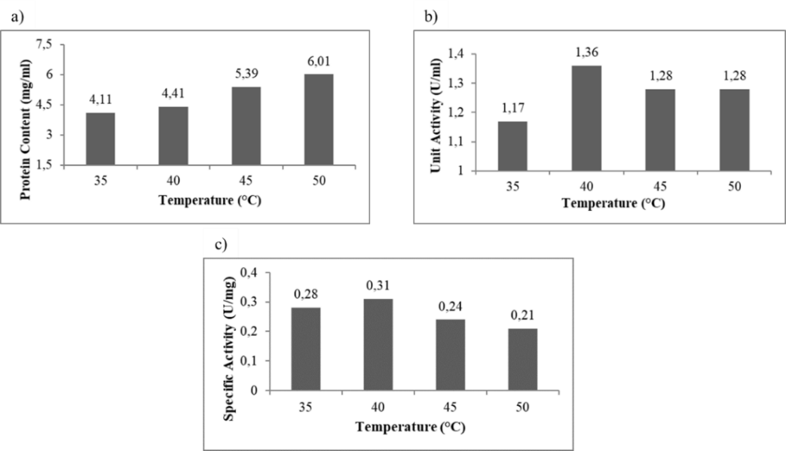
Fig. 1: Protein content (a), unit activity (b), and spacific activity (c) of bromelain crude extract from Queen pineapple crown at various drying temperature
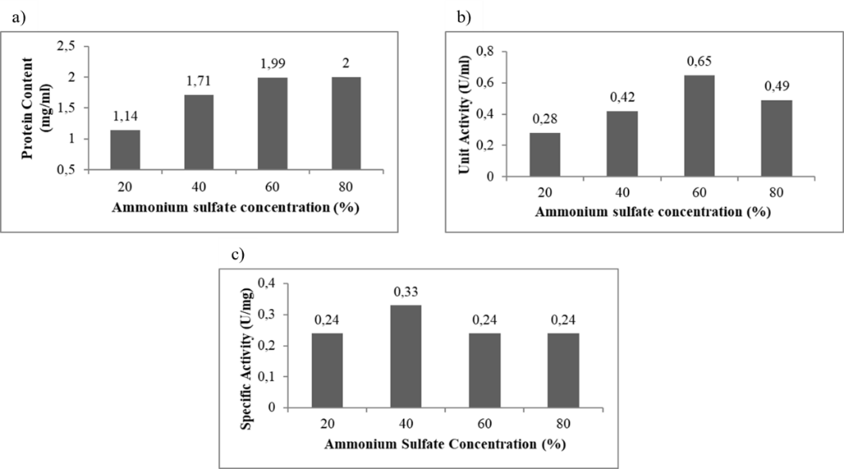
Fig. 2:Protein content (a), unit activity (b), and spacific activity (c) of bromelain extract from Queen pineapple crown at various concentration of ammonium sulfate

