**THE POTENTIAL OF *Rhizopus* sp. CULTURE FILTRATE IN CONTROLLING THE GROWTH OF *Aspergillus flavus* FNCC6109 IN CORN KERNELS (*Zea mays* L.)**

I.B.G. Darmayasa1, AA K Darmadi1, Arofi1, I Wayan Suanda2, I.K. Widnyana3*

1Microbiology Laboratory Faculty of Mathematics and Natural Sciences, Udayana University Denpasar, Indonesia

2Department of Biology Education, Faculty of Teacher Training and Education, University of PGRI Mahadewa Indonesia, Indonesia

3Department of Agrotechnology, Faculty of Agriculture, Mahasaraswati Denpasar University, Indonesia

*Correspondence email : [widnyanaketut@gmail.com](mailto:widnyanaketut@gmail.com)

**ABSTRACT**

Corn is a food ingredient with the highest carbohydrate content after rice in Indonesia. The contamination of *Aspergillus flavus* on corn kernels is a problem that often occurs in tropical areas. *A. flavus* is able to produce aflatoxins, resulting in decreased quality of corn. Chemical and physical controls have many constraints and side effects, so it is necessary to have biological control techniques. The purpose of this study was to determine the potential of the culture filtrate of *Rhizopus* sp. in controlling *A. flavus* FNCC6109 in corn kernels. The testing of the *Rhizopus* sp. filtrate against *A. flavus* FNCC6109 was carried out *in vitro* and *in vivo*. The *Rhizopus* sp. filtrate, which has been incubated for 3, 4, and 5 days, was tested *in vitro*. Whereas, *in vivo* treatment was given with a culture filtrate concentration of 0%(v/v), 10% (v/v), 20% (v/v), 30% (v/v), 40% (v/v) dan 50% (v/v) in corn kernel. The *in vitro* inhibition observation of the *Rhizopus* sp. culture filtrate was determined by measuring the diameter of *A. flavus* FNCC6109 colonies on PDA media given the culture filtrate, while the *in vivo* was determined by the plating method. The results showed that the culture filtrate of *Rhizopus* sp. is significantly (P <0.05) able to inhibit *A. flavus* FNCC6109 both *in vitro* and *in vivo*.

**Keywords**: Corn, *Aspergillus* *flavus* FNCC6109, *Rhizopus* sp.

**INTRODUCTION**

Maize or corn is a food ingredient with the second-highest carbohydrate content after rice in Indonesia and comes third in the world after wheat. Maize or corn is used as a raw ingredient for the animal feed manufacturing industry. The need for corn in Indonesia increased by 1,11% per year in 2010-2014. The official statistical news of Bali province reported that based on the preliminary figures in 2014, there was a decrease in corn production compared to 2013, namely the production of 40,613 tons of dry corn kernels. The decline was caused by several factors, such as the decreasing of land areas, the farming transitions into horticultural crops, and lack of water supply (Central Bureau of Statistics Indonesia, 2014).

Corn as a raw and feed ingredient must have good quality. The most frequent problem in public and among corn farmers is the contamination of aflatoxin compounds produced by *Aspergillus flavus* (Li *et al*. 2021). These fungi grow easily in tropical areas. Indonesia is one tropical country that has a high risk of being contaminated with these aflatoxins since Indonesia has a high level of humidity, rainfall, and optimum temperature for *A. flavus* to grow. Frequent contamination of aflatoxins can easily be found in whole grains, such as corns and peanuts. Several causes of aflatoxins contamination are the post-harvest handling, harvest storage, and processing of products made from corn. These factors are common in corn farmers and companies that use corn as raw material (Rahayu *et al*. 2010). The contamination of aflatoxin compounds in corn kernels results in losses to corn farmers and health problems in animals and humans, so the control and prevention of A. *flavus* are needed.

The prevention of aflatoxins contamination in raw and feed ingredients can be conducted more effectively by inhibiting the growth of *A. flavus*. It can be physically conducted through reduction of water content in the materials, reduction of temperature, and modification of storage space. It can be chemically conducted by giving disinfectants acidic and alkaline substances. Chemical control requires a lot of money regarding the high cost of the chemicals needed. In addition, at the farmers’ level, it is difficult to do so, so it is necessary to do the control biologically.

The biological control of *A. flavus* can be conducted using one of the antagonistic fungi, which is able to inhibit the *A. flavus.* According to Mauro *et al*. (2018), biological prevention is more effective than physical and chemical ones since it is assumed that the biological one costs quite cheap. Given the relatively fast microbial growth with a short generation time, it can be produced on a large scale.

*Rhizopus* sp. is a nonpathogenic fungus. This fungus is likely used for the fermentation process of raw ingredients becoming products that have high nutritional value, such as the fermentation of soybeans using the *Rhizopus* sp. yeast becoming into Tempeh. Nursadin and Supriyanto (2012) reported that *Rhizopus* sp. has a high ability to compete and able to inhibit the growth of pathogenic fungi. The results showed that *Rhizopus* sp. was able to inhibit *Fusarium oxysporum* by 60% so that *Rhizopus* sp. could be used as one of the considerations to see its potential in controlling the growth of *Aspergillus flavus* FNCC6109.

**RESEARCH METHOD**

**Research Location**

The research of the potential of *Rhizopus* sp. filtrate in controlling the growth of *A. flavus* FNCC6109 was conducted in the Microbiology Laboratory, Department of Biology, Faculty of Mathematics and Natural Sciences Udayana University.

**Isolation of *Rhizopus* sp. in Tempeh**

The isolation of *Rhizopus* sp. was conductedby aseptically taking as much as one loop of the part of the colony suspected of being *Rhizopus* sp., which grew on the surface of the Tempeh. This part of the colony was then placed right in the middle of Petri dishes which already contained PDA media. The Petri dishes were incubated at 28oC temperature for four days. The growth of fungal colonies on Petri dishes was observed macroscopically and microscopically by referring to the Pitt and Hocking 1997 identification book. The fungi that showed the characteristics of *Rhizopus* sp. were then being re-isolated until getting a pure culture.

**Regeneration of *Aspergillus flavus*****FNCC6109**

The *A. flavus* FNCC6109 isolate was obtained from the stock culture of the Microbiology Laboratory, Department of Biology FMIPA, Udayana University. The stock culture was rejuvenated by taking the hyphal flakes using a needle and then implanted right in the middle of the Petri dish that contained PDA media, then being incubated at 28oC for four days. The growing colonies of *A. flavus* FNCC6109 were used for the next testing stage.

**Inhibition Test of *Rhizopus* sp. against the Growth of *A. flavus* FNCC6109**

The inhibition of *Rhizopus* sp. was conducted *in vitro* using the dual culturemethod. The procedures started with taking the culture of *Rhizopus* sp. and *A. flavus* FNCC 6109 with a 5 mm diameter cork borer. Both colonies were grown side by side with a distance of 3 cm in Petri dishes containing PDA media, then being incubated at 28oC and measured the diameter for four days. Subsequently, the same control was conducted; however, only one type of fungi was grown. The antagonism effect of *Rhizopus* sp. against *A. flavus* FNCC6109 could be calculated with the PIRG (*Percentage Inhibition of Radial Growth*) (Singh and Vijay, 2011) :

$$PIRG \left(\%\right)=\frac{R1-R2}{R1}x100\%$$

PIRG: *Percentage Inhibition of Radial Growth*

R1: Colony area of *A. flavus* FNCC6109 without the antagonist (control)

R2: Colony area of *A. flavus* FNCC6109 with the antagonist (dual culture)

**Inhibition Test of *Rhizopus* sp. Culture Filtrate against the Growth of *A.flavus* FNCC 6109**

A bottle of 100 mL PDB (*Potato Dextrose Broth*) was prepared and then inoculated with the *Rhizopus* sp. that had the potential of inhibiting *A. flavus* FNCC 6109. Then, it was incubated for 3, 4, and 5 days at 28oC. Once the incubation period was over, the inhibition of the *Rhizopus* sp. culture filtrate was tested *in vitro* against the growth of *A. flavus* FNCC6109. This test started off with preparing the culture filtrate of *Rhizopus* sp. and took as much as 1 mL of it and placed on the Petri dish, which would be poured with PDA media afterward, then left to solidify. Next, the *A. flavus* FNCC6109 colony was taken using a 5 mm diameter cork borer and incubated for four days. After that, control was made by growing colonies of *A. flavus* FNCC6109 on PDA media without being given any culture filtrates. The effect of culture filtrate could be determined by measuring the colony area of *A. flavus* FNCC6109 using the formula:

$$Inhibition (\%)=\frac{L1-L2}{L1}$$

L1: Colony area of *A. flavus* FNCC6109 without the antagonist (control)

L2: Colony area of *A. flavus* FNCC6109 with control

**Inhibition of *Rhizopus* sp. Culture Filtrate against *A.flavus* FNCC 6109 in Corn Kernels**

A sterile Petri dish was prepared and contained with solid PDA media, colonies of *A. flavus* fungi were planted right in the middle of the Petri dish with a diameter of 5 mm, then incubated at a temperature of 28 for four days. The grown colonies dripped with sterile water as much as 5 mL, then rubbed it on the colonies' surface using a spatula. The liquid which contained the spores was then taken using a Pasteur pipette and then collected into a sterile bottle. To determine the density of the spores in the suspension, calculations were made using a hemacytometer.

The design used in determining the inhibition of *Rhizopus* sp. culture filtrate against the growth of *Aspergillus favus* FNCC 6109 in corn kernels was the Completely Randomized Design (CRD). The treatment given is in accordance with that shown in Table 1.

**Table 1.** Filtrate Treatment of *Rhizopus* sp. against the growth of *A. flavus* FNCC

6109 in corn kernels.

|  |  |
| --- | --- |
| Treatment | Information |
| A | Corn kernels without *Rhizopus* sp. culture filtrate and *A. flavus* FNCC 6109 |
| B | Corn kernels with 5 mL of *A. flavus* suspension |
| C | Corn kernels with *A. flavus* and 10% (v/v) concentration of *Rhizopus* sp. culture filtrate |
| D | Corn kernels with *A. flavus* and 20% (v/v) concentration of *Rhizopus* sp. culture filtrate |
| E | Corn kernels with *A. flavus* and 30% (v/v) concentration of *Rhizopus* sp. culture filtrate |
| F | Corn kernels with *A. flavus* and 40% (v/v) concentration of *Rhizopus* sp. culture filtrate |
| G | Corn kernels with *A. flavus* and 50% (v/v) concentration of *Rhizopus* sp. culture filtrate |

The giving treatments were conducted by preparing as much as 100 g of corn kernels for each treatment which was placed in 8 sterile containers. Each container was given treatment as mentioned in Table 1. The corn kernels were sprayed with as much as 15 mL of *Rhizopus* sp. filtrate, then adding 5 mL of *A. flavus* FNCC6109 spores were. After being given the treatment, they were stored for 15 days at 28oC. After the incubation period ended, the total population of *A. flavus* FNCC6109 was calculated using the plating method. To obtain the representative data, all treatments were repeated four times.

**Data Analysis**

Descriptive data were shown in figure and table forms, whereas the quantitative data were analyzed with ANOVA. If the data obtained have a significant difference at the test level of 5% (P≤0.05), it would be followed by the Duncan test to determine the differences in each treatment.

**Result and Discussion**

**The Isolation and Identification of** *Rhizopus* sp.

The macroscopic characteristics of the isolated *Rhizopus* sp. colonies in Tempeh showed the color of white to the grayish, diameter of 4 cm in the four days incubation period, cottony texture, no zoning, no radial, and growing zone. Whereas on the microscopic observation through 40×10 magnification on the *Rhizopus* sp. showed round or elliptical sporangium which had no insulation on the hyphae, there was a stolon that connected two sporangiophores and had rhizoid (Figure 1 and Table 2.). These characteristics were in accordance with the description stated by Yuliansih (2007) and Dolatabadi (2014) in which *Rhizopus* sp. macroscopically and microscopically have white to grayish colonies, have rhizoid like roots, the hyphae are not insulated, single sporangiophores, the sporangium is round or elliptical and have stolons. The difference between the genus of *Rhizopus* and other fungi is that the non-insulated hyphae have rhizoids and a distinctive sporangium shape.

Firmansyah (2007) had also isolated and identified *Rhizopus* spp. in Tempeh. The results obtained three species those were *Rhizopus oligosporus, Rhizopus stolonifer,* and *Rhizopus oryzae*. The same research had been conducted by Virgianti (2015), which showed that the isolated *Rhizopus* sp. colonies in Tempeh macroscopically had the characteristics of having white to grayish color and grew like cotton. Rahmawati *et al*. (2013) reported the results of the isolation and identification of molds in corns and found the presence of *Rhizopus oryzae* and *Rhizopus stolonifer*. Furthermore, McKelvey & Murphy (2017) stated the existence of *Rhizopus* sp. in cornflour had a role in producing cellulose, xylanase, and protease enzyme activities.

Table 2. The results of macroscopic and microscopic observations of the four days old *Rhizopus* sp. on PDA medium.

|  |  |  |
| --- | --- | --- |
|  | **Morphological Characteristics** | **Information** |
|  | Macroscopic |  |
| a. | Color of the colony | White to grayish |
| b. | Reverse color of the colony | White |
| c. | The texture of the colony | *Cottony* |
| d. | Radial line | No |
| f. | Growing zone | Yes |
| g. | Zoning | No |
|  | Microscopic |  |
| a. | Type of hyphae | No Septae |
| b. | Stolon | Yes |
| c. | Sporangium | Round |
| d. | Rhizoid | Yes |
| e. | Stolon | Yes |

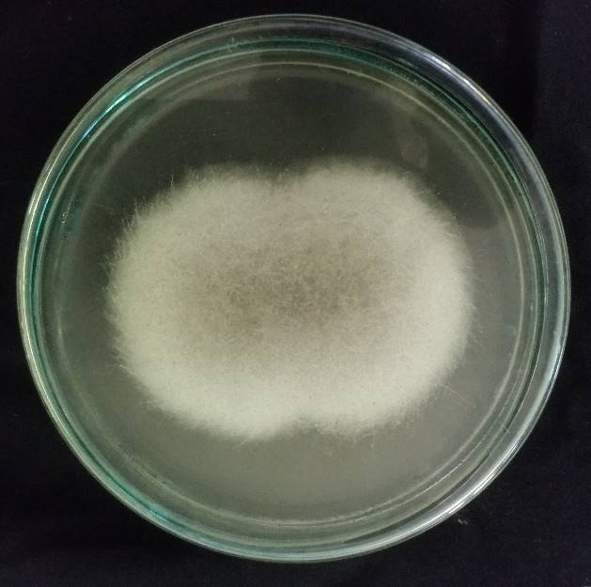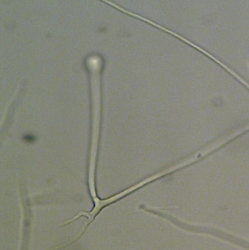

S

SP

Sn

R

**A B**

Figure 1. A. Colony morphology of *Rhizopus* sp. on PDA media with an incubation period of 3 days at a temperature of 28ºC.

B. Microscopic structure of *Rhizopus* sp. under a binocular microscope at 400× magnification (arrow S = Sporangium; SP = Sprongiophore; R = Rhizoid; Sn = Stolon).

***In Vitro* Inhibition of *Rhizopus* sp. against *Aspergillus flavus* FNCC6109**

Inhibition of *Rhizopus* sp. against *A. flavus* FNCC6109 using the dual culture method has obtained the average colony area of *A. flavus* FNCC6109 as much as 5.77 ± 0.773 cm2. In comparison, it had as much as 13,00±1,154 cm2 of colony area in 4 days incubation under control. In Table 3, it can be seen that the average percentage of inhibition power of *Rhizopus* sp. on the growth of *A. flavus* FNCC6109 was 56.08 ± 10.103% on PDA media with four days incubation period.

The colony area of *A. flavus* FNCC6109 on treatments seemed smaller than those with no treatments (Figure 2). There were allegations on the treatment of the *Rhizopus* sp. to be able to suppress the growth of *A. flavus* FNCC6109. Similar research had been conducted by Nursadin and Supriyanto (2012) that *Rhizopus* sp. was able to inhibit *Fusarium oxysporum* by 60%. Furthermore, it was conveyed that *Rhizopus* sp. could be used as a competitor because it has a very high competitive ability and very fast growth. The same thing was also conveyed by Anuragi and Sharma (2016) that *Rhizopus* sp. could be used as a biocontrol agent because of its ability to inhibit *Fusarium oxysporum* with an inhibitory percentage of 56.76%. Moreover, Adebola and Amadi (2010) reported that *Rhizopus* sp. could inhibit the growth of the pathogen *Phytophthora palmivora* with a 76% inhibition rate in 7 days incubation period.

The inhibition mechanism of *Rhizopus* sp. against the growth of *A. flavus* FNCC6109 other than by suppressing it was suspected that *Rhizopus* sp. produced metabolites that could inhibit *A. flavus* FNCC6109. *Rhizopus* sp. was also able to produce enzymes and bioactive compounds that are antimicrobial and antifungal. Virgianti (2015) reported that isolated *Rhizopus* sp. from local Tempeh was capable of producing antimicrobial bioactive compounds. The bioactive compounds produced were able to inhibit enteric pathogenic bacteria and have different inhibition zones.

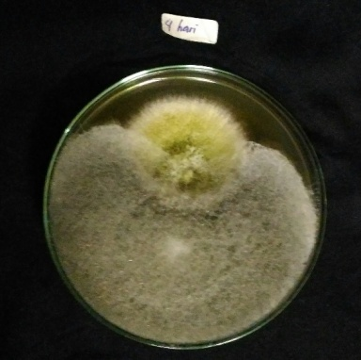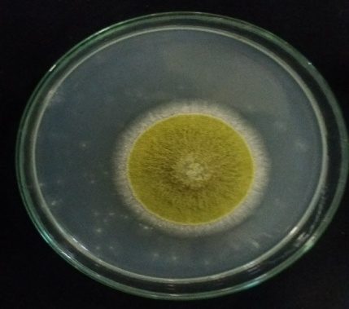

K

P

A

A

R

**Figure 2.** Inhibition of *Rhizopus* sp. against *A. flavus* FNCC6109 on PDA media with an incubation period of 4 days and at a temperature of 28ºC (K = Control; P = Treatment; A = *A. flavus* FNCC6109; R = *Rhizopus* sp.)

**Table 3.** Average inhibition of *Rhizopus* sp. against *A. flavus* FNCC6109

|  |  |
| --- | --- |
| Treatment | Everage (cm2) |
| control | 13,00±1,154 |
| *Rhizopus* sp. | 5,77±0,773 |
| Inhibition(%) | 56,08±10,103 |

***In Vitro* Culture Filtrate Test of *Rhizopus* sp. against *A. flavus* FNCC6109**

The inhibition of the culture filtrate of *Rhizopus* sp., which tested against the growth of *A. flavus* FNCC6109 in *vitro* showed that the culture filtrate had the ability to inhibit *A. flavus* FNCC6109. In Figure 3, it can be seen that the colonies of *A. flavus* FNCC6109 could not grow well in the presence of the culture filtrate of *Rhizopus* sp., while on the control, colonies of *A. flavus* FNCC6109 seemed bigger.

In numbers, the inhibition test of the *Rhizopus* sp. culture filtrate against *A. flavus* FNCC6109 can be seen in Table 4. The five-day incubation period of the culture filtrate of *Rhizopus* sp. on PDA media had the highest percentage of inhibitory, which was 67.27±2.70%, while the three days and four days incubation percentages were 61.26±5.13% and 64.07±7,04%. The culture filtrate of *Rhizopus* sp. showed positive results in inhibiting *A. flavus* FNCC6109 *in vitro*, presumably due to the presence of an active compound or enzyme capable of suppressing the growth of *A. flavus* FNCC6109. Meanwhile, *A. flavus* FNCC6109 grown on PDA media without culture filtrate suspension showed good growth of *A. flavus* FNCC6109 with a larger colony area.

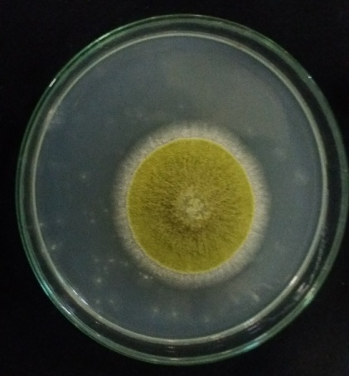

K

P

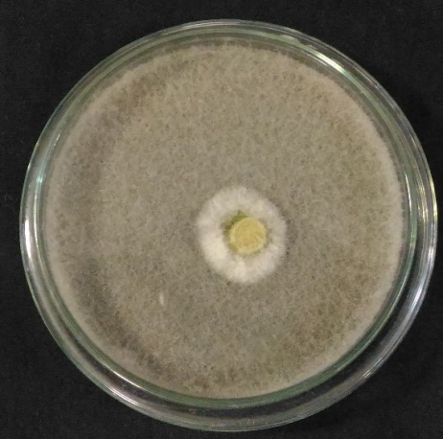

KF

KF

A

A

A

**Figure 3**. Inhibition of *Rhizopus* sp. culture filtrate against *A. flavus* FNCC6109 in *vitro* on PDA media with an incubation period of 4 days and at a temperature of 28ºC (Information on the figure K = control; P = treatment; KF = filtrate culture *Rhizopus* sp.; A = *Aspergillus flavus* FNCC6109)

**Table 4**. Percentage inhibition of *Rhizopus* sp. culture filtrate against *A. flavus* FNCC6109 *in vitro* on PDA media with an incubation period of 4 days and at a temperature of 28ºC

|  |  |
| --- | --- |
| **The incubation period of *Rhizopus* sp. culture filtrate** | **The inhibition against A. flavus FNCC6109.**  **(%)** |
| Three days | 61,27±5,13 |
| Four days | 64,07±7,05 |
| Five days | 67,27±2,70 |

The culture filtrate of *Rhizopus* sp. at five days incubation period had the highest inhibitory ability in inhibiting *A. flavus* FNCC6109. During the five days incubation period, the enzymes produced by *Rhizopus* sp. were thought to have optimum enzyme activity. This is supported by the statement of Pujiati *et al*. (2017) that the levels of crude protein cellulase enzymes from *Rhizopus* sp. in sugarcane bagasse substrate incubated for 3 to 12 days had an increase in the amount of protein content. The increase in protein content also indicated the activity of the cellulase enzyme has increased. This happened due to the increasing length of fermentation time.

*Rhizopus* sp. was able to produce *β-glucanase* enzymes. *The β-glucanase* enzyme is an extracellular enzyme capable of hydrolyzing carbohydrates of the glucan group. This meets the statement of Ravindran *et al.* (2018) that *Rhizopus* sp. is capable of producing *β-glucanase* enzymes. Glucans are one important component in making the cell walls of fungi in general. Glucans can be hydrolyzed by the *β-glucanase* enzyme produced by several types of fungi, namely *Rhizopus* sp. and *Trichoderma* sp. The *β-glucanase* enzyme produced also has an important role in the self-defense mechanism against pathogenic fungal attacks. Research conducted by Lorito *et al*. (1994) stated that *the β-glucanase* enzyme showed antifungal activity by hydrolyzing the glycan structures present in the cell walls of pathogenic fungi. The structure of glucans is known to be mostly found at the tip of the hyphae, so the pathogenic fungal hyphae are not able to grow properly in the presence of the *β-glucanase* enzyme. Furthermore, it was also confirmed by Budiarti and Widyastuti (2011) that the *β-glucanase* enzyme was able to influence the growth of hyphae, where the hyphae experienced swelling and necrosis.

**The population of *A. flavus* FNCC6109 in Corn Kernels added with *Rhizopus* sp. Culture Filtrate**

The corn kernels that gave the treatment of adding *Rhizopus* sp. culture filtrate had less population of *A. flavus* FNCC6109 colonies than the corn kernels that had not been given the culture filtrate. Table 5 represented several treatments of the culture filtrate concentration added to the corn kernels, which showed the varied population numbers of *A. flavus* FNCC6109. The calculation showed that at a concentration of 50%, the culture filtrate of *Rhizopus* sp. had the highest inhibitory ability with the average number of *A. flavus* FNCC6109 colonies 3×104 CFU/g, whereas in treatment B, which was only given a suspension of *A. flavus* FNCC6109 spores had a larger average population, namely 42×104 CFU/g after 15 days of the incubation period. This showed that the culture filtrate of *Rhizopus* sp. was able to suppress the population of *A. flavus* FNCC6109 in corn kernels.

Table 5. showed the lower the concentration of *Rhizopus* sp. culture filtrate added into the corn kernels, the higher the population of *A. flavus* FNCC6109 after an incubation period of 15 days. Whereas in treatment A (corn kernels without culture filtrate of *Rhizopus* sp. and *A. flavus* FNCC 6109), there were neither *Rhizopus* sp. nor *A. flavus* FNCC 6109 found. This proved that the corn kernels used in this study were free of contaminants from the two fungi.

**Table 5.** The population of *A. flavus* FNCC6109 colonies in corn kernels added with culture filtrate of *Rhizopus* sp. before and after the incubation period.

|  |  |  |  |
| --- | --- | --- | --- |
| Treatment | Total Population of  *A. flavus* FNCC6109 (CFU/g) | | Enhancement of *A. flavus* FNCC6109 (%) |
| Population Before the Incubation  (T0) | Population After the Incubation  (T15) |  |
| A | 0,00 | 0,00 a±0,00 | 0 |
| B | 21.104 | 44,7.104b±0,068.104 | 53 |
| C | 14.104 | 18,0.104c±0,062.104 | 22,2 |
| D | 11.104 | 13,7.104cd±0,051.104 | 19,7 |
| E | 9.104 | 10,3.104de±0,134.104 | 14,4 |
| F | 6.104 | 6,7.104df±0,127.104 | 10,4 |
| G | 5.104 | 5,3.104f±0,196.104 | 5,7 |

Note : In T15 is the average value with three replications and with different letter notations in the same column indicating a significantly different average value (P≤0.05) based on the Duncan test after conducting the analysis of variance (ANOVA)

Based on the statistical test, it showed the effect of the concentration treatment of *Rhizopus* sp. culture filtrate, which was given into the corn kernels during an incubation period of 15 days against *A. flavus* FNCC6109 in corn kernels. The average population of *flavus* FNCC6109 in treatment B (without culture filtrate) was 44,7x10 CFU/g, which was significantly different (P≤0.05) with treatment G (corn kernels with *A. flavus* and culture filtrate of *Rhizopus* sp. with a concentration of 50%. (v/v).

The concentration treatment of *Rhizopus* sp. culture filtrate given in corn kernels was able to decrease the population of *A. flavus* FNCC6109. It was proven by the decreasing tendency in the population of *A. flavus* FNCC6109; the higher the concentration of the culture filtrate given, the lower the population of *A. flavus* FNCC6109. This is thought to be *Rhizopus* sp. experiencing very fast growth and ability to compete in obtaining nutrients. In addition, it is also suspected that the performance of enzymes and other metabolites played a role in damaging the spore wall components of *A. flavus* FNCC6109 so that the spores of *A. flavus* FNCC6109 were not able to grow properly. This statement is supported by Calestino *et al*. (2006), who stated that *Rhizopus* sp. is able to produce *a β-glucanase* enzyme, which is thought to be able to damage the spore walls of *A. flavus* FNCC6109. Furthermore, *Rhizopus* sp. is able to produce volatile compounds, which are thought to affect in inhibiting the growth of *A. flavus* FNCC6109. This is supported by the statement of Lanciotti and Huang *et al*. (2019) that *Rhizopus* sp. is able to produce volatile compounds such as ethanol, isobutyl alcohol, and three methyl butanol, where these compounds are thought to be able to inhibit the growth of *A. flavus*. Similar results were stated by Guneser *et al*. (2017) that *Rhizopus* sp. produces volatile compounds. The isolation results of the volatile compounds by *Rhizopus* sp. obtained in fermented soybeans and barley, volatile compounds, namely ethanol, acetone ethyl acetate, 2-butanone, 2-methyl-1-butanol.

Based on the presumable performance of the enzymes and bioactive compounds produced by *Rhizopus* sp., it can be attempted that *Rhizopus* sp. could be used as a biocontrol agent in inhibiting the growth of pathogenic fungi. This statement is supported by Monk *et al.* (2020) that the inhibition mechanism of *Rhizopus* spp. against *A. flavus* and *A. parasiticus* by binding to element C (Carbon) contained in beans, causing *A. flavus* and *A. parasiticus* to lose.

The utilization of *Rhizopus* sp. culture filtrate has been conducted in many industries and can be used as a probiotic agent. Besides its ability to be a biocontrol in inhibiting the growth of pathogenic fungi and degrading mycotoxin compounds, *Rhizopus* sp. is thought to increase the quality of food quality as reported by Maryana *et al*. (2016), which stated that *Rhizopus oryzae* culture could increase the protein content in liquid tofu waste. The results obtained during fermentation for 48 hours could increase the protein content by 0,47%. Suarti & Budijanto (2021) stated that the use of *Rhizopus oligosporus* in concentrate feed with fermentation process was able to increase weight and reduce phytic acid levels. Phytic acid is a phosphorus compound that can bind mineral components such as iron, calcium, and zinc so that it cannot be absorbed directly by the body. According to Bhavsarv & Khire (2014) that giving *R. oligosporus* culture filtrate in concentrate, feed is thought to be able to produce phytase enzymes that affect in breaking down the phytic acid.

Based on the ability of the culture filtrate tested on corn kernels, it generally had a positive correlation, both *in vitro* and *in vivo,* in inhibiting the growth of *A. flavus* FNCC6109. So it can be seen that the culture filtrate of *Rhizopus* sp. has the potential in inhibiting the growth of *A. flavus* FNCC6109 in corn kernels with a decrease in the population of *A. flavus* FNCC6109 after an incubation period of 15 days.

**Conclusion**

Based on the results obtained, it can be concluded that:

1. *Rhizopus* sp. were able to inhibit *Aspergillus flavus* FNCC6109 with the highest inhibition percentage at 61,92, and the lowest is at 44,42.
2. Culture filtrate of *Rhizopus* sp. was able to inhibit *A. flavus* FNCC6109 with the highest inhibition percentage at 67,27±2,70 with a 5-day incubation period, and the lowest was at 61,27±5,13 with a 3-day incubation period.
3. The culture filtrate of *Rhizopus* sp. was able to affect the number of corn kernel population. The concentrate of the *Rhizopus* sp. culture filtrate with 50% concentration was able to suppress *A. flavus* FNCC6109 with the lowest average population of 55,3×104±0,196 CFU/g after an incubation period of 15 days.

**Suggestion**

Further researches need to be conducted on the enzymes and active compounds produced by *Rhizopus* sp., as well as testing the decrease in aflatoxin content produced by *A. flavus* FNCC6109 in corn kernels.

**Acknowledgments**

The authors would like to thank the Head of the Microbiology Laboratory, Department of Biology, Faculty of Mathematics and Natural Sciences, and the Joint Laboratory of the Faculty of Mathematics and Natural Sciences, Udayana University.

**REFERENCES**

Adebola, M.O and J.E. Amadi. 2010. Antagonistic activities of Paecilomyces and Rhizopus Species Against The Cocoa Black Pod Pathogen (*Phytophthora palmivora*). *African Scientist*. 11 (4) : 235-239.

Anurag, M, and T.K. Sharma. 2016. Biocontrol of Chickpea Wilt Disease by *Fusarium oxysporus* *F.Sp. Ciceri* with Rhizosphere Mycoflora. *Journal Flora and Fauna*. 22 (2): 201-209.

Central Bureau of Statistics. 2014. Bali in Numbers. BPS Bali Province. (in Bahasa)

Budiarti, S.W. and S.M. Widyastuti. 2011. Antifungal Activity of β-1,3-Glucanase *Trichoderma reesei* on Root Fungi of *Ganoderma philippii*.  *Jurnal Widyariset*. 14 (2) : 455 - 460. (in Bahasa)

Bhavsar, K., and Khire, J. M. (2014). Current research and future perspectives of phytase bioprocessing. *RSC advances*, *4*(51), 26677-26691.

Dolatabadi, S., Walther, G., Gerrits Van Den Ende, A. H. G., and De Hoog, G. S. (2014). Diversity and delimitation of Rhizopus microsporus. *Fungal Diversity*, *64*(1), 145-163.

Firmansyah, R. 2007. Isolation, Identification and Production of Mycelia *Rhizopus sp.* Low Nucleic Acid Levels. Essay. Biology Department, FMIPA Bogor Agricultural Institute. (in Bahasa)

Guneser, O., Demirkol, A., Yuceer, Y. K., Togay, S. O., Hosoglu, M. I., and Elibol, M. (2017). Production of flavor compounds from olive mill waste by Rhizopus oryzae and Candida tropicalis. *brazilian journal of microbiology*, *48*, 275-285.

Huang, Z. R., Guo, W. L., Zhou, W. B., Li, L., Xu, J. X., Hong, J. L., and Lv, X. C. (2019). Microbial communities and volatile metabolites in different traditional fermentation starters used for Hong Qu glutinous rice wine. *Food research international*, *121*, 593-603.

Li, H Montalbano, S., Degola, F., Bartoli, J., Bisceglie, F., Buschini, A., Carcelli, M. and Zani, C. (2021). The AFLATOX® Project: Approaching the Development of New Generation, Natural-Based Compounds for the Containment of the Mycotoxigenic Phytopathogen Aspergillus flavus and Aflatoxin Contamination. *International journal of molecular sciences*, *22*(9), 4520.

Lorito, M.; C.K. Hayes; A.D. Pietro; S.L. Woo and G.E. Harman. 1994. Purification, characterization, and synergistic activity of a glucan 1,3-β-glucosidase and *N-*acetyl- β-glucosamidinase from *Trichoderma harzianum. Journal Phytopathology*. 84: 398-405.

Maryana, L.; S. Anam and A.W. Nugrahani. 2016. Production of Single Cell Protein from *Rhizopus oryzae* Culture with Tofu Liquid Waste Medium. *Journal of Pharmacy*. 2(2): 132-137. (in Bahasa)

Mauro, A., Garcia-Cela, E., Pietri, A., Cotty, P. J., and Battilani, P. (2018). Biological control products for aflatoxin prevention in Italy: Commercial field evaluation of atoxigenic Aspergillus flavus active ingredients. *Toxins*, *10*(1), 30.

McKelvey, S. M., and Murphy, R. A. (2017). Biotechnological use of fungal enzymes. *Fungi Biology and Applications; Kavanagh, K., Ed.; John Wiley & Sons, Inc.: Hoboken, NJ, USA*, 201-225.

Monk, B. C., Sagatova, A. A., Hosseini, P., Ruma, Y. N., Wilson, R. K., and Keniya, M. V. (2020). Fungal Lanosterol 14α-demethylase: A target for next-generation antifungal design. *Biochimica et Biophysica Acta (BBA)-Proteins and Proteomics*, *1868*(3), 140206.

Nursadin, I.S. and Supriyanto. 2012. Screening of Lignocellulolytic Acidophilic Antagonist Fungi and Peat to Fusarium Wilt. *Jurnal Perkebunan dan Lahan Tropika*. 2 (1) : 27 – 34. (in Bahasa)

Pitt, J.I. and A.D. Hocking. 1997. *Fungi and Food Spoilage*. Printed in Great Britain at the University Press, Cambridge.

Pujiati; A. Sulistyarsi and M.W. Ardhi. 2017. Analysis of Cellulase Enzyme Crude Protein Levels from *Rhizopus sp*. on Sugarcane Bagasse Substrate Isolated from Clove Gardens, Kare, Madiun. *Jurnal Biota*. 3 (1) : 26-30. (in Bahasa)

Rahayu, E.S.; S. Raharjo and A. A. Rahmianna. 2010. Cemaran Aflatoksin pada Produksi Jagung di Daerah Jawa Timur. *Jurnal Teknologi Pertanian*. 8 : 1-16. (in Bahasa)

Rahmawati, R.D. Hariyadi, P. Hariyadi, D. Fardiaz and N. Richana. 2013. Isolation and Identification of Microorganisms During Spontaneous Fermentation of Maize. *J. Teknologi dan Industri Pangan*. 24 (1): 33-39.

Ravindran, R., Hassan, S. S., Williams, G. A., and Jaiswal, A. K. (2018). A review on bioconversion of agro-industrial wastes to industrially important enzymes. *Bioengineering*, *5*(4), 93.

Suarti, B., and Budijanto, S. (2021). Bio-active compounds, their antioxidant activities, and the physicochemical and pasting properties of both pigmented and non-pigmented fermented de-husked rice flour. *AIMS Agriculture and Food*, *6*(1), 49-65.

Singh, P.K. and V. Kumar. 2011. Biological Control of *Fusarium* with of *Chrysanthemum* with *Trichoderma* and Botanicals. *Journal of Agricultural Technology*. 7(6) : 1603-1613.

Virgianti, D.A. 2015. Antagonist Test of Tempe Mushroom (*Rhizopus sp*.) against Enteric Pathogenic Bacteria. *Jurnal Biosfera*. 32 (3): 163-168. (in Bahasa)

Yuliansih, R.R. 2007. Effect of Drying Temperature of Acid Soybeans on the Quality of Tempe Prepared as Tempe Kit. *Essay*. FTP. UGM. Yogyakarta.