Field and in vitro evaluation of mandarin cultivars resistance to Alternaria alternata
Zelmat Lamyaa^{1,2*}, Aouzal Sarra³, Ben El jilali Sarah⁴, Ibriz Mohammed² and El Guilli Mohammed^{1*}
¹ Plant Pathology and Post-Harvest Quality Laboratory, National Institute of Agricultural Research of Morocco (INRA), Kénitra, Morocco.
² Plant, Animal Productions and Agro-industry Laboratory, Faculty of Sciences, Ibn Tofail University, Kénitra, Morocco.
³ Agro-Food and Health Laboratory, Faculty of Science and Techniques, Hassan First University of Settat, Settat, Morocco.
⁴ Biology and Health Laboratory, Faculty of Sciences, Ibn Tofail University, Kénitra, Morocco.
*For correspondence: lamyaa_zelmat@hotmail.com; mguilli@yahoo.com
Abstract
Alternaria brown spot of tangerines (ABS) caused by the necrotrophic fungus Alternaria alternata (Fr.) Keissl, is one of the most destructive diseases affecting worldwide mandarins, especially under the Mediterranean climate. The present study aims to assess the susceptibility to the A. alternata, through in vivo and in vitro inoculation for 10 mandarins varieties from a Moroccan collection at INRA-Kénitra, including, Ananas, Bergamota, Dancy, Murcott Honey, Carvhalal, Satsuma Wase, Vohanisahy Ifranica, Temple, Nadorcott and Lée. Field inoculation trials were performed, in parallel, with the laboratory experiments by inoculation of fungal spores in fruits and young detached leaves. Therefore, in vitro leaves inoculations were conducted in both successive years to confirm results and selected the ABS-resistant hybrids. The severity of disease in fruits and leaves was determined by following a specific diagrammatic scale of ABS and calculating the disease progress curve (AUDPC). The results indicate that all the cultivars showed diseases symptoms on fruits and leaves either, in the field or in the laboratory. Temple, Nadorcott, Lée and Vohanisahy Ifranica had low ADPC values and seem to be resistant to the disease, whereas, others as Dancy, Carvhalal, Ananas, Murcott Honey, Satsuma Wase have exhibited a greater disease severity.
Keywords: Mandarins, resistance, Alternaria alternata.
Introduction
Morocco is a strong competitor country for worldwide citrus fruit production. According to the recent statistics reported by USDA (2021), tangerines and their hybrids constitute the most important and predominant group with a production of 1.2 Million tons (Mt) and exports exceeded 500 000 Million tons (Mt). In 2019, Morocco grabbing third place on tangerines and mandarins exportation (USDA, 2019). Despite its importance, the orchards suffer from a range of fungal diseases, especially, Alternaria brown spot (ABS) caused by the tangerine pathotype of Alternaria alternata (Fr.) Keissl. (Stewart et al., 2014, Azevedo et al., 2019). Recently, it was mentioned the occasional association of A. arborescens pathogen with Alternaria brown spot on Citrus (Moosa et al., 2020, Wang et al., 2021, Zelmat et al., 2021). The ABS is widely distributed throughout the world (Elena, 2006) and is considered distinct from other Alternaria diseases on citrus including Alternaria black rot (ABR) and Alternaria leaf spot of rough lemon. This disease causes necrotic lesions on leaves, twigs, and fruits in the pre-harvest stage (Aiello et al., 2020). Moreover, the ABS can be expressed after fruit harvesting and provokes different symptoms as stem-end rot infection and leads, consequently, to serious value loss of the mandarins (Garganese et al., 2016, Saito and Xiao, 2017). The produced necrotic areas are commonly associated with the ACT host-specific toxin production which distorts profoundly the plasma membrane permeability of the plant hosts cells (Kohmoto et al., 1993, Tsuge et al., 2013, Ma et al., 2019).
Until now, the main strategy used to control the ABS over the world is based essentially on the fungicide applications depending on the genotype and climate (Peres and Timmer, 2006, Vicent et al., 2007, Vega et al., 2012, Kim et al., 2017). In Morocco, copper, copper oxychloride, and copper hydroxide were applied heavily to managed the Alternaria diseases on citrus (Lahlali et al., 2021). However, current studies conducted on Florida and Brazilian orchards of tangerines and their hybrids to assess the A. alternata sensitivity to chemical compounds demonstrate that a large number of A. alternata isolates from citrus were resistant to the fungicides based on copper and quinone outside inhibitor (QoI) (Chitolina et al., 2021). In addition to the emergence of resistant A. alternata strains, intensive applications of fungicides have harmful and hazardous consequences for animals, humans, and the environment (Vicent et al., 2009). In fact, several studies have been carried out to find a sustainable solution and develop a long-term strategy to combat this disease, in particular, by researching new ABS-resistant cultivars (Reis et al., 2007, Pacheco et al., 2012, De Campos et al., 2017, Turgutoğlu and Baktir, 2019, da Costa et al., 2020, Pérez-Jiménez and Pérez-Tornero, 2021). The genotypes are classified mainly according to their level of resistance. ‘Dancy’, ‘Fortune’ and ‘Murcott’ were reported as susceptible to ABS, whereas ‘Afourer’ and ‘Carvalhais’ were considered among the resistant cultivars (Arlotta et al., 2020). In fact, the tolerance of the resistant cultivars to ABS is controlled by a single recessive locus (ABSr) (Cuenca et al., 2013, Gulsen et al., 2010). The present study aims to determine the susceptibility or resistance of 10 cultivated varieties of mandarins to A. alternata fungus isolated from citrus basing on the in vitro and in vivo inoculation.
Materials and Methods
Alternaria alternata isolate
A Moroccan single isolate of A. alternata (MW616576) originating from symptomatic ‘orange’ citrus fruit (Zelmat et al., 2021), was used in this study (Fig. 1). The pathogenicity of this isolate was performed in detached leaves of susceptible genotype, Citrus jambhiri ‘Rough lemon’ to examine and validate preliminary its capacity to develop necrosis around the inoculated point (Fig. 1).
Plant materials
The resistance to ABS was assessed for 10 varieties of mandarins/hybrids belonging to the INRA experimental orchards (Table 1). These plants were selected based both on their potential commercial value and on the availability of mature fruits during the period of inoculation.
Preparation of inoculum
The A. alternata inoculum was prepared from young cultures of five days as described by (da Costa et al., 2020) with some modifications. The conidia were collected by adding 10 ml of sterilized distilled water containing Tween 20 (0.02%, v/v) to each plate and scraping gently using a sterile scalpel. Then, the obtained suspension was filtered through two layers of sterile paper to eliminate the mycelium fragments, and adjusted to 10⁵ conidia mL⁻¹ using a hemocytometer technique.

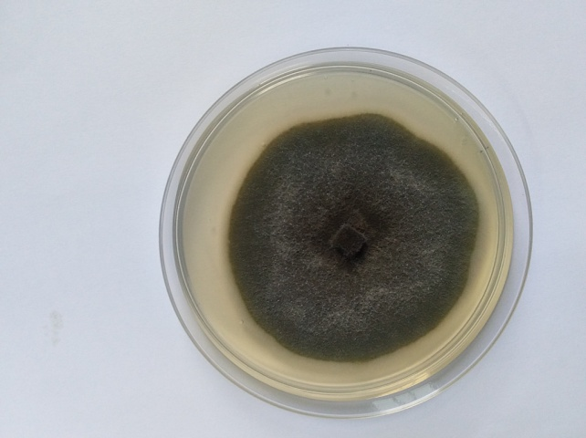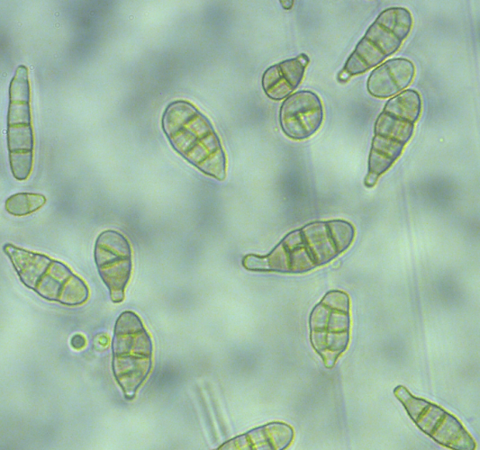
c
b
a
Fig. 1: A. alternata isolate from citrus fruit: (a) on PDA culture media, (b) conidia, (c) symptoms on leaves
Table 1. List of the mandarin cultivars used in this study, from INRA of Morocco
Accession | Description | System/References
Murcott Honey | ‘C. reticulata’ × ‘C. Sinensis’ | (Gogorcena et al., 1990)
Bergamota | Citrus reticulata | Swingle system; (Handaji et al., 2020)
Dancy | Seedling of Moragne ‘tangierine’ | (Hodgson, 1967, Arlotta et al., 2020)
Carvalhal | Citrus reticulate Blanco | Tanaka system; (Handaji et al., 2012)
Ananas | Citrus reticulate Blanco | Tanaka system; (Handaji et al., 2012)
Satsuma wase | Citrus unshiu | Tanaka system; (Handaji et al., 2012)
Vohanisahy Ifranica | Citrus reticulata | Swingle system; (Handaji et al., 2012)
Lee | ‘C. paradisi’ × ‘tangerine’ | (Handaji et al., 2012)
Temple | ‘C. reticulata’ × ‘C. sinensis’ | (Handaji et al., 2012)
Nadorcott | ‘Murcott’ tangor’ × ‘Mandalina’ mandarin | (Nadori, 2004, Arlotta et al., 2020)

Field inoculation
Field bioassays were carried out over previously selected trees of mandarins. Three plants of each cultivar were used in this experiment. A total of nine young leaves (5-7 cm) and nine mature fruits from each tree were marked before and inoculated manually by spraying appositively 2 ml of the conidia suspension per leaf/fruit (Pacheco et al., 2012). Controls were inoculated with the same volume of sterile distilled water. Thus, the inoculated samples were covered with a transparent polyethylene bag previously sprayed inside with sterile distilled water to serve as a humid chamber (Reis et al., 2007, de Souza et al., 2009). The assessments were performed four to seven days after inoculation (de Souza et al., 2009).
Inoculation of detached leaves
In vitro inoculations were performed in two consecutive years (2019 and 2020) for all tested cultivars. Young leaves measured 5-7 cm (Reis et al., 2007) and 2-3 cm in length (Pacheco et al., 2012, da Costa et al., 2020), were sampled from the plants and inoculated immediately after their harvest. Briefly, nine leaves per variety were disinfected in 1% of hypochlorite sodium and placed individually in Petri dishes with humid filter paper and inoculated using the same volume of suspensions mentioned above. Control leaves were sprayed only with distilled water and the plates were kept at the temperature of 27 °C under a 12-hour photoperiod. 27 °C. Disease assessments were performed 24 h, 48 h and 72 h after inoculation (Reis et al., 2007).
Assessment method
The severity of symptoms on the fruits was referred using a specific scale described by (Pacheco et al., 2012) as shown in Table 2. For leaves, the severity of symptoms was determined using a specific diagrammatic scale developed by (Martelli et al., 2016) to assess the ABS leaf symptoms (Table 3). The results were recorded by calculating the area under the disease progression curve (AUDPC) (DE CAMPOS et al., 2017) :
AUDPC = ∑ [((y1+y2)/2*(t2-t1)]
Where y1 and y2 are two consecutive evaluations carried out at times t1 and t2 respectively.
Table 2. Fruit disease severity rating scale.
Score | (%) of infection
0 | 0%
1 | 0.1%
2 | 1%
3 | 2.5%
4 | 5%
5 | 11%
6 | 25%

Table 3. Leaf disease severity sating scale.
Score | (%) of infection
0 | 0%
1 | 0.3%
2 | 3.5%
3 | 8%
4 | 15%
5 | 34%
6 | 61%
7 | 80%
8 | 90%
9 | 97%

Results
Field evaluation
In this experiment, the resistance level of ten varieties of mandarins to A. alternata was evaluated for both fruits and leaves. Field results showed that all studied varieties were affected and responded to this pathogen. Symptoms were typically characteristic of ABS disease as shown in the Figure 2. On fruit, small necrotic spots were dispersed randomly in their surface while the leaf lesions included large area brown to black areas according to the severity incidence In fact, the AUDPC values given in Table 3 indicate that lesions on fruits were more severe than on leaves. The minimum values of AUDPC were recorded by ‘Vohanisahy Ifranica’, ‘Lée’, ‘Temple’ and ‘Nadorcott’ cultivars, with 127.75, 125.88, 122.8, 87.63 on fruits, and with 40.69, 46.06, 32.88, 38.63 on leaves, respectively. The higher values of AUDPC were observed on fruits of ‘Murcott Honey’, ‘Bergamota’ and ‘Dancy’ and on leaves of Carvhalal, Ananas and Satsuma Wase.

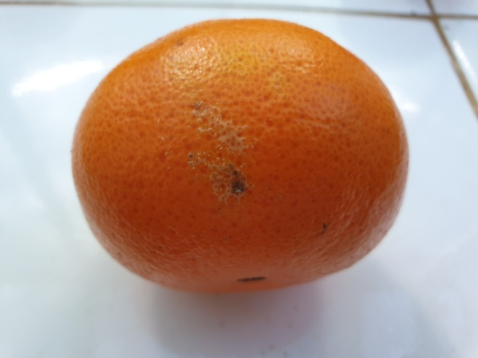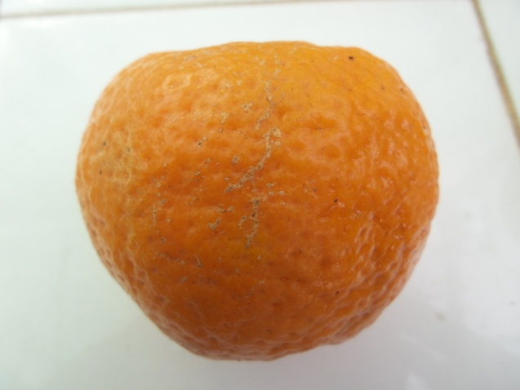
c
b
d
a
Fig. 2: Fruits showing the typical symptoms of ABS after 7 days of field inoculation (a); Temple (b); Ananas (c); Carvhalal (d); Vohanisahy Ifranica

In vitro evaluation of ABS
The detached-leaf method was repeated in two successive years depending on the leaves size. The ABS severity of each cultivar was calculated as AUDPCs (Table 3). Compared to the field inoculations, lesions on leaves inoculated under controlled conditions (in vitro) were slightly severe. On the other hand, results showed that the young leaves measuring 3 to 4 cm in size were more susceptible to ABS than those measuring 5-7 cm. The symptoms were generally typical and appeared as irregular areas with a dark brown color. Based on the in vitro results, Nadorcott and Temple seem the most resistant cultivars to A. alternata, whereas, high values of AUDPC were observed for Murcott, Dancy, Carvalhal and Ananas.

d
c
a
b
Fig. 3: Leaves showing the typical symptoms of ABS after 48 h of in vitro inoculation (a); Carvhalal (b); Dancy (c); Ananas (d); Satsuma wase
Table 3. Area under the disease progress curve (AUDPC) of ABS in 2019 and 2020
Cultivars | AUDPC
 | In field |  | In laboratory
 | Fruits | Leaves (5-7 cm) | Leaves (5-7 cm) | Leaves (2-3 cm)
Murcott Honey | 201.2 | 51,42 | 149,34 | 222,18
Bergamota | 182.66 | 57,57 | 75,27 | 158,64
Dancy | 175.26 | 56,34 | 78,99 | 264,78
Carvhalal | 157.39 | 74,04 | 74,68 | 295,05
Ananas | 154.27 | 70,32 | 76,52 | 200,06
Satsuma Wase | 149.89 | 70,33 | 88,87 | 254,9
Vohanisahy Ifranica | 127.75 | 40,69 | 86,39 | 296,88
Lée | 125.88 | 46,06 | 49,35 | 150,59
Temple | 122.8 | 32,88 | 33,93 | 68,5
Nadorcott | 87.63 | 38,63 | 41,33 | 140,09

Discussion
ABS is one of the severest diseases of mandarins (C. reticulata) and their hybrids leading to significant economic loss. Discovering and selection resistant cultivars to this disease became recently a major objective for several researchers. In the present study, the evaluation of ABS resistance was carried out in the field and on detached leaves of ten mandarins varieties using a virulent A. alternata isolate. Results showed the susceptibility to fruit and leaves inoculation for all the tested cultivars by ABS symptoms expression both under experimental and laboratory conditions. The produced lesions were observed as brown to black-colored areas dispersed in the leaf surface. Similar symptoms were detected on leaves of resistant and susceptible mandarin hybrids inoculated with A. alternata spores (DE CAMPOS et al., 2017, Arlotta et al., 2020). In the literature, it has been widely reported that the development of lesions is mainly due to the host-selective ACT-toxin production by A. alternata tangerines pathotype (Akimitsu et al., 2014). On the other hand, the detached leaves were found highly susceptible to the disease than those inoculated in the trees. This is in agreement with (de Souza et al., 2009, TURGUTOĞLU and BAKTIR, 2019) who notice the fast development of severe symptoms under controlled conditions in comparison with the in vivo experiments (de Souza et al., 2009, TURGUTOĞLU and BAKTIR, 2019). As assured, leaves lose gradually their physiological defense against pathogens when they are detached (Azevedo et al., 2010, Pacheco et al., 2012, Bastianel et al., 2014). On the other hand, the resistance level assessment of the studied cultivars Based on the AUDPC, showed the high susceptibility to A. alternata by Murcott Honey, Bergamota, Dancy, Carvhalal, Ananas, Satsuma Wase and Vohanisahy Ifranica. Lée, Temple and Nadorcott were recorded low severity and to be resistant to ABS to leaves and fruits. In accordance, Dancy and Murcott were reported in previous studies as highly susceptible genotypes to this disease and used as controls (Cuenca et al., 2013, DE CAMPOS et al., 2017). A current study demonstrates genetically that ‘Nadorcott’ mandarin (syn. Afourer) was moderately resistant to A. alternata fungus (Arlotta et al., 2020).. Likewise, (Reis et al., 2007, de Souza et al., 2009) describe the ‘Temple’ as slightly susceptible to this fungus. This variety was also found resistant to ABS in previous data (Cuenca et al., 2016).
Conclusion
In this study, detached leaf and field inoculations assays were conducted to evaluate the susceptibility of mandarin cultivars to A. alternata pathogen. Among the ten varieties, three revealed medium resistance. Furthermore, findings indicate the greater susceptibility of the leaves in the laboratory trials. Other new mandarins cultivars should be tested with different A. alternata isolates showing a high pathogenic ability to cause disease in the citrus crops.
ACKNOWLEDGMENTS
This study was supported by the grant from KAFACI (Project Number: KAH 20180108), Rural Development Administration of Korea.
References
AIELLO, D., GUARNACCIA, V., AZZARO, A. & POLIZZI, G. 2020. Alternaria brown spot on new clones of sweet orange and lemon in Italy. Phytopathologia Mediterranea, 59, 131-145.
AKIMITSU, K., TSUGE, T., KODAMA, M., YAMAMOTO, M. & OTANI, H. 2014. Alternaria host-selective toxins: determinant factors of plant disease. Journal of general plant pathology, 80, 109-122.
ARLOTTA, C., CIACCIULLI, A., STRANO, M. C., CAFARO, V., SALONIA, F., CARUSO, P., LICCIARDELLO, C., RUSSO, G., SMITH, M. W. & CUENCA, J. 2020. Disease Resistant Citrus Breeding Using Newly Developed High Resolution Melting and CAPS Protocols for Alternaria Brown Spot Marker Assisted Selection. Agronomy, 10, 1368.
AZEVEDO, F. A., POLYDORO, D. A., BASTIANEL, M., KUPPER, K. C., STUART, R. M., COSTA, F. P. & PIO, R. M. 2010. Response of different tangerine varieties and hybrids to in vitro and in vivo inoculation of Alternaria alternata. Revista Brasileira de Fruticultura, 32, 944-951.
AZEVEDO, F. A. D., MILANEZE, T. F., CONCEICAO, P. M. D., PACHECO, C. D. A., MARTINELLI, R. & BASTIANEL, M. 2019. Winter pruning: option for management against alternaria brown spot (’Alteraria alternata’ f. sp. “citri”) in Honey Murcott tangor [’Citrus reticulata’ Blanco x “C. sinensis” (L.) Osbeck], Southern Cross Journals.
BASTIANEL, M., SIMONETTI, L. M., SCHINOR, E. H., GIORGI, R. O. D., NEGRI, J. D. D., GOMES, D. N. & AZEVEDO, F. A. D. 2014. Avaliação do banco de germoplasma de mexericas com relação às características físico-químicas e suscetibilidade à mancha marrom de alternária. Bragantia, 73, 23-31.
CHITOLINA, G. M., SILVA-JUNIOR, G. J., FEICHTENBERGER, E., PEREIRA, R. G. & AMORIM, L. 2021. Distribution of Alternaria alternata isolates with resistance to quinone outside inhibitor (QoI) fungicides in Brazilian orchards of tangerines and their hybrids. Crop Protection, 141, 105493.
CUENCA, J., ALEZA, P., GARCIA-LOR, A., OLLITRAULT, P. & NAVARRO, L. 2016. Fine mapping for identification of citrus alternaria brown spot candidate resistance genes and development of new SNP markers for marker-assisted selection. Frontiers in plant science, 7, 1948.
CUENCA, J., ALEZA, P., VICENT, A., BRUNEL, D., OLLITRAULT, P. & NAVARRO, L. 2013. Genetically based location from triploid populations and gene ontology of a 3.3-Mb genome region linked to alternaria brown spot resistance in citrus reveal clusters of resistance genes. PLoS One, 8, e76755.
DA COSTA, G., CURTOLO, M., MAGNI, T. C. & CRISTOFANI-YALY, M. 2020. Response of citrus hybrids to Alternaria alternata inoculation. Comunicata Scientiae, 11, e3358-e3358.
DE CAMPOS, K. A. F., DE AZEVEDO, F. A., BASTIANEL, M. & CRISTOFANI-YALY, M. 2017. RESISTANCE TO ALTERNARIA BROWN SPOT OF NEW CITRUS HYBRIDS1. Revista Brasileira de Fruticultura, 39.
DE SOUZA, M. C., STUCHI, E. S. & DE GOES, A. 2009. Evaluation of tangerine hybrid resistance to Alternaria alternata. Scientia Horticulturae, 123, 1-4.
ELENA, K. 2006. Alternaria brown spot of Minneola in Greece; evaluation of citrus species susceptibility. European Journal of Plant Pathology, 115, 259-262.
GARGANESE, F., SCHENA, L., SICILIANO, I., PRIGIGALLO, M. I., SPADARO, D., DE GRASSI, A., IPPOLITO, A. & SANZANI, S. M. 2016. Characterization of citrus-associated Alternaria species in mediterranean areas. PloS one, 11, e0163255.
GOGORCENA, Y., ZUBRZYCKI, H. & ORTIZ, J. 1990. Identification of mandarin hybrids with the aid of isozymes from different organs. Scientia horticulturae, 41, 285-291.
GULSEN, O., UZUN, A., CANAN, I., SEDAY, U. & CANIHOS, E. 2010. A new citrus linkage map based on SRAP, SSR, ISSR, POGP, RGA and RAPD markers. Euphytica, 173, 265-277.
HANDAJI, N., BENYAHIA, H., ENNACIRI, H., HMIMIDI, A., ADERDOUR, T. & BENAOUDA, H. 2020. Analyse de la diversité phénotypique des variétés de mandariniers issues de la collection marocaine INRA Kenitra. African and Mediterranean Agricultural Research Journal-Al-Awamia.
HANDAJI, N., BENYAHIA, H., GABOUN, F. & IBRIZ, M. 2012. Caractérisation et structuration de la diversité génétique du germoplasme de mandarines par les marqueurs moléculaires ISSR au Maroc. J Appl Biosci, 57, 4186-4197.
HODGSON, R. W. 1967. Horticultural varieties of citrus. History, world distribution, botany and varieties, 431-591.
KIM, E., LEE, H. M. & KIM, Y. H. 2017. Morphogenetic alterations of Alternaria alternata exposed to dicarboximide fungicide, iprodione. The plant pathology journal, 33, 95.
KOHMOTO, K., ITOH, Y., SHIMOMURA, N., KONDOH, Y., OTANI, H., KODAMA, M., NISHIMURA, S. & NAKATSUKA, S. 1993. Isolation and biological activities of two host-specific toxins from the tangerine pathotype of Alternaria alternata. Phytopathology, 83, 495-502.
LAHLALI, R., JAOUAD, M., MOININA, A., MOKRINI, F. & BELABESS, Z. 2021. Farmers' knowledge, perceptions, and farm-level management practices of citrus pests and diseases in Morocco. Journal of Plant Diseases and Protection, 1-14.
MA, H., ZHANG, B., GAI, Y., SUN, X., CHUNG, K.-R. & LI, H. 2019. Cell-wall-degrading enzymes required for virulence in the host selective toxin-producing necrotroph Alternaria alternata of citrus. Frontiers in Microbiology, 10, 2514.
MARTELLI, I. B., DE ANDRADE PACHECO, C., BASTIANEL, M., SCHINOR, E. H., DA CONCEIÇÃO, P. M. & DE AZEVEDO, F. A. 2016. Diagrammatic scale for assessing foliar symptoms of alternaria brown spot in citrus. Agronomy Science and Biotechnology, 2, 57-57.
MOOSA, A., FARZAND, A., ABBAS, M. F., SAHI, S. T., KHAN, S. A. & GLEASON, M. L. 2020. First report of Alternaria brown spot of Citrus reticulata cv.‘Kinnow’caused by Alternaria arborescens in Pakistan. Journal of Plant Pathology, 102, 235-236.
NADORI, E. Nadorcott mandarin: a promising new variety. Proceedings International Society of Citriculture, 2004. 356-359.
PACHECO, C. D. A., MARTELLI, I. B., POLYDORO, D. A., SCHINOR, E. H., PIO, R. M., KUPPER, K. C. & AZEVEDO, F. A. D. 2012. Resistance and susceptibility of mandarins and their hybrids to Alternaria alternata. Scientia Agricola, 69, 386-392.
PERES, N. A. & TIMMER, L. W. 2006. Evaluation of the Alter-Rater model for spray timing for control of Alternaria brown spot on Murcott tangor in Brazil. Crop Protection, 25, 454-460.
PÉREZ-JIMÉNEZ, M. & PÉREZ-TORNERO, O. 2021. Comparison of Four Systems to Test the Tolerance of ‘Fortune’ Mandarin Tissue Cultured Plants to Alternaria alternata. Plants, 10, 1321.
REIS, R. F., DE ALMEIDA, T. F., STUCHI, E. S. & DE GOES, A. 2007. Susceptibility of citrus species to Alternaria alternata, the causal agent of the Alternaria brown spot. Scientia Horticulturae, 113, 336-342.
SAITO, S. & XIAO, C. 2017. Prevalence of postharvest diseases of mandarin fruit in California. Plant health progress, 18, 204-210.
STEWART, J. E., TIMMER, L. W., LAWRENCE, C. B., PRYOR, B. M. & PEEVER, T. L. 2014. Discord between morphological and phylogenetic species boundaries: incomplete lineage sorting and recombination results in fuzzy species boundaries in an asexual fungal pathogen. BMC Evolutionary Biology, 14, 38.
TSUGE, T., HARIMOTO, Y., AKIMITSU, K., OHTANI, K., KODAMA, M., AKAGI, Y., EGUSA, M., YAMAMOTO, M. & OTANI, H. 2013. Host-selective toxins produced by the plant pathogenic fungus Alternaria alternata. FEMS microbiology reviews, 37, 44-66.
TURGUTOĞLU, E. & BAKTIR, İ. 2019. In vitro and in vivo assessment of the sensitivity of some tangerine mutants to Alternaria alternata pv. citri. Mediterranean Agricultural Sciences, 32, 117-120.
USDA 2019. <Citrus : World Markets and Trade>.
USDA 2021. Citrus Semi-annual. Citrus. United States Department of Agriculture Foreign Agricultural Service.
VEGA, B., LIBERTI, D., HARMON, P. F. & DEWDNEY, M. M. 2012. A rapid resazurin-based microtiter assay to evaluate QoI sensitivity for Alternaria alternata isolates and their molecular characterization. Plant disease, 96, 1262-1270.
VICENT, A., ARMENGOL, J. & GARCÍA-JIMÉNEZ, J. 2007. Rain Fastness and Persistence of Fungicides for Control of Alternaria Brown Spot of Citrus. Plant Dis, 91, 393-399.
VICENT, A., ARMENGOL, J. & GARCÍA-JIMÉNEZ, J. 2009. Protectant activity of reduced concentration copper sprays against Alternaria brown spot on ‘Fortune’mandarin fruit in Spain. Crop Protection, 28, 1-6.
WANG, F., SAITO, S., MICHAILIDES, T. J. & XIAO, C.-L. 2021. Phylogenetic, morphological, and pathogenic characterization of Alternaria species associated with fruit rot of mandarin in California. Plant Disease, PDIS-10-20-2145-RE.
ZELMAT, L., MANSI, J. M., AOUZAL, S., GABOUN, F., KHAYI, S., IBRIZ, M., EL GUILLI, M. & MENTAG, R. 2021. Genetic Diversity and Population Structure of Moroccan Isolates Belong to <i>Alternaria</i> spp. Causing Black Rot and Brown Spot in Citrus. International Journal of Genomics, 2021, 9976969.

