Running title: In Silico Molecular Simulation of C. latifolia as Antiaging

In Silico Molecular Simulation of Reported Phytochemical Compounds from Curculigo latifolia Extract on Target Proteins Related to Skin Antiaging

Syamsu Nur^{1,2}, Muhammad Hanafi^{3,4}, Heri Setiawan⁵, Nursamsiar², Berna Elya¹*

¹Department of Phytochemistry and Pharmacognosy, Faculty of Pharmacy, Universitas Indonesia, Depok, 16424, Indonesia.
²Department of Pharmaceutical Chemistry, Sekolah Tinggi Ilmu Farmasi Makassar, Makassar, 90245, Indonesia.
³Research Centre for Pharmaceutical Ingredient and Traditional Medicine, National Research and Innovation Agency (BRIN), Serpong, 15314, Indonesia.
⁴Department of Phytochemistry, Faculty of Pharmacy, Pancasila University, South Jakarta, 12640, Indonesia.
⁵Department of Pharmacology, Faculty of Pharmacy, Universitas Indonesia, Depok, 16424, Indonesia.

*Correspondence: berna.elya@farmasi.ui.ac.id

Novelty Statement
This study provides an overview of some of the secondary metabolites of the plant Curculigo latifolia, reported previously to describe in silico predicted antiaging abilities with several protein targets, including elastase, TNF-alpha, and tyrosinase. Elastase, TNF-alpha, and tyrosinase are part of several pathways related to skin aging. In silico molecular interaction, studies carried out in the three pathways have not been fully reported in previous studies. We hope this study can complete the database of C. latifolia compounds through an in silico approach that can be used as a candidate for developing antiaging agents.
ABSTRACT
Curculigo latifolia Dryand.Ex W. T. Alton is a plant reported to have pharmacological effects. Several studies have shown that C. latifolia extract has the ability as an antioxidant and anti-aging. Previous studies have been conducted in silico studies with target proteins associated with antiaging. This study examines the in silico activity of phytochemical compounds reported as antiaging using unreported target proteins, including elastase, TNF-alpha, and Tyrosinase. Testing was carried out in silico using AutoDock 14.0 software. A total of 46 compounds were successfully anchored to each target protein. The test results showed that, in general, the reported compounds of C. latifolia had negative bond-free energy values. Still, only a few reported compounds had the most negative bond-free energy values and interacted with the target protein similar to native ligands. Compounds 4 (mundulone), 11 (orcinol glucoside), 12 (orcinol glucoside B), 14 (curculigoside B), 15 (curculigoside C), 23 (5,2,6-Trihydroxy-7,8 dimethoxyflavone-2-0-β-D-glucoside), 29 (aviprin), 30 (guaiacol), 34 (quercetin), 38 (monobenzone) and 42 (stigmastan 3,6 dione) were shown to have an inhibitory effect on one target proteins. However, compound 2 (pomiferin) and compound 40 (frangulin B) were predicted to be able to interact with multitarget on target proteins that cause anti-aging. Compounds 2 and 40 tend to fulfill the Lipinski rule, pharmacokinetics and toxicity requirements in silico so that they can be developed for further research. The confirmed compound of C. latifolia active in silico still needs in vitro and in silico studies to be developed as a candidate anti-aging drug.
Keywords: Anti-aging, Genus curculigo, Hypoxidaceae, Molecular Docking, Skin aging
1. Introduction
The skin is the outermost organ that covers the entire human body and has the function of protecting the body from various things that can be harmful. Healthy skin is everyone's dream. However, the skin can experience complex biological phenomena involving unavoidable and persistent physiological processes that cause skin aging (Nur et al., 2021; Yousef et al., 2020; Zhang & Duan, 2018a). Skin tissue slowly loses its capacity to replenish or regenerate itself, retain its structure, and carry out its usual functions as it ages. Some people age with age, while others experience faster aging, known as premature aging (Amaro-Ortiz et al., 2014; Anggraini et al., 2020; Lukitaningsih et al., 2020; Zhi-ying et al., 1994). This is due to a combination of intrinsic aging, which is influenced by genetic factors related to chronological age, and extrinsic aging, which is influenced by environmental factors such as UV exposure, smoking, chemicals, and gravity. One of the most important factors in extrinsic aging is ultraviolet radiation (UV), which occurs in photoaging, where repeated exposure to sunlight can lead to reactive oxygen species (ROS) formation (Nur et al., 2023a, 2022; Otang-Mbeng and Sagbo, 2020; Purohit et al., 2016).
Reactive oxygen species (ROS) contribute significantly to the dermal extracellular matrix changes brought on by intrinsic aging and photoaging from a molecular perspective. (Shin et al., 2019). Biochemically in the body, ROS can be produced from a variety of sources, including the mitochondrial electron transport chain, peroxisomal and endoplasmic reticulum (ER) localized proteins, the Fenton reaction, and enzymes such as cyclooxygenase, lipoxygenase, xanthine oxidase, and nicotinamide adenine dinucleotide phosphate (NADPH) oxidase (Oh et al., 2020; Snezhkina et al., 2020). Under normal conditions without ligand, receptor tyrosine kinase (RTK) activity on the cell surface is inhibited by receptor protein tyrosine phosphatase (RPTP), which dephosphorylates RTK. However, the cellular chromophore absorbs energy under UV radiation and becomes excited, generating oxidation products and ROS. ROS inhibit RPTP activity by binding to cysteine at the RPTP catalytic site, increasing levels of phosphorylated RTK and triggering downstream signalling pathways, including activation of mitogen-activated protein kinase (MAPK) and nuclear factor-kB (NF-kB) and transcription factor activator protein-1 (AP-1) (Nur et al., 2021b; Rittié & Fisher, 2015). In photoaged skin, activated NF-kB and AP-1 decrease collagen synthesis and enhance MMP gene transcription. In addition, the photoaging effect activates an increase in neutrophil elastase influx as a result of induction of the occurring angiogenesis so that the elastin network is degraded and triggers the appearance of wrinkles on the skin (M. Kim & Park, 2016; Y. H. Kim et al., 2008). Another effect caused by photoaging is the activation of tyrosinase, which causes the formation of eumelanin and hyperpigmentation clinically associated with aging (Resat Apak et al., 2017; Reşat Apak et al., 2010; Solano, 2020).
Cosmetics are commonly used to deal with premature aging, but most are made of synthetic materials whose continued use allows for adverse effects. Products made from natural ingredients with mild side effects allow them to be developed as an agent to prevent aging (Hoang et al., 2021; Michalak, 2022). Various plants are rich in antioxidant compounds that can protect the skin from various negative effects of the environment and biological processes in the body, so they correlate with preventing premature skin aging (Petruk et al., 2018). One of the plants that can be developed as an anti-aging drug candidate is Curculigo latifolia. Previous studies reported that C. latifolia is a plant rich in antioxidant compounds. In addition, C. latifolia extract has been reported to have antidiabetic, antibacterial, and generally potent antioxidant effects. Previous studies have shown that extracts from C. latifolia can protect the skin from UV exposure in vitro (Nur et al., 2022; Zabidi et al., 2019, 2021). The presence of antioxidant activity and protective effects against UV radiation is information supporting the development of C. latifolia as an anti-aging agent. Several studies reported that C. latifolia contains phenolic compounds, phenolic glycosides, flavonoids, and steroid/terpenoid groups, namely cycloartan derivatives. These compounds allow for anti-aging biological activity on the skin (Nur et al., 2022; Nur et al., 2023b).
Chemical compounds derived from natural ingredients offer attractive and effective bioactivity in providing biological activity, especially anti-aging. Therefore, a screening test for the potential of phytoconstituent as candidate molecules capable of inhibiting multiple target proteins that modulate premature aging was performed in this study. The structure-based design of drug molecules using phytochemical compounds provides a rapid predictive profile of the compounds' biological activity and reduces the associated ambiguity. Therefore, this research focuses on developing drug candidates that can be used as anti-aging agents from the previously reported phytochemical content of the C. latifolia plant. The in silico molecular docking assay model was chosen to investigate the binding affinity of the selected compounds to multiple target proteins involved in the mechanism of premature aging. This work may aid in generating candidate compounds with anti-aging biological activity for future testing.
2. Methods
2.1 Materials
The materials used were the 3D structure of the ligand binding domain (LBD) of elastase, TNF-alpha, and tyrosinase obtained from the Protein Data Bank online database (www.pdb.org) and compounds from C. latifolia (Table 1). Compounds from C. latifolia were obtained from research previously reported by (Mad Nasir et al., 2021; Umar et al., 2021; Wang et al., 2021; Zabidi et al., 2021; Zabidi et al., 2019). The instruments used were Acer Aspire-5 computer hardware with a Ryzen 5 processor technical specifications, 8 GB DDR3 memory (RAM), HD Graphics 1080, 15 HD monitor, 500 GB hard drive, and Windows 11 Ultimate operating system. The software package used was Chemdraw Ultra® 8.0 (www.cambridgesoft.com), Hyperchem® 8, ArgusLab® (www.arguslab.com), Discovery Studio® and the AutoDock Tools® application complete with AutoDock and Autogrid programs.
2.2 Ligands Preparation
The ligands used in this study were 46 compounds from the C. latifolia plant. The ligand preparation was started by creating a 2D structure with the ChemDraw Ultra 8.0 program in the ChemOffice v.8.0 package, followed by a 3D ligand structure created with Chem3D v.8.0 in the ChemOffice v.8.0 package and presented in (*mol ) file format. The 3D structure was then optimized for geometry using the HyperChem Release v8.07 program. The geometry optimization was performed by adding H and model builds and semi-empirical calculations with an AM1 force field in the HyperChem v8.07 program package with an RMS slope value of 0.001. The optimized ligand structure was then analyzed for its molecular properties, saved in file format (*.hin) and converted into a file format (*.pdb) using the ArgusLab program package for further use in the AutoDock Tools v.4.2 program package. With the help of the program package AutoDock Tools v.4.2, the ligand compounds All Hydrogen were given, then Compute Gasteiger and Merge Non-Polar were entered, and the file was saved in (*.pdbq) format, followed by Torsion Input, set several Torsions and selected atoms, which were then saved in (*.pdbqt) format (Nur et al., 2023b; Nursamsiar et al., 2020).
2.3 Protein preparation
The 3D structure of the enzymes elastase (1B0F), TNF alpha (3EWJ) and tyrosinase (5M8N) as target proteins was presented in the program package Discover Studio Visualizer v17.2.0. The elastase and TNF-alpha proteins were composed of 2 molecules (monomers), chain A and chain B, and then chain A was selected for elastase and chain B for TNF-alpha. The chain was separated from the water molecule and its natural ligands and stored in the (*.pdb) file. While protein tyrosinase is a tetramer consisting of 4 molecules (monomers), chains A, B, C and D. Chain B was selected based on the same sequence of each chain, so one chain can be selected. The chain structure was separated with the AutoDock Tools 4.2 program and provided with polar hydrogen atoms. At the same time, the partial charge of each atom was calculated using Kollman's add, which is included in the Autodock Tools 4.2 program package. Then the chain structure was saved in a (*.pdbqt) file. (Nur et al., 2023b; Nursamsiar et al., 2020).
2.4 Docking Method Validation
Validation was performed to demonstrate that the selected docking parameters can dock the androgen receptor ligands. Validation is carried out by recoupling natural ligands into the active centre of the receptor or protein. Docking was done with the default software conditions, with no changes to run or grid.
2.5 Ligand Docking Simulation
Using the AutoDock 4.2 package, a grid was formed with the appropriate dimensions, which was used during the validation process to cover all amino acid residues involved in ligand binding with the enzymes elastase (1B0F), TNF alpha (3EWJ), and tyrosinase (5M8N). The grid was formed at the site of the bound ligand structure. The information about target proteins and ligands and grid dimensions were saved in (*.gpf) format files. The electrostatic potential map, AutoGrid 4.2 grid map and calculation results were saved in (*.glg) format. Then select Docking Tools, select Lamarckian GA and then save it to a file in (*.dpf) format. Docking simulation results were saved in (*.dlg) format. (Nur et al., 2023b; Nursamsiar et al., 2022).
2.6 Analysis Data of Docking Simulation
The evaluation parameters consisted of the orientation of the ligand structure, hydrophobic interactions, the hydrogen bond formed, and the free energy value of the molecular docking process of each ligand.

3. Result
3.1 Visualisation of ligands and receptors
Based on the investigation of the chemical constituents reported from the C. latifolia plant, 46 compounds were determined to be applied in the current study (Table 1). Ligands, which are C. latifolia compounds, were obtained from studies that reported the compound content of C. latifolia root extract (Mad Nasir et al., 2021; Nur et al.,2023b; Wang et al., 2021; Zabidi et al., 2021; Zabidi et al. 2019). The 46 compounds were ligands visualized using the Software Discovery Studio Visualizer v4.5 program package. The target proteins used are the enzymes elastase (Papaemmanouil et al., 2022; Shin et al., 2019), TNF alpha (Khotimah et al., 2021), and tyrosinase (Papaemmanouil et al., 2022) which are types of receptors involved in the pathology of premature aging. The visualization of the target protein can be observed in Figure 1. The 3D structure of the enzymes elastase (1B0F) and TNF alpha (3EWJ) consists of two 2 molecules (monomers), namely chain A and chain B, while tyrosinase (5M8N) consists of 4 molecules (monomers) with chains A, B, C, and D.
3.2 Docking Method Validation
Validation of the analytical method was carried out by redocking native ligand 1-{3-methyl-2-[4-(morpholine-4-carbonyl)-benzoylamino]-butyryl}-pyrrolidine-2-carboxylic acid (3,3,4,4, 4-Penta fluoro-1-isopropyl-2-oxo-butyl)-amide (1), (1S,3R,6S)-4-oxo-6-{4-[(2-phenylquinolin-4-yl)methoxy]phenyl}-5-azaspiro[2.4]heptane-1-carboxylic acid (2), and mimosine (3) at the active site of the receptor are elastase, TNF alpha, and mimosine, respectively. This process aims to compare the position of the native ligand to the target protein tested with ligand copy. The visualization results show that each ligand copy has the same conformation as native ligands (Figure 2).

In the conformational overlay results for each native ligand before and after validation, the RMSD value of native ligands of 1B0F, 3EWJ, and 5M8N were 1.678, 0.78, and 1.65 Å, respectively. These results show that the conformation of the copy ligands was close to that of the native ligands. The results of the conformation of the copy ligands that were close to the native ligands can occur because the results of the RMSD value obtained are less than 2 Å, thus showing the copy ligand with the position of the atoms that are not much different from the position of the native ligands (Nursamsiar et al., 2022; Nursamsiar, et al., 2020). The smaller RMSD value indicates the position of the ligand from the redocking results, which is getting closer to the position of the ligand obtained from the crystallography results (Kontoyianni et al., 2004). The results of the validation of the docking method of each ligand for proteins 1B0F, 3EWJ, and 5M8N obtained RMSD values of less than 2 A with binding free energies (ΔG value) of -7.69, -15.86, and -6.44 kcal/mol, respectively. Each of these interactions used a grid box size of 34x54x20 Å (1B0F), 24x40x44 Å (3EWJ), and 40x40x40 Å (5M8N) with x,y,z coordinates of 69,048 Å, 51,487 Å, and 55,179 Å for proteins 1B0F, -44.320 Å, 25.911 Å, -19,073 Å for 3EWJ and 16.34 Å; -5.955 Å; 25,418 Å for 5M8N. The size and coordinates of each grid box were implemented against C. latifolia ligands.
3.3 Ligands Docking Simulation
This study used 46 test ligands tethered to each target protein. Each tested ligand will produce 10 conformations ranked based on the best ΔG value and then compared with the amino acids in the native ligands. In addition, this study will evaluate the interaction distance of the hydrogen bond formed, which is measured based on its ionization potential, which shows how much energy is needed to remove electrons from the highest molecular orbital to cause electron donor-acceptor transfer between the native ligand and the test ligand from C. latifolia (Nursamsiar, et al., 2020; Pratami et al., 2022). Many hydrogen bonds formed indicate a strong interaction between the native and test ligands. It shows similar interactions that describe similar activities (Nursamsiar et al., 2022; Savitri et al., 2023). The results of the docking simulation analysis of the 46 compounds from C. latifolia against the target proteins 1B0F, 3EWJ, and 5M8N can be seen in Tables 2, 3, and 4.

The docking simulation results in Table 3 show that compounds from C. latifolia can inhibit the action of elastase (1B0F) in silico. This can be observed from the negative bond free energy value generated between the ligands and the target protein. Even so, only a few of them have a bond-free energy value that is more negative and close to or even more negative than the bond-free energy value of the native ligand (ΔG -7.69 kcal/mol). These compounds include compounds 2 (pomiferin), 4 (mundulone), 29 (aviprin), 11 (orcinol glucoside), and 38 (monobenzone), with bond-free energy values of -8.35, -7.60, -6.03, -6.46, and -6.01 kcal/mol, respectively. The fifth compounds were selected not only based on bond-free energies similar to native ligands but also observed based on hydrogen interactions with the same key amino acids as native ligands, namely Tyr362, Arg374, and Ser394 (Figure 3). Compounds curculigosaponin F (20), 1,1,6-Trimethyl-1,2-dihydro naphthalene (25), and ubiquinone (41) showed no interaction with the target protein, which means that these compounds were not active in inhibiting elastase enzyme was observed in silico. However, in the docking analysis in this study, data was obtained that the stigmastan 3,6-diones (42) compound has a bond-free energy value (-8.27 kcal/mol) that is more negative than the native ligand. Still, the interactions with the key amino acids differ from those with the native ligand. Therefore, in this study, these compounds were not selected. The interaction between the active ligand from C. latifolia and the target protein 1B0F can be seen in Figure 3.
The molecular docking native ligand for protein 3EWJ has a bond-free energy value of -13.05 kcal/mol, which interacts via hydrogen bonding to the amino acid residues Leu348 and Gly349. The bond distance between them ranges from 2.86 to 3.0 Å. It was found that there were 2 hydrogen donors and 2 hydrogen acceptors for the 3EWJ amino acid residue. This information is then compared with the interaction that occurs between the ligands of the C. latifolia compound and the 3EWJ target protein.
Table 3 shows the molecular docking results of C. latifolia compounds against TNF alpha protein. These results indicate that compound 42 (stigmastan 2.6 dione) and compound 2 (pomiferin) produce bond-free energy values close to native ligands of -11.60 and -11.43 kcal/mol, respectively. These compounds have the same hydrogen bonding interactions with the amino acid residues Leu348 and Gly349 as native ligands. The number of hydrogen donors and hydrogen acceptors in each compound was similar to that of the native ligand. This shows that the mechanism of inhibition that occurs in the compound and the native ligand for the 3EWJ protein are thought to have similarities. Apart from compounds 42 and 2, compounds 40 (frangulin B), 15 (curculigoside C), and 23 (5,2,6-Trihydroxy-7,8 dimethoxyflavone-2-0-β-D-glucoside) were also found which interact with hydrogen with the amino acid residues Leu348 and Gly349 with bond-free energy values of -9.81, -7.99, and -7.81 kcal/mol, respectively. Even though these compounds have the same interaction with the native ligand, the bond-free energy value is still greater than that of the native ligand. However, this does not rule out the possibility that these compounds can still be categorized as active in silico in inhibiting the activity of the 3EWJ target protein.
The results of the docking simulation analysis between the C. latifolia ligand and the target protein tyrosinase (5M8N) can be seen in Table 4. The 43 C. latifolia compounds exhibited inhibitory interactions with the target protein with negative bond-free energy values. However, two of these compounds, including compound 25 (1,1,6-trimethyl-1,2-dihydro naphthalene) and compound 37 (Lucialdehyde B), gave negative ΔG values. Still, the two compounds did not have hydrogen (polar) interactions that occurred in target proteins. Whereas compounds 20 (curculigosaponin F), 21 (curculigosaponin I), and 41 (ubiquinone) did not provide good interactions with the target protein, indicating that their potency was not active in silico.
Although, in general, these compounds provide inhibitory interactions with the target protein, not all of these compounds provide interactions similar to native ligand (mimosine). It is known that the native ligand provides interaction with a binding free energy value for the 5M8N protein of -6.44 kcal/mol. Hydrogen interactions occur at the 5M8N amino acid residues, namely Tyr362, Arg374, Gln390, Ser394, and Gly388, with the number of donor and acceptor hydrogens, respectively, i.e., 5 and 3 with the bond distance between 2.1 -3.2 Å.
Based on the docking analysis results, compounds 2 (pomiferin), 14 (curculigoside B), 40 (frangulin B), 29 (quercetin), and 12 (orcinol glycoside B) give bond-free energy values close to mimosine and even more negative than mimosine (-6.44 kcal/mol). The five compounds have free energy values of -7.00, -6.52, -6.50, -5.90, and -5.47 kcal/mol, respectively. In addition, the hydrogen interactions that occur are generally at the same key amino acids as mimosine, namely Tyr362, Arg374, Gln390, Ser394, and Gly388 (Figure 5). The five compounds also provide almost the same number of hydrogen donors, acceptors, and bond distance (1.7 – 3.2 Å) as native ligands.

4. Discussion
Dermal aging is a condition of skin problems caused by various factors, both chronological aging and external factors (Nur et al., 2023a). Rapid changes in skin structure that cause wrinkling, sagging, and reduced skin elasticity are manifestations of skin aging. External factors largely influence Molecularly premature skin aging (Zhang & Duan, 2018b). Exposure to UV rays is one of the biggest factors causing premature skin aging. Exposure to UV light can increase ROS, disrupting the molecular and metabolic systems in skin tissue. ROS can activate extracellular matrix degradation, which includes matrix metalloproteinase (MMP) (Nur et al., 2023b). Elastase is one of the enzymes that are part of MMP, which can degrade elastin tissue so that it manifests the occurrence of wrinkles on the skin (Desmiaty et al., 2020). ROS can also activate cytokine release so that it will manifest in the formation of proinflammatory cytokines, including interleukins and tumour necrosis factor-alpha (TNF alpha). TNF alpha has a role in proinflammatory processes, induces the production of MMPs, and inhibits collagen synthesis in fibroblasts (Borg et al., 2013; Youn et al., 2011). In addition, exposure to UV rays will activate melanin due to overexpression of tyrosinase, causing skin hyperpigmentation (Di Petrillo et al., 2016). The effects of these problems will manifest in premature skin aging. Therefore, this study assessed the in silico bioactivity of C. latifolia compounds as antiaging agents in inhibiting elastase, TNF alpha, and tyrosinase as target proteins.
This study aimed to determine the activity profile of the C. latifolia molecule, which is predicted to have an antiaging effect on the skin through in silico molecular docking. The success of the in silico studies that have been carried out provides an overview for researchers to carry out further in vitro and in vivo so that study failures can be minimized (Ferreira et al., 2015). The ability of the C. latifolia compound to inhibit the target protein elastase, TNF alpha, and tyrosinase that cause skin aging can be observed based on the free energy value of the bond between the ligand and the residual amino acid of the target protein. The more negative the bond-free energy value, the greater the molecule's activity (Nur et al., 2023b; Nursamsiar et al., 2020). In this study, the ability of the compound molecule as an inhibitor of the target protein can be compared with that of each native ligand. The closer to the docking simulation results of C. latifolia compounds with native ligands, the greater the activity. These parameters are a reference to describe the in silico activity of C. latifolia compounds.
Several compounds from C. latifolia were identified to have the ability to inhibit target proteins elastase, TNF alpha, and tyrosinase. The existence of a bond-free energy value of the C. latifolia compound, which is negative and has similarities with each native ligand, so that the C. latifolia compounds were predicted to be able to inhibit the target protein. In addition, the number of hydrogen donors and acceptors is also an indicator of the compound's success in inhibiting the target protein. The number of hydrogen bonds formed determines the strength of the interaction between the ligand and the target protein. Ligands with hydrogen bonds will provide higher bond stability than ligands that do not have hydrogen bonds (Chen et al., 2016; Nursamsiar et al., 2022). In general, the active compounds interacting with each target protein have hydrogen bonds, so the bonding ability between the ligand and the protein is more stable. The docking simulation results show that pomiferin (2) and frangulin B (40) are predicted to work as multitarget. Pomiferin inhibited the activity of protein elastase, TNF-alpha, and tyrosinase in vitro which were observed based on the free energy value of the bonds, interactions with residual amino acids, donors, and acceptors of hydrogen which had similarities to each of the native ligands. The frangulin B compound is predicted to inhibit the activity of the target proteins elastase and tyrosinase but not TNF-alpha (Figures 3 and 5). Meanwhile, compounds 4, 11, 12, 14, 15, 23, 29, 34, and 38 were predicted only to be able to work on one of the target proteins (Figures 3, 4, and 5).
The activity of the pomiferin and frangulin B compounds can work by inhibiting multitarget proteins that cause aging in the skin. These compounds have antioxidant activity both in vitro and in vivo. Several studies have reported that these two compounds have a strong antioxidant effect. Pomiferin is a phenylated isoflavone derivative compound that supports its bioactivity as a strong antioxidant (Zabidi et al., 2019). The same applies to the compound frangulin B, a flavonoid derivative rich in hydroxyl groups to stabilize free radicals (Tims, 2017). Their activity as antioxidants in vitro and in vivo from the pomiferin and frangulin B compounds make it possible to be used as skin antiaging through the mechanism of reducing or inhibiting ROS so that they can inhibit the induction of enzymatic proteins, including elastase and tyrosinase as well as TNF alpha cytokines which play a role in modulating the formation of premature aging. This information is in line with in silico studies that have been conducted showing that pomiferin and frangulin B compounds can be developed as antiaging skin markers that work in a multitarget manner. Previous studies have also reported that pomiferin compounds can inhibit the action of collagenase target proteins (MMP-13) and gelatinase (MMP-9) in silico, both enzymes that also have a role in the pathophysiology of aging in the skin (Nur et al., 2023b). Based on the docking simulation analysis that has been carried out, it can be said that pomiferin and frangulin B are compounds that can be developed for further research.
Although the pomiferin and frangulin B compounds are active in silico in inhibiting target proteins that cause aging in the skin, this study needs to be further investigated in vitro and in vivo. In addition, these compounds' physicochemical characteristics, pharmacokinetic profile, and toxicity need to be observed. This study conducted an in silico assessment of the physicochemical, pharmacokinetic, and toxicity profiles of pomiferin and frangulin B compounds.
Physicochemical evaluation of pomiferin and frangulin B compounds with several drug-likeness parameters, including partition coefficient (Log P), molecular weight, hydrogen donor, hydrogen acceptor, and molar rotation, where these five parameters are known as the rule of five (Lipinski rule). The Lipinski rule provides requirements for drug candidates in the form of molecular weight <500 Da, hydrogen bond donors <5, hydrogen bond acceptors <10, octanol/water partition coefficient (MLogP) <5, rotatable bonds <10, and TPSA <140 Å2 (Adianingsih et al., 2022; Lipinski, 2004; Nur et al., 2023b). The Lipinski rule is a general guide in developing new agents and drug candidates related to a molecule's pharmacokinetic parameters and physicochemical properties. The two active compounds showed relevant results and complied with Lipinski's rules so that characteristically these two compounds could be developed as new targets with promising biological activity as antiaging (Table 5).
In silico pharmacokinetic analysis of pomiferin and frangulin, B compounds were evaluated based on the parameters HIA (Human Intent Absorption), Caco2 (Human colon adenocarcinoma), MDCK (Mandin darby canine kidney), plasma protein binding, skin permeability and its interaction with CYP metabolic enzymes (Adianingsih et al., 2022; Nur et al., 2023; Riwu et al., 2022). The pomiferin compound shows positive criteria in human intestinal absorption (HIA), meaning it can be absorbed in the intestinal tract > 30%. In silico permeability in Caco 2 cells shows that both compounds have moderate permeability with values ranging from 4-70 nm/sec. At the same time, the MDCK cells obtained the result that the two compounds had weak permeability (<1 x 10⁻⁶). in the distribution phase, it was shown that the pomiferin compound had a plasma protein binding value of >90%, which meant that the molecule was strongly bound to plasma proteins so that it was less in the blood so that the pomiferin compound might have a toxic effect. It differs from the compound frangulin B, which has a plasma protein binding value of 70% (<90%), indicating that this compound's presence in the blood is large enough to have an effect. Distribution prediction using PPB (plasma protein binding) parameters, which are drug fractions available in free form for distribution to different tissues, and by QSAR (Quantitative Structure-Activity Relationship) analysis, which aims to determine the estimated degree of plasma protein binding based on molecular structure parameters and physicochemical properties of compounds. (Sun et al., 2018; Yuan et al., 2020). This study found that pomiferin and frangulin B compounds showed low permeability in the skin. Nevertheless, these two compounds do not rule out the possibility of being developed as drug candidates orally and topically.
Based on predictions at the metabolic phase, pomiferin and frangulin B are CYP 2C19, CYP 2C9, and CYP 3A4 inhibitors. Drugs that are CYP2C19 and CYP2C9 inhibitors can increase plasma protein concentrations and sometimes cause side effects (Lynch & Price, 2007). This is in line with the prediction of protein binding, which is quite high. Meanwhile, compounds that can inhibit CYP 3A4 are enzymes that play a major role in metabolism in the liver, which is responsible for the oxidation process of small organic molecules (xenobiotics), such as poisons and drugs, so that they can be excreted from the body (Yanes-Roca et al., 2014). Pomiferin and frangulin B compounds are neither inhibitors nor substrates of CYP 2D6. The CYP parameters indicated that the two active compounds from C. latifolia generally did not adversely affect the metabolic phase. Based on the prediction of the toxicity of the pomiferin and frangulin B compounds through the Ames test and carcino mouse, it showed that the two compounds were identified as non-mutagenic.
In contrast, in carcino rats, the pomiferin compound was positively mutagenic. If it is observed from the toxicity prediction, it must be considered in the oral use of pomiferin compounds. But it does not rule out the possibility of modifying the structure if it is to be developed as an antiaging candidate so that these compounds can be used orally or topically.
5. Conclusion
Curculigo latifolia compounds were successfully docked in elastase, TNF-alpha, and Tyrosinase target protein pockets. The results of molecular simulations of the 46 compounds predict that several compounds have activity in interacting with and inhibiting target proteins that are similar to native ligands. Compounds 4 (mundulone), 11 (orcinol glycoside), 29 (aviprin), and 38 (mundulone) were predicted to be able to inhibit the elastase target protein (1B0F). Compounds 15 (curculigoside C), 23 (5,2,6-Trihydroxy-7,8-dimethoxy-flavone-2-0-β-D-glucoside), and 42 (stigmastan 3,6 dione). Meanwhile, compounds 12 (orcinol glycoside B), 14 (curculigoside B) interact with TNF-alpha protein (3EWJ), and 34 (quercetin) were predicted to interact with tyrosinase protein (5M8N) with the most negative bond free energy value. Compound 2 (pomiferin) and compound 40 (frangulin B) were predicted to have the ability to interact with all three target proteins, including elastase, TNF-alpha and tyrosinase with binding free energy and interactions with amino acid residues similar to each native ligand. According to the drug-likeness prediction, pharmacokinetics and toxicity, the pomiferin and frangulin B compounds showed results under the requirements so that they could be developed in further research as antiaging drugs both orally and topically.
Conflict Of Interest
The authors declare that they are not aware of any competing financial interests or personal relationships that might appear to have influenced the work described in this article.
Acknowledgement
The author would like to thank colleagues (Dr. Budiman Yasir and Ms. Noor. Fauziah Rahman) and student (Mika. K. Kalelean) who helped complete this project. This work was supported by the Indonesian Ministry of Education, Culture, Research and Technology through a Doctoral Dissertation Grant with contract numbers 021/E5/PG.02.00.PL/2023 and NKB-865/UN2.RST/HKP.05.00/2023.
References
Adianingsih OR, Khasanah U, Anandhy KD and Yurina V. 2022. In silico ADME-T and molecular docking study of phytoconstituents from Tithonia diversifolia (Hemsl.) A. Gray on various targets of diabetic nephropathy. J Pharm Pharmacogn Res., 10(4): 571–594.
Amaro-Ortiz A, Yan B, D'Orazio JA. 2014. Ultraviolet radiation, aging and the skin: prevention of damage by topical cAMP manipulation. Molecules.19(5):6202-6219.
Anggraini NB, Elya B, Iskandarsyah I. Antielastase Activity of Macassar Kernels (Rhus javanica) Stem Extract and Skin Elasticity Evaluation of Its Topical Gel Formulation. 2021. Adv Pharmacol Pharm Sci. 2021:6690029.
Apak R, Capanoglu E, Shahidi F. 2017. Electron transfer-based antioxidant capacity assays and the cupric ion reducing antioxidant capacity (CUPRAC) assay. In Measurement of Antioxidant Activity & Capacity (eds R. Apak, E. Capanoglu and F. Shahidi). 57-75.
Apak R, Güçlü K, Ozyürek M, Bektaşoğlu B, Bener M. 2010. Cupric ion reducing antioxidant capacity assay for antioxidants in human serum and for hydroxyl radical scavengers. Methods Mol Biol. 594:215-239.
Borg M, Brincat S, Camilleri G, Schembri-Wismayer P, Brincat M, Calleja-Agius J. The role of cytokines in skin aging. 2013. Climacteric. 16(5):514-521.
Chen D, Oezguen N, Urvil P, Ferguson C, Dann SM, Savidge TC. 2016. Regulation of protein-ligand binding affinity by hydrogen bond pairing. Sci Adv., 2(3):e1501240.
Desmiaty Y, Saputri FC, Hanafi M, Prastiwi R, Elya B. 2020. Anti-Elastase, Anti-Tyrosinase and Anti-Oxidant of Rubus Fraxinifolius Stem Methanolic Extract. Pharmacognosy J., 12(2):271-275.
Di Petrillo A, González-Paramás AM, Era B, Medda R, Pintus F, Santos-Buelga C, Fais A. 2016. Tyrosinase inhibition and antioxidant properties of Asphodelus microcarpus extracts. BMC Complement Altern Med., 16(1):453
Ferreira LG, Dos Santos RN, Oliva G, Andricopulo AD. 2015. Molecular docking and structure-based drug design strategies. Molecules. 20(7):13384-13421
Hoang HT, Moon J-Y, Lee Y-C. Natural Antioxidants from Plant Extracts in Skincare Cosmetics: Recent Applications, Challenges and Perspectives. 2021. Cosmetics. 8(4):106
Khotimah H, Setiawan A, Rita CI, Mardiyah M, Ali A, Sukatman MP, Retnaningtyas E, Ismail, DDSL, Widasmara D, Nurseta T, Sujuti H. 202). In silico studies of natural compounds of Centella Asiatica as anti-aging and wound healing agents. AIP Conference Proceedings. Malang- Indonesia.
Kim M and Park HJ. 2016. Molecular Mechanisms of Skin Aging and Rejuvenation. In Molecular Mechanisms of the Aging Process and Rejuvenation. Intech.
Kim YH, Chung CB, Kim JG, Ko KI, Park SH, Kim JH, Eom SY, Kim YS, Hwang YI, Kim KH. 2008. Anti-wrinkle activity of ziyuglycoside I isolated from a Sanguisorba officinalis root extract and its application as a cosmeceutical ingredient. Biosci Biotechnol Biochem. 72(2):303-311
ontoyianni M, McClellan LM, Sokol GS. 2004. Evaluation of docking performance: comparative data on docking algorithms. J Med Chem., 29;47(3):558-65
Lipinski CA. 2004. Lead- and drug-like compounds: the rule-of-five revolution. Drug Discov Today Technol., 1(4):337-341
Lukitaningsih E, Nur S, Qonithah F, Zulbayu A, Kuswahyuning R, Rumiyati R. 2020. In vitro anti-wrinkle and tyrosinase inhibitory activities of grapefruit peel and strawberry extracts. Trad Med J., 25(3),182–189.
Lynch T, Price A. 2007. The effect of cytochrome P450 metabolism on drug response, interactions, and adverse effects. Am Fam Physician. 76(3):391-396
Mad Nasir N, Ezam Shah NS, Zainal NZ, Kassim NK, Faudzi SMM, Hasan H. 2021. Combination of Molecular Networking and LC-MS/MS Profiling in Investigating the Interrelationships between the Antioxidant and Antimicrobial Properties of Curculigo latifolia. Plants (Basel)., 10(8):1488
Michalak M. Plant-Derived Antioxidants: Significance in Skin Health and the Ageing Process. 2022. Int J Mol Sci. 23(2):585
Nur S, Aswad M, Yulianty R, Burhan A, Khairi N, Sami FJ, Nursamsiar. 2023. The antioxidant and anti-ageing activity of lyophilisate kersen (Muntingia calabura L) fruit in vitro. Food Res., 7(2):23-30.
Nur S, Angelina AA, Aswad M, Yulianti R, Burhan A, Nursamsiar N (2021) In vitro anti-aging activity of Muntingia calabura L. fruit extract and its fractions. J Pharm Pharmacogn Res., 9(4): 409–421
Nur S, Hanafi M, Setiawan H, Nursamsiar, Elya B (2023) In silico evaluation of the dermal antiaging activity of Molineria latifolia (Dryand. ex W.T. Aiton) Herb. Ex Kurz compounds. J Pharm Pharmacogn Res., 11(2): 325–345
Nur S, Setiawan H, Hanafi M, Elya B. 2022. In vitro ultra violet ( UV ) protection of curculigo latifolia extract as a sunscreen candidate. IOP Conf. Series: Earth and Environmental Science.
Nursamsiar N, Mangande M, Awaluddin A, Nur S, Asnawi A. 2020. In Silico Study of Aglycon Curculigoside A and Its Derivatives as α-Amilase Inhibitors. Indonesian J Phar Sci and Tech., 7(1): 29-37.
Nursamsiar, Nur S, Febrina E, Asnawi A, Syafiie S. 2022. Synthesis and Inhibitory Activity of Curculigoside A Derivatives as Potential Anti-Diabetic Agents with β-Cell Apoptosis. J Mol Struct., 1265:133292.
Nursamsiar, Siregar M, Awaluddin A, Nurnahari N, Nur S, Febrina E, Asnawi A. 2020. Molecular docking and molecular dynamic simulation of the aglycone of curculigoside a and its derivatives as alpha glucosidase inhibitors. Rasayan J Chem., 13(1):690-698.
Oh YS, Shin SY, Kim S, Lee KH, Shin JC, Park KM. 2020. Comparison of antiaging, anti-melanogenesis effects, and active components of Raspberry (Rubus occidentalis L.) extracts according to maturity. J Food Biochem., 44(11):e13464
Ooi DJ, Chan KW, Sarega N, Alitheen NB, Ithnin H, Ismail M. 2016. Bioprospecting the Curculigoside-Cinnamic Acid-Rich Fraction from Molineria latifolia Rhizome as a Potential Antioxidant Therapeutic Agent. Molecules., 21(6):682
Otang-Mbeng W, Sagbo IJ. 2020. Anti-Melanogenesis, Antioxidant and Anti-Tyrosinase Activities of Scabiosa columbaria L. Processes., 8(2):236
Papaemmanouil CD, Peña-García J, Banegas-Luna AJ, Kostagianni AD, Gerothanassis IP, Pérez-Sánchez H, Tzakos AG. 2022. ANTIAGE-DB: A Database and Server for the Prediction of Anti-Aging Compounds Targeting Elastase, Hyaluronidase, and Tyrosinase. Antioxidants (Basel).11(11):2268
Petruk G, Del Giudice R, Rigano MM, Monti DM. 2018. Antioxidants from Plants Protect against Skin Photoaging. Oxid Med Cell Longev. 2018:1454936
Pratami MP, Fendiyanto MH, Satrio RD, Nikmah IA, Awwanah M, Farah N, Sari NIP, Nurhadiyanta. 2022. In-silico Genome Editing Identification and Functional Protein Change of Chlamydomonas reinhardtii Acetyl-CoA Carboxylase (CrACCase). Jordan J Biol Sci., 15(3):431-440.
Purohit T, He T, Qin Z, Li T, Fisher GJ, Yan Y, Voorhees JJ, Quan T. 2016. Smad3-dependent regulation of type I collagen in human dermal fibroblasts: Impact on human skin connective tissue aging. J Dermatol Sci., 83(1):80-83
Rittié L, Fisher GJ. 2015. Natural and sun-induced aging of human skin. Cold Spring Harb Perspect Med., 5(1):a015370.
Riwu AG, Nugraha J, Purwanto DA, Triyono EA (2022) In silico analysis of anti-dengue activity of faloak (Sterculia quadrifida R. Br) stem bark compounds. J Pharm Pharmacogn Res., 10(6): 1006–1014
Sampietro, D.A., Catalan, C.A.N., & Vattuone, M.A. (Eds.). (2009). Isolation, Identification and Characterization of Allelochemicals/ Natural Products (1st ed.). Taylor and Francies.
Savitri AD, Hidayati HB, Veterini L, Widyaswari MS, Muhammad AR, Fairus A, Zulfikar M QB, Astri M, Ramasima NA, Anggraeni DP, Nainatika RSA, Juliana. 2023. An In-Silico Study on Allicin Compound in Garlic (Allium Sativum) as A Potential Inhibitor of Human Epidermal Growth Factor Receptor (Her)-2 Positive Breast Cancer. Jordan J Biol Sci.,16(1): 7-12.
Shin JW, Kwon SH, Choi JY, Na JI, Huh CH, Choi HR, Park KC. 2019. Molecular Mechanisms of Dermal Aging and Antiaging Approaches. Int J Mol Sci. 29;20(9):2126
Snezhkina AV, Kudryavtseva AV, Kardymon OL, Savvateeva MV, Melnikova NV, Krasnov GS, Dmitriev AA. 2019. ROS Generation and Antioxidant Defense Systems in Normal and Malignant Cells. Oxid Med Cell Longev. 2019;2019:6175804
Solano F. 2020. Photoprotection and Skin Pigmentation: Melanin-Related Molecules and Some Other New Agents Obtained from Natural Sources. Molecules., 25(7):1537
Sun L, Yang H, Li J, Wang T, Li W, Liu G, Tang Y. 2018. In Silico Prediction of Compounds Binding to Human Plasma Proteins by QSAR Models. Chem Med Chem., 13(6):572-581
Tims M. 2017. Review of Isolation, Identification and Characterization of Allelochemicals/Natural Products. J Nat Prod.
Umar AH, Ratnadewi D, Rafi M, Sulistyaningsih YC. 2021. Untargeted Metabolomics Analysis Using FTIR and UHPLC-Q-Orbitrap HRMS of Two Curculigo Species and Evaluation of their Antioxidant and α-Glucosidase Inhibitory Activities. Metabolites., 11(1):42
Wang Y, Li J, Li N. 2021. Phytochemistry and Pharmacological Activity of Plants of Genus Curculigo: An Updated Review Since 2013. Molecules. 26(11):3396
Yanes‐Roca C. 2006. Husbandry and larval rearing of common snook (Centropomus undecimalis).
Youn UJ, Nam KW, Kim HS, Choi G, Jeong WS, Lee MY, Chae S. 2011. 3-Deoxysappanchalcone inhibits tumor necrosis factor-α-induced matrix metalloproteinase-9 expression in human keratinocytes through activated protein-1 inhibition and nuclear factor-kappa B DNA binding activity. Biol Pharm Bull., 34(6):890-893
Yousef H, Alhajj M, Sharma S. 2020. Anatomy, Skin (Integument), Epidermis. Stat Pearls Publishing.
Yuan Y, Chang S, Zhang Z, Li Z, Li S, Xie P, Yau WP, Lin H, Cai W, Zhang Y, Xiang X. 2020. A novel strategy for prediction of human plasma protein binding using machine learning techniques. Chemometrics and Intelligent Laboratory Systems.
Zabidi NA, Ishak NA, Hamid M, Ashari SE, Mohammad Latif MA. 2021. Inhibitory evaluation of Curculigo latifolia on α-glucosidase, DPP (IV) and in vitro studies in antidiabetic with molecular docking relevance to type 2 diabetes mellitus. J Enzyme Inhib Med Chem. 36(1):109-121
Zabidi NA, Ishak NA, Hamid M, Efliza Ashari S. 2019. Subcritical Water Extraction of Antioxidants from Curculigo latifolia Root. J Chem., 2019.
Zhang S, Duan E. 2018a. Fighting against Skin Aging: The Way from Bench to Bedside. Cell Transplant. 27(5):729-738
Zhi-ying Y, Guo-xiong G, Wei-qin Z, Zhe-fu L. (1994). Elastolytic activity from Flavobacterium odoratum. Microbial screening and cultivation, enzyme production and purification. Process Biochemistry. 29(6): 427-436.

Table 1. Compounds of C. latifolia plant
Compound No. | Molecul Name | Molecule Formula | References
1 | Phloridzin | C₂₁H₂₄O₁₀ | (Zabidi et al., 2019)
2 | Pomiferin | C₂₅H₂₄O₆ | (Zabidi et al., 2019)
3 | Scandenin | C₂₆H₂₆O₆ | (Zabidi et al., 2019)
4 | Mundulone | C₂₆H₂₆O₆ | (Zabidi et al., 2019)
5 | Dimethylcaffeic acid | C₁₁H₁₂O₄ | (Zabidi et al., 2019)
6 | Protocatechuic acid | C₇H₆O₄ | (Ooi et al., 2016)
7 | Syringic acid | C₉H₁₀O₅ | (Ooi et al., 2016)
8 | Cinnamic Acid | C₉H₈O₂ | (Ooi et al., 2016)
9 | Ferulic Acid | C₁₀H₁₀O₄ | (Ooi et al., 2016)
10 | Orcinoside H | C₂₇H₃₆O₁₄ | (Wang et al., 2021)
11 | Orcinol Glucoside | C₁₃H₁₈O₇ | (Umar et al., 2021)
12 | Orcinol Glucoside B | C₁₅H₂₁O₈ | (Umar et al., 2021)
13 | Curculigoside A | C₂₂H₂₆O₁₁ | (Wang et al., 2021)
14 | Curculigoside B | C₂₁H₂₄O₁₁ | (Umar et al., 2021)
15 | Curculigoside C | C₂₂H₂₆O₁₂ | (Wang et al., 2021)
16 | Curculigoside D | C₂₂H₂₆O₁₁ | (Wang et al., 2021)
17 | Curculigenin A | C₃₀H₅₀O₄ | (Umar et al., 2021)
18 | Curculigosaponin A | C₃₆H₆₀O₉ | (Umar et al., 2021)
19 | Curculigosaponin D | C₄₂H₇₀O₁₄ | (Umar et al., 2021)
20 | Curculigosaponin F | C₄₈H₈₀O₁₉ | (Umar et al., 2021)
21 | Curculigosaponin I | C₄₈H₈₀O₁₈ | (Umar et al., 2021)
22 | 4-0-caffeoylquinic acid-1 | C₁₆H₁₈O₉ | (Nur et al., 2023)
23 | 5,2,6-Trihydroxy-7,8 dimethoxyflavone-2-0-β-D-glucoside | C₂₃H₂₂O₁₃ | (Nur et al., 2023)

Table 1. Continue
No | Ligand | Molecule Formula | References
24 | 5,7,3,5-Tetrahydroxyflavanone | C₂₁H₂₂O₁₁ | (Nur et al., 2023)
25 | 1,1,6-Trimethyl-1,2-dihydronaphthalene | C₁₃H₁₆ | (Nur et al., 2023)
26 | Malvalic acid | C₁₈H₃₂O₂ | (Nur et al., 2023)
27 | Methyl-3-hydroxy-4-methoxybenzoate | C₉H₁₀O₄ | (Nur et al., 2023)
28 | Sugiol | C₂₀H₂₈O₂ | (Nur et al., 2023)
29 | Aviprin | C₁₆H₁₆O₆ | (Nur et al., 2023)
30 | Guaiacol | C₇H₈O₂ | (Nur et al., 2023)
31 | Smilaxin | C₁₇H₁₆O₆ | (Nur et al., 2023)
32 | 3-Tert-butyl-4-methoxyphenol | C₁₁H₁₆O₂ | (Nur et al., 2023)
33 | Stearidonic acid | C₁₈H₂₈O₂ | (Nur et al., 2023)
34 | Quercetin | C₁₅H₁₀O₇ | (Nur et al., 2023)
35 | Azedarachin C | C₃₂H₄₂O₁₀ | (Nur et al., 2023)
36 | Trichosanic Acid | C₁₈H₃₀O₂ | (Nur et al., 2023)
37 | Lucialdehyde B | C₃₀H₄₄O₃ | (Nur et al., 2023)
38 | Monobenzone | C₁₃H₁₂O₂ | (Zabidi et al., 2019)
39 | Hidrokuinon | C₆H₆O₂ | (Zabidi et al., 2021)
40 | Frangulin B | C₂₀H₁₈O₉ | (Zabidi et al., 2021)
41 | Ubiquinone | C₅₉H₉₀O₄ | (Zabidi et al., 2019)
42 | Stigmastan 3,6 dione | C₂₉H₄₈O₂ | (Umar et al., 2021)
43 | 2,3-dihydroxypropyl oleate | C₂₁H₄₀O₄ | (Umar et al., 2021)
44 | Hordatine A | C₂₈H₃₈N₈O₄ | (Zabidi et al., 2021)
45 | Emmotin A | C₁₆H₂₂O₄ | (Zabidi et al., 2019)
46 | Rubratoksin B | C₂₆H₃₀O₁₁ | (Zabidi et al., 2019)

Table 2. Results of molecular docking analysis of C. latifolia compounds against elastase target protein (1B0F).
Ligands | Molecular docking simulation
 | ΔG value | H- bond donor | H-Acceptor | Bond-Distance (Å) | H-bond residue
NL 1 (1B0F) | -7.69 | 6 | 1 | 2 - 3.2 | Phe41, Cys42, His57, Leu99b, Leu167, Phe192, Gly193, Ser195, Ser214, Phe215, Val216, Arg217
Compound 1 | -4,84 | 4 | 5 | 1.8 - 3.2 | Arg177, Ser195, Val216, Ser214
Compound 2 | -8,35 | 3 | 1 | 2 - 3.1 | Ser195, Val216
Compound 3 | -6,66 | 2 | 1 | 2 – 2.9 | Val216,Gly218
Compound 4 | -7,60 | 3 | 0 | 2.9 – 3.1 | Gly193, Ser195, Val216
Compound 5 | -4,99 | 10 | 6 | 1.9 – 2.96 | Gly193, Asp194, Ser195, Val216
Compound 6 | -4,78 | 5 | 3 | 2 – 3.2 | Gly193, Asp194, Ser195, Val216
Compound 7 | -5,05 | 3 | 2 | 2 – 2.94 | Gly193, Ser195, Val216
Compound 8 | -4,72 | 1 | 1 | 1.9 – 3.15 | Val216
Compound 9 | -5,11 | 5 | 2 | 1.8 – 2.83 | Gly193, Asp194, Ser195, Val216
Compound 10 | -5,32 | 6 | 2 | 1.9 – 3.12 | Gly193, Asp194, Ser195, Val216
Compound 11 | -6,03 | 5 | 2 | 1.88 – 3.13 | Gly193, Asp194, Ser195, Val216
Compound 12 | -6,01 | 5 | 1 | 1.96 – 3.2 | Ser195, Val216
Compound 13 | -4,90 | 3 | 2 | 1.8 – 2.9 | Gly193, Ser195, Val216
Compound 14 | -5,18 | 3 | 4 | 1.9 – 2.9 | Gly193, Ser195, Val216, Phe41
Compound 15 | -3,64 | 4 | 1 | 2 – 2.89 | Gly193, Ser195, Val216
Compound 16 | -5,59 | 4 | 3 | 1.99 – 3.01 | Gly193, Ser195, Val216, His57, Ser214
Compound 17 | -6,84 | 1 | 1 | 1.8 – 2.5 | Ser195, Ser214
Compound 18 | -6,88 | 2 | 1 | 2.2 – 3.1 | Ser195, Arg217, Ser214
Compound 19 | -6,41 | 3 | 2 | 2.1 – 3.2 | Arg177, Ser195, Arg217, Val216, Ser214
Compound 20 | - | - | - | - | -
Compound 21 | -5,18 | 1 | 1 | 1.8 – 2.88 | Rg177, Ser214
Compound 22 | -5,27 | 3 | 3 | 2 – 3.14 | Ser195, Val216
Compound 23 | -4,27 | 5 | 2 | 1.9 – 3.00 | Gly193, Ser195, Val216
Compound 24 | -5,74 | 7 | 4 | 1.72 – 3.0 | Gly193, Api194, Ser195, Ala227, Val216
Compound 25 | -5,65 | - | - | - | -
Compound 26 | -3,43 | 2 | 0 | 2.8 – 3.11 | Arg177, Arg177
Compound 27 | -4,71 | 3 | 0 | 2.8 – 3.05 | Gly193, Ser195, Val216
Compound 28 | -6,68 | 2 | 2 | 1.7 – 2.62 | Gly193, Ser195
Compound 29 | -6,46 | 4 | 2 | 1.9 – 3.12 | Gly193, Ser195, Val216

Table 2. Continue
Ligands | Molecular docking simulation
 | ΔG value | H- bond donor | H-Acceptor |  | Bond-Distance (Å) | H-bond residue
Compound 30 | -4,18 | 3 | 1 |  | 2 – 2.6 | Gly193, Ser195
Compound 31 | -5,26 | 5 | 2 |  | 2.1 – 3.16 | Gly193, Ser195, Val216, Gly218
Compound 32 | -5,76 | 3 | 1 |  | 1.87 – 2.9 | Gly193, Ser195, Val216
Compound 33 | -4,08 | 0 | 1 |  | 2.03 | Val216
Compound 34 | -6,06 | 6 | 2 |  | 2 – 3.2 | Gly193, Asp194, Ser195, Gly219
Compound 35 | -5,30 | 2 | 0 |  | 2.76 – 2.77 | Gly193, Ser195
Compound 36 | -4,57 | 2 | 1 |  | 2.12 – 3.21 | Gly218, Gly219, Val216
Compound 37 | -6,81 | 1 | 0 |  | 3.14 | Ser195
Compound 38 | -6,01 | 5 | 1 | 2 – 3.12 |  | Gly193, Asp194, Ser195, Val216
Compound 39 | -4,57 | 2 | 1 | 1.9 – 3.15 |  | Arg177, Arg217, Asn180
Compound 40 | -5,66 | 4 | 2 | 2 – 3.11 |  | Arg177, Val216
Compound 41 | - | - | - | - |  | -
Compound 42 | -8,27 | 2 | 0 | 2.5 – 3.1 |  | Arg217, Gly218
Compound 43 | -2,23 | 2 | 0 | 3.1 |  | Arg177, Arg217
Compound 44 | -5,21 | 1 | 6 | 2 – 2.74 |  | Val216, Leu167, Cys182, Asn180, Ser195, Ser214
Compound 45 | -5,49 | 2 | 1 | 2 – 3.1 |  | Val216, Ser214
Compound 46 | -4,43 | 1 | 1 | 1.9 – 2.99 |  | Val216, Val216
Note: (-) indicates that the compound does not interact with the target protein. The hydrogen bond column in bold shows the compound binding to amino acid residues similar to the native ligand.

Table 3. Results of molecular docking analysis of C. latifolia compounds against TNF-alpha target protein (3EWJ).
Ligands | Molecular docking simulation
 | ΔG value | H- bond donor | H-Acceptor | Bond-Distance (Å) | H-bond residue
NL 2 (3EWJ) | -13.05 | 2 | 2 | 2.86 – 3.0 | Leu348, Gly349
Compound 1 | -9.43 | 2 | 2 | 2.2 -2.89 | Gly394. Asn447
Compound 2 | -11.43 | 2 | 2 | 2.89 – 2.91 | Leu348, Gly349
Compound 3 | -10.46 | 1 | 0 | 1.86 | Gly349
Compound 4 | -9.71 | - | - | - | -
Compound 5 | -5.58 | 3 | 3 | 2.2 3.1 | His405, Lys432
Compound 6 | -4.41 | 2 | 3 | 1.9 – 3.1 | His405, Val440
Compound 7 | -4.40 | 0 | 2 | 1.8 – 2.3 | Ile438, Glu398
Compound 8 | -5.13 | 4 | 2 | 0.97 – 3.1 | Lys432, lys432, Asn447
Compound 9 | -5.70 | 1 | 2 | 1.9 -3.1 | Lys432, Val440, Val44
Compound 10 | -7.63 | 3 | 2 | 1.87 – 3.2 | Se441, Gly442, Glu398
Compound 11 | -7.84 | 2 | 3 | 1.88 – 3.3 | Ile438,Val440,Tyrr438, Tyr433, Ile438
Compound 12 | -8.12 | 2 | 2 | 1.9 – 2.93 | His405, Val440,Glu406, Leu401, Asn447
Compound 13 | -7.94 | 3 | 4 | 1.8 – 2.91 | Ile438,Ala439, Pro437, Met345, Ala439, Gly349
Compound 14 | -7.64 | 3 | 4 | 1.8 – 3.1 | Leu348, Ile438,, Ala439,Pro437, Tyr436,Glu406
Compound 15 | -7.99 | 5 | 6 | 1.7 – 3 | Leu348, Gly349, His405, Tyr436, Val440, Glu406, Val434, Tyr433, Ile438
Compound 16 | -8.63 | 1 | 2 | 1.9 – 3.2 | Val440, Glu406, Glu402
Compound 17 | -11.38 | 1 | 3 | 1.8 – 2.7 | Gly349, Glu406, Pro437, Met345
Compound 18 | -10.97 | 0 | 5 | 1.8 – 2.2 | Tyr433, Tyr436, Gly346
Compound 19 | -8.37 | 2 | 4 | 1.8 – 2.6 | Val440, Ser441, Tyr443, Val440, Tyr246, Gly349
Compound 20 | - | - | - | - | -
Compound 21 | -0.44 | 6 | 3 | 1.6 2.3 | Thr34, Leu348, Asn389, His415, Val440, Gly442, Thr347, Val434, Ile438
Compound 22 | -7.18 | 4 | 2 | 1.9 – 3.1 | Leu348, Tyr436, Val440, Asn447, Val434, Val440
Compound 23 | -7.81 | 6 | 3 | 2.1 – 3.1 | Leu348, Gly349, Ala349, Glu406
Compound 24 | -8.83 | 1 | 4 | 1.8 – 3.2 | Gly349, Ile438, Asn447, Glu406, Pro437
Compound 25 | -7.55 | - | - | - | -
Compound 26 | -5.95 | 3 | 1 | 1.8 – 3.0 | Leu348, Gly349
Compound 27 | -5.95 | 1 | 1 | 2.85 | Val440
Compound 28 | -10.49 | 2 | 1 | 2.45 – 3.17 | Val440, Ser441
Compound 29 | -8.51 | 1 | 2 | 1.9 – 2.8 | Val440

Table 3. Continue
Ligands | Molecular docking simulation
 | ΔG value | H- bond donor | H-Acceptor |  | Bond-Distance (Å) | H-bond residue
Compound 30 | -4.91 | 1 | 1 |  | 2.9 | Val440
Compound 31 | -8.26 | 0 | 2 |  | 1.93 | Glu406, Val440
Compound 32 | -6.26 | 0 | 1 |  | 1.96 | Tyr436
Compound 33 | -7.16 | 3 | 1 |  | 2 – 3.1 | Leu348, Gly349
Compound 34 | -8.72 | 2 | 4 |  | 1.7 – 3.1 | Val402, His405, Asn447, Pro437, Glu406c
Compound 35 | -7.65 | 1 | 1 |  | 2 – 3.1 | Thr337, Leu348, Ala439, Gly346
Compound 36 | -7.28 | 3 | 1 |  | 2 – 3.2 | Leu348, Gly349
Compound 37 | -4.97 | - | - |  | - | -
Compound 38 | -7.41 | 2 | 1 | 2.1 – 2.9 |  | Leu348, Gly349
Compound 39 | -4.79 | 1 | 2 | 1.8 – 3.1 |  | Val440, Asn447
Compound 40 | -9.81 | 4 | 2 | 1.7 – 3.1 |  | Leu348, Gly349, Ile438, Gly349
Compound 41 | - | - | - | - |  | -
Compound 42 | -11.60 | 2 | 2 | 2.8 – 3.0 |  | Leu348, Gly349
Compound 43 | -7.97 | 3 | 2 | 2 – 3.0 |  | Asn389, Tyr390, Ala439, Met345, Gly346
Compound 44 | -9.49 | 2 | 8 | 1.8 – 3.1 |  | Asn389,Val402, Val440, Ile438, Ile438, Val440, Gly346, Ala439, Ala439
Compound 45 | -8.51 | 1 | 1 | 2.9 |  | Val440, Val434
Compound 46 | -7.98 | 4 | 1 | 2 – 2.9 |  | Asn389,Val402, Val440, Ile438, Ile438, Val440, Gly346, Ala439, Ala439
Note: (-) shows no interaction with the protein target. The bold letter indicates the C. latifolia compounds interact with the target protein key amino acid, similar to the interaction of the native ligand with the protein 3EWJ.

Table 4. Results of molecular docking analysis of C. latifolia compounds against tyrosinase target protein (5M8N).
Ligands | Molecular docking simulation
 | ΔG value | H- bond donor | H-Acceptor | Bond-Distance (Å) | H-bond residue
NL 3 (5M8N) | -6,44 | 5 | 3 | 2.1 – 3.2 | Tyr362, Arg374, Gln390, Ser394, Gly388
Compound 1 | -6,34 | 3 | 3 | 2.1 – 3.0 | Tyr362, Arg374, Thr391, Asp212, His215
Compound 2 | -7,00 | 5 | 1 | 2.2 – 3.1 | Tyr362, Arg374, His381, Thr391, Ser394
Compound 3 | -8,46 | 2 | 2 | 2.1 2.7 | Arg374, Thr391, His192
Compound 4 | -5,60 | 3 | 0 | 2.9 – 3.0 | Arg321, Thr391
Compound 5 | -6,21 | 5 | 1 | 2.2 – 3.1 | Tyr362, Arg374, His381, Ser394
Compound 6 | -4,58 | 5 | 3 | 2.1 – 3.0 | Tyr362, Arg374, Thr391, Gly389
Compound 7 | -4,70 | 2 | 1 | 2.1 – 3.0 | Tyr362, Arg374
Compound 8 | -5,86 | 3 | 1 | 2.1 – 3.1 | Tyr362, Arg374
Compound 9 | -5,84 | 5 | 1 | 2.1 – 3.1 | Tyr362, Arg374, Ser394
Compound 10 | -6,21 | 5 | 3 | 1.7 – 3.1 | Tyr362, Arg374, Thr391, Gly389
Compound 11 | -5,75 | 4 | 3 | 1.9 – 3.1 | Tyr362, Arg374, Thr391, Gly389
Compound 12 | -5,47 | 4 | 2 | 2 – 3.2 | Tyr362, Arg374, His381, Gln390, Gly388
Compound 13 | -3,76 | 4 | 4 | 2.1 – 3.0 | Arg321, Arg324, Thr391, Gly389, Asn378
Compound 14 | -6,52 | 8 | 4 | 2.2 – 3.17 | Tyr362, Arg374, His381, Gln390, Gly388, Th391, His392
Compound 15 | -4,83 | 7 | 4 | 1.96 – 3.0 | Tyr362, Thr391, His392, Asn378, Glu360
Compound 16 | -4,93 | 5 | 3 | 2 – 3.0 | Tyr362, Arg374, Thr391, Glu216
Compound 17 | -6,82 | 0 | 2 | 1.8 – 2.31 | Gly389, Asp212
Compound 18 | -4,42 | 4 | 1 | 1.9 – 2.9 | Tyr362, Arg374, Thr391, His392
Compound 19 | -0,29 | 4 | 0 | 2.5 – 2.8 | Tyr362, Arg374, Thr391, His392
Compound 20 | - | - | - | - | -
Compound 21 | - | - | - | - | -
Compound 22 | -4,63 | 7 | 4 | 2 – 3.17 | Tyr362, Arg374, Thr391, Ser394, Gln390
Compound 23 | -5,50 | 4 | 4 | 1.9 – 3.14 | Tyr362, Arg374, Thr391, Gly389, Asp212, Val196
Compound 24 | -6,74 | 3 | 2 | 1.9 – 3.12 | Arg374, His381, Thr391, Gly388, Glu216
Compound 25 | -6,71 | - | - | - | -
Compound 26 | -4,68 | 3 | 1 | 2.3 – 3.12 | Tyr362, Arg374
Compound 27 | -5,24 | 3 | 1 | 1.97 – 3.2 | His381, Gln390, Ser394, Gly388
Compound 28 | -7,05 | 2 | 1 | 1.94 – 3.12 | Thr391, Asn378
Compound 29 | -5,20 | 3 | 2 | 1.82 – 2.96 | Arg374, Thr391, Gly389

Table 4. Continue
Ligands | Molecular docking simulation
 | ΔG value | H- bond donor | H-Acceptor |  | Bond-Distance (Å) | H-bond residue
Compound 30 | -4,34 | 1 | 1 |  | 2.5 – 3 | Ser394, Gln390
Compound 31 | -6,47 | 3 | 1 |  | 1.84 – 3.15 | Arg374, His381, Thr391, Asn378, Gly389, Glu216
Compound 32 | -5,57 | 1 | 0 |  | 2.5 | Thr391
Compound 33 | -5,77 | 4 | 1 |  | 2.2 – 3.2 | Tyr362, Arg374
Compound 34 | -5,90 | 6 | 3 |  | 2.2 – 3.1 | Tyr362, Arg374, His381, Ser394, Gly388
Compound 35 | -5,76 | 3 | 1 |  | 2 – 3.2 | Arg374, Glu216
Compound 36 | -5,10 | 3 | 1 |  | 2 – 3.0 | Tyr362, Arg374
Compound 37 | -8,52 | - | - |  | - | -
Compound 38 | -6,21 | 2 | 1 | 2.1 – 3.14 |  | Tyr362, Arg374
Compound 39 | -4,49 | 1 | 1 | 1.8 – 2.67 |  | Thr391
Compound 40 | -6,50 | 7 | 4 | 1.67 – 3.1 |  | Tyr362, Arg374, Thr391, His392, Asn378, Gly389
Compound 41 | - | - | - | - |  | -
Compound 42 | -8,09 | 4 | 0 | 2.8 – 3.0 |  | His381, Leu382. Thr391
Compound 43 | -3,13 | 2 | 0 | 3.01 |  | Arg374
Compound 44 | -4,87 | 4 | 2 | 1.82 – 3.2 |  | Arg321, Thr391, His392, Asn378
Compound 45 | -6,16 | 5 | 2 | 2.3 -3.2 |  | Arg321, Thr391, His392, Asn378
Compound 46 | -7,66 | 0 | 2 | 1-8 -1.97 |  | Arg321, Thr391, His392, Asn378
Note: (-) indicates that the compound does not interact with the target protein. The hydrogen bond column in bold shows the compound binding to amino acid residues similar to the native ligand.

Table 5. Druglikeness, farmacokinetic and toxicity profile of active compounds from C. latifolia
Parameters | Compounds
 | Pomiferin | Frangulin B
Druglikeness (rule of five) | Suitable | Suitable
ADME:
a. HIA | 92.5 | 57.25
b. Caco2 | 14.7 | 18.15
c. MDCK | 0.051 | 0.644
d. Plasma protein binding | 95.2 | 71.22
e. Skin permeability | -2.28 | -4.47
f. CYP 2C19 inhibition | Inhibitor | Inhibitor
g. CYP 2C9 inhibition | Inhibitor | Inhibitor
h. CYP 2D6 inhibition | No | No
i. CYP 2D6 Substrat | No | No
j. CYP 3A4 inhibition | Inhibitor | Inhibitor
k. CYP 3A4 substrate | Substrate | Weakly
Toxicity:
a. Ames Test | Non-mutagenic | Non-mutagenic
b. Carcino-Mouse | negative | negative
c. Carcino-Rat | Positive | negative

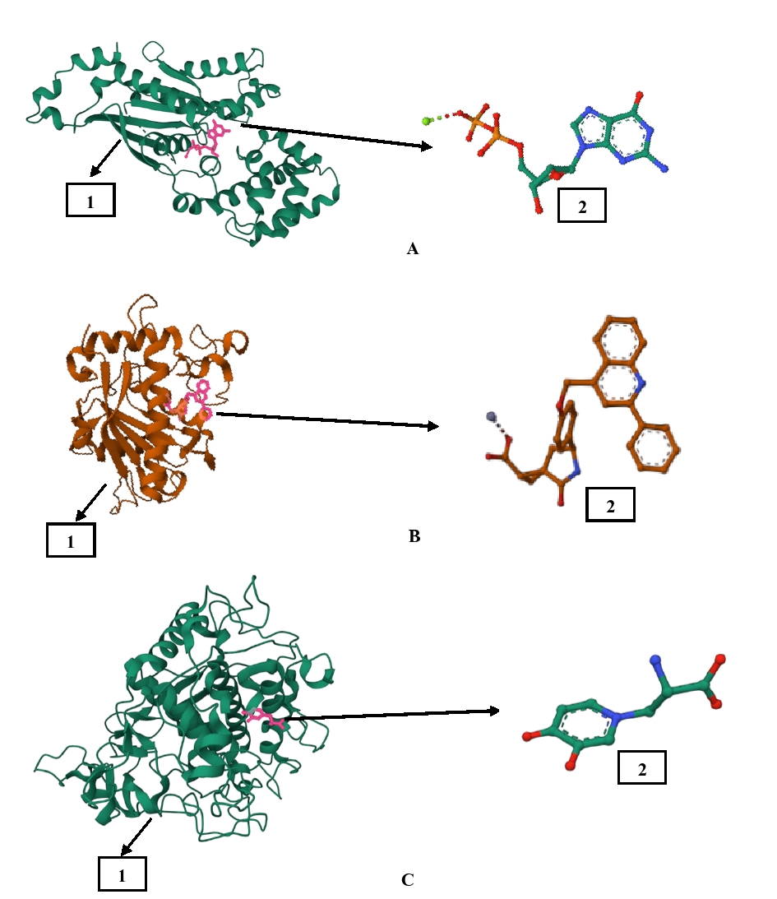
Figure 1. Visualization of elastase (A1) with native ligand 1-{3-methyl-2-[4-(morpholine-4-carbonyl)-benzoylamino]-butyryl}-pyrrolidine-2-carboxylic acid (3,3,4,4,4-pentafluoro-1-isopropyl-2-oxo-butyl)-amide (A2), TNF alpha (B1) with native ligand (1S,3R,6S)-4-oxo-6-{4-[(2-phenylquinolin-4-yl)methoxy]phenyl}-5-azaspiro[2.4]heptane-1-carboxylic acid (B2), and tyrosinase (C1) with native ligand mimosine (C2).

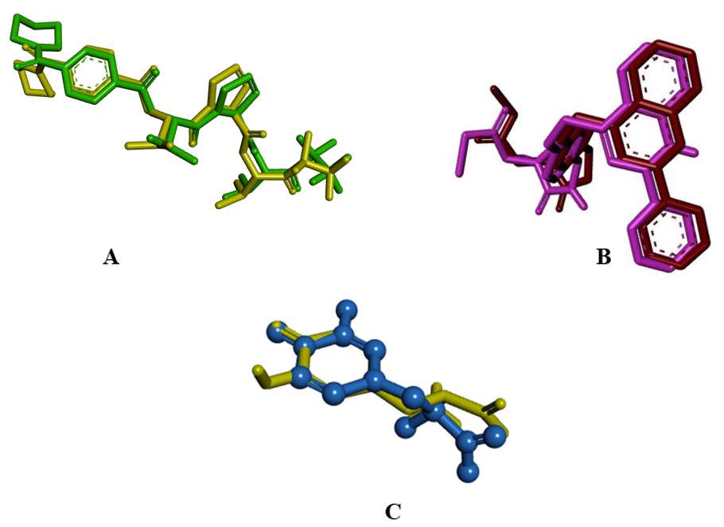
Figure 2. Overlay of ligands copy to native ligands (A) 1-{3-methyl-2-[4-(morpholine-4-carbonyl)-benzoylamino]-butyryl}-pyrrolidine-2-carboxylic acid (3,3,4,4, 4-Penta fluoro-1-isopropyl-2-oxo-butyl)-amide (1B0F), (B) (1S,3R,6S)-4-oxo-6-{4-[(2-phenylquinolin-4-yl)methoxy]phenyl}-5-azaspiro[2.4]heptane-1-carboxylic acid (3EWJ), and Mimosine (5M8N).

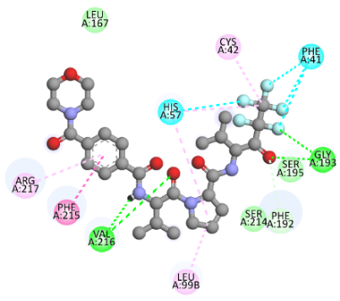
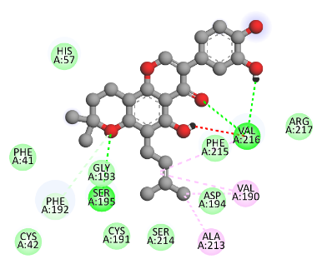
Native Ligan (1B0F) Compound 2 (pomiferin) Compound 4 (mundulone)
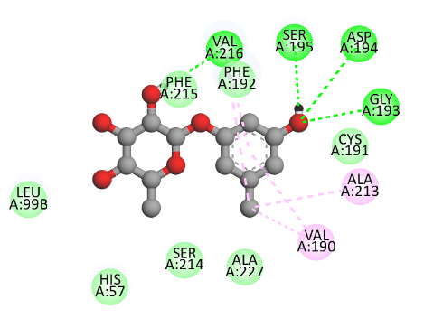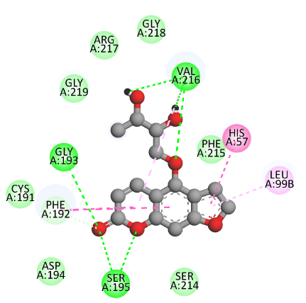

Compound 11 (orcinol glycoside) Compound 29 (aviprin) Compound 38 (monobenzone)

Note: Native ligands interact hydrogen with the amino acids Gly193, Ser195, and Val216. Van der Waals interactions with the amino acids Leu167, Ser214, and Phe192. Pi-pi stacked interactions with Phe215 amino acids. Alkyl/pi-alkyl interactions with Cys42, Leu99b, and Arg217 proteins. Interaction of halogens to the amino acids Phe41 and His57. Generally, compounds 2, 4, 11, 29, and 38 have hydrogen and van der Waals interactions similar to native ligands.
Figure 3. Interaction of native ligand and C. latifolia compound on elastase target protein (1B0F).

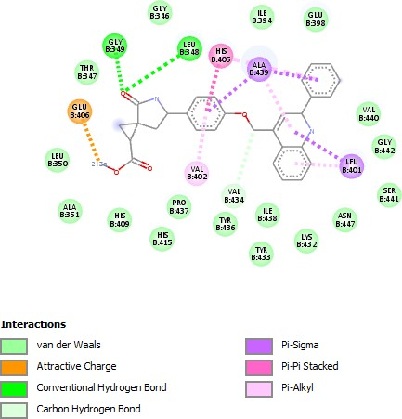
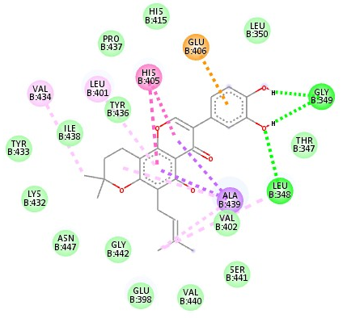

Native Ligan (3EWJ) Compound 2 (pomiferin) Compound 15 (curculigoside C)

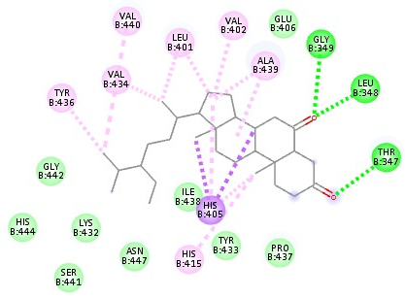
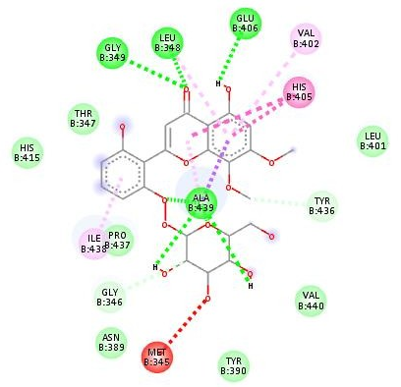
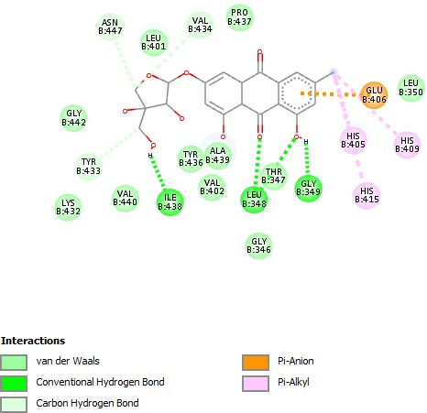

Compound 23 Compound 40 (frangulin B) Compound 42 (stigmastan 3,6 dione)
(5,2,6-Trihydroxy-7,8 dimethoxy-
flavone-2-0-β-D-glucoside)

Note: Native ligands interact hydrogen with amino acid residues Leu348 and Gly349. Van der waals interactions with the amino acids Gly346, Thr347, Leu350, Ala351, Glu398, His415, Tyr433, Val434, Tyr436, Pro437, Ile438, Val440, Ser441, Gly442, and Asn447. Interaction of pi-sigma with the amino acids Ala439 and Leu401. pi-alkyl interactions with the amino acid Val402. Pi-pi stacked interactions with His405 amino acids and attractive charge interactions with Glu406. All compounds have similar hydrogen and van der Waals interactions with amino acid residues with native ligands. Meanwhile, the pi-alkyl interactions with the amino acid residue Val402 only occurred in compounds 15, 23, and 42. Compounds 2 and compound 40 were found to have the same interaction with the amino acid residue Glu406 (attractive charge) as the native ligand. Meanwhile, the pi-sigma interaction with His439 only occurs in compound 2 and has the same interaction with the native ligand.
Figure 4. Interaction of native ligand and C. latifolia compound on TNF-alpha target protein (3EWJ).

Native Ligan (5M8N) Compound 2 (pomiferin) Compound 14 (orcinol glycoside B)

Compound 12 (curculigoside B) Compound 34 (quercetin) Compound 40 (Frangulin B)

Note: Native ligand 5M8N interacts with hydrogen to the amino acid,,
Figure 5. Interaction of native ligand and C. latifolia compound on tyrosinase target protein (5M8N)

