The development of Balqymyz beverage from honey and koumiss

Balgabay Maikanov^{1*}, Laura Auteleyeva¹, Zhuldyz Satayeva², Aigerim Aipova³
¹ Department of Veterinary Sanitation, S. Seifullin Kazakh Agrotechnical University, Nur-Sultan, Republic of Kazakhstan
² Department of Technology of Food and Processing Industries, S. Seifullin Kazakh Agrotechnical University, Nur-Sultan, Republic of Kazakhstan
³Department of Veterinary Sanitation, Ecology, Zoohygiene and Veterinary and Sanitary Expertise, Omsk State Agrarian University named after P.A. Stolypin, Nur-Sultan, Republic of Kazakhstan
*Corresponding author: bal_maikanov@rambler.ru

Abstract
The aim of the study is to develop a health–safe beverage from honey and koumiss – balqymyz, which has beneficial properties due to increased vitaminization and fatty acid content. The proposal can be useful in the post-pandemic period. The paper offers readers a step-by-step guide on preparing the suggested beverage at home. Balqymyz is rich in vitamins A (6.8%), B2 (2.6%), B5 (2.1%), and B6 (5.7%). The physical and chemical attributes of the beverage suggest the high quality and safety of the drink. The proposed production method increased the mean content (in % of total fat content) of oleic, linoleic, ʏ-linolenic and arachidonic acids from 13.589 ± 1.359, 6.531 ± 0.653, 0.158 ± 0.016 and 0.470 ± 0.047% to 14.674 ± 1.467, 6.228 ± 0.623, 0.169 ± 0.017 and 0.729 ± 0.073%, respectively. The content of stearic acid increased to 2.852 ± 0.285%. Other improvements occurred in the amino acid content of glutamic acid (8%), leucine (5%), lysine (4%), and tryptophan (4%). These improvements enhance the sensory characteristics of the beverage and lead to shelf life prolongation by more than 72 hours. Other advantages of balqymyz are naturalness, ease of production, little amount and high quality of ingredients, softer taste compared to koumiss, special aroma, and astringency.
Keywords: koumiss, honey, technology, nutritional value, quality and safety

Introduction
Koumiss, also spelled kumiss, kumys, kımız and qymyz, is a traditional drink of nomadic people in Central Asia. The key ingredient of koumiss is fermented mare’s milk obtained by using lactic acid bacteria and yeast. Mare’s milk undergoes two-stage fermentation − lactic fermentation and alcoholic fermentation. The final products of these fermentations are lactic acid, ethyl alcohol, carbon dioxide and other by-products, such as volatile acids, fusel alcohols and other compounds with a strong and distinctive aroma and taste (Czyżak-Runowska et al., 2018; Kondybayev et al., 2021; Shakirbaev, 2014; Pietrzak-Fiećko et al., 2009).
The COVID-19 pandemic has brought into focus the proactive approaches against viruses. Ibrahim et al. (2020) suggest that increasing use of probiotics and foods from the lactic acid fermentation process may be one of the best ways to strengthen the immune system and prevent viral infection. Other researchers emphasize the potential of mare’s milk as a useful product, pointing out its nutritional value and functional properties (Tang et al., 2020). For instance, it is a rich source of whey proteins and, consequently, essential amino acids (Brezovečki et al., 2014). Due to its health benefits, the producers of mare’s milk may face a rise in demand for this type of product in the global dairy market (Tang et al., 2020).
Historically, nomads have used mare’s milk and related products to recover tuberculosis (Dyakova et al., 2021). Today, the healing properties of koumiss coupled with honey could help people support their lung function (Li et al., 2020). The abundant species of bacteria in koumiss include Lactobacillus helveticus, Lactobacillus kefiranofaciens, Lactococcus lactis, Lactococcus raffinolactis, and Citrobacter freundii. The major yeast species are Dekkera anomala, Kazachstaniaunispora, Meyerozyma caribbica, Pichia sp.BZ159, Kluyveromyces marxianus, and uncultured Guehomyces (Chen et al., 2019).
In vitro and in vivo studies show that fermented milk products, including koumiss, contribute to normal homeostasis (Guo et al., 2019, 2020). The Saccharomyces cerevisiae yeast present in the given beverage was reported to have an antibacterial effect on Escherichia coli, possibly producing an antibacterial compound in metabolism (Chen et al., 2019). Drinking koumiss alleviates hyperlipidemia symptoms thanks to lactic acid bacteria (Lactobacillus and Streptococcus) and metabolites (S-adenosyl-L-methionine, carnosine, lysophosphatidylinositol and dipeptides) present in the beverage (Chen et al., 2019; Hou et al., 2019). In addition, koumiss is a nutrient-dense product with a health-strengthening effect (Mazhitova et al., 2015).
In recent years, many papers have tackled the production of drink mixes with koumiss as a core ingredient (Yelubayeva et al., 2018; Yuldasheva et al., 2020). The present study seeks to explore the combination of koumiss and bee honey, another valuable ingredient with rich composition. Natural honey appears as a nutraceutical product due to its nutritional value and therapeutic benefits. Not only it can speed up the metabolism process, but it also exerts the protective effects on the cardiovascular system, the oral cavity and bones (Afrin et al., 2020). Moreover, it also has favorable hematological and anti-cancer effects (Afrin et al., 2020). Honey can modulate oxidative stress and has anti-proliferative, pro-apoptotic, anti-inflammatory, immune-modulatory and anti-metastatic properties (Samarghandian et al., 2017). According to modern literature, honey can be beneficial for the treatment of various diseases, such as diabetes mellitus, respiratory, gastrointestinal, and cardiovascular diseases, and those of the nervous systems (Ajibola et al., 2012; Zhang et al., 2014).
Previous research shows negative correlations between three functional categories of proteins in the Cluster of Orthologous Group, particularly G, K and S, and the amino acid content of threonine, proline, arginine, lysine, phenylalanine, tyrosine, leucine, isoleucine, serine, and aspartic acid (Wu et al., 2021). Hence, one can conclude that the amino acid content of koumiss depends on the function of bacteria associated with the transport of amino acids and nucleic acids during fermentation (Li et al., 2020; Wu et al., 2021). Other researchers who investigates various honeys from Belarus, Kazakhstan and Poland reported the content of proline ranging from 70.8 to 461.4 mg/kg (Liu et al., 2019). Tyrosine found in honey from the Republic of Kazakhstan (429 mg/kg) was characteristic for honeys harvested in that country. Finally, cystine was present only in linden honey from Poland (0.1 mg/kg). Summarized results confirm the presence and diversity of the free amino acids in honey of different types and origin (Liu et al., 2019). Overall, the main amino acids found in Spanish honeys of five different botanical origins were proline, phenylalanine, tyrosine and lysine, followed by arginine, glutamic acid, histidine and valine (Ranneh et al., 2021). According to previous research, proline, the dominant amino acid in natural honeys, is absent in artificial honeys. In general, the total content of free amino acids was 186.19-921.08 mg/kg in natural honeys, 55.70 mg/kg in the adulterated honey and 15.81 mg/kg in the artificial one. The composition of free amino acids in honey can be a good indicator of their natural origin (Hermosı́n et al., 2003; Porcza et al., 2016).
Before research, we searched the patent database to see if there were any patents for nutritious beverage mix with koumiss and honey published in the past 10 years. The patent search involved just one International Patent Classification (IPC) class. Overall, 20 patents were found. Of those, six were from Russia, 12 were from China, one was from Japan, and one was from the U.S. The search results revealed zero patents for koumiss and honey beverage production issued in the Republic of Kazakhstan (Project name: № AP09562617, 2021).
Today, the Republic of Kazakhstan sees the rise of interest towards national food products. Balqymyz, Bashkir koumiss with honey, is the first drink from high quality, ecologically pure and nutritious domestic ingredients. The production technology of balqymyz enables a product with high biological and nutritional value, which could be useful for the post-COVID care.
The aim of the study is to develop a health–safe beverage from honey and koumiss – balqymyz, which has beneficial properties due to increased vitaminization and fatty acid content. The objectives of the study are to evaluate and select the optimal types and combination of honey and koumiss and to create the intended manufacturing method according to sanitary standards.

Materials and methods
Production methods
Balqymyz (62 samples) was produced experimentally in the Experimental Production Workshop for Milk Processing under the S. Seifullin Kazakh Agrotechnical University (Nur-Sultan). The samples of experimental beverage were formulated using just two ingredients in varying concentrations: koumiss and honey. Overall, there were six types of koumiss (62 samples) and five types of honey (65 samples) used to produce the balqymyz drink. The milk for the drink came from eight mares of the Zhabe breed. The mares were milked manually between May and June. Honeys used in this study involved the Katon Karagai horb honey, Katon Karagai melilot honey, Altai sunflower honey, Altai horb honey and Katon Karagai linden honey. After mixing, all samples of experimental beverage were stored in containers at -8 °C.
All ingredients and the final product underwent comprehensive quality assessment using the standard organoleptic and physicochemical methods. Nutritional value and safety were also estimated. The assessment process was in accordance with the Technical Regulations of the Customs Union on Safety of Milk and Dairy Products (TR CU 033/2013) and Food Safety (TR CU 021/2011).
To extend the shelf life of balqymyz, the technique of treating koumiss with ultrasound proposed by Gladkova (1999) was used. The pasteurization method is not always effective when treating koumiss, because, according to this author, re-detection of lactic acid thermophilic bacteria and bacilli in samples is possible. In addition, koumiss processed from pasteurized milk has an unpleasant greasy taste and lacks carbonation and characteristic odor. According to Gladkova (1999), koumiss samples are treated with ultrasound with a maximum power in the liquid medium (at 70 W and an ultrasound frequency of 900 + 15 MHz). By treating a thin layer of koumiss, it is possible to achieve a 64% reduction in bacterial contamination from the initial one and to bring the content of microorganisms in milk to a minimum of 9–12 thousand in 1 ml.
The pilot batch of balqymyz was produced using the reservoir and thermostatic methods. The technological line consisted of a fine filter, a storage tank for raw materials, a honey tank, a bath with a TMU-50 mixing and kneading jacket and a checkerboard counterflow jacket for cooling, a double-walled storage tank for the beverage, filling and capping equipment, a maturation chamber, and a thermostatic cooling chamber.

Amino acid composition
The experiments took place in five locations between April and September 2021. Those are the Food Safety Laboratory under the Faculty of Veterinary Medicine and Animal Husbandry; Experimental Production Workshop for Milk Processing under the S. Seifullin Kazakh Agrotechnical University (Nur-Sultan); Republican Veterinary Laboratory of the RK Committee for Veterinary Control and Supervision; Center for Sanitary and Epidemiological Expertise under the Medical Center of the Office of the President of the Republic of Kazakhstan; and Nutritest, LLP (Almaty).
The amino acid composition was determined using the high-performance liquid chromatography method according to the MVI.MN 1363-2000 measurement framework for amino acids in foods. For this, a high-performance liquid chromatograph (Water Corporation, USA) was used. The focus was on amino acid standard samples (Sigma-Aldrich), acetonitrile (ultrapure), isopropyl alcohol (extrapure), fluorescein isothiocyanate (FTIC; Sigma-Aldrich), phosphoric acid, and sodium acetate. The content of toxic elements, particularly lead and cadmium, was determined on a TA-Lab voltammetric analyzer (manufacturer: ТА-Lab, Russian Federation; unit of measurement: ТА, titratable acidity) according to GOST 33824-2016. The concentration of arsenic was measured according to GOST 31628-2012.

The organoleptic properties
The organoleptic properties (taste, aroma, color, and consistency) of koumiss were determined according to ST RK 1732-2007, the organoleptic method of quality assessment for milk and dairy products. Acidity was measured through titration (GOST 3624). The density of the beverage was determined with a hydrometer (GOST 3625). The mass fractions of fat and protein were measured using a SibagroPribor device according to MVI 2007.24.01/12. The alcohol content was determined by the pycnometer method using the relative mass of the distillate (GOST 3629). Radionuclides were measured on a АТ1315 Gamma Beta Spectrometer (AtomTech, Belarus) according to ST RK 1623-2007.
The organoleptic analysis of honey samples was in accordance with the GOST 19792-2017 standard. Their consistency was determined with a spatula immersed into the honey at a temperature of +20°C. The water content was measured using the refractometric method according to GOST 31774-2021. The mass fraction of reducing sugars was determined by the colorimetric method according to GOST 32167-2013. The diastasis activity was assessed by the colorimetric measurement of the substrate cleaved under the enzymatic reaction conditions (GOST 34232-2017), with the subsequent calculation of the diastase number. The hydrogen index was determined potentiometrically, whereas the free acidity was estimated by neutralizing free acids with sodium hydroxide solution (GOST 32169-2013). The concentration of mechanical impurities was measured through filtration according to GOST 19792-2017.

The taste testing procedure
The taste testing procedure involved scoring and descriptive methods. The organoleptic assessment of honey was carried out using a 9-point scale, where 9 − excellent; 7 − good; 5 − neutral; 3 − fair; 1 − poor.

Choosing the optimal concentrations of honey and koumiss
The best-tasting samples of honey and koumiss became the core of balqymyz production. The manufacturing process consists of the following steps (Figure 1): receiving the ingredients, preparing honey and koumiss, heating honey, mixing the ingredients, kneading, filling, packaging, aging, cooling, and maturation. Honey concentrations of 5, 7.5, and 10% were studied. The samples are weighed and placed in a container. Afterwards, they are preheated at 55-60 °C. Koumiss from mare’s milk of medium strength (TA, titratable acidity, 81-100 ° T) goes into a container to mix it with honey. The next step is kneading the beverage for 60-80 minutes at 25-26 °C using a liquid shaking device. Once the drink is well-mixed, it is poured into a consumer container, corked and left for 30-60 minutes at 15-20 °C to age and self-carbonate (until the process of vigorous fermentation starts again). After aging, the beverage matures in a cooling chamber at a temperature of 4-6 °C for 12-24 hours to lower the intensity of the fermentation process. Once the required acidity is reached, the final product, balqymyz, is stored at 4 ± 2 °C for more than 72 hours.
[Figure 1 here]
Statistical analysis was performed using Student’s t-test. P values less than 0.05 were considered statistically significant.

Results
The taste testing procedure
To provide a complete description of the novel beverage, its quality was evaluated against multiple parameters. Figures 2, 3 and 4 display evaluation results for balqymyz samples with a varying concentration of honey.
[Figure 2 here]
Among the beverage mixes containing 5% honey, sample 2 scored the highest with a taste score of 9.0 ± 0.1 points (Figure 2), indicating the excellent taste of the product. Samples 1, 3 and 5 were less appealing with a taste score of 5.0 ± 0.1 points each, followed by fair-tasting samples 4 and 6 (taste score, 3.0 ± 0.1 points).
[Figure 3 here]
In the taste test on balqymyz with 7.5% honey (Figure 3), samples 2 and 4 were the most preferred ones due to their excellent taste. These two samples scored an average of 9.0 ± 0.1 points. Other samples were considered less appealing (samples 1, 3, and 5) or fair (sample 6). Their scores were 15.0 ± 0.1 and 3.0 ± 0.1 points, respectively. Beverage mixes containing 10% of honey scored in the range from 3.0 ± 0.1 (fair) to 5.0 ± 0.1 (less appealing) points (Figure 4).
[Figure 4 here]

The organoleptic properties
After the taste tests, all beverage mixes underwent organoleptic, physicochemical, and safety analyses. The results are given in Table 1. As can be seen, the modified production technology gives a better quality of the final drink. For instance, the TA values of the beverage mixes 1 and 2 fell from 97 (koumiss base) to 92.3 and 91.4 °T, respectively. The TA value of sample 3 decreased from 112 to 97.2 °T. Improvements also occurred in AA. The implications include better sensory characteristics and shelf life prolongation by more than 72 hours. Consequently, honey has an inhibitory effect on the formation of free fatty acids and other acidic compounds in the koumiss-based beverage.
Table 1 in the Appendix shows that the beverage obtained had a reduced content of heavy metals and an increased content of vitamins and fatty acids. At least it can be argued that this beverage is unable to cause significant harm to human health. This beverage is no more dangerous than kefir, since it has approximately the same alcohol content. The low level of toxic elements indicates that the prepared honey-containing beverage is safe to use and meets sanitary standards. Balqymyz appears as a frothy, milky white drink of homogeneous consistency and moderate strength, slightly carbonated, with a sour, slightly tart taste, and honey aroma. The taste score of the beverage mix is 9.0 ± 0.1, indicating the excellent taste of the drink. The proposed beverage has the following physical and chemical properties: TA, 92.3 ± 1.9611 °T; AA, 3.7 ± 0.3926; fat content, 1.9 ± 0.2814%; protein content, 3.08 ± 0.3582%; carbohydrate content, 16.2 ± 0.8216%; alcohol content, 1.2 ± 0.2236%; and nutritional value, 94.22 kcal.

Amino acid composition
There are no differences in amino acid composition between koumiss and its honey-containing alternative. Substantial changes were only seen in glutamic acid (8%), leucine (5%), and lysine (4%). The tryptophan content increased by 4%. In our opinion, such an increase is possible due to the increase in carbohydrates and indicates the breakdown of some amino acids. There were tangible changes in the vitamin composition of koumiss and balqymyz. The proposed beverage mix is richer in vitamin A (6.8%), vitamin B2 (2.6%), vitamin B5 (2.1%), and vitamin B6 (5.7%). The vitamin content is provided in % of the norm per 100 g of the product. In addition, balqymyz is slightly higher in stearic acid (2.852 ± 0.285%) and unsaturated fatty acids, particularly oleic acid (13.589 ± 1.359% vs 14.674 ± 1.467%, р ≤0.05), linoleic acid (6.531 ± 0.653% vs 6.228 ± 0.623%, р ≤0.05), ʏ-linolenic acid (0.158 ± 0.016% vs 0.169 ± 0.017%, р ≤0.05), and arachidonic acid (0.470 ± 0.047% vs 0.729 ± 0.073%, р ≤0.05).

Quality assessment and selection of honey
Honeys for balqymyz have different origins (Katon Karagai and Altai) and come in various types (forb, melilot, sunflower and linden) and consistencies. The harvesting periods also differ. Honey samples had liquid consistency and their color ranged from white and light yellow to brown. The only exception was the half-crystallized, creamy sample 4. All honeys exhibited a typical composition, strong aroma, and sweet, pleasant taste without any foreign odor and after-taste. Among the selected honeys, forb samples (Altai) exhibited the lowest content of water (15.8%). Honeys with the highest water content (19.4%) were linden samples (Katon Karagai). The low water levels in honey indicate its maturity. Hence, the lower the water content, the higher the maturity.
Among the selected honeys, forb samples (Katon-Karagai) had the highest diastasis number (14). For comparison, sunflower honeys (Altai) had a diastasis number of 9, the lowest diastasis number found. This value indicates the nutritional value of honey and shows that it contains a high amount of enzymes. The value of acidity depends on the botanical origin of honey, harvesting conditions, and treatment. Linden honeys (Katon-Karagai) had the highest titratable acidity (TA) of 3.6 °T, whereas forb honeys (Katon-Karagai) exerted the lowest TA of 1.2 °T. This finding shows that honey is low in free acids and is less susceptible to change.
The pH value of honey affects the activity of enzymes, which can alter the final taste and aroma of honey after fermentation. According to the Association of Official Analytical Chemists, the pH values of honey range from 3.2 to 4.5; examples are the Algerian, Brazilian, Spanish and Turkish honeys, the pH values of which vary between 3.49 and 4.53, 3.10 and 4.05, 3.63 and 5.01 and 3.67 and 4.57, respectively (Anjos et al., 2017; Azeredo et al., 2003; Kumar, 2019; Ouchemoukh et al., 2007).
The pH value of honey plays an important role in mixing honey with dairy products. Honey samples examined in this study had their pH values with the range of 3.8 and 4.1. These pH values help prolong the shelf life of balqymyz. According to the results of safety analysis, toxic compounds and radionuclides in the examined honeys are within the normal range. Mechanical impurities were not present. The best quality honey with a high taste score and a high safety level was chosen as a second ingredient for the balqymyz formulation. It was the Katon-Karagai forb honey from the East Kazakhstan region.

Discussion
Quality assessment and selection of koumiss
According to the taste-test protocol, all samples of koumiss were encrypted. Based on the taste test results, the best-tasting koumisses were samples 2 and 3 (taste score, 9.0 ± 0.1 points). Samples 1 and 5 were described as less appealing (taste score, 5.0 ± 0.1 points). Finally, samples 4 and 6 tasted scored fair with a score of 3.0 ± 0.1 points. Depending on the duration of the fermentation process, koumiss can be divided into three categories: weak (one day fermentation), average (two-day fermentation), and strong (three-day fermentation). The TA of koumiss varies between these categories: weak, 70 to 80 °T; average, 81 to 100 °T; strong, 101 to 120 °T. The content of alcohol should be below 1.0 (weak), 1.5 (average) and 3.0% (strong) depending on the category. Supplementary Table 1 presents the results from the qualitative analysis of koumiss samples. As can be seen, samples 2 and 5 had the lowest TA values (97 and 93 °T, respectively). In addition, they belong to the average category of koumiss. The tested samples of koumiss also meet the quality requirements stipulated in the national food regulations.
The five types of koumiss selected for the taste tests varied in strength. The best-tasting beverages underwent physico-chemical analysis. The baseline values of pH (3.5), titratable acidity (97 °T), density (1.025 g/cm³), and mass fractions of fat (1.9%) and protein (3.08%) of sample 2 were better than in previous research, indicating the high quality of the drink.
According to previous studies, the pH value of koumiss decreases from 4.63 to 3.30 when exposed to 30-day storage. Meantime, the specific gravity of koumiss decreases from 1.034 to 1.028 g/cm³ (Çelebi et al. 2019). The alcohol content of koumiss from mare’s milk is within the range of 0.7 and 2.6% (Kozhahmetova and Kasenova, 2014; Uniacke-Lowe, 2011; Uniacke-Lowe and Fox, 2012).
One advantage of balqymyz over the existing analogues is naturalness: it does not contain any preservation agents or food additives of chemical origin. Honey softens the bitter taste of koumiss and gives a special aroma and astringency to the drink. The vitamin composition and nutritional value also improved. Another advantage is that the production process does not require other types of milk. In addition, this beverage brings corporate identity.
The present paper offers an intelligible flow chart depicting the steps in the balqymyz production process. The manufacturing technology in question prolongs the shelf life of the beverage. Other authors, Ishemgulov and Ishemgulova (2013), suggest using sodium benzoate for this purpose. However, it can provoke the formation of carcinogenic benzene in products containing vitamin C, such that its final concentration exceeds the maximum permissible level.
The immunomodulatory properties of the resulting product are determined by its components. If honey according to the literature has such properties (Samarghandian et al., 2017), then koumiss, thanks to Saccharomyces cerevisiae has antibacterial properties even before treatment by heating or ultrasound (Chen et al., 2019). Further, after mixing and processing, the resulting product has a reduced content of pathogens, as well as a number of useful substances for strengthening the immune system (amino acids, vitamins). This manifests the immunomodulatory property of the resulting drink.
Based on research results, balqymyz can be recommended for patients who have recently recovered from a lung disease (e.g., tuberculosis, bronchopneumonia, COVID-19-induced lung condition, etc.). Patients should take 100 to 200 ml of this drink, fresh and pre-shacked, three times a day after meals. Patients can make balqymyz themselves by following the steps depicted in the production flow diagram provided in this paper.

Conclusions
The proposed beverage, balqymyz, is a product with a high biological and nutritional value due to the properties of koumiss and honey. This paper offers an improved technology for the manufacture of koumiss-honey beverage mix. The addition of high-grade Kazakh honey resulted in better product composition. The physical and chemical attributes of the drink also improved. Substantial changes occurred in the amino acid content of glutamic acid, leucine, lysine, and tryptophan. The analysis shows an increase in stearic acids and unsaturated fatty acids, particularly oleic, linoleic, ʏ-linolenic, and arachidonic acids.
The advantages of balqymyz are naturalness, ease of production, little amount of ingredients, high quality of ingredients, prolonged shelf life, and softer taste compared to koumiss, special aroma, and astringency. The proposed beverage can be recommended for patients with pulmonary problems during the rehabilitation period and as a thirst-quenching, invigorating alternative to harmful energy drinks, Cola-Cola, Pepsi, beer, and so forth.
This paper not only offers a novel beverage formulation, but it also is the first to give a scientifically grounded recommendation for its intended use. The proposed beverage underwent a series of tests and found application in two rehabilitation centers in the Akmola region (Kazakhstan): Kokshe Regional Rehabilitation Center and Burabay Center for under the Health Department of the Akmola region.
Ethics approval and consent to participate. All methods were performed in accordance with the principles of the Declaration of Helsinki. The study was approved by Local Ethics Committees of S. Seifullin Kazakh Agrotechnical University (Protocol № 7 of 21.11.2021). Informed consent was obtained from all participants.
Consent for publication. Not applicable.
Availability of data and material. The datasets generated during and/or analysed during the current study are not publicly available due to privacy and ethical restrictions but are available from the corresponding author on reasonable request.
Competing interests. The authors declare that they have no competing interests.
Funding. This study is part of the project financed under the Budget Program 217 for Development of the Ministry of Education of the Republic of Kazakhstan in 2021 (AP09562617: Development of the domestic energy, immunomodulation drink ‘BALKYMYZ’).
Authors' contributions. BM conceived and designed the analysis; LA collected the data; ZS contributed data or analysis tools; AA performed the analysis; BM, LA, ZS and AA wrote the paper. All authors read and approved the final manuscript.
Acknowledgements. The S. Seifulin Kazakh Agro Technical University expresses its gratitude to Novolife Company, LLC, the clinic of hydrogen medicine run by Professor Khachatryan, for support during project implementation.

References
Afrin, S., Haneefa, S.M., Fernandez-Cabezudo, M.J., Giampieri, F., Al-Ramadi, B.K., Battino, M., 2020. Therapeutic and preventive properties of honey and its bioactive compounds in cancer: an evidence-based review. Nutr. Res. Rev. 33, 50–76. https://doi.org/10.1017/S0954422419000192
Ajibola, A., Chamunorwa, J.P., Erlwanger, K.H., 2012. Nutraceutical values of natural honey and its contribution to human health and wealth. Nutr. Metab. 9, 1–12. https://doi.org/10.1186/1743-7075-9-61
Anjos, O., Frazão, D., Caldeira, I., 2017. Physicochemical and sensorial characterization of honey spirits. Foods 6, 58. https://doi.org/10.3390/foods6080058
Azeredo, L.D.C., Azeredo, M.A.A., De Souza, S.R., Dutra, V.M.L., 2003. Protein contents and physicochemical properties in honey samples of Apis mellifera of different floral origins. Food Chem. 80, 249–254. https://doi.org/10.1016/S0308-8146(02)00261-3
Brezovečki, A., Čagalj, M., Antunac, N., Mikulec, N., Bendelja Ljoljić, D., 2014. Production, composition and properties of mare’s milk. Mljekarstvo: časopis za unaprjeđenje proizvodnje i prerade mlijeka 64, 217–227. https://doi.org/10.15567/mljekarstvo.2014.0401
Çelebi, M., Şimşek, B., Özkan, M., Acar, O., Özer, E., 2019. Effect of the traditional koumiss yeast produced in Turkey on some properties and carbonyl components of koumiss. Ukr. J. Food Sci. 7, 226–238. https://doi.org/10.24263/2310-1008-2019-7-2-7
Chen, Y., Aorigele, C., Wang, C., Hou, W., Zheng, Y., Simujide, H., 2019. Effects of antibacterial compound of Saccharomyces cerevisiae from koumiss on immune function and caecal microflora of mice challenged with pathogenic Escherichia coli O8. Acta Vet. Brno 88, 233–241. https://doi.org/10.2754/avb201988020233
Czyżak-Runowska, G., Wójtowski, J., Niewiadomska, A., Markiewicz-Keszycka, M., 2018. Quality of fresh and stored mares’ milk. Mljekarstvo: časopis za unaprjeđenje proizvodnje i prerade mlijeka 68, 108–115. https://doi.org/10.15567/mljekarstvo.2018.0204
Dyakova, N.A., Slivkin, A.I., Gaponov, S.P., Bobina, E.A., Shishorina, L.A., 2021. Accumulation of reducing sugars by small-leaved linden flowers (Tilia cordata Miller, 1768) in the Voronezh region of Russia. Drug. Dev. Regist. 10, 147–153. https://doi.org/10.33380/2305-2066-2021-10-4-147-153
Gladkova, E.E., 1999. Scientific and practical aspects of improving the methods of processing mares’ milk and optimizing symbiotic processes in koumiss. PhD diss., Federal State Budgetary Education Institution of Higher Education “Bashkir State Agrarian University”.
Guo, L., Xu, W.L., Li, C.D., Ya, M., Guo, Y.S., Qian, J.P., Zhu, J.J., 2020. Production technology, nutritional, and microbiological investigation of traditionally fermented mare milk (Chigee) from Xilin Gol in China. Food Sci. Nutr. 8: 257–264. https://doi.org/10.1002/fsn3.1298
Guo, L., Ya, M., Guo, Y.S., Xu, W.L., Li, C.D., Sun, J.P., Zhu, J.J., Qian, J.P., 2019. Study of bacterial and fungal community structures in traditional koumiss from Inner Mongolia. J. Dairy Sci. 102: 1972–1984. https://doi.org/10.3168/jds.2018-15155
Hermosı́n, I., Chicon, R.M., Cabezudo, M.D., 2003. Free amino acid composition and botanical origin of honey. Food Chemistry 83: 263–268. https://doi.org/10.1016/S0308-8146(03)00089-X
Hou, Q., Li, C., Liu, Y., Li, W., Chen, Y., Bao, Y., Saqila, W., Zhang, H., Menghe, B., Sun, Z., 2019. Koumiss consumption modulates gut microbiota, increases plasma high density cholesterol, decreases immunoglobulin G and albumin. Food Sci. Nutr. 52: 469–478. https://doi.org/10.1016/j.jff.2018.11.023
Ibrahim, S.A., Gyawali, R., Fidan, H., 2020. Self-defense: a practical approach to combatting COVID-19. Acta Sci. Nutr. Health 4: 33–37.
Ishemgulov, A.M., Ishemgulova, Z.R., 2013. Fermented milk product based on koumiss (Russian Federation Patent No. Patent RU2542970). Federal Service for Intellectual Property. https://patents.google.com/patent/RU2542970C1/ru?oq=RU2542970 (accessed 25 October 2021).
Kondybayev, A., Loiseau, G., Achir, N., Mestres, C., Konuspayeva, G., 2021. Fermented mare milk product (Qymyz, Koumiss). Int. Dairy J. 119: 105065. https://doi.org/10.1016/j.idairyj.2021.105065
Kozhahmetova, Z., Kasenova, G., 2014. Selection of lactic acid bacteria and yeast for koumiss starter and its impact on quality of koumiss. Appl. Technol. Innov. 9: 138–142.
Kumar, R., 2019. Comparison of Honey Quality of Kangra and Bilaspur District of Himachal Pradesh. GRIN Verlag, Munich.
Li, H., Wang, Y., Zhang, T., Li, J., Zhou, Y., Li, H., Yu, J., 2020. Comparison of backslopping and two‐stage fermentation methods for koumiss powder production based on chemical composition and nutritional properties. J. Sci. Food Agric. 100: 1822–1826. https://doi.org/10.1002/jsfa.10220
Liu, W., Wang, J., Zhang, J., Mi, Z., Gesudu, Q., Sun, T., 2019. Dynamic evaluation of the nutritional composition of homemade koumiss from Inner Mongolia during the fermentation process. J. Food Process Preserv. 43: e14022. https://doi.org/10.1111/jfpp.14022
Mazhitova, A.T., Kulmyrzaev, A.A., Ozbekova, Z.E., Bodoshev, A., 2015. Amino acid and fatty acid profile of the mare’s milk produced on Suusamyr pastures of the Kyrgyz Republic during lactation period. Procedia Soc. 195: 2683–2688. https://doi.org/10.1016/j.sbspro.2015.06.479
Ouchemoukh, S., Louaileche, H., Schweitzer, P., 2007. Physicochemical characteristics and pollen spectrum of some Algerian honeys. Food Control 18: 52–58. https://doi.org/10.1016/j.foodcont.2005.08.007
Pietrzak-Fiećko, R., Tomczyński, R., Świstowska, A., Borejszo, Z., Kokoszko, E., Smoczyńska, K., 2009. Effect of mare’s breed on the fatty acid composition of milk fat. Czech J. Anim. Sci. 54: 403–407. https://doi.org/10.17221/1683-CJAS
Porcza, L.M., Simms, C., Chopra, M., 2016. Honey and cancer: current status and future directions. Diseases 4: 30. https://doi.org/10.3390/diseases4040030
Ranneh, Y., Akim, A.M., Hamid, H.A., Khazaai, H., Fadel, A., Zakaria, Z.A., Albujja, M., Bakar, M.F.A., 2021. Honey and its nutritional and anti-inflammatory value. BMC Complement Med. Ther. 21: 1–17. https://doi.org/10.1186/s12906-020-03170-5.
Project name: № AP09562617 «Development of the domestic energy, immunomodulation drink «BALKYMYZ», 2021. Ministry of Agriculture of the Republic of Kazakhstan. https://kazatu.edu.kz/webroot/js/kcfinder/upload/files/%D0%BD%D0%B0%D1%83%D0%BA%D0%B0/%D0%BF%D1%80%D0%BE%D0%B5%D0%BA%D1%82%D1%8B/%D0%9C%D0%B0%D0%B9%D0%BA%D0%B0%D0%BD%D0%BE%D0%B2_%D0%B0%D0%BD%D0%B3%D0%BB.PDF (accessed 25 October 2021).
Samarghandian, S., Farkhondeh, T., Samini, F., 2017. Honey and health: A review of recent clinical research. Pharmacogn. Res. 9: 121–127. https://doi.org/10.4103/0974-8490.204647
Shakirbaev, A., 2014. Koumiss as a national brand. Kazakhstanskaya Pravda (Kazakh Truth). https://www.kazpravda.kz/en/interviews/view/koumiss-as-national-brand (accessed 25 October 2021).
Tang, H., Ma, H., Hou, Q., Li, W., Xu, H., Liu, W., Sun, Z., Haobisi, H., Menghe, B., 2020. Profiling of koumiss microbiota and organic acids and their effects on koumiss taste. BMC Microbiol. 20: 1–11. https://doi.org/10.1186/s12866-020-01773-z
Uniacke-Lowe, T., Fox, P.F., 2012. Equid Milk: Chemistry, Biochemistry and Processing. University College, Cork.
Uniacke-Lowe, T., 2011. Koumiss, in: Fuquay, J.W., Fox, P.F., McSweeney, P.L.H. (Eds.), Encyclopedia of Dairy Sciences, second ed. Academic Press, Cambridge, MA, pp. 512–517.
Wu, Y., Li, Y., Gesudu, Q., Zhang, J., Sun, Z., Halatu, H., Menghe, B., Liu, W., 2021. Bacterial composition and function during fermentation of Mongolia koumiss. Food Sci. Nutr. in press. https://doi.org/10.1002/fsn3.2377
Yelubayeva, M.E., Buralkhiyev, B.A., Tyshchenko, V.I., Terletskiy, V.P., Ussenbekov, Y.S., 2018. Results of Camelus dromedarius and Camelus bactrianus genotyping by Alpha-S -Casein, Kappa-Casein Loci, and DNA fingerprinting. Cytol. Genet. 52: 179–185. https://doi.org/10.3103/S0095452718030040
Yuldasheva, N.K., Gusakova, S.D., Nurullaeva, D.K., Farmanova, N.T., Zakirova, R.P., Kurbanova, E.R., 2020. Neutral lipids of oats fruit (Avena Sativa L.). Drug Dev. Regist. 9: 40–43. https://doi.org/10.33380/2305-2066-2020-9-4-40-43
Zhang, H., Chen, X., Dan, T., Dong, J., 2014. Traditional Chinese fermented dairy foods, in: Lactic Acid Bacteria. Springer, Dordrecht, pp. 493–535. https://doi.org/10.1007/978-94-017-8841-0_8
Tables
Supplementary Table 1. Organoleptic, physico-chemical and safety results of prepared beverages.
Indicator | Balqymyz samples
 | 2 | 3 |  | 4
Organoleptic properties:  - Color & consistency  - Aroma  - Taste | Milky white, homogeneous, not carbonated, without any foreign after-taste and odor
Physical-chemical properties:
Titratable acidity, °Т | 92.3±1.96 | 91.4±1.95 |  | 97.2±2.01
Active acidity, pH | 4.3±0.42 | 4.4±0.42 |  | 3.9±0.40
Density, g/cm³ | 1.025±0.206 | 1.026±0.206 |  | 1.015±0.205
Mass fraction of fat, % | 1.9±0.28 | 1.9±0.28 |  | 1.8±0.27
Mass fraction of protein, % | 3.08±0.35 | 3.08±0.35 |  | 3.68±0.39
Mass fraction of carbohydrates, % | 16.2±0.82 | 16.4±0.82 |  | 16.8±0.83
Mass fraction of alcohol, % | 1.2±0.22 | 2.1±0.29 |  | 2.0±0.28
Radionuclides:
Cesium-137, Bq/kg | 0.00±4.29 | 0.00±4.58 | 0.00±4.37
Strontium-90, Bq/kg | 7.20±26.20 | 29.10±17.60 | 4.50±26.70
Nutritional value, kcal | 94.22 | 95.02 | 98.12

Figure
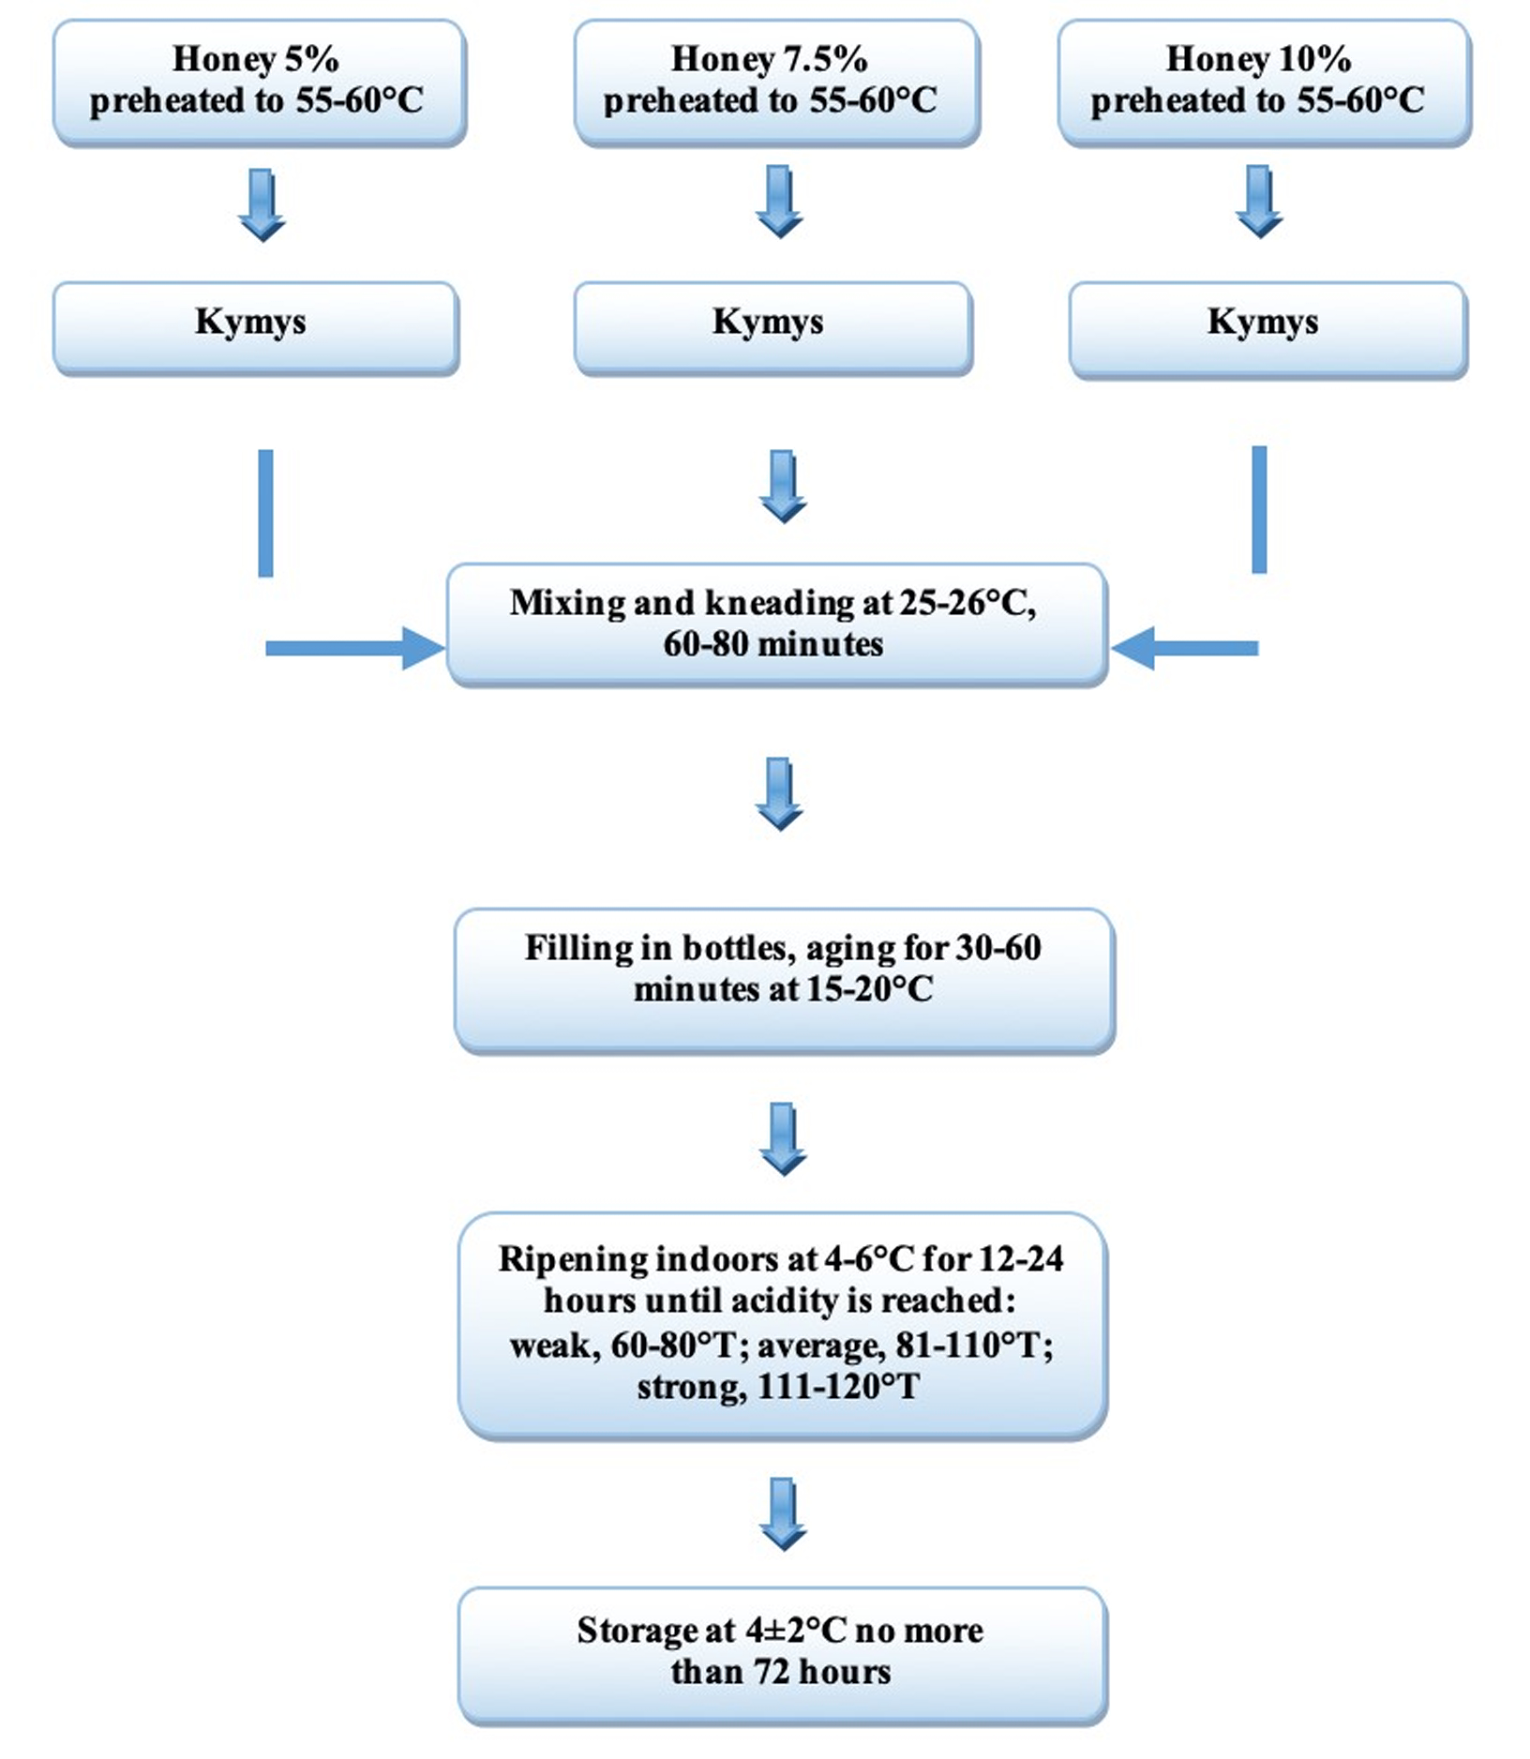
Fig. 1. Flow diagram for the manufacture of balqymyz

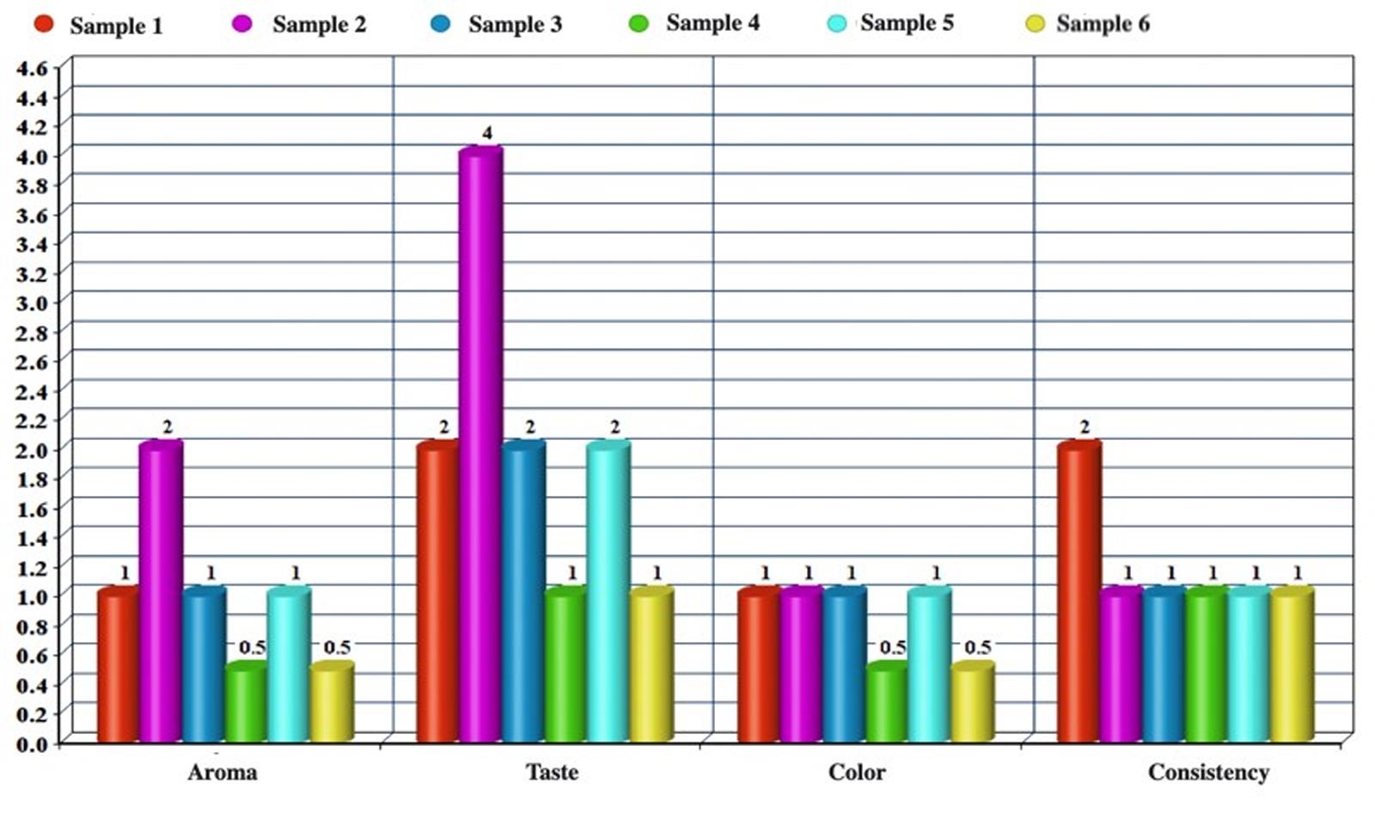
Fig. 2. Balqymyz taste test results (honey concentration, 5%; ρ ≤0.05)

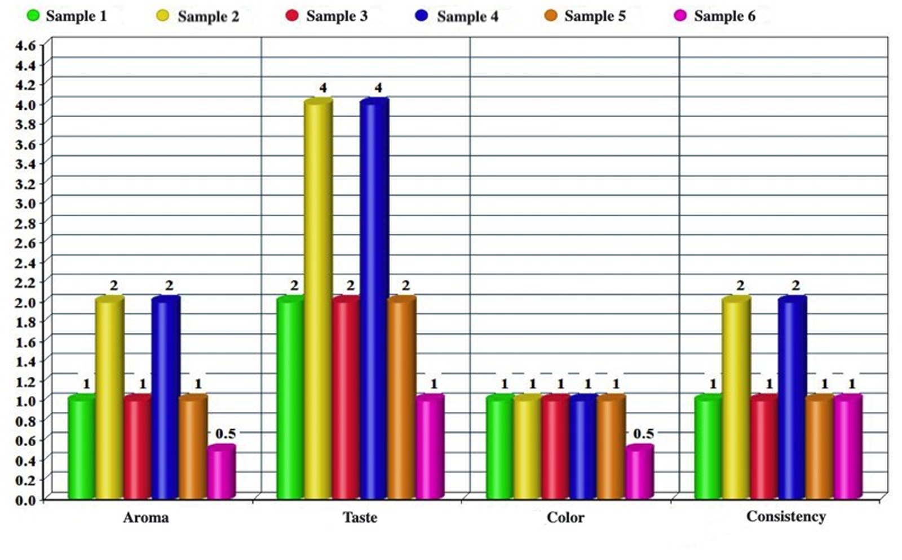
Fig. 3. Balqymyz taste test results (honey concentration, 7.5%; ρ ≤0.05)

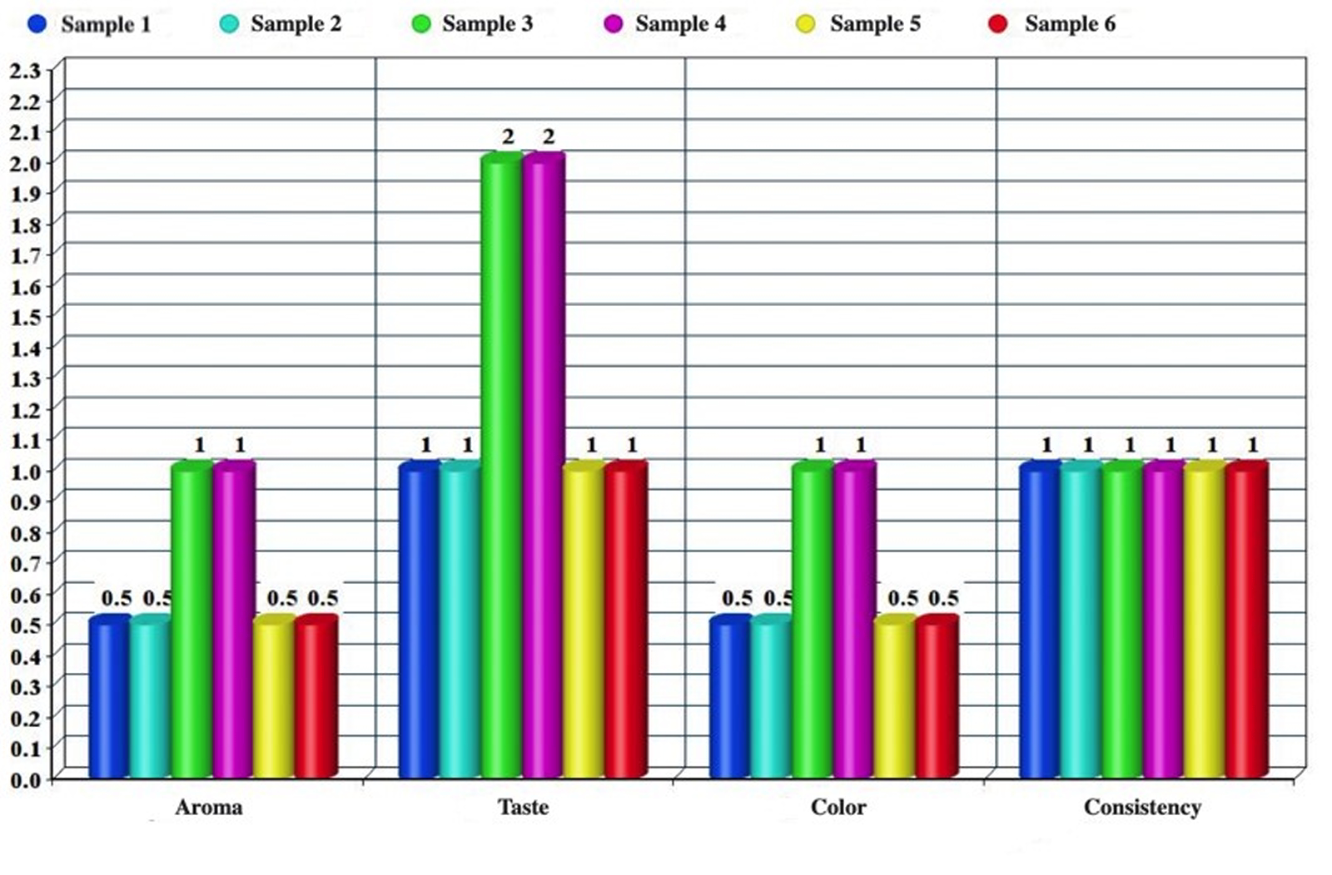
Fig. 4. Balqymyz taste test results (honey concentration, 10%; ρ ≤0.05)

Appendix 1. Tasting questionnaire
Date of tasting – 15.06.2021

Sample №1
Quality indicators | 9  «excellent» | 7  «good» | 5  «less appealing» | 3  «fair» | 1  «poor»
Aroma
Taste
Color
Сonsistence

Sample №2
Quality indicators | 9  «excellent» | 7  «good» | 5  «less appealing» | 3  «fair» | 1  «poor»
Aroma
Taste
Color
Сonsistence

Sample №3
Quality indicators | 9  «excellent» | 7  «good» | 5  «less appealing» | 3  «fair» | 1  «poor»
Aroma
Taste
Color
Сonsistence

Sample №4
Quality indicators | 9  «excellent» | 7  «good» | 5  «less appealing» | 3  «fair» | 1  «poor»
Aroma
Taste
Color
Сonsistence

Sample №5
Quality indicators | 9  «excellent» | 7  «good» | 5  «less appealing» | 3  «fair» | 1  «poor»
Aroma
Taste
Color
Сonsistence

Sample №6
Quality indicators | 9  «excellent» | 7  «good» | 5  «less appealing» | 3  «fair» | 1  «poor»
Aroma
Taste
Color
Сonsistence

