Review article

Non-timber Amazonian forest products and their valuable edible nuts: cutia nut, egg nut, sapucaia nut and Brazil nut

Beatriz de Oliveira Lopes¹, Caroline Correa de Souza Coelho², Aparecida das Graças Claret de Souza³ & Otniel Freitas-Silva^{*4}
¹Graduate Program in Food Science and Technology, Federal Rural University of Rio de Janeiro, Seropédica, Brazil; belopes_@hotmail.com
²The Food and Nutrition Graduated Program (PPGAN), UNIRIO, Rio de Janeiro, Brazil; carolcsc@hotmail.com
³Embrapa Western Amazon. Rodovia AM-010, Km 29, (Manaus / Itacoatiara Road), Mailbox 319, ZIP code: 69010-970, Manaus, Brazil; aparecida.claret@embrapa.br
⁴Embrapa Food Agroindustry, Rio de Janeiro, Brazil; otniel.freitas@embrapa.br

Received_______________; Accepted _______________; Published _______________

Abstract

The Amazon region contains the world’s leading genetic reserve of native plants, with most of the area located in Brazil. This region is rich in species that little known or still unknown by the population at large, including species that produce non-timber forest products (NTFPs) such as edible nuts. The objective was to verify the occurrence of these edible nuts in Brazil, to evaluate their potential and the possibility of other uses, in addition to expanding the knowledge about them. A bibliographic review of the last 50 years was carried out, mainly using the descriptors the popular name and the scientific name of the four nut trees present in the Amazon and their respective families, namely: agouti nut (Acioa edulis Prance) and egg nut (Acioa longipendula Pilg.) From the Chrysobalanaceae family, and sapucaia nut (Lecythis Pisonis Miers) and Brazil nut (Bertholletia excels Bonpl.) From the Lecythidaceae family. The Chrysobalanaceae has 450 species and 17 genera of woody plants and shrubs, producing oilseeds by some species, including egg and agouti nuts. The Lecythidaceae, on the other hand, has approximately 17 genera and 300 species, and in Brazil it is possible to find 9 genera and 122 species, 54 of them endemic, some of which produce edible seeds such as sapucaia and Brazil nuts. Those species have a great nutritional potential but more in-depth research on the subject is necessary, including on other biases for better knowledge of the species, discovery of other potential uses and benefits and, consequently, their valorization.

Keywords: Chrysobalanaceae; Lecythidaceae; Acioa edulis Prance; Acioa longipendula Pilg.; Bertholletia excels; Lecythis pisonis

Introduction

Known as the largest continuous area of tropical forest in the world, the Amazon has great biodiversity of species, both flora and fauna, attracting the attention of researchers who want to understand, the origins, ecology, evolution and processes that maintain diverse communities (Cardoso et al., 2017).
The Brazilian flora, mainly in the middle part of the North region and western portion of the Northeast, has species that are little known and can be used as raw material for various uses (Carvalho, 2008).
Non-timber forest products (NTFPs) can be used and/or sold in modest quantities by local people (Elias & Santos, 2016), enabling the conservation of the forest ecosystem together with economic development (Almeida, Bittencourt, Santos, Eisfeld, & Souza, 2009). These products can be used as basic foods for sustenance and have a wide range of medicinal applications, among others (Wiersum, 2017).
Among the NTFPs of Amazonian origin, some species still need to be studied for their potential of domestication and dissemination, among which species that produce edible nuts stand out: cutia nut (Acioa edulis Prance) and egg nut (Acioa longipendula), both belonging to the Chrysobalanaceae family, and sapucaia nut (Lecythis pisonis) and Brazil nut (Bertholletia excelsa), belonging to the Lecythidaceae family. Of these, only the Brazil nut is widely consumed, in Brazil and internationally.
It is necessary to perform research into native forest species to ascertain their potential to contribute to regional economies, as well as their possible suitability in projects to restore degraded areas. The knowledge gained can be used for the development of concepts for the utilization as crop plants which are aimed at improving nutrition and economical status of local, nature conservation, enable improving of local communities and also identify possible industrial uses (Carvalho, 2008; Leão, Araújo, Shimizu, & Felipe, 2016).
The objective of the article is, through a bibliographic review, to show the agronomic, botanical and economic aspects of four NTFP species from the Amazon that produce edible nuts, stressing the importance of their preservation and possible sustainable use in agroforestry for sale on local and global markets.

Material and Methods

The literature review was carried out by consulting various academic databases available via the internet, among them the Capes Portal, Google Scholar, Science Direct and Scopus.
The main descriptors used in the search were: cutia nut, (Acioa edulis), egg nut, (Acioa longipendula), Chrysobalanaceae, sapucaia nut, (Lecythis pisonis), Brazil nut, (Bertholletia excelsa) and Lecythidaceae.
The documents found were books, articles in scientific journals, and they were not limited as to the date of publication, so the scope was approximately 50 years.

Results and Discussion

With distribution in 9 states (Acre, Amapá, Pará, Roraima, Rondônia, Amazonas, Tocantins, Mato Grosso and part of Maranhão), the Legal Amazon, occupies about 58.9% of the Brazilian territory, corresponding to 5,015,067,749 km² (IBGE - Geociências, 2020), the Amazon has great biodiversity of species, both flora and fauna, and draws the attention of researchers. There is growing global recognition of the deforestation of the Amazon, which is estimated to have lost part of its forest area, raising concern about loss of biodiversity, changes in the hydrological cycle and consequently climate change (Machado, Souza, Sampaio, & Ferraz, 2017).
One of the processes that sustains local Amazon communities is extraction of NTFPs. Ideally, these products can be harvested without changing the structure and function of the forest and degradation of natural resources. When a species participates in a cultivation system, it is no longer considered a NTFP. It should be noted that the use of NTFPs can be part of a strategy for forest conservation and development, in addition to insertion in various social, political, economic, institutional and ecological systems (Elias & Santos, 2016).
The role and importance of NTFPs have been drawing special global attention since the 1990s regarding their potential to reduce deforestation, improve forest conservation and contribute as a means of subsistence. Gradually, it has been recognized that NTFPs can include both wild products obtained from natural forests and products obtained from domesticated forests (Wiersum, 2017).
Over the generations, small farmers have worked to domesticate species for inclusion of trees in agroforestry systems for the production of NTFP, to provide food and other products (e.g., medicinal substances) to meet the daily needs of local people. The term “Cinderella species” appeared in the 90s for species that addressed these needs (Leakey, 2017).
The extraction of NTFPs favors the continuity of populations in their place of origin, helping to maintain various traditional or agro-extractive rural communities that traditionally depend on these products for subsistence. These products, if extracted sustainably, can also supply domestic and foreign markets (Almeida et al., 2009; Pedrozo, Silva, Sato, & Oliveira, 2011).
In the map in Fig. 1 it is possible to observe the distribution in Brazilian territory of the four species of edible nuts. In general, the production of egg nut, cutia nut, and brazil nut is observed only in the Amazon biome, while the Sapucaia nut is observed in the Amazon, Cerrado and Atlantic Forest biome.

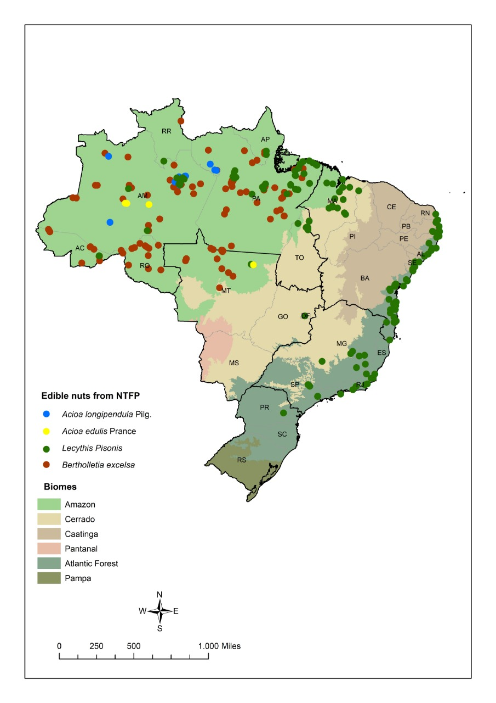

Fig. 1. Map of occurrence of NTFP edible nuts from the Chrysobalanaceae and Lecythidaceae families in Brazil. Source: Authors, created with data obtained from SiBBr (SiBBr, 2020).

The family Chrysobalanaceae, of the order Rosales and superorder Rosiflorae, consists of woody plants and shrubs found in tropical and subtropical regions. It has approximately 530 species divided into 18 genera (7 neotropical genera), with 278 species, of which 107 are endemic to Brazil (CORRÊA, 2013 apud Prance and Sothers, 2010 & Prance, 2007), (Zuque et al., 2004; Feitosa, Xavier & Randau, 2012).
This family is responsible for the production of oilseeds such as: curupira – (Couepia sp), pajura – (Couepia bracteosa Benth.), marirana – (C. subcordata Benth. ex Hook f.), and those studied in this review, tapir nut or egg nut (Couepia longipendula Pilg.) and cutia nut (Couepia edulis Prance) (Pesce, 2009).

Egg nut (Acioa longipendula Pilg.)

According to (Hassler, 2020), egg nut is known by the scientific name Acioa longipendula (Pilg.), with accepted names Sothers & Prance, and synonymous name Couepia longipendula Pilger.
The egg or tapir nut tree can reach up to 30 meters in height with a trunk diameter of 40 to 80 centimeters. The leaf of this tree is characterized, according to (Pesce, 2009) as: “lanceolate to oblong-lanceolate, with acute apex to spit, base wedged to rounded, entire margin; pendulum inflorescence, with long peduncle, flowers with wine-colored bell-shaped chalice.”
It can present two similar seeds with different oil production, the seed from the lower Amazon and the seed from the upper Amazon. The seed from the lower Amazon has an elongated and ovoid core, hard and thick shell, with white nut and not very consistent with a brown film, while the seed of the upper Amazon has brown oil with an unpleasant taste and odor. The seed is generally composed of 78% woody bark and 22% woody nut (PESCE, 2009).
The fruit, as can be seen in Fig. 2-A, can have oval or ellipsoid shape with length from 5 to 8 cm and diameter from 3.5 to 4.5 cm, the shape is like a chicken egg, the origin of its common name. It has a woody and slender mesocarp and pubescent epicarp. The nut is white in color, weighing 4 to 7 grams and 3 to 2 centimeters in diameter (Embrapa Amazônia Ocidental, 2003).
The egg nut has very limited harvest and unknown importance. It is propagated by seeds that cannot be stored for a long period, as they quickly lose viability. Germination can occur in 20 days, and production can reach 300 to 1,000 nuts per year when the tree reaches 20 years of age, but flowering starts between the fourth and fifth year (Embrapa Amazônia Ocidental, 2003).
The main potential uses are for wood production and oil extraction, and the nut can be consumed whole or ground into flour (Embrapa Amazônia Ocidental, 2003).

Cutia nut (Acioa edulis Prance)

The cutia nut has the accepted scientific name Acioa edulis Prance (synonym Couepia edulis (Prance) Prance). The nut was only described scientifically in 1933, and it is considered only to have local importance (Prance, 1975).
The nut tree is present in upland forests of the Amazon. It is endemic to the Amazon region, specifically between the municipalities of Tefé and Coari along the Amazon River (FAO, 1987). It is well adapted to clayey and poor soils in the rainforest, even in areas that normally flood (Leandro, Murta, & Yuyama, 2007; Pessoa et al., 2005).
The tree can reach up to 25 meters in height and 50 cm in diameter at breast height. Its trunk is brown and rough and is rarely straight, presenting small basal sapopemas. The canopy is 12 to 15 m in diameter. The leaves are characterized as oval-elliptical with rounded and accumulated tip and the fruit has a fibrous, dark brown color, thick skin and nuts with a white and oily content that is rich in protein (PESSOA, ASSIS, & BRAZ, 2004).
Flowering between the months of November and February and fruiting between February and March, the cutia nut tree has the capacity to produce more than 200 kg of fruits per year that need a year to mature. After this ripening period, the nuts are collected manually and stored in a dry and ventilated place. Its cultivation is considered primitive (Assis & Pessoa, 2009; Leandro et al., 2007; Pessoa et al., 2005).
The best system for the growth of this species is monoculture. In soils with good conditions, an adult tree can produce 2,400 fruits a year, equivalent to 200 kg, with 38 kg of nuts and 28 kg of oil (FAO, 1987). By using most of the soil during production, a year of good harvest will possibly be followed by a year of little or not production, as the recovery of the soil takes time (PESSOA et al., 2004).
The fruit of the cutia nut tree, as can be seen in Fig. 2-B, is similar to the Brazil nut and produces approximately 73% oil, which is used by local residents as a raw material for homemade soap and in cooking (Assis & Pessoa, 2009; Costa, Bitencourt, & Jorge, 2012; Leandro et al., 2007). The nut is considered very tasty and is consumed by the inhabitants of the region in various ways, such as raw, roasted and ground, often mixed with manioc flour or consumed together with other foods, such as coffee (Assis & Pessoa, 2009; Pessoa et al., 2005).
The presence of a hard shell makes production of nuts on a large scale difficult for sale, so the market is small (Pessoa et al., 2005). In order to extract the nut from the shell it is necessary to associate impact with cutting using adequate tools (PESSOA et al., 2004).

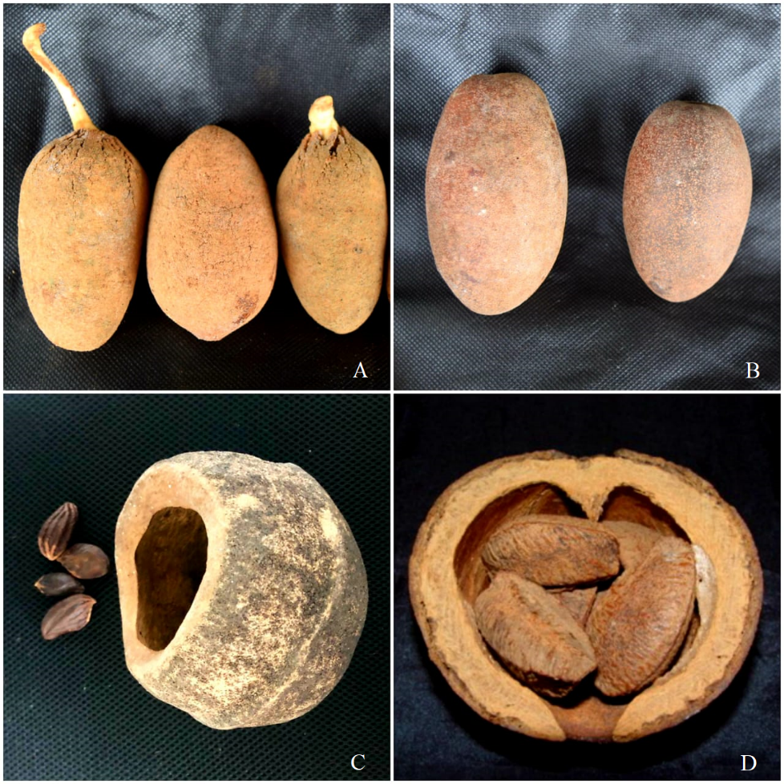

Fig. 2. Edible NTFP nuts in Brazil. Legend: A - Egg nut (Acioa longipendula Pilg.), B - Cutia nut (Acioa edulis Prance), C - Sapucaia nut (Lecythis Pisonis) and D - Brazil nut (Bertholletia excelsa). Source: Authors’ personal photos

With great diversity in Guyana and the Amazon Region, with endemic species also found in the Atlantic Forest biome, the Lecythidaceae, with approximately 17 genera and 300 species, has pantropical distribution. It has five subfamilies: Foetidioideae, Planchonoideae, Napoleonaeoideae, Scytopetaloideae and Lecythidaceae. The subfamily Lecythidaceae only occurs in the Neotropics, with 10 genera and 214 species. In Brazil it is possible to find 9 genera and 122 species, of which 54 are endemic (Matta & Scudeller, 2012).
In the Amazon Basin, the Lecythidaceae family is composed of trees producing the following seeds: sapucaia, sapucaia-açu - (Lecythis usitata Miers = L. pisonis Cambess), Brazil nut – (Bertholletia excelsa Bonpl.), and churu – (Goeldinia riparia Huber. = Allantoma lineata (Mart. & O. Berg) Miers) (Pesce, 2009).

Sapucaia nut (Lecythis usitata Miers = L. pisonis Cambess)

The sapucaia nut tree has several synonymous scientific names, among them: Lecythis amapaensis Ledoux; Lecythis densa Miers; Lecythis paraënsis Huber ex Ducke; Lecythis pisonis subsp. usitata (Miers) S.A.Mori & Prance; and Lecythis usitata Miers.
The genus Lecythis is considered Neotropical, with occurrence from Nicaragua to the state of São Paulo in Brazil, presenting 26 species. First described in 1829 as Lecythis pisonis in the province (now state) of Espírito Santo, it was later called Lecythis usitata, occurring in the province (state) of Pará. When the genus Lecythis was revised, it was concluded that both were the same species, so they were grouped with the oldest name: Lecythis pisonis (Souza et al., 2014).
It has many other popular names, like sapucaia-do-amazonas, sapucaia-grande, sapucaia-verdadeira, marmita-de-macaco, papo de anjo, fruta de cotia, cumbuca-de-macaco, cuia-de-macaco, sapucainha, sapucaí, sapucaiaçu, pau de cachimbo, fruta da lepra, sapucaia, árvore-de-caçamba, árvore-de-cambuca, caçamba-do-mato, sapucaia-branca, sapucaia-de-castanha and sapucaia-de-pilão, among others (Braga, Sousa, Gilberti, & Carvalho, 2007; Souza et al., 2014).
The sapucaia nut tree occurs naturally in almost all the Amazon region, and is also present from the states of Ceará to Rio de Janeiro Atlantic Forest remnants, with two species designations: sapucaia-açu (Lecythis paraensis Huber.) and the common sapucaia (L. usitata Miers.). Both can reach 50 meters in height, with a trunk of 50 to 90 centimeters in diameter (Braga et al., 2007; Carvalho et al., 2012).
The difference between the two species of sapucaia (Lecythis paraensis Huber and L. usitata Miers) it is only in the size of the fruit. Lecythis usitata Miers. has diameter varying from 10 to 13 cm and grows mainly in upland areas (terra firme), while Lecythis paraenses Huber. grows in moist soil and the fruit is 15 to 18 centimeters in diameter (Pesce, 2009).
The leaves are oval with an asymmetric base between 8 to 15 cm long, the flowers are purple and the seeds are spindle-shaped (Carvalho et al., 2012; Pesce, 2009). The wood has a light yellow color (Braga et al., 2007).
The fruit is firmly attached to the branch, and when it is ripe it falls to the ground with the seeds being contained inside a capsule. The tip of the capsule comes off when the fruits are ripe and the seeds are released (Fig. 2 – C), about 30 to 50 in number with soft skin that is easily broken. These have a light brown color, are sweet, fragrant and not very oily (Braga et al., 2007; Pesce, 2009).
The germination of new seeds can take 40 to 70 days. Flowering occurs between September and October and fruiting takes place from June to September and its fruits are large, about 20 centimeters in diameter (capsule), and can be used as containers (Braga et al., 2007). This species has a low natural frequency in forests, being able to bloom anywhere from annually to every 5 years. Therefore, it presents small annual seed production (Bernardes, Gonçalves, Sant’Ana, Alexandre, & Wendling, 2020).
Although the export price of sapucaia nuts is slightly higher than that of Brazil nuts, yearly exports amount to no more than the output of a few hectares. This is one of the reasons why the seed is not transformed into oil, since it is considered rare and expensive (Pesce, 2009).
Regarding their use, the seeds can be eaten raw, boiled or roasted and have a flavor similar to Brazil nuts (Carvalho, 2008).
According to (Souza et al., 2014), the sapucaia wood can be used for the production of door and window frames, toys, tool handles, musical instruments, sculptures, fence posts, pillars, agricultural implements, telephone poles, slats, flooring and etc. It is also used in boat and ship building because it is heavy, compact and strong, and is used for the manufacture of furniture and decorative household items (Braga et al., 2007).

Brazil nut (Bertholletia excelsa Bonpl.)

The Brazil nut tree is classified as a an endangered species according to the last assessment of January 1998 (IUCN Red List, 1998).
The Brazil nut tree (Bertholletia excelsa Bonpl.), has botanical synonyms Bertholletis nobilis Miers and Bertholletia excelss Silva Manso (Souza, Azevedo, Rossi, & Lima, 2008).
It is popularly known in Brazil as: castanha do Pará, castanheira do Brasil, castanha, castanheira da Amazônia, castanheira-verdadeira, castanheira-do-Maranhão, Noz-do-Brasil, castanheira-rosa, amendoeira- da-América and castanha mansa. Besides Brazil nut in English speaking countries, abroad it is known as noce-de-Brasil (Italy), noix du-Bresil (France), paranuss (Germany), and almendro (Colombia) (Souza et al., 2008).
It does not have geographic limits precisely defined in the North region, and in addition to Brazil, it is found in Bolivia and the Guianas. However, the species is native to the Amazon, occurring in the states Amapá, Roraima, Mato Grosso, Acre, Amazonas, Para, Maranhão, Rondônia and northern Goiás (Pesce, 2009; Souza et al., 2008).
It is considered one of the largest trees in the Amazon rainforest. It can reach a height of 50 meters trunk diameter at the base of 2 meters or more. It produces cream-colored flowers and globose-like, woody and indehiscent fruits (OLIVEIRA, 2018). A Brazil nut (Fig. 2-D) can weigh 5 to 20 grams with approximately 28% moisture, being composed of woody bark and nut in equal proportions (Pesce, 2009).
A tree can reach an age between 361 and 401 years. Fruit production can start between 73 and 93 years, with a maximum production reached at 240 years. Its fruits can take up to 14 months to mature after flowering, which usually occurs in November. Each fruit has the capacity to produce an average of 125 liters of nuts, and the capsules fall to the ground when ripe. They are 10 to 15 centimeters in diameter and the bark is woody and very hard. Inside, each one contains 12 to 22 nuts (Pesce, 2009).
Nut harvesting is an important activity to generate income for traditional communities and for the maintenance and conservation of the forest, so it is an activity advocated for environmental protection (Sousa Silva, Meneghetti, Pinheiro, Santos, & Parintins, 2019). The harvest period lasts from 5 to 6 months, and is carried out in conditions generally considered inadequate (Pesce, 2009).
For export, the nuts are transported to markets in Belém and Manaus, from where they are shipped in bulk by sea (Pesce, 2009). The nuts are produced only by extractivism, which favors price fluctuation, being the only product in the nut and almond sector that is not produced by cultivation (Brose, 2016).
The Brazilian production of Brazil nuts is concentrated in the states of the North region and in the state of Mato Grosso. In 2015, the state of Acre presented the highest production of nuts, with 8,742 tons, ahead of Pará with a production of 6,866 tons. In 2016, according to data from the Brazilian Institute of Geography and Statistics (IBGE), Brazil nut production decreased by 14.7%, reaching 34,664 tons, with the state of Amazonas responsible for 14,945 tons, with an estimated production value of approximately US $ 20.54 million. Climate problems such as lack of rain are the main cause of reduced productivity (IBGE, 2016).
The states with the highest production during the period 2011 to 2017 were Acre and Amazonas, which together represented more than 60% of national production. The great demand from the world market and the increase in domestic consumption are factors that generate income for extractive communities (Silva et al., 2019).
Brazil nuts are one of Brazil’s products with the longest demand in the European market. One of the oldest reports was by Cristóvão de Lisboa, a Franciscan friar, in the 17th century, describing the production and botanical aspects of the fruits and nuts along with their commercial exploitation. However, the nuts were already marketed before that. In the 18th century, the nuts were widely sold, but only after 1920 did they become the country’s main extractivism product (Silva et al., 2019).
The nuts are widely consumed, especially during holidays such as Thanksgiving and Christmas, in addition to consumption as ingredients in sweets and chocolates. In recent years, demand has increased for use in cosmetics and pharmaceuticals (Brose, 2016; Silva et al., 2019).
The trees are estimated to cover approximately 1.5 million hectares, with total production of 54 million liters or 34 thousand tons of nuts with the shell (Silva et al., 2019).
The United States is the main importer of the nuts, with about 45,000 tons annually, generating approximately US $ 33 million. Therefore, for the Amazon region, the collection and export is an important activity (Yang, 2009).
The export of Brazil nuts today is from trees growing on 700 thousand hectares between Belém and Manaus (the two major cities in the Brazilian Amazon), compared to the year 1850, when trees from only 30 thousand hectares were exploited. Although nuts from Bolivia and Acre are more sought after by industry due to their smaller size, which facilitates the shelling process, those from Manaus are more appreciated because they are larger (Pesce, 2009).
The historical revenue generated by Brazil nut commerce has varied greatly due to influences such as the two World Wars. Currently the annual revenue is about USD 150 million (Brose, 2016; Pesce, 2009).
Considered as one of the most valuable plants for NTFPs in the Amazon, the Brazil nut is the extractive plant product with the greatest food, social, economic and ecological importance in the Amazon. They are sold both shelled and unshelled as well as ground and dehydrated for better conservation. There has been little technological evolution for processing the nuts (Silva, Ascheri, & Souza, 2010).
The oil has high quality and is pleasant to the taste and smell, making it attractive in the food and cosmetics industries. The fruits and the capsule, can be used as fuel and like handmade products (MAPA, 2014). The nuts can be consumed plain or as an ingredient in other preparations such as sweets, protein supplements, milk, diet drinks, bread, confectioneries, porridges, flour and ice cream, generating income for rural and urban workers (OLIVEIRA, 2018).
The table below summarizes the relevant aspects of the nuts:
Tab.1: Main characteristics of NTFP edible nuts from Chrysobalanaceae and Lecythidaceae in Brazil.

Scientific name | Popular name | Occurrence | Production Data | Potential Uses | References
Acioa edulis Prance | Cutia Nut | It is native to Brazil, originating in the western Amazon rainforest.⁶ | Adult trees can produce more than 200 kg of fruit per year.³ | The oil can be used for cooking and as a raw material for soap production by the local community. In addition, the nuts can be eaten roasted.³ | (Leandro et al., 2007)³; (Assis & Pessoa, 2009)⁶
Acioa longipendula Pilg. | Egg nut | Endemic to Brazil, especially the central Amazon region around Manaus.¹⁰ | The estimated annual production is 300 to 1000 nuts from trees that are around 2 years old.⁵ | Wood can be used and oil from the seeds can be extracted. The nuts can be eaten roasted, ground, raw or associated with other foods.⁵ | (Embrapa Amazônia Ocidental, 2003)⁵; (FAO, 1987)¹⁰
Lecythis pisonis | Sapucaia nut | Distributed in the Amazon region and in remnant Atlantic Forest areas.¹ It can be found in the North, in low-density forests and in Cerrado biome areas. It occurs from Rio de Janeiro to Ceará.² | It has an annual production with a price slightly higher than Brazil nuts. Each fruit (capsule) has 30 to 50 seeds.⁹ | Can be eaten raw, baked or boiled, inserted as ingredients in sweets or savory preparations ⁴ | (Demoliner et al., 2018)¹, (Carvalho, 2008)²; (Carvalho et al., 2012)⁴; (Pesce, 2009)⁹
Bertholletia excelsa | Brazil nut | Present in practically the entire Amazon rainforest in Brazil and in the countries that border it.⁷ | National production in 2016 reached 34664 tons with a reduction of 14.7%, when compared to the previous year. The production value is estimated at US $ 20.54 million.⁸ | Besides food, it can be used in various products such as cosmetics and pharmaceuticals. The bagasse can be used for animal feed, bark as fuel, capsules for handcrafts, and wood for civil construction.⁷ | (Ministério do Meio Ambiente - Brasil, 2017)⁷; (IBGE, 2016)⁸

In recent years, several types of Brazilian seeds and nuts have been studied especially in the Amazon area, and most have presented bioactive compounds with functional potential. Even so, some native species, as they are little known and of limited economic importance have not yet been submitted to any study (Teixeira, Ávila, Silveira, Ribani, & Ribani, 2018), such as the case of the egg nut shown in Table 2, in which data of its qualitative importance and nutritional value were not reported in the literature.
Another example of edible nut is the Brazil nut, which is consumed worldwide and is considered a food source of Selenium (Table 2), a potent antioxidant, which is considered an essential nutrient for humans, as it would be associated with minimizing some pathologies. (OLIVEIRA, 2018; SILVA JUNIOR et al., 2017). Brazil nuts have several possibilities of use, and have great commercial value, which is an alternative income for forest peoples with potential for community organization, generation of work and income, which allows families to settle in the territory and consequently the preservation of the Amazon biome (Freitas-Silva & Venâncio, 2011; MAPA, 2014).
Therefore, if Brazil nuts have this importance, it is of interest to cover this vision for other non-wood forest products, such as cutia, egg and sapucaia nuts, unknown edible nuts that present a risk of disappearance, before their extensive benefits on health and nutrition are known. Thus, in Table 2, it is possible to observe some nutritional and quality aspects of chestnuts occurring in the Amazon biome.
Tab. 2: Nutritional and quality aspects of edible nuts from the Brazilian Amazon

Nuts | Nutritional value | Quality features | References
Cutia Nut (Acioa edulis Prance) | It consists of 74.1% oil, 16.6% protein, 3.6 water and 2.7% nitrogen.¹ | The oil is characterized as odorless and clear. In addition to being considered dry, due to its iodine content.¹ | ¹(PESSOA, ASSS, & BRAZ, 2004).
Egg Nut (Acioa longipendula Pilg.) | It has 75% oil and the oil extraction residue is characterized by 32.5% protein, 10.6% fiber and 8.3% ash.² | - | ²(Embrapa Amazônia Ocidental, 2003).
Sapucaia Nut (Lecythis pisonis) | The composition of the nuts may vary. Therefore, carbohydrates range from 5 to 11%, proteins range from 18 to 26% and lipids from 51 to 64%, with linoleic acid being the most prevalent.³ | Nut Considered easier to digest than Brazil nut, it flavor has a sweet characteristic.³ | ³(Teixeira et al., 2018)
Brazil Nut (Bertholletia excelsa) | It has a high content of lipids ranging from 60 to 70% and 15 to 20% of proteins. Rich in selenium, being considered the main mineral.⁴ | It has great commercial value with several possibilities of use. Known for combating cell aging, preventing the development of tumors and neurodegenerative diseases, used to treat malnutrition and anemia.⁵ | ⁴(Bitencourt, 2020); ⁵(MAPA, 2014).

The benefits to local populations are related to the sustainable management of forest resources, to maintain the structure and functionality of the forest, and consequently the conservation of ecosystems. NTFPs contribute to the conservation of biological diversity and provide subsistence for local communities simultaneously (Elias & Santos, 2016). Therefore, the increased demand for NTFPs can encourage reforestation of degraded areas, including reintroduction of native species (Wiersum, 2017).

Conclusion

Further research on the subject is necessary, to obtain better knowledge of species, including an exhaustive investigation on the potential health benefits posed by all nuts. Of the four nut species covered, the Brazil nut is the best known and most widely consumed. However, because cultivation of the trees is uneconomic, the species is considered to be endangered (IUCN, 2020). The other three species are little known to the general public, but are used regionally, and are also at risk of disappearance, due to burning in the Amazon and the lack of a large repository project for these species. These problems require political intervention to promote sustainable local agroforestry.

Acknowledgements

We are grateful for financial support provided by the Rio de Janeiro State Research Foundation (FAPERJ) (project E-26.202749/2018) and to the National Council for Scientific and Technological Development (CNPq) (project 311936/2018-0).

References

Almeida, A. N. de, Bittencourt, A. M., Santos, A. J. dos, Eisfeld, C. de L., & Souza, V. S. de. (2009). Evolução da produção e preço dos principais produtos florestais não madeireiros extrativos do Brasil. Cerne, 15(3), 282–287.
Assis, O. B. G., & Pessoa, J. D. C. (2009). An evaluation of fibrous structure and physical characteristics of Cutia nut (Couepia edulis Prance) shell. Acta Amazonica, 39(4), 981–986. https://doi.org/10.1590/s0044-59672009000400027
Bernardes, V. P., Gonçalves, E. de O., Sant’Ana, B. T., Alexandre, R. S., & Wendling, I. (2020). Vegetative Rescue and Clonal Propagation of Lecythis Pisonis Cambess. Floresta e Ambiente, 27(4), 4–11. https://doi.org/10.1590/2179-8087.026118
Bitencourt, M. A. F. (2020). Isotermas de dessorção, secagem e caracterização nutricional das amêndoas das Castanha-do-Brasil da Região Amazônica. Instituto Federal de Educação, Ciência e Tecnologia – Campus Rio Verde; Pró-Reitoria de Pesquisa, Pós-Graduação e Inovação; Programa de Pós-Graduação Em Ciências Tecnologia de Alimentos, 63.
Braga, L. F., Sousa, M. P., Gilberti, S., & Carvalho, M. A. C. de. (2007). Caracterização morfométrica de sementes de castanha de sapucaia (Lecythis pisonis Cambess. - Lecythidaceae). Revista de Ciências Agro-Ambientais, 5(1), 111–116.
Brose, M. E. (2016). Cadeias produtivas sustentáveis no desenvolvimento territorial: a castanha na Bolívia e no Acre, Brasil. Interações (Campo Grande), 17(1), 77–86. https://doi.org/10.20435/1518-70122016108
Cardoso, D., Särkinen, T., Alexander, S., Amorim, A. M., Bittrich, V., Celis, M., … Forzza, R. C. (2017). Amazon plant diversity revealed by a taxonomically verified species list. Proceedings of the National Academy of Sciences of the United States of America, 114(40), 10695–10700. https://doi.org/10.1073/pnas.1706756114
Carvalho, M. G. de. (2008). Barras de cereais com amêndoas de chichá, sapucaia e castanha-do-gurguéia, complementadas com casca de abacaxi. (Universidade Federal do Ceará). https://doi.org/10.1016/j.cell.2009.01.043
Corrêa, M. M. (2013). Morfoanatomia foliar de Chrysobalanaceae R. Br. da Reserva Florestal Adolpho Ducke. Programa de Pós-Graduação Em Diversidade Biológica – PPG/DB, 78.
Costa, T., Bitencourt, T., & Jorge, N. (2012). Caracterização e compostos bioativos do óleo da castanha de cotia (Couepia edulis). Revista Instituto Adolfo Lutz, 71(1), 61–68.
da Silva, R. F., Ascheri, J. L. R., & de Souza, J. M. L. (2010). Influência do processo de beneficiamento na qualidade de amêndoas de castanha-do-Brasil. Ciencia e Agrotecnologia, 34(2), 445–450. https://doi.org/10.1590/s1413-70542010000200025
de Carvalho, I. M. M., Queirós, L. D., Brito, L. F., Santos, F. A., Bandeira, A. V. M., de Souza, A. L., & de Queiroz, J. H. (2012). Caracterização química da castanha de sapucaia (Lecythis pisonis Cambess.) da região da zona da mata mineira. Bioscience Journal, 28(6), 971–977.
Demoliner, F., de Britto Policarpi, P., Ramos, J. C., Bascuñan, V. L. A. F., Ferrari, R. A., Jachmanián, I., … Block, J. M. (2018). Sapucaia nut (Lecythis pisonis Cambess) and its by-products: A promising and underutilized source of bioactive compounds. Part I: Nutritional composition and lipid profile. Food Research International, 108(October 2017), 27–34. https://doi.org/10.1016/j.foodres.2018.03.028
Elias, G. A., & Santos, R. dos. (2016). Non-timber forest products and sustainable exploration potential in a tropical rain forest in Santa Catarina State, Brazil. Ciencia Florestal, 26(1), 249–262. https://doi.org/10.5902/1980509821117
Embrapa Amazônia Ocidental. (2003). Fruteiras Nativas da Amazônia - II. Empresa Brasileira de Pesquisa Agropecuária, Embrapa Amazônia Ocidental - MAPA, (92), 29–30.
FAO. (1987). Especies forestales productoras de frutas y otros alimentos 3. Ejemplos de America Latina. In S. de D. de R. F. D. de R. F. D. de Montes (Ed.), Organlzaclon de las Naciones Unidas para la Agricultura y la Alimentaclón.
Feitosa, E. A., Xavier, H. S., & Randau, K. P. (2012). Chrysobalanaceae: Traditional uses, phytochemistry and pharmacology. Brazilian Journal of Pharmacognosy, 22(5), 1181–1186. https://doi.org/10.1590/S0102-695X2012005000080
Freitas-Silva, O., & Venâncio, A. (2011). Brazil nuts: Benefits and risks associated with contamination by fungi and mycotoxins. Food Research International, 44(5), 1434–1440. https://doi.org/10.1016/j.foodres.2011.02.047
Hassler, M. (2020). World Plants: World Plants: Synonymic Checklists of the Vascular Plants of the World (version Nov 2018). In: Species 2000 & ITIS Catalogue of Life. Retrieved April 16, 2020, from IUCN Red List of Threatened Species website: www.iucnredlist.org
IBGE. (2016). Produção da extração vegetal e da silvicultura. Instituto Brasileiro de Geografia e Estatística., 31, 1–54. Retrieved from http://www.sidra.ibge.gov.br/bda/pesquisas/pevs/default.asp.
IBGE - Geociências. (2020). IBGE atualiza Mapa da Amazônia Legal. Retrieved September 10, 2020, from https://agenciadenoticias.ibge.gov.br/agencia-sala-de-imprensa/2013-agencia-de-noticias/releases/28089-ibge-atualiza-mapa-da-amazonia-legal
IUCN Red List. (1998). IUCN Red List of Threatened Species. Retrieved April 16, 2020, from www.iucnredlist.org
Leakey, R. R. B. (2017). Agroforestry Tree Products (AFTPs): Targeting Poverty Reduction and Enhanced Livelihoods. Multifunctional Agriculture, 123–138. https://doi.org/10.1016/B978-0-12-805356-0.00013-1
Leandro, R. C., Murta, G. C., & Yuyama, K. (2007). Produção de mudas de castanha de cutia (Couepia edulis Prance ) utilizando ácido naftaleno acético. Revista Brasileira de Biociências, 5(1), 87–89.
Leão, N. V. M., Araújo, E. A. A., Shimizu, E. S. C., & Felipe, S. H. S. (2016). Características biométricas e massa de frutos e sementes de Lecythis pisonis Cambess. Enciclopédia Biosfera, Centro Científico Conhecer, 13(24), 167–175. https://doi.org/10.18677/EnciBio
Machado, M. R., Souza, R. C. de, Sampaio, P. de T. B., & Ferraz, J. B. S. (2017). Aspectos Silviculturais da Castanha-do-Brasil (Bertholletia excelsa Humb. e Bonpl.). Biotaamazonia, 7(3), 41–44. https://doi.org/10.18561/2179-5746
MAPA. (2014). Castanha-do-Brasil: Boas Práticas para o extrativismo sustentável orgânico. Cadernos de Boas Práticas Para o Extrativismo Sustentável Orgânico Da Castanha-Do-Brasil, 1, 43.
Matta, L. B. V., & Scudeller, V. V. (2012). Lecythidaceae Poit. in the Tupé sustainable development reserve, Manaus, Brazil. Brazilian Journal of Botany, 35(2), 195–217. https://doi.org/10.1590/s1806-99592012000200008
Ministério do Meio Ambiente - Brasil. (2017). Castanha-do-brasil: Boas práticas para o extrativismo sustentável orgânico. Caderno Do Agente de Assistência Técnica e Extensão Rural, 55.
OLIVEIRA, J. M. DE. (2018). Cinética de decomposição do ozônio, efeito fungicida e na qualidade de Castanha-do-Brasil (Bertholletia excelsa H.B.K.). Programa de Pós-Graduação Em Agronomia; Faculdade de Agronomia e Medicina Veterinária Cinética, 75.
Pedrozo, E. Á., Silva, T. N. da, Sato, S. A. da S., & Oliveira, N. D. A. de. (2011). Produtos Florestais Não Madeiráveis (PFNMS): as Filières do Açaí e da Castanha da Amazônia. Revista de Administração e Negócios Da Amazônia, 3(2), 88–112.
Pesce, C. (2009). Oleaginosas da Amazônia. In Museu Paraense Emílio Goeldi - Núcleo de Estudos Agrários e Desenvolvimento Rural (2ª edição). Belém.
PESSOA, J. D. C., ASSIS, O. B. G. DE, & BRAZ, D. C. (2004). Caracterização morfomecânica para beneficiamento do fruto da castanha-de-cutia (Couepia edulis). Revista Brasileira Frutic, 103–106.
Pessoa, J. D. C., Leeuwen, J. Van, Assis, O. B. G. de, Braz, D. C., Gomes, J. I., Silva, S. E. L. da, & Kanno, S. S. (2005). Contribuições da Pesquisa para o Beneficiamento da Castanha-de-Cutia (Couepia edulis Prance) e Aproveitamento de seus Resíduos. Embrapa Documentos, 18.
Prance, G. T. (1975). The correct name for Castanha de cutia (Couepia edulis (Prance) Prance - Chrysobalanaceae). Acta Amazonica, 5(2), 143–145. https://doi.org/10.1590/1809-43921975052143
sibbr. (2020). Dados Cartográficos, Google. Retrieved April 26, 2020, from Sistema de Informação sobre a Biodiversidade Brasileira website: https://www.sibbr.gov.br/
Silva Junior, E. C., Wadt, L. H. O., Silva, K. E., Lima, R. M. B., Batista, K. D., Guedes, M. C., … Guilherme, L. R. G. (2017). Natural variation of selenium in Brazil nuts and soils from the Amazon region. Chemosphere, 188, 650–658. https://doi.org/10.1016/j.chemosphere.2017.08.158
Silva, L. de J. de S., Meneghetti, G. A., Pinheiro, J. O. C., Santos, E. M. dos, & Parintins, D. M. (2019). O Extrativismo como elemento de desenvolvimento e sustentabilidade na Amazônia: Um estudo a partir das Comunidades Coletoras de Castanha-Do-Brasil em Tefé, AM. Revista Destaques Acadêmicos, 11(2), 168–187. https://doi.org/10.22410/issn.2176-3070.v11i2a2019.2271
Souza, A. S. de, Margalho, L., Prance, G. T., Gurgel, E. S. C., Gomes, J. I., Carvalho, L. T. de, & Martins-da-Silva, R. C. V. (2014). Conhecendo Espécies de Plantas da Amazônia: Sapucaia (Lecythis pisonis Cambess. – Lecythidaceae). In Comunicado Técnico, 250 - Embrapa Amazônia Oriental. Belém, PA.
Souza, C. R. de, Azevedo, C. P. de, Rossi, L. M. B., & Lima, R. M. B. de. (2008). Castanha-do-Brasil (Bertholletia excelsa Humb. & Bonpl.). Documentos 60, Embrapa Amazõnia Ocidental, (1517–3135).
Teixeira, G. L., Ávila, S., Silveira, J. L. M., Ribani, M., & Ribani, R. H. (2018). Chemical, thermal and rheological properties and stability of sapucaia (Lecythis pisonis) nut oils: A potential source of vegetable oil in industry. Journal of Thermal Analysis and Calorimetry, 131(3), 2105–2121. https://doi.org/10.1007/s10973-017-6742-1
Wiersum, K. F. (2017). New Interest in Wild Forest Products in Europe as an Expression of Biocultural Dynamics. Human Ecology, 45(6), 787–794. https://doi.org/10.1007/s10745-017-9949-7
Yang, J. (2009). Brazil nuts and associated health benefits: A review. LWT - Food Science and Technology, 42(10), 1573–1580. https://doi.org/10.1016/j.lwt.2009.05.019
Zuque, A. L. F., Watanabe, E. S., Ferreira, A. M. T., Arruda, A. L. A., Resende, U. M., Bueno, N. R., & Castilho, R. O. (2004). Avaliação das atividades antioxidante, antimicrobiana e citotóxica de Couepia grandiflora Benth. (Chrysobalanaceae). Revista Brasileira de Farmacognosia, Vol. 14, pp. 129–136. https://doi.org/10.1590/s0102-695x2004000200006

