Original Research Article
Chlorophyll Fluorescence as an Indicator for The Performance of Tomato Seedlings under The Illumination of LEDs
Ahmed Fathy Yousef^{1,4}, Yong Xu ^{2,3,*}, Faxing Chen ^{1,*}, Hao Yang ², Shehu Abubakar Tadda^{1,5}, and Muhammad Moaaz Ali¹.
¹College of Horticulture, Fujian Agricultural and Forestry University, Fuzhou 350002, China
² College of mechanical and Electronic Engineering, Fujian Agriculture and Forestry University, Fuzhou 350002, China
³ Institute of Machine Learning and Intelligent Science, Fujian University of Technology, 33 Xuefu South Road, Fuzhou 350118, China
⁴ Department of horticulture, College of Agriculture, University of Al-Azhar (branch Assiut), Assiut71524, Egypt
⁵Department of Crop Production and Protection, Faculty of Agriculture and Agric. Technology, Federal University, Dutsin-Ma, Katsina, Nigeria.
Corresponding Authors: Professor Xu Yong: y.xu@fafu.edu.cn; Professor Chen Faxing: cfaxing@126.com.
Highlights
- The chlorophyll fluorescence model is a fast and simple method and non-invasive means of estimating light employment in Photosystem II (PS II).
- There are many devices developed for chlorophyll fluorescence determination that exist and used.
- The puddle model is the older model for quenching protocol, which uses qP for estimation of photochemical quenching and NPQ for non-photochemical quenching.
- chlorophyll fluorescence measurements approaches were used to evaluate the best-LED light quality that produce strong seedlings of tomato cultivars based on its physiological performance.

Abstract
The chlorophyll fluorescence model is a fast and simple method and non-invasive means of estimating light employment in Photosystem II (PS II). This study assesses the aspect related to the thoroughness and applicability of chlorophyll fluorescence for the measurement of PS II photochemical quantum yield in intact leaves of tomato seedlings. In this research, we provided advice and protocols for fast timescale chlorophyll fluorescence measurements using a handheld apparatus in the laboratory or in the field. The parameters of chlorophyll fluorescence under different qualities of LED light were estimated. It was found that, the best treatments for physiological performance were a mixture of red and blue light with high ratio of red light, it leded to increase in both of Effective quantum yield of PSII photochemistry Y(II), Photochemical quenching (qP) and Electron transpolrt ratio (ETR), while the mixture of red and blue light with high ratio of blue light, it leded to increase in Non-photochemical quenching (NPQ). Based on this study, we found that the technique is suitable for applications in circumstances where rapidity, convenience, and sensitivity are required for evaluating the quality of tomato seedlings, while the interpretation of some measured parameters demands wariness.
Keywords:
LED light, Effective quantum yield of PSII photochemistry (Y(II)), Non-Photochemical Quenching (NPQ) , Photochemical Quenching (qP), Electron Transport Rate (ETR).

Abbreviations:
R | Red light 100% | Y(NO) | The quantum yield of non-regulated energy dissipation in PSII
R₇:B₃ | Red and Blue lights with a ratio of 70:30% | (Fv/Fm) | Maximum photochemical efficiency of PSII
R₅:G₂:B₃ | Red, Green and Blue lights with a ratio of 50:20:30% | (ΦPSII) | Quantum efficiency of PSII
R₃:G₂:B₅ | Red, Green and Blue lights with a ratio of 30:20:50% | (NPQ) | Non-Photochemical Quenching
R₃:B₇ | Red and Blue lights with a ratio of 30:70% | (qP) | Photochemical Quenching
B | Blue light 100% | (ETR) | Electron Transport rate
WFL | White Fluorescent Lamps | PAR | Photosynthetic active radiatio
Y(II) | Effective quantum yield of PSII photochemistry | J | (Solanum lycopersicum var. Gangmu No.1(钢木1号))
Y(NPQ) | The quantum yield of regulatory energy dissipation in PSII | M | (Solanum lycopersicum var. Millennium (千禧))

Introduction
Chlorophyll fluorescence is the term refers to the light re-radiated by chlorophyll atoms during the process from energized to non-energized states. It is utilized as a pointer of photosynthetic energy transformation in higher plants, algae, and bacteria. Energized chlorophyll disperses the consumed light energy by driving photosynthesis (photochemical energy conversion), as the heat in non-photochemical quenching or as a fluorescence radiation. As these processes are correlative, the examination of chlorophyll fluorescence is a significant instrument in plant’s light metabolism due to its wide spectrum of applications (Lu et al., 1999). Chlorophyll fluorescence has many applications in plant diagnoses:
- As a tool for selection of plants with different photosynthetic capacity for breeding purposes (Bürling et al., 2010; Fracheboud et al., 1999).
- As a tool to assess types of plant stress, e.g. extremes of temperature (Dong et al., 2019; Haldimann et al., 2004; Sobrado, 2008; Wada et al., 2019), light (Favaretto et al., 2011; Genty et al., 1989; Kalmatskaya et al., 2019; Tian et al., 2017; Zhang et al., 2019), water (Doughty et al., 2019; Liu et al., 2018; Lu & Zhang, 1999; Nemeskéri & Helyes, 2019; Nemeskéri, Neményi, et al., 2019; Sánchez-Reinoso et al., 2019; Wada et al., 2019; Wang et al., 2018), salinity (Alyemeni et al., 2018; Kalaji et al., 2011; Kalaji, Schansker, et al., 2014; Neocleous et al., 2008) and insect or pathological stresses (Chávez-Arias et al., 2019; Huang et al., 2013; Wang et al., 2018) that can reduce the ability of a plant to perform optimally.
- As a tool for nutrient status assessment (Cartelat et al., 2005; Kalaji et al., 2018; Kalaji et al., 2016; Kalaji, Oukarroum, et al., 2014; Lu et al., 2001; Sitko et al., 2019; Wang et al., 2018).
- As a trusted mechanism in estimating plant photosynthetic performance (Baker et al., 2004; Wang et al., 2018).
- As a tool in postharvest quality studies or assessments of horticultural and other crop plants (Deell et al., 2003).

1.1 Chlorophyll Fluorescence Measurement
Chlorophyll fluorescence is measured by estimating the minimum level of fluorescence, it is usually made by the initial measurement in the non-attendance of photosynthetic light (Maxwell et al., 2000). To utilize measurements of chlorophyll fluorescence to analyze photosynthesis, researchers must differentiate between non-photochemical quenching and photochemical quenching (heat dissipation). This is accomplished by halting photochemistry, which enables us to quantify fluorescence in the existence of non-photochemical quenching alone. To decrease photochemical quenching to minimum levels, a short flash of light with high intensity is used on the leaf. This temporarily shuts all PSII reaction centers, which prohibits the energy of PSII being passed to downstream electron carriers. Non-photochemical quenching will not be influenced if the flash of light is very short. During the flash, the fluorescence appears at the level of non-attendance of any photochemical quenching, known as maximum fluorescence Fm. (Maxwell & Johnson, 2000).
The performance of photochemical quenching (which is a representation of the performance of PSII) can be evaluated by comparing Fm with the yield of fluorescence in the absence of photosynthetic light F0 and the steady yield of fluorescence in the light Ft. The performance of non-photochemical quenching is affected by multiple internal and external factors. A modification in heat scattering signifies changes in maximum fluorescence Fm. Heat scattering cannot be totally stopped, this implies that the yield of chlorophyll fluorescence in the non-attendance of non-photochemical quenching cannot be measured. Therefore, researchers used a dark-acclimatized point Fm′ in evaluations of non-photochemical quenching processes (Maxwell & Johnson, 2000).

1.2 Chlorophyll fluorometers
There are many devices developed for chlorophyll fluorescence determination that exist and used. One of them is the lake model FV/FM, which measures maximum photochemical efficiency of PSII plants at a widespread and known as dark-acclimatized state(Baker & Oxborough, 2004), Y(II), an effective quantum yield of PSII photochemistry , Y(NYO), the quantum yield of regulatory energy dissipation in PSII, and Y(NO), the quantum yield of non-regulated energy dissipation in PSII (Genty et al., 1989; Kramer et al., 2004). The puddle model is the older model for quenching protocol, which uses qP for estimation of photochemical quenching and NPQ for non-photochemical quenching (Kooten et al., 1990). NPQ has also been revitalized to the lake model mathematically (Guo et al., 2018), and ETR for electron transport rate (Schreiber, 2004).
In this study, chlorophyll fluorescence measurements approaches were used to evaluate the best-LED light quality that produce strong seedlings of tomato cultivars based on its physiological performance.

Material and Methods
All experiments were conducted in the LED light chambers at Fujian Agriculture and Forestry University, Fujian, China. The experimental system set up includes seven (7) chambers; Each Chamber has dimensions of 60 x 60 x 60 cm. Different LED light treatments for tomato cultivars were used in the range of 100 μmol.m⁻².s⁻¹ with different spectra. The details of these treatments are shown in Table 1 and Figure 1. Two cultivars of tomato (Solanum lycopersicum var. Gangmu No.1(钢木1号)) and (Solanum lycopersicum var. Millennium (千禧)) were sown in 32-cell cells plug trays (28 cm width × 54 cm length × 8 cm height. Luoxi Plastic Products Co., Shandong, China) that is filled with commercial growing substrate (N-P₂O₅- K₂O ≥ 3%, Organic matter≥ 45% pH 5.5:6.5, Jiangping Enterprise Co., Fujian, China). One growth box per light spectrum containing one plug tray per cultivar was used. In total, 32 seeds were sown in each growth box per cultivar. During the growth, irrigation for seedlings was applied daily or as required. One week after sowing, seedlings started to receive fertilization based on water-soluble fertilizers (compound fertilizers "N-P₂O₅- K₂O ≥ 54% 20:20:20+TE", Ruierkang Co., Russia, and Stimufol Amino (compound fertilizers “N 25%, P 16%, K 12%, Amino acids 2%, Boron 0.044%, Fe 0.17%, Molybdenum 0.001%, Zink 0.03%, Copper 0.085, Cobalt 0.01%, Mg 0.02%, Manga 0.085% and EDTA” Shoura Co., Egypt.) two times per week along with the irrigation.
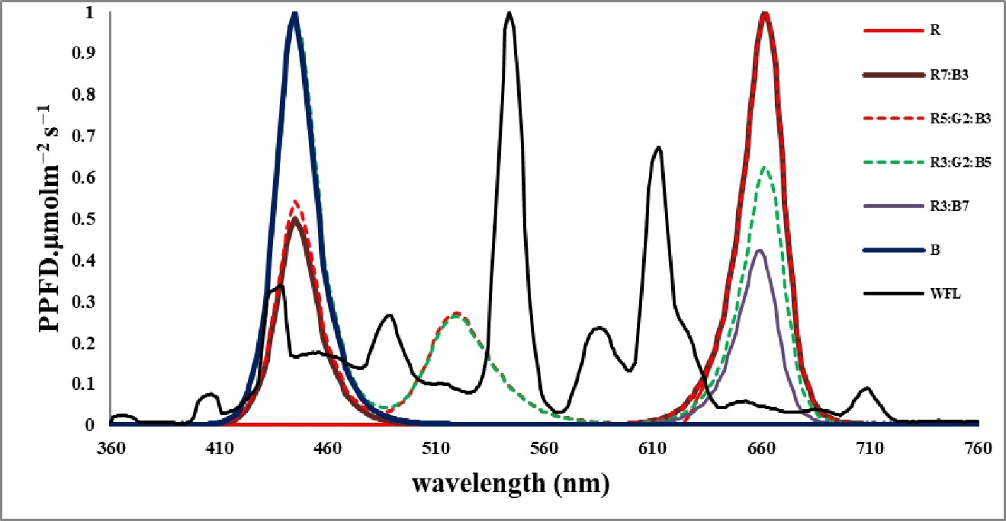
Fig. 1. Spectrum distribution of the treatments light in the experiment.

Table 1. LED light, light quality, light intensity, photoperiod, temperature and humidity used in the environments.
Light Treatments | Light spectral ratios | Peak wave length  λp (nm) | light intensity (μmol.m⁻².s⁻¹) | Photoperiod  Light/Dark | Temperature (ºC) |  | Relative humidity (%)
 |  |  |  |  | Day | Night
R | 100 | 662 | 100 ±2 | 12h /12h | 25 ± 2 | 20 ± 2 | 60 ± 10
R₇:B₃ | 70:30 | 662 | 100 ±2 | 12h /12h | 25 ± 2 | 20 ± 2 | 60 ± 10
R₅:G₂:B₃ | 50:20:30 | 662 | 100 ±2 | 12h /12h | 25 ± 2 | 20 ± 2 | 60 ± 10
R₃:G₂:B₅ | 30:20:50 | 445 | 100 ±2 | 12h /12h | 25 ± 2 | 20 ± 2 | 60 ± 10
R₃:B₇ | 30:70 | 445 | 100 ±2 | 12h /12h | 25 ± 2 | 20 ± 2 | 60 ± 10
B | 100 | 445 | 100 ±2 | 12h /12h | 25 ± 2 | 20 ± 2 | 60 ± 10
WFL | 100 | 544 | 100 ±2 | 12h /12h | 25 ± 2 | 20 ± 2 | 60 ± 10

Data collection: Data were collected based on the following methods:

Plant Growth characteristics
Data of growth parameters were collected 45 days after sowing (DAS). Plant height (cm) was measured using a ruler; it was measured from the base of the plant at soil surface to top of the plant. Stem diameter (mm) was measured using a digital Vernier caliper. Leaf area was determined according to the method of (Pandey et al., 2011), total leaf area (cm²) was calculated by the number of leaves × leaf area.

Measurement of Photosynthetic Activity
Chlorophyll fluorescence was estimated by using a PAM 2500 chlorophyll fluorescence meter (Heinz Walz GmbH, Effeltrich, Germany). The fourth leaf from each plant was selected randomly for estimation. The leaf area of the standard measuring head is 1.3 cm² and a saturated flash illumination from red LEDs (25000 μmol.m⁻².s⁻¹, 300 ms duration) was applied to determine the maximum chlorophyll fluorescence with closed PSII centers after dark acclimation (Fm) and during illumination (Fm'). Fluorescence induction kinetics was measured after dark adaptation for 30 min, then the rapid light curve (RLC) was recorded immediately. The steady-state fluorescence was measured after 20s of exposure to the light similar to the growth irradiance (100 μmol.m⁻². s⁻¹), the light intensity gradient of the RLC was (0, 1, 30, 63, 100, 140, 197, 362, 618, 784, and 1159 μmol.m⁻². s⁻¹).
Under dark and light conditions, the effective quantum yield of PSII photochemistry Y(II) (Butler, 1978), the quantum yield of non-regulatory energy dissipation [Y(NO)=Fs/Fm] and the quantum yield of regulatory energy dissipation [Y(NPQ)=1–Y(II)–Y(NO)] were measured. Non-photochemical quenching (NPQ), photochemical quenching (qP) and the electron transport rate (ETR) were also measured. Measurements were conducted 4 replicates per treatment.

Data analysis
The experiment was laid out in a completely randomized design with three replicates. All of the data were subjected to one-way analysis of variance (ANOVA). SPSS statistical software package version 16.0 (SPSS Inc., Chicago, IL, USA) was used for statistical analysis of the data. Significantly different means were separated using Duncan’s multiple range test at the P < 0.05 level of probability (Duncan, 1955). All graphs were made using Excel 2007 (v12.0) using means and standard error for each data point.

Results

Plant Growth characteristics
Light quality with LEDs had significant effects on morphological appearances of tomato seedlings (Table 2, Fig. 2). The plant height of cultivars J and M under R₅:G₂:B₃ and R₇:B₃ treatments were significantly lower and higher than other treatments respectively. Stem diameter of plants irradiated with R₃:B₇ was significantly larger than those under the other LED combinations and there was no significant difference among those under the irradiations of the other LEDs. Total Leaves area (cm²) of plants irradiated with R₇:B₃ had significantly larger area than those under more other LEDs except fort R₅:G₂:B₃ and R.
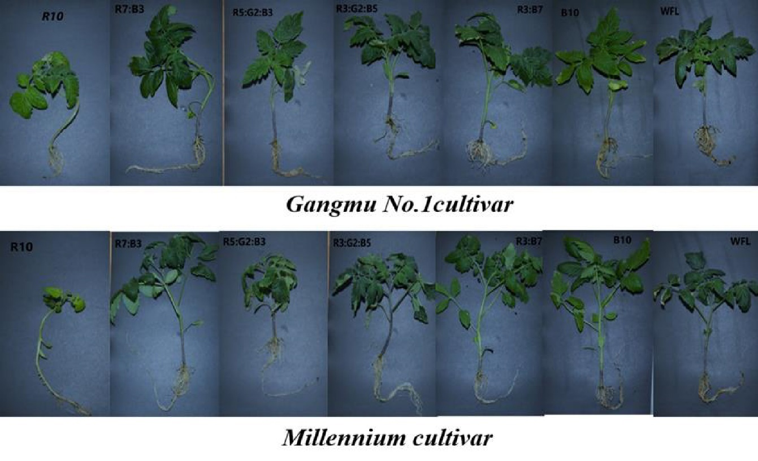
Fig. 2. Tomato seedlings growth under diﬀerent LED lighting 40 days

Table 2. Effect of LED light quality on plant growth characteristics of tomato seedlings Gangmu No.1 and Millennium cultivars.
Light Treatments | Gangmu No.1 |  |  | Millennium
 | Plant height  (cm) | Stem diameter (mm) | Total Leaves area (cm²) | Plant height  (cm) | Stem diameter (mm) | Total Leaves area (cm²)
R | 21.07±0.96 b | 2.85±0.05 ab | 123.67±7.17 d | 22.00±0.29 b | 2.66±0.05 b | 71.33±10.74 d
R₇:B₃ | 24.33±0.33 a | 3.05±0.19 ab | 194.75±9.59 a | 26.67±1.96 a | 3.57±0.09 a | 231.71±18.31 a
R₅:G₂:B₃ | 17.67±0.72 c | 2.96±0.23 ab | 117.33±14.11 d | 17.00±0.29 d | 2.70±0.10 b | 85.13±17.81 cd
R₃:G₂:B₅ | 19.50±0.76 bc | 3.10±0.11 ab | 184.45±18.42 ab | 19.00±0.58 cd | 3.58±0.33 a | 141.96±8.89 bc
R₃:B₇ | 21.00±0.58 b | 3.26±0.19 a | 176.27±16.28 a-c | 23.00±0.76 b | 3.75±0.36 a | 203.81±9.27 ab
B | 20.50±0.76 b | 2.95±0.07 ab | 143.27±15.98 b-d | 23.17±0.60 b | 3.24±0.16 ab | 191.92±39.94 ab
WFL | 18.00±0.58 c | 2.63±0.18 b | 134.87±7.96 cd | 21.67±0.93 bc | 2.69±0.12 b | 159.41±9.06 b
Values are means of three replicates. Different letters in the same column indicate significant differences according to Duncan’s multiple range test at P ≤ 0.05.

Chlorophyll fluorescence measurements

Measurements under dark-acclimated samples
We measured the rapid light curves (RLCs) of dark-adapted and the results are shown in Figure 4. Dark-adaptation allows PSII reaction centers to open, electron transport chain to be oxidized, photoprotective mechanisms (Xanthophyll Cycle) and the trans-thylakoid to be relaxed and gradient to be depleted. The effective quantum yield of PSII photochemistry Y(II) decreased directly with stable light intensity of 100 μmol.m⁻². s⁻¹ at both light qualities in both cultivars, and then increased rapidly with continued exposure to light at both light qualities in both cultivars. The Y(II) under R₃:G₂:B₅ was significantly higher than other treatments at 60-140 and 180-300 seconds in the J cultivar (Fig.3 J-1) , while in cultivar M, it was significantly higher than other treatments at 40-300 seconds (Fig.3 M-1).
The quantum yield of regulated energy dissipation in PSII [Y(NPQ)] increased rapidly at both light qualities and cultivars. The [Y(NPQ)] in cultivar J was the highest under B, WFL and R₃:B₇ treatments at 60-100, 120-140 and 160-300 seconds respectively, (Fig.4 J-1), while in cultivar M, it was the highest under B and R₃:G₂:B₅ treatments at 60-80, 140-300 seconds respectively, (Fig.4 M-1). The quantum yield of non-regulated energy dissipation in PSII [Y(NO)] increased rapidly when initially exposed to light and decreased directly at 40 seconds with increasing timeframe at all light qualities in both cultivars. The [Y(NO)] in cultivar J was the highest under R treatment at 60-300 seconds (Fig. 5 J-1), while in cultivar M, it was the highest under R treatment at 120-300 seconds (Fig. 5 M-1).
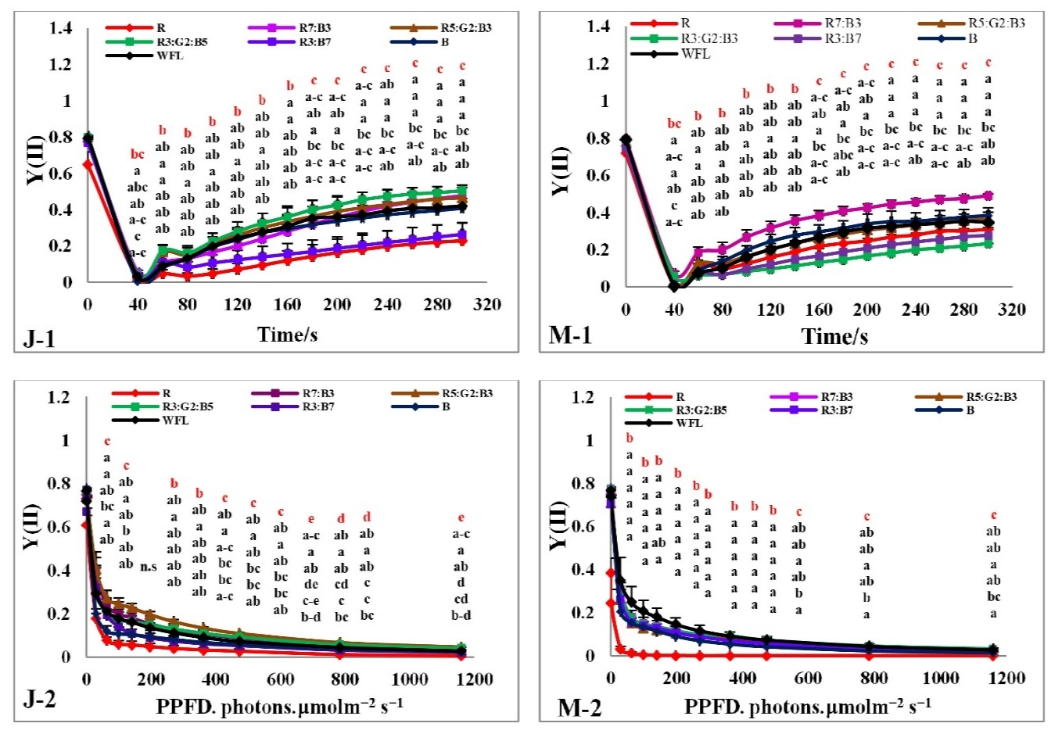
Fig. 3. Effects of LED light quality on RLC of the dark and light-adapted effective quantum yield of PSII photochemistry Y(II) in tomato leaves (J-1,M-1, J-2,M-2). Line markers indicate the average ± standard error (P≤0.05, n=4).

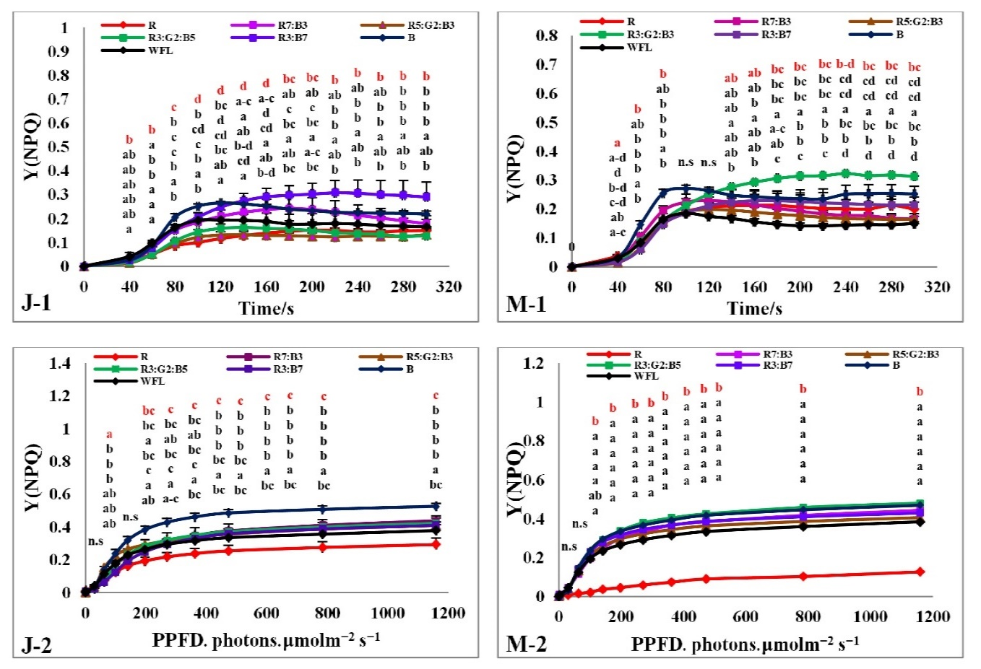
Fig. 4. Effects of LED light quality on RLC of the dark and light-adapted quantum yield of regulatory energy dissipation in PSII Y(NPQ) in tomato leaves (J-1,M-1,J-2,M-2). Line markers indicate the average ± standard error (P≤0.05, n=4).

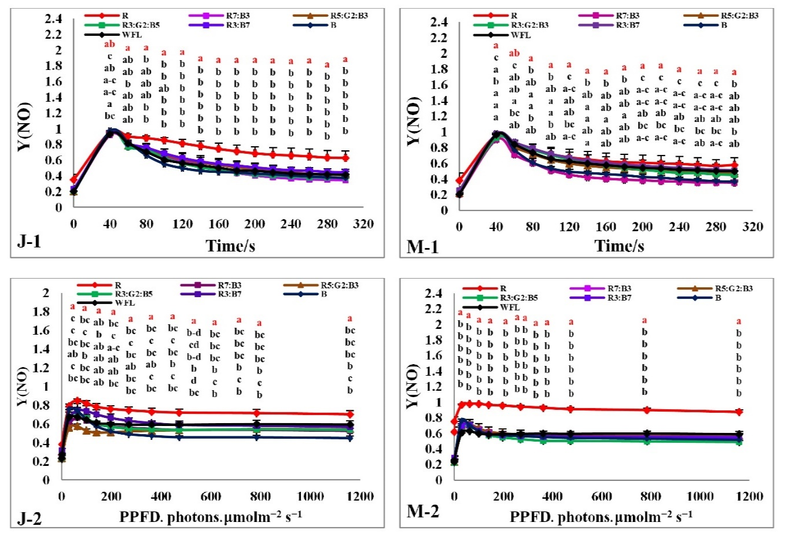
Fig. 5. Effects of LED light quality on RLC of the dark and light-adapted quantum yield of non-regulated energy dissipation in PSII Y(NO) in tomato leaves (J-1,M-1,J-2,M-2). Line markers indicate the average ± standard error (P≤0.05, n=4).

Non photochemical quenching (NPQ) increased rapidly with increased timeframe all light qualities in both cultivars. The (NPQ) in cultivar J was highest under B and R₃:B₇ treatments at 40-160 seconds and R₇:B₃, R₃:B₇, and B treatments at 160-300 hours (Fig. 6 J-1), while in cultivar M, it was the highest under B at 40-120 seconds, R₇:B₃ at 140-160 seconds, R₃:G₂:B₅ at 180-280 seconds and then B treatment at 300 seconds (Fig. 6 M-1). Photochemical quenching coefficient (qP) decreased directly with stable light intensity of 100 μmol.m⁻². s⁻¹ all light qualities in both cultivars then increased rapidly with continued exposure to light at both light qualities in both cultivars. The (qP) in (J) cultivar was the highest under R₃:G₂:B₅, R₅:G₂:B₃, and B in cultivar J at 80-300 seconds (Fig. 7 J-1), while in cultivar M, it was highest under B and R₇:B₃ at 80-300 seconds (Fig. 7 M-1).

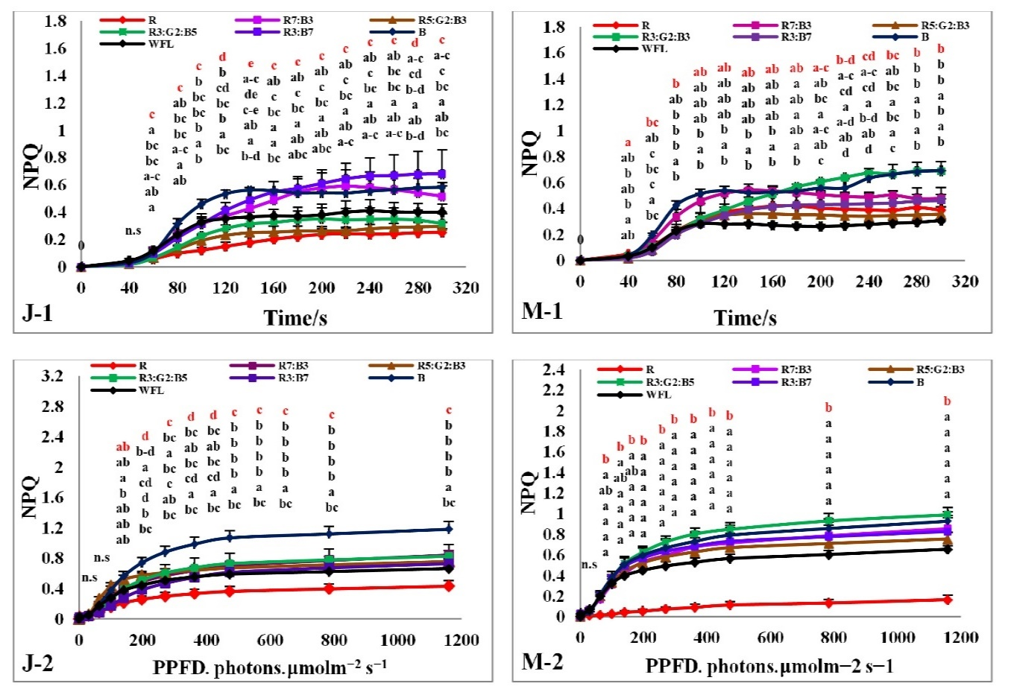
Fig. 6. Effects of LED light quality on RLC of dark and light-adapted non-photochemical quenching (NPQ) in tomato leaves (J-1,M-1,J-2,M-2). Line markers indicate the average ± standard error (P≤0.05, n=4).

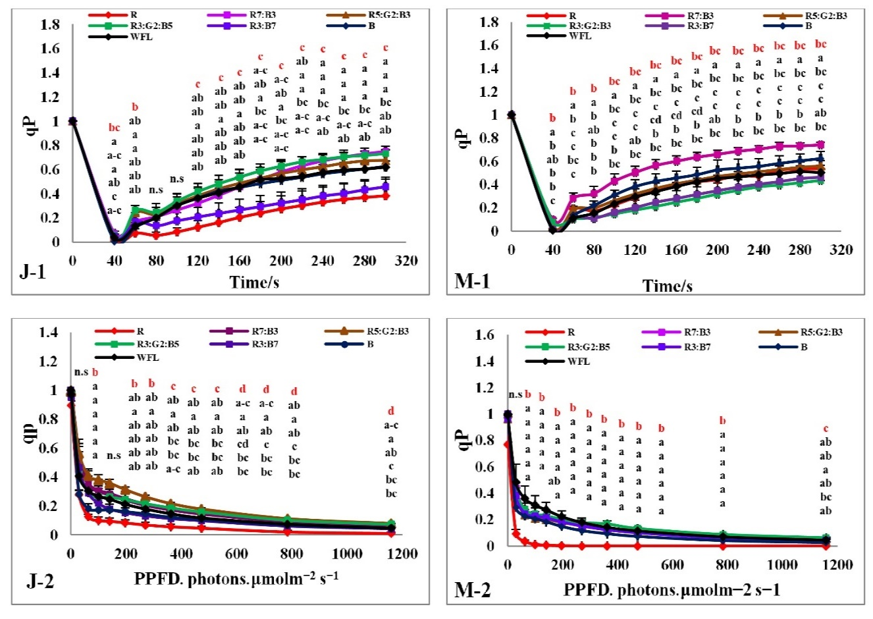
Fig. 7. Effects of LED light quality on RLC of dark and light-adapted photochemical quenching coefficient (qP) in tomato leaves (J-1,M-1,J-2,M-2). Line markers indicate the average ± standard error (P≤0.05, n=4).

The electron transfer rate of PSII (ETR) increased rapidly with increase in exposure time at both light qualities in both cultivars. The ETR performed best under R₃:G₂:B₅ in cultivar J (Fig. 8 J-1), while the best performance was observed under R₇:B₃ in cultivar M at 40-300 seconds (Fig. 8 M-1). The ETR in cultivar J was the highest under R₃:G₂:B₅ treatment in cultivar J at 40-160 seconds then 200-300 seconds, there was no significant difference among all treatments except R at 40-140 seconds, R₃:G₂:B₅, R₇:B₃, and R₅:G₂:B₃ (Fig. 8 J-1), while in cultivar M, ETR was the highest under the R₇:B₃ treatments at 40-300 seconds (Fig. 8 M-1).
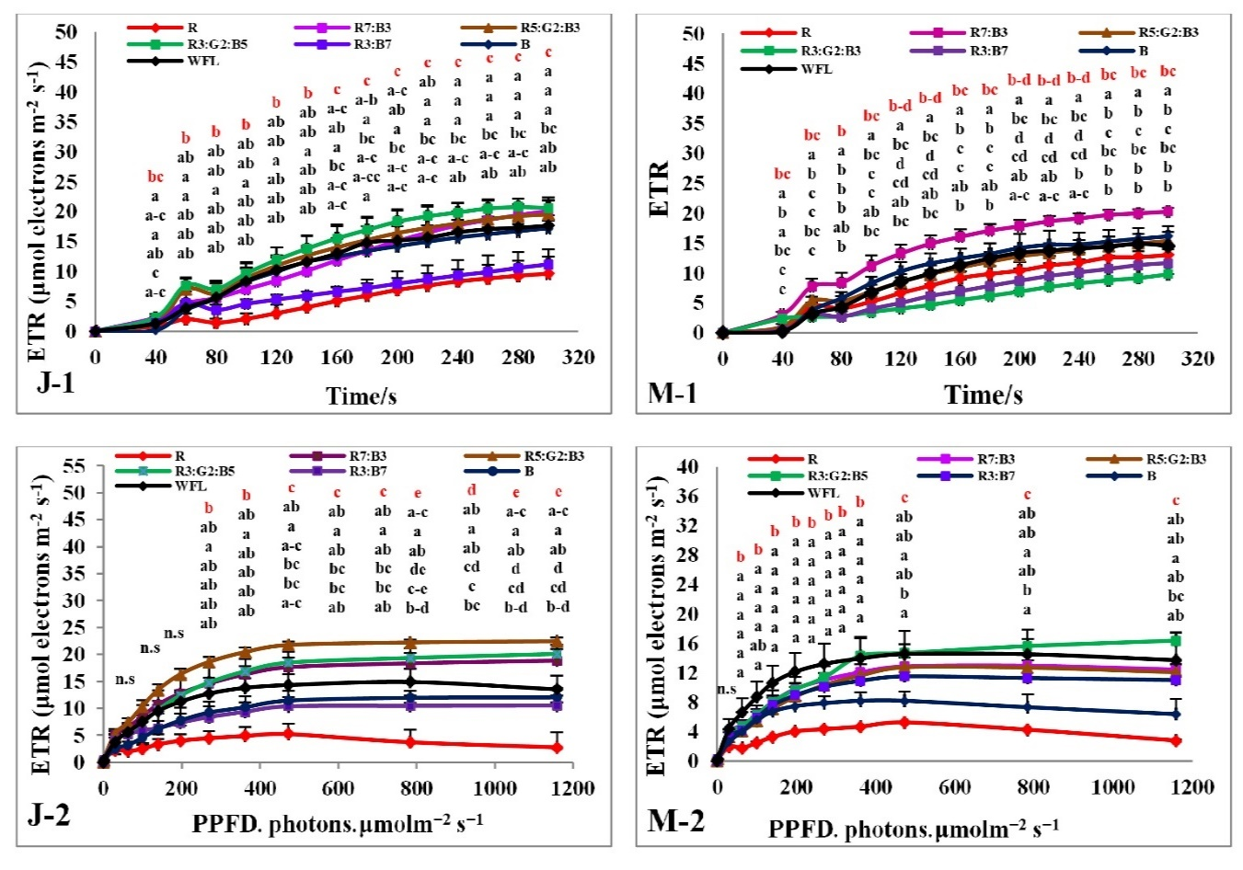
Fig. 8. Effects of LED light quality on RLC of dark and light-adapted electron transport ratio (ETR) in tomato leaves (J-1,M-1,J-2,M-2). Line markers indicate the average ± standard error (P≤0.05, n=4).

Measurements under light-acclimated samples
The rapid light curves (RLCs) of light-acclimated photosynthetic quantum yields for PSII were measured. The results showed that the photosynthetic electron transport activity was sensitive to spare light energy and significantly correlated to the oxidation state of electron transfer concatenation. The effective quantum yield of PSII photochemistry Y(II) had the best performance under R₅:G₂:B₃ and WFL in both cultivars (Fig.3 J-2 and M-2). It decreased gradually with increasing light intensity at both light quality treatments. The Y(II) under R₅:G₂:B₃ and R₃:G₂:B₅ were significantly higher than others at almost all light intensities for cultivar J (Fig.3 J-2), while under WFL it was significantly higher than other treatments at almost all light intensities for cultivar M (Fig. 3 M-2).
The quantum yield of regulated energy dissipation in PSII [Y (NPQ)] had the best performance under B in both cultivars (Fig. 4 J-2 and M-2). It increased rapidly with increasing light intensity at both light qualities used in both cultivars with the highest being under B in cultivar J at almost all light intensities (Fig. 3 J-2). Nevertheless, it was statistically similar under all treatments except under R where it was lower in cultivar M (Fig. 4 M-2). The quantum yield of non-regulated energy dissipation in PSII [Y(NO)] had the best performance under R in both cultivars (Fig. 5 J-2 and M-2). It increased rapidly when initially exposed to light and stabilizes after slightly decreased. But it increases by increasing light intensity up to 63 μmol.m⁻². s⁻¹ at all light qualities in both cultivars. The Y(NO) was the highest under the R treatment in both cultivars at all light intensities (Fig. 5 J-2, M-2).
Non photochemical quenching (NPQ) had the best performance under B and R₃:G₂:B₅ in both cultivars (Fig.6 J-2 and M-2). The (NPQ) increased gradually with increasing light intensity at all light qualities in both cultivars. The NPQ was significantly higher under B and R₃:G₂:B₅ treatments compared to WFL at almost all light intensities in both cultivars (Fig.6 J-2 and M-2). The Photochemical quenching coefficient (qP) had the best performance under treatments R₅:G₂:B₃ and WFL in both cultivars (Fig. 7 J-2 and M-2). It decreased gradually with increasing light intensity at all light qualities tested in both cultivars. The qP was significantly lower under R, R₃:B₇ and B compared to WFL at almost all light intensities in both cultivars (Fig.7 J-2 and M-2).
The electron transfer rate (ETR) of PSII performed better under R₅:G₂:B₃ in cultivar J (Fig.8 J-2), while under the WFL in cultivar M, it performed best before the light intensity reached 270 μmol.m⁻².s⁻¹ and R₃:G₂:B₅ after light intensity reached 270 μmol.m⁻².s⁻¹ (Fig.8 M-2). The ETR increased when the light intensity increases and it became steady when the light intensity reached 473, 618, 748 and 1159 μmol.m⁻².s⁻¹ depending on the treatments except R which declined after it reached 473 μmol.m⁻².s⁻¹ in both cultivars. The ETR of R₅:G₂:B₃ was significantly higher than that of other treatments in cultivar J (Fig.8 J-2), while it was statistically similar under all other treatments at all light intensities except R where it was lower in cultivar M (Fig.8 M-2).

Discussion
In general, the morphological and physiological characteristics of the plant are strongly affected by the quality of light (Kalmatskaya et al., 2019; Whitelam et al., 2007). In this research, the interactions between photosynthesis and chlorophyll fluorescence parameters were exploited and how they are affected by light quality provided by LED light quality and fluorescent lamps. In this context, it was hypothesized that the efficiency of the process of photosynthesis and chlorophyll fluorescence parameters significantly affected the performance of tomato seedlings.

Growth parameters
The process of photosynthesis in higher plants requires the interception of light and its utilization. The light trapped by the leaves is influenced by the wavelength, the intensity and angle of incidence (Brodersen et al., 2010) as well as the total leaves area Gangmu No.1 and Millennium cultivars reacted strongly to R₇:B₃ not only in terms of total leaf area but also plant height as shown in Table 2. Similar results were obtained by Yang et al. (2017) and Kim et al. (2019), they observed a mixture of red and blue LED lights was favorable for total leaves area and plant height. In terms of stem diameter, Gangmu No.1 and Millennium cultivars reacted strongly under R₃:B₇. This result was in agreement of the findings of Yang et al. (2017), Naznin et al. (2019) and Tang et al. (2019). For tomato seedlings, it showed that a mixture of red and blue LED light was effective on stem diameter (Kim & Hwang, 2019; Yang et al., 2018).

Chlorophyll fluorometers
Effects of LED light on RLC of dark-adapted reaction centers in tomato leaves were studied, RLC measurements were obtained through the application of 20 second stable light photosynthetically active radiation (PAR) at 100 μmol.m⁻².s⁻¹. Rapid light curve (RLC) measurements were obtained through exposing the seedlings to 20 seconds light and increasing the PAR (0, 30, 63, 100, 140, 197, 362, 618, 784, and 1159 μmol.m⁻².s⁻¹).
In the dark, all photosynthetic reaction centers of plants are open and can be excited, all electron acceptors are in the oxidized state and are able to accept more electrons. At that moment, a sudden increase in chlorophyll ﬂuorescence occurs followed by a slow decrease in the induced ﬂuorescence. This phenomenon was first observed by Kautsky in 1931, and it is known as Kautsky’s effect (Kautsky et al., 1931). When plants are exposed to light, all photosynthetic reaction centers are closed, all electron acceptors are fully oxidized and cannot accept oxidized electrons (Kalaji et al., 2017). The electron transport carrier’s activity is adjusted specifically by light. The specific spectrum of solar radiation can weaken the photosystems, especially PSII, causing extra photo inhibition (Takahashi et al., 2010; Tikkanen et al., 2014; Zavafer, Cheah, et al., 2015; Zavafer, Chow, et al., 2015). In this study, the photosynthetic electron transport was significantly observed to be influenced by light qualities on tomato leaves. The combination of red and blue light, as well as white light, was more helpful to efficient photosynthesis process and performance in tomato leaves; these findings were in agreement with previous studies (He et al., 2017; Wang et al., 2016; Yang et al., 2018).
These results indicated that the different light qualities of LED specifically regulated energy distribution, state transition, heat dissipation, cyclic electron transfer, and the activity of the photosynthetic electron transport chain. Light quality can directly impact the photochemical reaction during short-term lighting and indirectly impacts photosynthetic electron transport by adjusting multiple biochemical processes such as endogenous hormonal balance and metabolic reactions. In tomato leaves, the reaction centers were open, active and capable of accepting electrons, the effective photochemical quantum yield of photosystem II constantly is increasing with time (Fig.3 J-1 and M-1), while Y(II) was observed under light-acclimated exposures with increasing PAR (0, 30, 63, 100, 140, 197, 362, 618, 784, and 1159 μmol.m⁻².s⁻¹) in tomato leaves. The reaction centers were closed, and not excited, all electron acceptors are fully oxidized and cannot accept more oxidized electrons, thus Y(II) decreases with increase timeframe and PAR (Fig.3 J-2, M-2). Our findings were supported by that of Yang et al. (2018).
The quantum yield of regulatory energy dissipation in PSII Y(NPQ) corresponds to the fraction of energy dissipated in the form of heat via the regulated photoprotective NPQ mechanism. When Y(II)’s value approaches zero at high quantum flux densities, high values of Y(NPQ) are the indications of high photoprotective capacity (Klughammer et al., 2008). The results of this study showed that the difference between the values of Y(NPQ) under dark-acclimated and light-acclimated was significant. The best treatments with high photoprotective capacity and ability of plant to protect itself against damages by excess illumination in cultivar J were observed under B and R₃:B₇, while B and R₃:G₂:B₅ in cultivar M (Fig.4 J-(1-2) and M-(1-2)), which were in agreement with the findings of (Yang et al. (2018)).
The quantum yield of non-regulated energy dissipation in PSII Y(NO) reflects the fraction of energy that is passively dissipated in the form of heat and fluorescence, mainly due to closed PSII reaction centers. The high values of Y(NO) reflect the inability of a plant to protect itself against damages by excess illumination (Klughammer & Schreiber, 2008). These results showed that the value of Y(NO) under dark-acclimated and light-acclimated decreased slowly. The inability of the seedlings to protect itself against damage by excess illumination in both cultivars was observed under R (Fig.5 J-(1-2) and M-(1-2)) which is in tandem with the findings of Yang et al. (2018).
In order to decrease photo damage, plants have devised several preventive mechanisms, including non-photochemical quenching (NPQ) which quenches the agitation of chlorophyll molecule within the light-harvesting antennae of PSII by converting excitation energy into thermal energy, which can then be sent out (Kasajima et al., 2011; Zhao et al., 2017). According to one NPQ model (Chávez-Arias et al., 2019; Zaks et al., 2012), rice leaves are often unable to utilize all the light absorbed by their photosynthetic pigments for CO₂ fixation. A limited range for CO₂ fixation limits photosynthetic electron transport, which then restricts the performance of the reaction centers of photosystem I (PSI) and PSII. In the case of PSII, these results leads to reactions that create harmful oxygens (Long et al., 2015) as well as causing damage to the reaction center (Evans et al., 2011) and membranes (Davison et al., 2002; Nicol et al., 2019).
Additionally, under drought stress, a lower NPQ was observed when comparing drought-susceptible with drought-resistant plants. The photorespiration of drought-susceptible plants was significantly higher than that of drought-resistant plants (Beis et al., 2012). It is known that the photorespiration process can disperse surplus equivalents of energy and decrease the generation of reactive oxygen species. It is also a source of H₂O₂ oxidization signal in the regulation of oxidization homeostasis. Generally, photorespiration is suggested as photoprotective mechanism important in reducing oxidative stress (Kangasjärvi et al., 2012; Suzuki et al., 2012; Voss et al., 2013). There is likely to be cooperation or integration between photorespiratory metabolism and NPQ in order to keep oxidation homeostasis inside cells. Some other photoprotective mechanisms have been identified as closely related to NPQ, such as water-water cycle and cyclic electron transport and in organizing the induction of NPQ (Johnson et al., 1994; Kramer et al., 2003; Miyake et al., 2005). The results showed that the value of NPQ under dark-acclimated and light-acclimated continuously increased with increasing time or increasing light intensity, the best combinations that dissipated excess reducing energy were R₃:B₇ and B in cultivar J and B and R₃:G₂:B₅ in cultivar M after dark-acclimated (Fig.6 J-1 and M-1), while the best treatment dissipated excess reducing energy was B in cultivar J and R₃:G₂:B₅ and B in cultivar M after light-acclimated (Fig.6 J-2 and M-2). These findings are supported by He et al. (2017) and Hoffmann et al. (2015).
Photochemical quenching (qP) is used as a parameter for estimating the fraction of PSII centers in open states based on a puddle model for the photosynthetic unit (Kramer et al., 2004). qP was observed under dark-acclimated stable light PAR (100 μmol.m⁻².s⁻¹) in tomato leaves to be constantly increasing with time (Fig.7 J-1 and M-1), which indicated that the reaction centers increased in their work over time. On the other hand, qP under light-acclimated was observed to decrease with increase in PAR (0, 30, 63, 100, 140, 197, 362, 618, 784, and 1159 μmol.m⁻².s⁻¹) in tomato leaves and also decreased with time (Fig.7 J-2 and M-2), which indicated the reaction centers decreases with increasing photosynthetically active radiation. The best light combinations that helped keep as much as possible on the largest possible number of open reaction centers were R₇:B₃ and R₃:G₂:B₅ in cultivar J and R₇:B₃ in cultivar M in dark-acclimated (Fig.7 J-1 and M-1), while the best light combinations that helped keep as much as possible the largest possible number of open reaction centers were R₅:G₂:B₃ and R₃:G₂:B₅ in cultivar J and R₃:G₂:B₅ in cultivar M under light-acclimated (Fig.7 J-2 and M-2), which was supported by He et al. (2017) and Yang et al. (2018) .
Electron transport rate (ETR) is also a light-acclimated parameter that is directly correlated to Y(II) by the equation ETR = Y(II) × PAR × 0.84 × 0.5 and the relative estimation of ETR is achieved by adopting the procedure of Schreiber (2004). The results showed that the value of ETR under dark-acclimated and light-acclimated were continuously increasing with increase in time or increasing light intensity. The best light combinations that increased electron transfer rate were R₃:G₂:B₅ and R₅:G₂:B₃ in cultivar J and R₇:B₃ in cultivar M in dark-acclimated (Fig.8 J-1 and M-1), while the best treatments that increased electron transfer rate in light-acclimated were R₅:G₂:B₃ and R₃:G₂:B₅ in cultivar J and R₃:G₂:B₅ and WFL in cultivar M (Fig.8; J-2 and M-2), which was supported by (Hoffmann et al. (2015)).

Conclusion
Chlorophyll fluorescence can be used to asses types of plant stress, e.g. extremes of temperature, light, water, salinity and insect or pathological stresses that can reduce the ability of a plant to perform optimally. It can also be used to evaluate the performance of tomato seedlings during growth stages. In this study, one of the most important results obtained was that the parameters of chlorophyll fluorescence measured under dark-acclimation and light-acclimation did not change in all photosynthetic reaction centers significantly other than Y(II) and qP in both cultivars. Most of the light combinations containing a mixture of red and blue light were the best in effective quantum yield of PSII photochemistry (Y(II)), and electron transport rate (ETR) in both cultivars after dark-acclimated and light-acclimated. The variations among these characteristics suggested the linking morphological and physiological characteristics are insufficient to understand the effect of optical spectra on plant growth, so it is necessary to conduct molecular analysis and link them with morphological and physiological characteristics to know mechanisms of the effect of LED light on seedlings growth. In addition important to complete these treatments with seedlings until the production of the fruits.

Acknowledgments: This research was supported by the Project of Fujian Agriculture and Forestry University (FAFU). The authors would like to express their appreciation of the cooperation of the employees of the College of Horticulture and College of Mechanical and Electronic Engineering of Fujian Agriculture and Forestry University (FAFU).
Author Contributions:
Authors of manuscript equally contributed in planning, execution, data collection, statistical analysis, draft development, commenting, revising and approving the manuscript for submission.
Conflict of interest: None

References
Alyemeni, M. N., Ahanger, M. A., Wijaya, L., Alam, P., Bhardwaj, R., & Ahmad, P. 2018. Selenium mitigates cadmium-induced oxidative stress in tomato (Solanum lycopersicum L.) plants by modulating chlorophyll fluorescence, osmolyte accumulation, and antioxidant system. Protoplasma, 255(2), 459-469.
Baker, N. R., & Oxborough, K. 2004. Chlorophyll fluorescence as a probe of photosynthetic productivity Chlorophyll a Fluorescence (pp. 65-82): Springer.
Beis, A., & Patakas, A. 2012. Relative contribution of photoprotection and anti-oxidative mechanisms to differential drought adaptation ability in grapevines. Environmental and Experimental Botany, 78, 173-183.
Brodersen, C. R., & Vogelmann, T. C. 2010. Do changes in light direction affect absorption profiles in leaves? Functional Plant Biology, 37(5), 403-412.
Bürling, K., Hunsche, M., & Noga, G. 2010. Quantum yield of non-regulated energy dissipation in PSII (Y (NO)) for early detection of leaf rust (Puccinia triticina) infection in susceptible and resistant wheat (Triticum aestivum L.) cultivars. Precision Agriculture, 11(6), 703-716.
Butler, W. L. 1978. Energy distribution in the photochemical apparatus of photosynthesis. Annual Review of Plant Physiology, 29(1), 345-378.
Cartelat, A., Cerovic, Z., Goulas, Y., Meyer, S., Lelarge, C., Prioul, J.-L., . . . Agati, G. 2005. Optically assessed contents of leaf polyphenolics and chlorophyll as indicators of nitrogen deficiency in wheat (Triticum aestivum L.). Field crops research, 91(1), 35-49.
Chávez-Arias, C. C., Gómez-Caro, S., & Restrepo-Díaz, H. 2019. Physiological, Biochemical and Chlorophyll Fluorescence Parameters of Physalis Peruviana L. Seedlings Exposed to Different Short-Term Waterlogging Periods and Fusarium Wilt Infection. Agronomy, 9(5), 213.
Davison, P., Hunter, C., & Horton, P. 2002. Overexpression of β-carotene hydroxylase enhances stress tolerance in Arabidopsis. Nature, 418(6894), 203.
DeEll, J. R., & Toivonen, P. M. 2003. Use of chlorophyll fluorescence in postharvest quality assessments of fruits and vegetables Practical applications of Chlorophyll fluorescence in plant biology (pp. 203-242): Springer.
Dong, Z., Men, Y., Li, Z., Zou, Q., & Ji, J. 2019. Chlorophyll fluorescence imaging as a tool for analyzing the effects of chilling injury on tomato seedlings. Scientia Horticulturae, 246, 490-497.
Doughty, R., Köhler, P., Frankenberg, C., Magney, T. S., Xiao, X., Qin, Y., . . . Moore, B. 2019. TROPOMI reveals dry-season increase of solar-induced chlorophyll fluorescence in the Amazon forest. Proceedings of the National Academy of Sciences, 116(44), 22393-22398.
Duncan, D. B. J. B. 1955. Multiple range and multiple F tests. 11(1), 1-42.
Evans, J. R., & von Caemmerer, S. 2011. Enhancing photosynthesis: Am Soc Plant Biol.
Favaretto, V. F., Martinez, C. A., Soriani, H. H., & Furriel, R. P. 2011. Differential responses of antioxidant enzymes in pioneer and late-successional tropical tree species grown under sun and shade conditions. Environmental and Experimental Botany, 70(1), 20-28.
Fracheboud, Y., Haldimann, P., Leipner, J., & Stamp, P. 1999. Chlorophyll fluorescence as a selection tool for cold tolerance of photosynthesis in maize (Zea mays L.). Journal of experimental botany, 50(338), 1533-1540.
Genty, B., Briantais, J.-M., & Baker, N. R. 1989. The relationship between the quantum yield of photosynthetic electron transport and quenching of chlorophyll fluorescence. Biochimica et Biophysica Acta (BBA)-General Subjects, 990(1), 87-92.
Guo, M., Wang, Y., Dong, S., Wen, Y., Song, X., & Guo, P. 2018. Photochemical changes and oxidative damage in four foxtail millet varieties following exposure to sethoxydim. Photosynthetica, 56(3), 820-831.
Haldimann, P., & Feller, U. 2004. Inhibition of photosynthesis by high temperature in oak (Quercus pubescens L.) leaves grown under natural conditions closely correlates with a reversible heat‐dependent reduction of the activation state of ribulose‐1, 5‐bisphosphate carboxylase/oxygenase. Plant, Cell & Environment, 27(9), 1169-1183.
He, J., Qin, L., Chong, E. L., Choong, T.-W., & Lee, S. K. 2017. Plant growth and photosynthetic characteristics of Mesembryanthemum crystallinum grown aeroponically under different blue-and red-LEDs. Frontiers in plant science, 8, 361.
Hoffmann, A. M., Noga, G., & Hunsche, M. 2015. Acclimations to light quality on plant and leaf level affect the vulnerability of pepper (Capsicum annuum L.) to water deficit. Journal of plant research, 128(2), 295-306.
Huang, J., Zhang, P.-J., Zhang, J., Lu, Y.-B., Huang, F., & Li, M.-J. 2013. Chlorophyll content and chlorophyll fluorescence in tomato leaves infested with an invasive mealybug, Phenacoccus solenopsis (Hemiptera: Pseudococcidae). Environmental entomology, 42(5), 973-979.
Johnson, G. N., Young, A. J., & Horton, P. 1994. Activation of non-photochemical quenching in thylakoids and leaves. Planta, 194(4), 550-556.
Kalaji, H. M., Bąba, W., Gediga, K., Goltsev, V., Samborska, I. A., Cetner, M. D., . . . Karmowska, K. 2018. Chlorophyll fluorescence as a tool for nutrient status identification in rapeseed plants. Photosynthesis research, 136(3), 329-343.
Kalaji, H. M., Bosa, K., Kościelniak, J., & Żuk-Gołaszewska, K. 2011. Effects of salt stress on photosystem II efficiency and CO2 assimilation of two Syrian barley landraces. Environmental and Experimental Botany, 73, 64-72.
Kalaji, H. M., Jajoo, A., Oukarroum, A., Brestic, M., Zivcak, M., Samborska, I. A., . . . Ladle, R. J. 2016. Chlorophyll a fluorescence as a tool to monitor physiological status of plants under abiotic stress conditions. Acta physiologiae plantarum, 38(4), 102.
Kalaji, H. M., Oukarroum, A., Alexandrov, V., Kouzmanova, M., Brestic, M., Zivcak, M., . . . Goltsev, V. 2014. Identification of nutrient deficiency in maize and tomato plants by in vivo chlorophyll a fluorescence measurements. Plant physiology and biochemistry, 81, 16-25.
Kalaji, H. M., Schansker, G., Ladle, R. J., Goltsev, V., Bosa, K., Allakhverdiev, S. I., . . . Dąbrowski, P. 2014. Frequently asked questions about in vivo chlorophyll fluorescence: practical issues. Photosynthesis research, 122(2), 121-158.
Kalaji, M. H., Goltsev, V. N., Żuk-Gołaszewska, K., Zivcak, M., & Brestic, M. 2017. Chlorophyll fluorescence: understanding crop performance—basics and applications: CRC Press.
Kalmatskaya, O. А., Karavaev, V. A., & Tikhonov, A. N. 2019). Induction of chlorophyll fluorescence in Tradescantia leaves acclimated to growth light of different intensities. Paper presented at the Saratov Fall Meeting 2018: Optical and Nano-Technologies for Biology and Medicine.
Kangasjärvi, S., Neukermans, J., Li, S., Aro, E.-M., & Noctor, G. 2012. Photosynthesis, photorespiration, and light signalling in defence responses. Journal of experimental botany, 63(4), 1619-1636.
Kasajima, I., Ebana, K., Yamamoto, T., Takahara, K., Yano, M., Kawai-Yamada, M., & Uchimiya, H. 2011. Molecular distinction in genetic regulation of nonphotochemical quenching in rice. Proceedings of the National Academy of Sciences, 108(33), 13835-13840.
Kautsky, H., & Hirsch, A. 1931. Neue versuche zur kohlensäureassimilation. Naturwissenschaften, 19(48), 964-964.
Kim, H. M., & Hwang, S. J. 2019. The Growth and Development of ‘Mini Chal’Tomato Plug Seedlings Grown under Various Wavelengths Using Light Emitting Diodes. Agronomy, 9(3), 157.
Klughammer, C., & Schreiber, U. 2008. Complementary PS II quantum yields calculated from simple fluorescence parameters measured by PAM fluorometry and the Saturation Pulse method. PAM application notes, 1(2), 201-247.
Kooten, O., & Snel, J. F. 1990. The use of chlorophyll fluorescence nomenclature in plant stress physiology. Photosynthesis research, 25(3), 147-150.
Kramer, D. M., Cruz, J. A., & Kanazawa, A. 2003. Balancing the central roles of the thylakoid proton gradient. Trends in plant science, 8(1), 27-32.
Kramer, D. M., Johnson, G., Kiirats, O., & Edwards, G. E. 2004. New fluorescence parameters for the determination of Q A redox state and excitation energy fluxes. Photosynthesis research, 79(2), 209.
Liu, X., Li, L., Li, M., Su, L., Lian, S., Zhang, B., . . . Li, L. 2018. AhGLK1 affects chlorophyll biosynthesis and photosynthesis in peanut leaves during recovery from drought. Scientific reports, 8(1), 2250.
Long, S. P., Marshall-Colon, A., & Zhu, X.-G. 2015. Meeting the global food demand of the future by engineering crop photosynthesis and yield potential. Cell, 161(1), 56-66.
Lu, C., & Zhang, J. 1999. Effects of water stress on photosystem II photochemistry and its thermostability in wheat plants. Journal of Experimental Botany, 50(336), 1199-1206.
Lu, C., Zhang, J., Zhang, Q., Li, L., & Kuang, T. 2001. Modification of photosystem II photochemistry in nitrogen deficient maize and wheat plants. Journal of plant physiology, 158(11), 1423-1430.
Maxwell, K., & Johnson, G. N. 2000. Chlorophyll fluorescence—a practical guide. Journal of experimental botany, 51(345), 659-668.
Miyake, C., Miyata, M., Shinzaki, Y., & Tomizawa, K.-i. 2005. CO2 response of cyclic electron flow around PSI (CEF-PSI) in tobacco leaves—relative electron fluxes through PSI and PSII determine the magnitude of non-photochemical quenching (NPQ) of Chl fluorescence. Plant and Cell Physiology, 46(4), 629-637.
Naznin, M. T., Lefsrud, M., Gravel, V., & Azad, M. O. K. 2019. Blue Light added with Red LEDs Enhance Growth Characteristics, Pigments Content, and Antioxidant Capacity in Lettuce, Spinach, Kale, Basil, and Sweet Pepper in a Controlled Environment. Plants, 8(4), 93.
Nemeskéri, E., & Helyes, L. 2019. Physiological Responses of Selected Vegetable Crop Species to Water Stress. Agronomy, 9(8), 447.
Nemeskéri, E., Neményi, A., Bőcs, A., Pék, Z., & Helyes, L. 2019. Physiological Factors and their Relationship with the Productivity of Processing Tomato under Different Water Supplies. Water, 11(3), 586.
Neocleous, D., & Vasilakakis, M. 2008. Effects of boron and salinity on red raspberry in vitro. International Journal of Fruit Science, 8(3), 216-225.
Nicol, L., Nawrocki, W. J., & Croce, R. 2019. Disentangling the sites of non-photochemical quenching in vascular plants. Nature plants, 1-7.
Pandey, S., & Singh, H. 2011. A simple, cost-effective method for leaf area estimation. Journal of botany, 2011.
Sánchez-Reinoso, A. D., Ligarreto-Moreno, G. A., & Restrepo-Díaz, H. 2019. Chlorophyll α Fluorescence Parameters as an Indicator to Identify Drought Susceptibility in Common Bush Bean. Agronomy, 9(9), 526.
Schreiber, U. 2004. Pulse-amplitude-modulation (PAM) fluorometry and saturation pulse method: an overview Chlorophyll a fluorescence (pp. 279-319): Springer.
Sitko, K., Gieroń, Ż., Szopiński, M., Zieleźnik-Rusinowska, P., Rusinowski, S., Pogrzeba, M., . . . Małkowski, E. 2019. Influence of short-term macronutrient deprivation in maize on photosynthetic characteristics, transpiration and pigment content. Scientific reports, 9(1), 1-12.
Sobrado, M. 2008. Leaf characteristics and diurnal variation of chlorophyll fluorescence in leaves of the ‘Bana’vegetation of the Amazon region. Photosynthetica, 46(2), 202.
Suzuki, N., Koussevitzky, S., Mittler, R., & Miller, G. 2012. ROS and redox signalling in the response of plants to abiotic stress. Plant, Cell & Environment, 35(2), 259-270.
Takahashi, S., Milward, S. E., Yamori, W., Evans, J. R., Hillier, W., & Badger, M. R. 2010. The solar action spectrum of photosystem II damage. Plant physiology, 153(3), 988-993.
Tang, Z., Yu, J., Xie, J., Lyu, J., Feng, Z., Dawuda, M. M., . . . Hu, L. 2019. Physiological and Growth Response of Pepper (Capsicum annum L.) Seedlings to Supplementary Red/Blue Light Revealed through Transcriptomic Analysis. Agronomy, 9(3), 139.
Tian, Y., Sacharz, J., Ware, M. A., Zhang, H., & Ruban, A. V. 2017. Effects of periodic photoinhibitory light exposure on physiology and productivity of Arabidopsis plants grown under low light. Journal of experimental botany, 68(15), 4249-4262.
Tikkanen, M., & Aro, E.-M. 2014. Integrative regulatory network of plant thylakoid energy transduction. Trends in plant science, 19(1), 10-17.
Voss, I., Sunil, B., Scheibe, R., & Raghavendra, A. 2013. Emerging concept for the role of photorespiration as an important part of abiotic stress response. Plant biology, 15(4), 713-722.
Wada, S., Takagi, D., Miyake, C., Makino, A., & Suzuki, Y. 2019. Responses of the Photosynthetic Electron Transport Reactions Stimulate the Oxidation of the Reaction Center Chlorophyll of Photosystem I, P700, under Drought and High Temperatures in Rice. International journal of molecular sciences, 20(9), 2068.
Wang, H., Qian, X., Zhang, L., Xu, S., Li, H., Xia, X., . . . Liu, X. 2018. A Method of High Throughput Monitoring Crop Physiology Using Chlorophyll Fluorescence and Multispectral Imaging. Frontiers in plant science, 9, 407.
Wang, J., Lu, W., Tong, Y., & Yang, Q. 2016. Leaf morphology, photosynthetic performance, chlorophyll fluorescence, stomatal development of lettuce (Lactuca sativa L.) exposed to different ratios of red light to blue light. Frontiers in plant science, 7, 250.
Whitelam, G., & Halliday, K. 2007. Annual Plant Reviews Volume 30: Light and Plant Development.
Yang, X., Xu, H., Shao, L., Li, T., Wang, Y., & Wang, R. 2018. Response of photosynthetic capacity of tomato leaves to different LED light wavelength. Environmental and Experimental Botany, 150, 161-171.
Yang, Z., He, W., Mou, S., Wang, X., Chen, D., Hu, X., . . . Bai, J. 2017. Plant growth and development of pepper seedlings under different photoperiods and photon flux ratios of red and blue LEDs. Transactions of the Chinese Society of Agricultural Engineering, 33(17), 173-180.
Zaks, J., Amarnath, K., Kramer, D. M., Niyogi, K. K., & Fleming, G. R. 2012. A kinetic model of rapidly reversible nonphotochemical quenching. Proceedings of the National Academy of Sciences, 109(39), 15757-15762.
Zavafer, A., Cheah, M. H., Hillier, W., Chow, W. S., & Takahashi, S. 2015. Photodamage to the oxygen evolving complex of photosystem II by visible light. Scientific reports, 5, 16363.
Zavafer, A., Chow, W. S., & Cheah, M. H. 2015. The action spectrum of Photosystem II photoinactivation in visible light. Journal of Photochemistry and Photobiology B: Biology, 152, 247-260.
Zhang, Y., Kaiser, E., Zhang, Y., Yang, Q., & Li, T. 2019. Red/blue light ratio strongly affects steady‐state photosynthesis, but hardly affects photosynthetic induction in tomato (Solanum lycopersicum). Physiologia plantarum, 167(2), 144-158.
Zhao, X., Chen, T., Feng, B., Zhang, C., Peng, S., Zhang, X., . . . Tao, L. 2017. Non-photochemical quenching plays a key role in light acclimation of rice plants differing in leaf color. Frontiers in plant science, 7, 1968.

