Terrace Farming: A Step Towards Urbanization
Sindhusha Pedada¹,Monisha Rawat²,Anil Kumar¹
1-M.Sc Student,2-Assitant Professor
Department of Horticulture, Lovely Professional University, Phagwara, Punjab, India – 144421
*Corresponding author: sindhupedada@gmail.com
Abstract:
As the population of Indian cities are increasing, demand for food and expenditure also increasing. However, the resources are limited as farmland converts into residential, commercial or industrial space. This limits the risk of growing more and more diverse foodstuffs. Urban agriculture (UA) has the ability to support inner-city populations by reducing food transport distances, raising food production awareness, and enhancing nutrition, health, and economic status. Contamination of food such as toxic chemical fertilizers and use of pesticides, etc., again grows at an unprecedented pace. In this situation, the establishment of growing vegetables on the roof top can be a feasible and possible option to solve these problems and find a way out. Rooftop vegetable farming can fulfil food demand by providing quality and hygienic vegetables, lowering household spending on vegetables, improving air quality and absorbing carbon from the environment, and reducing the effects of climate change.
Key words: chemical fertilizer, Pesticides, Rooftop farming, Carbon, Climate change

Introduction:
India is the world's second most densely populated country, after China. It has been envisaged that the population of India would reach approximately 2.0 billion by 2050, with which, India can claim the world's most populated country title. As population is increasing geometrically, while food supply and energy for food production rise arithmetically (Chandy and Michelle, 2005). Population increase will also result in hunger, poverty, malnutrition, and social instability. Every now and then, people migrate from rural to urban areas in search of work and a better way of life, resulting in a population boom. This continuous moving population creates fluctuation in the availability of the natural resources of that area where they migrate to. Not only due to the population migration but population explosion causes this problem too. This so ever-growing population is always demanding more and more. Thus, as a result, the majority of farm fields have been turned into residential areas, resulting in a decline in the supply of land for agriculture and horticulture crop production, and if the situation prevails then the hunger crisis can be clearly envisaged in upcoming decades. The development of multistory buildings in urban areas has resulted in a lack of land for growing household vegetables. It is quite clear that controlling population is not possible at once, rather this change will be a gradual process and it might take few more decades to get balanced. Till we reach to that balance level we have to feed the existing population. Though as above mentioned that, the agricultural land now a days is being converted to residential areas etc. because of which the total cultivation area is reducing. But if we look into the positive site of this situation which that every building has a rooftop which is generally empty. However, available space on roofs, balconies, corridors, and terraces, among other places, can be used for vegetable production. The practice of growing greenery and sustaining it on a roof is known as "Roof cultivation" or "Terrace gardening." (Delburgo, 2006). This roof top cultivation, in other terms, also called as urban agriculture or one of its type, and this urban agriculture now-a-days is getting a pace in cities as the peoples are growing more vigilant toward their health (Walters and Stoelzle Midden, 2018). These forms of gardening also helps in the reduction of the stress on agricultural land (Specht et.al., 2013). The actual roof top can be efficiently used for growing fruit trees, tomatoes, herbs, and smallholding medicinal plants using this technique. Rooftop gardens are getting prominence because they have the potential to satisfy the increasing demand for food in cities while also improving the environment and conserving biodiversity (Kumar, J. R et. al., 2019). So, with the advancement in agriculture, now a days we are having various techniques with which we can take high production and productivity even from a small chunk of area. Hydroponics, greenhouse and vertical farming are some of the methods which we can use in rooftop cultivation of crops. Every building has a different size of rooftop so every rooftop cannot be converted into production unit for commercial purpose perhaps the small buildings terrace can be used as kitchen garden i.e. to fulfil the family need of vegetables. Vegetables are best option to be grown on terraces as they exude short life duration, gives output quickly and they are also widely regarded as "protective foods" because they contain vitamins, minerals, and profuse anti-oxidants. Some of the vegetables which are not always easily available in market viz. fennel, leek and soya etc., so even those vegetables can be raised in container throughout the year (Utami and Jayadi 2011). Not only the roof but the other unused areas of a building like as balcony is also used for cultivation which is termed as “balcony gardening of vegetables”(Bal and Pal, 2020).
The urban center in developed countries has challenges with various environmental concerns such as mass emissions, waste production, fast population growth, heavy demand and inefficient use of natural resources. The rooftop garden collects rainwater by plant absorption and reduces overflow on roads. Temperature on the rooftop garden and space under the roof garden are adjustable. Green rooftop reduces air pollution by reducing greenhouse gas emissions, in essence, by removing particulate matter and pollutant gases such as nitrous oxide, Sulphur dioxide and carbon monoxide. Green roofs, hydroponics, hybrid, aeroponics, and container gardens are often used to farm on the rooftops of buildings in urban areas (Asad & Roy 2014). Almost all types of buildings such as residential flats, detached homes, apartments may have roof gardening (Kisan central, 2018). Contributing to urban landscaping, reducing the urban heat island impact, lowering transportation prices, reducing spoilage from long food delivery chains, providing food and employment for city residents, and encouraging food security and development are only a few of the advantages of urban farming (Moket al. 2014; Eigenbrod & Gruda 2015; Goldstein et al. 2016). These green roofs can help us to again reclaim the agricultural area that we had otherwise used for the construction for buildings (Getter and Rowe. 2006)With respect to the rooftop vegetables, experimental results from Taylor et al. (2012) of growing lettuce in a 19m² net shack estimated that the roof hydroponics would minimize ~2000 t of CO2 by reduced feed mills, air conditioning and all metropolitan areas (1248 t annually) (from lowering building temperature). Gardening on the Rooftop is not regarded as a new phenomenon. They are thought to have a long history. Around 600 BC, the ancient Mesopotamians are thought to be the first known civilization to cultivate this style of gardening. The plantation began with decorative plants that they would place on their terraces, as most of them did. Other civilizations that practised rooftop gardening included the Romans and Egyptians. Egyptians used to have roof gardens to finish off their structures. They used to have water wheels to irrigate their gardens as well. (John, 2012).
Benefits of Terrace farming:
For the Environment:
- Combined sewage overflow prevention
- Reducing soil erosion and increasing soil fertility.
- Reduce effects on carbon monoxide and maximize storage of oxygen.
- Neutralize the acid rain impact by removing nitrogen emissions from the rain.
- Improves the air quality.
For the Community:
- Reduce the amount of stormwater runoff.
- Reduce the influence of city heat island.
- Reduce energy usage and improves aesthetics.
- It aids in the consumption of chemical-free vegetables.
Type of vegetable crops grown for terrace gardening:
For terrace farming we can go with any type of crop plant with respect to the season if doing in open area whereas off season can be grown in greenhouse established over roof. Choice of the crop is also made on the basis of type of container being used for growing. There is variety of container available out there for the aforesaid reason. These types of container will be discussed in the later part of this paper. The table 1 () enlists the type of vegetables which can be grown in terrace farming, but this list is not exhaustive one.
S.no. | Vegetables | Scientific name | Direct Sowing/ transplanting
1 | Okra | Abelmoschus esculentus | Sowing
2 | Radish | Raphanus caudatus | Sowing
3 | Beetroot | Beta vulgaris | Sowing
4 | Turnip | Brassica campestris ssp.rapifera | Sowing
5 | Amaranthus | Amaranthus spp. | Sowing
6 | Bitter gourd | Momordica charantia | Sowing
7 | Ridge gourd | Luffa acutangular | Sowing
8 | Bottle gourd | Lagenaria siceraria | Sowing
9 | Tomato | Solanum lycopersicum | Transplanting
10 | Brinjal | Solanum melongena | Transplanting
11 | Chilli | Capsicum annum | Transplanting
12 | Coriander | Coriandrum sativum | Sowing
13 | Spinach | Spinacia oleracea | Sowing
14 | Palak | Beta vulgaris var.bengalensis | Sowing
15 | Fenugreek | Trionella foenumgraceum | Sowing
16 | Onion | Allium cepa | Transplanting
Table 1
Structures used for terrace farming:
- Wide boxes: The seed boxes can also be used as seed pans. They are made of wood, porcelain of 40cm wide and 60cm length and 6-12 inches deep. Over this, the appropriate soil mixture is applied, and the vegetables are raised in direct sunlight. Plants with shallow roots, such as beans, garlic, green onion, and other leafy vegetables like spinach, palak, and lettuce, can be grown in a 6-inch deep box. Tomato, brinjal, peppers, carrots, cucumber and almost every kind of vegetable can grow 12 deep inch boxes wide. (Fig a )
- Trough: An inward trough is formed in the un-utilized spaces of the roof top (Siva et. al., 2017), similar to a sunkened trough, for efficient use of roof spaces . The length and depth of the trough can be customised to meet particular requirements. To prevent water seepage into the roof area, the usable area is adequately covered with water-proofing materials. To aid drainage, the inner side is built with a gradual slope (Hodgson, 2006). To ensure drainage, the drainage hole is filled with wire mesh and gravel. (Fig b)
- Earthen pots: Earthen pots of varying sizes made of burnt porous clay to hold enough soil for cultivation. They have straight sides and are thicker at the top than the bottom to keep the compost and to make it easier to remove the soil (ball of earth) intact with roots while planting or repotting. Pots of various types, such as tube pots, ¼ scale, ½ size, and ¾ size, are widely used in India. (Fig c)
- Coconut fiber pots: These come in small sizes ranging from 5 to 10 cm in width and in circular or square shapes. They are biodegradable and last longer in the presence of soil and plants. (Fig d)
- Plastic pots: Vegetables like tomato, brinjal, chilli and leafy vegetables and some indoor plants can be grown in plastic containers, both circular and square. Plastic pots have a wide range of applications and are portable, lightweight, non-porous, and need minimal storage space. (Fig e)
- Plastic bottles: Small to big plastic bottles filled with a porous rooting medium and drilled holes at the bottom for drainage. Tomato, brinjal, chilli, turmeric, coriander, and Amaranthus are among the vegetables whose seedlings are grown in nurseries and then transplanted into these bottles for cultivation. (Fig f)
- Thermocol box: These are those sorts of container which are familiar to almost every household. Generally, there are no special thermocol boxes manufactured for the sole purpose of crop production. The ones which basically are used for protection of various commodities like as mixer-grinder, glasswares etc., These thermocol boxes are durable and have enough space in them to raise plants in them. (Fig g)
- Coconut baskets: -These are small to large baskets which is prepared from the bamboo by weaving. They can also be used for growing almost every vegetables. The major problem with them is that they are not having good shelf life. (fig h)
- PVC pipes: PVC poly vinyl Chloride pipes are the most common type of pipes which are used widely throughout the globe. These pipes along with a small modification can be utilized for terrace farming. (Fig i & j)
- Plastic buckets: These general household buckets or the buckets paint buckets which are durable enough to be used in terrace farming. Buckets of any size can be used, it should be kept in mind that bigger the size of container larger size plants can be cultivated. (Fig k)
- Raised beds: Cement beds of suitable length and width may be built on the open roof top, depending on the bearing load of the building. The soil mixture (two parts red soil, one part sand, and one part compost) was filled and used to grow leafy and vegetable crops (Hodgson,2006). To make irrigation easier, leave a one-inch gap around the rim. The height and width of the terrace are perhaps the most significant advantages of raised beds.
Types of green roof system:
There are 2 types of green roof system namely: (1) Extensive
(2) Intensive
Extensive: Extensive roofs are thin lightweight roof systems usually having a 6 to 20 cm deep planting media with shallow-root plants like leafy vegetables. An extensive roof weighs between 60 and 150 kg/m2. They are most often used in single family and multi-family homes. The greatest advantage of extensive green roofs is the low maintenance needed. Plants rarely need water if selected correctly for the environment so an irrigation system is not necessary. Fertilizers are also not needed unless weeds are managed in rare cases. All that really is required is a casual inspection to verify that the plants grow and the trays are safe. The cheapest method to be installed and maintained are extensive roofs. The extensive roof design is intended to provide high efficiency in terms of water usage and thermal benefits while keeping the roof's total weight low.
Intensive: Intensive roofs has heavier, thicker green roofs and their growing media ranges in thickness from 20 cm to 100 cm. Roofs weighing more than 180 kg/m2 and up to 500 kg/m2 are considered intensive roofs. Intensive green roofs are commonly used on commercial buildings where the owners want broad green areas with a variety of plant sizes and styles. Grass, ground covers, herbs, shrubs, and even trees will be planted on these roofs. Paths and walkways will often connect various architectural features to provide room for people to communicate with the natural environment. People can relax, dine, or work in park-like settings with benches, tables, planter boxes, greenhouses, ponds, and fountains. Because of the plant varieties that will be supported, intensive green roofs will need more maintenance. Vegetable and herb gardens look great on these rooftops, and they are a little easier to maintain than ground-level gardens because less pests and weeds make their way up there. Fertilizer and water will be required by all plants, and many will need clipping and pruning. These green roofs, which are often irrigated, appear to look better in dry weather.
Growing Medium:
Once Upon a time the agriculture was not that extensive people used to grow crops in their traditional ways like tilling the soil and using cow dung and other waste materials for crop production they hey were totally unaware of the potential benefits of those crop waste they in 1960 hey the green revolution took place due to Norman borlaug and M.S Swaminathan in India hey this green evolutions gives best results hey with the help of high yielding variety seeds Anne along with fertilizers hey these fertilizers are supposed to be used at a recommended rate but the farmers has been using them inadvertently as result of which hey the soil health has been deteriorating it to greater extent along with it the quality of produce also has nosedived. from the past few decades the agricultural sector has been focusing on ameliorating the soil by various organic and inorganic methods like addition addition of gypsum lime FYM crop residues etc. which ultimately will boost up the health of soil. The some of the recent advances in agriculture like hydroponics, aquaponics, aeroponics which are citied as the best soilless crop production systems. Soiless medias are those which are used for raising crop. They are good enough to encourage the healthy crop growth. Managing these substrates nutritional content is very challenging because the green-roof top is constructed with the low amount of organic matter (Whittinghill et. al., 2016). There are different crop medias like perlite, vermiculite, compost, vermicompost, sand, cocopeat etc. Among all the growing medias, the compost is found to be best due to its decent amount of nutritional content and microbial population (Mather, 2006) as well as the vermicompost is prepared by recycling of the degradable waste which ultimately will help in reduction of various natural calamities and global warming (Kishor and Patil, 2015). In the terrace gardening the composition of the growing medium is determined by weight considerations as well as the amount of space and nutrients that different plants need for growth. In order to provide a deeper soil depth and for more effective plant growth and health use of lighter medium is effective.
Points to be remembered:
Waterproofing is probably one of the most important aspects of a green roof. Since the primary purpose of a roof is to keep the building dry, this layer acts as an important barrier against rainwater penetration into the building. There are a variety of waterproofing systems available, including:
1. Bituminized fabrics or bitumen/asphalt roofing like polyethylene plastic sheeting
2. SEBS polymer modified bitumen and coal tar pitch/polyester built-up systems with SBS modified bituminous membrane sheets.
3. Fluid membranes that prevents entry of water into the buildings.
A concrete admixture is a substance that is added to concrete to make it stronger.
Constraints of terrace gardening:
Roof load: every building has its own limit of carrying load. That limit should not be crossed to avoid its demolition. The load bearing capacity decreases with time as the building become old. The roof garden's roof load is mostly made up of live and static loads. The roof garden's live load on the old building does not exceed 150 kg/m2. Also, it should not be done during the assembly or results (Wenjun Wang)
Drainage: A green roof system's drainage layer is extremely critical. It manages rain and storm water, directing it safely away from the roof and into gutters and downpipes. It protects the system as well as the plants from saturation and root degradation by coping with excess water. The stud profile on these green roof drainage membranes helps to ensure proper drainage.
Light: Roof gardens receive the most sunshine if there are no overhanging trees or tall buildings in the field. Since heat may be an issue in the roof garden due to overexposure to sunlight, it's important to find ways to keep heat-sensitive plants cool. It's possible that some shading is needed. Latticework sheets can be useful because they have enough shade to keep the plants cool and damp during the hottest times of the day.
Wind: The biggest issue with wind and roof gardens is that heavy winds will blow the growing media away. In order to avoid this we have to make some special mesh coverings to prevent the soil loss and prevents the breakage of plants.
Accessibility of roof garden: It should be simple to get to the roof garden section. The open exterior edges, especially for children, should be fitted with a railing. Window-like displays are often used to hold the horizon in maximum direct vision. The outside limits of the roof garden should have higher plants and containers while the building walls have a higher carrying power.
Maintenance: The complete maintenance of the green roof is required, however it is obvious that you have to do some job to ensure that the atmosphere stays productive. We should take care our green roof like a greenhouse, which means it would need to be watered and weeded.
Conclusion:
Everyone is now aware about the current problem of population explosion and the problems initiated due to this. Millions of peoples are suffering from hunger and malnutrition as day by day the quality environment is deteriorating as well as the crops produced in that environment are also not nutritious. The concept of terrace farming can be used for the redemption of people from this food and nutritional insecurity. Though this strategy is bit tough to establish at commercial level, but it can be carried over, with great success rate, at small scale. Apart from using soil as growth media, we can also go with different growth media available now-a-days in market for production of crop plants. Among a broad list of growth medias, vermicompost, cocopeat, perlite and vermiculite are broadly utilized for crop production due to their easy availability and better performance as comparative to other. Soils are generally not suggested for terrace farming because, if the cultivation is limited to a few containers than we can go with soil but for large number of container, growing medias are recommended because they are very light in weight and thus more number of container can be accommodate without exceeding the wight limit of the terrace. One of the not important thing to be kept in mind is drainage. The drainage should be very well maintained as if not cared than the water can damage the terrace by continuous percolation. This problem is majorly occurred in the raised beds and troughs build on the roofs for terrace farming. The base of these structures can be made of tiles or marvels. Instead, we can also used a thick plastic sheet on the base of these structure and then we can fill it with water. There should be a proper outlet for the excess water from the containers established for terrace farming.
If cared, the terrace farming can easily full fill the daily vegetable requirement of a family. The more the area more will be the production. Choice of the type of containers to be used and their regular maintenance targets towards the successful terrace farms
Reference:
Anonymous (2014). Urban agricultural notes [online] Vancouver, City Farmer. Available: http://www.cityfarmer.org/mumbai.html [Accessed 22 July 2014].
Asad, K. M., Roy, M. R., Planner, T., & Housing, A. (2014). Urban Greening and Roof Top Gardening: Scope and Opportunities in Bangladesh. Retrieved from gobeshona. net:〈 http://gobeshona. net/wp-content/uploads/2015/01/Urban-Greening-and-Roof-Top-Gardening-Scope-and-Opportunities-in-Bangladesh. pdf.
Bal, S., & Pal, S. (2020). Balcony Gardening of Vegetable Crops. Agriculture and Food: E-Newsletter, ISSN, 2581-8317Chandy K.T. Agricultural and environmental education. Terrace vegetable gardening. Booklet No. 595.Vegetable Production: VPS – 3.
Delburgo Alberto (2006). “Terrasse et balcons transformés en jardins”, L’ express, http://www.expressoutremont.com/article41808-Terrasse-e
Eigenbrod, C., & Gruda, N. (2015). Urban vegetable for food security in cities. A review. Agronomy for Sustainable Development, 35(2), 483-498.
Getter, K.L., Rowe, D.B. The role of extensive green roofs in sustainable development. HortScience 2006, 41, 1276–1285.
Goldstein, B., Hauschild, M., Fernández, J., & Birkved, M. (2016). Urban versus conventional agriculture, taxonomy of resource profiles: a review. Agronomy for sustainable development, 36(1), 9.
Hodgson and Larry. (2006). “Raising the Rooftops”, Raising the Rooftops” Canadian Gardening Magazine.www.canadiangardening.com.
John (2012). Ecosystem services come to town: greening cities by working with nature. John Wiley & Sons.
Kumar, J. R., Natasha, B., Suraj, K. C., Kumar, S. A., & Manahar, K. (2019). Rooftop farming: an alternative to conventional farming for urban sustainability. Malaysian Journal of Sustainable Agriculture, 3(1), 39-43.
Kishore, M. V., & Patil, M. S. A TERRACE GARDEN FROM BIODEGRADABLE WASTE Wang, W. (2018, May). Problems and Solutions in the Construction of Roof Garden in the Old Buildings. In 8th International Conference on Social Network, Communication and Education (SNCE 2018) (pp. 102-106). Atlantis Press.
Michelle. (2005). “Rooftop Gardens Bear Fruits”.Arrondissement.com,“Le nouveau jardin urbain”.
Mok, H. F., Williamson, V. G., Grove, J. R., Burry, K., Barker, S. F., & Hamilton, A. J. (2014). Strawberry fields forever? Urban agriculture in developed countries: a review. Agron Sustain Dev 34 (1): 21–43.
Siva, M., Prasad, B. V. G., Thirupathi, R., Kiran Patro, T. S. K. (2017). Terrace gardening for vegetable cultivation. International Joournal of Advances in Science Engineering and Technology, 5(4), 2321-9009.
Specht K, Siebert R, Hartmann I, Freisinger UB, Sawicka M, Werner A, Thomaier S, Henckel D, Walk H and Dierich A (2013). Urban agriculture of the future: an overview of sustainability aspects of food production in and on buildings. Agriculture and Human Values 31(1):33-51.
Taylor, R., Carandang, J. S., Alexander, C., & Calleja, J. S. (2012). Making global cities sustainable: Urban rooftop hydroponics for diversified agriculture in emerging economies. OIDA International Journal of Sustainable Development, 5(7), 11-28.
Utami, S. N. H., & Jayadi, R. (2011, March). Vertical gardening for vegetables. In I International Symposium on Sustainable Vegetable Production in Southeast Asia 958 (pp. 195-202).
Mather, D. Compost utilization goes through the roof. Biocycle 2006, 47, 37.
Whittinghill, L.J.; Rowe, D.B.; Ngouajio, M.; Cregg, B.M. Evaluation of nutrient management and mulching strategies for vegetable production on an extensive green roof. Agroecol. Sustain. Food Syst. 2016, 40, 297–318.
Walters, S. A., & Stoelzle Midden, K. (2018). Sustainability of urban agriculture: Vegetable production on green roofs. Agriculture, 8(11), 168.
.
.

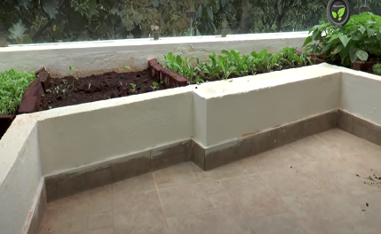
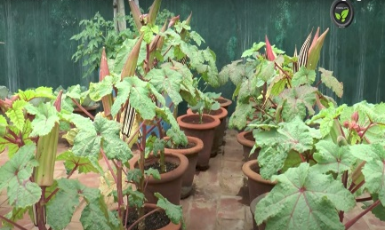
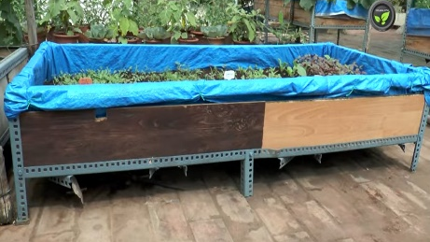
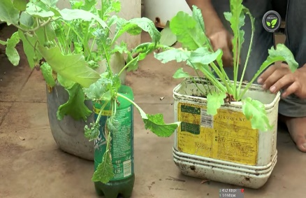
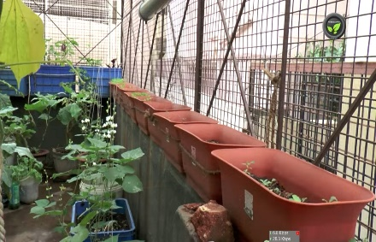
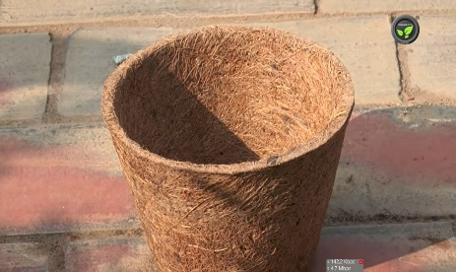
- Wide boxes b) Troughs c) Earthen pots

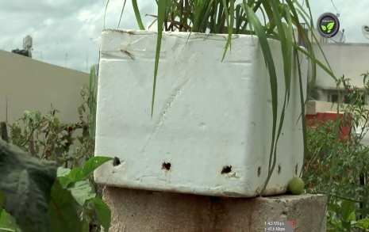
d) Coconut pots e) Plastic containers f) Plastic bottles
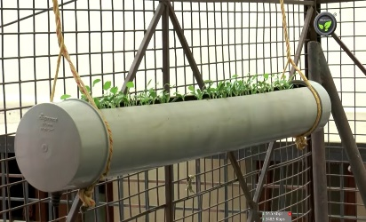
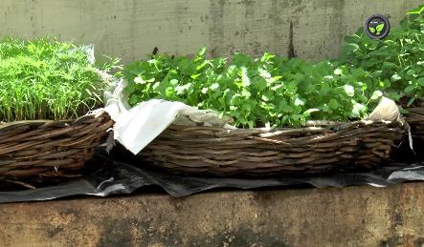

g) Thermocol boxes h) Bamboo baskets i) Horizontal PVC pipes
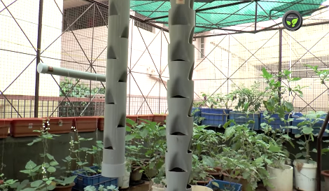
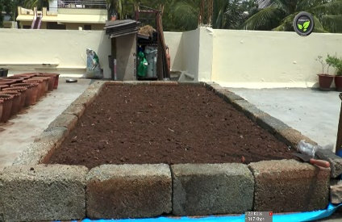
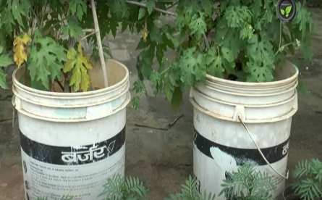

- Vertical Pvc pipes j) Plastic buckets k) raised beds

Fig : - a to k shows the pictures of different container’s and structure’s which can be used for terrace farming.

