Weed detection in pea cultivation with the Faster RCNN ResNet 50 convolutional neural network

HABIB Mohammed, Pr Youssef OUNEJJAR  Spectrometry, Materials and Archaeomaterials Laboratory (LASMAR)  Moulay Ismail University, Faculty of sciences  MEKNES, MOROCCO  moh.habib@edu.umi.ac.ma | Pr Adil TANNOUCHE  Laboratoire de l'Ingénierie et de Technologies Appliquées (LITA)  Ecole Supérieure de Technologie de Béni Mellal, MOROCCO  Université Sultan Moulay Slimane

- Abstract :
The fight against weed remains one of the major challenges in agriculture to improve land productivity. The first and most important step of this fight is to detect and locate this weed. Artificial intelligence has played a very important contribution in this detection. Several applications have been developed using Deep Learning techniques to detect and identify weed, but the variety of weed types complicates this operation. We propose a Deep Learning technique to detect and localize the crop, by training the pretrained Faster RCNN ResNet model with a rich dataset. We developed an algorithm able to detect and ultra-localize the pea crop with a classification accuracy up to 100%. The obtained results show the feasibility of this method to distinguish the crop among weed.
- Key words: Computer vision, Deep Learning, Weed detection, Precision agriculture, Pea cultivation.

- Introduction:
The fight against weed is part of the daily life of farmers, because it affects their productivity. To achieve this fight, the use of chemical treatments is necessary. The Artificial intelligence, and more precisely Deep Learning, can help to identify or extract precisely the location of this weed, which can help to limit the use of chemical products by treating only the areas concerned.
The works that have been realized in our research team has made it possible to optimize the use of chemical treatments, through the automatic control of sprayers according to the location of weed, with the objective of preserving the environment and limiting the use of herbicides, using artificial intelligence techniques. These works were based, in the first place, on the combination of Haar's pseudo-features with the Ada Boost algorithm, to detect weed of different crops in real time (Tannouche, Sbai, Rahmoune, Agounoune, et al., 2016). In the same framework, another work has developed a new adjacency descriptor for weed selection in real time for sprayer control (Tannouche, Sbai, Rahmoune, Zoubir, et al., 2016).
In the context of organic agriculture, which excludes the use of chemical treatments to maintain the health of soils, ecosystems and people (Alonso & Guzmán, 2010; de Ponti et al., 2012; Gabriel et al., 2013), weed control is based on the practice of manual weeding, which is a tiring operation that requires the presence of humans in the fields (Melander & Rasmussen, n.d.; Ramahi & Fathallah, 2006). In the perspective of dehumanising this procedure and to explore agriculture 4.0 (Blackmore, 2016; Blackmore et al., 2005; Rose & Chilvers, 2018; UK-RAS White Papers The Future of Robotic Agriculture, n.d.; Zhai et al., 2020), we have a vision of realising an automated mechanical system, based on artificial intelligence (Dimitriadis & Goumopoulos, 2008), able to simulate manual weed removal by mechanical, thermal or chemical destruction of the weed by targeting only itself. Here appears the necessity to have a new method of detection and ultra-localization of weed.
In the last few years, neural networks have been developed in a remarkable way, and they have given amazing results, specifically, in the detection and classification of objects in images, agriculture as an application field (dos Santos Ferreira et al., 2017; Kamilaris & Prenafeta-Boldú, 2018), the most popular of these networks are the SSD model (Liu et al., 2015), Faster RCNN (Ren et al., n.d.), the ResNet (He et al., n.d.), the Inception GoogleNet (Szegedy et al., n.d.) etc.
The objective of this study is to develop an algorithm based on Deep Learning, by training the Faster RCNN ResNet model, to detect and ultra-locate the crop among weed with a very high accuracy.
Materials and Methods:
Our method consists of fine-tuning the predefined Faster RCNN ResNet model, with a collected and pre-treated DataSet and augmented to generate a neural network that can detect and locate the crop and draw a bounding box around it and associate its prediction percentage, i.e. discriminate the plant from the weed.
- Acquisition and images annotations:
The selected plant is the pea (JELBANA in Arabic), we chose it because it is a crop that is fragile and more sensitive to weed, and it is more popular in the study area.
The images of this plant were collected using a digital camera phone (Huawei Y7 prime), the crop was planted in a field located in the city of MEKNES in MOROCCO (N33°52’37.647" & O5°34'4.25").
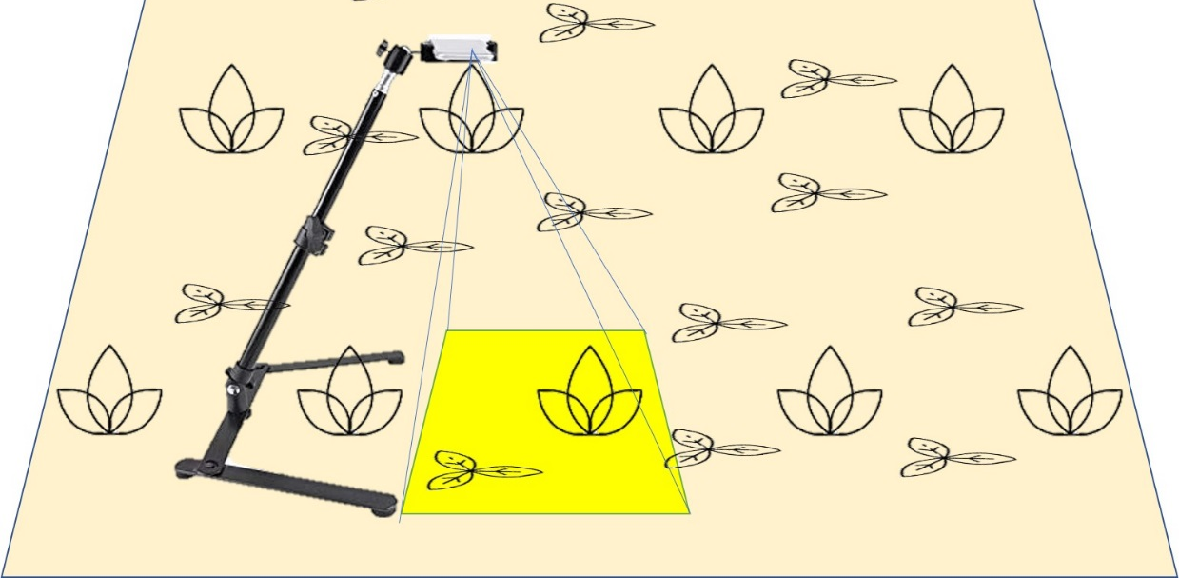
Figure1: image acquisition devices (at about 40cm from the soil).
The original dimensions of the images are 3120x4160 pixels, they are taken in different types of parcel of land and different times of the day. Subsequently they are resized to the working size of 780x1040 pixels using the image processing functionalities of the OpenCv and Python libraries, for reasons of acceptable size for the model and the limitation of storing the data in Google Drive.
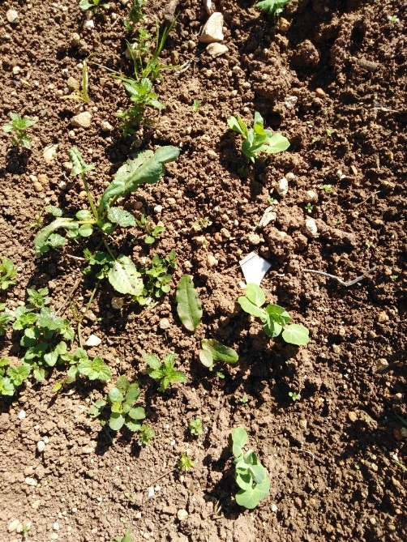 | 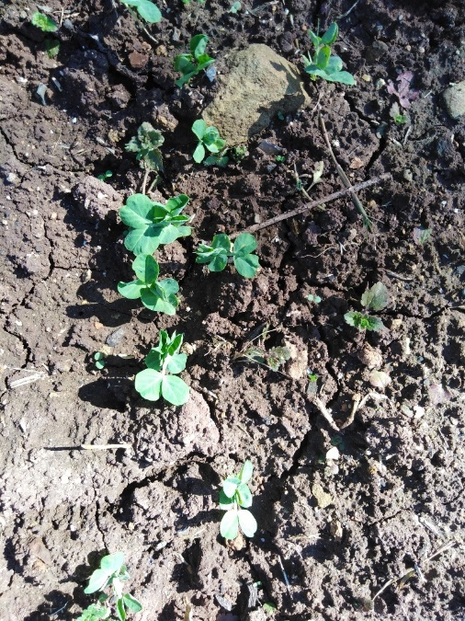
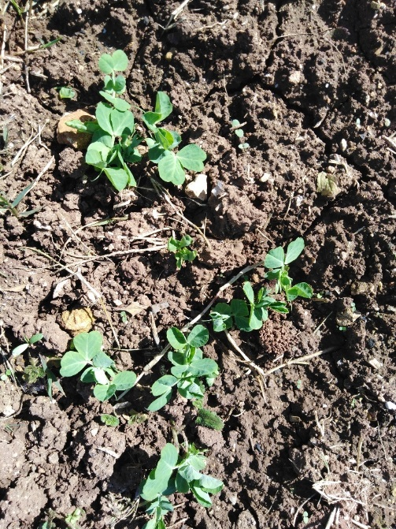 | 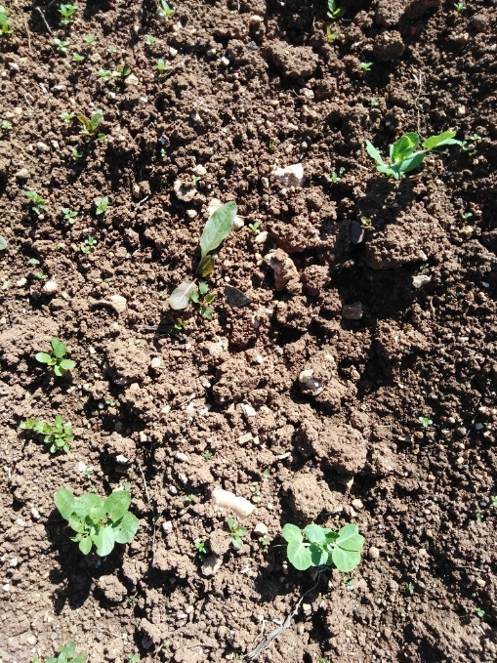
Figure 2 : The basic samples of image data
The annotations of the images (or labelling) were done manually with the LabelImg software, which allows to draw the bounding box around the plants and exports an xml file containing the coordinates (xmin, xmax, ymin, ymax) of each bounding box as well as the object class and the name of the image that contains it.
- DataSet augmentation:
The training data contains 1156 images, and to enrich the DataSet, we proceeded to increase the data, using image processing methods with the Python OpenCv library. From a single image we generated 8 different images, 180° rotation, brightness increases and decreases, horizontal mirroring, contrast enhancement, Gaussian noise and histogram equalization. With these methods we obtained 9248 images.
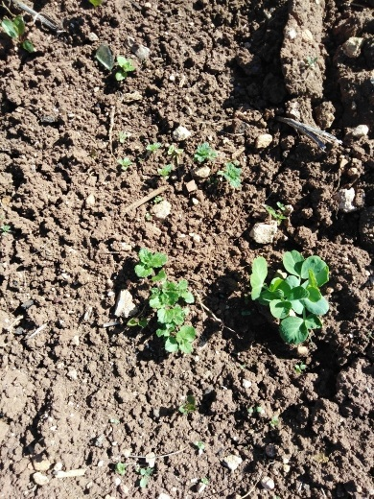  (a) | 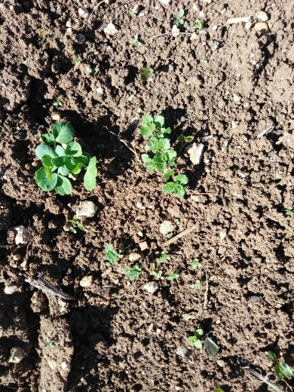  (b) | 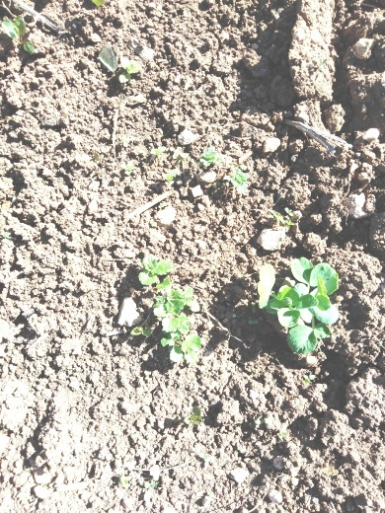  (c) | 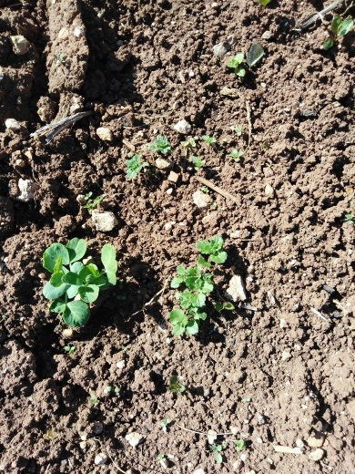  (d)
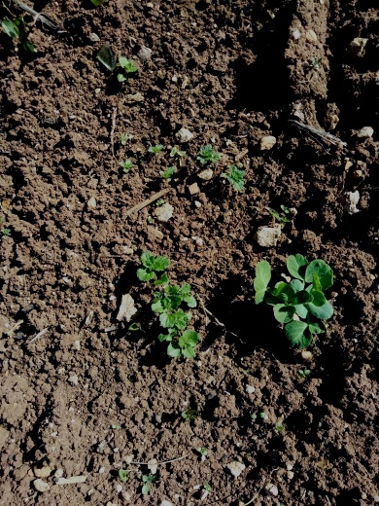  (e) | 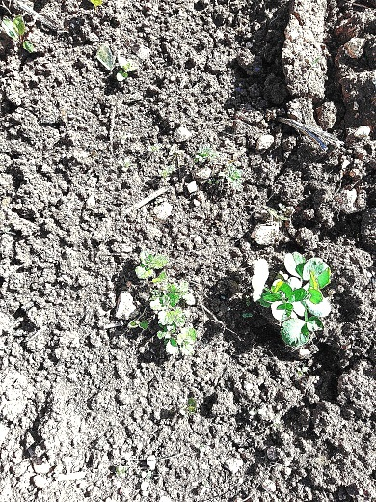  (f) | 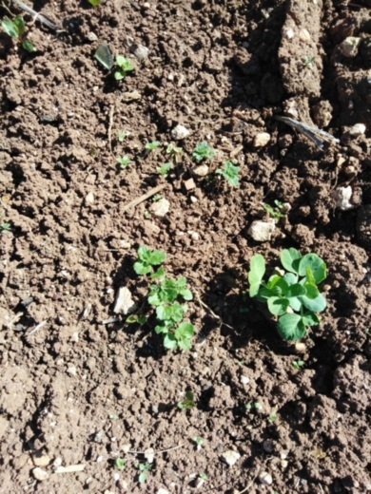  (g) | 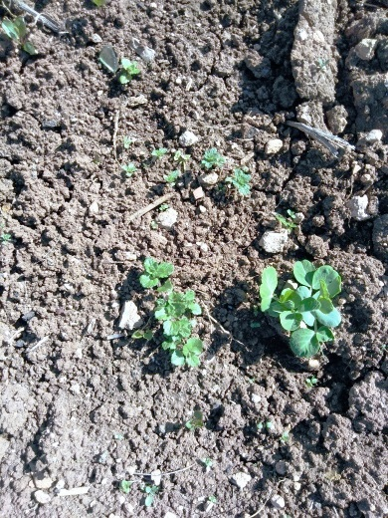  (h)
Figure 3 : An original image (a) augmented 8 ways using, 180° rotation (b), brightness increase (c), horizontal mirror (d), brightness decrease (e), contrast enhancement (f), gaussian noise (g), histogram equalization (h).
- The Faster RCNN RESNET 50 model :
We chose to work with the Faster RCNN ResNet 50 model which is one of the most popular models, it is a fast model (89ms), its accuracy is 30 COCO mAP and it is able to generate bounding boxes around the objects.
The R-CNN is a convolutional neural network based on selective search to extract about 2000 regions called region proposals from the image. It allows to reduce the number of locations taken into account considerably. The application of this method solved the CNN localisation problem, but it was still too slow. It takes almost 50 seconds of testing per image(Girshick et al., n.d.).
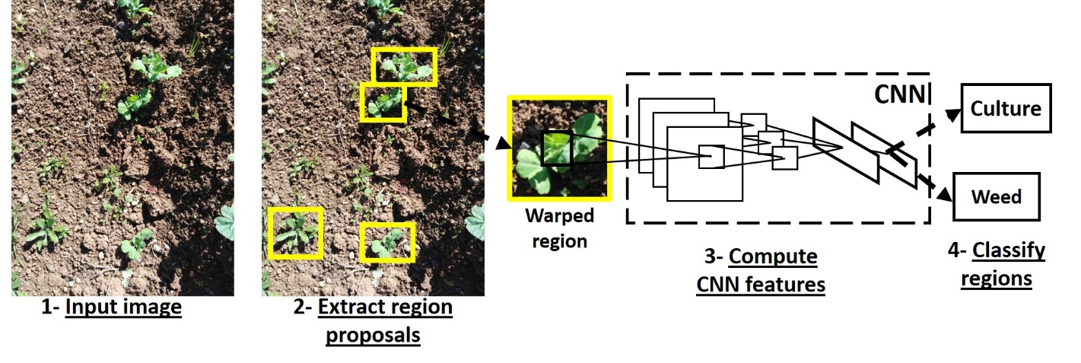
Figure 5 : R-CNN model architecture
Faster R-CNN (Ren et al., n.d.) was introduced to solve the problem of slow image processing speed, it is composed of Deep CNN to propose regions and Fast R-CNN to use the proposed regions. Faster R-CNN is quite faster than other models because it uses the method of selective search. A region proposal network (RPN) mainly tells the R-CNN where to search exactly.
A single CNN takes the entire image as input and produces a feature map. On the feature map, RPN generates a set of proposed rectangles with objectivity scores as output. These values are then resized using RoI pooling to predict classes and offset values for bounding boxes (Ren et al., n.d.).
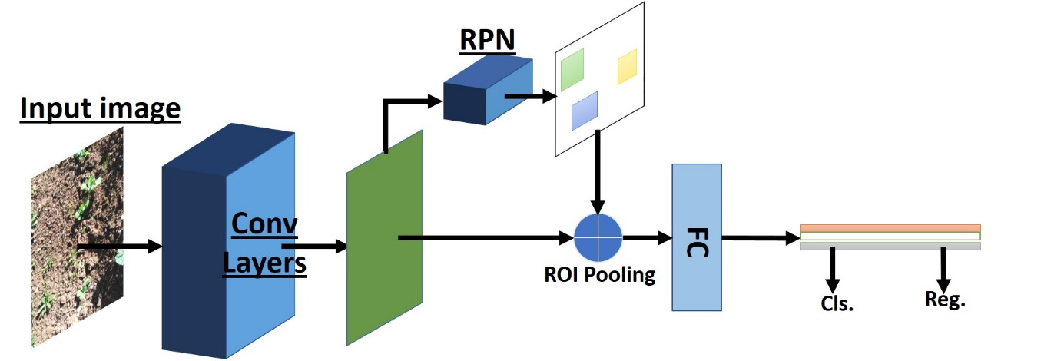
Figure 6 : Structure of the Faster R-CNN model (Chen et al., n.d.)
ResNet is an abbreviation for a residual network, as Deep Learning reaches its limits Microsoft had proposed a method to overcome the problem, which is the use of ResNet.
It consists of predicting results not only based on stacked layers, but also based on shortened connections that can skip one or more layers (He et al., n.d.).
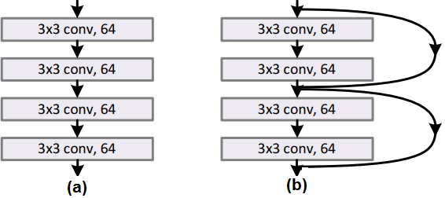
Figure 7: a comparative example of a network with ResNet (b) and a network without ResNet (a) (He et al., n.d.)
For the 50-layer ResNet each 2-layers block is replaced in the 34-layers network by this 3-layers block, giving a 50-layers ResNet.
For the ResNet advantage, its results converge faster than its ordinary network (He et al., n.d.).
For this research we adopted the Faster RCNN ResNet 50 model to detect the crop, it combines the functionalities of the two models which were already mentioned (Faster RCNN and ResNet 50).
The platform we chose for the creation and training of our model is "Google Colab"(Bisong, 2019), it is based on the Python language, as well as being configured with the essential machine learning and artificial intelligence libraries, such as TensorFlow, Matplotlib, and Keras. It is also possible to save and import files from google Drive, and most importantly it allows the use of GPU processor (Carneiro et al., 2018).
We took this opportunity to speed up and to perfect the learning of our model.
In order to make the reading of the data quicker, we opted to import our data on Google Drive.
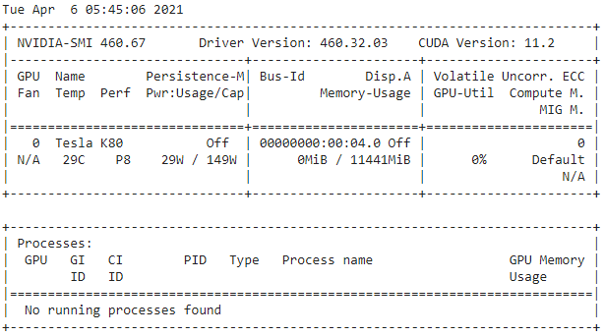
Figure 4 : the processor performances and characteristics that we used for the training
- Results and discussion:
The code we created allows us to read the data stored in Google Drive, 80% of the data is used for training and 20% for validation. The code converts the xml annotations to a csv file which compiles all these annotations in a table format and then creates a Tfrecord file which allows the serialization/deserialization of the data, this is a format highly recommended by TensorFlow as it uses less space to hold a large amount of data.
The pre-trained model was downloaded from the TensorFlow 1 Detection Model Zoo open source platform, with the configuration file (Rathod V & Wu N, 2017).
We have modified the configurations in order to obtain better results, the initial configurations are mentioned in the table :
Num classes | Batch size | Optimizer | Initial learning rate | Momentum | Num steps | Iou threshold
1 | 4 | Momentum optimizer | 0.0003 | 0.9 | 20000 | 0.50
Tableau 1 : the model training configurations
The training was started with a loss = 1.54 , the training time in each 100 steps is almost 70 seconds, with a learning speed of 1.42 steps/sec almost stable throughout the training process :
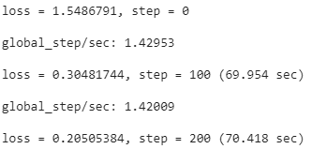
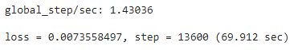
When arriving at very advanced stages we notice that the error decreases a lot (Fig. 9), it stabilizes around values lower than 0.05 which means a good learning:
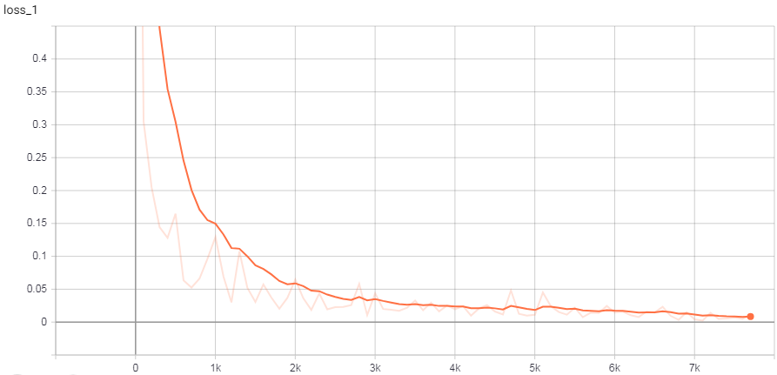
Figure 9 : the training loss plot
To measure the accuracy of our model during training, we used the mAP (mean Average Precision) index, which is a metric used to measure the accuracy of object detectors such as Faster R-CNN, SSD, etc. (Lai et al., 2017). The general definition of mean average precision (AP) is:
$AP=\int_{0}^{1}{p(r)}$ (1)
With p the precision and r the recall, these two parameters are defined by (Goutte & Gaussier, n.d.):
$p=\frac{TP}{TP+FP}$ (2)
$r=\frac{TP}{TP+FN}$ (3)
Avec :
TP : True Negative
TN : True Positive
FP : False Positive
FN : False Negative
Using the TensorBoard tool, we plotted the accuracy traces of our model for the evaluation data, the model evaluation is done at every 50 steps:
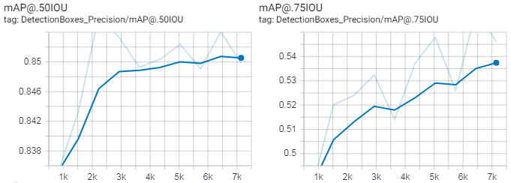
Figure 10 : mAP accuracy traces during training process
The results change depending on the IoU threshold (Rezatofighi et al., n.d.), for a threshold of IoU=0.75 the evaluation accuracy is limited to around 55%, and with a threshold of IoU=0.5 the evaluation accuracy stabilizes around 85%, that's why we chose a threshold of IoU=0.5.
At the end of the training, we tested the model generated by the test images with different conditions :
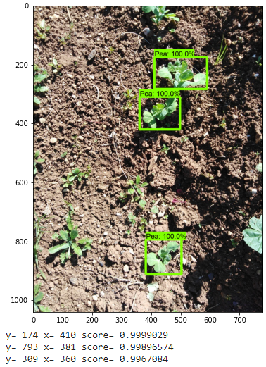 | 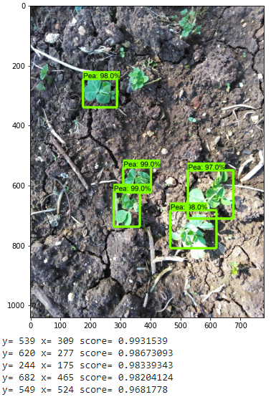
Figure 11 : Detection and ultra-localization of the culture under different conditions
So the trained model can identify and ultra-locate the crop with high predictions.
As we have previously mentioned, the variety of weed types has led us to the idea of crop detection alone which will help us to locate the weed as long as they are the rest of the weed that make up the image. This is a simpler method compared to the detection and classification of all weed types.
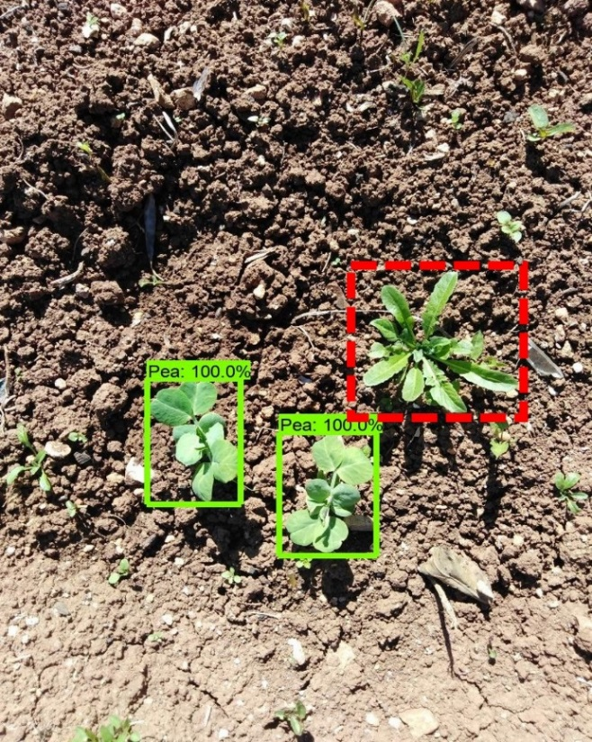
Figure 12 : Detection of pea in the presence of a weed (red box)
Looking at the results obtained, it can be seen that the choice of a lower IoU threshold caused small errors in the bounding box occlusion of the whole crop (Fig. 13), but this error does not affect the location of the plants, and can be resolved by enriching DataSet.
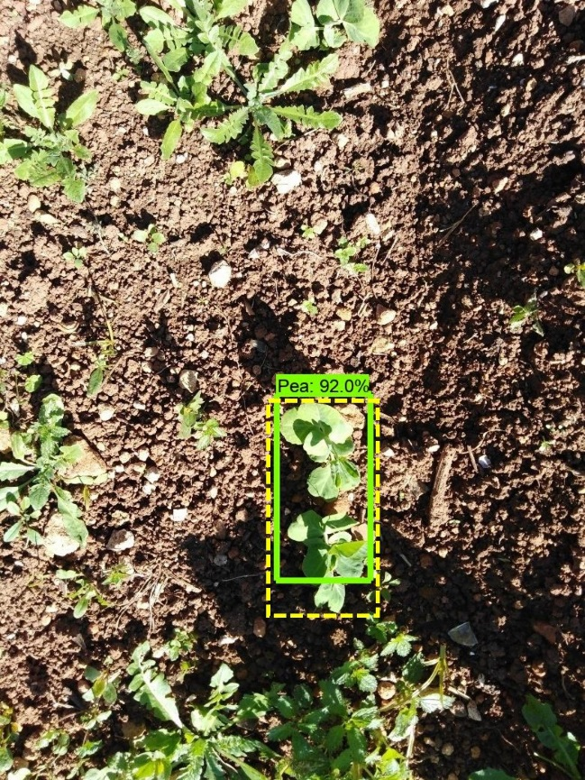
Figure 13 : the yellow box indicates the desired result
- Conclusion :
We have succeeded in building an algorithm based on Deep Learning that is able to detect and identify the pea plant among the weed. The algorithm is created from the pre-trained Faster RCNN ResNet model trained with images collected, pre-processed, annotated and increased. The obtained results are satisfactory enough, the trained model detects the crop with very high prediction accuracy reaching 100%.
The great variety of weed species complicates the detection process directly in images, because the model training requires a very rich database that contains all the weed variants, the absence of one type will cause the error of identification of this weed, so the idea of detecting the crop alone is more efficient and easier to implement.
The algorithm we have created highly supports our vision of an automatic weed control system for organic agriculture, and the results obtained show the feasibility of this system.
- References :
Alonso, A. M., & Guzmán, G. J. (2010). Comparison of the efficiency and use of energy in organic and conventional farming in Spanish agricultural systems. Journal of Sustainable Agriculture, 34(3), 312–338. https://doi.org/10.1080/10440041003613362
Bisong, E. (2019). Building Machine Learning and Deep Learning Models on Google Cloud Platform. In Building Machine Learning and Deep Learning Models on Google Cloud Platform. Apress. https://doi.org/10.1007/978-1-4842-4470-8
Blackmore, S. (2016). Towards robotic agriculture. Autonomous Air and Ground Sensing Systems for Agricultural Optimization and Phenotyping, 9866, 986603. https://doi.org/10.1117/12.2234051
Blackmore, S., Stout, B., Wang, M., & Runov, B. (2005). Robotic agriculture-the future of agricultural mechanisation? Wageningen Academic Publishers. www.AgroTechnology.kvl.dk
Carneiro, T., da Nobrega, R. V. M., Nepomuceno, T., Bian, G. bin, de Albuquerque, V. H. C., & Filho, P. P. R. (2018). Performance Analysis of Google Colaboratory as a Tool for Accelerating Deep Learning Applications. IEEE Access, 6, 61677–61685. https://doi.org/10.1109/ACCESS.2018.2874767
Chen, Y., Li, W., Sakaridis, C., Dai, D., & Gool, L. van. (n.d.). Domain Adaptive Faster R-CNN for Object Detection in the Wild.
de Ponti, T., Rijk, B., & van Ittersum, M. K. (2012). The crop yield gap between organic and conventional agriculture. Agricultural Systems, 108, 1–9. https://doi.org/10.1016/j.agsy.2011.12.004
Dimitriadis, S., & Goumopoulos, C. (2008). Applying machine learning to extract new knowledge in precision agriculture applications. Proceedings - 12th Pan-Hellenic Conference on Informatics, PCI 2008, 100–104. https://doi.org/10.1109/PCI.2008.30
dos Santos Ferreira, A., Matte Freitas, D., Gonçalves da Silva, G., Pistori, H., & Theophilo Folhes, M. (2017). Weed detection in soybean crops using ConvNets. Computers and Electronics in Agriculture, 143, 314–324. https://doi.org/10.1016/j.compag.2017.10.027
Gabriel, D., Sait, S. M., Kunin, W. E., & Benton, T. G. (2013). Food production vs. biodiversity: Comparing organic and conventional agriculture. Journal of Applied Ecology, 50(2), 355–364. https://doi.org/10.1111/1365-2664.12035
Girshick, R., Donahue, J., Darrell, T., & Malik, J. (n.d.). Rich feature hierarchies for accurate object detection and semantic segmentation. http://arxiv.
Goutte, C., & Gaussier, E. (n.d.). LNCS 3408 - A Probabilistic Interpretation of Precision, Recall and <TEX>{\itshape F}</TEX>-Score, with Implication for Evaluation.
He, K., Zhang, X., Ren, S., & Sun, J. (n.d.). Deep Residual Learning for Image Recognition. http://image-net.org/challenges/LSVRC/2015/
Kamilaris, A., & Prenafeta-Boldú, F. X. (2018). A review of the use of convolutional neural networks in agriculture. In Journal of Agricultural Science (Vol. 156, Issue 3, pp. 312–322). Cambridge University Press. https://doi.org/10.1017/S0021859618000436
Lai, S.-H., Lepetit, V., Nishino, K., & Sato, Y. (Eds.). (2017). Computer Vision – ACCV 2016 (Vol. 10115). Springer International Publishing. https://doi.org/10.1007/978-3-319-54193-8
Liu, W., Anguelov, D., Erhan, D., Szegedy, C., Reed, S., Fu, C.-Y., & Berg, A. C. (2015). SSD: Single Shot MultiBox Detector. https://doi.org/10.1007/978-3-319-46448-0_2
Melander, B., & Rasmussen, G. (n.d.). Effects of cultural methods and physical weed control on intrarow weed numbers, manual weeding and marketable yield in direct-sown leek and bulb onion. http://www.daehnfeldt.com
Ramahi, A. A., & Fathallah, F. A. (2006). Ergonomic evaluation of manual weeding practice and development of an ergonomic solution. Proceedings of the Human Factors and Ergonomics Society, 1421–1425. https://doi.org/10.1177/154193120605001335
Rathod V, & Wu N. (2017). https://github.com/tensorflow/models/blob/master/research/object_detection/g3doc/tf1_detection_zoo.
Ren, S., He, K., Girshick, R., & Sun, J. (n.d.). Faster R-CNN: Towards Real-Time Object Detection with Region Proposal Networks. https://github.com/
Rezatofighi, H., Tsoi, N., Gwak, J., Sadeghian, A., Reid, I., & Savarese, S. (n.d.). Generalized Intersection over Union: A Metric and A Loss for Bounding Box Regression.
Rose, D. C., & Chilvers, J. (2018). Agriculture 4.0: Broadening Responsible Innovation in an Era of Smart Farming. Frontiers in Sustainable Food Systems, 2. https://doi.org/10.3389/fsufs.2018.00087
Szegedy, C., Liu, W., Jia, Y., Sermanet, P., Reed, S., Anguelov, D., Erhan, D., Vanhoucke, V., & Rabinovich, A. (n.d.). Going Deeper with Convolutions.
Tannouche, A., Sbai, K., Rahmoune, M., Agounoune, R., Rahmani, A., & Rahmani, A. (2016). Real time weed detection using a boosted cascade of simple features. International Journal of Electrical and Computer Engineering, 6(6), 2755–2765. https://doi.org/10.11591/ijece.v6i6.11878
Tannouche, A., Sbai, K., Rahmoune, M., Zoubir, A., Agounoune, R., Saadani, R., & Rahmani, A. (2016). A fast and efficient shape descriptor for an advanced weed type classification approach. International Journal of Electrical and Computer Engineering, 6(3), 1168–1175. https://doi.org/10.11591/ijece.v6i3.9978
UK-RAS White papers The Future of Robotic Agriculture. (n.d.). www.ukras.org
Zhai, Z., Martínez, J. F., Beltran, V., & Martínez, N. L. (2020). Decision support systems for agriculture 4.0: Survey and challenges. In Computers and Electronics in Agriculture (Vol. 170). Elsevier B.V. https://doi.org/10.1016/j.compag.2020.105256

