Morphological and Molecular Characterization of Five Cultivars of Ziziphus spp. Cultivated in Southern Iraq.
Ahmed Yousef Lafta Hzaa^{a*} - Israa malallah alkanan^{b**}
ªDepartment of Horticulture, College of Agricultural, University of Basrah, Iraq.
^{b} Department of Anesthesia and Intensive Care, Technical Institute, Southern Technical University,.
*Corresponding author’s Email: ahmed.lafta@uobasrah.edu.iq, Phone: +9647702681501
linkedin.com/in/ahmed-lafta-9a8aaa182
Email: israa.malallah@stu.edu.iq**

ABSTRICT
Ziziphus spp. is one of the economic fruit trees whose cultivation spreads in southern Iraq, so the study was conducted with the aim of characterizing the morphological, molecular, and genetic diversity of five cultivars (Malasy, Normal, Zaytony, Bambawi, Tofahy), using 12 morphological indicators for leaf and fruit and six primers for RAPD technology. The results of the morphological characterization showed that the two cultivars (Normal and Malasy) recorded the highest genetic kinship between them amounting to 10.04, while the farthest genetic distance between the two cultivars (Zaytony and Normal) was recorded, which amounted to 29.38. As for the molecular characterization results, the primers produced 113 bands, with an average of 18.8 bands for each primer, and the percentage of polymorphism was 100%, and unique bands totaling 51 bands appeared, including 17 bands with different molecular weights characteristic of the cultivars. The genetic tree diagram showed the distribution of cultivars in two groups. The combination of morphological and molecular characterization is one of the most important tools that can be relied upon in finding genetic differences and determining fingerprints, especially between types of genders or cultivars of the same species.

Introduction
Sidr (Ziziphus spp) is a perennial evergreen tree and shrubs. Its cultivation is spread in tropical, semi-tropical and temperate regions, It belongs to the family Rhamnaceae, and the genus ziziphus is one of the most prominent genera of the family, as it includes about 170 species (Christenhusz and Byng., 2016). Sidr trees are considered multi-purpose, as their fruits are eaten fresh due to their high content of vitamins, especially ascorbic acid, carbohydrates, fiber and minerals. It is rich in protein compared to apples and ripe fruits. Sidr trees are used as windbreaks or as fuel, in addition to the medicinal benefits of its leaves and bark (AL-Marzooq 2014 ; Bukar et al 2015).
Morphological markers are the basis that researchers have followed since ancient times in the study of plant classification, and it is one of the methods used to study the genetic relationships between cultivars. These markers to characterize the new cultivars of each plant depend on a set of traits that have the ability to distinguish the cultivars from each other (Judd et al 1999). With the progress of molecular biology, many molecular markers have emerged that have been used in many fields, especially the study of genetic diversity, finding genetic fingerprints for plants, genetic mapping, finding genetic affinity, and in plant breeding programs (Xu et al 2016). The flowering period in Ziziphus (up to 7 years) and during this period the plant needs a lot of agricultural and economic service operations. DNA tags are a very useful tool for cultivar identification during breeding and growth (Singh et al., 2009). Genetic diversity in the genus Ziziphus was assessed using different systems of DNA molecular markers, such as RAPD and SRAP (Li et al., 2010). ISSR (Al-asadi, 2018).
Molecular analysis was used to study the genetic diversity of three cultivars of Ziziphus spp. in Egypt.Three primers were used for RAPD and ten primers for SRAP technology.The results showed the emergence of 75 bands produced by RAPD primers, of which 32 (42.67%) were polymorphic and 43 (57.33%) were monomorphic.Also, 21 unique bands specific to the cultivar appeared, and 11 common and unique bands were obtained between each of the two cultivars studied. (Youssef & Elazab 2013).
A study (Bhattarai and Pathak, 2015) recorded a new species in Nepal based on finding differences in leaf shape, dimensions, tree shape and size, and comparing it with other species.
A study was conducted by (Tatari et al. 2016) to assess the genetic diversity of five different ecotypes of Ziziphus jujuba Mill based on morphological characteristics in Isfahan Province, Iran. The results showed that the quantitative characteristics were more important in the ecological patterns such as the dimensions of the leaves and the weight, length and diameter of the fruit, the results also showed a significant negative and positive correlation between some traits. Morphological and molecular characterization was carried out for ten cultivars of Sidr trees (Ziziphus nummularia Burm. F.) grown in different regions of India, A large discrepancy was observed between the cultivars by analyzing five quantitative traits and 25 qualitative morphological traits for leaves, fruits and seeds. ISSR markers also showed polymorphism (86.58%).The genetic similarity value was in the range 0.45-0.77 indicating a moderate level of genetic diversity among the cultivars, and two of the eleven ISSR primers were also able to generate unique cultivar-specific bands, which can be used to determine the genetic fingerprint of the cultivars Zadber-5 and Zadber- 8. The study revealed that morphological and molecular markers can be used successfully to determine the genetic diversity and genetic relationship of Sidr cultivars and use them in breeding programmes. (Akhtar et al., 2017).
A comparison of morphological and molecular traits was evaluated for characterization among three species of Ziziphus in Iran using a combination of morphological and molecular traits, Both morphological and molecular data revealed a high level of internal qualitative differences between the accessions. The percentage of formal polymorphism was 90.49%, and the average content of the information polymorphism was 0.37. At the same time, a significant correlation was recorded between morphological and molecular markers, suggesting this could serve as a useful tool in optimization programs (Zarei et al. 2021).

Materials and methods
The study was carried out on five cultivars of Sidr trees (Malasy, Normal, Zaytony, Bambawi Tofahy) planted in different regions of southern Iraq. The study included morphological characterization using 12 leaf and fruit characteristics, which included (leaf length, leaf width, leaf holder length, leaf area, fruit weight, fruit length, fruit width, fruit size, fruit pulp weight, seed weight, seed length, diameter seed). As for the molecular study, it included molecular characterization using six primers of Random Amplified Polymorphic DNA (RAPD) technique. The molecular study was conducted in the Biotechnology Laboratory at the Department of Horticulture and Landscaping - College of Agriculture - University of Basra. Samples were collected from young leaves, sterilized and preserved until DNA extraction.
DNA extracted according to the method of Doyle (1991), the DNA concentration and purity were estimated using a Nano Drop ND-2000 Spectrophotometer (THERMO SCIENTIFIC, USA) at a wavelength of 260 nm, according to the ratio A260/A280.
The polymerase chain reaction (RAPD-PCR) was carried out according to the replication stages: the initial denaturation phase of the DNA strand was one cycle at 94ºC for a period of 7 minutes, followed by the replication phase was 40 cycles, each cycle included: 30 seconds for the template denatured at 94ºC, then 60 seconds at 94ºC. Heat (32) to bind the DNA template to the primers, then 2 minutes at a temperature of 72 to elongate the primers. Then the final elongation stage, one cycle at 72 ºC, for 5 minutes.
data analysis:
The morphological characterization was carried out based on the studied traits, as the genetic distances were measured after the Eucliden disstandes matrix was created between the cultivars under study using the Eucliden coefficient. The genetic kinship tree was drawn by applying the unweighted pair group method with arithmetic average (UPGMA) to show the distribution of cultivars into clusters or clusters in the form of a dendrogram. A Principal coordinate analysis (PCA) was also carried out using Past software ver 3, (Hammer et al., 2001).
As for the molecular characterization, it first included determining the molecular weights of the bands produced by the polymerase chain reaction (PCR) based on the DNA Ladder 100 bp volume guide produced by Promega company. Using Gel Analyzer 2010a Image Documentation Software. Then, the results of the bands obtained using the above techniques were recorded and converted into descriptive tables in Microsoft Excel by placing (1) when the band is present, and setting (0) for its absence. The results were analyzed according to the pre-prepared tables using the biostatistical program Past software ver 3. The genetic dimension was analyzed using the Jaccard coefficient of genetic similarity between the cultivars under study.

Results
Morphological characterization:
The results of the analysis of the main components (Fig. 1) showed the presence of four factors that contributed to the total cumulative variance between the variables, and the first component had the highest contribution rate of 76.62% of the total variance. While the second component contributed 17.65%, it should be noted that the other components had low contribution rates.

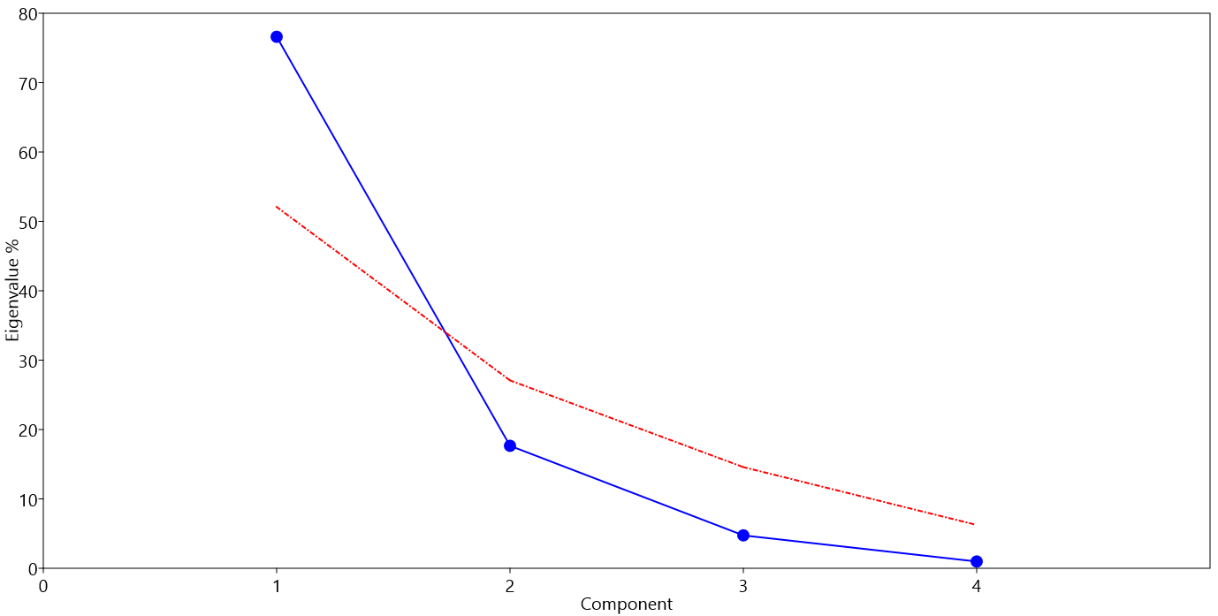
Figure 1. Diagram of imaginary roots for Sidr cultivars based on morphological characteristics.

Figure (2) shows the percentages of the contributions of the variables that represent the differences in the first component (which recorded the highest percentage of contributions to the total variance) resulting from the phenotypic traits. It is noticed that the characteristic of the length of the fruit recorded the highest percentage of contributions in finding differences, followed by the characteristic of leaf area, while the rest of the attributes recorded varying percentages of contributions in the variations of the first component.
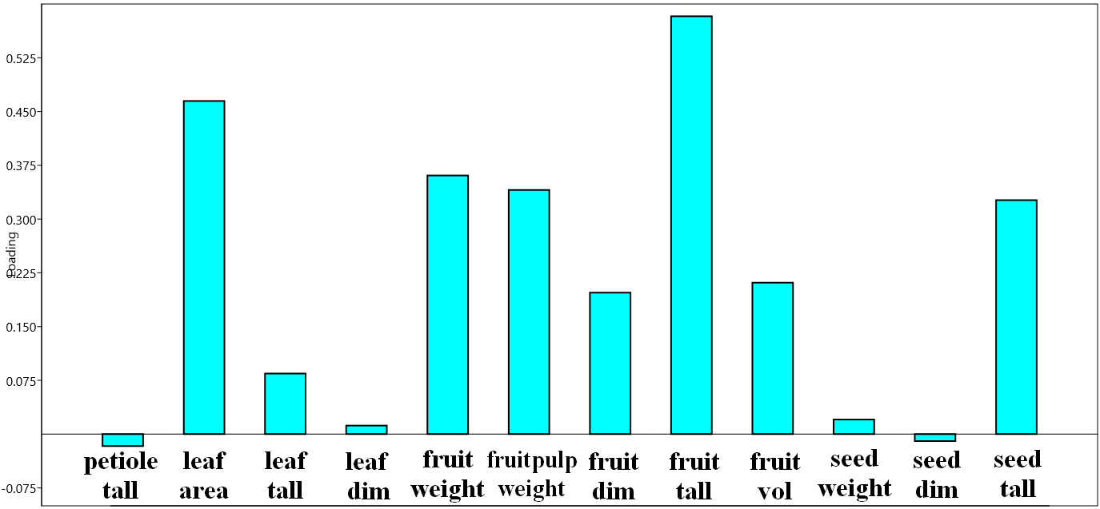
Figure 2 . Variable Contribution Ratios in the variance of the basic components on the basis of morphological characteristics
As for the relationship between the varieties and the morphological features that participate in the study of diversity among the cultivars, in Figure (3) this relationship is shown on the two orthogonal axes. If it is noted from the figure that the characteristics of the length of the fruit and the leaf area are among the most significant characteristics and greatly affected the association and distribution of varieties,(Table 1). And the determination of the genetic relationship, and this could indicate that these two characteristics are the result of gene expression processes and genes of common origin. In addition, it had a major role in the spacing and convergence of genetic distances between cultivars.
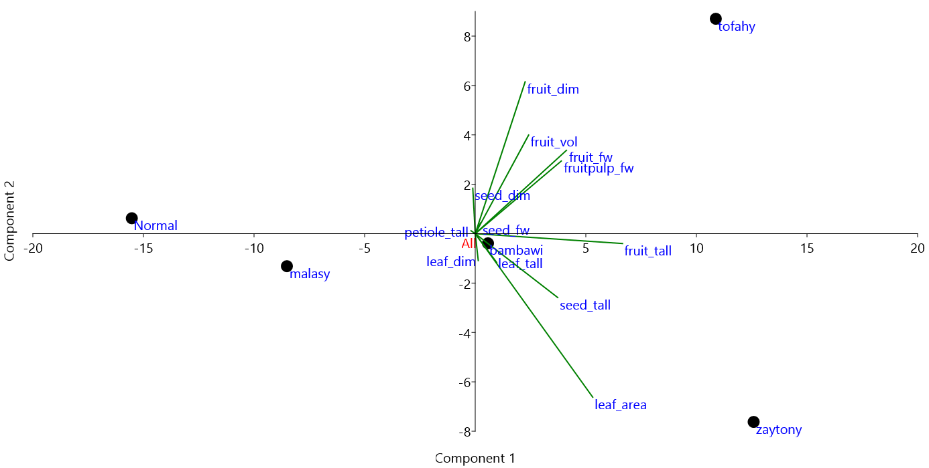
Figure 3.. Principal Coordinates Analysis of the contribution of morphological characteristics to the association and distribution of cultivars

Table 1. Morphological characteristics of the leaf, fruits and seed of the five-sidr cultivars.

 | petiole  tall | leaf  area | leaf  tall | leaf  dim | fruit  fw | fruitpulp  fw | fruit  dim | fruit  tall | fruit  vol | seed  fw | seed  dim | seed  tall
Malasy | 1.4 | 18.09 | 4.42 | 3.7 | 5.03 | 4.81 | 22.08 | 19.62 | 5 | 0.22 | 6.67 | 10.29
Normal | 1.71 | 10.11 | 4.34 | 3.8 | 3.42 | 3.17 | 18.2 | 17.12 | 4.55 | 0.25 | 9.81 | 10.89
Zaytony | 1.1 | 29.12 | 7.3 | 4.75 | 11.09 | 10.62 | 20.35 | 33.19 | 7.5 | 0.47 | 7.39 | 20.88
Bambawi | 1.5 | 17.15 | 6.5 | 5.21 | 7.51 | 6.78 | 22.13 | 28.41 | 7.55 | 0.73 | 8.71 | 16.74
Tofahy | 1.28 | 19.22 | 5.45 | 3.19 | 15.18 | 14.13 | 29.26 | 31.53 | 12.8 | 1.05 | 9.68 | 16.27
The results of the cluster analysis (Fig. 4) showed that the cultivars were distributed in two groups (A, B). Group A included three cultivars, as the two cultivars (Normal and Malasy) combined into one cluster and recorded the highest genetic kinship between them amounting to 10.04, while the bambawi cultivar was isolated alone. Cluster associated with the two classes.
As for group B, it included the two cultivars (tofahy and Zaytony). The farthest genetic distance between the two cultivars (Zaytony and Normal) was recorded, which was 29.38. As for the rest of the cultivars, different genetic dimensions were recorded (Table 2).

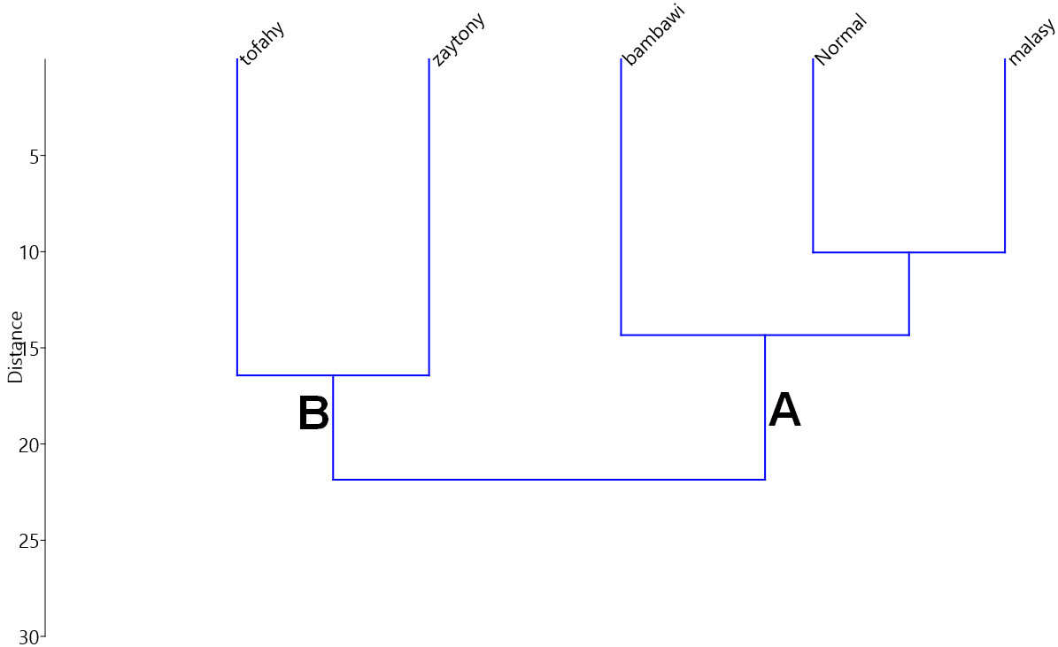

Figure 4 : Dendrogram of Sidr varieties depending on morphological characteristics

Table 2 Matrix of genetic dimensions of Sidr cultivars based on morphological characteristics.

 | malasy | Normal | zaytony | bambawi | tofahy
malasy | 0 | 10.04 | 22.53 | 12.14 | 22.19
Normal | 10.04 | 0 | 29.38 | 16.54 | 27.76
zaytony | 22.53 | 29.38 | 0 | 14.72 | 16.43
bambawi | 12.14 | 16.54 | 14.72 | 0 | 14.55
tofahy | 22.19 | 27.76 | 16.43 | 14.55 | 0

The phenotypic variance between cultivars that have a common genetic origin is affected by different factors. For example, inter-individual variance in the degree and location of DNA methylation, a genetic phenomenon widely observed in plants, leads to the production of new phenotypic variance that can be inherited steadily through generations (Kalisz and Purugganan 2004).
The phenotypic variance may also be affected by the environmental conditions surrounding the plant, which lead to changes in the morphological features, which reveals an expression by the environment of new loci and phenotypes.( Whitehead and Crawford 2006). Through the above results, the discrepancy in the morphological characteristics of leaves and fruits can be explained by the presence of genetic factors specific to the species. Also, the environmental impact can indirectly affect the phenotypic traits and that it falls under limited levels that are subject to genetic signals represented by the gene expression processes of the phenotypic traits associated with these varieties. (El-Nagerabi et al., 2013).
The variance between the characteristics of the leaf had an effect in distinguishing between the varieties, as (Akhtar et al., 2017) studied 8 components of the phenotypic characteristics of Sidr, and the highest percentage of the first component was 96.74%. The results were also in agreement with (Sulusoglu et al., 2014), which showed that the characteristics of the length and diameter of the fruit had a significant impact on the variance between the studied cultivars.
Molecular characterization:
The results of cultivar amplification by RAPD primers (Table 3) showed that they varied in the number of amplified bundles, as they produced 113 bands, with an average of 18.8 bands for each primer, as the OPB-09 produced the largest number of bands and amounted to 24 bands, while the OPB-11 gave less the number of inflated bands amounted to 14 bands (Figure 5). As for the number of polymorphic bands, it amounted to 76 bands, with an average of 12.6 bands for each primer. The OPA-09 produced the highest number of polymorphic bands, amounting to 16, while the OPB-07 gave 9 bands of polymorphism, which is the lowest number of bands generated by the primers.
The primers also produced unique bands totaling 51 bands and an average of 8.5 bands for each primer. OPA-09 gave 14 unique bands, while the OPC-09 gave only three unique bands. Some unique bands distinguished for the cultivar appeared at different molecular weights. It did not appear in the rest of the cultivars, which could be a genetic fingerprint for these cultivars that appeared in it. Also (Table 3) shows that the six cultivars gave a high percentage of formal polymorphism in the cultivars amounting to 100%. As for the efficiency of the primers, the OPB-09 recorded the highest efficiency rate of 21.24%, while the lowest efficiency rate was 12.34% recorded by the primer OPB-11 , As for the diagnostic ability of the primers only, the OPA-09 gave the highest diagnostic ability of 21.05%, while the OPB-07 gave the lowest discriminatory ability of 11.84%.

Table 3- RAPD primers from the bands, their efficiency ratios and their discriminatory ability in Sidr cultivars.

primers | Sequence (5´-3´) | No total bands | Mono | Poly | Unique bands | Poly | Primer Efficiency% | Primer Discrimination power %
 |  |  | morphism bands | morphism bands |  | morphism %
OPA-09 | GGGTAACGCC | 18 | 0 | 16 | 14 | 100 | 15.93 | 21.05
OPA-11 | CAATCGCCGT | 14 | 0 | 12 | 10 | 100 | 12.34 | 15.79
OPB-07 | GGTGACGCAG | 20 | 0 | 9 | 4 | 100 | 17.70 | 11.84
OPB-09 | TGGGGGACTC | 24 | 0 | 14 | 8 | 100 | 21.24 | 18.42
OPC-08 | TGGACCGGTG | 16 | 0 | 14 | 12 | 100 | 14.16 | 18.42
OPC-09 | CTCACCGTCC | 21 | 0 | 11 | 3 | 100 | 18.58 | 14.47
total |  | 113 | 0 | 76 | 51
Mean |  | 18.8 | 0.0 | 12.6 | 8.5 | 100 | 16.66 | 16.66

Figure 5. PCR amplification of RAPD six primers in five Sider cultivars on 2% agarose gel, M=100bp plus DNA ladder ( 1. Malasy 2. Normal 3. Zaytony 4. Bambawi 5. Tofahy )

The tree cluster analysis diagram for the cultivars, based on the results of the primers, showed that the cultivars were distributed in two main clusters (Fig. 6). The first cluster A included the two cultivars (Tofahy and Bambawi), while the second cluster B included the Normal cultivar, which was isolated by itself and linked to a sub-cluster that included the two cultivars (Zaytony and Malasy) together.
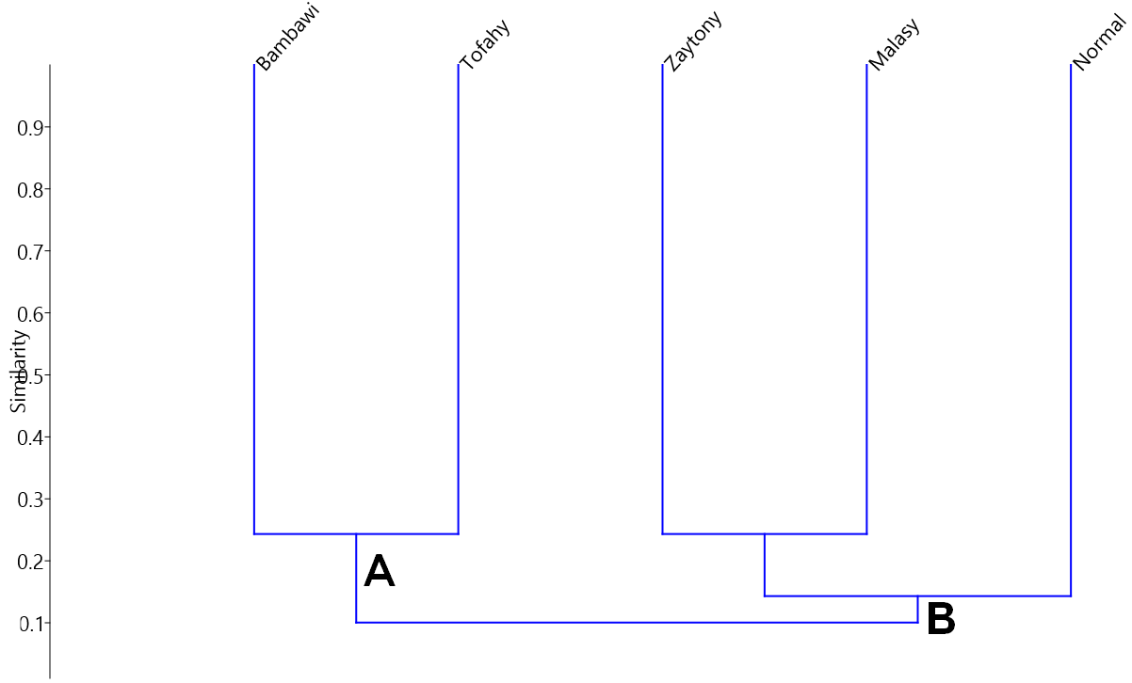
Figure 6 : Tree cluster analysis diagram of Sidr cultivars depending on six RAPD primers.
Table (4) indicates the values of genetic similarity between the cultivars, as the highest genetic similarity value was between the two cultivars (Zaytony and Malasy) and amounted to 0.243, As for the lowest value of genetic similarity, it was recorded between the two cultivars (Bambawi and Zaytony), and it was 0.049. The genetic similarity values for the rest of the cultivars ranged between the highest and the lowest, as the values were low, and this indicates the genetic diversity among the cultivars.
Table 4. Matrix of genetic dimensions of Sidr cultivars based on six RAPD primers.
 | Malasy | Normal | Zaytony | Bambawi | Tofahy
Malasy | 1 | 0.158 | 0.243 | 0.075 | 0.065
Normal | 0.158 | 1 | 0.128 | 0.206 | 0.068
Zaytony | 0.243 | 0.128 | 1 | 0.049 | 0.140
Bambawi | 0.075 | 0.206 | 0.049 | 1 | 0.243
Tofahy | 0.065 | 0.068 | 0.140 | 0.243 | 1

Discussion
The results of the molecular characterization show that there are differences in the number of amplified bands and their molecular weights resulting from amplifying samples of cultivars according to the different primer used, resulting from a difference in the number of complementary sites for that primer or the absence of complementary sites for the primer in the genome of Sidr plant. As in Youssef & Elazab (2013) study of genetic diversity, using three RAPD primers, which gave 75 bands, of which 32 (42.67%) are polymorphic and 43 (57.33%) are monomorphic. Also, 21 unique bands specific to the cultivar appeared.
Some leaf and fruit morphological traits were found to be cultivar-specific such as leaf area in combination with fruit length. Although all these traits may change to some extent with changing climatic conditions and other biotic and abiotic factors; Nevertheless they provide a reliable basis for cultivar identification in Sidr.
Morphological assessment of current plant genetic resources is an essential component of the management, use and improvement of each plant species (Zarei et al. 2019). Wide phenotypic variance within and between Ziziphus species is revealed in the present work.
According to Gao et al. (2011) Both genotype and environmental status are among the major factors influencing plant characteristics and may lead to significant variation in fruit dimensions. Improving the weight and length of fruits is one of the most important objectives of Sidr breeding programs (Norouzi et al. 2017). Therefore, the current cultivars are a rich source of selection and cross-breeding aimed at improving fruit characteristics in Ziziphus species.

Conclusion
Overall, the morphological and molecular analysis indicated that the genetic material under study presented some distinctive features, considering the different traits described in Sidr. Although varieties can be distinguished based on quantitative and qualitative traits.
The combination of morphological and molecular characterization is one of the most important tools that can be relied upon in finding genetic differences and determining fingerprints, especially between types of genders or cultivars of the same species.
Acknowledgments
All the appreciation and thanks go to the Biotechnology Laboratory - Palm Research Center - University of Basra. and The Department horticulture & landscap for supporting this work.

References
Akhtar Y, Choudhary R, Sharma K C, Sharma M. 2017. Genetic variability and relationship studies of Ber Ziziphus nummularia (Burm. F.) using morphological and molecular markers. Pharmacognosy Journal, 9(3). http://dx.doi.org/10.5530/pj.2017.3.71
Al-asadi M T. 2018. Study of the phenotypic, chemical and molecular characterization of some cultivar sider Zidiphus spp and the response of the CV.tofahy to spray by salicylic acid and tryptophan in some vegetative and fruit traits M.Sc. College of Agriculture - University of Basra. 208 pp.
AL-Marzooq M A. 2014. Phenolic compounds of Napek leave (Zizyphus spina-christi L.) as natural antioxidants. J. F. Nutr. Scie. 2(5): 207-214. doi: 10.11648/j.jfns.20140205.11
Bhattarai K R, Pathak M L. 2015. A New Species of Ziziphus (Rhamnaceae) From Nepal Himalayas. Indian. J.Plant.Sci..4 (2): pp.71-77.

Bukar A M, Kyari M Z, Gwaski P A, Gudusu M, Kuburi F S, Abadam Y I. 2015. Evaluation of phytochemical and potential antibacterial activity of Ziziphus spina-christi L. against some medically important pathogenic bacteria obtained from University of Maiduguri Teaching Hospital, Maiduguri, Borno State – Nigeria. J. Pharm. Phyto. . 3(5):98-101.
Christenhusz J M, Byng I W. 2016. The number of known plants species in the world and its annual increase. Phytotaxa 261 (3): 201–217. https://doi.org/10.11646/phytotaxa.261.3.1
Doyle J. 1991. DNA protocols for plants. In Molecular techniques in taxonomy , 283-293: Springer.
https://link.springer.com/chapter/10.1007/978-3-642-83962-7_18
El-Nagerabi S.A.F, Elshafie A.Q, Alkhanjari S.S. 2013. Endophytic fungi associated with Ziziphus species and new records from mountainous area of Oman. Bio 14 (1): 10-16. https://doi.org/10.13057/biodiv/d140102
Gao QH, Wu PT, Liu JR, Wu CS, Parry JW, Wang M. 2011. Physicochemical properties and antioxidant capacity of different jujube (Ziziphus jujuba Mill.) cultivars grown in loess plateau of China. Sci Hortic 130:67–72. https://doi.org/10.1016/j.scienta.2011.06.005
Hammer Ø., Harper D. A, Ryan P D. 2001. PAST: paleontological statistics software package for education and data analysis. Palaeontologia electronica 4(1): 1-9. https://palaeo-electronica.org/2001_1/past/issue1_01.htm
Judd W. S, Campbell C S, Kellog E A, Stevens P F. 1999. Plant Systematic ,a Phylogenetic Approach .Sinauer Associates. Sander and Massachusetts, USA.,464pp. https://doi.org/10.1080/10635150490445878
Li L., Jian-ying P, Rui-xia B. 2010. Analysis of the Genetic Relationships in Chinese Ziziphus with SRAP Markers. Agricultural Sciences in China 9:1278-1284. https://doi.org/10.1016/S1671-2927(09)60217-0
Kalisz S, Purugganan MD. 2004. Epialleles via DNA methylation: consequences for plant evolution. Trends in Ecology & Evolution. 1;19(6):309-14. https://doi.org/10.1016/j.tree.2004.03.034
Norouzi E, Erfani-Moghadam J, Fazeli A, Khadivi A . 2017. Morphological variability within and among three species of Ziziphus genus using multivariate analysis. Sci Hortic 222:180–186. https://doi.org/10.1016/j.scienta.2017.05.016
Singh A K., Singh R, Singh N.K. 2009. Comparative evaluation of genetic relationships among ber (Ziziphus sp.) genotypes using RAPD and ISSR markers. Indian J. Genet. 69(1):50-57.
Sulusoglu M, Cavusoglu A, Dede, N, Unver H. 2014. Morphological, pomological and nutritional traits of jujube (Ziziphus jujuba Mill.). Pomology, Viticulture and Enology.49(9): 727-731. https://www.cabdirect.org/cabdirect/abstract/20163271326
Tatari M., Ghasemi A., Mousavi A. 2016. Genetic diversity in Jujube germplasm (Ziziphus jujuba Mill.) based on morphological and pomological traits in Isfahan province, Iran. Crop Breeding Journal, 6(2), 79-85. https://dx.doi.org/10.22092/cbj.2016.107110
Whitehead A, Crawford DL. 2006. Variation within and among species in gene expression: raw material for evolution. Molecular ecology. 15(5):1197-211. https://doi.org/10.1111/j.1365-294X.2006.02868.x
Xu C, Gao J, Du Z, Li D, Wang Z, Li Y, Pang X. 2016. Identifying the genetic diversity, genetic structure and a core collection of Ziziphus jujube Mill. var. jujuba accessions using microsatellite markers. Sci. Rep.6(13): 503. http://dx.doi.org/10.1038/srep31503
Youssef M, Elazab D S. 2013. Molecular analysis of Ziziphus spp. cultivars in Egypt. In III International Symposium on Molecular Markers in Horticulture 1100 (pp. 37-44). https://doi.org/10.17660/ActaHortic.2015.1100.4
Zarei A, Erfani-Moghadam J, Jalilian H. 2019. Assessment of variability within and among four Pyrus species using multivariate analysis. Flora. 1;250:27-36. https://doi.org/10.1016/j.flora.2018.11.016
Zarei A., Rezaei A., Esmailpour M., Ebrahimi A. 2021. A comparative assessment of morphological and molecular characterization among three Ziziphus species. Physiology and Molecular Biology of Plants, 27(5), 1007-1025. https://doi.org/10.1007/s12298-021-01000-7

