Running title: Estimation of spread rate of ND and AI in South Punjab, Pakistan
SEROPREVALENCE OF NEWCASTLE DISEASE VIRUS AND AVIAN INFLUENZA H9N2 IN VARIOUS DISTRICTS OF SOUTH PUNJAB, PAKISTAN FROM 2020-2022
Kinza Khan^{1*}, Amna Rafiq², Rizwana Sultan³, Saba Sana⁴, Ume Kalsoom Bashir², Abdul Haseeb Khan⁵ ,
¹Department of Microbiology, Faculty of Veterinary and Animal Sciences, The Islamia University of Bahawalpur, Pakistan
²Department of Pathobiology, Faculty of Veterinary Sciences, Bahauddin Zakariya University, Multan, Pakistan.
³Department of Pathology, Cholistan University of Veterinary and Animal Sciences, Bahwalpur, Pakistan.
⁴Institute of Microbiology, University of Veterinary and Animal Sciences, Lahore, Pakistan.
⁵Jadeed Feeds Industries, Private, Limited, Multan, Pakistan.
*Corresponding Author: khan.kinza4@gmail.com

Statement of Novelty
ND and H9N2 infection are two important viral diseases of Poultry and even after regular vaccination, they are quite common in Pakistan. This study was based with the aim of finding their prevalence in the region of South Punjab, which was not previously find out collectively in vasrious districts of the region. Our finding showed that the spreading potential of H9N2 is very common in commercial flocks as compared to NDV.

ABSTRACT
NDV and H9N2 are highly contagious and pathogenic poultry viruses and are endemic in Pakistan. The seroprevalence of these viral infections was monitored in different areas of South Punjab, Pakistan. For this purpose, a sum of 6972 serum samples was collected from May 2020 to October 2022 to detect NDV and H9N2 from various districts, including Lodhran, Bahawalpur, and Multan. These samples were tested through a haemagglutination inhibition test to determine the serum antibody levels. The overall prevalence was 7.34% for H9N2, 3.82% for NDV and 5.00% for co-infections of ND and H9N2. Year-wise, sample processing showed less positivity in 2020 than in 2021 and 2022. In contrast, area-wise prevalence showed that Lodhran city has the highest prevalence of 8.77%, 4.52% and 5.71% for H9N2, NDV, and co-infection, respectively, compared to Multan and Bahawalpur.
Keywords: NDV, H9N2, seroprevalence, South Punjab
INTRODUCTION
The commercial poultry sector is one of Pakistan's largest agriculture-based industries, which links the gap between the demand and supply of animal protein. Besides this, the poultry industry also engenders employment and generates a source of income directly and indirectly for above 1.5 million people in Pakistan (Liaquat at al. 2018). This sector's growth rate is estimated at 10-12% per annum. There are approximately 15,000 broiler farms in Pakistan, and their capacity ranges from 5,000 to 500,000 birds. Annually, 1245 million Kg of chicken meat is produced by this industry. (Khan at al. 2022). The sector has faced some important challenges with a fast growth rate, including economic and public health issues (Ali at al. 2019). Multiple infections have been reported that hinder the growth of this industry, including viral respiratory diseases like avian influenza virus (AIV), Newcastle disease (ND), infectious bronchitis virus (IBV), infectious laryngotracheitis (ILT), infectious bronchitis (IB), swollen head syndrome (SHS), avian metapneumovirus (aMPV) and infectious laryngotracheitis virus (ILTV) (Umar at al. 2019).
NDV is a well-characterized member of the avian paramyxoviruses (Ganar at al. 2014). This is an enveloped virus with negative sense, non-segmented, single stranded RNA as a genome. (Shabbir at al. 2013). This virus causes Newcastle disease (ND), a highly infectious avian species disease. The susceptibility of the disease varies among different types of birds. The ND was first reported in 1926 from Indonesia and then in 1927 from England (Alexander at al. 2001). The disease has economic significance due to high rates of morbidity and mortality. In Pakistan, the disease is considered enzootic and is continuously reported yearly due to negligence in vaccination, especially in backyard poultry. (Clemmons at al. 2021). Humans also play a role in spreading infection from one farm to another and are susceptible to mild NDV infection. It manifests in humans with conjunctivitis (pink eye disease) with mild flu-like symptoms and laryngitis. But recovery is rapid, and the infection subsides with frequent washing of the eyes with good antiseptic (Swayne and David 2003).
Avian influenza (AI) is another economically significant infection of poultry. In 1966 the virus was first discovered and isolated in the USA (Gu at al. 2017). Low Pathogenic (LPAI) strain H9N2 of this virus is known to circulate in domestic poultry. The first outbreak was recorded in the early 1990s in China. In Pakistan, the first outbreak of the H9N2 virus was reported in 1998, and the following outbreaks led to increasing genetic variation within the strain of this virus (Peacock at al. 2019).
AIV are type A Influenza viruses that are enveloped having single-stranded, segmented RNA as a genome with negative polarity. These viruses belong to the family Orthomyxoviridae that cause infections of variable pathogenicity in various hosts, including avian and mammalian species. Type B and type C influenza viruses only cause low severity in humans and show less genetic variation as their infection is limited to human beings only (Iftikhar at al. 2023). Type A viruses continue to circulate between different host ranges and display genetic diversification attained through genetic mutations and reassortments. Over time, several influenza A subtypes have adapted from wild birds to poultry birds, posing considerable zoonotic risks to the public (Jakhesara at al. 2014).
Moreover, outbreaks of AIV have repeatedly occurred in Asian countries for the last few decades, which is the main reason for the major economic defeat of commercial poultry farming (Channa at al. 2020). Despite extensive vaccination programs, the poultry industry in Pakistan continues to suffer from the devastating effects of these infections, with numerous outbreaks occurring even in flocks that have been vaccinated. One possible reason for these outbreaks in vaccinated birds is the emergence of new virus strains that local birds have not developed adequate immunity against, resulting in vaccine failure (Numan at al. 2005). Continuous monitoring and surveillance are needed to determine the prevalence of these viruses in the field. So that the vaccination program would be upgraded to avoid any future outbreak. The current study was designed to find out the seroprevalence of these important viruses in the South Punjab region of Pakistan.
MATERIAL AND METHOD
Study Region
The study was conducted in the Southern region of the Punjab province of Pakistan, also known as South Punjab (figure 1). It includes three divisions; Multan, Bahawalpur, and Dera Ghazi Khan. Our study was conducted in Multan and Bahawalpur regions. Its total area is 116,518 km2, making up 57% of the total land and 36% of the population in Punjab, Pakistan (Hussain at al. 2019). In previous years, commercial poultry farming was less common due to the hot climatic conditions of this region. But as the era changed from conventional farming to modern poultry farming, commercial farming trends also began in the region.
Sampling
Multan and Bahawalpur are two main divisions of South Punjab, Pakistan. Sampling was done on a timely basis, and cooperation of farmers. Blood samples of suspected poultry flocks were collected from the wing vein of birds from commercial poultry farms (both broilers and layers). The sampling was done from May 2020 to October 2022 from the Bahawalpur, Lodhran, and Multan districts of Punjab Province, Pakistan.
Harvesting and storage of serum
After collecting the blood, samples were allowed to clot at an angle of 45⁰ for an hour at room temperature. The clear fluid at the surface of the clot was then transferred in a microfuge tube of 2mL capacity and stored at -20℃ till further use.
Haemagglutination Inhibition Assay
The haemagglutination inhibition test was performed against NDV and H9N2 separately using the vaccine virus and procedure described in OIE 2012. In a V-bottom microtiter plate, 50 µl of PBS was added in all 12 wells in a row, followed by 50 µl of the serum sample in the first well. The sample was serially diluted till the 10th well. Subsequently, 50µl of 4HA unit suspension of the antigen (NDV in case of ND detection and H9N2 in influenza detection) was added to each well until the 11th well. The microtitration plate was left to incubate at 37℃ for 30 minutes. Then, 50µl of 1% (v/v) chicken RBCs suspension was added to each well from 1-12th well. The plate was allowed to settle for 45 minutes at room temperature before being evaluated for agglutination. The HI titers were determined as the highest dilution of serum that could inhibit 4HA units of antigen. The plate was tilted to assess the agglutination, and the wells in which the RBC stream matched the control were considered the inhibition value. (Stear at al., 2005)
RESULTS
6972 samples were collected from Multan, Lodhran, and Bahawalpur Districts. Out of these, 267 were found positive for NDV, 512 for H9N2, and 338 were positive for both NDV and H9N2 virus (co-infection). Overall prevalence was highest for H9N2, followed by co-infection and NDV of 7.34%, 5.00%, and 3.82% respectively (figure 2).
Most of the suspected samples were reported from Lodhran and Multan districts during the study. Among these samples, year-wise positivity was found to be highest for H9N2, recorded in the Lodhran district in 2022. In Bahawalpur (BWP) district, positivity was almost similar during the study period. In 2020, 3.79%, 4.47%, and 4.46% for NDV, H9, and mixed infection, respectively. In 2021, 3.33%, 5.43%, 4.38%, and in 2022, 3.82%, 4.52%, 4.52% in respective manner for the infections. Samples collected from the Multan district showed huge variation during the study period. In 2020, the least positive samples were collected, and more positivity was observed in successive years (table 1).
Area-wise prevalence was highest for H9N2 in Lodhran (8.77%), followed by Multan (6.65%) and BWP (5.39%). For NDV, 4.52% was recorded in Lodhran, 3.64% in BWP, and 2.93% in Multan. While the cases positive for ND and influenza H9 simultaneously were 5.71% in Lodhran, 4.45% in BWP, and 3.85% in Multan. Overall results showed a maximum ND and influenza H9 prevalence in the Lodhran district during the study period (figure 3).
DISCUSSION
Respiratory infections are quite common in the poultry sector. Among these, ND and AI are poultry's most important viral diseases. Both are endemic in Pakistan. Even though frequent vaccination strategies are adopted to control these disorders, new variants emerge after a few years, leading to vaccine failure. ND is found in three forms, velogenic, mesogenic, and lentogenic (Mushtaq at al., 2006). Among these, velogenic ND is deadly endemic in Pakistani poultry leading to high morbidity and mortality (Abrar at al. 2021). Influenza, being segmented genome viruses, undergo rapid genetic drifts and shifts. Among these, H9N2 is a common problem in Pakistan, which cause high morbidity, low mortality, and severe economic losses due to its low pathogenicity (Khan at al., 2023).
ND was first reported in Pakistan in 1963; it has been constantly circulating in the field. The prevalence of the disease continues to vary depending on the outbreak areas and the type of poultry (Abrar at al., 2021). A study in 2005 showed the overall prevalence was 43% in desi breeds in the Sheikhupura district (Mustafa and Ali 2005), while a study during 2007-2008 in the Khushab district showed a 7.85% prevalence of ND in commercial poultry (Abbas at al. 2015). A recent study conducted in Punjab, Pakistan, in 2018 showed an overall prevalence of NDV at 4.31% and H9 co-infection at 4.09% in vaccinated flocks. It also showed that ND is more prevalent in backyard poultry, with 6.9% than in commercial poultry, with a 3.5% prevalence rate. The reason behind this is good management and following the vaccination schedule in commercial poultry farms compared to backyard poultry (Ali 2018). Results of our study also validate this previous study with an overall prevalence of 3.82% for NDV and 5.00% for co-infection with H9N2 in vaccinated commercial flocks.
Avian influenza H9N2 was first reported in 1998; since then, it has been continuously reported yearly (Khan at al., 2023). Contrary to ND, H9 is known to be LPAI, showing a low mortality rate in the field. In 2018, the virus showed an overall prevalence of 5.75% in Punjab, Pakistan, with 6.7% in commercial poultry and 2.7% in backyard poultry (Ali 2018). A study conducted in 2019-2020 showed an overall prevalence of 7.8% of H9N2 in Punjab, Pakistan (Khan² at al. 2021). Another study conducted in the Bahawalpur region showed that backyard poultry is much more genetically resistant to H9N2 with a 4% prevalence rate than non-vaccinated commercial poultry (Khan¹ at al. 2021). In the current study, commercial flocks of South Punjab districts showed a 7.34% prevalence of H9N2 even after vaccination. This shows that the virus is continuously mutating in the field, and regular upgradation of vaccinal seed should be done.
Conclusion
Our study shows that, although ND and AI are RNA viruses due to the segmented genome of AI viruses, they mutate more rapidly than NDV. So, continuous surveillance at regular intervals is needed to upgrade the seed virus of the vaccines being used in the field.
REFERENCES
Abrar M, Rao S, Bashir L, Abbas F, Sarwar F, Fatima H, Kanwal A, Asif T, Akhtar MS, Islam S, Liaqat M, Luqman M, Mukhtar N. 2021. Prevalence of Newcastle Disease Virus in Pakistan, its present status and future challenges. Biomedical Letters. 7(2):169-177.
Ali A, Abdelaziz A & Abdallah F. 2021. Inclusive Review on Common Emerging Viral Infections Affecting Quail. Suez Canal Veterinary Medical Journal. SCVMJ, 26(1), 113-121.
Ali M, Yaqub T, Mukhtar N, Imran M, Ghafoor A, Shahid M F & Su Y C (2019). Avian influenza A (H9N2) virus in poultry worker, Pakistan, 2015. Emerging infectious diseases. 25(1): 136.
Ali M. 2018. Segment six based antigenic diversity of avian influenza virus (H9N2) isolated from commercial and backyard poultry in Pakistan. Thesis (Ph. D). University of Veterinary and Animal Sciences, Lahore.
Abbas G, Khan S H, Hassan M, Mahmood S, Naz S, & Gilani S S. 2015. Incidence of poultry diseases in different seasons in Khushab district, Pakistan. Journal of Advanced Veterinary and Animal Research. 2(2): 141-145.
Alexander D J. 2001. Newcastle disease. British poultry science. 42(1): 5-22.
Channa A A, Kalhoro N H, Nizamani Z A, Mangi A H & Soomro J. 2020. Prevalence of Newcastle disease virus and avian influenza virus (H7N3) in poultry at Karachi. RADS Journal of Biological Research & Applied Sciences. 11(1): 9-14.
Clemmons E A, Alfson K J & Dutton III J W. 2021. Transboundary animal diseases, an overview of 17 diseases with potential for global spread and serious consequences. Animals. 11(7): 2039.
Gu M, Xu L, Wang X & Liu X. 2017. Current situation of H9N2 subtype avian influenza in China. Veterinary research. 48(1): 1-10.
Ganar K, Das M, Sinha S & Kumar S. 2014. Newcastle disease virus: current status and our understanding. Virus research. 184:71-81.
Hu Y, Raza A, Syed N R, Acharki S, Ray R L, Hussain S, Dehghanisanij H, Zubair M, Elbeltagi A. 2023. Land Use/Land Cover Change Detection and NDVI Estimation in Pakistan's Southern Punjab Province. Sustainability. 15: 3572. https://doi.org/10.3390/ su15043572
Hussain S, Mubeen M, Akram W, Ahmad A, Habib-Ur-Rahman M, Ghaffar A, Amin A, Awais M, Farid H U, Farooq A. 2019 Study of land cover/land use changes using RS and GIS: a case study of Multan district, Pakistan. Environ. Monit. Assess. 192: 2. https://doi.org/10.1007/s10661-019-7959-1.
Iftikhar R, Khan K, Masud I, Shahid MF, Rafiq N, Javed S. 2023. Oseltamivir induced mutations: The irrational use in poultry could lead to genesis of neuraminidase inhibitors resistant avian influenza viruses. Pak Vet J. http://dx.doi.org/10.29261/pakvetj/2023.068.
Jakhesara S J, Bhatt V D, Pate N V, Prajapati K S & Joshi C G. 2014. Isolation and characterization of H9N2 influenza virus isolates from poultry respiratory disease outbreak. Springerplus. 3(1): 1-8.

Khan K, Yaqub T, Shabbir M Z, Aslam A, Mukhtar N, Fazal S, Iftikhar R and Hassan M.2023. In-silico vaccine matching and its validation through in-vivo immune protection analysis for imported and indigenous vaccine against recent field isolate of avian influenza H9N2. Veterinary Vaccine. In press.
Khan N A, Ali M, Ahmad N, Abid M A & Kusch-Brandt S. 2022. Technical Efficiency Analysis of Layer and Broiler Poultry Farmers in Pakistan. Agriculture. 12(10) 1742.

Khan¹ K, Yaqub T, Shabbir M Z & Aslam A. 2021. Prevalence of avian influenza subtypre H9N2 in backyard poultry in and around Bahwalpur city. Journal of Animal & Plant Sciences. 31(6): 1873-1878.
Khan² K, Yaqub T, Shabbir M Z & Aslam A. 2021. Avian Influenza Subtype H9N2 Isolated from Various Districts of Punjab Pakistan during 2019‒2020. Intl J Agric Biol 26:651‒655.
Liaqat I. 2018. Pakistan poultry industry growth and challenges. Approach Poult Dairy Veterin Sci. 2: 174-175.
Mushtaq I, Rizvi F & Ullah M S. 2006. Effect of pigeon origin Newcastle disease virus on various liver enzymes and associated pathological changes in experimentally infected pigeons. Pakistan Veterinary Journal. 26(4): 171-175.
Mustafa M Y & Ali S S. 2005. Prevalence of infectious diseases in local and fayoumi breeds of rural poultry (Gallus domesticus). Punjab Univ J Zool. 20(2): 177-180.
Numan M, Zahoor M A, Khan H A & Siddique M. 2005. Serologic status of Newcastle disease in broilers and layers in Faisalabad and surrounding districts. Pakistan Veterinary Journal. 25(2): 55.
Peacock T H P, James J, Sealy J E & Iqbal M. 2019. A global perspective on H9N2 avian influenza virus. Viruses. 11(7): 620.
Shabbir M Z, Zohari S, Yaqub T, Nazir J, Shabbir M A B, Mukhtar N & Munir M. 2013. Genetic diversity of Newcastle disease virus in Pakistan: a countrywide perspective. Virology journal. 10(1): 1-10.
Swayne D E and David J K. 2003. Zoonosis updates: Avian influenza and Newcastle disease. Journal of American Veterinary Medical Association. 222(22):1534-1540.
Umar S, Teillaud A, Aslam H B, Guerin J L & Ducatez, M F. 2019. Molecular epidemiology of respiratory viruses in commercial chicken flocks in Pakistan from 2014 through to 2016. BMC veterinary research. 15(1): 1-12.

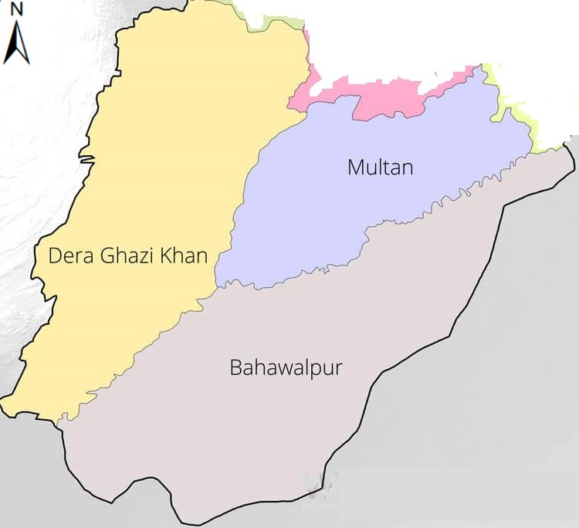
Figure 1: Map of South Punjab, Pakistan showing various divisions in the region (Hu at al. 2023)

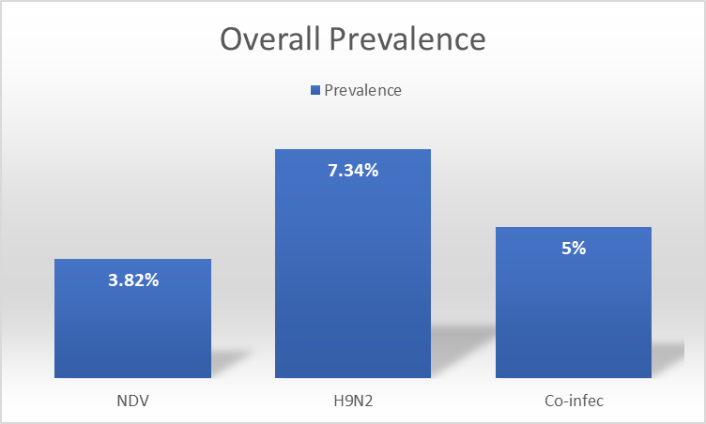
Figure 2: Overall prevalence of NDV, H9N2, and Mixed infection in various districts of South Punjab, Pakistan

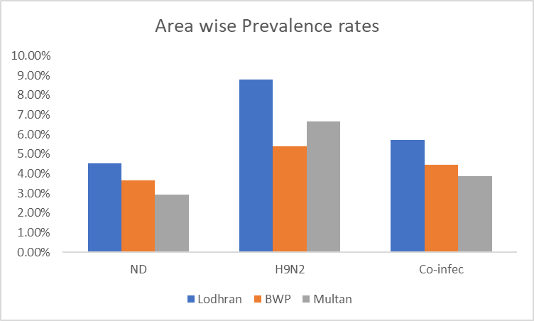
Figure 3: Area-wise prevalence of NDV, H9N2, and Co-infection
Table 1: Yearly collected samples and positivity
Districts | Year | ND +ve | H9N2 +ve | Co-infec | No. of Samples
Lodhran | 2020 | 32 | 66 | 43 | 1015
 | 2021 | 21 | 73 | 35 | 1046
 | 2022 | 92 | 142 | 105 | 1140
BWP | 2020 | 17 | 29 | 20 | 448
 | 2021 | 19 | 31 | 25 | 570
 | 2022 | 22 | 26 | 26 | 575
Multan | 2020 | 2 | 4 | 0 | 139
 | 2021 | 11 | 74 | 23 | 896
 | 2022 | 51 | 67 | 61 | 1143
Total |  | 267 | 512 | 338 | 6972

