**Taxonomy of five ladybird beetles of tribe Chilocorini Mulsant (Coleoptera, Coccinellidae) with a checklist from Pakistan**

Muhammad Ali1, Rukhsana Perveen2, Ghulam Raza1, Muhammad Akber1

*1 Department of Biological Science, University of Baltistan, Skardu, Gilgit-Baltistan, Pakistan*

*2 Department of Zoology, University of Karachi, Karachi, Sindh, Pakistan*

**Corresponding author:** Muhammad Ali, muhammad.ali@uobs.edu.pk

**Abstract:** The tribe Chilocorini Mulsant, 1846 of the subfamily Coccinellinae Latreille, 1807 (Coleoptera: Coccinellidae) from Pakistan is revised. Overall, four genera with thirteen species are listed, namely*Chilocorus nigritus* (Fabricius, 1798), *Chilocorus bijugus* Mulsant, 1853a , *Chilocorus bipustulatus* (Linnaeus, 1758), *Chilocorus circumdatus* (Gyllenhal, 1808), *Chilocorus melas* Weise, 1898, *Chilocorus rubidus* Hope, 1831, *Parexochomus nigripennis* (Erichson, 1843), *Parexochomus pubescens* Küster, 1848, *Priscibrumus uropygialis* (Mulsant 1853), *Priscibrumus lituratus* (Gorham, 1894a), *Priscibrumus trijunctus*(Kapur, 1969),*Brumoides suturalis* (Fabricius, 1798) and *Simmondsius pakistanensis* (Ahmad & Ghani, 1966). Only five species *C*. *nigritus*, *P*. *nigripennis*, *P*. *pubescens*, *P*. *uropygialis* and *B*. *suturalis* are re-described including genitalia but others are reported based on literature.

Keys to genera and species are presented.

**Keywords:** Coccinelloidea**;** Chilocorini; lady beetles; Pakistan; coccidophagous; predators, Sindh.

**Introduction**

The members of the tribe Chilocorini possess a predacious nature against scale insects, aphids, mealy bugs and psyllids (Hayat *et al*. 2017). The individuals of this tribe are shiny in color, usually without spots or patterns on their elytra. The tribe was investigated by many authors throughout the world (Kirsch 1871; Crotch 1874; Bedel 1892; Andres 1913). Chilocorini together with Platynaspini Mulsant 1846 and Telsimiini Casey 1899 belonged to the subfamily Chilocorinae sharing the head capsule having a strongly expanded clypeus and reduced antennae (Sasaji 1968b). However, recent phylogenetic studies of family Coccinellidae based on molecular data indicate that Chilocorinae is not a monophyletic group (Giorgi *et al.* 2009, Seago *et al.* 2011). As per the classification proposed by Slipinski (2007) and Seago *et al.* (2011), Chilocorinae and its three tribes are now included in the subfamily Coccinellinae and the tribe Chilocorini has been classified as a sister group of Coccinellini (Magro *et al.* 2010; Seago *et al.* 2011; Escalona *et al.* 2017; Che *et al.* 2017). At the time of writing, Chilocorini include 27 genera and more than 280 species (Łackzynski and Tomaszewska 2012; Li *et al.* 2020). The tribe chilocorini, excluding *Chilocorellus* Miyatake, was found as monophyletic and closely related to Plotinini as sister group (Li *et al*. 2020). In the most recent classification of Coccinellidae, based on the maximum likelihood analyses of the amino acid dataset, three subfamilies in Coccinellidae: Microweiseinae, Monocoryninae stat. nov., and Coccinellinae were recognized, subfamily relationships were strongly supported as (Microweiseinae, (Monocoryninae stat. nov., Coccinellinae) and the tribes of ladybirds are mostly monophyletic, except Ortaliini, Sticholotidini, Scymnini, and Coccidulini (Che *et al*. 2021)

Nine genera of this tribe have been reported from Palaearctic region including *Brumoides* Chapin 1965, *Chilocorus* Leach 1815, *Chujochilus* Sasaji 2005, *Exochomus* Redtenbacher 1843, *Parexochomus* Barovsky 1922, *Phaenochilus* Weise 1895, *Priscibrumus* Kovár 1995, *Simmondsius* Ahmad & Ghani 1966 and *Xanthocorus* Miyatake 1970 (KOVAR. 2007).

Most members of Chilocorini are coccidophagous(Giorgi *et al*. 2009; Escalona *et al*. 2017), but aphidophagy is also present in some species (Ślipinski and Giorgi 2006), therefore the members of this tribe have the potential as effective biological control agents of coccids and aphids (Drea and Gordon 1990; Ponsoby and Copland1997).

From Pakistan, the genus *Simmondius* with a new species, *Simmondius pakistanensis* were both described by Ahmad (1966). Hashmi and Tashfeen (1992) reported 162 species of the family Coccinellidae including some members of the subfamily Chilocorinae but with doubtful synonyms. Irshad (2001) listed 71 species of this family including six species of the tribe Chilocorini from different localities of Pakistan. seventy-five predatory coccinellid species including five genera with twelve species the tribe Chilocorini from different localities of Pakistan (Rafi *et al*. 2005). Two members of the tribe, *Brumoides suturalis* Fabricius 1798 and *Exochomus nigripennis* (Erichson 1843) were reported from the Faisalabad and Sargodha districts of Punjab province (Abbas *et al*. 2013; Ehsan and Naureen 2019). The coccinellids, *Brumoides suturalis* Fabricius 1798*, Chilocorus rubidus* Hope 1831, *Chilocorus circumdatus* (Gyllenhal 1808) and *Priscibrumus uropygialis* (Mulsant 1853) were reported from Bannu, Chitral, Karak, Swabi, Noshera, Mardan, Lower Dir and Buner districts of Khyber Pakhtunkwa province as well as Azad Jammu and Kashmir (Khan *et al*. 2007; Rahatullah *et al*. 2011; Urooj and Ali (2016), Saeed *et al*. 2016; Usman *et al*. 2017; Rehman *et al*. 2018; Hayat *et al*. 2014, 2016, 2017). The remotest area of Pakistan is the Gilgit-Baltistan region from where members of the tribe Chilocorini, *Chilocorus infernalis* Mulsant 1853a**,** *Exochomus*  nigripennis Erichson, 1843 and *Priscibrumus trijunctus* Kapur 1969have been reported (Ashfaque 2012). Hayat *et al*. (2014) reported 8 species of the tribe chilocorini from Azad Jammu and Kashmir. Only *Brumoides suturalis* Fabricius 1798) was reported from Tandojam of Sindh Province (Masori *et al*. 2016). Only two species, *C*. *infernalis* Mulsant 1853 and *E*. *nigripennis* (Erichson 1843) were reported from Baluchistan (Mohibullah *et al*. 2019). Sindh Province has a rich insect fauna diversified into cities like Karachi, Tandojam, Hyderabad, Larkana, Sukhur, Mirpur Khas, Badin and Tharparkar. The Sindh province is the only best documented one, from where, despite the lack of literature and collection, for the first time in the history of Pakistan, taxonomic treatments have been made on 29 members of Coccinellidae including five members of the tribe Chilocorini (Ali 2013; Ali *et al*. 2014; Ali *et al*. 2015; Ali *et al*. 2018; Ali *et al*. 2018). The description of the other species of this tribe is based on the literature availabled from Pakistan.

The present investigation deals with the taxonomy of five species of this tribe with an updated checklist as a part of the series of research work continued from the last few years to repair the deficiencies in the records of the tribe chilocorini from Pakistan. The other aim of this study is to develop interest in the systematics the family coccinellidae being important in the field of IPM. Keys to the genera and species of Chilocorini are also constructed based on important diagnostic characters. The male and female genitalia five species are described and illustrated for better understanding at species level.

**Materials and Methods**

The representatives of the tribe Chilocorini were collected from different localities of the Sindh Province, such as Larkana, Sukkur, Mirpur Khas, Tandojam, Hyderabad, and Karachi. More than 2000 specimens were collected during various surveys and visits arranged during 2006 through 2010 and were preserved and mounted as per standard procedures. Among these specimens, five species of this tribe were reported from Sindh. All the specimens including the remaining eight species were identified following the checklists, descriptions, and keys provided by Casey (1899), Dobzhansky (1931), Ahmad and Ghani (1966), Hashmi and Tashfeen (1992), Poorani (2004), Biravand *et al*. (2017), Hayat *et al*. (2014), Rafi *et al*. (2005), Ashfaque (2012), Ali (2013) and with the help of the following websites: Coccinellidae of Indian Subcontinent, Wikispecies, and NBAII. Identifications were confirmed by Dr. Claudio Canepari, an authority on the family Coccinellidae from Italy. For synonyms, holotypes, lectotypes, and distribution of taxa, and nomanclature follows the checklist made by Poorani (2004) and a book written by Rafi *et al*. (2005) A micrometer scale was used for the measurements of the body and various body structures using at least five males and five females of each taxon when commonly available.

For the study of external morphology of head, thorax and abdomen, the entire specimen was boiled in 10% KOH for ca. 15 min then washed in to tap water. All the parts of head, thorax and abdomen were dissected and drawn where necessary. After completion of the study and diagrams, these dissected parts were preserved in microvials with glycerin.

For the study of male and female genitalia, the complete abdomen was removed from the base and warmed in to 10% KOH on an electric heater for ca. 5 - 10 min. The male and female genitalia were then detached from the terminal segments of the abdomen very carefully and then dissected out in water. Before the examination of structures of genitalia, the parts were washed in 70% ethanol and the structures of the genitalia were examined in a drop of glycerin sometime a piece of cotton dipped in glycerin was used as substrate to avoid movement. After the examination of these structures, both male and female genitalia of five species were illustrated and their dissected parts were preserved in microvials with a drop of glycerin, pinned with specimens.

In the present study, specific taxonomic characters were selected at tribal, generic, and species levels. The taxa were described in detail and compared with their closest allies. Keys to both genera and species are presented.

**Results**

Five species of the tribe Chilocorini are described from Sindh Province of Pakistan with a checklist containing thirteen species reported with the help of literature.

**Subfamily Coccinellinae Latreille 1807**

**Tribe Chilocorini Mulsant 1846**

**Diagnosis.** Body oval to nearly circular, moderately to strongly convex; dorsal surfaceglabrous or pubescent; antennae short, with fusiform club; clypeus anterolaterally strongly expanded, shelflike; mandible with bifid apex but sometimes single; maxillary palp with terminal segment parallel sided, weakly ; prosternum without carinae; tibia simple or angulate, with or without spurs; claws simple or with swollen base or with basal tooth; abdomen mostly six segmented in male, five in female or sometime five or six in both,;

Siphon moderate, with siphonal capsule hammer shaped with adjacent arm elongatedandslightly curved while opposite arm smaller, shorter; parameres narrowed, usually longer than median lobe; trabes narrow, nearly straight, apically flat; genital plate as well as lateral plate short to elongated, triangular; spermatheca with cornu thick to deeply pointed terminally but without ramus or nodulus.

**Key to the genera of the tribe Chilocorini**

1. Dorsal surface always pubescent; antennae always ten segmented ­­­---------------- **2.**

– Dorsal surface mostly glabrous; antennae eight or seven segmented -------------- **3.**

**2.** Pronotum black with lateral angle yellow; elytra black with or without

spots; abdomen with six visible sternites; postcoxal line complete or nearly so

---------------------------------------------------------------- ***Parexochomus* Redtenbacher.**

– Pronotum black with lateral angle black; elytra coloured with black spots or

stripes; abdomen with five visible sternites; postcoxal line complete ------------------

-------------------------------------------------------------------------- ***Priscibrumus* Kovar.**

**3.** Tarsal claws somewhat falciform with basal portion broad -----------------------------

----------------------------------------------------------- ***Simmondsius* Ahmad & Ghani.**

– Tarsal claw moderately long slightly thickened at base -------------------------------- **4.**

**4.** Head, pronotum, elytra always black, pronotum with anterolateral angles rarely

pale or yellow----------------------------------------------------------- ***Chilocorus* Leach.**

– Head, pronotum usually black; elytra black mostly with coloured spots but

sometimes with coloured longitudinal stripes---------------------- ***Brumoides* Chapin.**

**Genus *Chilocorus* Leach 1815**

Chilocorus Leach 1815b: 116; Redtenbacher 1843: 1; Mulant 1850: 452; Crotch 1873:

376; Crotch 1874b: 183; Gorham 1892: 175; Korschefsky 1932: 237;

Wingo 1952: 25; Belicek 1976: 318; Chapin 1965a: 263 1974: 50; Gordon 1985; Poorani 2004; Rafi *et al*. 2005.

Type species: *Coccinella cacti* Linnaeus 1767, monobasic

**Diagnosis.** Adult length 2.5 − 4.8 mm; body broadly oval, convex; dorsum glabrous. Dorsalsurface glabrous; head, pronotum, elytra usually black, pronotum with anterolateral angles rarely pale or yellow. Antennae eight-segmented, first segment elongated, sub-cylindrical, slightly bent; second nearly equilateral, dome-shaped, greatest width near base; third wedge shaped, fourth quadrate; fifth through to eighth forming a fusiform club; mandible moderate. Prosternal process without carinae; elytral margin never reflexed, finely beaded; epipleuron descending externally, shallowly foveate; tibia without spurs; tarsal claw with small, quadrate tooth at base. Abdomen with six visible sternites in male, five in female; postcoxal line incomplete, reaching to the posterior margin of first sternite.

**Key to species of the genus *Chilocorus***

1. Body subcircular to oval, Head with fine pubescence ……………………………………3

* Body oblong, head not pubescence ……………………………………………………......….2

1. Frons broader than eye width, elytra and pronotum finely punctured ………………...…... 4

* Frons narrower than eye width, elytra and pronotum not punctured………………………......5

1. Head, side parts of pronotum, legs, venter and elytral

epipleura yellowish brown; lateral margins of elytra often paler than disc, vertex of head

and side parts of pronotum dark brown to black in some individuals, especially females …………………………………… *Chilocorus nigritus* (Fabricius)

* Head yellowish-brown in males, black to pitchy fading anteriorly in females; venter, elytral epipleura, lateral margins of elytra, vertex of head and side parts of pronotum black; legs, yellowish-brown……………………… *Chilocorus melas* Weise

1. Ground colour black and shiny; head deeply inserted and not visible from above; elytra each with a pair of reddish testaceous or yellowish-orange spots almost in the middle portion, inner spot a little larger than the outer spot, very rarely equal in size; venter black; legs black………………………………………………… *Chilocorus infernalis* Mulsant

* Ground colour brown-black; head small, less than 1/5 of the body width; elytron with large longitudinal oblong oval cherry-red spot; border between red spot and black elytral surface usually indistinct; venter red brown; legs jet-black-brown or black………*Chilocorus rubidus* Hope

1. Body helmet-shaped; head black; elytra brown; these beetles are of rich orange colour with a fine black margin around the base of the elytra; legs black …………………………………………………… *Chilocorus circumdatus* (Gyllenhal)

* Body wedge shaped; head red yellow; elytra black or brown with three small transverse red yellow spots at middle of elytra, often fused with each other in single transverse band; legs dark brown …………………………….............................. *Chilocorus bipustulatus* (Linnaeus)

***Chilocorus nigritus* (Fabricius 1798)**

*Coccinella nigrita* Fabricius 1798: 79.

*Chilocorus nigritus*:Mulsant 1850: 463; Bielawski 1957: 86.

**Material examined.** Pakistan,Sindh: 2 ♂, 3 ♀, Tandojam, 24.VI.1971, leg. M.I. Khan; 4 ♂, 2 ♀, Larkana, 30.VI.1971, leg. M.I. Khan; 1♂, 3 ♀, Mirpur Khas, 20.VI.1971, leg. M. Khan; 5 ♂, 2 ♀, Thatta, 30. IV.1971, leg. M.I. Khan; 5 ♂, 7 ♀, Karachi, 23. XII.1972, leg. Mehdi; 2 ♂, 2 ♀, Karachi, 12. VI. 2010, leg. M. Ali (NHMUK).

**Diagnosis.** Adult length 3.2 - 4.0 mm; width 2.9 – 3.9 mm; subcircular; broadly convex.

Head dull orange yellow; pronotum black with anterolateral angles black but sometime dark brown to yellow; elytra black, shiny, with fine punctations; abdomen, legs, inner margins of elytral epipleura yellow to yellowish brown, outer margins of epipleura brownish black. Head with frons variably punctured from moderate to coarse; anterior margin of labrum straight; ligula anteriorly slightly convex; mentum broader than long. Prosternal process thick, broader; carinae absent; scuto-scutellar suture thick and straight; elytra with emarginated margin, outer margin of epipleuron fringed with setae or hairs while the inner margin deeply concave. Postcoxal line parallel with anterior margin of second sternite before ascending; terminal sternite in male with posterior margin with minute hairs. Genital plates oval with narrow anterior portion perpendicular to the basalportion; lateral plates triangular; spermatheca with cornu apically narrowed, hook shaped embedded in basal enlarged portion.

**Distribution.** Tandojam, Larkana, Mirpur Khas, Thatta, Karachi, Muree, Rawalpindi and Islamabad (Rafi *et al*. 2005; Ali 2013)

**Remarks.**  This species resembles with*C***.** *inornatus*in coloration of the pronotum and elytra but differs inhaving the pronotum half anterolaterally yellow but sometimes it may have a distinctly black pronotum and elytra.

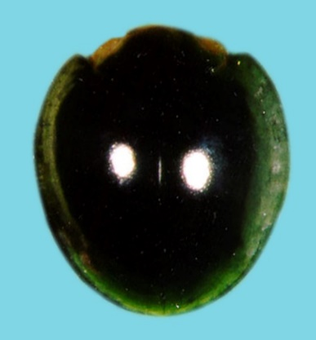

**A**

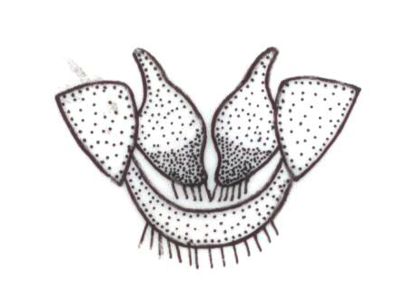

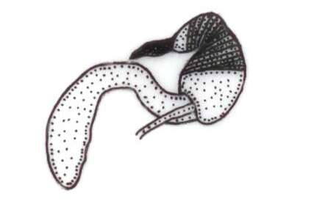

**B C**

**________**

**0.2mm**

**Fig.1:** Female genitaliaof *Chilocorus nigritus* (Fabricius): (**A**) Adult female (**B**) Genital plates (**C**) Spermatheca

***Chilocorus infernalis* Mulsant 1853**

*Chilocorus infernalis* Mulsant 1853: 189. (lectotype; UCCC); Crotch 1874: 183; Gordon 1987: 23 (lectotype design.)

*Chilocorus bijugus* Mulsant 1853: 61.

*Chilocorus bijugus infernalis* Korschefsky 1932: 242; Fotidar 1941: 236

*Chilocorus bijugus* Mulsant 1853a: 189; 1853b: 61.-Crotch 1874: 183; Korschefsky 1932: 242 (cat.); Kapur 1956a: 259 (desc., habitus & genitalia figd.); Nagaraja and Hussainy 1967: 249 (rev.); Miyatake 1970a: 324-325 (habitus, female genitalia figd.); Ren *et al.* 2009: 126; Li *et al*. 2018.

**Diagnosis:** Adult length 4.5 – 5.5 mm; width 3.8 – 4.5 mm; body oblong, convex; head black, deeply inserted with grayish pubescence, not visible from above; pronotum completely black; scutellum clearly visible and black (Inayatullah *et al*., 2005); ground colour black and shiny; elytra each with a pair of reddish testaceous or yellowish-orange spots almost in the middle portion, inner spot a little larger than the outer spot, very rarely equal in size (Hayat *et al*, 2014).

**Distribution:** Abbottabad, Murree, Swat, Skardu, Bagh, Tarar Khal and Azad Jammu & Kashmir (Rafi *et al*.2005; Hayat *et al* 2014)

***Chilocorus bipustulatus* (Linnaeus 1758)**

*Coccinella bipustulata* Linnaeus 1758: 367.

*Chilocorus bipustulatus* Mulsant 1846: 170; Crotch 1874: 185; Jakobson 1916: 990.

**Diagnosis:** Adult length 3.1 – 4.5 mm; width 2.7 – 3.9 mm; body wedge shaped, broadly oval, moderately convex, shiny and finely punctate; post coxal first abdominal ventrite merging with posterior margin of ventrite; head transverse, red yellow covered with short sparse pubescence; clypeus expanded in the form of broad plate covering antennal bases; mouth parts yellow-red; antenna short, yellow red, 8 segmented with weakly developed club; eyes with minute facets; pronotum black or brown with deep excavation at anterior margin and projecting sides, base arcuate, with double border not joining elytra at sides, considerably narrower than elytra; prosternum smooth, black, hardly longer than mesosternum; scutellum small, black with more elongate lateral sides; elytra black or brown with broad strongly concave epipleura, without foveae for femoral apices. Three small transverse red yellow spots at middle of elytra, often fused with each other in single transverse band. Venter and legs with sparse and short pubescence; metasternum broad, moderately concave with longitudinal grooves in middle; legs dark brown; femora broad and large; claw with tooth at base; first abdominal sternite black, sparsely and coarsely punctate (Kuznetsov, 1997).

**Distribution:** Mustang and Pishin (Rafi *et al*.2005)

***Chilocorus melas* Weise 1898**

*Chilocorus melas* Weise 1898: 229 (lectotype ♀; MNHUB); Korschefsky 1932: 243 (cat.); Booth 1998: 364 (redesc., lectotype design.).

Chilocorus *gressitti* Miyatake 1970a: 330 (Holotype ♂? CAS/EU); Pang & Mao 1979: 84; Synonymised by Booth 1998: 364.

**Diagnosis:** Adult length 3.1 – 3.8 mm; width 2.9 – 3.7 mm; body subcircular, convex, shiny; elytra and pronotum (except a fine border *melas* as *C. gress* around anterior angles) jet black; head yellowish-brown in males, black to pitchy fading anteriorly in females; legs, yellowish-brown; head with fine pubescence, frons broader than eye width, coarsely punctured; pronotum finely punctured; elytra shiny, finely punctured. Species closely resembles with *Chilocorus nigritus* (Booth 1998).

**Distribution:** Islamabad, Azad Jammu and Kashmir (Rafi *et al*. 2005; Hayat *et al*.2014)

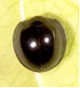

**Fig. 2:** *Chilocorus melas* Weise (Adult)

***Chilocorus rubidus* Hope 1831**

*Chilocorus rubidus* Hope in Gray 1831: 31 (lectotype; BMNH); Mulsant 1850: 453; Crotch 1874: 183; Korschefsky 1932: 241 (cat.); Kapur 1956a: 262 (redes. & genitalia figd.); Nagaraja & Hussainy 1967: 253 (rev.); Miyatake 1970a: 318-319.- Booth & Pope 1989: 362 (lectotype desig.).

*Coccinella tristis* Faldermann 1835: 452.

*Chilocorus tristis*: Mulsant 1850: 452; Crotch 1874: 183; Weise 1885b: 51 (syn.).

*Chilocorus rubidus* ab. tristis: Korschefsky 1932: 241 (cat.); Kapur 1956a: 262 (rev.).

**Diagnosis:** Adult length 5.8 – 7.2 mm; width 5.2 – 6.0 mm; body rather large, shortened oval and strongly convex; head, pronotum, scutellum black; head small, less than 1/5 of the body width; frons distinctly and finely depressed and very coarsely punctate; anterior margin of clypeus with deep bow shaped emargination; pronotum finely punctate with rather dense white pubescence and round impression near each anterior angle; scutellum oblong-triangular with sparse punctuation; elytra black; each elytron with large longitudinal oblong oval cherry-red spot; border between red spot and black elytral surface usually indistinct; elytral punctation as fine as that of pronotum and denser towards lateral sides; venter red brown; sometime prostrenum and mesostrenum dark; epipleura of elytra very broad; legs jet-black-brown or black (Kuznetsov 1997).

**Distribution:** Abbottabad, Chitral, Parachinar and Peshawar (RAFI et al. 2005, HAYAT et al. 2014)

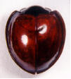

**Fig. 3:** *Chilocorus rubidus* Hope (Adult)

***Chilocorus circumdatus* (Gyllenhal 1808)**

*Coccinella circumdata* Gyllenhal, in Schönherr, 1808: 152

*Chilocorus circumdatus*: Mulsant 1850: 454; Crotch 1874: 186; Korschefsky 1932: 242 (cat.); Nagaraja & Hussainy 1967: 250 (rev.).

*Chilocorus nigromarginatus* Motschulsky 1859: 174 (lectotype; UM); Crotch 1874: 186 (syn.); Iablokoff-Khnzorian 1972: 168.

**Diagnosis:** Adult length 5.5 – 6.0 mm; width 5.0 – 5.5 mm; body short, oval, convex, smaller than *C. rubidus*; pronotum and scutellum black; head small, black; elytra brown; epiplura of elytra broad and blackbrown; legs black; orange colour with a fine black margin around the base of the elytra; helmet-shaped beetle commonly known as red *Chilocorus*.

**Distribution**: Chitral (Rafi *et.al*. 2005)

**Genus *Simmondsius* Ahmad & Ghani 1966**

***Simmondsius pakistanensis* Ahmad & Ghani 1966**

**Diagnosis:** Adult length 3.6 – 4.5 mm; width 2.9 – 3.2 mm. Body elongate-oval, strongly convex. Colour greenish-blue with metallic luster. Head beset with fine and minute pubescence. Eyes black and finely facetted. Presternum without carinae. Elytra convex, broadest at about the middle, slightly shorter in length than the combined breadth. Elytral puncture deeper and larger than those of pronotum. Tarsal claw somewhat falciform with basal portion broad. Thoracic sternites shinning black, abdominal sternites brown. First segment of antenna twice as long as broad, second segment slightly longer than broad, third segment club shaped, fourth to seventh segment forming a filiform club with greatest width at sixth segment. Pronotum almost twice as broad as median length with shallow punctures, puncture variable in size. Maxillary palp with basal segment small, second segment somewhat club shaped.

**Male genitalia:** Median lobe of male genitalia fairly wide at the base, gradually tapering to a pointed apex, parameres as long as median lobe.

**Female genitalia:** Receptaculum seminis in female genitalia with appendiculate cornu and sperm duct moderately long (Ahmad and Ghani 1966).

**Distribution:** InPakistan,it was collected from Kaghan, Shogran and Murree (Rafi *et al*.2005)

**Genus *Parexochomus* Barovsky 1922**

*Exochomus* (*Parexochomus*) Barovsky 1922: 293. Type species: *Exochomus pubescens* Küster 1848, by subsequent designation of Chapin 1965. *Parexochomus*: Kovář 2007: 595.

**Diagnosis.** Adult length 3.0 − 3.7 mm; width 3.0 mm – 3.2 mm; body broadly oval to almostrounded. Dorsal surface pubescent; head black, pronotum mostly black with lateral angles yellow; elytra black. Antennae ten-segmented, first segment slightly curved, second barrel shaped, third obconical, fourth to sixth nearly equal, seventh to tenth forming a slender fusiform length, mandible heavy. Prosternal process narrow, truncate at apex without carinae; elytra rounded; elytral margin strongly beaded; epipleuron not foveolate for reception of femoral apices; tibia slender with spurs 0-2-2, tarsal claw with subquadrate basal tooth. Abdomen with six visible sterna in male, five in female; postcoxal line complete or nearly so.

**Key to the species of the genus *Parexochomus***

1. Large; broadly convex; pronotum black with 1/3 anterolaterally yellow; elytra black, propleuron, leg, and most of abdomen yellow; sipho terminally with saw-shaped

process ……………………………………........... ***Parxochomus nigripennis*** **(Erichson)**

* Small; strongly convex; pronotum black with 3/4th part anterolaterally brownish yellow; elytra black, propleuron, leg, and most of abdomen brownish black; siphon terminally bearing a triangular, narrowed process …. ……………***Parexochomus pubescens* Küster**

***Parexochomus nigripennis* (Erichson 1843)**

*Chilocorus nigripennis* Erichson 1843: 267.

*Exochomus xanthoderus* Fairmaire 1864: 648.

**Material examined.** Pakistan,Sindh: 2 ♂, Hyderabad, 20.III.1982, leg. M.I. Khan; 2 ♂, 6 ♀, Mirpur Khas, 22.VI.1971, leg. M. Khan; 5 ♂, Karachi, 23. XII.1972, leg. Mehdi; 2 ♂, 2 ♀, Karachi, 20. VI. 2010, leg. M. Ali (NHMUK).

**Diagnosis.** Adult length 3.5 mm – 4.4 mm; width 0.3 mm – 3.5 mm; oval-elongated, dorsumconvex. Dorsum slightly pubescent; eyes black, coarsely faceted; head brownish yellow; pronotum black, 1/3 anterolaterally brownish yellow, elytra completely black; legs yellow. Eyes large; labrum with anterior margin notched; ligula rounded anteriorly. Pronotum broader than long; prosternal process small, narrow; elytral epipleuron slightly broader terminally. Abdomen with postcoxal process slightly straight; postcoxal line complete, broadly curved.

**Male genitalia.** Sipho narrowed broadly curved, terminally bearing a saw-shaped process,siphonal capsule with opposite short, broad; paramere slightly thick; median lobe deeply narrowed apically; trabes apically expanded.

**Remarks.** Externally it resembles with *E*.*pubescens*but differs in having a larger body size, being slightlypubescent, with a broadly convex body, pronotum with 1/3 anterolaterally brownish yellow.

**Distribution.** Hyderabad, Tandojam, Karachi, Dir, Hangu, Kohat, Murree, Parachinar,Rawalpindi, Swat, Wah and Azad Jammu Kashmir (RAFI et al.2005, ALI. 2013)

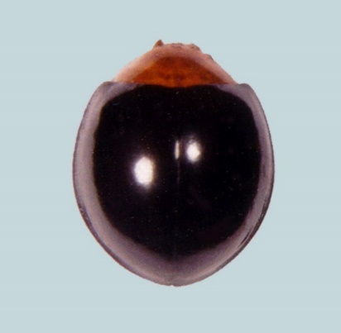

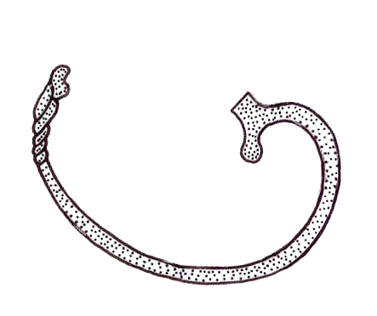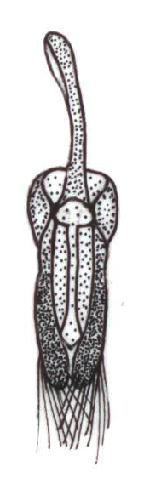

**B C**

**_______**

**0.2mm**

**Fig. 4:** Female genitaliaof *Parexochomus nigripennis* (Erichson): (**A**) Adult male (**B**) Sipho

(**C**) Tegmen

***Parexochomus pubescens* Küster 1848**

*Exochomus pubescens* Küster 1848: 94

*Exochomus apicatus* Fairmaire 1884: 59.

*Exochomus circumcinctus* Sahlberg 1903: 36.

*Platynaspis flavilabris* Motschulsky 1849: 155.

*Platynaspis flavilabris* Mulsant 1850b: 947.

*Exochomus gestroi* Fairmaire 1875: 540.

*Exochomus lugubrivestis* Mulsant 1853: 194.

*Exochomus saharae* Sicard 1929: 60

**Material Examined.** Pakistan,Sindh: 10 ♂, 12 ♀, Tandojam, 12.XII.1965, leg. M.I. Khan; 4 ♂, 10 ♀, Mirpur Khas, 20.VI.1972, leg. M. Khan; 15 ♂, 12 ♀, Karachi, 24. XII.1972, leg. Mehdi; 10 ♂, 7 ♀, Karachi, 22. VI. 2010, leg. M. Ali (NHMUK).

**Diagnosis.** Adult length 3 mm – 4.2 mm; width 2.8 mm – 3 mm; body oval-elongated, dorsumconvex. Dorsum strongly pubescent; eyes black, coarsely faceted; head black; pronotum black, 3/4 anterolaterally brownish yellow, elytra completely black, propleuron, legs, and most of abdomen brownish black**.** Eyes small; labrum with anterior margin notched; ligula rounded anteriorly convex. Pronotum broader 3/4; prosternal process very short; meso and meta sternum strongly articulated; elytral epipleuron foveate, terminally pointed. Abdomen with postcoxal process convex anteriorly; postcoxal line complete, deeply curved.

**Male genitalia.** Sipho narrow deeply curved, terminally bearing a triangular process, siphonalcapsule with opposite arm longer, narrowed; paramere narrowed; median lobe broadly narrowed apically; trabes apically pointed.

**Female genitalia.** Genital plate large, triangular, and expanded anteriorly; lateral plates small,deeply curved; spermatheca with cornu deeply curved; accessory gland large, elongate-oval, sperm duct narrow elongated.

**Remarks.** Externally it resembles with *E*.*nigripennis*but differs by having a smaller body size,it isthickly pubescent, and has a strongly convex body; pronotum with ¾, anterolaterally brownish yellow.

**Distribution.** Tandojam, Hyderabad, Sukkar, Mirpur Khas, Thatta, Karachi, Faisalabad,Sargodha, Maini forest (Ali 2013)

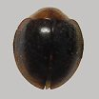

**A**

 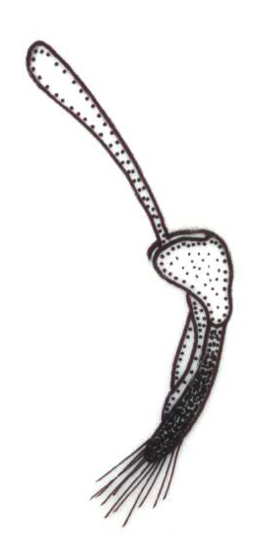 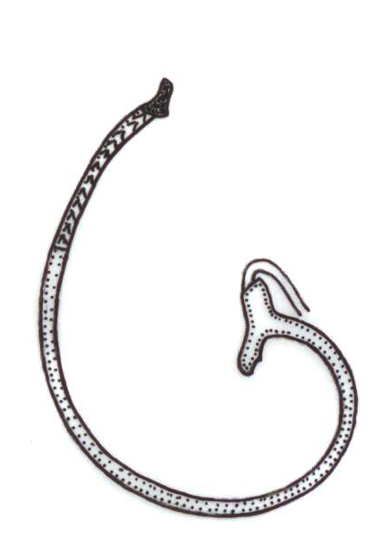

**B C D**

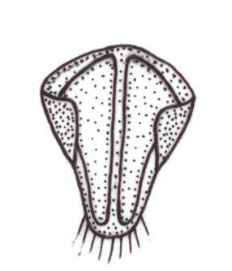 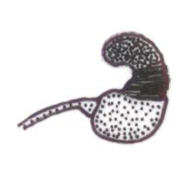

**E F**

_______

**0.2mm**

**Fig.5:** Female genitaliaof *Parexochomus pubescens* Küster: (**A**) Adult male (**B**) Tegmen ventral view (**C**)Tegmenlateral view(**D**) Sipho (**E**) Genital plate (**F**) Spermatheca

**Genus *Priscibrumus* Kovar, 1997**

*Priscibrumus* Kovář 1997: 117. Type species, by original designation: *Exochomus puniceipennis* Semenow 1900.

**Diagnosis.** Adult length 4.0 − 4.3 mm; body elongate-oval bluntly pointed posteriorly.

Dorsum pubescent; pronotum black; elytra yellow or redish brown with longitudinal stripes or spots; abdomen black. Antennae ten-segmented, first segment slightly curved, second barrel shaped, third obconical, fourth to sixth nearly equal, seventh to tenth forming a slender fusiform, mandible heavy. Prosternal process narrow, truncate at apex with carina; elytra elongated; elytral margin strongly beaded; epipleura plain in the anterior part, oblique in the posterior fourth; tibia slender with spurs 0-2-2; tarsal claw with subquadrate basal tooth. Abdomen with five visible sternites, all segments narrower medially while broader laterally; postcoxal line complete.

**Key to species of the genus *Priscibrumus***

1. Large sized; body elongated, tapering posteriorly……………………………………………………. 2

* Medium sized; body elongated-oval wide posteriorly; elytra with ground colour brownish yellow, marked with three broad black longitudinal lines, one on mid-dorsal along sutural line, touching anterior margins, more broad at middle.............................................................*Priscibrumus trijunctus*(Kapur)

1. Elytra reddish brown with a V-shaped dark grey band, which covers the greater part; white pubescent head, pronotum, elytra and venter ………………………………………............... *Priscibrumus lituratus* (Gorham)

* Elytra reddish brown with two black triangular spots on the apical junction; dorsum brownish pubescent but not venter …………………………*Priscibrumus uropygialis* (Mulsant)

***Priscibrumus uropygialis* (Mulsant 1853)**

*Exochomus uropygialis* Mulsant 1853a

*Brumus uropygialis*: Crotch 1874: 196

*Priscibrumus uropygialis*: Kovar 1997: 117

Material examined.Pakistan,Sindh: 1 ♂, 1 ♀, Karachi, 20. III. 1982, leg. Mehdi; 10 ♂, 7 ♀, Karachi, 22. VI. 2010, leg. M. Ali (NHMUK).

**Diagnosis.** Adult length 4.0 − 4.3 mm; body elongate-oval bluntly pointed posteriorly.

Dorsum pubescent, head with black lateral margin; mandible brownish black dorsolaterally while anterior parts brownish yellow, pronotum black, elytra reddish brown with two black triangular spots on the apical junction; ventrites black. Eyes large; labrum with anterior margin slightly notched; ligula with anterior margin convex; submentum tetragonal. Pronotum broader than long; prosternal process small, narrow. Abdomen with postcoxal process convex anteriorly; postcoxal line complete, deeply curved.

**Male genitalia.** Sipho terminally with a very sharped triangular process, siphonal capsule withopposite arm with dorsal margin thick, longer, convex while, adjacent arm with ventral margin as well as outer margin common between the arms slightly w-shaped; median lobe broader medially whereas strongly pointed distally; parameres strongly narrowed medially but broader-oval, sharply pointed distally, trabes straight, narrow, flattened apically.

**Female genitalia.** Genital plate sclerotized, narrowed, distinctly elongated, parallel with eachother, slightly depressed medially, distal end very sharped, slightly curved, lateral plate elongated, triangular, strongly mesad; spermatheca with base short, 3/4th broader than long, strongly rounded; cornu short, narrow.

**Distribution.** Karachi, Hyderabad, Peshawar, Galiat, Malam Jaba, Murree and Chitral (Rafi *et al*.2005; Ali 2013)

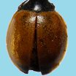

**A**

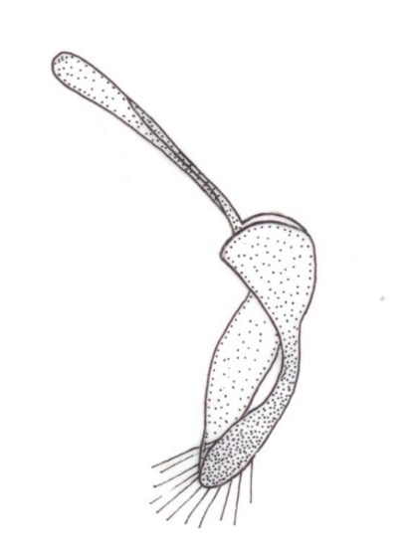

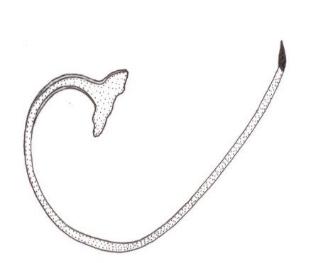

**B C**

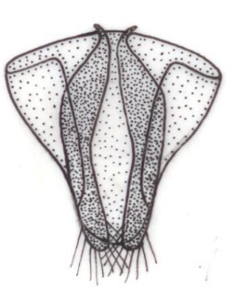

**D**

**________**

**0.2mm**

**Fig.6:** Female genitaliaof *Priscibrumus uropygialis*(Mulsant): (**A**) Adult female (**B**) Sipho (**C**) Penis (**D**) Genital plate

***Priscibrumus trijunctus* (Kapur 1969)**

(**Fig.7**)

*Exochomus trijunctus* Kapur 1969: 377

*Priscibrumus trijunctus* Kovar 1997: 117

**Diagnosis:** Body medium sized and elongated, ground colour brownish-yellow. Head black, not visible from above, eyes raised, black and surrounded by yellow canthus; pronotum entirely black, slightly pubescent; scutulum small, triangular and black; elytra with ground colour brownish yellow, marked with three broad black longitudinal lines, one on mid-dorsal along sutural line, touching anterior margins, more broad at middle, two on lateral sides along outer margins, terminating before anterior margins, also not touching outer margins anterior elytral margins.

**Distribution:** Jammu and Kashmir, Gilgit-Baltistan, Astore, Jaglot and Diamer (Ashfaque 2012)

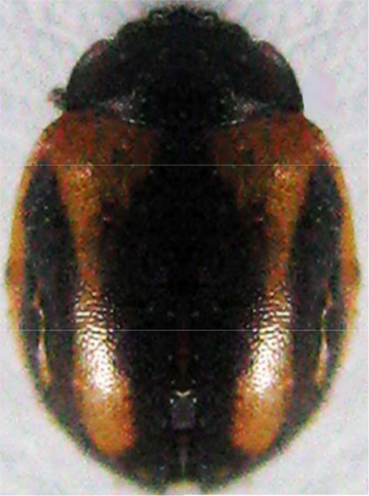

**Fig.7:** *Priscibrumus**trijunctus* (Adult)

***Priscibrumus lituratus* (Gorham 1894a)**

*Exochomus lituratus* Gorham 1894a: 203 (BMNH); Korschefsky 1932: 255 (cat.); Smith 1965: 363 (cytological species separation); Nagarkatti & Ghani 1972: 58 (biol., immature stages desc., larval chaetotaxy).

*Exochomus* (Exochomus) *lituratus*: Chapin 1965: 249.

*Priscibrumus* *lituratus*: Kovar 1997: 117.

**Diagnosis:** Adult length 4.5 mm; width 3.0 mm; body elongate oval, tapering posteriorly; elytra reddish brown with a V-shaped dark grey band, which covers the greater part; white pubescent head, pronotum, elytra and venter; pronotum well developed, convex medially, sloping up on both sides to the margin, which is raised; scutellum dark brown and hidden under elytra; tarsi 3 segmented and claw bifid.

**Distribution:** Jammu & Kashmir, Pakistan (Poorani 2004)

**Genus *Brumoides* Chapin 1965**

*Brumoides* Chapin 1965: 237. Type species: *Coccinella suturalis* Fabricius, 1798: 78, by original designation

**Diagnosis:** Adult length 3mm − 5 mm; width 2mm – 3mm; oval, moderately convexDorsal surface glabrous, pronotum mostly black; elytra black mostly with colored spots but sometimes with coloured longitudinal stripes. Antennae eight-segmented, first segment short and stout, slightly bent, second as wide as first at base, gradually tapering to half width at apex, third to fifth similar and nearly equal, sixth longer than wide, apex of seventh obliquely truncate, eighth small, partly embedded in the apex of seventh; mandible moderate. Prosternal process narrow, truncate apically without carinae; elytra elongate-oval; elytral margin slightly reflexed; epipleuron descending, without foveae for reception of femoral apices; tibia slender, spurs present; tarsal claw moderately long slightly thickened at base but without angular basal tooth. Abdomen with six visible sterna in male, five in female; postcoxal line complete.

***Brumoides suturalis* (Fabricius, 1798)**

*Coccinella suturalis* Fabricius 1798: 78.

*Brumus suturalis*: Mulsant 1850: 494

*Brumoides suturalis*: Chapin 1965: 237

**Material examined.** Pakistan, Sindh: 6 ♂, 8 ♀, Maini forest, Tandojam 12. XII. 1965, leg. Ahmed: 5 ♂, 6 ♀, Hyderabad, 12. VIII. 1972, leg. Khan; 4 ♂, 6 ♀, Sukkar, 19. III. 1975, leg. Khan; 9 ♂, 12 ♀, Mirpur Khas, 20.X.1979, leg. Haque; 12 ♂, 10 ♀, Karachi, 19. III. 2009, leg. Ali; Gilgit-Baltistan: Baltistan, 11 ♂, 15 ♀, Karachi, 19. III. 2009, leg. Ali (NHMUK).

**Diagnosis.** Adult length 3.0 – 4.0 mm; width 2.3 – 2.7 mm; body oval, dorsum convex.Dorsum glabrous, eyes brownish black, head, pronotum orange yellow, elytra satiny white to creamy yellow, with three black stripes, one on each elytron in a mid-dorsal position not extending to apex and one along sutural line nearly extending to apex, apical portion yellowish to reddish brown, body ventrally yellowish brown, brownish black in the region of meso and metathoracic sternum. Eyes larger; labrum with anterior margin notched; ligula rounded anteriorly. Prosternal process thick, broader; carinae absent; scuto-scutellar suture thick and straight; elytra with emarginated margin, outer margin of epipleuron fringed with setae or hairs while the inner margin deeply concave. Abdomen with postcoxal process anteriorly notched; postcoxal line complete reaching to the anterior margin of first sternite.

**Male genitalia.** Sipho terminally hollow, broader before ending with a pointed triangularprocess; with siphonal capsule with short, tetragonal opposite arm while the adjacent arm elongated, narrow; parameres broader, elongated; median lobe distinctly short broader proximally, pointed distally, trabes straight and spoon shaped.

**Female genitalia.** Genital plates elongated triangular; lateral plates small triangular;spermathecal capsule with cornu short, thick, sclerotized.

**Distribution.** Tandojam, Hyderabad, Sukkar, Mirpur Khas, Thatta, Karachi, Faisalabad,Sargodha, Buner, Swabi, Noshera, Karak, Lower Dir, Banu, Maini forest and Gilgit-Baltistan (Rafi *et al*. 2005; Ali 2013).

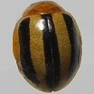

**A**

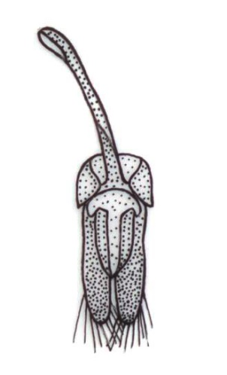 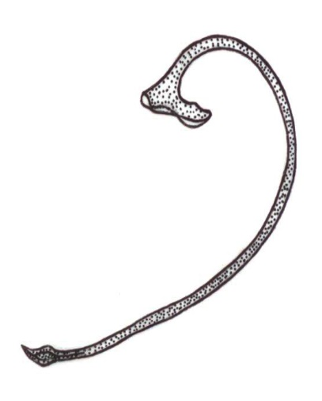

**B C**

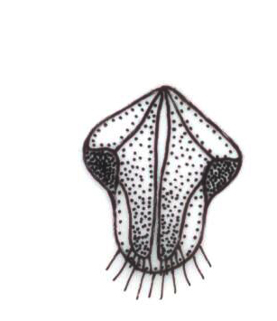 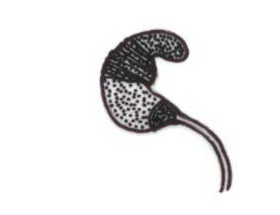

**D E**

**_________**

**0.25mm**

**Fig. 8:** Female genitaliaof *Brumoides suturalis* (Fabricius): (**A**) Adult female (**B**) Tegmen (**C**) Sipho (**D**) Genital plates (**E**) Spermatheca

**Discussion**

The members of the tribe Chilocorini play important role in biological control of scale insect pests fed upon different fruit trees of economically important in Pakistan. The study of literature with this group of the family coccinellidae confirmed that majority of the findings (Rehman 1940; Chaudry *et al*. 1970; Irshad 2001; Ahmed *et al* 2017; Yasinsai *et al*. 2019) were totally related with their biodiversity and ecology in relation with their pests and host plants. From West Pakistan before partition from British India, two species with wrong synonymies, *Brumus suturalis* (F.) and *Chilomenes bijugus infernalis* Muls. (Rehman 1940), now these are *Brumoides suturalis* (F.) and *Chilocorus infernalis* Mulsant. After partition, four species were reported but out of which named as *Brumus suturalis* (F.), *Exochomus flavipes* (Thb) var.*nigripennis* Er. and *E*. *flavipes* Thb (Chaudry *et al*. 1970), now the last two species are considered as single species, *Parexochomus nigripennis* (Erichson). Eleven species were reported as *Brumus suturalis* (F.), *Chilocorus tristis* Fabr., *C*. *bipustulatus* (L.), *C. nigritus* (F.), *C*. *rubidus* Hope., *E*. *flavipes* (Thb.), *E*. *gaurdan* Muls., *E. orbsulus* Er. and *E*. *uropygialis* Er. (Hashmi and Tashfeen 1992), out of which, the two species *E*. *gaurdan* and *E*. *orbisulus* are totally absent in the literature availabed, some were wrongly synonymized as *C*. *tristis* (*C*. *infernalis*), *E*. *flavipes* (*P*. *nigripennis*), *E*. *uropygialis* (*Priscibrumus* *uropygialis*). Nine species reported from northern parts of Pakistan with wrong synonymies with three species of the genus *Exochomus* and one species of the genus *Chilocorus* (Irshad 2001) but now these are the species of *Parexochomus* and *C*. *infernalis*. Twelve species reported also from northern regions of Pakistan but wrong synonymies with two species of *Chilocorus*, three species of *Exochomus* (Rafi *et al*. 2005). Wrong synonymies are also found in the literature related with fauna of coccinellids of Baluchistan, Punjab, Khyber-Pakhtunkhwa, Gilgit-Baltistan and Kashmir regions (Rahatullah *et al*. 2011; Yasinsai *et al*. 2019; Ashfaque 2012; Hayat *et al*. 2014). In the findings of Hayat *et al*. (2014) the two species of the genus *Exochomus* were named oppositely, which are corrected as *Parexochomus nigrippennis* and *P*. *pubescens* Küster. The overall corrected names of the members of the tribe in the present study are written as *Brumoides suturalis*, *Chilocorus infernalis*, *C*. *pakistanensis* Ahmad & Ghani, *Parexochomus nigripennis*, *P*. *pubescens*, *P*. *kiritshenkoi*, *Priscibrumus. lituratus* and *Pricibrumus uropygialis*. In this way recently about fifteen species of the tribe Chilocorini are included in the updated checklist. In Pakistan, for the first time, a comprehensive taxonomic study of five members of the tribe Chilocorini was carried from the Sindh Province. These five species are described in detailed including the male and female genitalia. The other provinces are still lacking with research activities related with the taxonomy and systematics of coccinellid predators. The present study may be considered as the only comprehensive work in the history of Pakistan to investigate the taxonomy of the members of the tribe chilocorini as well as providing much information about their taxonomic importance necessary for their authentic and valid role in the field of biological control and integrated pest management against insect pests.

An updated checklist and keys to genera and species of the tribe chilocorini are constructed based on their taxonomy and the literatures availabled at the time of this research study. Finally, the present study reflects the importance of the taxonomic study of these coccinellids in relation with their authentic identification and confirmation necessary for satisfied and valid pest control management in future. This study also provides basic information and learning source in the field of taxonomy of coccinellids for interested researchers concerned with different aspects of entomology.

**Conclusion**

Five species of the tribe Chilocorini are studied taxonomically from Sindh province. Totally thirteen species of this tribe are listed in the form of a checklist. This taxonomic study is attempted for the first time from Pakistan.

**Author Contributions**

MA: proposed the research, drafted and finalizing the manuscript, RP: Laboratory facilitation, GR and MA helped in specimen collection. All authors provided critical feedback and helped in the preparation of the manuscript.

**Conflicts of Interest**

The authors declare no conflicts of interest.

**Ethics Approval**

Not applicable

**Acknowledgements**

The authors would like to express their heartfelt gratitude to Dr. Rukhsana Perveen, who provided guidance, necessary facilities, and took a keen interest throughout the progress of this research. We would like to extend our deep gratitude and sincere thanks to Dr. Claudio Canepari, an authority on the family Coccinellidae, who spent his valuable time assisting us in identification, confirmation, and guidance.

**References**

Abbas MN, S Kausar, SK Rana (2013). Diversity and Distribution of Ladybird beetles (Coccinellidae) in the Cropland of Faisalabad District. *Int J Adv Res* 1: 27-33.

Ahmed R, MA Ghani (1966). A new genus and species of Chilocorini (Coleoptera:

|  |  |
| --- | --- |
| Coccinellidae) from Pakistan. *Proc Royal Ento Soc London* | (B) |
| 35: 9-10. |  |
| Ahmed R (1968). A new species of *Pseudoscymnus* Chapin (Col., Coccinellidae) predaceous | on |
| scale insects in West Pakistan. *Entomophaga* 13: 377-379. |  |

Ahmed R (1970). A new species of *Pharoscymnus* Bedel (Coleoptera: Coccinellidae) predacious on scale insects in Pakistan. *Entomophaga* 15: 233-235.

Ahmed R (1973). A new tribe of the family Coccinellidae (Coleoptera). *Bull Ento Res* 62: 449-452.

Ali M, R Perveen, NY Siddique and R Hussain (2012). Redescription of three species of the genus *Coccinella* (Coccinellidae: Coleoptera) from Sindh, Pakistan. *Pak Ento* 34: 167–171.

Ali M, R Perveen, MJ Yousuf, S Khawja and M Amin (2014). Predatory potential of five coc-cinellids against cotton mealy bug *Phenacoccus solenopsis* (Tinsley) from Sindh, Pakistan. *Pak Ento* 36: 7–12.

Ali M, AN Naqvi, R Perveen, K Ahmed and I Hussain (2014). First Record of the Tribe Bulaeini (Coleoptera: Coccinellidae) With Generic and Species Descriptions from Pakistan. *Pak J Zool* 46: 1475–1478.

Ali M, R Perveen, AN Naqvi, K Ahmed, G Raza and I Hussain (2015). The Tribe Scymnini (Coc cinellidae: Coleoptera) From Sindh Province, Pakistan. *J Ins Sci* 15: 146. <https://doi.org/10.1093/jisesa/iev105>

Ali M, K Ahmed, S Ali, G Raza, I Hussain, MA Nafees and SI Anjum (2018). An annotated checklist of Coccinellidae with four new records from Pakistan (Coleoptera, Coccinellidae). *ZooKeys* 803: 93–120. https://doi. org/10.3897/zookeys.803.22543

Ali M, G Raza, S Ali, SI Anjum and I Hussain (2018). The Tribe Coccinellini Weise (Coleoptera: Coccinellidae) in Sindh, Pakistan. *The Col Bull* 72: 629–638.

Andres A (1913b). Sur une listed Coleopteres captures en 1867a 1869 par le D. O. Schneider a Ramleh Pres d’ Alexandrie. *Bull Ento Soc Egypt* 3:39-48.

Ashfaque M, Farhatullah and MA Rafi (2013) Genus *Coccinella* (Coccinellidae: Coleoptera) from Gilgit-Baltistan with two new records from Pakistan. *Sar J Agri* 29: 240–247.

Barosky V (1922). Revisio specierum palaearticarum Coccinellidarum generis *Exochomus* Redtb. *Annuaire du Musée Zoologique de l’Académie des Sciences de Russie* 23: 289–303.

Bedel L (1892). Supplement aux Coccinellidae de Weise. *Abeille* 28:85-95.

Biravand A, W Tomaszewski, W Li, V Nicolas, J Shakarami, L Fekrat and S Hesami (2017). Review of the tribe Chilocorini Mulsant from Iran (Coleoptera: Coccinellidae). *ZooKeys*, 712: 43–68.

Casey TL (1899). Revision of the American Coccinellidae. *J New York Ento Soc* **7**: 71-169.

Chapin EA (1965) The genera of the Chilocorini (Coleoptera: Coccinellidae). *Bull Mus Comp Zool Har* 133: 227-271.

Che LH, P Zhang, SH Deng, HE Escalona, X Wang, Y Li, H Pang, N Vendenberg, A Slipinski, W Tomezewska and D Liang (2021). New insights into the phylogeny and evolution of lady beetles (Coleoptera: Coccinellidae) by extensive sampling of genes and species. *Mole Phylogen and Evol* 156: 107045

Che LH, SQ Zhang, Y Li, D Liang, H Pang, A Slipinski and P Zhang (2017). Genome-wide survey of nucle ar protein-coding markers for beetle phylogenetics and their application in resolving both deep and shallow-level divergences. *Mole Eco Res* 1–17. <https://doi.org/10.1111/1755-0998.12664>

Crotch GR (1874). Description of new species of Coleoptera from Pacific Coast of the United States. *Trans Amer Entol Soc* 5:73-80.

Crotch GR (1874). A revision of the Coleopterous family Coccinellidae. E. W. Janson and Rippon, London 311.

Drea JJ and RD Gordon (1990). Predators. Coccinellidae. In: Rosen D (Ed.) The Armored Scale Insects, their Biology, Natural Enemies and Control. Elsevier, Amsterdam, 19–40.

Escalona HE, A Zwick, HS Li, JH LI, XM Wang, H Pang, D Hartley, L Jermiin, O Nedved, B Misof, O Niehius, A Slipinski and W Tomazewska (2017). Molecular phylogeny reveals food plasticity in the evolution of true ladybird beetles (Coleoptera: Coccinellidae: Coccinellini). *BMC Evol Biol* 17: 151. <https://doi.org/10.1186/s12862-017-1002-3>.

Giorgi JA, NJ Vandenberg, JV Muchugh, JA Forrester, SA Slipinski, KB Miller, LR Shapiro and MFWtiting (2009).The evolution of food preferences in Coccinellidae. *Biol Cont* 51: 215–231. <https://doi.org/10.1016/j.biocontrol.2009.05.019>

Kirsch TFV (1871). Neue Kâfer- Artenaus Egypten, gesammelt von Dr. Schneider. *Ber Ento Zeit*14:389-396.

Kovar I (2007). Coccinellidae. In: Löbl I, Smetana A (Eds) Catalogue of Palaearctic Coleoptera.Volume 4. Elateroidea, Derodontoidea, Bostrichoidea, Lymexyloidea, Cleroidea, Cucujoidea. Apollo Books, Stentrup, Denmark.

Hashmi AA and Tashfeen A (1992). Coleoptera of Pakistan. Proc. *Pak Cong Zool* 12: 133 – 170.

Hayat A and MR Khan (2013). Biodiversity and species Composition of Ladybird Beetles (Coccinellidae; Coleoptera) from Mirpur Division of Azad Jammu & Kashmir, Pakistan. *Sarhad J Agri* 30: 341-350.

Hayat A, KM Rafique, N Falak and MA Rafi (2014). Ladybird beetles of sub-family chilocorinae (coccinellidae: coleoptera) of Azad Jammu and Kashmir. *Pak Ento* 36:135-143.

Hayat A, N Falak, MR Khan and M Ashfaque (2016). Biodiversity and species composition of Coccinellid beetles (Coccinellidae: Coleoptera) from Poonch division, Azad Jammu and Kashmir. *J Biod & Envir Sci* **9**: 17-28.

Inayatullah C and EM Siddiqui (1978). Comparative studies on the anatomy of the abdomen of *Coccinella septumpunctata* and *Coccinella undecimpunctata* (Coleoptera: Coccinellidae). *Pak J Zool* 10: 261–271.

Inayatullah C and EM Siddiqui (1979). Comparative skeletal anatomy of the head capsule of *Coccinella septumpunctata* and *Coccinella undecimpunctata* (Coleoptera: Coccinellidae). *Pak J Zool* 11: 85–97.

Inayatullah C (1980). Comparative skeletal anatomy of the thorax of *Coccinella septumpunctata* and *Coccinella undecimpunctata* (Coleoptera: Coccinellidae). *Pak J Zool* 12: 225–237.

Irshad M (2001a) Aphids and their biological control in Pakistan. *Pak J Biol Sci* 4: 537 – 541.

Irshad M (2001b). Distribution, hosts, ecology and biotic potentials of coccinellids of Pakistan.

*Pak J Biol Sci* 4:1259 – 1263.

Irshad M (2003). Parasitoids, predators and pathogens of agricultural and forest pests of Pakistan. National IPM Programme, National Agricultural Research Centre, Islamabad, 78pp.

Khan I, S Din, SK Khalil and MA Rafi (2006). Survey of predatory coccinellids (*Coleoptera: Coccinellidae*) in the Chitral District, Pakistan. *J Insect Sci***7**: 7–10.

Khuhro SN, MK Lohar, GH Abro, MA Talpur and R Khohro (2012). Feeding potential of ladybird beetle, *Brumus suturalis* Fabricius (Coleoptera: Coccinellidae) on cotton Mealybug, *Phenacoccus solenopsis* Tinsley in laboratory and field. *Sarhad J Agri* 28: 259 –265.

Łaczanski P and W Tomaszewska (2012). *Chapinaria*, new genus of Chilocorini for *Endochilus* *meridionalis* Sicard from Africa (Coleoptera: Coccinellidae). *Annales Zoologici* (Warszawa)62:1–9 <https://doi.org/10.3161/000345412X633658>

Li W, LZ Huo, D Ahrens, SX Ren and XM Wang (2017). *Renius cornutus*, a new genus and species of Chilocorini from Tibet, China (Coleoptera, Coccinellidae). *ZooKeys* 678: 121–128. <https://doi.org/10.3897/zookeys.678.11862>

Wenjing L, P Laczynski, HE Escalona, J Eberle, L Huo, X Chen, W Huang, B Chen, D Ahrens, A Slipinski, W Toamzewska and X Wang (2020). Combined molecular and morphological data provide insights into the evolution and classification of Chilocorini ladybirds (Coleoptera: Coccinellidae). *Syst Ento* 45: 447–463.

Magro A, E Lecompete, F Magne, J Hemptinne and SB Crouou-Roy (2010). Phylogeny of ladybirds (Coleoptera: Coccinellidae): are the subfamilies monophyletic? *Mole Phylo and Evol* 54: 833–848. <https://doi.org/10.1016/j.ympev.2009.10.022>

Maqbool A, SU Rather, SA Akbar and AA Wachkoo (2020). Preliminary Survey of Ladybird Beetle Composition (Coleoptera: Coccinellidae) in Unmanaged Apple Orchard Ecosystems of Kashmir Himalayas. *Proc Zool Soc* 73:160–174

Mohibullah, MI Yasinzai, S Shamsullah, S Akhtar, SA Essote and AU Rehman (2019). Faunistic study of ladybird beetle on the basis of external morphology of urban and rural areas of district Pishin, Baluchistan. *University of Sindh journal of animal sciences* 3: 1 – 8.

Nedved O and I Kovar (2012). Phylogeny and classification: Appendix: List of genera in tribes and subfamilies. In: Hodek I., Honěk A., van Emden H.F. (eds) [Ecology and Behaviour of the](http://eu.wiley.com/WileyCDA/WileyTitle/productCd-1405184221.html) [Ladybird Beetles (Coccinellidae)](http://eu.wiley.com/WileyCDA/WileyTitle/productCd-1405184221.html). John Wiley and Sons Ltd.London 526–531.

NBAII. 2009: Factsheets on Agriculturally Important Insects. [http://www.nbaii.res.in/Featured](http://www.nbaii.res.in/Featured%20insects/featured-insects.html) [%20insects/featured-insects.html](http://www.nbaii.res.in/Featured%20insects/featured-insects.html) (Accessed on 12 September (2009)

Ponsoby DJ and JW Copland (1997). Predators. Coccinellidae and other Coleoptera. In: Ben-Dov Y, Hodgson CJ (Eds) Soft Scale Insects-their biology, natural enemies and control, Vol. 7B. Elsevier, Amsterdam, 29–60. https://doi.org/10.1016/S1572- 4379(97)80076-0.

Poorani J (2004). An annotated checklist of the Coccinellidae (Coleoptera) (excluding Epilachninae) of the Indian subregion. *Oriental Ins* 36: 307-383.

Poorani J (2008). Coccinellidae of Indian Subcontinent. [http://www.angelfire.com/bug2/j_](http://www.angelfire.com/bug2/j_%20poorani/index.html) [poorani/index.html](http://www.angelfire.com/bug2/j_%20poorani/index.html).

Rahatullah, HF, Ahmad and M Inayatullah (2010). M. Phil. thesis on species diversity of coccinellidae of Dir valley, Department of Zoology, Hazara University, Mansehra, Pakistan

Rahatullah HF, SA Mehmood, K Saeed and M Rehman (2011). Diversity and distribution of ladybird beetles in District Dir Lower, Pakistan. *Int J Biod & Cons* 3: 670-675.

Rahatullah HF, H Ahmed, M Inayatullah, K Saeed and S KHAN (2012). Morphological characteristics of ladybird beetles collected from District Dir Lower, Pakistan. *Afri J Biotech* 11: 9149-9155.

Rafi MA, M Irshad and M Inayatullah (2005). Predatory ladybird beetles of Pakistan. National Insect Museum & Insect Pest Informatics, IPM Programme, Rohani Art Press, Blue Area, Islamabad. 105pp.

Rehman AU, ZUR Awan, AH Shah, J Khan and FN Khan (2018). Bionomics of Ladybird beetels in District Bannu of Khyber Pahktunkhwa, Pakistan. *Fed Ur Uni Arts, Sci and Techn J Biol* **8**: 249-256

Urooj Z and A Ali (2016). Ladybird beetles (Coleoptera: Coccinellidae) fauna in district Swabi, Noshera and Mardan. *Int J Agri and Env Res* 2: 86 -92.

Saeed K, MNK Khattak, F Khan, N Falak and N Akhtar (2016). Morphological Characteristics of Ladybird Beetles (Coccinellidae: Coleoptera) of District Buner, Khyber Pakhtunkhwa, Pakistan. *Pak J Zool* 48: 1367-1372.

Seago AE, JA Giorgi, JH Li and A Ślipinski (2011). Phylogeny, classifi cation and evolution of ladybird beetles (Coleoptera: Coccinellidae) based on simultaneous analysis of molecular and morphological data. *Molecular Phylog and Evol* 60: 137–151. <https://doi.org/10.1016/j.ympev.2011.03.015>

Ślipinski A and JA Giorgi (2006). Revision of the Australian Coccinellidae (Coleoptera). Part 6. Tribe Chilocorini. *Annal Zool* 56: 265–304.

Ślipinski A (2007). Australian Ladybird Beetles (Coleoptera: Coccinellidae), their Biology and Classifi cation. ABRS, Canberra Stephens JF 1832 Illustrations of British entomology. Mandibulata, London. 4:367-413.