High-frequency direct organogenesis from cotyledonary node explants and plantlet regeneration of peanut (Arachis hypogaea L.) cultivar
Abraham Lamboro¹*, Xiao Han¹, Songnan Yang ¹, Xueying Li¹, Dan Yao², Abdourazak Alio Moussa¹, Mazhar Rasul Chaudhry³, JP Harold W Ilboudo², Baixing Song¹, Qiulin Wu¹, Yongyi Xing¹, Jun Zhang¹*
1Department of Crop Genetics and Breeding, College of Agronomy, Jilin Agricultural University, Changchun 130118, China
2 Department of Biochemistry and Molecular biology, College of Life science, Jilin Agricultural University, Changchun 130118, China
3.Department of Molecular epigenetics, College of Life science, North east Normal University, Changchun, China
* Corresponding authors: Jun Zhang, email: zhangjun@jlau.edu.cn Abraham Lamboro, email: abraham.lire8@gmail.com
Abstract
Peanut (Arachis hypogaea L.) is an economically important oil bearing allotetraploid legume crop. The efficient plantlets regeneration of peanut is the most important and a prerequisite to successfully transform gene and apply recently developed genome editing techniques for crop yield improvement. The aim of this study was to evaluate and optimize regeneration potential of different concentration of hormones for selected peanut cultivars from their respective cotyledonary node explant and develop plantlets regeneration protocol. We optimized shoot and root regeneration protocol for two peanut cultivars. Both cultivars had shown positive response for the cytokinin plant growth hormone 6-benzylaminopurine (BAP) and thidiazuron (TDZ). The highest shooting rate (97%) was found in a medium supplemented with 4mg/L BAP and (94.33%) for 1 mg/L TDZ. Thus, shoots were induced more efficiently at higher concentration of BAP than TDZ. However; the maximum root regeneration (81%) was found on medium containing 0.3mg/L 2, 4-dichlorophenoxyacetic acid (2,4-D) and the highest rooting rate (96.33%) was obtained in a medium supplemented with 1mg/L α-naphthalene acetic acid (NAA), indicating lower concentration of NAA induce more rooting rate than 2,4-D treatment. In the present study, we used cotyledonary node as explant source and this method was found to be efficient, rapid and reproducible for in vitro peanut regeneration.
Key words Auxin; Cotyledonary nodes; Cytokinins; Peanut; Plant regeneration
Introduction
Cultivated peanut (Arachis hypogaea L.) is an important oil seed and grain legume crops of world wide. It is cash crop, good source of food, vegetable oil, feedstock and ground cover (Wynne et al. 1989). Peanut is the second most important legume crops after soybean, is primarily grown as a subsistence crop in semiarid tropical region in Africa and Asia and its seed is rich in oil (40-55%), dietary protein (25%), fiber (2%), many essential vitamins and minerals, a significance source of resveratrol, and folic acid (King et al. 2008). The total genome size of cultivated peanut is approximately 2.7 GB, is an allotetraploid (2n=4x=40, AABB) plant species derived from a single recent hybridization event involving two diploid wild peanut species, (Arachis duranensis (A genome) and Arachis ipaensis (B genome), followed by a polyploidisation event (Bertioli et al. 2016). The average production share of peanut with shell by region from 1994-2019 were 64, 8.6, 27.3, 0.1 and 0 % in Asia, America, Africa, Oceania and Europe respectively. China is the largest peanut producer in the world with 17, 519, 600 tonnes production volume per year. After China, India comes second with total production of 6, 727, 180 tonnes per year and both countries together produce more than 50% of the world's total (FAOSTAT 2019).
In vitro propagation method provides an important alternative for peanut mass propagation. Although the cultivated peanut is considered to be relatively recalcitrant to tissue culture (Cheng et al. 1992; Heatley and Smith 1996; Akasaka et al. 2000), efficient and successful protocols using different explant sources were developed. Several in vitro regeneration using different explant sources have been reported in peanut, including: epicotyl (Little et al. 2000; Shan et al. 2009), immature leaflet (Venkatachalam et al. 1999; Tiwari and Tuli 2009), hypocotyl (Venkatachalam et al. 1997; Matanda and Prakash, 2007), somatic embryos (Hazra et a l. 1989; Joshi et al. 2003), Cotyledonary node (Banerjee et al. 2007; Hsieh et al. 2017; Limbua et al. 2019), cotyledon (Baker and Wetzstein 1995; Masanga et al. 2013), seed (McKently et al. 1990), embryo axes (Atreya et al. 1984), leaf segment (Akasaka et al. 2000). In all these reports the regeneration frequency varied due to explant sources and the type and concentration of hormone used.
Kenyan peanut genotypes, ICGV12991, CG7 and Red Valencia have been successfully regenerated using cotyledonary node and medium supplemented with 3mg/L BAP combined with 1mg/L TDZ were reported a regeneration frequency of 80 to 81% for all genotypes (Limbua et al. 2019). On the other hand US peanut cultivars, Georgia green, Florunner and New Mexico Valencia (NMVA) were reported 86 and 98% shooting rate with no significance difference at different concentration of BAP (Hsieh et al. 2017). Sharma and Anjaiah (2000) reported an efficient method (more than ninety percent) for the production of adventitious shoot buds using mature cotyledonary explants cultured on Murashige and Skoog (MS) medium (Murashige and Skoog 1962) containing N6-benzyladenine (BA) and 2,4-D. However; an expansion of a direct shoot organogenesis system to include elite US peanut market type produced low (twenty five percent) incidence of shoot induction, and required about three to four months between explant culture initiation to transfer of rooted greenhouse acclimatized plants (Burns et al. 2012).
In addition to regenerating shoot buds and/or developing roots using different explant sources through tissue culture methods, are also very important in the development of transgenic plants. For instance to transform gene using Agro bacterium mediated gene transformation, efficient plant regeneration method and appropriate explant are useful in crop breeding programs. One of the pre requisites for successful gene transfer to plants is the availability of a suitable protocol for transformation which is compatible with in vitro plant regeneration methods of the targeted plant species (Kar et al. 1996). Some scientific research findings have been reported in peanut (Sharma and Anjaiah 2000; Anuradha et al. 2006; Bhatnagar et al. 2010), reported that the cotyledon regeneration system proved to be an excellent vehicle for the production of a large number of independently transformed plants. Similarly, Hsieh et al (2017) reported that the cotyledonary node-based direct regeneration system is time efficient and amenable to genetic transformation. Therefore, the major goal of the current research were to establish plant regeneration system from cotyledonary node (CN) and to evaluate suitable plant growth hormone concentration for the Chinese peanut cultivar.
Materials and Methods
Plant Material and Cultivar Selection
Mature seeds of peanut cultivar Yu-hua-14 and N3 were used which was previously stored stock in the department of crop genetics and breeding, Jilin Agricultural University, China.
Explant Preparation and In vitro Culture Condition
The embryo axes were removed from the dry seed and soaked for about 14hours in double distilled water. Hydrated embryo axes were surface sterilized in 10% (w/v) sodium hypochlorite (Naocl) solution for 7 minute and 1minute in 70% (w/v) ethanol. Then, washed three times in sterilized distilled water for 6-7 minute each. The embryo axes were germinated in glass jar 100ml shoot initiation medium (SIM) containing MS salts with vitamin, 3% (w/v) sucrose, pH 5.8 (Coolaber Science and Technology Co., Ltd, Beijing, China), and 0 to 5mg/L of 6-benzylaminopurine (BAP), with 0.8% (w/v) agar (Shanghai Aladdin Biochemical technology Co., Ltd, China) in culture vessel. The embryo axes were incubated under 25/25 º C day/night, 16hour photoperiod and 130-150 μmol m⁻² s⁻¹ florescent light conditions. The radicle, apical and axillary shoots from 3 week old plantlets were removed and cotyledonary nodes were excised by cutting both epicotyls and hypocotyls approximately 4mm above and below the node as described (Hsieh et al. 2017). Finally CNs were transferred to shoot elongation medium (SEM) with similar concentration of BAP for an additional 3 weeks to allow repetitive initiation and breaking of adventitious shoot buds.
Following the procedures described by (Hsieh et al. 2017), elongated adventitious shoots were excised longitudinally from CNs and placed on to root induction medium (RIM), (MS salts and vitamins, 3% (w/v) sucrose, 1mg/L NAA, pH 5.8 and 0.8% (w/v) agar for 4 more weeks to generate roots. Plantlets with root system were transferred to plastic cups containing the soil mix, sand: soil: vermiculite (1:1:1) and acclimatized in the plant growth room. Established plantlets were transferred to green house and allowed to grow in a plastic pots for maturity (in plant biotechnology center, Jilin Agricultural University). After acclimatization harden plantlets were transplanted in to plastic pots containing soil and sand mixture (1:1 v/v) and moved to the green house.
Optimization of Shoot Induction and Elongation Media
Two different cytokinins (BAP and TDZ) were applied in the shoot induction medium (SIM) and shoot elongation medium (SEM) separately for comparison of shoot regeneration induction response. To test induction response of TDZ, 2mg/L were initially applied in the SIM, and the cotyledonary nodes were transferred to SEM with 0, 0.5, 1, 2mg/L TDZ. To evaluate induction response of BAP different concentration of (0, 1, 2, 3, 4, 5mg/L) were applied in both SIM and SEM. The experiment were conducted with three replicates in a completely randomized block design and each experimental unit consisted of one culture vessel with ten CNs. After one month shoot elongation period half the total number of cultured CNs in each vessel were scored for total number of shoots (longer than 3mm) induced, shoot induction rate, shoot length and fresh weight while the shoots from the other half of the total number of CNs were excised for root induction.
Optimization of Root Induction Media
To optimize different synthetic auxin effect on root induction in RIM, two different auxins, 2, 4-D and NAA were used separately in RIM. Shoots originally grown in 4 mg/L BAP SIM and SEM, 2mg/L TDZ SIM and 1mg/L TDZ SEM were transferred to RIM with different concentrations of 2, 4-D (0, 0.1, 0.2, 0.3 mg/L), NAA (0, 1, 2, 3, 4mg/L) in a completely randomized block design with three replicates and each experimental unit consists of five shoots in a culture vessel. The whole experiment were conducted in a growth room (25/25 º C day/night, 16hour photoperiod light intensity: 130-150 μmol m⁻² s⁻¹) for 1month. After one month of root induction, the rooting rate, root number, root fresh weight and length were recorded and analyzed.
Statistical analysis
Each experiment had a completely randomized design and was replicated three times. Appropriate standard deviation and means separations were calculated according to Takey‘s Multiple Range Test. Minitab 17 software was used for analysis.
Results
Shoot optimization
Plant growth hormones like BAP and TDZ were used for shoot induction. Both hormones applied in SIM separately with different concentrations to evaluate and select appropriate hormone for peanut shoot induction. More adventitious shoots were obtained at BAP medium (Fig. 2a). The result showed that shoot induction in peanut in response to TDZ and BAP were efficient. However; relatively better regeneration and shoot elongation were observed at BAP medium. More over, morphologically thin shoots observed under TDZ treatment (Fig. 2b). This indicating that TDZ may cause some morphological variation in shoots on SEM. Further to optimize BAP and TDZ concentration for shoot induction we used five different BAP concentration (0, 1, 2, 4, 5 mg/L) and four different TDZ concentration (0, 0.5, 1, 2 mg/L) using two different cultivars, Yu-hua-14 and N3. The result indicated that both cultivars at different level of BAP and TDZ concentration responded (Fig. 3A, 4a). There were significant difference in shoot number (p< 0.001) and shoot length (p< 0.001) for both cultivars at different concentration of BAP and TDZ (Fig. 3c, d, 4c, d).
The highest shooting rate (97%) (Fig. 3b) with the relatively medium number of shoot length (6.66) was found in N3 with BAP at concentration of 4mg/L (Fig. 3d). The shoot number ranged from 1 to 4.33 for N3 and 1.33 to 4.66 for Yu-hua-14 (Fig. 3c). The highest shoot number 4.66 were found at concentration of 5mg/L BAP (Fig. 3c). Indicating that, the shoot number increased with increasing BAP concentration. On the other hand, shoot length was found medium as BAP concentration increased for both cultivars (Fig. 3d). There was no significance difference for shoot weight between cultivars at different concentration of BAP used (Fig. 3e). The result showed that for both SIM and SEM 4mg/L BAP and 1mg/L TDZ were prefereble for both cultivars to produce healthy shoot number and shoot length.

a b c
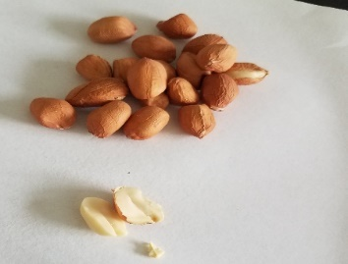
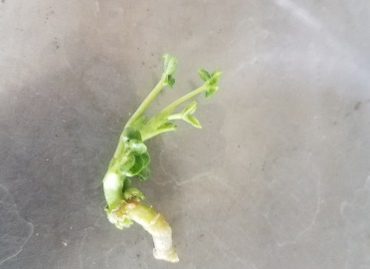 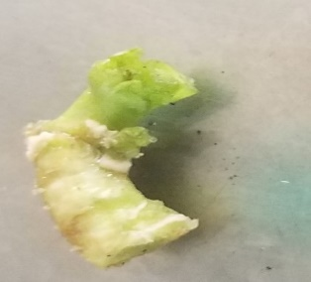
d e f
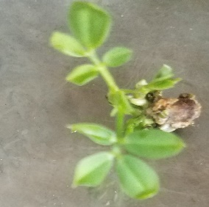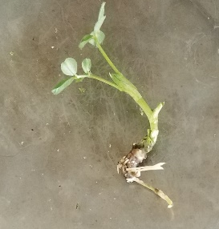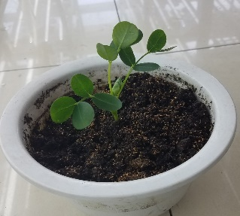
Fig. 1: Cotyledonary node regeneration system of peanut variety Yu-hua-14. a healthy mature seeds and embryo, b 3 week old regenerated peanut plantlets from SIM, c Cotyledonary node, d 1month-old shoots regeneration from Cotyledonary node, e regeneration of roots, f regenerated plants transferred to soil.
a BAP (mg/L)________________
0 2 4 5
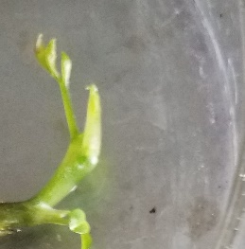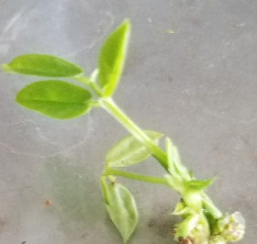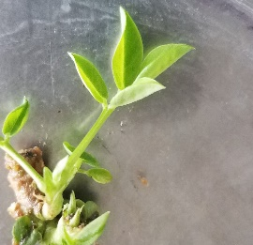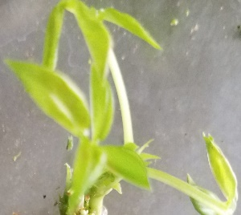

b TDZ (mg/L)__________________
0 0.5 1 2
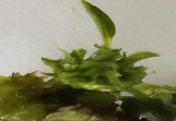
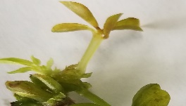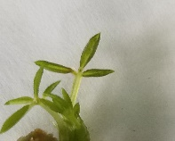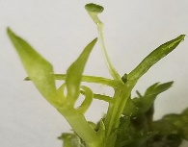
Fig. 2: BAP or TDZ effect on the peanut Yu-hua-14 variety. a Shoot from CNS with BAP treatment for 1month, b shoot from CNS with TDZ treatment for 1month.

a __BAP (mg/L)_______________________________________________

0 1 2 4 5 Yu-hua-14 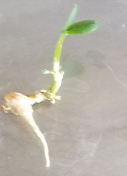 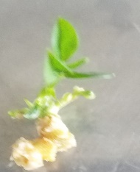 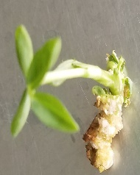 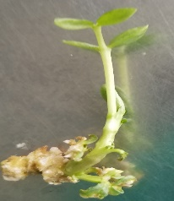 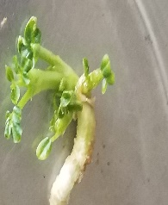
N3 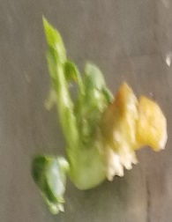 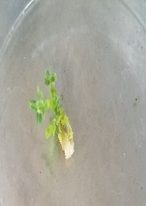 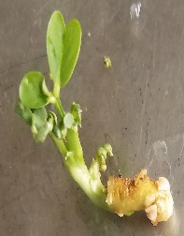 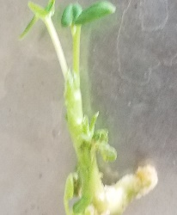 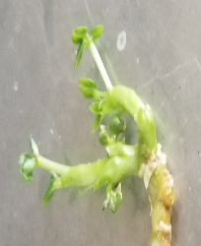

Fig. 3: 6-benzylaminopurine effect on peanut cultivar Yu-hua-14 and N3 at different concentration of BAP. a three week old Yu-hua-14 and N3 peanut cultivar under different concentration of BAP treatment, b shooting rate, c shoot number, d shoot length, e shoot weight

Effect of TDZ on shoot induction
The effect of TDZ treatment on Yu-hua-14 and N3 peanut cultivars CNs explant culture on shoot induction and elongation capacity by comparing four different concentration of TDZ (0, 0.5,1, 2mg/L) were investigated. Four morphological parameters were determined: the shooting rate (%) (Fig. 4b), shoot number (Fig. 4c), shoot length (Fig. 4d) and shoot weight (Fig. 4e). We found that shooting rate ranged between (80.33-94.33%) for N3 and (81.33-94%) for Yu-hua-14 (Fig. 4b). The number of shoots was substantially increased from (1.67-5) for N3. TDZ induced shoots that were genotypically independent. The 0.5mg/L TDZ formed shoot number of average ranging from (2-5), (2.67-5) for N3 and Yu-hua respectively (Fig. 4c).
a TDZ (mg/L)__________________
0 0.5 1 2
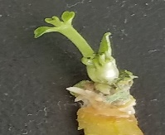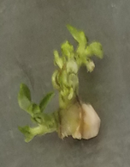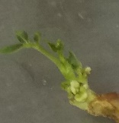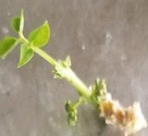
Yu-hua-14
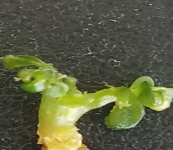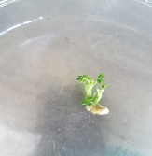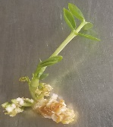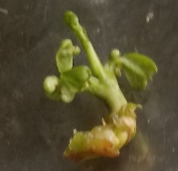
N3

Fig. 4: Thidiazuron effect on peanut cultivar Yu-hua-14 and N3 at different concentration of TDZ. a three week old Yu-hua-14 and N3 peanut cultivar under different concentration of TDZ treatment, b shooting rate, c shoot number, d shoot length, e shoot weight.
The 2mg/L TDZ concentration induced greatest number of shoots (5) for both cultivars (Fig. 4c). The study showed that TDZ was effective in forming shoots in peanut cultivar. The average shoot length (mm) decreased from (8-4.67) for N3 and (7-4.67) for Yu-hua-14, indicating the shoot length decreases as the concentration of TDZ increases (Fig. 4d). Relatively the maximum shoot weight (0.33) was found at the 2mg/L TDZ for N3 cultivar. The culture medium having TDZ (1-2mg/L) did not show any significant effect on shoot weight.
Effect of 2,4-D and NAA on root regeneration: initially grown at BAP medium
Responses of CNs cultures to different concentration of 2, 4-D and NAA on RIM are shown in (Fig 5 and 6) that includes the development of callus and roots. The development of roots was observed after 7 days of growth on RIM. The root induction increase with increase of 2, 4-D. At 0.3mg/L 2, 4-D of the medium, highest (80.67%) rooting rate was found for Yu-hua-14 and (80.33%) for N3 (Fig. 5b).
a 2, 4-D (mg/L) 0 0.1 0.2 0.3
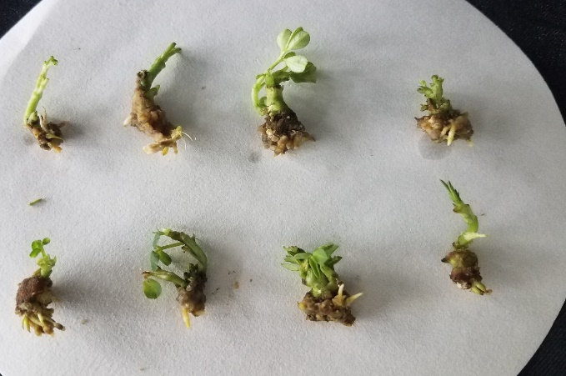
Yu-hua-14
N3

Fig. 5: Effect of 2, 4-D on the in vitro response of peanut cultivar Yu-hua-14 and N3 at different concentration of auxin treatment initially grown on BAP medium. a 1 month old Yu-hua-14 and N3 peanut cultivar under different concentration of 2,4-D treatment, b rooting rate, c root number, d root length, e root fresh weight.
Root number and root fresh weight increased as the concentration of 2, 4-D increased. However; the level of 2, 4-D exceeds 0.2mg/L, root number decreased (Fig. 5c, e). Further increments in 2, 4-D level did not improve number of root formation in peanut. Root length was obtained high at zero concentration (Fig. 5d). There was no significance difference at 0.1, 0.2 and 0.3mg/L 2, 4-D concentration for both cultivars.
a NAA(mg/L) 0 1 2 3 4
Yu-hua-14
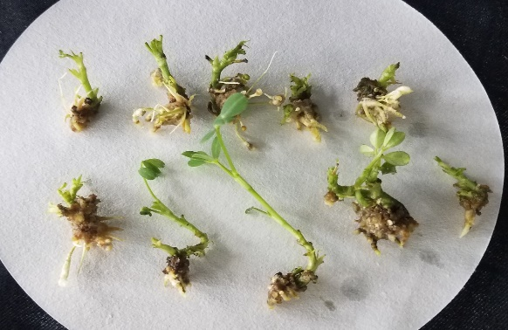
N3

Fig. 6: Effect of NAA on the in vitro response of peanut cultivar Yu-hua-14 and N3 in different concentration of auxin treatment initially grown on BAP medium. a 1 month old Yu-hua-14 and N3 peanut cultivar under different concentration of NAA treatment, b rooting rate, c root number, d root length, e root fresh weight.
The highest rooting rate (96.33%) and root number (10) for N3 cultivar were obtained on RIM containing 1mg/LNAA and 4mg/L NAA respectively (Fig. 6b, c). Root induction rate were decreased as the concentration of hormone exceeded 1mg/L NAA for N3. However, for the cultivar Yu-hua-14, root induction decreased as level of hormone exceed 2mg/L NAA (Fig. 6b). Root length was decreased as the concentration of auxin increases. Lower hormone concentration is required to induce root. The root fresh weight ranged between 0.233 to 0.57 for Yu-hua-14 and 0.17 to 0.566 for N3. The maximum root fresh weight (0.57) was found in a medium supplemented with 4mg/L NAA for Yu-hua-14 (Fig. 6e). Both cultivars were shown positive response for NAA and the roots first initiated at 7th day of culture.

Effect of 2,4-D and NAA on root regeneration: initially grown at TDZ medium
For root regeneration, peanut cultivars initially grown on TDZ medium was tested at different concentration of 2, 4-D and NAA. Regenerated roots are shown (Fig. 7a, 8a).The root regeneration we observed in 2,4-D treatment initially grown at TDZ medium was less effective. The maximum rooting rate (81%) was found for Yu-hua-14 in a medium supplemented with 0.3mg/L 2, 4-D (Fig. 7b), indicating 2, 4-D was not effective hormone for regeneration of roots as compared to NAA (Fig. 7b, 8b). Root number and root fresh weight increased somewhat as the concentration of hormone increased (Fig. 7c, e).
a 2, 4-D (mg/L) 0 0.1 0.2 0.3
Yu-hua-14
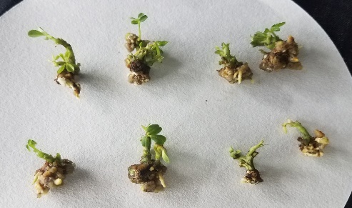
N3

Fig.7: Effect of 2, 4-D on the in vitro response of peanut cultivar Yu-hua-14 and N3 in different concentration of auxin treatment initially grown on TDZ medium. a 1 month old Yu-hua-14 and N3 peanut cultivar under different concentration of 2,4-D treatment, b rooting rate, c root number, d root length, e root fresh weight.

It was observed that both cultivars regenerated maximum rooting rate (94%) (Fig. 8b).The highest root number 10 was found at 4mg/LNAA and root length decreased as the concentration of NAA increased for both cultivars (Fig. 8c, d). Root fresh weight ranged from 0.1-0.56g for N3 and 0.14-0.52g for Yu-hua-14 (Fig. 8e).The result shows there was TDZ influence on the root formation, therefore, further investigation is needed.
a NAA (mg/L) 0 1 2 3 4
Yu-hua-14
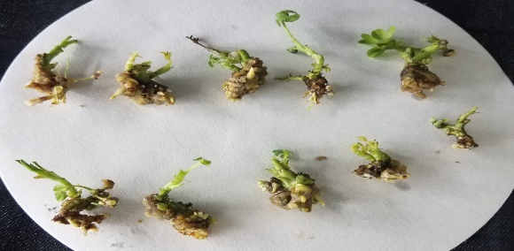
N3

Fig. 8: Effect of NAA on the in vitro response of peanut cultivar Yu-hua-14 and N3 in different concentration of auxin treatment initially grown on TDZ medium. a 1 month old Yu-hua-14 and N3 peanut cultivar under different concentration of NAA treatment, b rooting rate, c root number, d root length, e root fresh weight.

Discussion
The availability of an efficient regeneration system is an important prerequisite for applying genetic transformation in the plant species. Several research finding had been reported for peanut using different explant sources. Some reports had shown low regeneration frequency (34.7%) for the generation of plantlets (Akasaka et al. 2000) and takes long time (about 4 month (Tiwari and Tuli, 2009; Akasaka et al. 2000). However; few reports showed that using cotyledonary nodes which are located at the junction between embryo axes and the cotyledons have a better regeneration response and time efficient than many other explants and there are more regenerative axillary meristem cells in this area (Hsieh et al. 2017).
The effect of different concentration of TDZ and BAP was evaluated and compared on in vitro regeneration from cotyledonary nodes (Fig. 3 and Fig. 4) of peanut. The explants developed regenerant shoot buds from CNs within 3 weeks of culture. BAP at all concentration (1-5mg/L) evaluated (Fig. 3b) and TDZ at low concentration (0.5-2mg/L) induced shoots (Fig. 4c). Some reports shown that MS medium supplemented with different combinations of hormones regenerates maximum number of shoot buds. For instance, Limbua et al. (2019) reported highest regeneration frequency (98%) using cotyledonary nodes with the increase in BAP concentration up to 5mg/L combined with 1mg/L TDZ. Shoot bud formation (77.76-81.5%) on medium supplemented with 3mg/L and 0.92 mg/L NAA using immature leaflets on four genotypes was reported (Tiwari and Tuli 2009; Palanives et al. 2002) recorded the maximum percentage of calli having shoot buds from the treatment of 3.0mg/L BAP plus 0.5mg/L IAA (63.2%) for VRI-2 and 57.4% for VRI-3 genotypes. However; using BAP alone, we found highest regeneration frequency (97%) which is in line with (Hsieh et al. 2017). Shoot bud regeneration frequency varies among various BAP concentration. In our study cultivar difference were observed with regard to shoot regeneration. Between the two cultivars tested, N3 responded best with the highest shooting rate of (97%) on medium supplemented with 4mg/L BAP and (94.33%) on 1mg/L TDZ. Hence, shoots were induced more efficiently at higher concentration of BAP than TDZ. Suggesting, BAP was an effective growth regulator for peanut shoot regeneration. Previous studies on lentil (Chhabra et al. 2008), peanut (Gill and Saxena 1992) and soybean (Kaneda et al. 1977) reported that lower concentration of TDZ than BAP were effective for shoot organogenesis.
The present report indicated that both cultivars (Yu-hua-14 and N3) responded positively for both BAP and TDZ and shoot buds were regenerated from the cotyledonary nodes across cultivars, indicating that shoot regeneration using CNs might be genotype independent. Previous studies showed that using true cotyledonary nodes as explants allow high, fast and genotype independent shoot regeneration (Limbua et al. 2019; Hsieh et al. 2017; Sanyal et al. 2003). However (Banerjee et al. 2007) reported shoot buds from the cotyledonary nodes for BAP differed across cultivars.
To evaluate the auxin concentration, normal elongated shoot were transferred to RIM. Two different synthetic auxins, 2, 4-D and NAA were applied separately in RIM for both cultivars initially grown in 4mg/L BAP SIM and SEM and in 2mg/L TDZ SIM and 1mg/L TDZ SEM (Fig. 5a and 6a ). Visual observation were made periodically after 6 days of culture on RIM. Root development was initiated at seventh day on a medium containing NAA. Healthy roots were formed after one month of root induction and all rooted plantlets grew normally (Fig. 1f). The maximum root regeneration (81%) was found on medium containing 0.3mg/L 2, 4-D for the peanut cultivar Yu-hua-14 which was grown originally at TDZ medium (Fig. 7b). However; the maximum root regeneration (80.67%) was found on medium containing 0.3mg/L 2, 4-D initially grown on BAP medium (Fig. 5b). By contrast, the highest rooting rate (96.33%) was obtained in a medium supplemented with 1mg/L NAA for the peanut cultivar N3 which was originally grown at 4mg/L BAP medium (Fig. 6b). On the other hand, high root regeneration frequency (94%) was obtained with in 1month of culture initiation on Murashige and Skoog (MS) medium supplemented with 2mg/L NAA and 3mg/L NAA which were initially grown on TDZ shoot initiation and elongation medium (Fig. 8b). Which indicated lower concentration of NAA in tissue culture condition could be better to develop morphologically healthy peanut. NAA was found superior than 2, 4-D in generating roots. In line with our finding, Hsieh et al. (2017) reported NAA was superior to 2, 4-D in inducing roots and the lowest concentration of NAA (5.37μM) was preferred for root induction and subsequence plantlet adaptation to soil. We observed that TDZ or BAP has effect on morphological features such as root number, root length and root fresh weight (Fig. 5-8). Moreover, There were no root regeneration on a medium containing combination of 4mg/L BAP and 1mg/L NAA (data not shown) but only shoots regenerated, indicating NAA alone is effective for root regeneration.
The maximum frequency of root regeneration (68.3%) on MS medium supplemented with 2mg/L BAP and 1.5mg/L NAA in black gram (Adinge et al. 2014), (93.3%) on medium with 1mg/L NAA in peanut (Masanga et al. 2013) and (100%) on medium containing 5.7 μM NAA in peanut (Hsieh et al. 2017) were reported. In the present study the percentage of rooting success increased at lower auxin concentration. This finding disagree with (Banerjee et al. 1988; Palanivel et al. 2002) who reported the percentage of rooting success increased at higher auxin concentration.
Phenotypic data for root were recorded for both cultivars that were initially grown at 4mg/L BAP medium. Accordingly the highest root number (7 ± 0.577) was recorded at 0.2mg/L 2, 4-D treatment (Fig. 5c) and maximum root number (10 ± 0.577) was obtained at 4mg/L NAA. However, root length was longest on RIM with zero 2, 4-D and NAA (Fig. 5d and Fig. 6d). Root fresh weight was highest (0.443) on RIM with 0.3mg/L 2, 4-D for Yu-hua-14 and (0.57) on RIM with 4mg/L NAA for N3 cultivar (Fig. 5e, 6e). Additionally to evaluate the effect of 2,4-D and NAA, we measured root morphological data for peanuts that were initially grown at 2mg/L TDZ shoot initiation and 1mg/L TDZ shoot elongation medium. The maximum root number (10) was obtained on a medium containing 4mg/L NAA for both cultivars while at 0.2 and 0.3mg/L 2,4-D the highest root number (6) was obtained (Fig. 7c, 8c). In this case root number increased as the concentration of hormone increased. Hsieh et al. (2017) reported highest root number (10.81 ± 2.51) at 0.5μM 2, 4-D and (15.837± 1.14) at 26.85μM NAA treatments. In all auxin hormone treatments, root length were highly decreased as compared to zero hormone treatment and the longest root were observed at zero 2,4-D and NAA medium (Fig. 5d, 6d,7d, 8d). No Significance difference were observed for root fresh weight at 0, 2, 3 and 4mg/L NAA while significance difference were found at 0, 0.1 and 0.2mg/L 2,4-D (Fig. 7e, 8e).
Conclusion
The present protocol gives the advantage of efficient and effective shoot bud regeneration, shoot elongation and root formation. Among the cultivars tested, N3 responded best with the highest shooting rate of (97%) on medium supplemented with 4mg/L BAP and (94.33%) on 1mg/L TDZ. Hence, shoots were induced more efficiently at higher concentration of BAP than TDZ, suggesting BAP was an effective growth regulator for peanut shoot regeneration. On the other hand, the highest rooting rate (96.33%) was obtained in a medium supplemented with 1mg/L NAA for the peanut cultivar N3, which shows lower concentration of NAA in tissue culture condition could be better to develop morphologically healthy peanut and NAA was found superior than 2, 4-D in generating roots. Such plantlets regeneration system is suited for genetic transformation research in peanut. The present protocol is therefore a substantial improvement over cotyledonary node explant derived regeneration system reported earlier for this economically important crop.
Acknowledgment: We would like to thank Professor Piwu Wang for allowing plant biotechnology center to do the experiment. This work was funded by Jilin Province key research and development project (20180201070NY), China
Author contributions: AL, conducted experiment, wrote and revised the manuscript. JZ, SY, XH supervised the whole process and revised and edited the manuscript. AL, AAM, DY, XL, MRC, Q W, JP H, YX & BS analyzed data. All authors read and approved the final manuscript.
Conflicts of interest: The authors declare there is no conflicts of interest
References
Adlinge PM, KC Samal, RV Kumara Swamy et al (2014).Rapid in vitro plant regeneration of black gram (Vigna mungo
L.Hepper) Var.sarala. an important legume crop. Proc NatlAcad Sci India secB Biol Sci 84:823-827.https://doi.org/10.1007/s40011-013-0281-8
Akasaka Y, H Daimon, M Mii (2000). Improved plant regeneration from cultured leaf segments in peanut (Arachis
hypogaea L.) by limited exposure to thidiazuron. Plant Sci 156:169-175
Anuradha TS, SK Jami, RS Datla et al (2006).Genetic transformation of peanut (Arachis hypogaea L.) using
cotyledonary node as explant and a promoterless gus::nptII fusion gene based vector. J Biosci 31:235246. https://doi.org/10.1007/BF02703916
Atreya CD, JP Rao, NC Subrahmanyam (1984). In vitro regeneration of peanut (Arachis hypogaea L.) plantlets from
embryo axes and cotyledon segments. Plant Sci Lett 34:379-383
Baker CM and H Wetzstein (1995) Repetitive somatic embryogenesis in peanut cotyledon cultures by continual
exposure to 2,4-d. Plant Cell Tissue Organ Culture 40:249-254. https://doi.org/10.1007/BF0004813
Banerjee P, S Maity, SS Maiti, N Banerjee (2007). Influence of genotype on in vitro multiplication potential of Arachis
hypogaea L. Acta Bot Croat 66:15-23
Banerjee S, S Bandyopadhayaya, PD Ghosh (1988). Cotyledonary- node culture and multiple shoot formation in
peanut: Evidence for somatic embryogenesis. Curr Sci 57: 252-255
Bertioli DJ et al (2016). The genome sequence of Arachis duranensis and Arachis ipaensis, the diploid ancestor of
cultivated peanut. Nat Genet 48: 438-446
Bhatnagar M, K Prasad, P Bhatnagar-Mathur, ML Narasu, F Waliyar, KK Sharma (2010). An efficient method for the
production of marker-free transgenic plants of peanut (Arachis hypogaea L.). Plant Cell Rep 29:495-502. Doi 10.1007/s00299-010-0838-4
Burns SP, M Gallo, BL Tillman (2012). Expansion of a direct shoot organogenesis system in peanut (Arachis hypogaea
L.) to include US cultivars. In Vitro Cell Dev-pl 48: 58-66
Cheng M, DCH His, GC Phillips (1992). In vitro regeneration of Valencia-type peanut (Arachis hypogaea L.) from
cultured petiolules, epicotyl section and other seedling explants. Peanut Sci 19: 82-87
Chhabra G, D Chaudhary, M Varma et al (2008). TDZ-induced direct shoot organogenesis and somatic embryogenesis
on cotyledonary node explants of lentil (Lens culinaris Medik.). Physiol Mol Biol Plants14:347-353. https://doi.org/10.1007/s12298-008-0033-z
Food and Agricultural organization of the United Nations, 2019. http://www.fao.org/faostat.Accessed 15March 2021
Gill R, Saxena PK (1992) Direct somatic embryogenesis and regeneration of plants from seedling explants of peanut
(Arachis hypogaea): promotive role of TDZ. Can J Bot 70: 1186-1192
Hazra S, S Sathaye, A Mascarenhas (1989). Direct somatic embryogenesis in peanut (Arachis hypogaea). Nat
Biotechnol 7:949-951. https://doi.org/101038/nbt0989-949
Heatley ME, RH Smith (1996). Whole plant regeneration from the shoot apex of Arachis hypogaea L.. In Vitro Cell
Dev Biol 32:115-118
Hsieh YF, M Jain, J Wang et al (2017). Direct organogenesis from cotyledonary node explants suitable for
Agrobacterium-mediated transformation in peanut (Arachis hypogaea L.). Plant Cell Tiss organ Cult 128:161-175. https://doi.org/10.1007/s11240-016-1095-1
Joshi MV, NA Sahasrabudhe, S Hazra (2003). responses of peanut somatic embryos to thidi-azuron. Biol Plant 46(2):
187-192
Kaneda Y, Y Yabei, S Nishimura, K Harada, T Akhima, K Kitamura (1977). Combination of thidiazuron and basal
media with low salt concentrations increases the frequency of shoot organogenesis in soybean (Glycine max.L.Merr.). Plant cell Rep 17: 8-12
Kar S, TM Johnson, P Nayak, SK Sen (1996). Efficient transgenic plant regeneration through Agrobacterium
mediated transformation of chickpea (Cicer arietinum L.). Plant Cell Rep16:32-37
King JC, J Blumberg, L Ingwesen, M Jenab, KL Tucker (2008). Tree nuts and peanuts as components of a healthy diet.
J Nutr 138:1736S-1740S
Limbua PG, MP Ngugi, RO Oduor (2019). In vitro regeneration protocol of Kenyan adapted groundnut (Arachis
hypogaea L.) genotypes using cotyledonary node explants. J Plant Biochem Physiol 7:1. Doi:10.4172/2329-9029.1000233
Little EL, ZV Magbanua, WA Parrott (2000). A protocol for repetitive somatic embryogenesis from mature peanut
epicotlys. Plant Cell Rep 19:351-357
Masanga J, S Ommeh, R Kasili, A Alakonya (2013). An optimized protocol for high frequency regeneration of selected
groundnut (Arachis Hypogaea L) varities from East Africa using cotyledons. International Journal of Agriculture and Crop Sciences 6:1420-1421
Matand K, CS Prakash (2007). Evaluation of peanut genotypes for in vitro plant regeneration using thidiazuron. J
Biotechnol 130:202- 207
McKently AH, GA Moore, FP Gardner (1990) .In vitro plant regeneration of peanut from seed explants. Crop Sci 30:
192-196
Murashige T, F Skoog (1962). A revised medium for rapid growth and bio assays with tobacco tissue cultures. Physiol
Planta 15:473-497
Palanivel S, S Parvathi, N Jayabalan (2002). Callus induction and plantlet regeneration from mature cotyledonary
segment of groundnut (Arachis hypogaea L.). J Plant Biol 45:22-27. https://doi.org/10.1007/BF03030428
Sanyal I, A K Singh, DV Amla (2003). Agrobacterium tumefaciens mediated transformation of Chickpea (Cicer
arietinum L.) using mature embryonic axes and cotyledonary nodes. Indian J Biotechnol 2:524-532
Shan L, G Tang, P Xu, Z Liu, Y Bi (2009). High efficiency in vitro plant regeneration from epicotyl explants of
Chinese peanut cultivars. In Vitro Cell Dev Biol Plant 45: 525-531
Sharma KK, VV Anjaiah (2000). An efficient method for production of transgenic plants of peanut (Arachis hypogaea
L.) through Agrobacterium tumefaciens-mediated genetic transformation. Plant Sci 159:7-19
Tiwari S, R Tuli (2009) Multiple shoot regeneration in seed-derived immature leaflet explants of peanut (Arachis
hypogaea L.). Scientia Hortic 121: 223-227
Venkatachalam P, P B Kavi Kishor, N Jayabalan (1997). High frequency somatic embryogenesis and efficient plant
regeneration from hypocotyl explants of groundnut (Arachis hypogaea L.). Current Science 72:271-275
Venkatachalam P, P B Kavi Kishor, N Geetha et al (1999). A protocol for somatic embryogenesis from immature
leaflets of groundnut (Arachis hypogaea L.) In Vitro Cell Dev Biol Plant. 35:409-412. https://doi.org/10.1007/s11627-999-0056-3
Wynne J C, T Haiward, D A Knauft (1989). Cytogenetics and genetics of Arachis. Crit Rev Plant Sci 8:189-220

