Overexpression of Tea CsANR Increases Proanthocyanidin Content and Induces Early Flowering in Transgenic Tobacco
Yong QI^{2,3}, Xinzhuan YAO¹ ,Yunxiao HUANG⁴, Degang ZHAO^{2,3}, Litang Lu^{1,3}*
¹College of Tea Science, Guizhou University, Guiyang, 550025, People’s Republic of China
² Guizhou Academy of Agricultural Sciences, Guiyang, 550025, China
³College of Life Sciences and The Key Laborato ry of Plant Resources Conservation and Germplasm Innovation in Mountainous Region (Ministry of Education), Institute of Agro-Bioengineering, Guizhou University, Guiyang, 550025, China
⁴ Bijie City Plant Protection and Plant Inspection Station, Bijie, 551700, China
*Correspondence: E-mail: ltlv@gzu.edu.cn

Abstract
Procyanidins are polyphenol compounds that are uniquely found in plants, and has been demonstrated that these compounds are natural antioxidants that possess efficient free radical scavenging capabilities. Anthocyanidin reductase (ANR) is a key enzyme within the proanthocyanidins (PAs) biosynthesis pathway that serves play important regulatory role affecting PAs accumulation in plant tissues. In this study, overexpression of the ANR gene of the tea plant Camellia sinensis (CsANR) significantly increased PAs content in tobacco plants and induced early flowering. The transgenic tobacco flowers were white in color, as opposed to the pink of wild-type tobacco, and the transgenic lines flowered 12~16 d early compared to wild type. Gene expression analysis showed that early flowering-related genes were significantly upregulated in the transgenic plants. Moreover, the contents of flavan-3-ols (i.e., gallocatechim and epigallocatechin) were increased in leaf tissues of the transgenic lines. The expression of other endogenous flavonoid biosynthetic pathway genes in the leaves and flowers of CsANR-overexpressing plants were analyzed. As such, it appeared that overexpression of CsANR increased flavan-3-ol and PAs contents by modulating the expression of various flavonoid biosynthetic pathway genes in these transgenic plants.
Key Words Procyanidins, anthocyanidin, CsANR, early flowering, flavan-3-ols

Introduction
Proanthocyanidins (PAs), also called condensed tannins, result from the condensation of flavan-3-ols and are found extensively in higher plants (Xu et al. 2015) . PAs are natural antioxidants with efficient free radical scavenging capabilities that demonstrate scavenging activities 50 times that of VE (Vitamin E) and 20 times that of VC (Vitamin C) (Robertson 2001). Furthermore, procyanidin has been implicated in the prevention and cure of cardiovascular disease and has been shown to possess anti-inflammation, anti-cancer, anti-mutagenic, anti-diabetic, anti-inflammatory, and anti-radiation activities (Albert, 2015; Gesell et al. 2014; Liao et al. 2015). Moreover, these compounds have been shown to enhance immunity, and improve the ability. In addition, PAs affect the taste of fruits and the feeding behavior of herbivores in pastures (Bagchi et al. 2000; Dixon et al. 2010). As such, PAs possess a broad development prospective due to their diverse biological functions and extremely high safety profile.
The biosynthetic pathway for generating PAs is well known, and the outline of the general flavonoid biosynthetic pathway (Supplementary Fig 1). It is a secondary metabolite produced by the metabolic process of phenylalanine. The biosynthesis of PAs is divided into three stages: phenylalanine→4-coumarolyl-CoA→dihydroflavonol→procyanidins. The first and second stages are the same as the biosynthesis of anthocyanins. The product of the second stage, dihydroflavonol, generates leuco anthocyanins under the action of dihydroflavonol 4-reductase (DFR), where it is divided into two branches (Xueqing et al 2017; Springob et al. 2003). One is thatleuco anthocyanins produce catechins under the catalysis of leuco anthocyanin reductase (LAR). The other branch is that leuco anthocyanins are first converted into anthocyanins under the catalysis of enzymes, and then epicatechins are produced under the action of anthocyanin reductase (ANR). The ANR pathway is characterized by the anthocyanin-synthase–catalyzed reduction of non-cyanidins into anthocyanins, followed by ANR-catalyzed oxidation of anthocyanins to flavan-3-ols(Xie et al. 2004).The above two products are all procyanidin monomers, and the two are further polymerized to form procyanidins in different forms and numbers.
Flavan-3-ol, the product of the ANR reaction, can be divided into flavan-3α-ol and flavan-3β-ol. Flavan 3α-ol mainly includes epicatechin, epigallocatechin and gallic acid ester derivatives. Flavan-3β-ol mainly includes catechins, gallocatechins and gallic acid ester derivatives. All of these substances contain 2-phenylbenzopyran structure, so they are all flavonoids. At the same time, for PAs, which are widely present in various plants in the plant kingdom, flavan-3-ol is not only the main component, but also the starting unit of PAs polymerization. Therefore, the catechins, the reaction products of ANR, play a very important role in the physiological functions of various plants.
At present，the genes encoding ANR have been cloned and characterized from numerous plants, including Arabidopsis (Xie et al. 2004), M. truncatula (Pfeiffer et al. 2006), L. corniculatus (Terrier et al. 2009), V. vinifera(Ashton et al. 2005), and C. sinensis (Singh et al. 2009). Expression of ANR has been shown to correlate with the accumulation of flavan-3-ols during development of leaves and flowers in C. sinensis (Kumar et al. 2012); however, the effect of ANR overexpression in tobacco in regard to PAs content in tobacco leaves has not been extensively reported. In the current study, we further characterized the role of ANR in development by isolating an ANR cDNA (CsANR) from Camellia sinensis and expressing it in tobacco plants. In addition to an increased content of flavan-3-ols, we also observed that tobacco plants carrying the 35S::CsANR transgene demonstrated significantly increased PAs content and that these plants flowered 12-16 d earlier than wild-type plants. These results suggested that CsANR is a functional regulator of the PAs synthetic pathway and may be a useful molecular tool for promoting early flowering in plants.
Methods
Plant materials, growth conditions, and isolation of total RNA
Tobacco (Nicotiana tabacun var. xanthine) sterile seedling (provided by Institute of Agro-Bioengineering) were cultivated on MS medium in a growth chamber at 23ºC with a light intensity of 40 µmol/m²/s, and 8-week-old leaves of tobacco plants were used for Agrobacterium -mediated genetic transformation. Place Young fresh tobacco leaves (0.1 g) in pre-cooled mortar, add liquid nitrogen and quickly grind them into powder. After extracting the total RNA according to the RNAiso Plus extraction kit (R6837-02; Omega, USA) instructions, add 50 μL of DEPC to dissolve the RNA, and digest the remaining genomic DNA with DNAse I, and finally detect it by 1.2% agarose gel electrophoresis. Using the RNA of each sample as a template and Oligo(dT)₁₅ (10 μmol/L) as a primer, cDNA was synthesized using M-MLV reverse transcriptase.
Plasmid construction
All DNA manipulations were performed as previously described (Saumweber et al. 1990; Yong et al.2018). The binary plasmid PSH-737 was double digested with Xba Ⅰ and BamH Ⅰ, and the artificially synthesized target fragment was digested with Kpn Ⅰ and EcoR Ⅰ and ligated with T₄DNA ligase to form the plant expression vector PSH-CsANR, driven by the cauliflower mosaic virus 35S promoter (CaMV 35S) neomycin phosphotransferase gene (NPT Ⅱ)::β-glucuronidase gene (GUS) fusion gene was used as a selection marker gene and reporter gene (Fig.1).Plasmid pSH737-35S-CsANR was transferred into the Agrobacterium tumefaciens strain LBA4404 (Horsch et al. 1985). Colonies resistant to kanamycin were selected, and enzyme digestion and PCR amplification were employed to ensure the presence of all plasmids.
Plant transformation
Refer to Yong et al. (2019) tobacco leaves were prepared for transformation using a leaf disk transformation method, genomic DNA was extracted from the leaves of transgenic plants, and positive tobacco plants were screened by ordinary PCR verification, using detection primers designed according to the CsANR sequence (Supplementary Table 1).
Quantitative Real-time PCR
Quantitative Real-time determination of the expression levels of target genes, early flowering-related genes, and key enzyme genes in the anthocyanin synthesis pathway were carried out using SYBR Green dye method (Yong et al., 2019). The total RNA from the leaves of the same part of transgenic tobacco and wild-type tobacco was extracted, and reverse transcribed into cDNA according to ABI (USA) kit. Using β-actin as the internal reference gene, using Primer 5.0 software, design the relevant gene qRT-PCR primers (Supplementary table 1). The qRT-PCR reaction system is 20 μL, including Power SYBR Green PCR Master Mix (2×) 10 μL; forward and reverse primers (10 μ mol/L) each 1.0 μL; cDNA (30 ng/μL) 4 μL and ddH₂O 4.0 μL. The PCR amplification program is: 95 ℃ 10 min; 95 ℃ 15 s; 60 ℃ 1 min, 40 cycles in total after the reaction, confirm the amplification curve and melting curve of Real Time PCR, and refer to the operation manual of Step OneTM Real-Time PCR Systems for the data analysis method.Each sample is sampled 3 times, with 3 repetitions set each time.
Relative quantitative formula: ΔΔ Ct = Δ Ct (experimental sample)-Δ Ct (reference sample), where: Δ Ct (experimental sample) = Ct (experimental sample, target gene)-Ct (experimental sample, internal reference gene); Δ Ct (reference sample) = Ct (reference sample, target gene)-Ct (reference sample, internal reference gene); relative expression level = 2^{-ΔΔ Ct}.
Flavonoid analysis
Using the method of Monika (2011) et al., Gallocatechim (GC) and epigallocatechin (EGC) in tobacco plant leaf tissues were analyzed by high performance liquid chromatography.
Proanthocyanidins and anthocyanin content estimations
The content of the PAs in tobacco was measured via the vanillin-hydrochloric acid method (Xue et al. 2018).
Statistical analysis
By using the least significant difference test (LSD test) to analyze the significance of PA, EGC, GC, polyphenol content, the relative expression of flavonoid biosynthesis pathway genes and early flowering genes. For qRT-PCR, three biological replicates were assessed. Microsoft Excel and Graph Pad Prism 5.0 software were employed in the data analysis. One-way ANOVA with Duncan’s multiple range test (post hoc) was used for the comparison of multiple variables.
Results
Confirmation of transgenic tobacco plants overexpressing the CsANR
The open reading frame (ORF) of CsANR was obtained from Camellia sinensis and was 1233 bp in length and encoded 410 putative amino acids. The sequence was deposited in GenBank under accession number AY641729.1. We constructed a plant expression vector, pSH-CsANR, and transferred the vector into tobacco (Nicotiana tabacum) via leaf Agrobacterium-mediated transformation. The integration of the CsANR cDNA in the genomes of the transgenic lines was confirmed by PCR (Fig.1). We obtained a total of 30 transgenic strains and harvested T₁ generation seeds. TP-6, TP-9, and TP-16 demonstrated the highest expression levels of CsANR among all the transgenic plants. T₁ homozygous lines of these transgenic plants were selected and confirmed, and these three lines were used for further phenotypic and expression analysis.
Tobacco plants overexpressing CsANR showed early flowering and altered expression of flowering-related genes
In addition to affecting the color of the tobacco flowers (see below), flowering time was also altered in the transgenic lines compared to the wild-type plants. The relative growth of the transgenic lines overexpressing CsANR compared with wild-type tobacco is shown in Fig.2A. The transgenic lines flowered early and completed their life cycle 12-16 days in advance compared to wild-type plants (Fig.2B). In order to explore the reasons for the early flowering of the transgenic lines, we analyzed the key genes that affect tobacco flowering in transgenic tobacco leaves and flowers. As shown in Figure 2, gene expression analysis via qRT-PCR revealed that the expression of SOC1, NFL1, AP1, CMB1, and MADS were all upregulated in the leaves and flowers of the TP-6, TP-9, and TP-16 lines compared to wild-type tobacco plants. Of note, the expression of FT4 was upregulated in leaves and downregulated in flowers compared to wild-type plants. These results implied that overexpression of CsANR in tobacco regulated the expression of SOC1, NFL1, AP1, CMB1, MADS, and FT4 in both leaves and flowers.
Floral development and flavonoid content in CsANR transgenic and wild-type plants
Flowers of the CsANR-overexpression lines and wild-type plants were analyzed for their morphological features. The flowers of transgenic tobacco are white (Fig.3A,B), and this was consistent with a decline of anthocyanin content (Fig.3I). Compared with the corolla and calyx, there was the smallest difference between transgenic plants and wild-type plants (Fig.3D-H). Among the interior floral parts, the stamens were present in a 4+1 orientation and showed no variation (Fig.3F, G), and the gynoecium also showed no significant difference in appearance or length between the transgenic lines and wild-type plants (Fig.3E). We also measured the content of PAs, and the result indicated that the PAs contents of the transgenic plants were increased significantly compared with wild-type, with the PAs contents of the three positive transgenic plants increasing 87.30%, 77.48%, and 107.56% (Fig.3J), respectively.
Expression analysis of endogenous flavonoid biosynthetic pathway genes in CsANR-overexpression transgenic tobacco plants
Compared the expression of key genes related to flavonoid synthesis in CsANR-overexpression transgenic tobacco plants using qRT-PCR. The data showed that overexpression of CsANR greatly influenced expression of flavonoid structural genes in the leaves and flowers. The expression of the CHS, CHI, PAL, DFR, and FLS genes were all altered in the leaves and flowers of the transgenic lines compared to wild-type tobacco plants (Fig.4A-F). The transcript levels of the CsANR gene were evaluated in the leaves and flowers of the TP-6, TP-9, and TP-16 transgenic lines, and the expression of CsANR in the flowers of TP-6, TP-9, and TP-16 were higher than that observed in the leaves (Figure 4A), suggesting a possible positional effect of transgene integration in the host genome.
The relative expression of the CHI and FLS genes were increased in the leaves and decreased in the flowers of TP-6, TP-9, and TP-16 compared to wild-type tobacco (Fig. 4C-F). In addition, the relative expression of CHS gene in transgenic tobacco decreased in leaves, while the expression of TP-6, TP-9 and TP-16 increased in flowers. (Fig.4B). Compared with wild-type plants, the transcription levels of PAL and DFR genes are increased in the leaves and flowers of transgenic lines (Fig.4E). Among all the genes investigated, CsANR, CHI, FLS, PAL, and DFR were all upregulated in the leaves of transgenic plants. Moreover, CHI and FLS, showed decreased levels of expression in the flowers of the transgenic lines compared to wild-type control plants, while transcript accumulation of the CsANR, CHS, and PAL genes was significantly higher in the flowers of the transgenic plants compared to wild type.
Accumulation of flavan-3-ols in transgenic and wild-type plants
To further elucidate the influence of CsANR overexpression on flavan-3-ol content in transgenic and wild-type plants, we surveyed the GC and EGC contents in leaf tissues of the TP-6, TP-9, and TP-16 transgenic lines as well as wild-type tobacco plants. The results showed that the GC content was 4.214% DW, 4.347% DW, and 4.817% DW in TP-6, TP-9, and TP-16 lines, respectively, as compared with 3.454% DW in wild-type tobacco plants (Fig.5A). The EGC content of TP-6, TP-9 and TP-16 strains is estimated to be 0.869% DW, 1.238% DW and 2.413% DW, respectively, while the EGC content of wild-type tobacco plants is only 0.606% DW (Fig.5B).
Discussion
Phenolic compounds are widely distributed among plant species and are know to possess potent antioxidant activities; as such, they are important biological and medicinal compounds. Flower color and flowering time are important characteristics of ornamental plants, and among phenolic compounds, anthocyanins and flavonoids are the most important determents of flower color, resulting in variations of colors, including white, yellow, red, and purple (Tanaka et al. 2008; Morita et al 2014). Overexpression of the Pueraria montana CHR gene results in changes in flavonoid content and flower color in transgenic tobacco plants (Nishihara et al. 2011). The primary function of ANR is to catalyze the synthesis of flavan-3-ols from anthocyanin (Zhang et al. 2012), competing with the common substrate of UFGT, anthocyanidin, which it converts to anthocyanin (Ashton 2005). Moreover, ANR catalyzes the synthesis of flavan-3-ols from the substrates cyanidin and leucoanthocyanidin. As flavan-3-ols are the initiating monomers of PAs synthesis, these ANR-catalyzed reactions play a crucial role in the levels of both flavan-3-ols and PAs in plants.
Vinay Kumar's research showed that overexpression of CsANR can increased the content of Flavan-3-ols and reduced anthocyanins, which makes the flowers of transgenic tobacco white (Kumar et al. 2012). In this study, our results are basically the same as Vinay Kumar, but the overexpression of CsANR not only regulated the conversion of anthocyanins to flavan-3-ols, reduced the content of anthocyanins, but also significantly increased the content of PAs in transgenic tobacco plants (Fig.3I, J and 5A, B). Furthermore, we compared the expression of key endogenous genes related to flavonoid synthesis in CsANR-overexpression transgenic tobacco plants. The data showed that the relative expression of the CHI and FLS genes were downregulated in the flowers of transgenic lines (Fig. 4C, F) compared to wild-type tobacco, which is consistent with the observation that overexpression of apple ANR genes inhibits expression of CHI genes in flowers, leading to a loss of anthocyanin in tobacco, as reported by Han et al (Han et al. 2012). Moreover, we analyzed the expression of the CHS, PAL, and DFR genes in the leaves and flowers of CsANR transgenic lines relative to wild-type tobacco plants. Overexpression of CsANR resulted in upregulated expression of the endogenous PAL, CHS, and DFR genes in the flowers of these plants (Fig.4C-E). Previously, the expression of the CHS and DFR genes in Capsicum annuum were shown to be higher in pigmented flowers than in white flowers (Stommel et al. 2009). Additionally, the co-suppression of tobacco chalcone synthase using a petunia chalcone synthase construct results in white flowers (Wang et al. 2006). As such, these observations indicate that CHS and DFR play a role in regulating the content of anthocyanin.
CsANR-overexpression transgenic lines flowered early and completed their life cycle 12-16 days in advance compared to wild-type tobacco (Fig.2A, B). In order to determine the key positive or negative regulators influencing this early flowering, we assessed the expression of endogenous flowering-related genes in transgenic tobacco leaves and flowers. To this end, we analyzed the expression of the FT4, SOC1, NFL1, AP1, CMB1, and MADS genes in leaves and flowers of CsANR transgenic lines compared to wild-type tobacco plants. Previously research has shown that overexpression of FT orthologs can induce early flowering in different plants, such as tomato(Shalit et al. 2009), spring orchid(Lin et al. 2012), fig(Hidetoshi et al. 2013), and tobacco(Harig et al. 2012; Wickland et al. 2015), and in early flowering, the FT4 gene is required to activate AP1 expression, which promotes expression of other genes required for floral meristem differentiation(Lee et al. 2010). Four FT-like genes have been identified in the tobacco genome: FT1, FT2, FT3, and FT4, which act antagonistically to regulate floral initiation (Harig et al. 2012). Our study showed that the expression of FT4 was downregulated and that of AP1 was significantly upregulated in tobacco flowers (Fig.3C, F). Furthermore, overexpression of BpMADS and SOC1 in transgenic tobacco plants has been shown to result in early flowering (Qu et al. 2013; Ma et al. 2011). In this current study, the expression of SOC1, AP1, CMB1, and MADS were all upregulated in the leaves and flowers of transgenic lines overexpressing CsANR compared with wild-type tobacco. These data indicated that the expression of FT4, SOC1, AP1, CMB1, and MADS could be regulated by CsANR. Therefore, CsANR might function to upregulate the genes that regulate flowering in these transgenic tobacco plants, and overexpression of CsANR, thus, may serve to significantly increased the content of PAs and induce early flowering.
Conclusion
Overexpression of CsANR significantly increased the PAs and flavan-3-ol (i.e., GC and EGC) contents in tobacco and served to induce early flowering. These results indicate that CsANR interacts with the flavonoid biosynthetic pathway to regulate flavonoid biosynthesis, at the same time, CsANR might upregulate endogenous flowering-related genes to regulate flowering in these transgenic tobacco plants. This study contributes to our understanding of the regulation of the PAs biosynthetic pathway in plants and provides a potential molecular tool for inducing early flowering in other plants.
AUTHOR CONTRIBUTION STATEMENT
YQ , LTL and DGZ conceived and designed the research. YQ and LTL conducted the experiments. YQ ,YXH and XZY contributed analytical tools and analyzed data. YQ wrote the manuscript. All authors read and approved the manuscript.
ACKNOWLEDGMENTS
Research on key technologies for improving the quality of albino, yellowing, and purple tea tree varieties. Project ID: Qianke Heping Talents [2019]5651

Reference
Albert, N. W (2015) Subspecialization of r2r3-myb repressors for anthocyanin and proanthocyanidin regulation in forage legumes. Frontiers in Plant Science, 6. DOI 10.3389/fpls.2015.01165
Ashton AR (2005) Proanthocyanidin synthesis and expression of genes encoding leucoanthocyanidin reductase and anthocyanidin reductase in developing grape berries and grapevine leaves. Plant Physiology 139(2), 652-63. DOI:10.1104/pp.105.064238
Bagchi D, Bagchi M, Stohs SJ, Das DK, Ray SD, Kuszynski CA (2000) Free radicals and grape seed proanthocyanidin extract: importance in human health and disease prevention. Toxicology 148(2–3), 187-197. DOI 10.1016/S0300-483X(00)00210-9
Dixon RA, Xie DY, Sharma SB (2010) Proanthocyanidins a final frontier in flavonoid research?. New Phytologist 165(1), 9-28. DOI 10.1111/j.1469-8137.2004.01217.x
Gesell A, Yoshida K, Lan TT, Constabel CP (2014) Characterization of an apple TT2-type R2R3 MYB transcription factor functionally similar to the poplar proanthocyanidin regulator PtMYB134. Planta. 240(3):497-511. DOI 10.1007/s00425-014-2098-y
Han Y, Sornkanok V, Elena SGR, Korban SS (2012) Introduction of apple ANR genes into tobacco inhibits expression of both chi and dfr genes in flowers, leading to loss of anthocyanin. Journal of Experimental Botany 63(7), 2437. DOI 10.1093/jxb/err415
Harig L, Beinecke FA, Oltmanns J, Muth J, Müller O, Rüping B (2012) Proteins from the flowering locus t-like subclade of the pebp family act antagonistically to regulate floral initiation in tobacco.Plant Journal for Cell & Molecular Biology 72(6), 908-21. DOI 10.1111/j.1365-313X.2012.05125.x
Hidetoshi I, Hitoshi N, Yoshiaki I, Shuichi H, Hiroshi Y, Chiharu H (2013) Expression offcft1, a flowering locus t-like gene, is regulated by light and associated with inflorescence differentiation in fig (ficus carical.).Bmc Plant Biology 13(1), 216.
DOI 10.1186/1471-2229-13-216
Horsch RB, Fry JE, Hoffmann NL, Eichholtz D, Rogers SG, Fraley RT (1985) A simple and general method for transferring genes into plants. Science 227(4691), 1229-31.
DOI 10.1126/science.227.4691.1229
Kumar V, Yadav S K (2013) Overexpression of CsANR increased flavan-3-ols and decreased anthocyanins in transgenic tobacco. Molecular Biotechnology, 54(2), 426-435.
DOI 10.1007/s12033-012-9580-1
Lee J, Lee I (2010) Regulation and function of soc1, a flowering pathway integrator. Journal of Experimental Botany 61(9),2247-2254. DOI 10.1103/PhysRevA.57.2379
Lepiniec L, Debeaujon I, Routaboul JM, Baudry A, Pourcel L, Nesi N (2006) Genetics and biochemistry of seed flavonoids. Annual Review of Plant Biology 57(1), 405.
DOI 10.1146/annurev.arplant.57.032905.105252
Liao L, Vimolmangkang S, Wei G, Zhou H, Korban SS, Han Y (2015) Molecular characterization of genes encoding leucoanthocyanidin reductase involved in proanthocyanidin biosynthesis in apple. Frontiers in Plant Science 6(243), 243.
DOI 10.3389/fpls.2015.00243
Lin X, Li X, Qin D, Guo F, Wu C, Miao L (2012) Functional analysis of flowering locus t, orthologs from spring orchid ( cymbidium goeringii, rchb. f.) that regulates the vegetative to reproductive transition. Plant Physiology & Biochemistry Ppb 58(3), 98.
DOI 10.1016/j.plaphy.2012.06.011
Ma G, Ning G, Zhang W, Zhan J, Lv H, Bao M (2011) Overexpression of petunia soc1-like gene fbp21 in tobacco promotes flowering without decreasing flower or fruit quantity. Plant Molecular Biology Reporter 29(3), 573-581. DOI 10.1007/s11105-010-0263-4
Monika M, Singh AP, Kumar YS (2011) Post-transcriptional silencing of flavonol synthase mrna in tobacco leads to fruits with arrested seed set. Plos One 6(12):e28315.
DOI 10.1371/journal.pone.0028315
Morita Y, Takagi K, Fukuchi-Mizutani M, Ishiguro K, Tanaka Y, Nitasaka E(2014) A chalcone isomerase-like protein enhances flavonoid production and flower pigmentation. Plant Journal 78(2), 294. DOI 10.1111/tpj.12469
Nishihara M, Nakatsuka T(2011) Genetic engineering of flavonoid pigments to modify flower color in floricultural plants. Biotechnology Letters 33(3), 433-441.
DOI 10.1007/s10529-010-0461-z
Pfeiffer J, Kühnel C, Brandt J, Duy D, Punyasiri PAN, Forkmann G (2006) Biosynthesis offlavan 3-ols byleucoanthocyanidin 4-reductases andanthocyanidin reductases inleaves ofgrape ( vitisvinifera, l.), apple ( malusx domestica, borkh.) andother crops. Plant Physiol Biochem 44(5–6), 323-334. DOI 10.1016/j.plaphy.2006.06.001
Qu GZ, Zheng T, Liu G, Wang W, Zang L, Liu H (2013)Overexpression of a mads-box gene from birch (betula platyphylla) promotes flowering and enhances chloroplast development in transgenic tobacco. Plos One 8(5), e63398. DOI 10.1371/journal.pone.0063398
Robertson, K (2001) Botanical influences of illness: a sourcebook of clinical research, second edition m.r. werbach and m.t. murray. JOURNAL OF ALTERNATIVE AND COMPLEMENTARY MEDICINE -NEW YORK 379-380(2)
Saumweber H, Frasch M, Korge G (1990) Two puff-specific proteins bind within the 2.5 kb upstream region of the Drosophila melanogaster, Sgs-4 gene. Chromosoma 99(1):52. DOI 10.1007/bf01737289
Shalit A, Rozman A, Goldshmidt A, Alvarez JP, Bowman JL, Eshed Y (2009) The flowering hormone florigen functions as a general systemic regulator of growth and termination. Proceedings of the National Academy of Sciences of the United States of America 106(20), 8392-7. DOI 10.1073/pnas.0810810106
Singh K, Rani A, Paul A, Dutt S, Joshi R, Gulati A (2009) Differential display mediated cloning of anthocyanidin reductase gene from tea (camellia sinensis) and its relationship with the concentration of epicatechins. Tree Physiology 29(6), 837. DOI 10.1093/treephys/tpp022
Springob K, Nakajima JI, Yamazaki M, Saito K (2003) Recent advances in the biosynthesis and accumulation of anthocyanins. Natural Product Reports 20(3), 288. DOI 10.1039/b109542k
Yong Q, Xinzhuan Y, Degang Z, & Litang L (2018) Overexpression of sbskip, a pre-mrna splicing factor from sorghum bicolor, enhances root growth and drought tolerance in petunia hybrida. Scientia Horticulturae, 240, 281-287. DOI：10.1016/j.scienta.2018.06.056
Yong Q, Xinzhuan Y, Degang Z, & Litang L (2019) Cloning of CsANS Gene from Tea Plant (Camellia sinensis) and Its FunctionalAnalysis in Transgenic Tobacco (Nicotiana tabacum) .Journal of Agricultural Biotechnology, 2019, 27(4): 636~644 DOI：CNKI:SUN:NYSB.0.2019-04-007
Yueqing L , Xingxue L , Xinquan C , Xiaotong S, Ruifang G , & Song Y (2017) Dihydroflavonol 4-reductase genes from freesia hybrida play important and partially overlapping roles in the biosynthesis of flavonoids. Frontiers in Plant Science, 8. DOI 10.3389/fpls.2017.00428
Stommel JR, Lightbourn G J, Winkel BS, Griesbach RJ (2009) Transcription factor families regulate the anthocyanin biosynthetic pathway in capsicum annuum. Journal of the American Society for Horticulturalence 134(2), 244-251. DOI 10.1051/fruits/2009006
Tanaka Y, Sasaki N, Ohmiya A (2008) Biosynthesis of plant pigments: anthocyanins, betalains and carotenoids. Plant Journal 54(4), 733-749. DOI 10.1111/j.1365-313X.2008.03447.x
Terrier N, Torregrosa L, Ageorges A, Vialet S, Verriès C, Cheynier V (2009) Ectopic expression of vvmybpa2 promotes proanthocyanidin biosynthesis in grapevine and suggests additional targets in the pathway. Plant Physiology 149(2), 1028. DOI 10.1104/pp.108.131862
Wang CK, Chen PY, Wang HM, To KY (2006) Cosupression of tobacco chalcone synthase using petunia chalcone synthase construct results in white flowers. Botanical Studies 47(1), 71-82. DOI 10.1663/0006-8101(2006)72[1:DADOFS]2.0.CO;2
Wickland, Daniel , Hanzawa, Yoshie (2015) The flowering locus t / terminal flower 1 gene family: functional evolution and molecular mechanisms. Journal of Botany 8(7), 983-997. DOI 10.1016/j.molp.2015.01.007
Xie D Y, Sharma SB, Dixon R A (2004) Anthocyanidin reductases from medicago truncatula and arabidopsis thaliana. Archives of Biochemistry & Biophysics 422(1), 91-102. DOI 10.1016/j.abb.2003.12.011
Xie DY, Dixon R A .2003. Role of anthocyanidin reductase, encoded by banyuls in plant flavonoid biosynthesis. Science 299(5605), 396-9. DOI 10.1126/science.1078540
Xu WJ, Dubos, Christian, Lepiniec, Loïc(2015) Transcriptional control of flavonoid biosynthesis by myb-bhlh-wdr complexes. Trends in Plant Science 20(3), 176-185. DOI 10.1016/j.tplants.2014.12.001
Xue SZ, Wen Z, Shu XL, Ren LW (2018) The Study of the Extraction and Purification of procyanidins from Black Bean Seed Coats. Modern Food Science and Technology 34-1. DOI 10.13982/j.mfst.1673-9078.2018.1.024
Zhang X, Liu Y, Gao K, Zhao L, Liu L, Wang Y (2012) Characterisation of anthocyanidin reductase from shuchazao green tea. Journal of the Science of Food & Agriculture 92(7), 1533. DOI 10.1002/jsfa.4739

a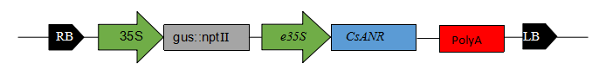
b 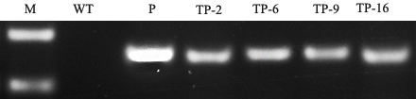
Figure.1 Structure of the transformation vector pSH-CsANR used in the study (A). Molecular validation of transgenic tobacco plants (B). We constructed the plant expression vector pSH-CsANR and transferred the vector into tobacco using the leaf disc transformation method. After resistance selection and PCR identification, we obtained a total of 25 strains of transgenic plants. The lines TP-2, TP-6, TP-9, and TP-16 demonstrated the highest expression levels of CsANR among all the transgenic plants. The three lines TP-6, TP-9, and TP-16 were used to analyze PA contents.

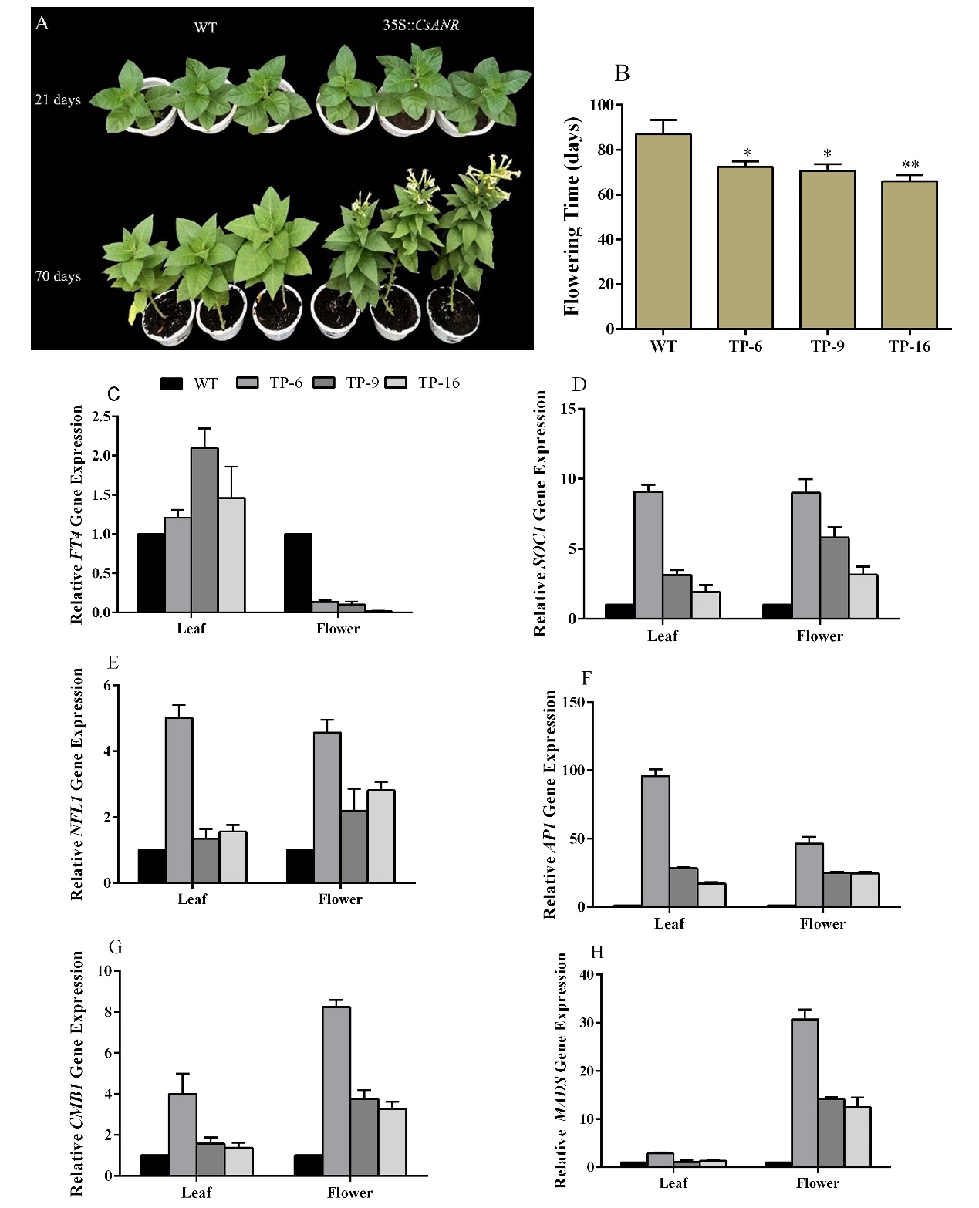
Figure.2 Morphological characterization and gene expression related to early flowering in CsANR overexpressing transgenic lines and wild-type tobacco plants. (A) Plants demonstrated early flowering in transgenic 35S::CsANR lines compared to wild-type tobacco. (B) CsANR-overexpressing transgenic lines underwent early flowering as compared to control tobacco plants. (C-H) Gene expression related to early flowering in transgenic 35S::CsANR lines in leaves and flowers compared to wild-type plants. Error bars indicate SD (n = 4); statistical significance is indicated *P<0.05.

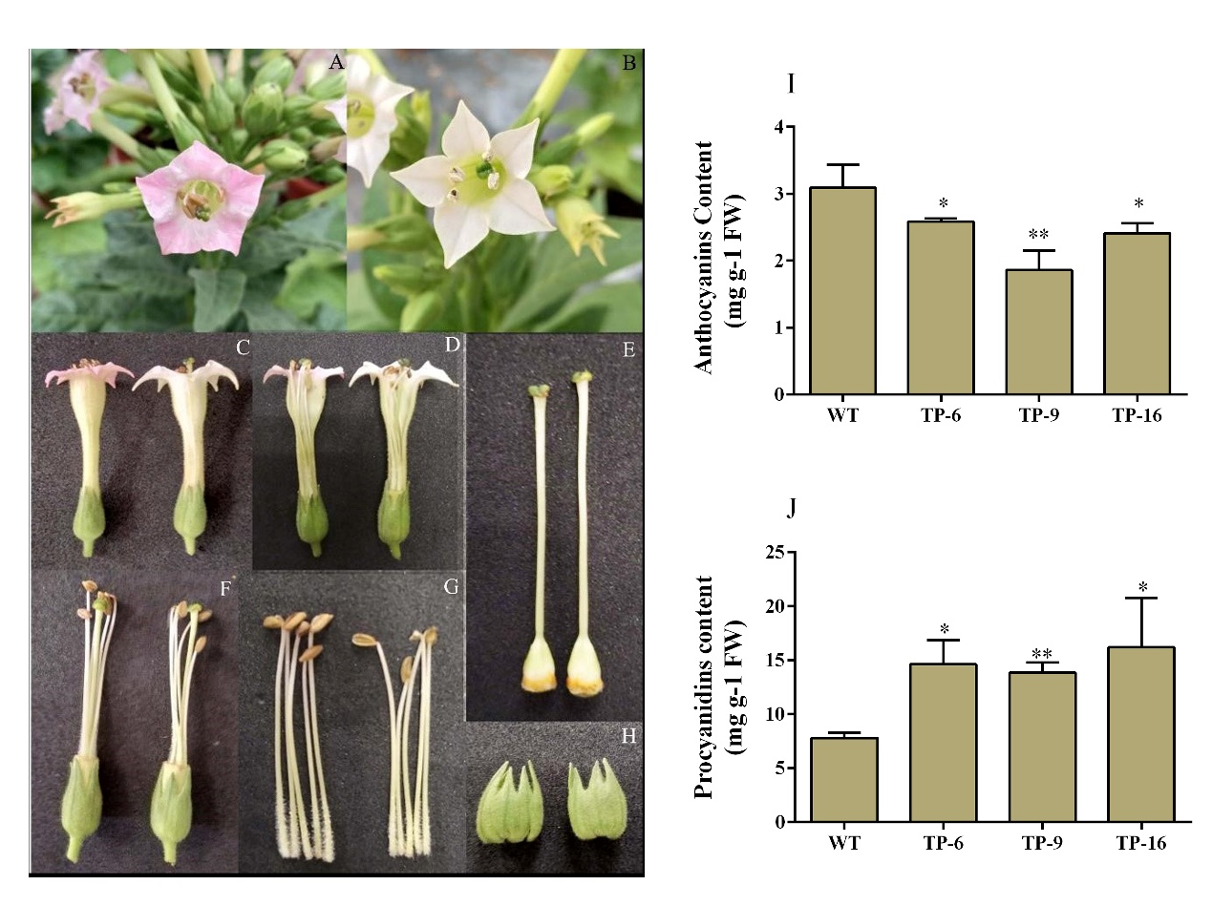
Figure.3 Morphological characterization and the anthocyanins and procyanidins content of CsANR-overexpressing transgenic lines and wild-type tobacco plants. (A-B) Complete flower from wild-type and transgenic lines. (c-d) Longitudinal section of both wild-type and transgenic lines. (e) Gynoecia of wild-type and transgenic lines. (f) Flower interior of wild-type and transgenic lines. (g) Androecia of wild-type and transgenic lines showing the filament and anthers. (h) Calyx of wild-type and transgenic lines, respectively. (i-j) Anthocyanins and procyanidins content of transgenic lines as compared to wild-type plants.

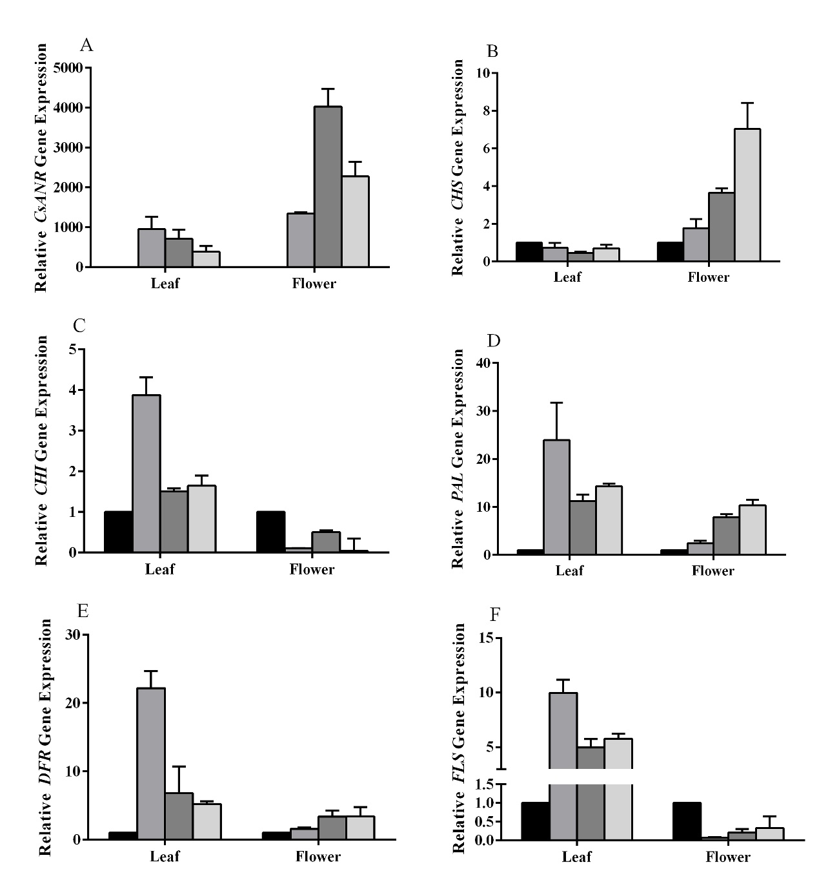
Figure.4 Relative transcript expression of endogenous flavonoid biosynthetic pathway genes and the CsANR transgene in leaves and flowers of CsANR transgenic and wild-type flowers. The CsANR transgene expression was absent in the wild-type flowers. Error bars indicate SD (n = 4).

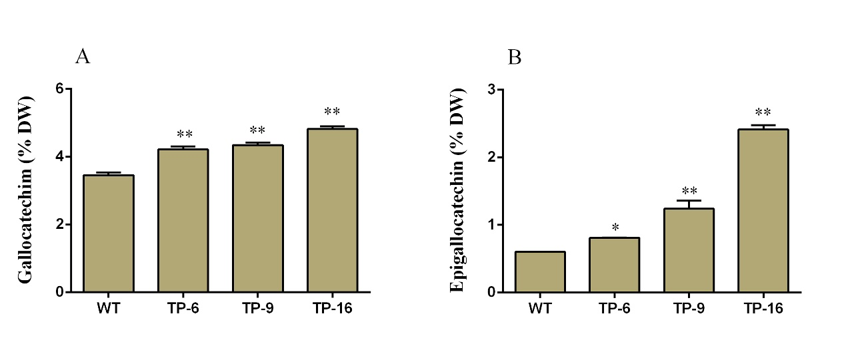
Figure.5 The leaf flavan-3-ols content in transgenic lines. GC (a) and EGC (b) contents in the TP-6, TP-9, and TP-16 transgenic lines and wild-type tobacco plants. Error bars indicate SD (n = 3). Statistical significance is indicated *P<0.05.

Supplementary materal

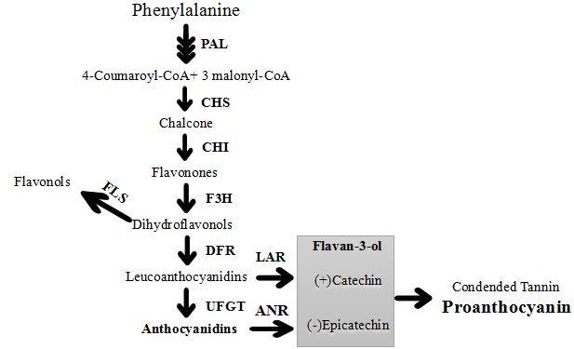
Supplementary figure.1 Schematic diagram of the flavonoid biosynthesis pathway, including the main branches of anthocyanin, proanthocyanidin, and flavonol synthesis. PAL, phenylalanine ammonia lyase; CHS, chalcone synthase; CHI, chalcone isomerase; F3H, flavonone 3-hydroxylase; DFR, dihydroflavonol reductase; FLS, flavonolsynthase; LAR, leucoanthocyanidin reductase; ANR, anthocyanidin reductase; UFGT, UDP-glucose: flavonoid 3-O-glucosyltransferase.

Supplementary table.1 Oligonucleotide primers used for confirmation of transgenic lines and expression analysis of various endogenous genes.
Gene | Sequence of primers used for expression analysis
CsANR | Forward 5’-GCTGTCAGGCTCAATCTCCAT
 | Reverse 5’-GACCAGAGGCCGATTCTTTCT
PAL | Forward 5’-GGTGTTACTACTGGTTTTGGTGCT
 | Reverse 5’-TGCCCTTGTTGCTGAATGTG
CHS | Forward 5’-GTTGGGCTTACATTCCACTTACTC
 | Reverse 5’-TGCTTCCACTAGGCTTTTCTCA
CHI | Forward 5’-GACTATGATCTTGCCTTTGACGG
 | Reverse 5’-CATCGGTGTAGGTTCCTATTGCT
DFR | Forward 5’-ATAAGGACTTGCCCGTGGTG
 | Reverse 5’-ATCTGCTGTGCTTTGGGTAGAA
FLS | Forward 5’-AGGGAAGCAAATGAGGAATACG
 | Reverse 5’-CCTAACCCAAGCCCAAGTGA
AP1 | Forward 5’-AAGGCAATCCAGGAGGAGAAT
 | Reverse 5’-GTGGTTGTAGGAGGAAAGATGCT
CMB1 | Forward 5’-ATCGTCAACTCCCTCCACAAA
 | Reverse 5’-TGCATTAACCTCGTTTCCACC
FT4 | Forward 5’-CCCAAGCAACCCTAACCTGA
 | Reverse 5’-TGAAATTCTGACGCCAACCTG
NFL1 | Forward 5’- AATGTTGGGGCATGGAGACA
 | Reverse 5’-CCACCAGAAACCGAGCTAGAAG
MADS4 | Forward 5’-ATCGTCAACTCCCTCCACAAA
 | Reverse 5’-CATTAACCTCGTTTCCACCCA
SOC1 | Forward 5’-TCCGAGCACGAAAGATTCAA
 | Reverse 5’-GCCACCAAACTTCTCCCTCA

