High-performance thin layer chromatography fingerprint profile and antifungal activity of Jatropha platyphylla methanolic extracts against Colletotrichum cliviae, Fusarium oxysporum f. sp. lycopersici, and Fusarium oxysporum f. sp. radicis-lycopersici

Mario Alejandro Leyva-Acuña,¹ Isidro Márquez-Zequera,² Raymundo Saúl García-Estrada,² Federico Soto-Landeros,² Julio Montes-Avila,¹ Miguel Angel Angulo-Escalante*²

- Programa Integral de Posgrado en Biotecnología, Facultad de Ciencias Químico-Biológicas, Universidad Autónoma de Sinaloa, Ciudad Universitaria s/n, 80010 Culiacán, Sin., México.
- Centro de Investigación en Alimentación y Desarrollo, A.C. (CIAD), Coordinación Culiacán, 80110, Sinaloa, México.

ABSTRACT
Fungi of the genera Colletotrichum and Fusarium are important phytopathogens of a wide variety of crops, which affect agricultural foodstuffs both in crop yield and economic loss. Thus, phytopathogenic fungus control has become one of the critical problems. The increased use of antifungal agents has also resulted in developing resistance to these drugs. In this sense, the discovery of new classes of antifungal compounds is of great interest. Plants are rich sources of a wide variety of bioactive secondary metabolites, such as tannins, terpenoids, saponins, alkaloids, flavonoids, and other compounds reported to have in vitro antifungal properties. Therefore, this study is designed to perform phytochemical screening, high-performance thin layer chromatography (HPTLC) fingerprint profile, and in vitro antifungal activity of Jatropha platyphylla bark and leaf methanolic extracts against Colletotrichum cliviae, Fusarium oxysporum f. sp. lycopersici and F. oxysporum f. sp. radicis-lycopersici. The HPTLC chromatogram analysis confirmed the presence of terpenoids and flavonoids. Additionally, apigenin 7-O-glucoside was identified in bark and leaf samples and confirmed by the chromatogram standards by comparing its retention factor (Rf = 0.977). The methanolic bark and leaf extract added at a concentration of 0.05% stopped C. cliviae mycelium growth significantly at 96.50% and to a lesser degree to both Fusarium species. These results suggest J. platyphylla as a possible candidate to study its fungicide activity.
Keywords: Phytopathogenic fungi, Jatropha platyphylla, HPTLC, Mycelial inhibition, Secondary metabolites.

INTRODUCTION
Phytopathogenic fungal infections are considered as one of the major problems in agricultural industry due to their difficult control, affecting producers around the world with an annual loss of US billion dollars for damaged crops and postharvest losses (Chen et al. 2018). Amongst the broad variety of fungal diseases, anthracnose – caused by Colletotrichum spp. – is one of the most harmful that limits globally the production of several crop varieties, such as chili, citrus fruits, rose apple, avocado, grapes, mango, and papaya. Preharvest anthracnose reduces yield, while postharvest affects fruit quality, negatively impacting fruit export and marketability (Worku and Sahe 2018). Similar to anthracnose, Fusarium wilt, caused by Fusarium oxysporum, is another notorious fungal disease that affects tomato production by attacking the plant roots, causing heavy economic losses on plant growth (Smaoui et al. 2022). Furthermore, Fusarium species can produce mycotoxin in several kinds of cereals, fruits, and vegetables representing a major threat to human and animal health since they are responsible for many different toxicities (Price et al. 2015).
To combat these pathogens, farmers often depend on the rapid action and efficacy of synthetic fungicides. The widely available commercial fungicides used to control the plant fungal pathogens in the field are azoles, phenylamides, quinone-outside inhibitors (QoIs), dicarboximides, anilinopyrimidines, and carboxylic acid amides (CAA) (Vielba-Fernández et al. 2020). Although these fungicides have different modes of action and target sites, the resistance of numerous fungal pathogens to these fungicides has increased due to the constant use over the years making their treatment difficult (Casida and Durkin 2017). Moreover, most of these chemical residues have been well documented to be highly toxic for humans and organisms in the environment because they can persist for years in the soil where they are sprayed altering the ecosystem. Hence a great demand exists for safer, alternative, and effective antifungal agents (Matrose et al. 2021).
Among the strategies in controlling plant diseases, the use of natural compounds from medicinal and aromatic plants offers a promising treatment to reduce the incidence of postharvest diseases (Broda 2020). Many studies have revealed the potential of natural compounds, such as monoterpenes, phenolic compounds, flavonoids, alkaloids or saponins as bio-based herbicides, fungicides, and insecticides (Bueso et al. 2016).
In this regard, species from the genus Jatropha have been widely used in traditional folk medicine to cure various ailments. Thus, several studies have focused on identifying compounds, including phenolics, terpenoids, and alkaloids. Jatropha platyphylla is a wild non-toxic species, endemic to Mexico (Ambriz-Pérez et al. 2017), which is known to have leaves and fruits that are rich in polyphenols and lipophilic compounds with anti-inflammatory activity (Leyva-Acuña et al. 2020). Recently, this research group has proven that the alkaloids obtained from J. platyphylla leaf methanolic extract inhibit Aspergillus niger fungal growth (Dave et al. 2021).
Based on previous results, this study tested the antifungal capabilities of methanolic extract from J. platyphylla bark and leaves in vitro against Fusarium oxysporum f. sp. lycopersici, F, oxysporum f. sp. radicis-licopersici and Colletotrichum cliviae to develop natural fungicides. All extracts were also subjected to phytochemical testing and high-performance thin layer liquid chromatography (HPTLC) fingerprinting.

MATERIALS AND METHODS
Chemicals, reagents, and materials
The highest quality available reagents were purchased from Sigma-Aldrich®, USA and used without further purification. The reference substances used for the analyses were naringin, (95% purity), chlorogenic acid (95% purity), apigenin 7-O-glucoside (97% purity) and diosgenin (93% purity) (Sigma-Aldrich®, USA). For the HPTLC analysis, methanol, hexane, ethyl acetate were HPLC grade (J.T. Baker®, USA), and purified water was used (PURELAB® Classic UV, ELGA LabWater, USA). The derivatizing agents used were 2-aminoethyl diphenylborinate at 98% and 400 polyethylene glycol (Sigma-Aldrich®, USA). Other chemicals and solvents were of analytical grade.
Plant material
Bark and leaves of J. platyphylla were obtained from specimens located in Ejido de la Campana (24° 53´ 52.3´´ N; 107° 27´ 18.3´´ W and 94 m a.s.l.) in Culiacán, Sinaloa, Mexico. The samples were transferred to the Bioresources Laboratory at CIAD (Centro de Investigación en Alimentación y Desarrollo), dried under laboratory conditions for one week and ground with an electric homogenizer (Oster®, USA) to obtain flour, of which 40 g were weighed and macerated with 400 mL of analytical degree methanol (FAGALAB, Mexico) with an orbital agitator S-500 (VWR International, USA) in darkness at room temperature for 24 h. The sample was vacuum filtered with a porcelain funnel and filter paper Whatman No.1 (Sigma-Aldrich®, USA). The filtering obtained was evaporated to dryness in a rotavapor (BUCHI, Canada) at 365 mbar, 45 ºC and at 50 rpm until a total concentrate was obtained and stored at 4°C until use.
Phytochemical screening
Phytochemical screening was performed following the methodology reported by Dave et al., 2021. Tannins were determined with the FeCl₃ test. Shinoda test was used to determine phenolic compounds and Dragendorff, Mayer and Wagner for alkaloids, foam for saponins, Salkowski and Libermann for determining terpenoids.
High-performance Thin Layer Liquid Chromatography analysis
The studies performed were based on Reich’s methodology (Reich et al. 2006) in a system of HPTLC (CAMAG, Switzerland) equipped with Linomat V applicator, TLC scanner and Visioncats software; 10 mg of the concentrated extracts were dissolved in 3 mL of MeOH, filtered using 0.45-µm nylon acrodiscs (MILLEX, Germany) in a HPTLC run, 4 µL of each sample. Standards (naringin, chlorogenic acid, apigenin 7-O-glucoside, and diosgenine) were applied in band form in position X and Y at 15 mm, 11 mm in length, and a track distance of 13.4 mm on a silica gel G-25 UV254 glass plate (10 cm × 10 cm) (MACHEREY-NAGEL, Germany) developed in a HPTLC (CAMAG, Switzerland) camera and saturated with a mobile phase of ethyl acetate: formic acid: and water (15:1:1) for flavonoids and hexane: ethyl acetate (6:4) for terpenoids at an optimum temperature of 25 °C for 30 min. After that, the plate was left to develop in the mobile phase until a solvent front of 85 mm was reached.
Once the solvent front was reached, the plate was left to dry with cold air for five min, scanned with a densitometer (CAMAG, Switzerland) at 254 and 366 nm, and placed on a heating plate at 100 °C for three minutes. The HPTLC plate -still hot- was sprinkled with 2-aminoethyl diphenylborinate at 98% and 400 polyethylene glycol to reveal flavonoids and anisaldehyde in sulfuric acid for terpenoids. Then, the plate was placed in an ultraviolet (UV) light visualizer (CAMAG, Switzerland) of 254 and 366 nm, and photographic images were taken. Finally, it was scanned again in densitometer at 366 nm for the chromatogram (Mishra et al. 2020; Ramaiah and Garampalli 2015).
Fungal material
The fungal strains Fusarium oxysporum f. sp. lycopersici and F. oxysporum f. sp. radicis-licopersici donated from CIAD Plant Pathology Laboratory were isolated and identified from tomato crops from Culiacan Sinaloa, México. Colletotrichum cliviae was isolated and identified from papaya from Cotaxtla, Veracruz, México.
Antifungal activity
Antifungal activity of J. platyphylla bark and leaf methanolic extracts were tested in 50 mm Petri boxes. A total of 200, 100 and 50 mg of the extract was added at 100 mL of the PDA (potato dextrose agar) medium previous to gelification (approximately at 50 °C), corresponding to concentrations of 0.2, 0.1, and 0.05%. Sterile water was added to the PDA medium, which served as the control. With the help of a puncher, 5 mm of the inoculated medium with Fusarium oxysporum f. sp. lycopersici, F. oxysporum f. sp. radicis-licopersici and Colletotrichum cliviae were taken and placed face down in the center of the Petri boxes with the media prepared (Jug et al 2018). The plates were inoculated at 25°C and waited until the control group was full to measure mycelium inhibition. The assay was performed in triplicate with three comparisons for each strain. The inhibition of each extract was calculated with the following equation:

$$\% Inhibition=\frac{Diameter of the sample colony - Inoculation diameter}{Diameter of the control colony } x 100$$

Statistical analysis
A completely randomized-block experimental design was performed where the blocks corresponded to the fungus species. The inhibition of mycelium growth was analyzed by the analysis of variance (ANOVA) comparing the media by Tukey´s at α = 0.05. Terms were blocked in the analysis using the statistical package Minitab 17.
RESULTS
Phytochemical screening
The results of the preliminary phytochemical studies demonstrated the presence of pharmacologically important compounds, such as flavonoids, tannins, alkaloids, saponins, and terpenoids in J. platyphylla bark and leaf methanolic extracts, which could account for the plant antimicrobial activities (Table 1).

Table 1. Phytochemical constituents of Jatropha platyphylla leaf and bark methanolic extracts.
Constituent | Test | MeOH J. p leaf | MeOH J. p bark
Tannins | FeCl₃ | +++ | ++
 | Gelatine | ++ | ++
Flavonoids | Shinoda | +++ | +
Alkaloids | Dragendorff | + | +
 | Mayer | + | +
 | Wagner | + | +
Saponins | Foam | ++ | ++
Terpenoids | Salkowiski | +++ | ++
 | Libermann | +++ | ++
(+++) Strong concentration; (+++) Medium concentration (+++); Low concentration; (-) Absent.
HPTLC fingerprint profile
Flavonoid compound profile in Jatropha platyphylla methanolic extract
The HPTLC profile of J. platyphylla bark methanolic extract of bark and leaves showed the presence of flavonoids before and after derivatization. The J. platyphylla leaf extract showed the presence of up to 12 types of flavonoids at different Rf values in a range from 0.019–0.996 with colors that varied from yellow, blue, green, and orange (Table 3 and Fig. 1-2), while the bark extract had a number of up to eight flavonoids at Rf values in a range from 0.23 –0.97 and colors from blue to pale green (Table 4 and Fig. 1-2). As a control of the chromatography runs, three standards were used (naringin, chlorogenic acid, and apigenin 7-O-glucoside) (Table 2 and Fig. 1-2).
Fig. 1 High-performance thin layer liquid chromatography (HPTLC) fingerprint chromatogram for flavonoids; (a) standard; (b) J. platyphylla leaf methanolic extract; (c) J. platyphylla bark methanolic extract.
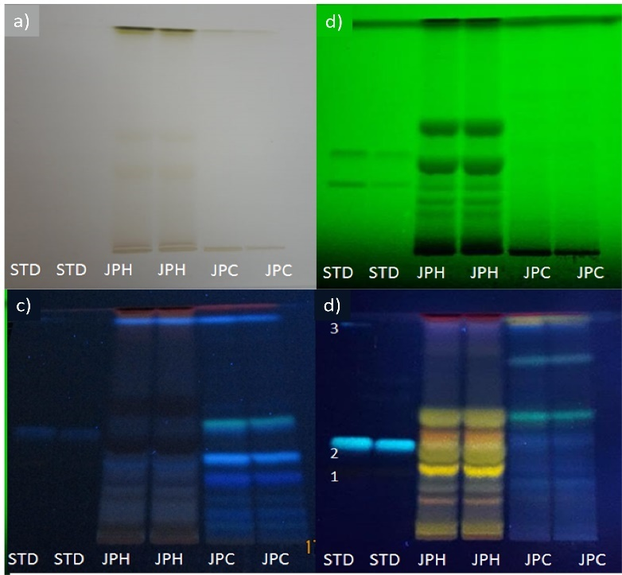
Fig. 2 High-performance thin layer liquid chromatography (HPTLC) fingerprint profile for flavonoids of standard of naringin, chlorogenic acid, and apigenin 7-O-glucoside (STD); J. platyphylla leaf methanolic extract (JPH); J. platyphylla bark methanolic extract (JPC) at: (a) daylight; (b) 254 nm; (c) 365 nm; (d) 365 nm after derivatization 2-aminoethyl diphenylborinate at 98% and 400 polyethylene glycol.

Table 2. Standard chromatographic profile
Peaks | Rf | Height | Area | Substance
1 | 0.250 | 0.2428 | 0.0068 | Naringin
2 | 0.384 | 0.2027 | 0.0085 | Chlorogenic Acid
3 | 0.977 | 0.2709 | 0.0097 | Apigenin 7-O-glucoside
Rf: Retention factor.
Table 3: Chromatographic profile of J. platyphylla leaf ethanolic extract
Peaks | Rf | Height | Area | Substance
1 | 0.019 | 0.1216 | 0.0041 | Flavonoid 1
2 | 0.073 | 0.0110 | 0.0002 | Flavonoid 2
3 | 0.127 | 0.0891 | 0.0025 | Flavonoid 3
4 | 0.180 | 0.2265 | 0.0069 | Flavonoid 4
5 | 0.271 | 0.1189 | 0.0031 | Flavonoid 5
6 | 0.310 | 0.5428 | 0.0398 | Flavonoid 6
7 | 0.484 | 0.5603 | 0.0452 | Flavonoid 7
8 | 0.659 | 0.0110 | 0.0044 | Flavonoid 8
9 | 0.824 | 0.0261 | 0.0009 | Flavonoid 9
10 | 0.853 | 0.0201 | 0.0002 | Flavonoid 10
11 | 0.977 | 0.0367 | 0.0004 | Apigenin 7-O-glucoside
12 | 0.996 | 0.0267 | 0.0002 | Flavonoid 12
Rf: Retention factor

Table 4. Chromatographic profile of J. platyphylla bark methanolic extracts
Peaks | Rf | Height | Area | Substance
1 | 0.230 | 0.0205 | 0.0004 | Flavonoid 1
2 | 0.329 | 0.0068 | 0.0002 | Flavonoid 2
3 | 0.394 | 0.0194 | 0.0011 | Flavonoid 3
4 | 0.517 | 0.0388 | 0.0016 | Flavonoid 4
5 | 0.557 | 0.0315 | 0.0008 | Flavonoid 5
6 | 0.653 | 0.0088 | 0.0004 | Flavonoid 6
7 | 0.780 | 0.0864 | 0.0033 | Flavonoid 7
8 | 0.976 | 0.2169 | 0.0053 | Apigenin 7-O-glucoside
Rf: Retention factor
Terpenoid compound profile in Jatropha platyphylla methanolic extract
The HPTLC fingerprinting for terpenoids was well resolved at UV 366 nm after derivatization. The plates were sprayed with anisaldehyde in sulfuric acid reagent followed by heating and then visualized in daylight, which showed bands from blue to violet colorations (Fig. 3-4), corresponding to terpenoid natural metabolites (Ramaiah and Garampalli, 2015). The chromatograms obtained from leaf extract revealed 12 peaks at different Rf values at a range of 0.044–0.967 (Table 6), while the bark showed the presence of seven peaks at Rf values of 0.003–0.967 (Table 7). As a control of the chromatography runs, diosgenin was used (Table 3-4 and Fig. 5).
Fig. 3 High-performance thin layer liquid chromatography (HPTLC) fingerprint chromatogram for terpenoids; (a) standard; (b) leaf methanolic extract of J. platyphylla; (c) bark methanolic extract of J. platyphylla.
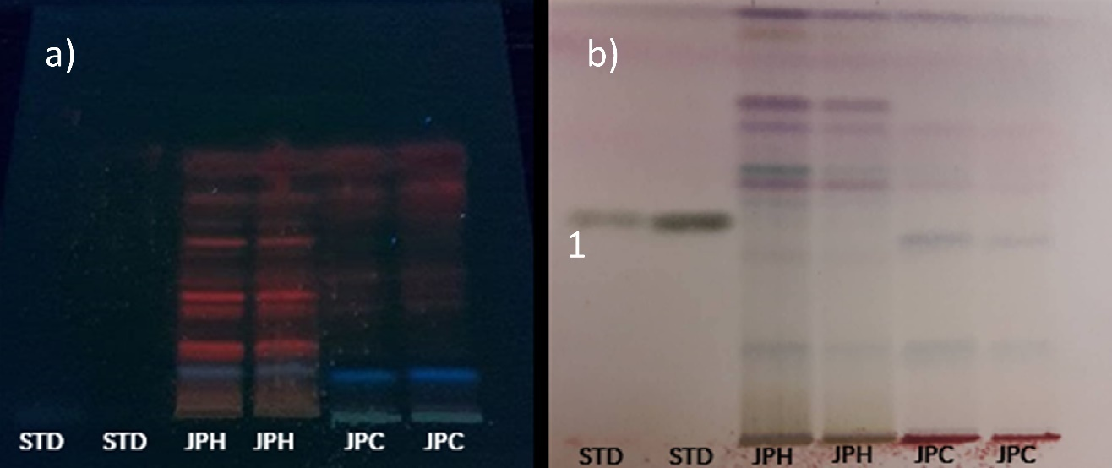
Fig. 4 High-performance thin layer liquid chromatography (HPTLC) fingerprint profile for terpenoids of diosgenin standard (STD); J. platyphylla leaf methanolic extract (JPH); J. platyphylla bark methanolic extract (JPC) at: (a) 365 nm; (b) daylight after derivatization with anisaldehyde in sulfuric acid.

Table 5. Standard chromatographic profile
Peaks | Rf | Height | Area | Substance
1 | 0.441 | 0.2179 | 0.0083 | Diosgenine
Rf: Retention factor.
Table 6. Chromatographic profile of J. platyphylla leaf ethanolic extract
Peaks | Rf | Height | Area | Substance
1 | 0.044 | 0.0159 | 0.0006 | Terpenoid
2 | 0.144 | 0.0804 | 0.0029 | Terpenoid
3 | 0.367 | 0.0786 | 0.0044 | Terpenoid
4 | 0.509 | 0.1386 | 0.0042 | Terpenoid
5 | 0.549 | 0.2931 | 0.0104 | Terpenoid
6 | 0.596 | 0.2647 | 0.0084 | Terpenoid
7 | 0.684 | 0.1814 | 0.0072 | Terpenoid
8 | 0.739 | 0.2875 | 0.0113 | Terpenoid
9 | 0.810 | 0.0107 | 0.0002 | Terpenoid
10 | 0.850 | 0.0193 | 0.0006 | Terpenoid
11 | 0.911 | 0.1068 | 0.0032 | Terpenoid
12 | 0.967 | 0.1628 | 0.0030 | Terpenoid
Rf: Retention factor

Table 7. Chromatographic profile of J. platyphylla bark methanolic extracts
Peaks | Rf | Height | Area | Substance
1 | 0.001 | 0.0108 | 0.0001 | Terpenoid
2 | 0.114 | 0.0922 | 0.0042 | Terpenoid
3 | 0.367 | 0.1655 | 0.0067 | Terpenoid
4 | 0.533 | 0.0931 | 0.0031 | Terpenoid
5 | 0.606 | 0.0448 | 0.0008 | Terpenoid
6 | 0.677 | 0.0697 | 0.0027 | Terpenoid
7 | 0.961 | 0.1008 | 0.0020 | Terpenoid
Rf: Retention factor
Antifungal activity of Jatropha platyphylla methanolic extract
In general, the methanolic extracts from bark and leaf of J. platyphylla showed significant antifungal activity (p < 0.05) compared to the negative control with percentages of mycelial growth inhibition from 61.37–96.50% at concentrations of 0.05 and 0.2%, where the application of these extracts was associated with a decrease and deformation of colony growth. The colonies in the control grew with normal shape, size, and color after day 9 (Fig. 5-8).
The J. platyphylla bark and leaf methanolic extracts were observed highly effective in C. cliviae mycelial inhibition growth with percentages of inhibition of 96.50% even at concentrations of 0.05% of the extracts (Fig. 5). Significant statistical differences were recorded between the methanolic bark concentrations at 0.2 and 0.1%. However, no differences were found between the concentrations of 0.05 and 0.1% (Fig. 8). Likewise, the methanolic extract of J. platyphylla bark and leaves were statistically similar at the same concentrations against C. cliviae (see Fig. 8).
In contrast, F. oxysporum f. sp. lycopercisi and F. oxysporum radicis-lycopercisi were less affected by the methanolic extracts of J. platyphylla, where 61.37–70.25% of the mycelial inhibition of F. oxysporum radicis-lycopercisi and a 68.12–76.25% in the case of F. oxysporum f. sp. Lycopercisi were achieved as shown in Fig. 6-8. In the case of C. cliviae, no significant difference was observed between the concentrations of bark and leaf methanolic extract evaluated against Fusarium spp. (Fig. 8). However, a greater efficacy of both extracts can be noted in mycelial growth inhibition of F. oxysporum f. sp. Lycopercisi, where it grows amorphously when the extracts are included in the medium compared to F. oxysporum radicis-lycopercisi, whose mycelium grows uniformly, thus showing a slightly higher susceptibility (Fig. 6-7).
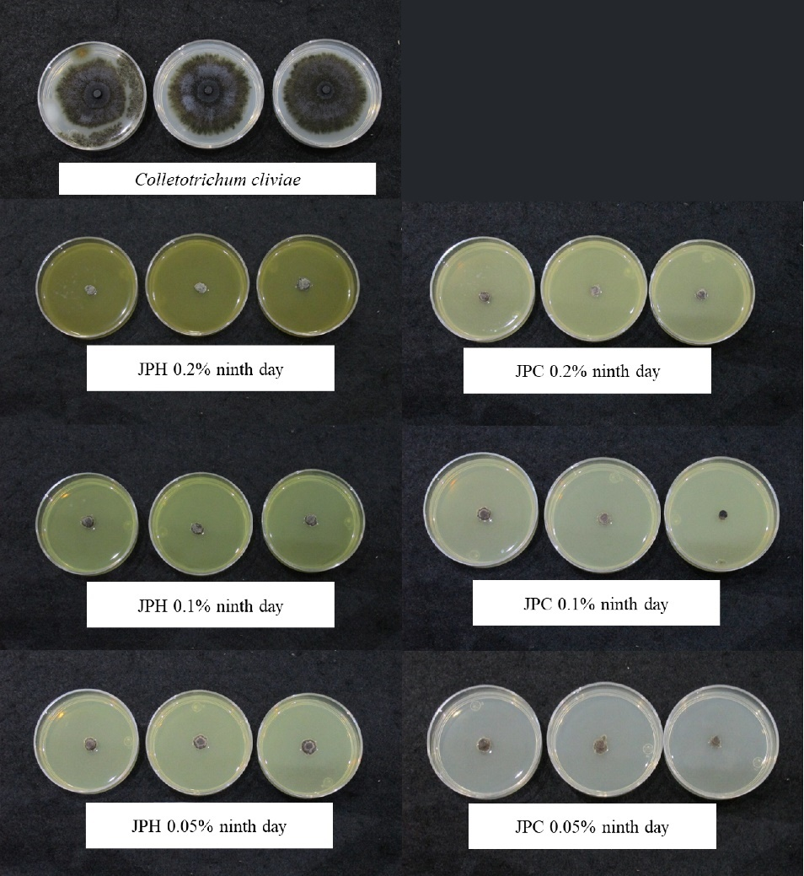
Fig. 5 Growth inhibition zone (mm) of Colletotrichum cliviae after incubation for nine days at 37 °C on potato dextrose agar medium containing J. platyphylla extracts from bark (JPC) and leaves (JPH).
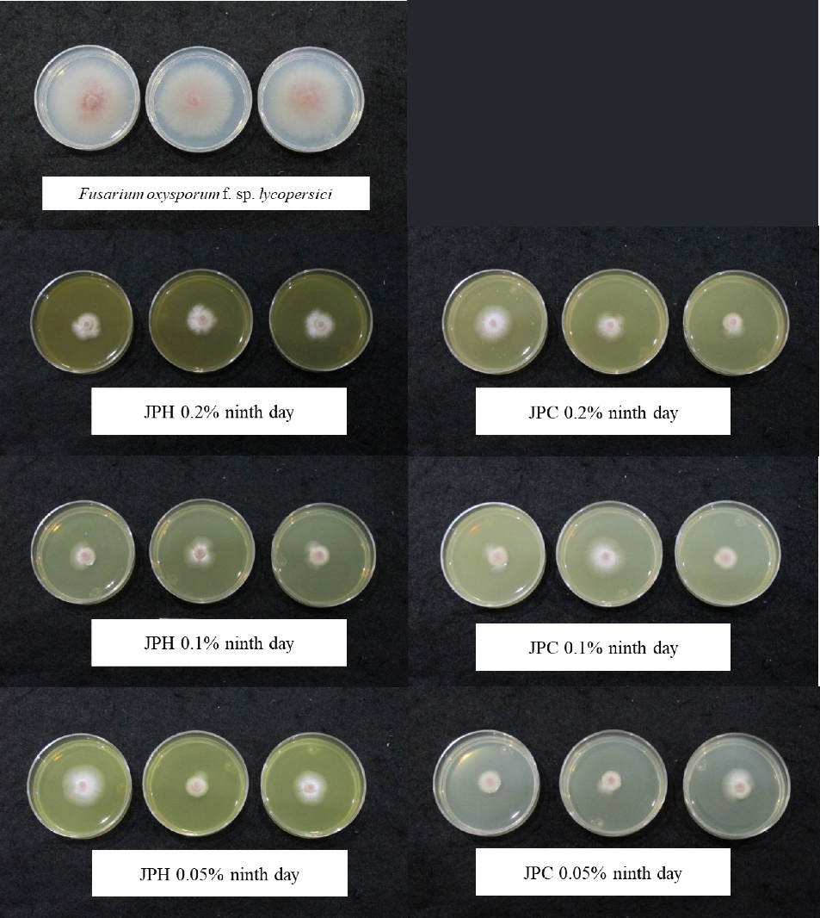
Fig. 6 Growth inhibition zone (mm) of Fusarium oxysporum f. sp. lycopersici after incubation at 37 °C on potato dextrose agar medium containing J. platyphylla extracts from bark (JPC) and leaves (JPH) for nine days.
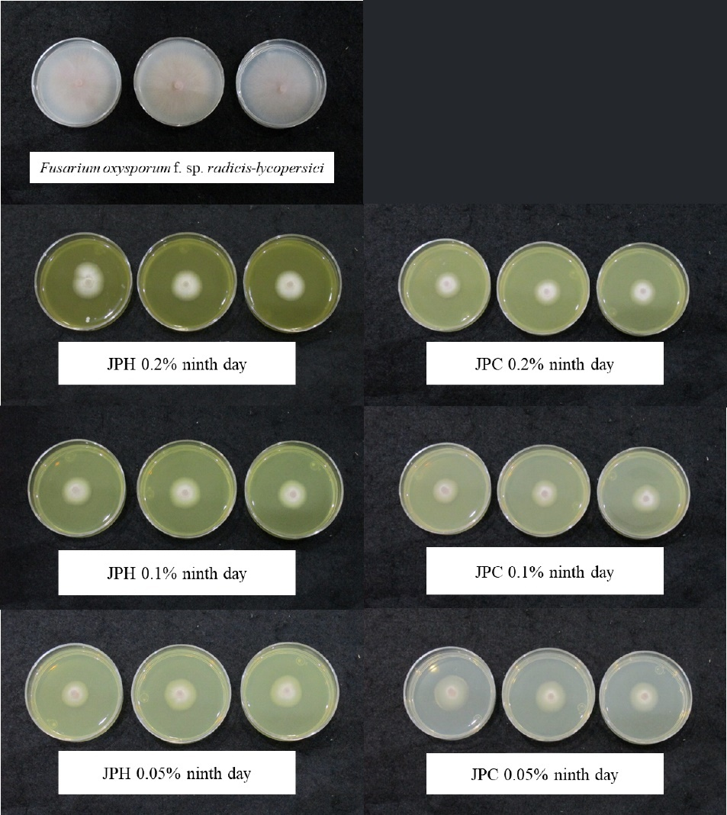
Fig. 7 Growth inhibition zone (mm) of Fusarium oxysporum f. sp. radicis-lycopersici after incubation at 37 °C on potato dextrose agar medium containing J. platyphylla extracts from bark (JPC) and leaves (JPH) for nine days.
Fig. 8 Effect of the amount of methanolic extract of J. platyphylla bark and leaves on Colletotrichum clivae musae growth by the agar dilution method. Values are means of three replicates. Significant differences among treatments at P < 0.05 are indicated with a letter as measured by Tukey’s test.

DISCUSSION
Control of fungal diseases with synthetic chemicals has become a problem due to potential toxic effects on human health and environmental contamination. A great need exists to develop cost-effective alternatives to synthetic fungicides for plant disease sustainable management. In recent years, the use of natural plant products in phytopathological disease management has gained significant attention since several studies have revealed the efficacy of herbal preparations in managing plant pathogens. In this sense, Jatropha species have been studied in relation to its medicinal uses, chemical constituents, and biological activities, such as antileishmanial (Martins et al. 2018), antimicrobial (Rahu et al. 2018), anthelmintic (Jamaluddin et al. 2022), and antifungal (Sama et al. 2021).
This study showed that J. platyphylla methanolic extracts from bark and leaves have a pronounced antifungal activity against C. cliviae, F. oxysporum f. sp. lycopersici, and F. oxysporum f. sp. radicis-lycopersici and may be considered sources of bioactive phytochemicals. Although not many studies are related to the antifungal activities of J. platyphylla, several reports of extracts from species of the Jatropha genus have demonstrated their ability to exert antifungal activity. Rahman et al. (2012) reported that the methanolic extract of J. curcas seed at a concentration of 10 mg/mL was effective controlling 78.87% of C. gloeosporioides mycelial growth until day seven, while the fruit extract only inhibited 46.42% of mycelial growth at the same concentration. Similarly, Saetae and Suntornsuk (2010) demonstrated that of J. curcas seed crude extract inhibited 100% of C. capsici mycelial growth at 4 mg/mL. These concentrations can be considered high, since J. platyphylla extracts of bark and leaves were effective to inhibit up to 96.50% at concentrations of 0.5 mg/mL even after nine days. This variation in activity may be due to the difference in the groups of active compounds reported in J. curcas fruit cake and seeds, which are mainly proteins, fats and phorbol esters found in these extracts (Rahman et al. 2012; Saetae and Suntornsuk 2010). On the other hand, J. platyphylla species develops wild in high humidity environments (Makkar et al. 2011), which facilitates fungal growth, which could be forcing the plant to constantly interact with a high variety of fungi. Over the years, this natural interaction could have induced an evolutionary defense response against phytopathogenic fungi, promoting the development of a wide variety of secondary metabolites in the most exposed J. platyphylla organs, such as the leaf and stem, which could explain the variation in activity among the extracts from different species (Hiruma 2019).
Similarly, previous works have reported partial inhibition of Fusarium species mycelial growth using J. curcas oils. However, in the case of Colletotrichum, the necessary concentrations are high as reported by Cordoba-Albores et al. (2014), a decrease in mycelial growth rate of 0.77 cm per day was observed when 2.5 mg/mL concentrations of J. curcas seed oil in PDA were used against F. oxysporum f. sp. gladioli, suggesting a fungistatic effect. In a subsequent study, since J. curcas oil from seed can cause changes in the morphology of the external cover of the mycelium and conidia, as well as inhibition of metabolic processes, the fungistatic effect on F. solani has been possible, which was verified by different microscopic and fluorochromatic techniques (Cordova-Albores et al. 2016). These results are similar to those obtained in this research with J. platyphylla extracts, which despite a decrease in mycelial growth of up to 76.25% at 0.2 mg/mL and the observed modification of its morphology, it did not prevent its growth, determining the fungistatic potential of the metabolites present in J. platyphylla on the evaluated F. oxysporum species.
Because the quality of plant extracts and their biological properties depend on the presence of active phytoconstituents in their organs, phytochemical analyses were performed on the methanolic extracts evaluated. The results indicated that J. platyphylla bark and leaves are rich in a wide variety of secondary metabolite groups, such as flavonoids, tannins, saponins, alkaloids, and terpenoids. The J. platyphylla HPTLC fingerprint profile revealed a total of 12 spots for leaves and eight for bark, using 2-aminoethyl diphenylborinate at 98% and 400 polyethylene glycol derivatizing agents for flavonoids. Ju et al. (2018) reported that the use of these reagents provides a wide diversity of color fluorescence bands for different flavonoids at 366 nm, such as green (kaempferide, apigenin, naringenin, pinocembrin, kaempferol) orange (quercetin dihydrate, myricetin, chrysin), blue for some phenolic acids (chlorogenic acid, rosmarinic acid, caffeic acid) and yellow (luteolin). In this sense, the J. platyphylla extracts show a great variety of flavonoids in their profile, previously reported by Ambriz-Perez et al. (2016), where 17 phenolic compounds were detected in phenolic extracts from J. platyphylla leaf and fruit – most of them were apigenin, genistein, and luteolin glycosides. Moreover, apigenin and luteolin glycosides have been found in other Jatropha species, such as J. curcas (Abd-Alla et al. 2009), J. multifida (Moharram et al. 2007), and J. gossypifolia (Mariz et al. 2010).
Additionally, as shown in the chromatograms, one of the spots between the leaf and bark extracts showed similar Rf and color characteristic to the apigenin 7-O-glucoside standard (leaf Rf: 0.979, blue color, bark Rf: 0.979, blue color, and to the apigenin 7-O-glucoside Rf: 0.977, blue color) (Table 2-4 and Fig. 1-2). In this sense, the extract from leaf and bark could be assumed to contain the apigenin 7-O-glucoside, which has been related to its antifungal activity on Candida spp. (Smiljkovic et al. 2017). Flavonoids have been widely associated with a large range of biological activities, highlighting its antimicrobial activity (Górniak et al. 2019). The inherent antimicrobial properties of these compounds have been reported to be determined by their chemical structure since in ring A, hydroxylations at positions 5 and 7 are the most critical for flavonoids antimicrobial activity (Cushnie and Lamb 2011; Yang et al. 2017). Furthermore, because its capacity of inhibiting fungal growth had been reported with various underlying mechanisms, including plasma membrane disruption, the mitochondrial dysfunction induction , and inhibiting the following: cell wall formation, cell division, RNA and protein synthesis, and the efflux mediated pumping system (Al Aboody and Mickymaray 2020) .
While the terpene profile in J. platyhylla methanolic extracts shows the presence of 12 different terpenes in the leaf and seven in the bark, different types of terpenes have been previously reported in Jatropha species, including curcusone B and stigmasterol from the stem bark of J. curcas, and jatrophone from the stem bark of J. gossypifolia, which showed great antibacterial activity against Staphylococcus aureus and antifungal activity against Aspergillus niger (Sahidin et al. 2012). Additionally, two diterpenes (jatrophone and jatropholone B) and a triterpene (9,13-dihydroxyisabellione) were isolated from J. isabelli rhizomes (Pertino et al. 2007). These compounds have been reported as typical constituents of several Euphorbiaceae, including J. gossypifolia (Purushothaman et al. 1979). Thus, the presence of a great diversity of terpenes in both extracts is of great interest because this group of metabolites is associated with potent antifungal activity since they can change the microbial cell membrane properties and functions because of increasing membrane fluidity observed under exposure (Tao et al. 2019). Alterations in membrane permeability vary according to the concentration, since high concentrations cause severe damage and loss of homeostasis (Scariot et al. 2021). Likewise, some terpenoid components interfere with the amino acid involved in spore germination, and denature the enzymes responsible for germination, energy production and synthesis of structural compounds (de Matos Castro Silva D et al. 2020).

CONCLUSION
This study shows that methanolic extracts from J. platyphylla bark and leaf can act as a strong fungicide by inhibiting the mycelial growth of C. cliviae by up to 96.50%, 70.25%, 76.25%, and F. oxysporum lycopercisi 76.25% at a concentration range of 0.2 -0.05%. The phytochemistry essay showed the presence of tannins, flavonoids, alkaloids, saponins, terpenoids, and alkaloids. The HPTLC analysis reports the presence of apigenin 7-O-glucoside from J. platyphylla bark and leaves; moreover, the fingerprint profile from the extracts confirmed at least 12 different types of flavonoids in leaves, and eight for bark, as well as 12 different types of terpenoids in leaves and seven for barks, which could have contributed to its antifungal activity. As a perspective, the purification of these groups of molecules should be performed to determine their role in antifungal activity.
Acknowledgments The authors are grateful to CONACYT (Consejo Nacional de Ciencia y Tecnología) for financing the project and granting a Master of Science scholarship 454581 to the student Mario Alejandro Leyva Acuña; thanks to the Phytopathology research group of the Food and Development Research Center, Culiacán Coordination and Diana Fischer for English edition.
Compliance with ethical standards
Conflict of interest The authors declare that they have no conflict of interest.
Ethical approval This article does not contain any studies with human participants or animals performed by any of the authors.

REFERENCES
- Chen, C., L. Long and F. Zhang F, 2018. Antifungal activity, main active components and mechanism of Curcuma longa extract against Fusarium graminearum. Rev. Mex. Fitopatol., 2013: S2–S3.
- Worku M. and S. Sahe, 2018. Review on disease management practice of tomato wilt caused Fusarium oxysporum in case of Ethiopia. J. Plant. Pathol. Microbiol., 9: 2.
- Smaoui, S., T. Agriopoulou S, D’Amore and L. Tavares, 2022. The control of Fusarium growth and decontamination of produced mycotoxins by lactic acid bacteria. Crit. Rev. Food. Sci. Nutr., 1-28.
- Price, C.L., J.E. Parker, A.G. Warrilow, D.E. Kelly and S.L. Kelly, 2015. Azole fungicides–understanding resistance mechanisms in agricultural fungal pathogens. Pest. Manag. Sci., 71: 1054-1058.
- Vielba-Fernández, A., Á. Polonio, L. Ruiz-Jiménez, A. de Vicente, A. Pérez-García and D. Fernández-Ortuño, 2020. Fungicide resistance in powdery mildew fungi. Microorganisms, 8: 1431.
- Casida, J.E., and K.A. Durkin, 2017. Pesticide chemical research in toxicology: lessons from nature. Chem. Res. Toxicol., 30: 94-104.
- Matrose, N.A., K. Obikeze, Z.A Belay and O.J. Caleb, 2021. Plant extracts and other natural compounds as alternatives for post-harvest management of fruit fungal pathogens: A review. Food Biosci., 41: 100840.
- Broda, M., 2020. Natural compounds for wood protection against fungi—A review. Molecules, 25: 3538.
- Bueso, F., I. Sosa, R. Chun and R. Pineda, 2016. Phorbol esters seed content and distribution in Latin American provenances of Jatropha curcas L.: potential for biopesticide, food and feed. SpringerPlus, 5: 1-7.
- Ambriz-Pérez, D., R. Ramos-Payan, M. Angulo-Escalante, J. Leon-Felix, F. Delgado-Vargas and J. Heredia, 2017. Antioxidant capacity and protective role of methanolic extracts of Jatropha platyphylla against oxidative stress on macrophage cells. Int. J. Pharma. Bio. Sci., 8: 245-253.
- Leyva-Acuña, M.A., E.A. Quintana-Obregón, F. Soto-Landeros, K.M. Baez-Parra, J. Montes-Ávila and M.A. Angulo-Escalante, 2020. Actividad antifúngica de alcaloides del extracto metanólico de Jatropha platyphylla contra Aspergillus parasiticus. Biotecnia, 22: 100-107.
- Dave, K., P. Patel and R. Patel, 2021. HPTLC Fingerprint profile and antifungal activity of selected botanical extract against Fusarium oxysporum for management of cumin wilt disease. Bull. Env. Pharmacol. Life. Sci., 10: 54-68.
- Reich, E., A. Schibli, V. Widmer, R. Jorns, E. Wolfram and A. DeBatt, 2006. HPTLC methods for identification of green tea and green tea extract. J. Liq. Chromatogr. Relat., 29: 2141-2151.
- Orsini, F., I. Vovk, V. Glavnik, U. Jug and D. Corradini, 2019. HPTLC, HPTLC-MS/MS and HPTLC-DPPH methods for analyses of flavonoids and their antioxidant activity in Cyclanthera pedata leaves, fruits and dietary supplement. J. Liq. Chromatogr. Relat., 42: 290-301.
- Mishra, S., N. Gupta and K. Shanker, 2020. HPTLC method for the simultaneous determination of six bioactive terpenoids in Putranjiva roxburghii Wall. J. Planar. Chromatogr. - Mod. TLC., 33: 353-364.
- Ramaiah, A.K. and R.K.H. Garampalli, 2015. In vitro antifungal activity of some plant extracts against Fusarium oxysporum f. sp. lycopersici. Asian J. Plant. Sci., 5: 22-27.
- Jug, U., V. Glavnik, E. Kranjc and I. Vovk, 2018. HPTLC–densitometric and HPTLC–MS methods for analysis of flavonoids. J. Liq. Chromatogr. Relat., 41: 329-341.
- Martins, G.V., D.R. Alves, F.M. Viera-Araújo, F. Rondon, R. Braz-Filho and S.M. Morais, 2018. Estudo químico e avaliação das atividades antioxidante, antiacetilcolinesterase e antileishmanial de extratos de Jatropha Gossypifolia L.(Pião Roxo). Rev. Virtual de Química, 10: 21-36.
- Rahu, M.I., S.H.A. Naqvi and N.H. Memon, 2021. Determination of antimicrobial and phytochemical compounds of Jatropha curcas plant. Saudi J. Biol. Sci., 28: 2867-2876.
- Jamaluddin, A.W., H. Ainun, A. Ris and M.N. Amir, 2022. Anthelmintic activity of Jatropha (Jatropha curcas linn) leaf extract against Ascaridia galli worms in vitro. J. Riset. Vet. Ind., 6: 57-66. https://doi.org/10.20956/jrvi.v6i1.19648
- Sama, H., P.A.E.D. Sombié, S. Guenne, H.B. Soura and A. Hilou, 2021. Antifungal potential and fatty acid profile of two Jatropha curcas (Euphorbiaceae) oils. J. Agric. Food. Inf., 6: 100244.
- Rahman, M., S.H. Ahmad, M.T.M. Mohamed M.Z.A. Rahman, 2011. Extraction of Jatropha curcas fruits for antifungal activity against anthracnose (Colletotrichum gloeosporioides) of papaya. Afr. J. Biotechnol. 10: 9796-9799.
- Saetae, D. and W. Suntornsuk, 2010. Antifungal activities of ethanolic extract from Jatropha curcas seed cake. J. Microbiol. Biotechnol., 20: 319-324.
- Makkar, H.P., V. Kumar, O.O. Oyeleye, A.O. Akinleye, M.A. Angulo-Escalante, K. Becker, 2011. Jatropha platyphylla, a new non-toxic Jatropha species: Physical properties and chemical constituents including toxic and antinutritional factors of seeds. Food Chem., 125: 63-71.
- Hiruma, K., 2019 Roles of plant-derived secondary metabolites during interactions with pathogenic and beneficial microbes under conditions of environmental stress. Microorganisms, 7: 362.
- Cordova-Albores, L.C., M.Y. Rios, L.L. Barrera-Necha and S. Bautista-Baños, 2014. Chemical compounds of a native Jatropha curcas seed oil from Mexico and their antifungal effect on Fusarium oxysporum f. sp. gladioli. Ind. Crops Prod., 62: 166-172.
- Cordova-Albores, L.C., E.S. Zapotitla, M.Y. Ríos, L.L. Barrera-Necha, M. Hernández-López and S. Bautista-Baños, 2016. Microscopic study of the morphology and metabolic activity of Fusarium oxysporum f. sp. gladioli treated with Jatropha curcas oil and derivatives. J. Microsc. Ultrastruct., 4: 28-35.
- Jug, U., V. Glavnik, E. Kranjc and I. Vovk, 2018. HPTLC–densitometric and HPTLC–MS methods for analysis of flavonoids. J. Liq. Chromatogr. Relat., 41: 329-341.
- Ambriz-Pérez, D.L., W.Y. Bang, V. Nair, M.A. Angulo-Escalante, L. Cisneros-Zevallos and J.B. Heredia, 2016. Protective role of flavonoids and lipophilic compounds from Jatropha platyphylla on the suppression of lipopolysaccharide (LPS)-induced inflammation in macrophage cells. J. Agric. Food Chem., 64: 1899-1909.
- Abd-Alla, H.I., F.A. Moharram, A.H. Gaara and M.M. El-Safty, 2009. Phytoconstituents of Jatropha curcas L. leaves and their immunomodulatory activity on humoral and cell-mediated immune response in chicks. Z. Naturforsch., 64: 495-501.
- Moharram, F.A., M.S. Marzouk, E.G. Haggag, S. El-Batran and R.R. Ibrahim, 2007. Biological examination and novel biflavone di-C-glycosides from Jatropha multifida L. leaves. Planta Med., 73: P_048.
- Mariz, S.R., A.C.R. Borges, M.F.F. Melo-Diniz and I.A. Medeiros, 2010. Possibilidades terapêuticas e risco toxicológico de Jatropha gossypiifolia L.: uma revisão narrativa. Rev. Bras. Pl. Med. 12: 346-357.
- Smiljkovic, M., D. Stanisavljevic, D. Stojkovic, 2017. Apigenin-7-O-glucoside versus apigenin: Insight into the modes of anticandidal and cytotoxic actions. EXCLI. J. 16: 795.
- Górniak, I., Bartoszewski, R. and J. Króliczewski, 2019. Comprehensive review of antimicrobial activities of plant flavonoids. Phytochem. Rev., 18: 241-272.
- Cushnie, T.T., A.J. Lamb, 2011. Recent advances in understanding the antibacterial properties of flavonoids. Int. J. Antimicrob. Agents., 38: 99-107.
- Yang, S., J. Zhou, and D. Li, C. Shang, L. Peng and S. Pan, 2017. The structure-antifungal activity relationship of 5, 7-dihydroxyflavonoids against Penicillium italicum. Food chem., 224: 26-31.
- Al-Aboody, M.S. and S. Mickymaray, 2020. Anti-fungal efficacy and mechanisms of flavonoids. Antibiotics., 9: 45.
- Sahidin, S., A. Ardiansyah, T. Muhammad and M. Marianti, 2012. Terpenoids from the stem bark of Jatropha plants and their biological activities. Makara J. Sci., 15: 106-110.
- Pertino, M., G. Schmeda-Hirschmann, J.A. Rodríguez and C. Theoduloz, 2007. Gastroprotective effect and cytotoxicity of terpenes from the Paraguayan crude drug “yagua rova”(Jatropha isabelli). J. Ethnopharmacol, 111: 553-559.
- Purushothaman, K.K., S. Chandrasekharan, A.F. Cameron, J.D. Connolly, C. Labbé, A. Maltz and D.S. Rycroft, 1979. Jatropholones A and B, new diterpenoids from the roots of Jatropha gossypiifolia (Euphorbiaceae)-crystal structure analysis of jatropholone B. Tetrahedron Lett., 20: 979-980.
- Tao, N., Y. Chen, Y. Wu, X. Wang, L. Li and A. Zhu, 2019. The terpene limonene induced the green mold of citrus fruit through regulation of reactive oxygen species (ROS) homeostasis in Penicillium digitatum spores. Food chem., 277: 414-422.
- Scariot, F.J., M.S. Pansera, A.P.L. Delamare and S. Echeverrigaray, 2021. Citral and geraniol induce necrotic and apoptotic cell death on Saccharomyces cerevisiae. World J. Microbiol. Biotechnol., 37: 1-10.
- de Matos Castro Silva, D., R.K. de Luca Ito and L.X. Bonfietti, 2020. Antifungal and antibacterial activity of terpenes for improvement of indoor air quality. Curr. Fungal Infect. Rep., 14: 299-309.

