Running title: Moringa oleifera leaf extract formula for productivity therapy in mice

The Efficacy of Ethanol Compounds as Solvents for Moringa oleifera Leaf Extraction in Enhancing Palatability, Consumption,
and Live Weight in Female Mice (Mus musculus)

Lukman Affandhy^{1*}, Aryogi¹, D. Pamungkas¹, M. Luthfi¹, S. Setiasih¹, R. Damayanti², E. Martindah², D. T. Ramsiati¹, and M. Chanafi¹

¹Animal Husbandry Research Center, Agriculture and Food Research Organization, National Research and Innovation Agency, Republic of Indonesia, Cibinong, West Java, Indonesia.
²Research Center for Veterinary Science, Health Research Organization, National Research and Innovation Agency, Republic of Indonesia, Cibinong, West Java, Indonesia.
*For correspondence : lukm017@brin.go.id
Received _____________; Accepted ____________; Published ____________

Novelty statement
This study aims to determine the effect of supplementing Moringa leaf extract with ethanol solvents at various doses with added minerals and vitamins on extract concentration, levels of antioxidants, flavonoids, live weight, and average daily gain, feed consumption as well as the internal organs of experimental animals (mice). The use of a bolus formula based on Moringa leaf extract has an impact on increasing the reproductive efficiency of cattle and farmer income.

Abstract

This study aims to determine the effect of supplementing Moringa leaf extract with ethanol solvents at various doses with added minerals and vitamins on extract concentration, levels of antioxidants, flavonoids, live weight, and average daily gain, feed consumption as well as the internal organs of experimental animals. The research used 48 experimental female white mice five weeks old in non-pregnant condition; which were divided into 2 solvent factors and 4 doses of Moringa leaf extract. The experimental design used a factorial with two types of solvents (96% ethanol and n-hexane), and four treatment doses of Moringa leaf extract (PI=0.1 mg; PII=0.2 mg; PIII= 0.3 mg; and PIV = 0 mg as control). Data were analyzed with ANOVA using SPSS. while histopathological data is described descriptively. The results of research activities showed that the use of ethanol to extract Moringa leaves was better (16.78%) than the use of n-hexane (2.83%) and the resulting extract with ethanol has a higher solubility than the use of n-hexane; Likewise, the results of the analysis of total flavonoid levels with ethanol extract material showed a better figure of 57.51±33.53 (mg QE/g extract) which was very significantly different (p<0.01) compared to n-hexane extract material, which was 22.23±7.10 (mg QE/g extract). The bolus formulation resulting from Moringa leaf extract with ethanol solvent in treatments I, II, and III is better than n-hexane solvent, especially in terms of feed adequacy and average daily gain of mice. On post mortem observation the liver were swolen, especially in treatments using n-hexane solvent compared to ethanol solvent, while other organs do not seem to show differences between solvent factors, namely either ethanol or n-hexane solvent, especially the kidneys, stomach and ovaries. It was concluded that the results of extraction using n-hexane obtained higher antioxidants, while the results of extracting Moringa leaves using ethanol solvent produced higher levels of total flavonoids, so it is recommended that for extracting Moringa leaves, ethanol solvent can be used and the results of observations of the liver organ seem to show greater numbers, especially in treatments using n-hexane solvent compared to ethanol solvent, while other organs do not seem to show differences between solvent factors.
Keywords: Moringa extract, ethanol, performance of mice

Introduction

Indonesia has a biodiversity that can be processed into various medicines, one of which is Moringa oleifera Lam (M. oleifera). Due to its immense potential as a medicinal and non-medical plant, M.oleifera is regarded as an important herbal plant and is also known as the "tree of life" or "magic tree." (Pareek et al. 2023). M. oleifera is believed to have originated in northwestern India and is commonly grown throughout all subtropical and tropical climates in the world (Kuete 2017).
Moringa oleifera has not been thoroughly studied as a feed supplement in animal nutrition. Furthermore, not much information is available on whether dietary M. oleifera could improve reproductive performance in animals. Moringa leaves contain many active compounds, especially polyphenols and flavonoids which provide high antioxidant activity. The existing scientific studies confirm its improved animal health, resistance to diseases, and higher protein intake promoted the growth and productivity of animals, resulting in higher financial gains, for the smallholder farmers. The M. oleifera leaves can be supplemented to improve growth and reproductive performance with no negative effects on ewes’ health (Ghattas and Hassan 2019). Prabsattroo et al. (2015) reported that M. oleifera leaves contain rich phenols and flavonoids as natural antioxidants and can enhance spermatozoa density in stressed rats. The Study by Laoung-On et al. (2021) suggests that M. oleifera leaf tea contains rich total phenols, flavonoids, and antioxidants, that could enhance sexual function and the male rat reproductive system. Medicinal plants can help with sexual dysfunction and can be a solution to poor reproductive performance in ruminants due to their antioxidant and antimicrobial activities (Shai et al. 2022). However, there is little information on whether dietary M. oleifera as a feed supplement could improve reproductive performance in female mice that experience ovary hypofunction due to malnutrition.
Mice and white rats are often used as experimental animals (model animals) because they are cheap, reproduce quickly, and have anatomical and physiological characteristics that are similar to other mammals such as humans and livestock (Nugraha 2018). Experiments on female mice have been carried out to increase productivity by using various herbal plants, such as gardenia flowers (Gardenia jasminoides L) which have a pharmacological activity to increase the fertility level of female mice (Puspita et al., 2022), and extract of “kumis kucing” (Orthosiphon aristatus) leaf which can restore the estrous cycle (Musaddad and Sumarmin, 2021). There has been little information on the study on flavonoid induction formulas based on herbal plants, vitamins, and micro-minerals that are environmentally friendly, available surrounding farmers, and easy to apply in the field. Flavonoids are natural polyphenolic compounds in many vegetables, fruits, grains, and tea. As plant secondary metabolites, flavonoids play an important role in many biological processes and responses to environmental factors in plants (Sen et al. 2022). Likewise, Moringa leaves also contain chemical compounds such as alkaloids, saponins, polyphenols, fats, tannins, sterols, amino acids, chlorogenic acids, essential oils, potassium, magnesium, aluminum, phosphorus, iron, vitamin C, vitamin A, and flavonoids. Setiasih et al. (2019) reported the existence of isoflavone compounds, namely daidzein, formononetin, biochanin A, and Glycetein. Isovlavone is a flavonoid compound that is estrogenic.
This study aims to determine the effect of supplementing Moringa leaf extract with hexane and ethanol solvents at various doses with added minerals and vitamins on extract concentration, levels of antioxidants, flavonoids, live weight, and average daily gain (ADG), feed consumption (fresh, crude protein, crude fat, and crude fiber) as well as the internal organs of experimental animals (liver, kidney, stomach, and reproductive organs). These results not only provide a series of significant data but also enhance and enlighten the knowledge on the development of M. oleifera or its bioactive components in the field of animal reproduction.

Materials and Methods
Location and Time of Research
Research activities were done at the Herbal Materia Medika Laboratory of the East Java Province Health Service in Batu City, ELSA point and KKI KRP of National Research and Innovation Agency, Agricultural Products Technology Testing Laboratory, Brawijaya University Malang, and the Pathologu laboratory of Indonesian Center for Veterinary Standard, Bogor. Research activities were conducted from January to December 2023.

Materials and Design Research
Sampel. The research used 48 experimental female white mice five weeks old in non-pregnant condition; which were divided into 2 solvent factors and 4 doses of Moringa leaf extract. The experimental design used a factorial with two types of solvents (96% ethanol and n-hexane), and four treatment doses of Moringa leaf extract (PI=0.1 mg; PII=0.2 mg; PIII= 0.3 mg; and PIV = 0 mg as control).
Stages and extraction techniques. a. Maceration. Moringa leaf powder is macerated with two different types of solvent treatment, namely a polar solvent using 96% ethanol (1:20, w/v) and a non-polar solvent, namely n-hexane (1:20, w/v), at room temperature for 4 days and filtered with Whatman paper. Another portion of solvent is added and the extraction is repeated until the final extract is colorless. The concentrated extracts were combined and evaporated under a pressure of 75 mbar at a temperature 40oC using Buchi brand rotary vacuum evaporator. The thick extract was evaporated in a boiling water bath until constant weight was obtained. b. Percolation. Moringa leaf powder is coated with solvent, using 96% ethanol or n-hexane at room temperature (flow rate 1 ml/minute). Another portion of the solvent is added and extracted until the final extract (colorless). The combined extract filtered and concentrated were evaporated under pressure of 75 mbar at a temperature of 40oC using Buchi brand rotary vacuum evaporator. The thick extract was evaporated in a boiling water bath until a constant weight was obtained. c. Sochletation. Moringa leaf powder was extracted with 96% ethanol or n-hexane using Sochlet apparatus (60-80oC; 1:50; 1:20 w/v) until the final extract. The extract and concentrated filtrate were evaporated under pressure of 75 mbar at 40oC using Buchi brand rotary vacuum evaporator. The thick extract was evaporated in a boiling water bath until constant weight. d. Decoction. Moringa leaf powder was extracted by boiling distilled water (1:20, w/v) for 6 hours and then filtering. Another portion of distilled water was added and extraction was repeated until the final extract. The combined extracts were evaporated in a boiling water bath until constant weight, filtered to take filtrate, and separated from solvent by evaporation using a rotary vacuum evaporator with a temperature of 40oC at a pressure of 175 mbar and rotation speed 120 rpm to thick extract is obtained, then the yield is calculated.
Determination of Total Flavonoid Content. Five milliliters of 2% aluminum chloride (AlCl3) in methanol were mixed with the same volume of sample solution. Absorption readings at a wavelength of 415 nm on a uv-vis spectrophotometer were taken after 10 minutes with a blank consisting of 5 ml of sample solution and 5 ml of methanol without AlCl3. Total flavonoid content was determined using a routine standard curve (10-100 mg/ml). The average of three readings was used and expressed as mg of routine equivalents (RE)/100 g of extract.
Formulas of Moringa extract. The formula consists of Moringa extract plus vitamin A, vitamin E, vitamin D3, macromineral calcium, and micromineral selenium. Formula ingredients were weighed and made in liquid form. The ingredients in the Moringa extract formulas made for each treatment are listed in (Table 1).
Clinical trials of animal, Clinical trials to determine the dose of Moringa leaf extract, used female mice exposed to the hyperglycemic method (cotton seed powder with dose 0,07 g/head/days given orally for 24 days), until mice experienced ovarian hypofunction (Novriyanti et al., 2014). Then, mice were given Moringa leaf extract according to each treatment formula (Table 1).
Statistical analysis
The parameters that were observed included total flavonoid extracts, types of phytochemical compounds extracts (flavonoids), live weight, feed consumption, and histology of internal organs (liver, kidney, stomach, and reproductive organs). Data were analyzed with ANOVA using SPSS. while histopathological data is described descriptively. If differences are found between treatments, the test is continued using Duncan's multiple-range test.

Result
Moringa leaf extract analysis
The results of research activities showed that the use of ethanol to extract Moringa leaves was better (16.78%) than the use of n-hexane (2.83%) and the resulting extract with ethanol has a higher solubility than the use of n-hexane; Likewise, the results of the analysis of total flavonoid levels with ethanol extract material showed a better figure of 57.51 ± 33.53 (mgQE/g extract) which was very significantly different (p<0.01) compared to n-hexane extract material, which was 22.23±7.10 (mgQE/g extract) (Table 2)
Live weight of mice
The results showed that there were no significant differences between treatments (Figure 1 and 2). While the use of n-hexane solvent at a dose of 0.2 mg resulted in the best growth in the live weight of mice (Figure 3), but ability to achieve live weight was higher at the used ethanol dose of 0.3 mg.
Nutrient Consumption
The data in Figure 4 shows that the ethanol extract solvent at the 0.1 mg level shows the highest level of protein consumption in both the ethanol (a) solvent (0.92 g/day) and the n-hexane (b) solvent (0.93 g/day), although statistically, it does not show a difference
Mice Internal Organs
The results of observations of the liver organ seem to show greater numbers, especially in treatments using hexane solvent compared to ethanol solvent, while other organs do not seem to show differences between solvent factors, namely either ethanol or n-hexane solvent, especially the kidneys, stomach and ovaries as shown in Figure 5
Discussion

Based on the IC50 value, it is known that the antioxidant activity of the ethanol extract was better (172.21 ug/ml) than the n-hexane extract (444.39 ug/ml). According to Molyneux (2004), antioxidant activity is very strong if the IC50 has a value of less than 50 ug/ml, is strong if the IC50 value is around 50-100 ug/ml, is moderate if the IC50 is 100-150 ug/ml, is weak if IC50 150-200 ug/ml and very weak with IC50 more than 200 ug/ml. The results of this antioxidant test are the same as the results of research by Kiswandono and Maslahat (2011) which stated that the best antioxidant test was found in ethanol extract, namely 118.19 μg/mL with an R2 value of 99.9% and hexane solvent as high as other solvents, namely solvents n-hexane was 692.39 μg/mL (R2=99.9). This is because the ethanol extract in herbal plants contains more flavonoids which are natural antioxidants (Aryal et al., 2019). High antioxidants use n-hexane solvent which produces high antioxidants because it is a chemical compound that can inhibit oxidation reactions by donating free radicals or acting as a free radical acceptor (Jadhav et al., 1996) so that binding with hexane is easier which ultimately produces antioxidants. Even though the antioxidants are higher, the results of Moringa leaf extract using ethanol solvent are higher, as are the total levels of flavonoids, so it is recommended that ethanol solvent be used. Information on the use of n-hexane is not recommended because it can damage organs such as the liver (Bouakkaz et al., 2018).
This shows that extract Moringa leaves up to a dose of 0.3 mg using ethanol solvent has no effect on the live weight gain of mice, but the body weight growth graph for mice in the PIII treatment is the best compared to other treatments, while PIV showed to be the lowest. Therefore, to extract Moringa leaves using ethanol solvent, a dose of 0.3 mg is used. It is suspected that ethanol solvent with a dose of 0.3 mg produces the highest flavonoid content to support the growth of body weight in mice. While the use of n-hexane solvent at a dose of 0.2 mg resulted in the best growth in the live weight of mice (Figure 3), but ability to achieve live weight was higher at the used ethanol dose of 0.3 mg. The results of research by Mardiati and Sitasiwi (2016) on mice given water extract of papaya seeds (Carica papaya Linn.), which contains flavonoids, also resulted in no different live weights. Meanwhile, the use of n-hexane solvent at a dose of 0.2 mg resulted in the best growth in body weight in mice (Figure 2), but the ability to achieve body weight was higher in those using ethanol at a dose of 0.3 mg. Based on Figures 1 and 2 above, if the treatment is averaged per dose of extraction used, then compared with the control, the data obtained is as in Figure 3
Nutrients are chemical compounds required by the body for growth, development, and maintenance of normal function. Nutrients can be divided into several groups, including carbohydrates, proteins, fats, vitamins, and minerals. Nutrient consumption refers to the process of taking in and using nutrients or nutrients by organisms, such as humans or animals, to meet functional and metabolic needs. Fresh consumption (as fed) results in ethanol and n-hexane solvents did not show any differences (3.9 to 4.9 g/day) between each treatment, however, there were indications that as fed consumption in P1 was the highest (4.9 g/day ). The average results of as fed consumption in the study were no different for mice fed water extract of papaya seeds, which ranged from 4.23 – 5.27 g/head (Mardiati and Sitasiwi, 2016). The same thing is shown in the consumption of fat and crude fiber. The average fat consumption ranges from 0.20-0.22 g/day, while the average fiber consumption is 0.16-0.18 g/day. Ethanol can help extract active compounds that are soluble in organic solvents, such as flavonoids, polyphenols, alkaloids, and other bioactive compounds from Moringa leaves. These compounds may have potential health and nutritional benefits. Ethanol can help protect the active compounds extracted from Moringa leaves because of its properties as a natural preservative. This can prevent the degradation of these compounds during the extract extraction and storage process. The 70% ethanol extract of Moringa leaves (Moringa oleifera LAM) has moderate antioxidant activity with an IC50 value (50.595 µg/mL) and an AAI value (0.98) (Riskianto et al. 2021). Ethanol has good solubility for various types of organic compounds, including some found in Moringa leaves. This allows these solvents to take up large amounts of these compounds during the extraction process.
N-Hexane solvent can cause swelling in the liver because n-Hexane solvent is toxic. Histopathological features in animals given hexane can include bronchopneumonia, fibronectin lesions, congestion, bleeding, type II pneumocyte hyperplasia, alveolar lesions, degradation of the bronchial epithelium (Bouakkaz et al., 2018). Meanwhile, the weight of the stomach, kidneys, and ovaries was almost the same for those using n-hexane or ethanol solvents. Hesturini et al. (2022) stated that research on the n-hexane fraction in trembesi leaves had an analgesic activity at an effective dose of 350 mg/kgBW with an analgesic power of 55.78% and the toxic effect was categorized as mild toxic and there was no irritation to the stomach.
Conclusion
The results of extraction using n-hexane obtained higher antioxidants, while the results of extracting Moringa leaves using ethanol solvent produced higher levels of total flavonoids, so it is recommended that for extracting Moringa leaves, ethanol solvent can be used. The bolus formulation resulting from Moringa leaf extract with ethanol solvent in treatments I, II, and III is better than n-hexane solvent, especially in terms of feed adequacy and average daily gain of mice and The results of observations of the liver organ seem to show greater numbers, especially in treatments using n-hexane solvent compared to ethanol solvent, while other organs do not seem to show differences between solvent factors
Author's contribution
LA, AR, DP, ML, RD, EM, SS designed the experiment. and conducted research and collected the data. LA, AR, DP, ML, RD, EM, SS, DTR, and MC analyzed the data and finalized the write-up of this manuscript. All authors approved and finalized the manuscript.
Acknowledgments
Gratitude to the 1Animal Husbandry Research Center, Health Research Organization, National Research and Innovation Agency, Republic of Indonesia, Cibinong, West Java, Indonesia and Research Center for Veterinary Science, Health Research Organization, National Research and Innovation Agency, Republic of Indonesia, Cibinong, West Java, Indonesia.
Informed consent
The animal care and use committee of etic has carefully studied that the proposed research protocol was approved by the institutional review board with decision letter
References
Aryal, S., M. K. Baniya, K. Danekhu, P. Kunwar, R. Gurung, and N. Koirala. 2019. Total Phenolic Content, Flavonoid Content and Antioxidant Potential of Wild Vegetables from Western Nepal. Plants. 8 (96): 1-12. doi:10.3390/plants8040096
Bouakkaz, I., K. Khelili, T. Rebai, and A. Lock. 2018. Pulmonary Toxicity Induced by N-Hexane in Wistar Male Rats After Oral Subchronic Exposure. Dose-Response, 16 (4): 1-8. doi: 10.1177/1559325818799560
Ghattas T.A., Ghadda H., Hassan, A.R. 2021. Effect of Moringa oleifera Supplementation on The Reproductive Performance in Barki Ewes. The Journal of the Egyptian Medical Association 79 (4): 929-944. DOI:10.13140/RG.2.2.18850.35529
Hesturini, R.J., K. K. Pertiwi, M. N. Astari, and A. A. Febriana. 2022. Analgesic test and toxicity of n-hexane fraction trembesi leaves (Samanea saman (Jacq.) Merr.) in mice (Mus musculus l.). Jurnal Farmasi Sains dan Praktis.
Jadhav, S.J., S.S. Nimbalkar, A.D. Kulkarni, and D.L. Madhavi. 1996. Lipid Oxidation in Biological and Food Systems. Di dalam Madhavi, D.L., S.S. Deshpande, and D.K. Salunkhe (Eds.). Food Antioxidants, Technological, Toxicological and Health Perspectives. Marcel Dekker, Inc. New York.
Kiswandono, A. A. dan M. Maslahat. 2011. Uji Antioksidan Ekstrakheksana, Etil Asetat, Etanol, Metanol 80% Dan Air Daun Kelor(Moringa Oleifera, Lamk. Jurnal Sains Natural Universitas Nusa BangsaVol. 1, No. 1, Januari 2011, 33-38. DOI: https://doi.org/10.31938/jsn.v1i1.11
Kuete, V. 2017. Moringa oleifera in Medicinal spices and vegetable from Africa (Therapeutic Potential Against Metabolic, Inflammatory, Infectious and Systemic Diseases), Editor: Victor Kuete, Chapter 22, pp 485-496. Academic Press. https://doi.org/10.1016/B978-0-12-809286-6.00022-4
Laoung-on, J., Saenphet, K., Jaikang, C., and Sudwan, P. 2021. Effect of Moringa oleifera Lam. Leaf Tea on Sexual Behavior and Reproductive Function in Male Rats. Plants 2021, 10, 2019. https://doi.org/10.3390/ plants10102019
Mardiati, S. M, and A. J. Sitasiwi. 2016. Weight Gain Mice (Mus musculus L.) after Treatment Water Seed Extract Papaya (Carica papaya L.) Oral For 21 Days. Buletin Anatomi dan Fisiologi, 1 (1): 75-80. ejournal2.undip.ac.id/index.php/baf/index
Molyneux, P. 2004. The use of the stable free radical diphenylpicrylhydrazyl (DPPH) for estimating antioxidant activity Songklanakarin J. Sci. Technol., 26 (2): 211-219. https://www.researchgate.net/publication/237620105
Musaddad and R. Sumarmin. 2021. Effect of Cat Whisker Leaf Extract Orthosiphon aristatus) on Estrus Cycle Recovery of Mice (Mus musculus L.). Serambi Biologi. 6 (2): 15-19.
Novriyanti, E., R. Sumarmin, N. Zayani, and S. A. Ramadhani. 2014. Pengaruh Ekstrak Biji Kapas (Gossypium Hirsutum L.) Terhadap Reproduksi Mencit Betina (Mus musculus L., Swiss Webster). Jurnal Sainstek, 4 (1): 1-16.
Nugraha, R. A. 2018. Mengenal mencit sebagai hewan coba labotarorium Publisher Mulawarman University. Press, August 2018 edition: 160 pages. https://repository.unmul.ac.id/bitstream/handle/123456789/1305/file_10219000341.pdf?sequence=3
Nutrient Requirements of Laboratory Animals: Fourth Revised Edition, 1995.National Research Council (US) Subcommittee on Laboratory Animal Nutrition.Washington (DC): National Academies Press (US); 1995.
Pareek, A., Pant M, Gupta M.M., Kashania P, Ratan Y, Jain V, Pareek, A and Chuturgoon, A.A. 2023. Moringa oleifera: An Updated Comprehensive Review of Its Pharmacological Activities, Ethnomedicinal, Phytopharmaceutical Formulation, Clinical, Phytochemical, and Toxicological Aspects. Int. J. Mol. Sci. 2023, 24, 2098. https://doi.org/10.3390/ijms24032098 [CrossRef]
Prabsattroo,T., Wattanathorn, J., Iamsaard, S. Somsapt, P. Sritragool, O., Thukhummee,W. Muchimapura, S. 2015. Moringa oleifera extract enhances sexual performance in stressed rats. J. Zhejiang Univ. Sci. B 2015, 16, 179–190. [CrossRef]
Puspita, S., Firman Rezaldi, Galaresa, A. V., Priyoto, P., & Octavia, R. (2022). Uji Aktivitas Farmakologi Pada Bunga Kacapiring (Gardenia jasminoides L) Pada Mencit (Mus musculus L) Betina Galur Ddy Yang Terpapar Asap Rokok Terhadap Morfometri Ovarium Melalui Metode Bioteknologi Fermentasi Kombucha. Jurnal Kesehatan Dan Kedokteran, 1(1), 15–25. https://doi.org/10.56127/jukeke.v1i1.575
Riskianto, S. E. Kamal. And M. Aris. 2021. Aktivitas Antioksidan Ekstrak Etanol 70% Daun Kelor (Moringa Oleifera Lam.) Terhadap DPPH. Jurnal Pro-Life Volume 8 Nomor 2, Juli 2021: 168-177.
Setiasih , Wahjuningsih Sri, Winarsih Sri , H. Soetanto , 2019. The Effects Of Adding Moringa Oleifera Leaves Extract On Rabbit Does’ Milk Production And Mammary Gland Histology. Rjoas, 8(92), August 2019 ; 298-304
Shai K., Lebelo, S.L., Ng'ambi, J. W., Mabelebele, M. and Sebola, N.A. 2022. A review of the possibilities of utilizing medicinal plants in improving the reproductive performance of male ruminants, All Life, 15:1, 1208-1221, DOI: 10.1080/26895293.2022.2147225
Shen, N., T. wang, Q. gan, S. Liu, L. wang and B. Jin. 2022. Plant flavonoids: Classification, distribution, biosynthesis, and antioxidant activity. Food Chemistry, Elsever.Volume 383, 30 July 2022, 132531

Table 1. Giving formula doses to mice is based on treatment
formula ingredients | Ethanol Solvent |  |  |  | n-Hexane
 | PI | PII | PIII | PIV | PI | PII | PIII | PIV
Vitamin A (mg/kg diet) | 0,22 | 0,22 | 0,22 | - | 0,22 | 0,22 | 0,22 | -
Vitamin E (mg/kg diet) | 0,22 | 0,22 | 0,22 | - | 0,22 | 0,22 | 0,22 | -
Vitamin D3 (mg/kg diet) | 0,025 | 0,025 | 0,025 | - | 0,025 | 0,025 | 0,025 | -
Selenium (mcg/kg diet) | 150 | 150 | 150 | - | 150 | 150 | 150 | -
Zinc (mg/kg diet) | 10 | 10 | 10 | - | 10 | 10 | 10 | -
Calcium (g/kg/diet) | 0,016 | 0,016 | 0,016 | - | 0,016 | 0,016 | 0,016 | -
Moringa leaf extract (mg/mice) | 0,1 | 0,2 | 0,3 | - | 0,1 | 0,2 | 0,3 | -
Source: Nutrient Requirements of Laboratory Animals: Fourth Revised Edition, 1995.National Research Council (US) Subcommittee on Laboratory Animal Nutrition.Washington (DC): National Academies Press (US); 1995. Moringa leaf extract (PI=0.1 mg+V+M; PII=0.2 mg+V+M; PIII= 0.3 mg+V+M; and PIV = 0 mg as control).
Table 2. Results of Moringa leaf extract, antioxidant and flavonoid activity in Moringa leaf extract using different extract ingredients
Parameters | Solvents
 | Ethanol | n-hexane | p-value
Total extraction results of Moringa leaf (%) | 16.78±2.74^{b} | 2,83±0.17ª | 0,02
Total flavonoid levels (mg QE/g extract) | 57.51±33.53^{b} | 22,23±7.10ª | 0,01
Antioxidant activity (IC50(ug/ml)) | 172.21±19.25ª | 444.39±51.77^{b} | 0,01
^{ab}different superscripts on the same row show significant differences (p<0.01)

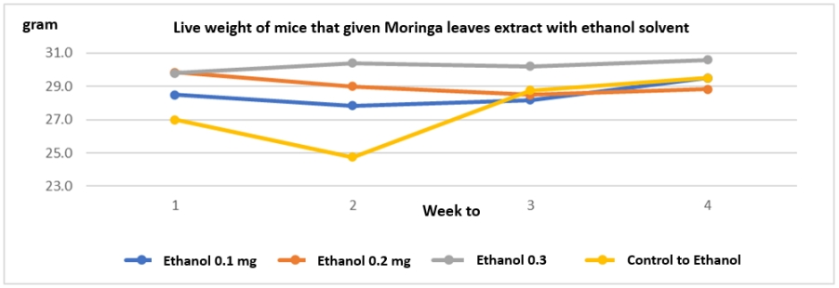
Figure 1. Live weight of mice that were given Moringa leaf extract with ethanol solvent.
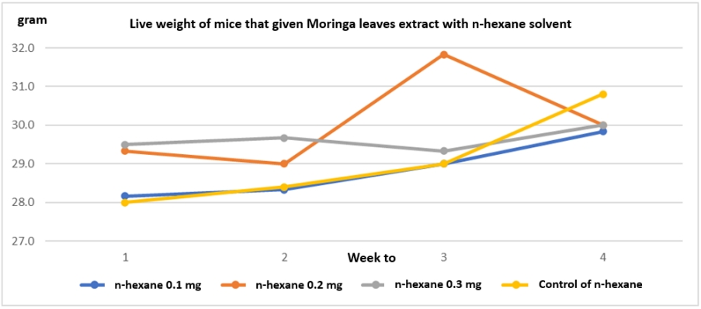
Figure 2. Live weight of mice that were given Moringa leaves extract with n-hexane solvent.
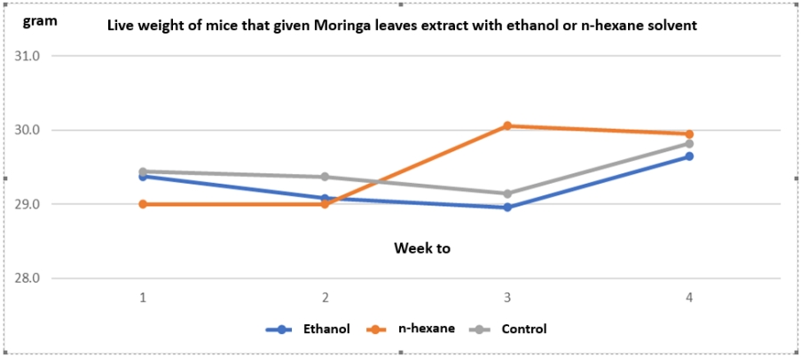
Figure 3. Live weight of mice that were given Moringa leaves extract with ethanol or n-hexane solvent.
Figure 4. (a) Effect of Ethanol of P1: 0.1 mg, P2: 0.2 mg, P3: 0.3 mg, P4: control. (b) Effect hexane of P1: 0.1 mg, P2: 0.2 mg, P3: 0.3 mg, P4: control, on nutrient consumption (g/day).

Figure 5. Weight of kidneys, liver, stomach, and ovaries in mice with ethanol and n-hexane solvents

