Morphological and molecular identification and characterization of Alternaria alternata isolates associated with tomato fruits spoilage during post-harvest storage in Saudi Arabia
Running Title: Alternaria alternata associated with tomato fruits spoilage
Jehan S. Al-brahim¹*, Omer A. Abdalla² , Khadiga AL-Harbi¹, Albandary N. Alsaloom¹, Fatima S. Bagrwan¹

¹ Department of Biology, College of Sciences, Princess Nourah bint Abdulrahman University, Riyadh 84428, Saudi Arabia

²Plant Protection Department, College of Food and Agriculture Sciences, King Saud University, P. O. Box 2460, Riyadh, 11451, Saudi Arabia

1* For correspondence: jsalbrahim@pnu.edu.sa

Novelty statement:
This research recommends that fruits that are going to be stored prior to marketing need to be handled with care at harvest. Minor injuries of fruits at harvest , handling predispose fruits to microbial infection even at proper storage conditions. Such infections result in significant yield losses, render fruits unmarketable and unfit for human consumption. Results of this study suggest further investigations as to whether isolates of Alternaria, in general, are closely related as this research indicated close phylogenetic relationships among the Saudi isolates of the fungus as well as their close relationships with isolates in the GenBank.

Abstract
The high water content of tomato fruits is probably one of the reasons for its susceptibility to microorganism’s spoilage during post harvest storage. Microorganisms’ infections deteriorate the tomato fruits, decreasing their quality and economic value. Fungi that spoil tomato fruits produce mycotoxins harmful to human beings upon their consumption. Fungal disease symptoms were observed on tomato fruits in a supermarket in Riyadh city, Saudi Arabia. Symptoms included fruit rot, sunken dark spots and patches covering most of the fruit surface. Isolation that was made from the symptomatic fruits on PDA plates indicated growth of a dark mycelium fungus. Light microscope examination of slides prepared from the fungal growth revealed septate mycelia and chains of pear-shaped conidia typical of Alternaria. Use of DNA extracted from the fungal growth in the PDA plates and specific primers in the PCR assay indicated positive results for Alternaria alternata. Nucleotide sequencing of purified DNA fragments that were excised from the jell subsequent to electrophoresis, indicated occurrence of five distinct isolates of Alternaria alternata in the affected fruits. Upon submission of nucleotide sequences of the distinct Saudi isolates of the fungus to GenBank, they were assigned accession numbers as follows: MK560182.1, MK560183.1, MT991478.1, MT991479.1 and MT991480.1.
GenBank Keywords: Alternaria, Nucleotide, PCR, Saudi Arabia, Microorganism, isolate

Introduction
Tomato fruit is rich in proteins, vitamins, carbohydrates, fats, potassium, fibres and known to have several medical benefits (Bello et al., 2016). It is one of the favorite vegetables that are consumed raw, cooked or processed. However its high water content is probably one of the factors that predispose it to microorganisms infections such as fungi (Mohammed and Kuhiyep, 2020). Mycotoxins produced as a result of spoilage render the fruit unfit for human consumption (Mukesh and Swarnmala, 2019). The Deuteromycetes fungal genus Alternaria has several species (Anuj Mamgain et al., 2013 ). Some of these species are well known as notoriously destructive plant pathogens that cause a widespread destruction in many of the major crops such as vegetable, field and tree crops. Alternaria has a severe impact on many plant species in several plant families including Cruciferae, Cucurbitaceae, Solanaceae and Bracicaceae which are of nutritional as well as economical significance. Alternaria infections cause world-wide economic losses on plant species belonging to these families (Conn and Tewari, 1990; Kirk, 2008; Anuj et al., 2013). Rotting symptoms induced by fungal infection can be seen on field plants, during storage, shipping, and even at supermarkets. One of the most prevalent diseases of tomato (Solanum lycopersicum) is the rot disease induced by Alternaria alternata which causes tangible losses in fruit quality rendering large amounts of tomato fruits unfit for marketing and consumption (Asai and Shirasu, 2015). Alternaria spp. usually induces diseases of variable symptoms such as early blight disease of potato and tomato, leaf blight and the leaf spot diseases in other host plants such as the one produced in Withania somnifera (Akhtar et al., 2004; Pati et al., 2008; Younes et al., 2019) in addition to its capability of infecting many other plant species producing symptoms on several plant parts such as leaves, petioles and fruits. As a result of fruit infection, lesions of purple to dark colour were formed on the stem- end. Most of fruit surface as well as the inner fruit tissues are commonly affected due to expansion of these lesions. Infection induces premature fruit drop and if fruits reach maturity they become unmarketable. During the post-harvest storage, tomato fruits are subject to deterioration due to diseases induced by some fungal pathogen agents such as black mold disease of tomato caused by Alternaria (Akhtar et al., 1994; Rosalba et al., 2014; Onuorah Samuel and Orji M.U., 2015; Hussein, 2020).
For its sensitivity, precision and the rapid results obtained by polymerase chain reaction (PCR), it was employed as a detection tool to identify phytopathogenic fungi (Johnson et al., 2000; Pryor and Gilbertson, 2001) and will consequently be used for the same purpose in this study as well. The objective of the current investigation is to isolate and identify post-harvest pathogenic agents that induce deterioration and spoilage of tomato fruits during storage in Saudi Arabia, using morphological methods and polymerase chain reaction (PCR) assay.

Materials and Methods
Source of tomato fruits and fungal isolation
Tomato fruits expressing variable symptoms including irregularity in fruit colour and patches covering large areas of the fruit surface, sunken dark spots and fruit rot, were collected from a supermarket in Riyadh city (Fig 1). Fungal isolation isolation was made on PDA prepared according to Ana Beatriz et al. 2019. Small pieces of symptomatic tomato were excised, sterilized in NaOCl at a concentration of 1% and aseptically placed in PDA plates after being rinsed with sterilized distilled water according to methods described earlier (Thilagam et al., 2018; Marak et al., 2014). The plates were allowed to incubate for seven days in an incubator at 37 °C. Microscopic slides were prepared from the fungal culture and examined in a light microscope. The fungus was then purified using single spore technique according to (Ke Zhang et al., 2013).
Molecular identification of fungal isolates:
PDA was prepared, autoclaved and dispenced in petri plates. The petri plates, which were used to grow the fungal isolates, were incubated for a weak at optimum temperature for growth, 28°C, (Pitt and Hocking, 2009). The extraction kit (Patho-gene-spin DNA/RNA) obtained from the Korean company, Intron Biotechnology, was employed for extraction of DNA of the fungal isolates in Assiut University Molecular Biology Research Unit. Polymerase chain reaction (PCR) of the extracted DNA and ITS sequencing of purified PCR products were performed at the Korean company, SolGent. Two universal primer sets namely, ITS1 (forward) and ITS4 (reverse) were added to the PCR reaction mixture before performing the assay. Composition of Primers was as follows: ITS1 (5' - TCC GTA GGT GAA CCT GCG G - 3'), and ITS4 (5'- TCC TCC GCT TAT TGA TAT GC -3'). PCR products were purified and sequenced using the above primers after addition of ddNTPs in the reaction mixture (White et al., 1990). Analysis of nucleotide sequences was performed using BLAST tool obtained from NCBI website. MegAlign (DNA Star) software version 5.05 was used for phylogenetic analysis of the sequences. Sequences of the Saudi isolates of the fungus were used to make a phylogenetic tree (Fig 4). Another phylogenetic tree was constructed by aligning sequences of the Saudi isolates of the fungus with those obtained from the GenBank using Clustal-W method (Fig 5).

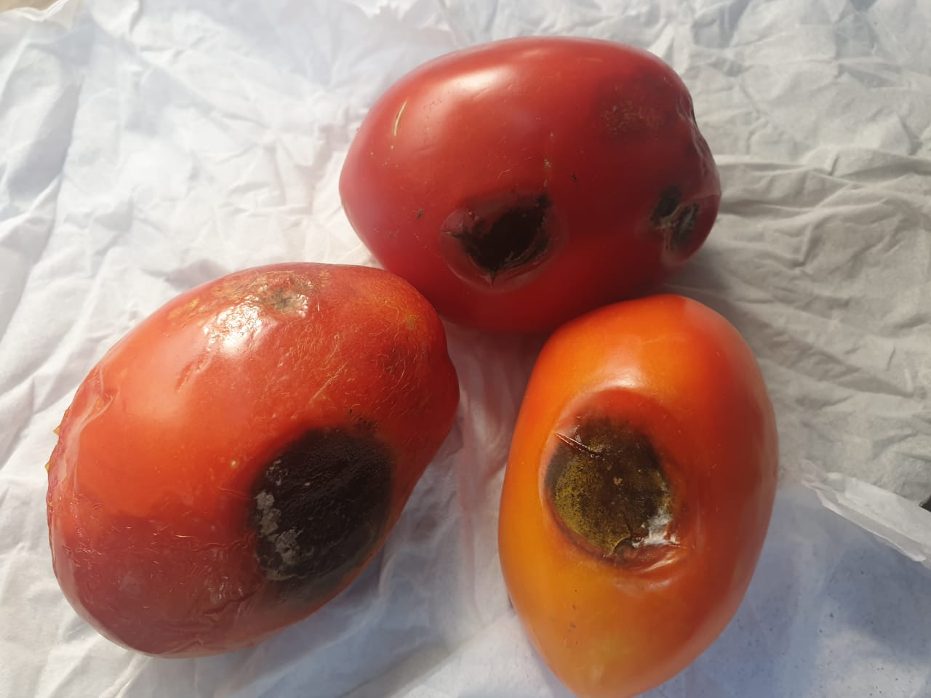
Fig 1. Fruit rot and sunken dark areas caused by Alternaria alternata on tomato fruits.

Results
Fungal growth and identification
Fungal growth was observed in the incubated PDA plates a few days after incubation. The growth of this isolate was relatively fast. In a few days, the fungus was able to produce a circular colony of dark central region and lighter margins composed of massive mycelial growth that was progressively turning from white to light brown colour. Examination of the slides prepared from the fungal growth in different PDA plates under light microscope revealed light brown, septate and irregularly branched mycelium and abundant number of conidia (Fig 2). Conidia were typical of Alternaria, club-shaped spores, dark brown in colour, with the characteristic longitudinal and transverse septation, and were produced in chains (Fig 3).
PCR assay using DNA extracted from the fungal growth in the different single spore culture plates and specific primers for the fungus revealed positive results for Alternaria alternata indicating infection of the tomato fruits with this fungus. Nucleotide sequences of most of the sequenced DNA fragments excised from the jell were similar, however sequences of five isolates
were found to be distinct enough from each other and from the rest of all other identical sequences, indicating occurrence of five different isolates of Alternaria alternata in the infected tomato fruits.
The phylogenetic tree constructed from nucleotide sequences of the A. alternata isolates detected in Saudi Arabia indicated very close relationships of (99.5-100%) among them (Fig 4). Similarly, the phylogenetic tree constructed from nucleotide sequences of the Saudi isolates of A. alternata and isolates for the same fungus reported in the GenBank indicated close phylogenetic relationships of (99-100%) between them (Fig 5).

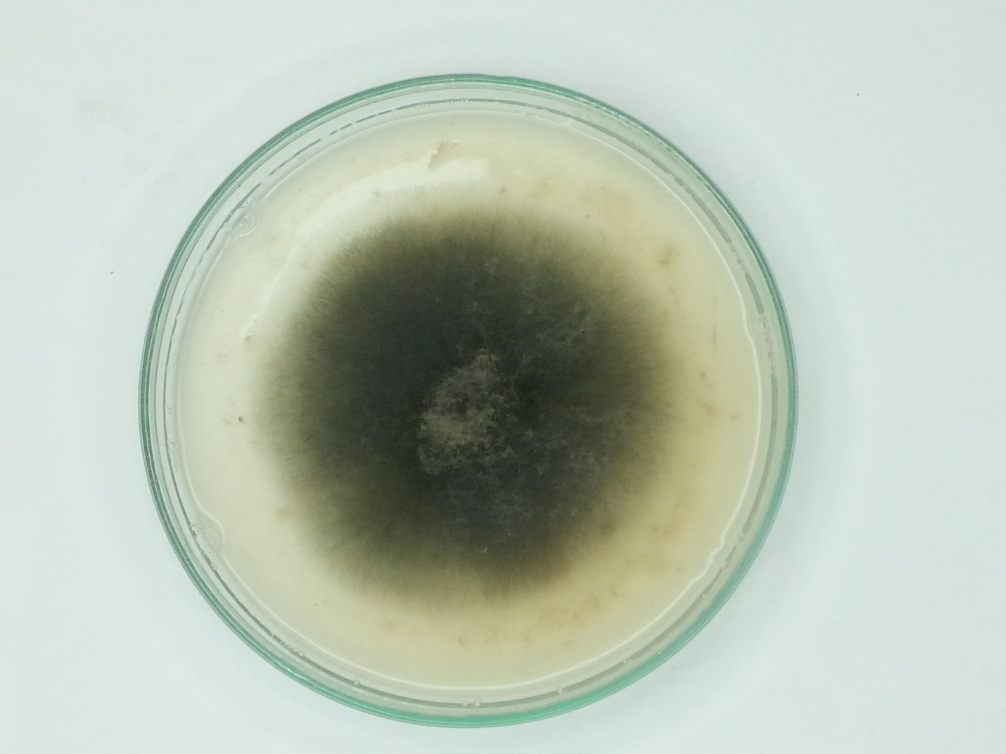
Fig 2. Seven days old colony of Alternaria alternata on PDA.
The phylogenetic tree constructed from nucleotide sequences of the A. alternata isolates detected in Saudi Arabia indicated very close relationships of (99.5-100%) among them (Fig 4). Similarly, the phylogenetic tree constructed from nucleotide sequences of the Saudi isolates of A. alternata and isolates for the same fungus reported in the GenBank indicated close phylogenetic relationships of (99-100%) between them (Fig 5).
Discussion
Although Several fungi were reported to deteriorate tomato fruits during the post-harvest storage (Onuorah and Oriji, 2015; Bello et al., 2016), causing substantial economic losses and sometimes
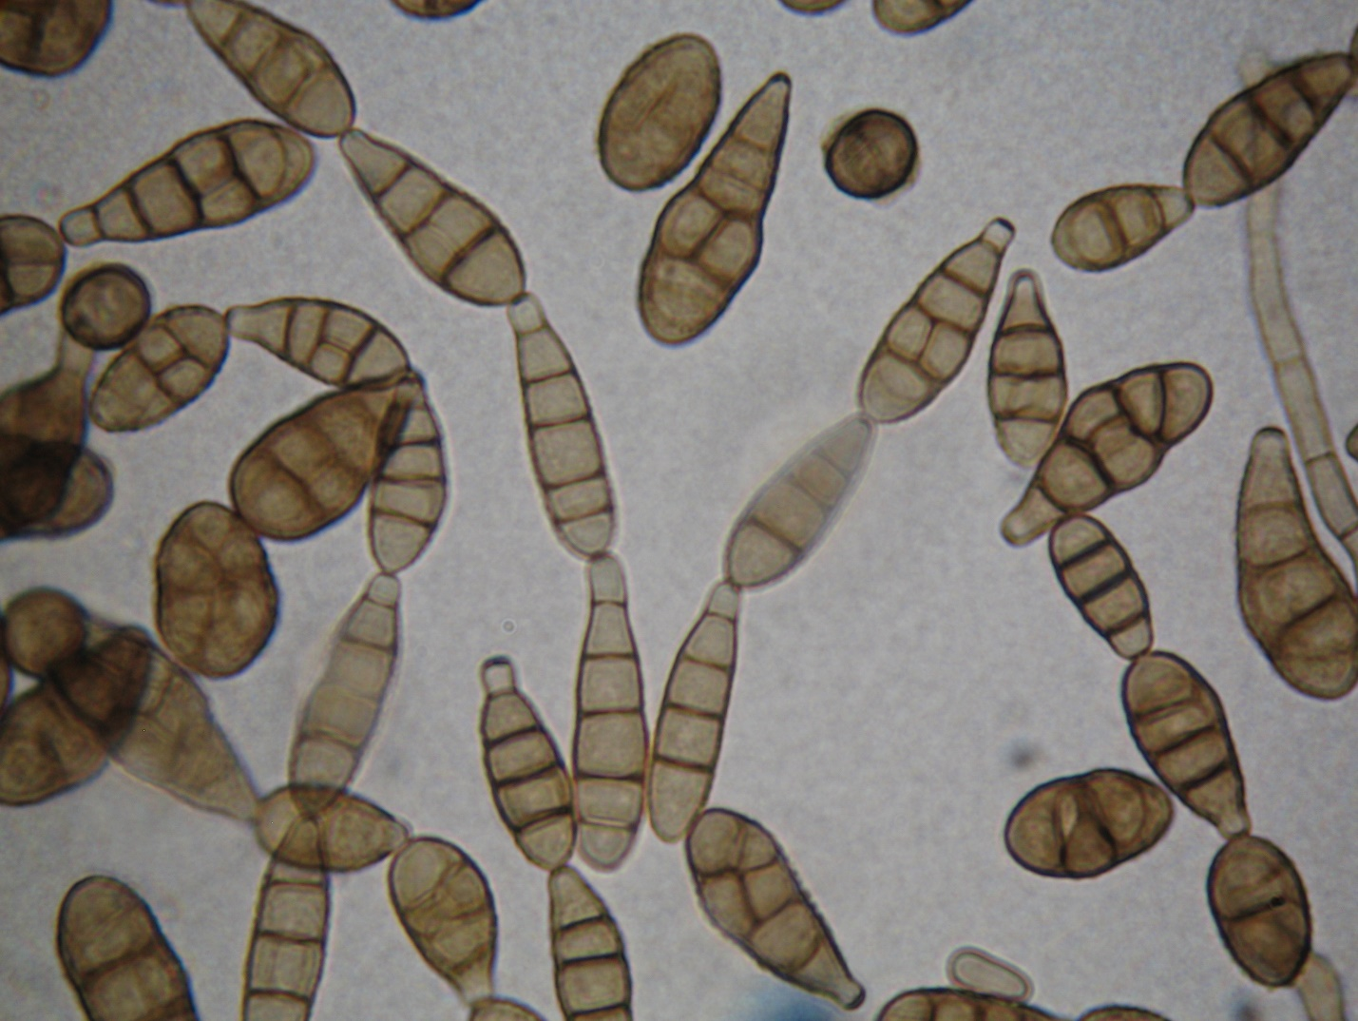
Fig 3. Conidia chains of Alternaria alternata
contaminate fruits with toxins produced during their infections (Bahaskara et al., 2000), A. alternata, the tomato black mold rot disease agent, is one of the fungal species often associated with such infections (Johnson et al., 2000; Onuorah Samuel and Orji M.U., 2015; Hussein, 2019).
In earlier investigations, fruit losses caused by some of these fungi were estimated to reach 32-57% (Conn and Tewari, 1990). However, more recent studies have shown that losses of tomato fruits as a result of microbial infections during the post-harvest storage were found to be even higher and were reported to range between 50-90% (Bello et al., 2016). By inducing disease symptoms on tomato fruits during storage, Alternaria alternata frequently causes such significant
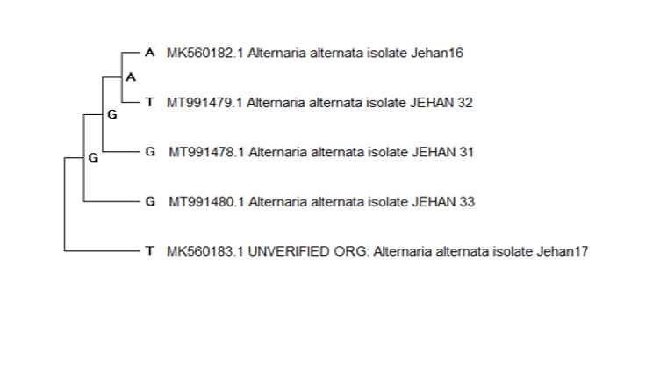
Fig 4: Phylogenetic tree of nucleotide sequences of Five Alternaria alternata strains isolated from post-harvest storage tomato fruits in Saudi Arabia [Jehan (16, 17, 31, 32 and 33)] that showed sequence identity of 99.5% - 100%.

losses in tomato fruits (Hussein 2019). Of seven fungal isolates associated with deterioration of tomato fruits during post-harvest storage, A. alternata was the one that was frequently detected (Akhtar et al., 1994). The ability of Alternaria alternata to infect a variety of fruits and vegetables under a wide range of variable cultivation and storage conditions suggests that losses resulting from infections of this fungus are as high as those induced by other fungal genera such as Penicillium Link, Fusarium Link, Aspergillus P. Mich ex Link, Rhizopus stolonifera, Saccharomyces cerevisiae, and Geotrichum candidum (Stinson et al., 1980; Bhaskara et al., 2000; Onuorah and Orji, 2015). It seems that Alternaria uses different means of pathogenic factors to affect its host. One of these factors is the production of toxins that contaminate tomato
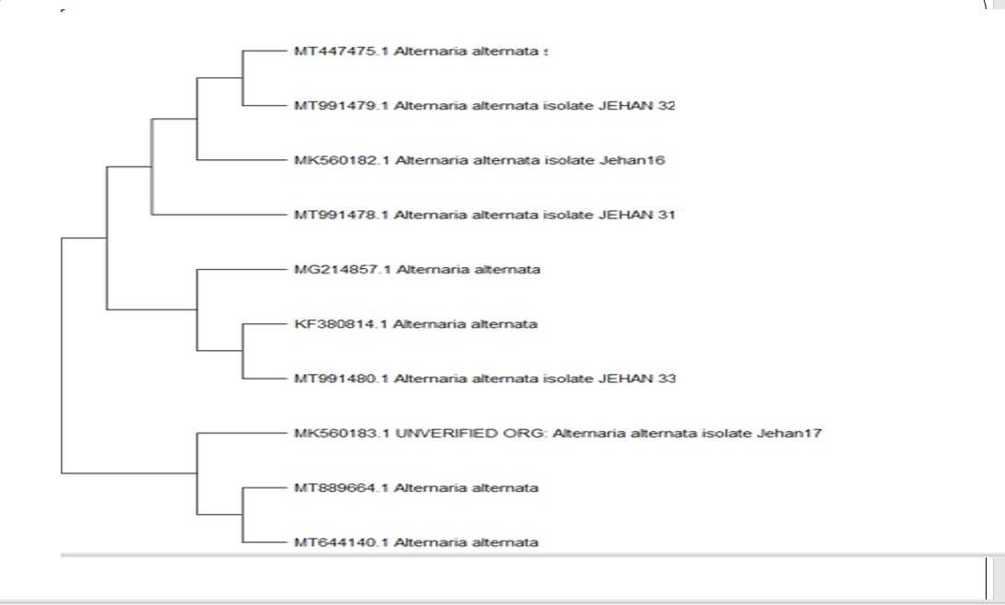
Fig 5: Phylogenetic tree of nucleotide sequences of the five Saudi strains of A. alternata from tomato [Jehan (16, 17, 31, 32 and 33)] and strains reported in the GenBank. The Saudi Alternaria alternata strains detected in the current study showed 99% - 100% identity with similar strains in the GenBank.

fruits (Bahaskara et al., 2000). A recent study reported that Alternaria pathogenesis is attributed to production of toxic substances that usually contaminate fruits, causing severe poisoning (Mukesh and Swarnmala, 2019) and render fruits unfit for human consumption. It was also reported that volatile substances that are released during the infection process are probably responsible for the change in fruit aroma and interfere with the resistance response of the fruit (Encinas et al., 2017). It is interesting that the phylogenetic study that was carried out indicated close relationships among the Saudi isolates of A. alternata as well as close phylogenetic relations between them and the isolates obtained from the GenBank. Although it seems plausible to think that phylogenetically related Alternaria isolates would probably have less pathogenic diversity, it turns out that variability among isolates of this fungus seems to be not only dependent on phylogenetic relationships but also on other factors such as the host plant, as was suggested from previous studies (Pryor and Michailides, 2002; Sima and Mahdi, 2013; Zhu and Xiao, 2015).
Conclusion
Tomato fruits are subject to spoilage as a result of microorganisms infections in the post harvest storage (Akhtar et al., 1994; Fatih et al., 2005). Alternaria is one of the important fungi associated with spoilage of fruits during the post-harvest storage (Hussein, 2019). Alternaria has several species, some of which cause plant diseases of great significance, destructive nature and severe impact on several important plant species belonging to different plant families (Stinson, 1980). Hence it causes economic losses on plants in the field as well as on fruits in post-harvest storage. Although several fungal species were reported to cause spoilage of fruits during post-harvest storage (Pitt and Hocking, 2009; Onuorah and Orji, 2015), Alternaria alternata is not only one of the important fungi that cause such effect but it also produce toxins that render fruits unmarketable and unfit for human consumption as well. Fruit losses due to microbial infections during post-harvest storage were reported to reach 32-57% (Conn and Tewari, 1990), however recent studies have reported losses of 50-90% (Bello et. Al, 2016, Hussein, 2019). It is interesting that five Alternaria isolates were isolated from infected tomato fruits in Saudi Arabia in this study. These Saudi isolates of A. alternata were found to be phylogenetically closely related with each other as well as with some other isolates reported in the GenBank.

Acknowledgement:
The authors greatly appreciate the financial support of Princess Nourah bint Abdulrahman University Researchers Supporting Project number (PNURSP2022R180), Princess Nourah bint Abdulrahman University, Riyadh, Saudi Arabia.
References:
- 1295
Akhtar, K. P., M. Matin, J. H. Mirza, , A. S. Shakir, and M. Rafique, 1994. Some studies on post-harvest diseases of tomato fruits and their chemical control. Pakistan Journal of Phytopathology, 6: 125-129.
Akhtar, K. P., M. Y. Saleem, M. Asghar, and M. A. Haq., 2004. New report of Alternaria alternata causing leaf blight of tomato in Pakistan. Plant Pathology, https://doi.org/10.1111/j.1365-3059.2004.01099.x
Ana Beatriz Monteiro Ferreira, Ivan Herman Fischer, Luís Garrigós Leite, Carlos Roberto Padovani, and César Júnior Bueno, 2019. Culture media to detect and criteria to evaluate and report the activity of extracellular enzymes produced by phytopathogenic fungi. Arq. Inst. Biol., 86: 1-9, e0592017
Anuj Mamgain, Rajib Roychowdhury and Jagatpati Tah., 2013. Alternaria pathogenicity and its strategic controls. Research Journal of Biology, 1: 01-09.
Asai, S., and K. Shirasu, Plant cells under siege:, 2015. Plant immune system versus pathogen effectors. Curr. Opin. Plant Biol., 28: 1–8. [CrossRef] [PubMed]
Bello, O. B., Habib, Ullah, O. J. Olawuyi, A. S. Opeyemi, A. H. Alafe, and T. A. Owoade, 2016. Microorganisms causing post-harvest tomato (Solanum lycopersicum L.) fruit decay in Nigeria. Journal of Entomology and Zoology Studies, 4: 374-377.
Bhaskara Reddy, M.V., Paul Angers, Francois Castaigne, and Joseph Arul, 2000. Chitosan Effects on Blackmold Rot and Pathogenic Factors Produced by Alternaria alternata in Postharvest Tomatoes. J. AMER. SOC. HORT. SCI. 125: 742–747.
Conn K. L. and J. P.Tewari, 1990. Survey of Alternaria blackspot and Sclerotinia stem rot in central Alberta in 1989. Can. Plant Dis. Survey, 70: 66-67.
DOI: 10.1016/B978-0-12-411552-1.00005-3
Encinas, David, Quintanar, María Isabel Valenzuela, Sánchez, Alberto, Hernández, Martin Ernesto Tiznado, Rodriguez, Armida, and Rojas, Rosalba Troncoso, 2017. Alterations in volatile metabolites profile of fresh tomatoes in response to Alternaria alternata (Fr.) Keissl. 1912 infection. Chilean Journal of Agricultural Research, 77: 194-201.
Fatih Kalyoncu, A. Usame Tamer and Mustafa Oskay, 2005. Determination of Fungi Associated with Tomatoes (Lycopersicum esculentum M.) and Tomato Pastes. Plant Pathology Journal, 4: 146-149. http://dx.doi.org/10.4067/S0718-58392017000300194
Hussein, G. S., 2019. The use of PCR to detect Alternaria alternata fungi which isolated from tomato fruit. Biochemical and Cellular Archives . 19: 4203-4206.
Johnson R. D., L. Johnson, K. Kohmoto, H. Otani, C. R. Lane and M. Kodama, 2000. A Polymerase chain Reaction- Based Method to specifically Detect Alternaria alternata Apple Pathotype (A.mali), the Causal Agent of Alternaria Bloch of Apple. Phyt. Path., 90: 973- 976.
Kirk P. M., P. F. Cannon, D.W. Minter, and J. A. Stalpers, 2008. Dictionary of the Fungi. 10th ed., Wallingford, CABI. p. 22.
Marak, T. R. , B. S. Ambesh, and S. Das, 2014. Cultural, morphological and biochemical variations of Alternaria solani causing diseases on solanaceous crops. Plant Pathology, 9: 1295-1300.

Mohammed S.S.D. and C.Y. Kuhiyep, 2020. Bacteria and Fungi Co-Biodeterioration of Selected Fresh Tomatoes Sold Within Ungwan Rimi, Kaduna. Science World Journal, 15: 1597-6343. www.scienceworldjournal.org ISSN
Mukesh Meena, and Swarnmala Samal., 2019. Alternaria host-specific (HSTs) toxins: An overview of chemical characterization, target sites, regulation and their toxic effects. Toxicol Rep., 6: 745–758. Published online 2019 Jul 17. doi: 10.1016/j.toxrep.2019.06.021
Onuorah Samuel and Orji M.U., 2015. Fungi Associated with the Spoilage of Post-harvest Tomato Fruits Sold in Major Markets in Awka, Nigeria. Universal Journal of Microbiology Research, 3: 11-16, http://www.hrpub.org DOI: 10.13189/ujmr.2015.030201
Pati Pratap, Sharma Monica, Salar Raj Kumar, Sharma Ashutosh, Gupta AJAI Prakash, and Singh Bikram, 2008. Studies on leaf spot disease of Withania somnifera and its impact on secondary metabolites. Indian Journal of Microbiology, 48: 432-437. DOI: 10.1007/s12088-008-0053-y
Pitt J. I. and A. D. Hocking, 2009. Fungi and Food Spoilage. Springer Nature Switzerland AG. Part of Springer Nature (524 pages).
Pryor B. M. and T. J. Michailides, 2002. Morphological, pathogenic, and molecular characterization of Alternaria isolates associated with Alternaria late blight of pistachio. Phytopathology, 92: 406-416.
Pryor, B. M. and R. L. Gilbertson, 2001. A PCR-based assay for detection of Alternaria radicina on carrot seed. Plant Dis., 85: 18-23.
Rosalba Troncoso-Rojas, Martin Ernesto, and Tiznado-Hernández, 2014. Alternaria alternata (Black Rot, Black Spot). Chapter 5 In book: Postharvest Decay, 1st edition (pp.147-187). APS Press.
Sima Khodaei, and Mahdi Arzanlou, 2013. Morphology, phylogeny and pathogenicity of Alternaria species, involved in leaf spot disease of sunflower in northern Iran. Archives of Phytopathology and Plant Protection, 461: 2224- 2234.
Stinson, E. E., D. D. Bills, S. F. Osman, J. Siciliano, M. J. Ceponis, and E. G. Heisler, 1980. Mycotoxin production by Alternaria species grown on apples, tomatoes, and blueberries. J. Agr. Food Chem., 26: 960–963.
Thilagam, R., G. Kalaivani, and N. Hemalatha, 2018. Isolation and identification of phytopathogenic fungi from infected plant parts. International Journal of Current Pharmaceutical Research, 10: 26-28. ISSN- 0975-7066 .
White, T. J., T. Bruns, S. Lee, and J. Taylor, 1990. Amplification and direct sequencing of fungal ribosomal RNA genes for phylogenetics. In PCR Protocols: A guide to Methods and Applications (ed. M. A. Innis, D. H. Gelfand, J. J. Sninsky & T. J. White), pp. 315-322. Academic Press: San Diego, U.S.A.
Younes Ramezani, Parissa Taheri and Mojtaba Mamarabadi, 2019. Identification of Alternaria spp. associated with tomato early blight in Iran and investigating some of their virulence factors. Journal of Plant Pathology, 101: 647- 659.
Zhang, Ke., Yuan-Ying Su, Lei Cai., 2013. An Optimized Protocol of Single Spore Isolation for Fungi. Cryptogamie Mycologie, 34: 349-356.
Zhu, X. Q. and C. L. Xiao, 2015. Phylogenetic, morphological, and pathogenic characterization of Alternaria species associated with fruit rot of blueberry in California. Phytopathology, 105: 1555–1567.

