Characterization and selection of some genotypes of lentil (Lens culinaris medik.) tolerant to phosphorus deficiency
Wassila BOUGHANEM ^{1,2*}, Ibrahim BOUSSALHIH ¹, Mohamed LAZALI ¹

¹Laboratoire de recherche ERP, Faculté des Sciences de la Nature et de la Vie & des Sciences de la Terre. Université Djilali Bounaama de Khemis Miliana, Route Theniet El Had, Soufay 44225 Khemis Miliana, Algeria
²Institut Technique des Grandes Cultures (ITGC), El Harrach – Alger, Algeria.
*For correspondence: wassila.ensa@live.fr , w.boughanem@univ-dbkm.dz
Received _______________; Accepted _______________; Published __________
Abstract
Lentil are well recognized for their nutritional and health benefits as well as for their impact in the sustainability of agricultural systems, it is an excellent cultural precedent for other crops, capable of establishing a symbiotic relationship with rhizobia for nitrogen fixation. Low availability of phosphorus (P) in soil is a major constraint for symbiotic nitrogen fixation and productivity of legumes. This P-deficiency also affects multiplication of rhizobia in rhizosphere resulting in a reduction of the probability of infection and it also reduces growth of nodules. The main objective of this study is to see the degree of adaptation of lentil to P-deficiency in order to select the best genotypes grown taking into account growth rate, grain yield and the efficiency in use of rhizobial symbiosis. In this context, our work is focused on the study of behavior of some genotypes of lentil grown at Khemis Miliana area during two growing seasons 2018 and 2019. In terms of yield, the results illustrated show that the yield values are a little heterogeneous among genotypes, varies between 5 and 12 qha⁻¹, specifically the genotypes Large blonde and Ibla1 recorded the highest yield during two growing seasons. In addition, efficiency in use of the rhizobial symbiosis of lentil was better for Djendel during 2018 season with (1.57gshoot DWg^{–1}nodule DW) followed by Large blonde (0.2gshoot DWg^{–1}nodule DW). It is concluded that the genotypes selected for their P use efficiency had a higher yield and could best adapt to low-P availability under field conditions.

Keywords: phosphorus, legumes, N₂ fixation, rhizobia, symbiosis.

Introduction
Legumes are one of most important crops not only for their nutritional quality but also for their various agro-environmental benefits. Legume seeds and powders are important sources of protein, carbohydrates, vitamins, minerals and dietary fiber (Baljeet et al., 2014; Rachwa-Rosiak et al., 2015). They play a major environmental role in cropping systems, principally as a source of symbiotic N₂ fixation that may save N fertilizer and also in weed and pest management in crop rotations (Graham, 2008). Phosphorus (P) may be a critical constraint for legumes under low nutrient environments because there is a substantial P requirement for the N₂ fixation process (Schulze et al., 2006; Tsvetkova and Georgiev, 2007). This high P requirement of nodules increases the sensitivity of legumes to P-deficiency, a major limiting factor for legume production particularly in acidic or calcareous soils (Graham and Vance, 2003; Vance et al., 2003; Drevon et al., 2015). The application of P fertilizers is essential for improving crop yield (Gonzalez-Dugo et al., 2005; Li et al., 2007). However, P fertilization is generally little efficient for crops; i.e. only a few percent of the added P is usually taken up the same year, while the rest is stored in soil under organic, adsorbed and mineral forms (Li et al., 2008; Zhang et al., 2014; Gérard, 2016).
In response to P-deficiency, nodulated legumes implement two adaptive strategies (Araujo et al., 2008). The first strategy consists in developing a more efficient P acquisition system by increasing the root exchange surface (Hinsinger et al., 2018) or by secreting organic acids (Lazali and Bargaz, 2017) and phosphatases (Wang and Liu, 2018) whose role is to dissolve insoluble P from the soil. This strategy addresses the external P requirement of the plant, i.e. the minimum P concentration of the soil solution for optimal plant growth. The second strategy is to optimize the metabolic P use efficiency (PUE) for symbiotic N₂ fixation (SNF) by producing more biomass or fixing more N₂ per unit P consumed. It concerns the internal P requirement (Wang et al., 2018), i.e. the minimum P content of plant for optimal growth. Indeed, the selection of P deficiency tolerant symbioses could focus on the PUE for N₂ fixation that seems specific to the interaction of the two symbioses (Wang et al., 2018).The exploration of genotypic variability in the responses of the lentil to P-deficiency may allow identification of physiological or biochemical tools for screening tolerant varieties and enable the productivity of this crop to be improved. Thus the aim of the present study was to improve our understanding of the role of P for SNF in developing strategies to improve the tolerance of nodulated lentil to low P-soils.
Materials and methods
Experimental site study area
The field experiment was conducted repeatedly over two seasons, 2017-18 and 2018-19. The experiment was conducted at the Demonstration Farm and Seed Production (FDPS) belonging to the station of the Technical Institute of Field Crops (ITGC) of Khemis Miliana. On a clayey-silt soil according to the USDA Duchaufour soil texture triangle (Duchaufour, 1970) and a previous wheat crop. The experimental site is located at the geographical coordinates 36°15'03''N 2°14'25''E at an altitude of 277 m. Khemis Miliana’s Mediterranean climate was characterized by a rather rainy and cold winter, dry and hot summer and a short spring (April-May) with different thermal amplitudes between winter and summer and between night and day. The region has irregular rainfall with an annual mean of 565 mm in 2018 and 482,8mm in 2019. The beginning of two-year experiment had low rainfall especially during September.
Physico-chemical properties of topsoil were determined in 2017. It was approximately 47% clay, 45% loam and 8% sand. The experimental soil was alkaline (pH 7); with1.81gkg⁻¹CaCO₃and low organic matter content (1.69 %). The soil was both N-deficient (Total N, 0.78 g N kg⁻¹) and P-deficient (Olsen P, 9.52 mg Pkg⁻¹).

Cropping system and field plot design
The field experiment was carried out using five lens cultivars (Djendel, Ibla1, Large blonde, LVS and Metropole). They were growing during two seasons 2018 and 2019 adopting a complete randomized block experimental design which covered an area of 122.4m². With a density of 200 plants m⁻² for each genotype. The field trial was divided into three blocks, with each block further divided into five subplots. Each subplot was used for one of lentil genotypes and measuring 5 m x 1.2 m with a surface area of 6 m².

Plant and soil sampling and measurements
Before first sowing season, physico-chemical properties of soil were measured on five topsoil samples (0–20 cm) collected by auger. At the full flowering stage (100 days after sowing), we collected rhizosphere and bulk soil samples corresponding in order to perform measurements. This sampling was carried out from 25 to 30 cm depth. The rhizosphere was sampled in a standard manner; i.e. by brushing <1–4mm aggregates of soil adhering to lens roots gently using a paintbrush (Hinsinger, 2001; Latati et al., 2014). We bulked the three replicates of rhizosphere and corresponding bulk soil samples to each genotype.
Plants samples were also sampled at full flowering stage, when flowering reaches 50% of the elementary plot for each genotype, 9 plants were harvested and separated into shoots and roots, dried for 48 h at 65°C, and weighed. Nodules were separated from roots, dried and weighed separately. Shoot and roots were ground and digested in a microwave oven in nitric and perchloric acids at 135°C and 1.5 × 10⁶ Pa. Biomasses data of shoots and nodules were used to assess the efficiency in use of the rhizobial symbiosis (EURS) for plant growth by correlation analysis in order to test whether cropping treatment over two growing season would affect the relationship between nodulation and shoot growth (Lazali et al., 2016).
Plant P uptake corresponded to the amount of nutrients taken up by plants during plant growth and were calculated as follows P concentrations in shoots and roots were measured using malachite green method as performed for total soil P. All soil and rhizosphere samples were dried, sieved (2 mm) and stored at 4°C for 72 h before analysis. We used Olsen method to assess P availability (Olsen et al. 1954) and pH was measured in soil suspension with deionized water (soil: water ratio = 1:2.5; Shen et al. 1996). The total soil P content was measured spectrophotometrically at 630 nm using malachite green method after soil digestion by perchloric and nitric acids (Valizadeh et al., 2003). Total N and organic matter contents were measured using the Kjeldahl (Kjeldahl, 1883) and Walkley–Black (Walkley and Black, 1934) methods, respectively.
Plant P uptake corresponded to the amount of nutrients taken up by plants during plant growth and were calculated as follows (Cavigelli and Thien, 2003).
P uptake (mg) = [P concentration in shoot (mg g⁻¹) × shoot DW (g)] + [P concentration inroot (mgg⁻¹) × root DW (g)]– seed P content(mg).
At plant maturity stage, the grain yield was determined by harvesting all the plants within 1 m² with three replicates in each plot.
Statistical analysis
We performed a one-way ANOVA using genotype as factor. Plant biomass, P uptake, rhizosphere P availability, and grain yield were determined using analysis of variance (ANOVA) at a significance level of p = 0.05, and Tukey's test was used to determine if the difference between the mean values of each treatment was significant, we determined the efficiency in use of rhizobia symbiosis (EURS) by the slope of the linear regression between shoot dry weight (SDW) and nodule dry weight (NDW). All the statistics were performed with Statistica10 (V.8.5) software.
Results
Plant growth and nodulation
Figures (2, 3 and 4) show that three compartments of lentil biomass (shoots, roots and nodules) varied no significantly between genotypes. The largest shoot DW was found in genotypes Ibla1 and Large Blonde, during the first growing season 2018 with (7.33 g plant⁻¹) and (7.14g plant⁻¹) respectively followed by genotype Djendel (6,50 g plant⁻¹). In 2019 season, Metropole and Ibla1 presented the highest shoot DW (7,20 g plant⁻¹) and the lowest shoot DW was recorded for LVS genotype during two growing seasons
Root DW was always substantially higher in Large blonde and LVS genotypes whatever the growing season, and the lowest root DW were observed in Ibla1 genotype for the two seasons. Overall, the highest nodule dry DW was recorded by Ibla1 and LVS for both seasons and the lowest nodule DW was recorded for Large blonde for both seasons.
Estimated grain yield
The results illustrated in Fig. 1 show that the yield values are a little heterogeneous among genotypes, varies between 5 and 12 q.ha⁻¹, specifically the varieties Large blonde and Ibla1 recorded the highest yield during two growing seasons: (12.35 q.ha⁻¹ and 11,06 q.ha⁻¹ in2017) and: (12,05q.ha⁻¹ and 9,40q.ha⁻¹in 2018) respectively. The variety LVS gave the lowest yield during both seasons with 5.44q.ha⁻¹ and 5.93 q.ha⁻¹.

Efficiency in use of the rhizobial symbiosis (EURS)
To assess whether the N₂ fixation based on nodule biomass relative to the plant growth, varied among genotype of lentil, values of shoot biomass of each individual plant were plotted as a function of its nodule biomass. Biomass of shoots and nodules were significantly correlated and varied among lentil (Fig. 5). Efficiency in use of the rhizobial symbiosis estimates as the slope of the linear regression of the curves shown in (Fig. 5), No significant correlation was found in Metropole between NDW and SDW during two growing seasons. In contrast, these two plant variables were significantly correlated for rest. Was the highest for Djendel (1,57 g shoot dry weight g^{–1} nodule dry weight) during 2017 with (R²=0,809***) and (1,07 g shoot dry weight g^{–1} nodule dry weight) during 2018 with (R²=0,788***) followed by Large blonde (0,2 g shoot dry weight g^{–1} nodule dry weight)in 2017 and (0,87 g shoot dry weight g^{–1} nodule dry weight) in 2018 with (R²= 0,756***) and (R²= 0,749***) respectively, and the lowest for Metropole (0,03g shoot dry weight g^{–1} nodule dry weight) in 2017 and (0,19 g shoot dry weight g^{–1} nodule dry weight) in 2018.
Phosphorus concentration and uptake
Results showed in Table (1) and figure (6) indicate that P concentrations in shoot and root compartments of lentil varied significantly (p< 0.001) according to the different genotypes. The lowest P concentrations were found in shoots and roots of Djendel genotype during the two growing seasons (Table 1). Indeed, the highest P concentrations were found in plants of genotype Ibla1 in both seasons, followed by large blonde.
However, the lowest P uptake was found in LVS during two growing seasons with a value of 27.05 in the first season and 26.77 for the second season, and highest P uptake is noted in Ibla1 during two seasons (Table 1). Other genotypes exhibited intermediate values of P uptake.
Relationship between nodulation and phosphorus content
Since important role of P in nodule functioning is indicated by their higher P content compared with shoots organs, values of nodule P content were plotted as a function of nodule biomass (Fig. 5). A positive correlation was found between these two parameters for all genotypes during two growing seasons, but this correlation tended to be highly significant in Djendel (R² = 0.96, P < 0.001) and Large blonde (R² = 0.93, P < 0.001) in 2018 seasons compared to other genotypes. Indeed, for each increase of 1 mg nodule P content nodulation of genotypes LVS, Ibla1 and Metropole increased in first season by 339, 210, and 156 mg nodule DW per plant, respectively, and in second season by 148, 247 and 230 mg nodule DW per plant, respectively. By contrast, for each increase of 1 mg nodule P content nodulation of genotypes Large blonde and Djendel increased by 132 and 27 mg nodule DW per plant, respectively during the season 2017 and 31 and 58 mg nodule DW per plant, respectively in second season 2018.
Discussion
Lentil cultivation is traditional in Algeria. This plant is a classic grain legume that has always been used in human nutrition. Additionally to relatively low maintenance requirement, lentil is well adapted to poor soils which enriches with nutrients and organic matter. In general, lentil and legumes are more environmentally sustainable because they require fewer natural resources to grow (Sellami et al., 2021). In this study, nodule biomass and growth for genotypes LVS and Metropole were lower than those of Ibla1 and Large blonde (Fig. 2.4). This is due to the sensitivity of these genotypes to low soil-P availability, which is consistent with a previous conclusion that P-deficiency decreases the biomass of nodules as well as their nitrogenase activity (Qiao et al., 2007; Hernandez et al., 2007) and thereby the total N₂ fixation (Kouas et al., 2005). Our results are also in line with previous findings that P-deficiency may indirectly affect nodule development by restricting metabolite supply from the host plant in common bean (Alkama et al., 2012), soybean (Ribet and Drevon, 1995; Drevon and Hartwig, 1997), and alfalfa (Schulze and Drevon, 2005). Differences in the response of nodulation to P-deficiency appear to be related to legume species, genotype, rhizobial strain, and experimental conditions (Rodiño et al., 2011; Drevon et al., 2015). In this study, the analysis of variance of the yield of 5 lentil accessions did not reveal any significant difference between these genotypes, proving that the performance of all genotypes was not affected by different environmental conditions. The slightly higher yields in the first season (9.41qha⁻¹) compared to the second (8.83qha⁻¹) is explained by the difference in the quantity of rain received during these seasons (565 mm in the first season and 482,8 mm in the second season). In the semi-arid zone, water requirements of lentil are estimated at 364–391 mm (INRA, 2015). It is generally cultivated in areas with rainfall between 300 and 450 mm.
The significant correlation between nodulation and shoot biomass indicates that nodules were efficient (Fig. 5). This statement confirms previous observations in farmers’ fields of Lauragais in southern France (Drevon et al., 2011), Setif in Algeria (Lazali et al., 2016) and Mauguio Southeast of Montpellier, France (Lazali et al., 2017). High nodule biomass was generally considered as a trait for symbiosis efficiency because nodules grow and fix N at the expense of roots (Schulze et al., 1999; Qiao et al., 2007) and also at the expense of shoots during the vegetative stage (Qiao et al., 2007). Legumes are important crops as they are atmospheric nitrogen fixers. This process of N₂ fixation induce a number of rhizosphere-induced changes that contributes to P-availability in the soil and interest in plant growth (Hinsinger et al., 2003; Alkama et al., 2009, 2012; Bargaz et al., 2012; Latati et al., 2016). Indeed, the higher efficiency of nodules of genotypes Djendel and Large blonde than Metropole and LVS (Fig. 5) suggests that internal remobilization of acquired P through SNF ability may help the lentil genotypes to establish higher shoot biomass under P-deficient conditions. This is in agreement with the tolerance of nodulation to P-deficient conditions that was attributed to a lower immobilization of P in nodule (Vadez et al., 1999; Schulze and Drevon, 2005).The efficiency in use of the rhizobial symbiosis is one of the most important biological indicators for monitoring environmental changes in the rhizosphere of cropped legumes, which rely on N₂ fixation generally help to increase P and N availability in the rhizosphere through rhizosphere acidification mechanisms (Betencourt et al., 2012; Brooker et al., 2014). Indeed, the increase in rhizobial symbiosis utilization efficiency under P deficiency in some genotypes compared to others could be a kind of adaptation involving mechanisms adjusting the weight growth of the plant and its nodular biomass (Lazali, 2019).
Phosphorus concentrations in the shoot part showed significant variations between genotypes (p<0.001, Table 1, Fig. 6) of soil studied. This parameter varied from 4.45 to 5.83 mg of Pg⁻¹DW. The highest content of P concentrations was recorded in Ibla 1 with a mean value of 9.65 mg Pg⁻¹ DW while the lowest P content was recorded in Djendel with mean value of 5 mg Pg⁻¹DW during both seasons. The rest of the genotypes showed intermediate shoots P levels. Nodules P content of lentil plants showed significant variations (p <0.001, Table1, Fig. 6) of soil studied. In general, the nodules of Lens culinaris plants accumulated more P compared to their corresponding shoots and roots parts. In the first season, Large blonde recorded the highest concentration with 8.53 mg Pg-¹ DW followed by Djendel with 8.42mgPg⁻¹ the opposite was observed in the second season, with Djendel recording 8.53 mg Pg-¹ and Large blonde recording 8.50 mg Pg⁻¹. Metropole showed the lowest P content in both seasons with mean value of 7.33 mg P.g⁻¹ DW and 7.26 mg P.g⁻¹ DW respectively, (Fig.6C). This could be due to the fact that root nodules could uptake P directly from soil solution. Our results have also shown that P contents in shoots and nodules are generally higher for plants with high biomass (Khadraji, 2020). This further proves the positive effect of phosphorus on the growth and nodulation of plants. Similarly, Bargaz et al. (2012) and Singh et al. (2016) showed that the accumulation of P was significantly and positively correlated with the biomass of cultivated plants.
In our study, the positive correlation between nodule biomass and P content (Fig. 7) suggests tight regulation between N₂ fixation and the nodule P requirement. The high level of P in nodules may constitute an adaptive mechanism for P deficiency since high nodule P content induces an increase in nodule conductance to the O₂ diffusion which is described as the main regulator for N₂ fixation (Jebara et al., 2005; Bargaz et al., 2013; Lazali and Drevon, 2014). Thus, P allocation rate may play an important role in the determination of the symbiotic efficiency as well as the degree of legume adaptability under low-P conditions.
Conclusion
Our results showed significant differences between genotypes for yield, nodular P demands and symbiotic N fixation (SNF) abilities. In response to P deficiency, the Large Blonde, Ibla 1 and Djendel genotypes were the most efficient in P use for SNF and recorded the highest yields compared to Metropole and LVS. The selection of P-efficient genotypes may contribute to the improvement of the N₂– dependent growth of legumes in agro-ecosystems where P is deficient in the soil, which is a limiting factor of symbiotic N₂ fixation. The use of P-efficient genotypes and rhizobial strains with a great ability to grow and yield in P-deficient soil is, therefore, an important goal for improving legume P nutrition under P-deficient conditions. Although the increased above-ground biomass and grain yield were associated with the stimulation of efficiency use of the rhizobial symbiosis (indicating higher symbiosis efficiency), P availability, and soil resource use efficiency.
Acknowledgments
The authors are grateful to the technical institute of field crop (ITGC) for the support we received from its experimental station (Khemis Miliana) and for giving us the opportunity to use the five lentil genotypes during this research, as well as hosting our experiment to achieve this study. We also acknowledge the master students of the University of Djilali Bounaama of Khemis Miliana who helped us, without which this study could not have been completed.
Author Contributions
Wassila BOUGHANEM: Experimental work (sowing in the field), explained the results, Statistical analysis, Writing of the original project, Revision of the writing and editing. Ibrahim BOUSSALHIH: Supervision, Revision and editing of the text. Mohamed LAZALI: Supervision, Revision and editing of the text.
Conflict of Interest
All authors declare no conflict of interest
Data Availability
Data presented in this study will be available on a fair request to the corresponding author
Ethics Approval
Not applicable to this paper

References
Alkama N, Bolou Bi Bolou E, Vailhe H, Roger L, Ounane SM, Drevon JJ (2009). Genotypic variability in P use efficiency for symbiotic nitrogen fixation is associated with variation of proton efflux in cowpea rhizosphere. Soil Biol. Biochem 41: 1814–1823.
Alkama N, Ounane SM, Drevon JJ(2012). Is genotypic variation of H+ efflux under P deficiency linked with nodulated-root respiration of N₂–fixing common-bean (Phaseolus vulgaris L.) J. Plant Physiol. 169:1084–1089.
https://doi:10.1016/j.jplph.2012.03.013
Araujo AP, Plassard C, Drevon JJ (2008). Phosphatase and phytase activities in nodules of common bean genotypes at different levels of phosphorus supply. Plant and Soil 312:129-138
Baljeet SY, Ritika BY, Reena K (2014). Effect of incorporation of carrot pomacepowder and germinated chickpea flour on the quality characteristics of biscuits. International Food Research Journal 21:217-222
Bargaz A, Lazali M, Amenc M, Abadie J, Ghoulam C, Farissi M, Faghire M, Drevon JJ (2013). Differential expression of trehalose 6-P phosphatase and ascorbate peroxidase transcripts in nodule cortex of Phaseolus vulgaris and regulation of nodule O₂ permeability. Planta 238:107–119. https://doi:10.1007/ s00425-013-1877-1
Bargaz A, Ghoulam C, Amenc L, Lazali M, Faghire, M, Abadie J, Drevon JJ (2012). A phosphoenol pyruvate phosphatase transcript is induced in the root nodule cortex of Phaseolus vulgaris under conditions of phosphorus deficiency. J Exp Bot 63: 4723–4730
Bargaz A, Ghoulam C, Faghire M, Aslan Attar H, Drevon JJ (2011). The nodule conductance to the O₂ diffusion increases with high phosphoruscontent in the Phaseolus vulgaris-rhizobia symbiosis. Symbiosis 53:157–164.
https://doi:10.1007/ s13199-011-0121-7
Betencourt E, Duputel M, Colomb B, Desclaux D, Hinsinger P, (2012). Intercropping promotes the ability of durum wheat and chickpea to increase rhizosphere phosphorus availability in low P soil. Soil Biology and Biochemstry. 46:21–33
Cavigelli MA, Thien SJ (2003). Phosphorus Bioavailability following Incorporation of Green Manure Crops. Soil Sci. Soc. Am. J. 67:1186–1194.
https://doi.org/10.2136/sssaj2003.1186
Brooker RW, Bennett AE, Cong WF, Daniell TJ, George TS, Hallett PD, Hawes C, Iannetta PP M, Jones HJ, Karley AJ, Li L, Mckenzie BM, Pakman RJ, Paterson E, Schoeb C, Shen J, Squire G, Watson CA, Zhang C, Zhang F, Zhang J, White PJ(2014). Improving intercropping: A synthesis of research in agronomy, plantphysiology and ecology. New Phytol. 206:107–117.
Drevon JJ, Abadie J, Alkama N, Andriamananjara A, Amenc L,Bargaz A , Carlsson G, Jaillard B, Lazali M, Ghoulam C, Ounane SM (2015). Phosphorus use efficiency for N2 fixation in the rhizobial symbiosis with legumes. In: F.J. de Bruijn, editor, Biological nitrogen fixation. John Wiley & Sons, Hoboken, NJ. p. 455–464. https://doi:10.1002/9781119053095.ch46
Drevon JJ, Alkama N, Araujo A, Beebe S, Blair MW, Hamza H, Jaillard B, Lopez A, Martinez-Ramero Esperanza, Rodin P, Tajini F, Zaman-Allah M (2011). Nodular diagnosis for ecological engineering of the symbiotic nitrogen fixation with legumes. Procedia Environ. Sci. 9:40–46.
https://doi:10.1016/j.proenv.2011.11.008
Drevon JJ, Hartwig UA (1997). Phosphorus deficiency increases the argon-induced decline of nodule nitrogenase activity in soybean and alfalfa. Planta 201:463–469.
https://doi:10.1007/ s004250050090.
Duchaufour PH (1977). Pédologie. Tome 1. Pédogenèse et classification des sols. Edition Masson, Paris.
Gérard F (2016) Clay minerals, iron/aluminum oxides, and phosphate sorption in soils. a myth revisited. Geoderma. 262:213–226.
Gonzalez-Dugo V, Durand JL, Gastal F, Picon-Cochard C (2005). Short term response of the nitrogen nutrition status of tall fescue and Italian ryegrass swards under water deficit. Aust J Agri Res. 56:1260–1276.
Graham PH (2008) Ecology of root-nodule bacteria of legumes. In: M.J. Dilworth, E.K. James, J.I. Sprent, and W.E. Newton, editors, Nitrogen-fixing leguminous symbioses. Springer, Dordrecht, the Netherlands. p. 23–43.
Graham PH, Vance CP (2003). Legumes: Importance and constraints to greater utilization. Plant Physiol. 131:872–877. doi:10.1104/pp.017004.
Gunawardena SFBN, Danso SKA, Zapata F (1992). Phosphorous requirement and nitrogen accumulation by three mungbean (Vigna radiata (L.) Welzek) cultivars. Plant Soil 147:267–274. https://doi:10.1007/BF00029078
Hernandez G, Ramírez M, Valdés-López O, Tesfaye M, Graham MA, Czechowski T, Schlereth A, Wandrey M, Erban A, Cheung F, Wu HC, Lara M, Ville CD, Kopka J, Udvardi MK, Vance CP(2007). Phosphorus Stress in Common Bean: Root Transcript and Metabolic Responses. Plant Physiol. 144:752–767.
https://doi:10.1104/pp.107.096958
Hinsinger P, Herrmann L, Lesueur D, Robin A, Trap J, Waithaisong K, Plassard C (2018). Impact of roots, microorganisms and microfauna on the fate of soil phosphorus in the rhizosphere. Annual Plant Reviews online, 377-407.
Hinsinger P, Plassard C, Tang C, Jaillard B (2003). Origins of root-mediated pH changes in the rhizosphere and their responses to environmental constraints: a review. Plant Soil 248, 43–59.
Hinsinger P (2001). Bioavailability of soil inorganic P in the rhizosphere as affected by root- induced chemical changes: a review. Plant Soil. 237:173–195.
INRA (2015). Guide Pratique Pour le Conseil Agricole: Lentille, Pois Chiche et Fève/والفول الحمص العدس الفالحيةاالستشارة دليل) Ar, Fr) Rabat (Ma), 56p Available online: https://www.inra.org.ma/fr/content/guide-pratique-pour-le-conseil-agricole-lentille-poischiche-et-f%C3%A8ve (accessed on 2 September 2021).
Jebara M, Aouani ME, Payre H, Drevon JJ (2005). Nodule conductance varied among common bean (Phaseolus vulgaris) genotypes under phosphorus deficiency. J. Plant Physiol. 162:309–315. doi:10.1016/j.jplph.2004.06.015
Khadraji A, Bouhadi M, Ghoulam Ch (2020). Effect of Soil Available Phosphorus Levels on Chickpea (Cicer arietinum L.) - Rhizobia Symbiotic Association. Legume Research. LR-524 :1-6.
Kjeldahl J (1883). New method for the determination of nitrogen in organic substances. Fresenius J Anal Chem. 22:366–383.
Kouas S, Labidi N, Debez A, Abdelly C (2005). Effect of P on nodule formation and N fixation in bean. Agron. Sustain. Dev. 25:389–393.
https://doi:10.1051/agro:2005034
Latati M, Bargaz A, Belarbi B, Lazali M, Benlahrech S, Tellah S, Kaci G, Drevon JJ, Ounane SM (2016). The intercropping common bean with maize improves the rhizobial efficiency, resource use and grain yield under low phosphorus availability. European Journal of Agronomy, 72: 80–90.
Latati M, Blavet D, Alkama N, Laoufi H, Drevon JJ, Gérard F, Pansu M, Ounane SM (2014). The intercropping cowpea-maize improves soil phosphorus availability and maize yields in an alkaline soil. Plant Soil. 85:181–191.
Lazali M, Brahimi S, Amenc L, Abadie J, Blavet D, Drevon JJ (2019). Variabilité génotypique de l’efficacité d’utilisation du phosphore pour la fixation symbiotique d’azote chez le haricot. Agrobiologia 9 (1): 1386-1396.
Lazali M, Blavet D, Pernot C, Desclaux D, Drevon JJ (2017). Efficiency of phosphorus use for dinitrogen fixation varies between common bean genotypes under phosphorus limitation. Agron J 109:283–290.
Lazali M, Bargaz A (2017). Examples of belowground mechanisms enabling legumes to mitigate phosphorus deficiency, In Legume nitrogen fixation in soils with low phosphorus availability (Sulieman S. & Tran L.S.P., eds). Springer International Publishing, Switzerland. pp. 135–152.
Lazali M, Brahimi S, Merabet C, Latati M, Benadis C, Maougal R, Blavet D, Drevon JJ, Ounane SM (2016). Nodular diagnostic of contrasting recombinant inbred lines ofPhaseolus vulgaris in multi-local field tests under Mediterranean climate. European Journal of Soil Biology 73 / 100-107.
Lazali M, Drevon JJ (2014). The nodule conductance to O₂ diffusion increases with phytase activity in N₂–fixing Phaseolus vulgaris L. Plant Physiol. Biochem. 80:53–59.
https://doi:10.1016/j. plaphy.2014.03.023.
Li H, Shen J, Zhang F, Clairotte M, Drevon JJ, Le Cadre E, Hinsinger P (2008). Dynamics of phosphorus fractions in the rhizosphere of common bean (Phaseolus vulgaris L.) and durum wheat (Triticumturgidum durum L.) grown in monocropping and intercropping systems. Plant Soil. 312:139–150.
Li L, Li SM, Sun JH, Zhou LL, Bao XG, Zhang HG, Zhang FS (2007). Diversity enhances agricultural productivity via rhizosphere phosphorus facilitation on phosphorus-deficient soils. PNAS. 104:11192–11196.
Pereira PAA, Bliss FA (1989). Selection of common bean (Phaseolus vulgaris L.) for N2 fixation at different levels of available phosphorus under field and environmentally-controlled conditions. Plant Soil 115:75–82.
https://doi:10.1007/BF02220696.
Qiao Y, Tang C, Han X, Miao S (2007). Phosphorus deficiency delays the onset of nodule function in soybean. J. Plant Nutr. 30:1341–1353.
https://doi:10.1080/01904160701555325.
Rachwa-Rosiak D, Nebesny E, Budryn G (2015). Chickpea composition, nutritional value, health benefits, application to bread and snacks: a review. » Critical review in Food Science and Nutrition, 55(8): 1137-45.
Ribet J, Drevon JJ (1995) Phosphorus deficiency increases the acetylene-induced decline in nitrogenase activity in soybean (Glycine max (L.) Merr.). J. Exp. Bot. 46:1479–1486.
https://doi:10.1093/jxb/46.10.1479.
Rodiño AP, De La Fuente M, De Ron AM, Lema MJ, Drevon JJ, Santalla M (2011). Variation for nodulation and plant yield of common bean genotypes and environmental effects on the genotype expression. Plant Soil 346:349–361.
https://doi:10.1007/s11104-011-0823-x.
Schuize J, Adgo E, Merbach W (1999). Carbon costs associated with N2 fixation in Vicia faba L. and Pisum sativum L. over a 14-day period. Plant Biol. 1:625–631.
https://doi:10.1111/j.1438-8677.1999.tb00273.x
Schulze J, Temple G, Temple SJ, Beschow H, Vance CP (2006). Nitrogen fixation by white lupin under phosphorus deficiency. Ann. Bot. (Lond.) 98:731–740.
https://doi:10.1093/aob/mcl154.
Schulze J, Drevon JJ (2005). P-deficiency increases the O2 uptake per N2 reduced in alfalfa. J. Exp. Bot. 56:1779–1784.
https://doi:10.1093/jxb/eri166.
Sellami MH, Pulvento C, Lavini A (2021). Selection of Suitable Genotypes of Lentil (Lens culinaris Medik.) under Rainfed Conditions in South Italy Using Multi-Trait Stability Index (MTSI). Agronomy 1109–1807.
Shen AL, Li XY, Kanamori T, Arao T (1996). Effect of long-term application of compost on some chemical properties of wheat rhizosphere and non-rhizosphere soils. Pedosphere. 6:355–363.
Singh N, Singh G, Khanna V (2016). Growth of lentil (Lens culinaris Medikus) as influenced by phosphorus, Rhizobium and plant growth promoting rhizobacteria. Indian Journal of Agricultural Research. 50: 567-572.
Tsvetkova GE, Georgiev GI (2007). Changes in phosphate fractions extracted from different organs of phosphorus starved nitrogen fixing pea plants. J. Plant Nutr. 30:2129–2140.
https://doi:10.1080/01904160701700616
Vadez V, Lasso JH, Beck DP, Drevon J.J (1999). Variability of N2–fixation in common bean (Phaseolus vulgaris L.) under P deficiency is related to P use efficiency. Euphytica 106:231–242.
https://doi:10.1023/A:1003512519558
Valizadeh GR, Rengel Z, Rate AW (2003). Response of wheat genotypes efficient in P utilization and genotypes responsive to P fertilisation to different P banding depths and watering regimes. Australian J Agric Res. 54:59–65.
Vance CP, Uhde-Stone C, Allan DL (2003). Phosphorus acquisition and use: Critical adaptations by plants for securing a nonrenewable resource. New Phytol. 157:423–447.
https://doi:10.1046/j.1469-8137.2003.00695.x
Walkley A, Black IA (1934). An examination of a method for determining soil organic matter and a proposed modification of the chromic acid titration method. Soil Sci. 37:29–37.
Wang L, and Liu D (2018). Functions and regulation of phosphate starvation-induced secreted acid phosphatases in higher plants. Plant science, 271: 108-116.
Wang M, Ma L, Strokal M, Chu Y, Kroeze C (2018). Exploring nutrient management options to increase nitrogen and phosphorus use efficiencies in food production of China. Agricultural systems, 163: 58-72.
Zhang M, Li CL, Li YC, Harris WG (2014). Phosphate minerals and solubility in native and agricultural calcareous soils. Geoderma. 232:164–171.

Table 1: Phosphorus concentration in shoots and roots and P absorbed by lentil plants in two growth seasons 2017-2018 and 2018-2019.
Phosphorus concentration and uptake
Genotypes | Season | Shoot P concentration (mg) | Root P concentration (mg) | P uptake (mgplant⁻¹)
DJENDEL | 2018 | 4,52±0,005ª | 2,29±0,005ª | 29,90±5,03ns
 | 2019 | 4,45±0,005ª | 2,19±0,005ª | 29,42±4,93ns
IBLA 1 | 2018 | 5,72±0,0115e | 3,52±0,017^{d} | 42,59±3,84ns
 | 2019 | 5,83±0,014^{c} | 3,45±0,005e | 43,74±3,67ns
LARGE BLONDE | 2018 | 5,21±0,115^{d} | 3,11±0,034^{c} | 38,45±3,02ns
 | 2019 | 5,11±0,23^{b} | 3,26±0,01^{d} | 37,76±2,42ns
LVS | 2018 | 5,07±0,011^{c} | 3,04±0,005^{c} | 27,05±1,53ns
 | 2019 | 4,95±0,005^{b} | 2,95±0,011^{b} | 26,77±1,89ns
METROPOLE | 2018 | 4,91±0,005^{b} | 2,93±0,011^{b} | 29,18±7,87ns
 | 2019 | 5,15±0,011^{b} | 3,16±0,005^{c} | 30,58±8,12ns
Values represent the mean of three repetitions±SE (standard error), different letters denots homogeneous groups at p<0.05

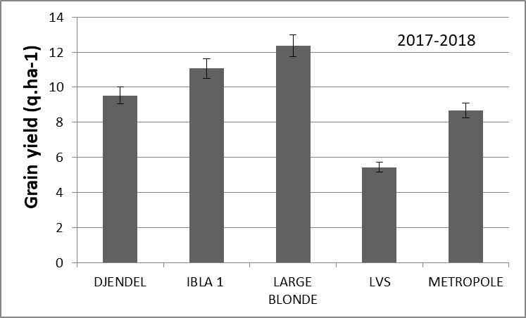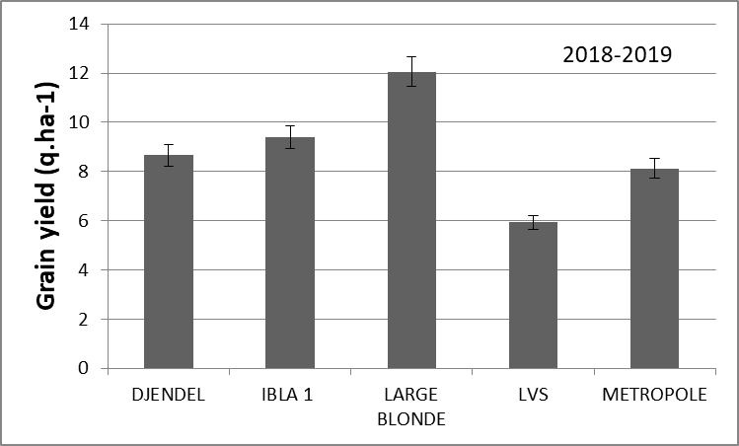
Fig. 1Grain yield (q.ha⁻¹) of five genotypes of lens culinaris grown under P-deficient conditions during two growing seasons 2018 and 2019. Data are corresponding to mean values ± standard error of three replicates harvested at physiological maturity stage.
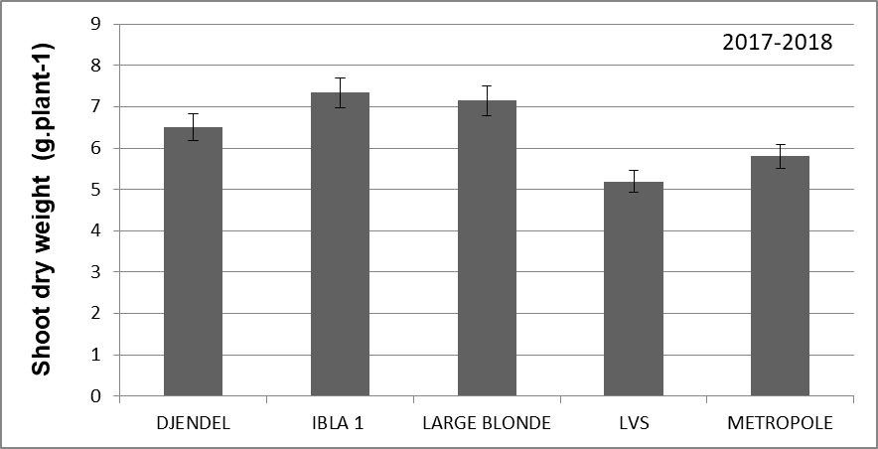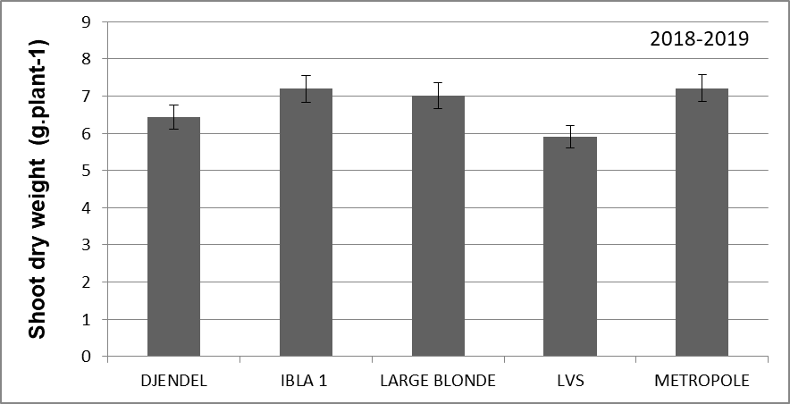
Fig.2 Shoot dry weight of five genotypes oflens culinarisgrown under P-deficient conditions during two growing seasons 2018 and 2019. Data are corresponding to mean values ± standard error as calculated with 9 plants.

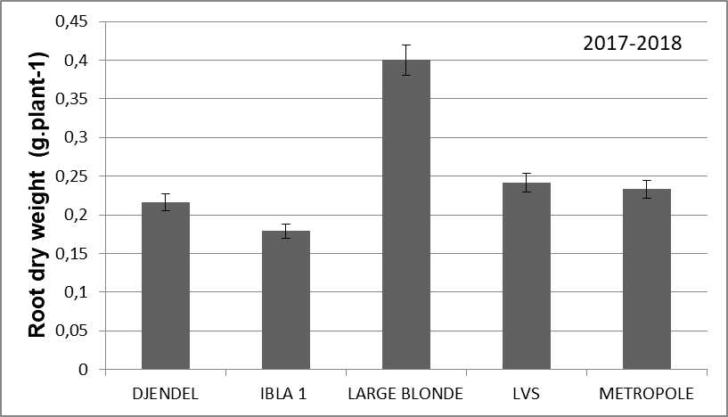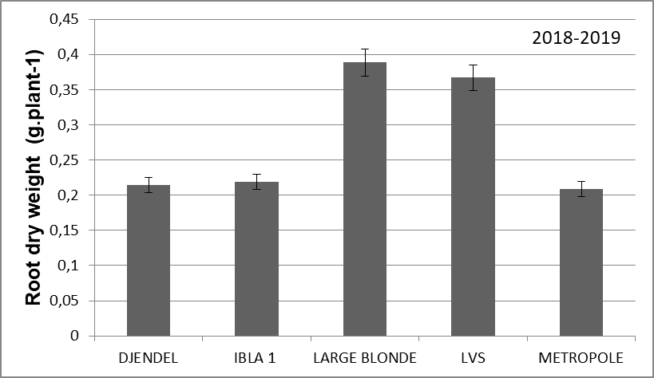

Fig.3 Root dry weight of five genotypes of lens culinaris grown under P-deficient conditions during two growing seasons 2018 and 2019. Data are corresponding to mean values ± standard error as calculated with 9 plants.

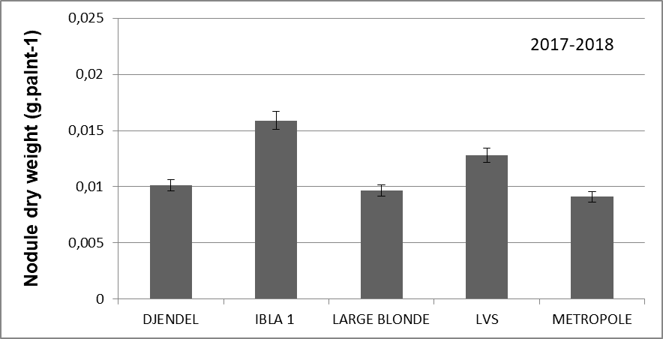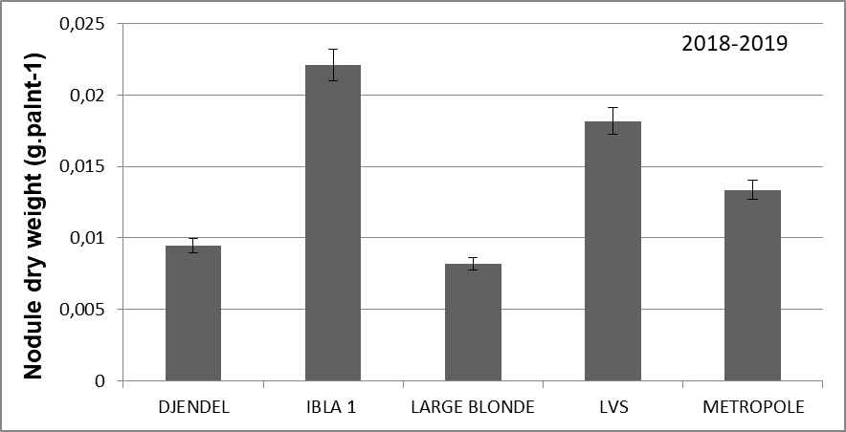
Fig.4 Nodule dry weight of five genotypes of lens culinaris grown under P-deficient conditions during two growing seasons 2018 and 2019. Data are corresponding to mean values ± standard error as calculated with 9 plants.

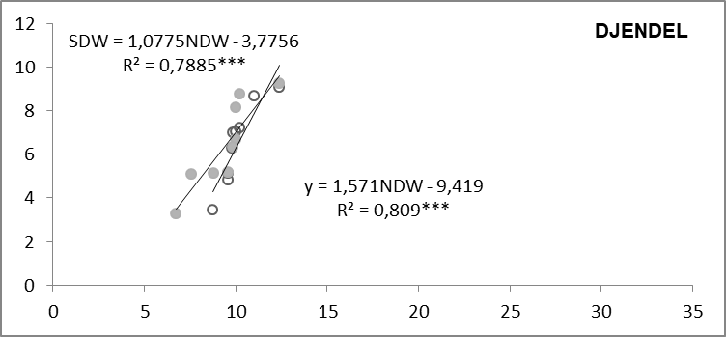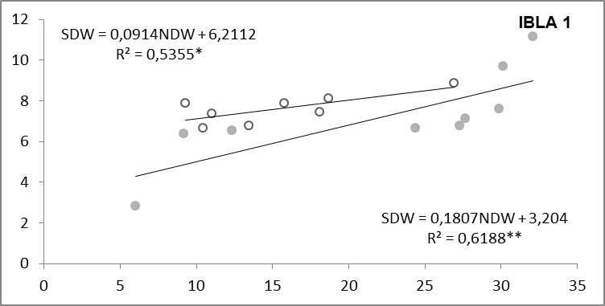
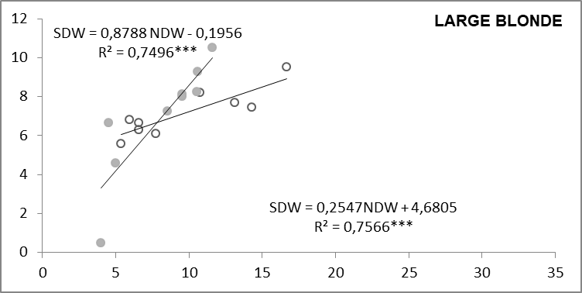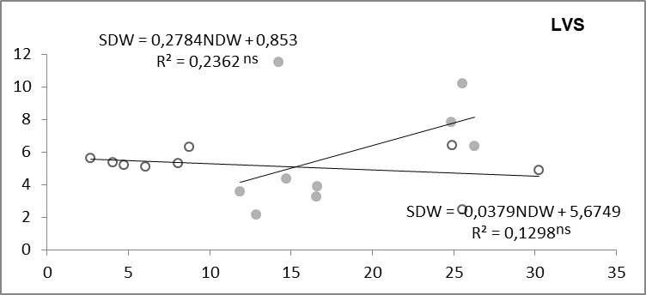
Shoot dry weight (g.plant⁻¹)

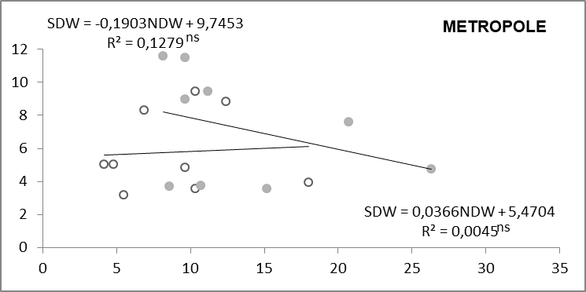
Nodule dry weight (g.plant⁻¹)
.palnt⁻¹)

Fig. 5 Linear relationships between nodule dry weight (NDW) and shoot dry weight (SDW) found using 9 plants harvested 100 d after sowing in 2017-2018 (open symbols) and 2018-2019 (closed symbols). ** and *** denote p< 0.01 and p< 0.001, respectively.

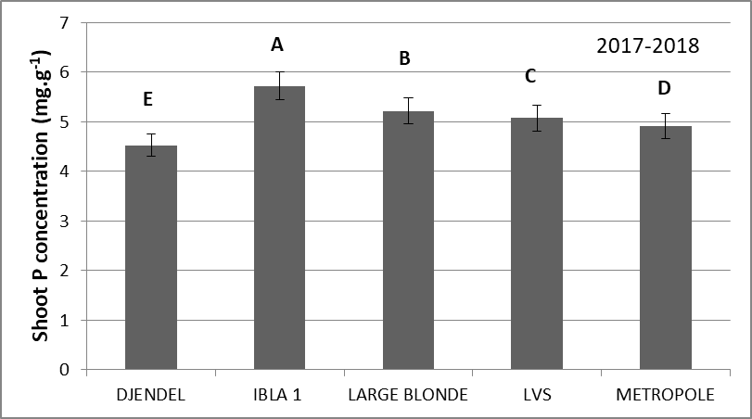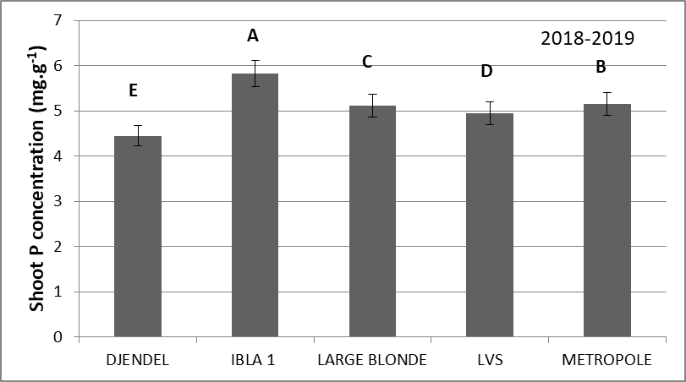
(a)
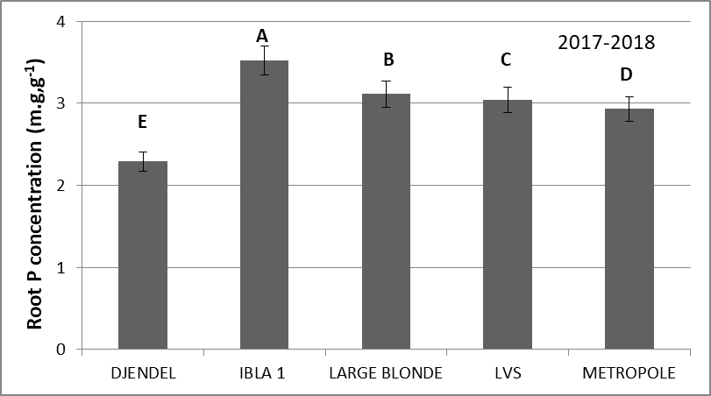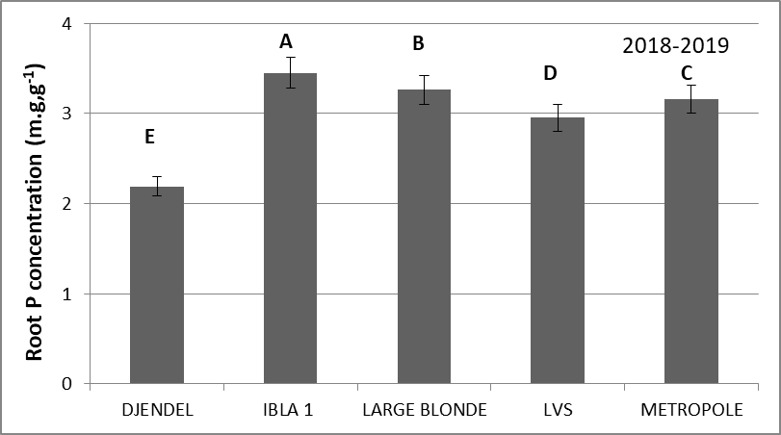
(b)
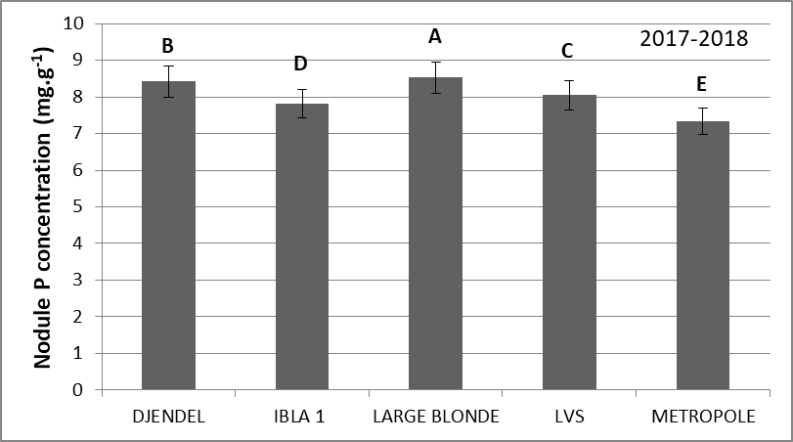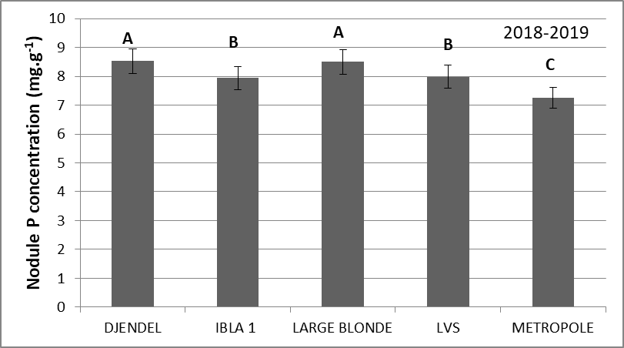
(c)
Fig. 6 Shoot P concentration (a), Root P concentration (b) and nodule P concentration (c) of five genotypes of lens culinaris grown under P-deficient conditions during two growing seasons 2018 and 2019. Data are corresponding to mean values ± standard error as calculated with 03plants sampled 100±3 d after sowing. Letters show significant differences between genotypes (p< 0.05).

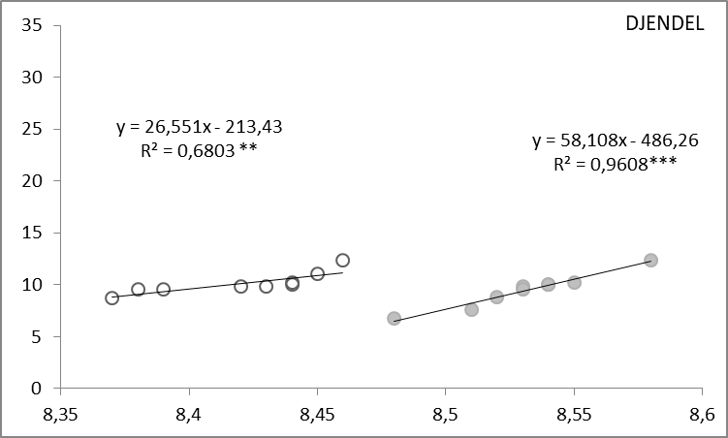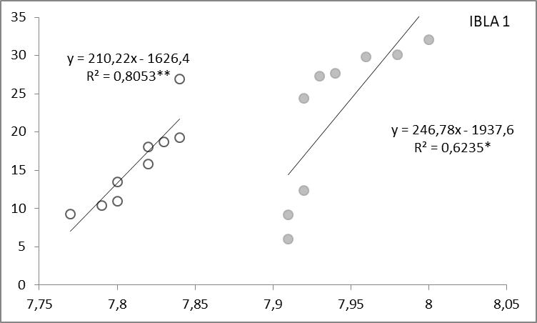
Nodule dry weight (g.plant⁻¹)
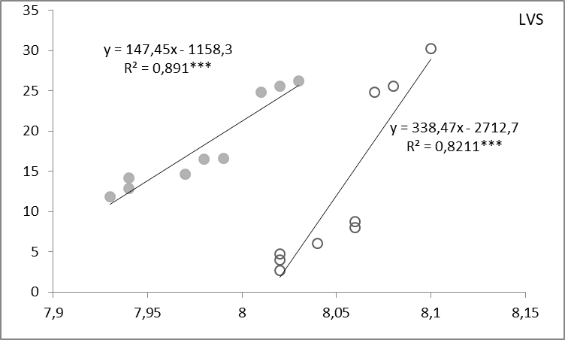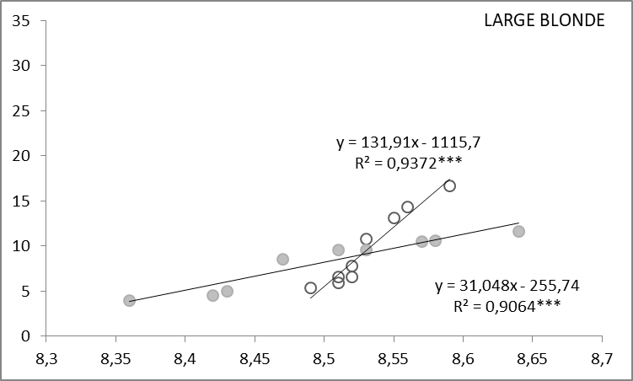
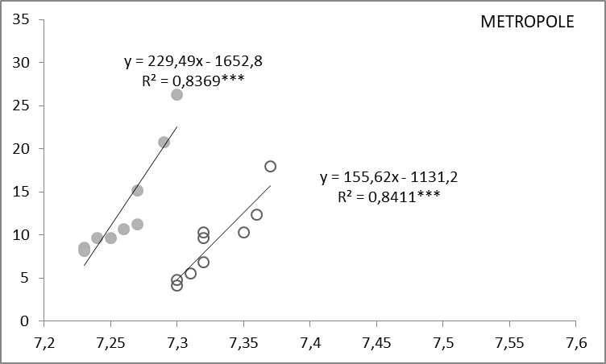
Nodule P content (mg.g⁻¹ DW)
Fig. 7 Relationship between nodule biomass and P content of five genotypes of lentil sowing in 2017-2018 (open symbols) and 2018-2019 (closed symbols), grown under low-soil P availability. Data are means of nine replicates per genotype, harvested at flowering stage. *, **, *** indicate that the differences between means were significant at P < 0.05; P < 0.01 and P < 0.001, respectively.

