**Evolution and distribution of mosaic disease caused by *Cowpea aphid born mosaic virus* (CABMV) on Bambara groundnut (*Vigna subterranea* (L.) Verdc.) in Burkina Faso**

**Zongo Aboubié Elisabeth1**\***; Ouattara Alassane2 ; Neya Bawomon Fidèle3; Koala Moustapha1,4; Néya Bouma James1 ; Traore Oumar1,4**

*1Laboratoire de Virologie et de Biotechnologie Végétales, Institut de l’Environnement et de Recherches Agricoles (INERA), 01 BP 476 Ouagadougou, Burkina Faso ;*

*2Laboratoire Biosciences, Université Joseph KI-Zerbo, Ouagadougou, 03BP 7021, Ouagadougou 03 Burkina Faso ;*

*3Centre Universitaire de Gaoua, Université Nazi BONI, Bobo Dioulasso, 01BP1091, Bobo-Dioulasso 01, Burkina Faso ;*

*4 Laboratoire Nationale de Biosécurité (LNB), 06BP 10798 Ouagadougou, Burkina Faso.*

*\**For correspondence: [zongoelisabeth29@gmail.com](mailto:zongoelisabeth29@gmail.com)

**Abstract**

Bambara groundnut is an important legume with great nutritional and economic potential. However, its production is limited by several constraints, including viral diseases. Among these diseases, mosaic disease caused by *Cowpea aphid born mosaic virus* (CABMV) is the most dominant and frequent on Bambara groundnut. The aim of this study was to investigate the evolution of the disease caused by CABMV in a real environment to develop effective and sustainable control strategies. Sampling was carried out in farmers’ fields in the localities of Dapelgo and Kamboinsé from central region of Burkina Faso. Symptomatic and asymptomatic samples were collected from Bambara groundnut and neighbouring crops, followed by periodic observations of the health of Bambara groundnut plants in the field. Serological and molecular diagnostic tests revealed the presence of CABMV in the samples collected. The spread of the disease varied according to locality and evaluation period. The results showed a variation in the average number of diseased seedlings from 0.5 to 11.94 respectively at 15 days after sowing (DAS) and 55DAS. Disease incidence was more severe in the Dapelgo locality with an average infection rate of 8.97% versus 5.25% in Kamboinsé. Plants aged between 15 and 45 Days were the most favorable for viral infection. Neighbouring crops were identified as CABMV reservoir hosts. This work constitutes the first on the epidemiology of CABMV on Bambara groundnut which is essential for the development of a virus management strategy to limit damage in the event of an epidemic.

**Keywords**: Bambara groundnut; *Cowpea aphid born mosaic virus;* Incidence; Distribution.

**Introduction**

Bambara groundnut (*Vigna subterranean*) is one of the main legumes cultivated in West Africa, with 162,361.34 tons harvested from 222,296 ha in 2021. This production represented around 67.76 % of the world production (FAOstat, 2023). For the same year, Burkina Faso was the largest Bambara groundnut producer with 65,965.95 tons harvested from 60673 ha followed by Zambia and Niger with 6316.89 and 52211.04 tons harvested from 25632 and 89104 ha, respectively (FAOstat, 2023). Bambara groundnut is mainly grown for its seeds, which are sources of nutrients such as proteins, carbohydrates and starch.

Despite this economic and nutritional importance, the crop is subject to numerous biotic stresses, in particular viral diseases, which cause up to 85% of the losses (Zongo *et al*., 2018). Six (6) main viruses were identified as causes of some diseases on Bambara groundnut in Burkina Faso. Those are *Cowpea aphid-born mosaic virus* (CABMV), *Blackeye common mosaic virus* (BlCMV), *Peanut mottle virus* (PeMV), *Cowpea mottle virus* (CPMoV) and two new species, *Bambara groundnut potyvirus* 1 (BGPV1) and *Bambara groundnut potyvirus 2* (BGPV2) (Konate *et al.*, 2017; Zongo *et al*., 2019).

Mosaic disease caused by *Cowpea aphid-borne mosaic* (CABMV) is a major threat to this crop among other diseases (Zongo *et al.,* 2019). CABMV is identified naturally on Bambara groundnut and is the most prevalent in Burkina Faso. The disease is characterized by a mosaic with deformation of the leaves and stunting of the plants. CABMV is transmitted by the aphids, *Aphis craccivora* and *Aphis gossypii,* with transmission rates varying between 64% and 71% (Bashir and Hampton, 1994). This virus could have major economic consequences if preventive measures are not adopted by farmers. Few data on the epidemiological aspects of CABMV are available on Bambara groundnut. Knowledge of these parameters is essential for developing a control strategy to prevent epidemics. The study will therefore assess the spread and distribution of CABMV in farmers' fields.

**Material and methods**

**Sites, survey and sampling**

Surveys of Bambara groundnut fields were carried out in two localities of Burkina Faso: Kamboinsé (Central region near Ouagadougou; latitude: 12° 27’44” N, longitude: 1° 33’17” W) and Dapelgo (Central region near Ouagadougou; latitude: 12°40’18 N, longitude: 1°32’22 W). Two farmers' fields were selected per locality on the basis of the prevalence of CABMV in that area to assess the number of emerged and diseased plants. Diseased plants were counted every ten days from 15 days after sowing (DAS) to 55 DAS. Each field was divided into four blocks to facilitate counting the total number of emerged and diseased plants. Disease severity was assessed on Bambara groundnut leaves showing the disease symptoms based on the rating scale of Gumedzoe *et al.,* (1990) ranging from 1 (no symptom) to 5 (severe symptom).

To study the factors of propagation and the evolution of CABMV on Bambara groundnut, symptomatic and asymptomatic cultivated plants belonging to the legume family were also collected (table 1).

All collected samples were packed in plastic bags, kept on ice and sent to the laboratory for identification tests described below.

**Table I**: List of cultivated plant species belonged to *Fabaceae* family collected around the Bambara groundnut fields in Kamboinse an Dapelgo in Burkina Faso

|  |  |  |  |
| --- | --- | --- | --- |
| **Locality** | **Especes** | **Varieties** | **number** |
| Dapelgo | *Vigna unguiculata* | KVX 61 | 06 |
| *Vigna unguiculata* | Komcalé | 05 |
| *Sesamum indicum* | - | 13 |
|  | *Arachis hypogaea* | - | 07 |
|  |  |  |  |
| Kamboinsé | *Vigna unguiculata* | Komcalé | 08 |
| *Vigna unguiculata* | Tiligré | 04 |
| *Arachis hypogaea* | - | 05 |

**Double antibody sandwish-Enzyme-Linked Immunosorbent Assay**

Leaf samples collected from Bambara groundnut fields and bordering crops were subjected to double antibody sandwish-Enzyme-Linked Immunosorbent Assay (DAS-ELISA). For this test, polyclonal antibodies were used to detect the presence of CABMV in the samples. A DAS-ELISA kit (AC diagnostic) was used, following the supplier's recommendations. The positive threshold was twice the average of the absorbance of non-infected samples.

**RNA extraction and RT-PCR diagnosis**

Total RNA from all samples was extracted using trizol. Detection of CABMV was carried out in an RT-PCR assay using the specific primer: Poty-GP1-5'CP-F/ CGARAAGGARTTRCAAAGG/ Poty-GP1-5'CP-R CAGCTGCGTCAGAGAAGTG (Zongo et *al.*, 2019). Reverse transcription (RT) and PCR amplification were performed according to the conditions described by Zongo *et al*. (2019). Amplified fragments were checked by electrophoresis on 1% agarose gels containing ethidium bromide and visualized under UV light to check the size of the amplified fragment. Samples with fragment sizes of approximately 600 bp were considered positive for CABMV.

**Fields data analyses**

All statistical analyses were performed using the R v.4.3.1 (R Core Team, 2023) statistical software.

Firstly, incidence of disease was calculated as the percentage of Bambara groundnut plants with symptoms of mosaic each 10 days during the 40 days of monitoring among all of plants from each field in both localities Kamboinse and Dapelgo. Incidences were examined using the chi-square test based on the contingency table containing the collected data $.$ Secondly, the prevalence of disease and that of virus infection were calculated as the percentage of Bambara groundnut plants with symptoms of mosaic and with positive DAS-ELISA and RT-PCR results, respectively, among all surveyed plants from each field from Dapelgo and Kamboinse. The differences between fields were then examined using the chi- square test based on a contingency table containing the collected data.

Thirdly, average disease severities were calculated for each of the four fields based on recorded disease notes of Bambara groundnut plants. Obtained data were compared pairwise among the four fields based on analysis of variance (ANOVA) and mean values were separated by Student–Newman–Keuls (SNK) multiple-range test (α = 0.05).

Fourthly, the disease prevalence and virus infection rate were calculated as the percentage of plants with symptoms of mosaic and with positive DAS-ELISA and RT-PCR results, respectively, among all cultivated plants belonging to the legume family collected around Bambara groundnut fields. The differences between plants species were then examined using the chi- square test based on a contingency table containing the collected data.

**Results**

**Description of symptoms observed from Dapelgo and Kamboinse**

In the fields surveyed, mosaic leaf and deformation symptoms were observed from Bambara groundnut in the both localities with different levels of severity (Figure 1).

The distinct symptoms on the leaves made it possible to classify the infection levels of the plants according to the Gumedzoe *et al*. (1990) (Figure 2). Average severity scores of 3.5 and 3.9 were recorded in Dapelgo in fields 1 and 2, while they were 3.44 and 3.38 in kamboinsé fields 1 and 2, respectively. The highest severity indices were recorded in Dapelgo. Very severe symptoms were observed at 55 days after showing (DAS). However, no variation in symptom severity indices was observed in the other plots at 55 DAS.

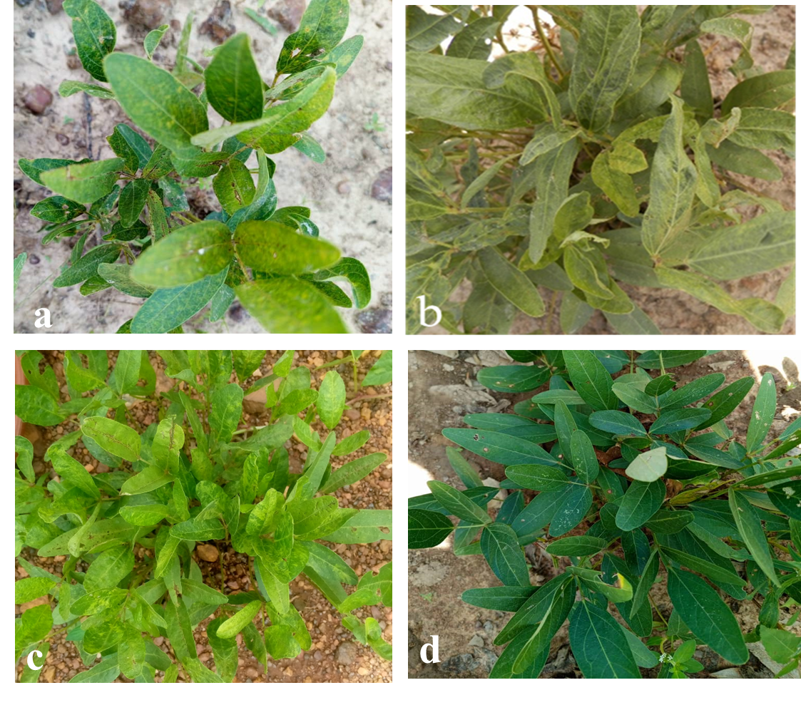

**Figure 1**: Viral symptoms on Bambara groundnut (Vigna subterranea) plants observed on farms’ fields in Burkina Faso. Mosaic (a,c); leaf deformation (b); asymptomatic (d).



**Figure 2:** Infection levels of Bambara groundnut plants according to the symptom severity scale of Gumedzoe et al. (1990). Each point represents the average for fields. The symptom severity scale (left scale bar) ranges from 1 (no symptoms) to 5 (severe symptom). For each dot, vertical bars represent 95% confidence intervals. Identical letters on top of the bars indicate groups with non-significant differences in disease severity.

**Incidence of Bambara groundnut mosaic leaf disease**

Incidence of Bambara groundnut mosaic leaf disease was assessed in the both localities based on the number of diseased plants. The Bambara groundnut mosaic leaf disease epidemic curves for the four fields show phases that vary in importance from field to field. There is an exponential phase in the infection rate of new plants from 25 to 45 days after infection, followed by a declining phase of variable duration (Figure 3). The speed at which the disease spread through the fields varied considerably. The number of infected plants increased rapidly from 25 DAS onwards, peaking at 45 DAS. Between 35 and 45 days, the Dalpelgo fields recorded higher rates of new infection (3.9% and 3.82% respectively for Field 1 and 2) than the Kamboinsé fields (2.48% for field 1 and 2.2% for field 2). After 45 days, new infection rates dropped to an average of 1.55%. Comparison analysis of disease incidences according to date not showed significant difference between all fields (p ≥ 0.09) except the field 1 and the Field 2 from Dapelgo and Kamboinse which showed significant difference at 55 DAS (p = 0.03).

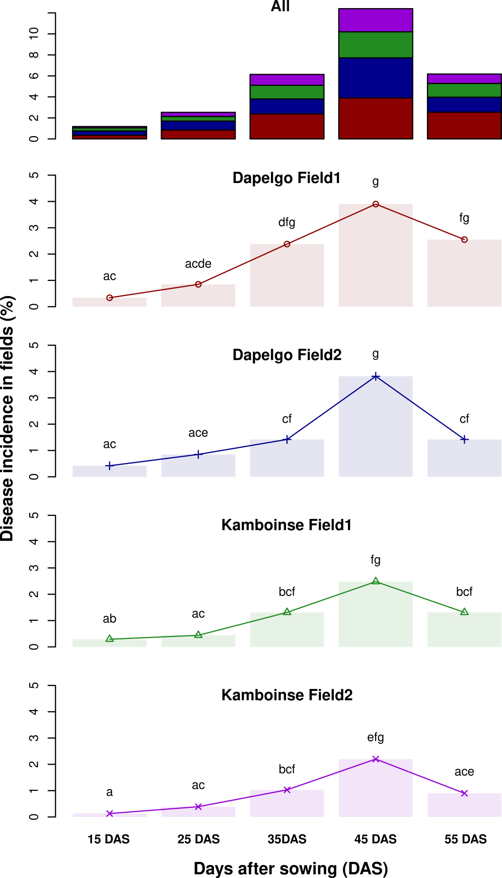

**Figure 3:** Bambara groundnut mosaic leaf disease incidence in farmers’ fields form two localities in Burkina Faso (Dapelogo and Kamboinse).

**Prevalence of Bambara groundnut disease and CABMV identified by DAS-ELISA and RT-PCR.**

The two fields at Dapelgo showed high prevalence with 10 % (59/589 from the field 1) and 7.93% (56/706 in the field 2) at 55 DAS (Table II). However, at the same time, 5.83% (40/686) and 4.65% (36/774) diseased plants were recorded in fields 1 and 2 at Kamboinse, respectively.

The DAS-ELISA diagnosis confirmed the presence of CABMV in some diseased plants from different fields (Table II). In fact, 50 leaf samples showing symptoms of virosis were tested by DAS-ELISA and RT-PCR, confirming CABMV infection in 38 and 48 samples respectively, with a detection rate of 68% and 76%. The tests revealed that, in addition to the CABMV-positive samples, there were other potential potyvirus species or strains that were not detected by the polyclonal antibodies and CABMV-specific primer used, despite the serological relationships that exist between the viruses.

**Table II:** Prevalence of CABMV detected based on DAS-ELISA and RT-PCR from Bambara groundnut collected from Dapelgo and Kamboinse in Burkina Faso

|  |  |  |  |  |
| --- | --- | --- | --- | --- |
|  |  |  | **CABMV prevalence** | |
|  |  | **Disease prevalence** | **DAS-ELISA** | **RT-PCR** |
| **Dapelgo** | Field 1 | 10.02% (59/589) | 71.43% (15/21) | 71.43% (15/21) |
|  | Field 2 | 7.93% (56/706) | 58.62% (17/29) | 72.41% (21/29) |
|  |  |  |  |  |
| **Kamboinse** | Field 1 | 5.83% (40/686) | 59.46% (22/37) | 75.68% (28/37) |
|  | Field 2 | 4.65% (36/774) | 50% (9/18) | 72.22% (13/18) |
| **Total** |  | **6.93% (191/2755)** | **60% (63/105)** | **73.33% (77/105)** |

**CABMV host range**

Serological tests revealed that all samples from neighbouring crops were positive for CABMV. Variable infection rates were recorded according to varietal species. The virus was identified in all cowpea with 69.23% and 100% infection. Infection rates of 61.54% (8/13) and 50% (6/12) were recorded on sesame and peanut respectively. Nevertheless, all neighbouring crops were identified as sources of CABMV propagation.

**Table 3**: Infection rate of CABMV

|  |  |  |
| --- | --- | --- |
| **Species** | **Varieties** | **Infection rate (infected/tested)** |
| *Vigna unguiculata* | Komcalé | 69.23% (9/13) |
| *Vigna unguiculata* | KVX 61 1 | 100% (6/6) |
| *Vigna unguiculata* | Tiligré | 100 (4/4) |
| *Sesamum indicum* | S42 | 61,54% (8/13) |
| *Arachis hypogaea* | - | 50% (6/12) |

**Discussion**

The CABMV is responsible for significant damage to legumes (Néya *et al*., 2015). The disease was present in the Bambara groundnut production fields covered by the present study, namely Kamboinsé and Dapelgo. This result corroborates those of Palanga *et al*. (2016) and Zongo *et al*. (2019) who showed that CABMV was the most prevalent virus on cowpea and Bambara groundnut in the Sudano-Sahelian zone. This guided the choice of sampling sites. The four fields sampled showed variable incidences and symptoms. This observation could be linked to the presence of CABMV viral strains inducing severe symptoms that varied from one field to another. To this end, two strains of CABMV have been identified infecting Bambara groundnut in Burkina Faso by Konate *et al*. (2017); Zongo *et al*. (2019).

Serological (DAS-ELISA) and molecular (RT-PCR) detection confirmed the close relationship between the symptoms observed and the virus. However, the ELISA test was less effective in detecting viruses (60%) than the RT-PCR test (73.33%). In fact, the specific primer of Zongo *et al*. (2019) used in RT-PCR amplifies a highly conserved area of the CABMV capsid protein gene, giving it a high detection efficiency of CABMV in samples even at low concentration. These results may be supported by the work of Sipahioğlu (2005) and Liebenberg et *al*. (2009) , who showed that molecular RT-PCR tests were more effective than ELISA tests. Symptomatic samples that responded negatively to DAS-ELISA and RT-PCR detection tests are either due to the presence of other viral infections other than CABMV, to the presence of viral strains whose antibodies and primers were not used in this study or to the fact that the symptoms observed were not of viral origin.

The progression of the disease caused by CABMV differed between the study field. Although both sites were in the same agro-ecological zone and with the same plant material, they did not have the same level of infection.

The appearance and spread of the disease in the fields could also be linked to a number of factors. Symptoms observed at 15 days after sowing may be seed-borne, as the seeds used by growers are generally from previous harvests. It was reported on cowpea by Néya (2011) that CABMV was also seed-transmitted at a rate of 5%. Although a similar study has not been carried out on Bambara groundnut, the possibility that CABMV was transmitted by seed in certain fields cannot be ruled out.

Furthermore, the increase in infection rates up to 45 days after planting (3.9% and 3.38% in Dapelgo and Kamboinsé fields) may be the result of mechanical contamination due to the shared use of farming tools and the abundance of insect vectors. It may also be associated with the phenological stage of seedlings (young seedlings) favorable to contamination (Aka *et al.,*2009) .

The spread of the disease can cause severe damage to Bambara groundnut fields and considerably reduce yields. During the study, the spread of the disease was illustrated by multi-phase progression curves. As the disease is polycyclic, during different infection cycles, plants infected during a previous cycle serve as sources of inoculum for the following cycle (Zadoks and Schein, 1979).

Phases of decline, characterized by new infections after 45 days (1.55), may be explained by a strengthening of resistance mechanisms or factors linked to the age of the plant. Nevertheless, the progression of the disease in all fields seems to be linked to the lack of treatment against insects. During the course of the study, the presence of aphids was noted on both sites. Néya (2011) has shown that high populations of aphid vectors of CABMV are a factor of dissemination and are often responsible for high incidences of the disease, for which the absence of insecticide treatments results in high parasite pressure.

Observations in the fields based on symptoms revealed a low incidence of CABMV in the Kamboinsé fields. These differences also seem to be linked to several factors, including inoculum sources and human activities in the fields. Variations in environmental factors such as wind and rain could also be responsible for the spread of CABMV in the fields (Colhoun, 1979). Crops adjacent to Bambara groundnut fields have been identified as alternative hosts for CABMV and may serve as a source of inoculum. In fact, peanut, cowpea, soybean and sesame fields in the Dapelgo locality were identified as being very close to Bambara groundnut fields. However, Bashir *et al.* (2002); Néya (2011) and González *et al*. (2013) reported that CABMV infects several species from different families, including *Amaranthaceae, Chenopodiaceae, Cucurbitaceae* and *Solanaceae*. This could also explain the strong spread of the disease in this locality. These hosts can harbour the virus, enabling it to be spread by insect vectors and other agro-climatic factors. It would therefore be necessary to keep the fields of these crops at a distance from the Bambara groundnut fields in order to avoid major epidemics. All these host species could play an important role in the maintenance and epidemiology of the virus. During the growing season, *Arachis hypogaea* and *Vigna unguiculata* could act as relay or vehicle plants for the disease. This is of particular concern, given that Bambara groundnut and these species are generally grown in association or in rotation, which could cause severe yield losses. (Zongo *et al.,* 2022) recorded yield losses of 80% on Bambara groundnut in Burkina Faso. Nevertheless, the same authors identified CABMV-tolerant Bambara groundnut genotypes. It would therefore be judicious to integrate them into varietal improvement programs in order to help reduce the spread of the disease in farmers' fields. Although wild species were not tested in this study, they could harbour the virus during the dry season. As such, they may play an important role as a source of inoculum for the spread of the virus in Bambara groundnut crops during the wet season. Virus control measures should therefore take all these plant species into account.

**Conclusion**

This study provided an overview of the spread of mosaic disease caused by CABMV on Bambara groundnut in growers' fields in Burkina Faso. The results showed a variation in the spread of the disease over time and space. The rate of spread is rapid when the plants are young (15 to 45 days old). Nearby crops, notably cowpeas, peanuts and sesame, are sources of CABMV spread. It would therefore be necessary to keep the fields of these crops at a distance from the Bambara groundnut fields in order to avoid major epidemics. The adoption of integrated management will help to combat the viruses more effectively.

**Acknowledgements**

The authors thank the Laboratoire Mixte International Patho Bios, Burkina Faso, for providing the technical platform. The author would like to thank the International Foundation for Science (IFS) for the financial support through the grant n° C/5884-1 awarded to A.E. Zongo.

**Author Contribution**

ZAE carried out tests, collected data; ZAE, AO analysed the data; ZAE, AO, NBF, KM and NBJ wrote and corrected the manuscript; OT supervised all the work.

**Conflict of Interest**

All authors declare no conflict of interest

**Data Availability**

Data presented in this study will be available on a fair request to the corresponding author

**Ethics Approval**

Not applicable to this paper

**References**

Aka AR, NK Koussi, TA Agnéroh, NA Amancho, A Sangaré (2009). Distribution et incidence de la mosaïque du concombre (CMV) dans des bananeraies industrielles au Sud-Est de la Côte d’Ivoire. *Sciences & Nature* 6:171–183.

Bashir M, RO Hampton (1994). Seed and aphid transmission of some isolates of blackeye cowpea mosaic and cowpea aphid-borne mosaic potyviruses. *Pakistan Journal of Phytopaphology* 6:140-146.

Bashir M, Z Ahmad, A Ghafoor (2002). Cowpea aphid-borne mosaic potyvirus: A review. *International Journal of Pest Management48*:155–168.

Colhoun J (1979). Predisposition by the environment. in: Horsfall JG, Cowling EB (eds). Plant disease, an advanced treatise, how pathogens induce diseases. New York. *Academic Press,* *4*:75-96

FAOstat (2023). Crop production*. Fao,* [*http://www.fao.org/faostat/en/#data/QC*](http://www.fao.org/faostat/en/#data/QC)*.*

González SLR, AE Fariña, DD González, APOA Mello, JAM Rezende, EW Kitajima (2013). Alternative hosts of *Cowpea aphid-borne mosaic virus (CABMV*) in sesame (*Sesamum indicum*) crops grown in Paraguay. *Tropical Plant Pathology*, 38: 539-542.

Gumedzoe MY, DY Sunu, G Thottappilly, A Asselin (1990). Importance du virus de la marbrure de niébé et du virus de la mosaïque jaune du niébé au Togo. *Phytoprotection*, 71: 85–91.

Konate MN, M Ouedraogo, BJ Neya, M Bangratz, E Palanga, H Nandkangre, A Ouoba, R Nanema, N Sawadogo, M Sawadogo (2017). Molecular characterization of virus isolates from genus Potyvirus infecting *Vigna subterranea* in Burkina Faso. *African Journal of Biotechnology,*16:1953–1961.

Liebenberg A, MJ Freeborough, CJ Visser, DU Bellstedt, JT Burger (2009). Genetic variability within the coat protein gene of Grapevine fanleaf virus isolates from South Africa and the evaluation of RT-PCR, DAS-ELISA and Immuno Strips as virus diagnostic assays. *Virus Res* 142 : 28-35.

Néya BJ (2011). Sérologie, Pathogénie, Epidémiologie et contrôle de la mosaïque*, Cowpea Aphid- Borne Mosaic Virus (*CABM) du niébé *(Vigna unguiculata (*L.) WALP.) Transmise par les pucerons *(Aphis craccivora, A. gossypii)* au Burkina Faso, 218 p. Thèse unique. Université de Ouagadougou, Burkina Faso.

Néya BJ, PE Zida, D Sérémé, OS Lund, O Traoré (2015). Evaluation of yield losses caused by *cowpea aphid-borne mosaic virus* (CABMV) in 21 cowpea (*Vigna unguiculata* (L.) Walp.) Varieties in Burkina Faso. *Pakistan Journal of Biological Sciences*, 18: 304–313.

Palanga E, DE Filloux , PM Darren, E Fernandez, D Gargani, F Romain, J.Zabré, Z Bouda, JB Neya, M Sawadogo, O Traore, M Peterschmitt, P Roumagnac (2016). Metagenomic-based screening and molecular characterization of cowpea-infecting viruses in Burkina Faso. *PLoS ONE*11: 1–21.

Sipahioğlu HM (2005). Comparison of DAS-ELISA and RT-PCR Methods for the Detection of Prunus Necrotic Ringspot Virus (PNRSV). Sci. *J. Agric.*, *15*: 153-158.

Zadoks JC, RD Schein (1979). Epidemiology and plant disease management, 427p. Oxford University Press, New York.

Zongo AE, BJ Néya, E Palanga, D Sérémé, M Koala, R Dimitri, S Longué, J Zabré, Z Bouda, N Barro, O Traoré (2019). Molecular Characterization of a Large Diversity of Bambara Groundnut Potyviruses *(Vigna subterranea* (L.) Verdc.*)* in Burkina Faso. *Advances in Bioscience and Biotechnology*, 10: 270–281.

Zongo E, BJ Néya, VSE Traoré, E Palanga, J Zabré, N Barro, O Traoré (2018). Impact of Cowpea mottle virus on the Growth and Yield of Bambara Groundnut (*Vigna subterranean* (L.) Verdc.). *American Journal of Plant Sciences*, 09:2053–2062.

Zongo AE., M Koala, BJ Neya, VSE Traore, PE Zida, A Ouoba, BarroN, O Traore (2022). Evaluation des accessions de voandzou pour la résistance au virus de la mosaïque du niébé (CABMV) au Burkina Faso. Evaluation of Bambara groundnut accessions for resistance toCowpea mosaic virus (CABMV*)* in Burkina Faso*. Sciences Naturelles et Appliquées* 41 : 33-47.