Development and Characterization of Efficient K-Solubilizing Rhizobacteria and Rhizobial Inoculants for Chickpea

Ali Raza Siddiqui¹, Sher Muhammad Shahzad^{1*}, Muhammad Ashraf², Rizwana Kausar³, Tahira Yasmeen⁴ and Shafaqat Ali^{4*}

¹Department of Soil and Environmental Sciences, College of Agriculture, University of Sargodha, Sargodha, Punjab, Pakistan
²Department of Soil Science, Faculty of Agricultural Sciences and Technology, Bahauddin Zakariya University, Multan, Punjab, Pakistan
³Soil and Water Testing Laboratory for Research, Sargodha, Punjab, Pakistan
⁴Department of Environmental Sciences and Engineering, GC, University Faisalabad, Punjab, Pakistan
*Corresponding author’s e-mail: smshahzad_pk@yahoo.com; shafaqataligill@yahoo.com

Running Title: Development and characterization of K-solubilizing bacteria for chickpea

Abstract
Use of mineral fertilizers have long been associated to improve growth of crop plants as well as increase their yield potential per unit area. However, incessant practice of imbalanced fertilizers application has mounted the economic and environmental costs for agricultural sector. The deficiency of potassium (K) has been identified as primary crop production challenge in certain semi-arid regions where soil-K reserves are increasingly being depleted. This study was aimed to isolate and characterize K-solubilizing bacterial and isolates from chickpea rhizosphere and root nodules. Initially, fifty isolates were isolated by serially-dilution method using Aleksandrov’s medium. Furthermore, 25 isolates were screened-out following a rigorous qualitative screening based on different physiological, morphological and biochemical tests. Among these, five isolates, each of rhizosphere and nodule origin were further screened and selected based on qualitative as well quantitative determination of various growth promoting traits. Besides efficient potassium and phosphate solubilization, selected isolates displayed better growth conditions as evident by glucose substrate use at 25°C and pH 7. In this study, we found that isolates, SKB3 (rhizosphere) and JKR7 (rhizobia), were recorded as the most efficient K-solubilizer. Additionally, they possessed diverse plant growth promoting traits like root colonization, synthesis of siderophores, exopolysaccharides, chitinase activity, indole-acetic acid production and 1-aminocyclopropane-1-carboxylic acid deaminase activity. Overall, our results suggested that application of bacterial K-solubilizer could be employed as a useful K-supplement in K-limited agroecosystems. Moreover, use of these K-inoculants may lead in alleviating the negative impact associated with chemical fertilizer use for environment.

Key words: Bacterial co-inoculants, K-solubilizing activity, screening, characterization, legumes

Introduction

Pakistan is the second largest chickpea producer in the world. In 2017-2018, chickpea production increased by 3% due to increase in cultivated area and favorable weather conditions prevalent at the time of sowing (GOP 2018). The high nutritional value of chickpea and its financial significance, the production of chickpea in Pakistan is very low, at 583 kilograms per hectare (Hassan and Khan 2007). Many factors are responsible for poor performance but among them, the use of traditional or low-yielding varieties and poor adaptation of management practices are of utmost importance (Ahmed et al. 2013).
Biological nitrogen fixation (BNF) has a number of benefits compared to N fertilizers such as; a) higher N use efficiency, b) minimize N leaching, and c) contamination in soil and water body (Graham and Vance 2000). While, the amount of N fixed by a legume varies depending on the crop type, soil and growth stage of the crop, as well as management practices (Chianu et al. 2011). Crop yield is limited due to availability of nutrients especially phosphorus (P). Therefore, the studies on the response of legumes and rhizobia to P fertilization have received substantial attention (Sheng et al. 2008). While to a lesser extent, research has focused on the response of legume-rhizobia to K, which is also scarce in many Pakistani soils.
Potassium is the fourth most abundant nutrient of the earth’s lithosphere and its concentration is varied in soil ranging 0.04 to 3.0 percent (Bhatti 2011). It plays a vital role in the production of amino acids and protein from NH₄⁺ ions, which are absorbed by plant roots from the soil. In addition, K also participates to better root growth, and has been proved to increase the size and number of nodules in legumes. The use of K in soil can promote both numbers and size of nodules in legumes (Sheng et al. 2008). It means that higher K allocation in nodule is very essential to sustain BNF potential, as K deficiency can inhibit or reduce nitrogenase activity, thus disrupt the symbiotic potential of the plant (Hafsi et al. 2014). As a result, legumes that gain N through BNF, generally have a higher need for K than those that only release N and P from the soil. As the total quantity of N fixed by bacteria increases, so does their need for energy sources to reduce or change N in to NH₄⁺ ions. The imperative role of K in photosynthetic activity that makes it an important benefactor to efficient N₂ fixation by leguminous crop plants (Pettigrew 2008). The process of N fixation is influenced by K for very distinctive reasons and depends on it. Moreover, K is the predominant cation in the plant body as like to calcium in the soil (Pettigrew 2008). While in Pakistan, current evaluation of the level of soil K in Punjab have revealed an average decrease in soil K up to 3 mg kg⁻¹ per year. This means a reduction of about 60 mg kg⁻¹ K in Punjab soils over the past two decades, and as a result, soil K levels that were once considered adequate for plant growth are now approaching the deficiency threshold level (Sheng et al. 2008; Mian et al. 2010). Furthermore, the plant growth prompting rhizobacteria have been reported to be the key elements for better plant growth under nutrients deficient conditions. While, their application in the sector of agriculture can be in the favor of reduction of agro-chemicals use and give help to eco-friendly crop production (Arif et al. 2017). While, plant up takes K from soil and its availability from soil depends on the dynamics of the K, as well as the total K content in soil (Ahmed et al. 2013).
But the second form of non-exchangeable K about 10 percent of K in the soil is primarily the intermediate layer of K such as lattice and elite in K feldspar (Archana 2008). Moreover, the release of non-exchangeable K to the exchangeable form takes place when the concentration of exchangeable K and in solution reduced by plant uptake, erosion, leaching, and/ or runoff (Parmar and Sindhu 2013). Multifarious microbes in soil are capable of solubilizing unavailable forms of K containing minerals, like micas, illite and orthoclases by excreting organic acids that directly dissolve the K rock or bounded silicon ions to change the K in soil solution. While, silicate bacteria were also observed to dissolve Si, K, and Al from insolvable minerals (Aleksandrov et al. 1967). Most of the K in soil is believed to exist as silicate minerals. Potassium becomes available to crop plants when silicate minerals slowly disintegrated in smaller fragments or dissolved (Bertsch et al. 1985). It has been reported that a wide range of soil bacteria release K in to available form from minerals containing K in soils (Liu et al. 2019). Application of K solubilizing co-inoculants could be more efficient due to their manifold effects on plant health by many growth promoting mechanisms (Singh et al. 2010). In addition, the benefits of co-inoculation can be enhanced by retaining high population of effective K solubilizing bacteria in the rhizosphere soil. Application of root associated bacteria having K-solubilizing activity could be helpful to reduce the effects of biotic and abiotic stresses on plant health throughout its life cycle (Hafsi et al. 2014). Therefore, the integrated use of PGPR and rhizobia could be very effective for improving nodulation and yield of chickpea. It restores the prerequisite to focus on a balanced K fertilization strategy to promote the efficacy of legume symbiosis under nutrient deficient conditions. The successful identification of an elite microbial strain capable of solubilizing K that can conserve present resources and reduce the risks of environmental contamination caused by the intensive application chemical fertilizers.
Therefore, in the light of above discussion, this study was planned with the following objectives; a) Isolation, screening, and selection of the most efficient rhizobacteria and rhizobial strains having K solubilizing activity on qualitative as well as quantitative basis, b) Optimization of growth conditions for selected bacterial strains to solubilize K from WM, and c) Characterization of the most effective bacterial strains having K-solubilization activity

Materials and Methods

A series of laboratory studies were carried out for isolation, purification and characterization of K solubilizing rhizobacteria (KSR) and rhizobial isolates from rhizosphereic soil and root nodule samples of chickpea (Cicer arietinum L.), respectively in the Department of Soil and Environmental Sciences, CA, University of Sargodha, Sargodha, Pakistan, and SWSD, IFAS, University of Florida, USA.

Collection of soil and plant samples
Soil, and plant (chickpea) samples were collected from different sites (irrigated and rainfed) of Punjab [Sargodha (32.0740° N, 72.6861° E), Noorpur Thal (31.8449° N, 71.8571° E), Jhang (31.2781° N, 72.3317° E)]. The chickpea plants were uprooted along with adjacent soil adherent to the plant roots. The uprooted chickpea plants were packaged in polythene bags and brought to the laboratory for isolation, and purification of rhizobia and rhizobacterial isolates having trait of K solubilization.

Isolation of potassium solubilizing rhizobacteria
For this, K-solubilizing bacteria from soil samples were isolated using dilution plate technique on Aleksandrov’s medium (Hu et al. 2006). For this, 10 g of rhizosphere soil from every sample was weighed and mixed with 95 mL sterile solution of NaCl (0.85 percent) in a 250 mL conical flasks. Flasks were shaken energetically for 10 minutes to form uniform suspensions of soil. The soil suspensions were then incubated under agitation for 45 minutes followed by filtration through sterile filter paper. Using 1.0 mL of filtered supernatant of soil suspension, samples were consecutively diluted up to 10⁻⁶ and 0.1 mL of aliquot from each of the dilution was shifted, and equally straighten out on Aleksandrov’s agar medium (Aleksandrov 1967). After this, media plates were incubated for 72 hours at 28 ± 2ºC. Morphologically well grown and prominent colonies (color, shape, size, and growth rate) were selected and purified by additional streaking on freshly prepared Aleksandrov’s agar medium using a four way streak plate technique. The diameter of the halo zone was measured and articulated in millimeters, and for further studies the pure cultures on agar slants were stored in the refrigerator at -40 ºC.

Isolation of potassium solubilizing rhizobia
Rhizobial isolates from nodules of chickpea were isolated using standard protocol. For this, healthy plant of chickpea (45-60 days old) were selected from field and then uprooted, and shifted to the lab using polythene bags. Bulk soil from roots of chickpea was detached by mild agitation and then the soil firmly adhering (rhizosphere soil) to the roots was removed. For isolation of rhizobia, the roots of chickpea plants were washed gently by tap water, and then nodules were detached from roots with the help of scissor. The collected nodules were surface disinfected for a moment (<10s) by immersing in 95 percent solution of ethanol, followed by immersing in 0.2 percent mercuric chloride solution for three minutes (Russell et al. 1982). Nodules were then washed several times with sterilized water to remove surface disinfectant. To obtain a milky suspension, the surface sterile/or disinfected nodules were crushed with a glass rod in sterile 5 mL water. A loop of milky suspension was striped on the Yeast Extract Mannitol (YEM) agar medium plates (Holt et al. 1994), and then incubated for 72 hours at 28 ± 2ºC. The isolated single colonies of rhizobial isolates were selected and picked with streaking needle and then restreaked on freshly prepared YEM agar medium plates. This process was repeated 3 to 4 times on freshly prepared YEM agar plates to obtain a pure cultures. In this way, 50 rhizobial isolates were isolated and designated with sampling sites. These isolates were stored in glycerol (20%) at -40 °C for further use.

Screening of potassium solubilizing rhizobacteria and rhizobial isolates
Potassium solubilizing ability of both bacterial isolates was tested on qualitative and quantitative basis from insoluble K bearing minerals.

Qualitative assessment of potassium released from insoluble K bearing mineral
For qualitative estimation of K, purified bacterial strains were initially selected for screening of K-solubilization on the basis of halo zone formation on agar medium having modified Aleksandrov’s medium via spot test method (Sindhu et al. 1999). Bacterial isolates showing the zone of solubilization in Aleksandrov’s agar medium were further tested to evaluate their potential to release K from the broth medium containing 1.0 percent mica mineral. For this purpose, 1.0 mL culture (overnight) of each bacterial isolates was inoculated to Aleksandrov’s broth having volume 25 mL (Aleksandrov 1967). All inoculated flasks were incubated for 3 weeks at 28±2°C. After this, the quantity of K was determined at 7, 14 and 21 days of incubation compared to control. Finally, the available K content was estimated by Flame Photometry method (Sugumaran and Janarthanam 2007).

General characterization of bacterial isolates having trait potassium solubilization
The bacterial isolates were tested for general characterization using the following procedures. These isolates were tested to determine the color, motility, shape, gram reaction, halo tolerance, as well as their ability to produce spores using the method described by Schaad et al. (2001). The selected isolates were tested for their ability to use divergent sources of carbon (C), namely sucrose, glycerol, maltose, and citrate. The sources of C were used at the rate of 2% in agar medium. After this, 24 hours old cultures were streaked on the medium and incubated for 24 hours at 28 ± 2°C. The degree of growth on media comprising various sources of C was generally observed and the growth was noted without growth (-) or growth (+). MR-VP Medium (Glucose phosphate broth) was used to perform Methyl Red test as described by Seeley and Vandemark (1981). While, the pre-sterilized tubes comprising broth test cultures MR-VP were inoculated for Voger-Proskauer test as studied by Seeley and Vandemark (1981). The method of Alariya et al. (2013) was used to detect Amylase activity of isolates. Freshly prepared cultures were streaked on Modified Czapek Mineral salt medium for the detection of the activity of cellulose enzyme (Aneja 2001). Catalase activity of isolates was tested by adding 3% H₂O₂ on developed growth colonies of selected isolates using method of Blazevic and Ederer (1975).
Tribibutyrene agar medium (TAM) was used for lipase activity. Lipolytic activity of selected isolates was verified by halo zone formation around the inoculation line and then inoculated plates were incubated for 72 hours at 25ºC (Anisha et al. 2012). Protease activity of isolates was checked using SMA (Skimmed Milk Agar) media (Smibert et al. 1994). The urease activity in selected isolates were determined as described by James and Sherman (1992). Qualitatively N fixing ability of bacterial cultures was determined using standard procedure as described by (Gothwal et al. 2008). Selected cultures were evaluated for P-solubilizing activity using protocol described by Pikovskaya (1948). Eckford (1927) method was used to test the potential of selected isolates to hydrolyse starch. In order to test for indole production assay, pre-sterilized sulfide-indole motility (SIM) agar tubes were inoculated with selected isolates. After this, SIM agar tubes were incubated for 48 hours at 28±2ºC. After the inoculation, Kovac’s reagent (10 drops) was added into each tube. Cherry Red production was considered positive for indole-production (Cheesborough 2006). While, the gelatin liquefaction of the bacterial cultures were determined as described by Blazevic and Ederer (1975). For hydrogen sulfide production assay was done using sterilized test tubes containing SIM (sulfide, indole, motility) agar medium (Cappuccino and Sherman 1992). Casein hydrolysis was determined by the method of Seeley and Vandemark (1981). The production of HCN (hydrogen cyanide) was estimated using modified King’s B agar medium (Baker et al. 1987)

Quantitative characterization of plant growth promoting traits in selected isolates of bacteria
For this, selected isolates were characterized for various plant growth promoting traits using the following protocols. Gordon and Weber (1951) method was used for estimation of indole-acetic acid (IAA) in selected isolates. The exopolysaccharides production was measured through inoculation of isolates on RCV (Rhodobacter-Capsulatus V) mineral medium after enrichment with Mannitol, glucose or sucrose, with and without NaCl (Ashraf et al. 2004). While, total carbohydrate content in the precipitated EPS was measured by standard procedure described by Dubois et al. (1956). Penrose and Glick (2003) protocol was used to determine the activity of ACC-deaminase activity in the cells of selected bacterial isolates in the form of α-ketobutyrate that resulting from the cleavage of ACC.
For the K-solubilization assay, 48 hours old bacterial cultures were used for inoculation of 25 mL
AMB spiked with WM in 50 mL capacity Erlenmeyer flask and then incubated in shaking incubator for six days at 28 ± 2ºC. The growth suspension of cultures was centrifuged at 7,000 × g for 10 minutes to separate the supernatant from cell growth, and the insoluble K and filtered. After this, filtered supernatant (1 mL) was taken in to a 50 mL flask and made the volume up to 50 mL using distilled water and then mixed well. Finally sample was analyzed for water soluble K content using flame photometer (Sugumaran and Janarthanam 2007).
For chitinase activity, the amount of N-Acetyl glucosamine (GlcNAc) produced from the colloidal chitin substrate was measured using procedure described by Reissig et al. (1955). The quantitative measurement of siderophores of K-solubilizing bacteria was done using CAS Shuttle Assay (Schwyn and Neilands 1987). For root colonization test, surface sterilized chickpea seeds inoculated for 48 hours old bacterial cultures and were sown in a glass jars filled with sterilized sand modified by Simon et al. (1996).

Bacterial growth optimization for potassium solubilization
Growth conditions (i.e. carbon sources, pH and temperature) were optimized for final selection of the most efficient K solubilizing isolates. Efficiency of bacterial strains for K solubilization from mica powder in Aleksandrov’s broth medium (ABM) was assessed using different combinations of above-mentioned growth conditions. The effect of glucose, galactose and cellulose as C sources at different temperatures (15, 25, 35 and 45 °C) and pH levels (6.5, 7.0, 7.5 and 8.5) was measured in terms of K solubilization potential of bacterial cultures. Each selected isolate was injected in 25 mL of amended ABM (Aleksandrov 1967), while, glucose was exchanged by either of two C sources (cellulose and galactose). After this, all flasks were incubated for 10 days at 28 ± 2ºC. The quantity of K released in to broth was measured compared to control though flame photometric method (Sugumaran and Janarthanam 2007).

RSULTS

Isolation and purification of effective K-solubilizing rhizobacteria and rhizobial isolates
For this, samples of rhizosphere soil and plant were collected from the chickpea cultivated areas of Punjab, Pakistan. Preliminary, 50 well grown and morphologically distinct colonies of each rhizobacteria and rhizobial isolates having trait K-solubilization were selected for purification. Selection of KSR isolates was based on growth of colonies on specific medium (i.e. Aleksandrov’s medium).

Qualitative screening of selected K-solubilizing rhizobacterial isolates
After purification, isolates were tested for their K-solubilization from WM on qualitative basis. For this, isolates were selected based on halo zone formation on Aleksandrov’s medium agar plates in 72
hours. Results of qualitative test showed that isolates with +, ++ and +++ signs produced halo zone of <2, >2 and >3mm, respectively (Table 1). While, isolates having negative (-ve) sign were found unable to form any halo zone on medium during incubation period. Out of 50 isolates, 25 gave maximum growth on medium spiked with WM as an insoluble K source. Twenty one isolates produced halo zone of >2mm while, five isolates produced halo zone of >3mm. These 25 isolates were selected for further quantitative screening which produced halo zones efficiently.

Qualitative screening of selected K-solubilizing rhizobial isolates
After purification, rhizobial isolates were tested for their K-solubilization from WM on qualitative basis. In this screening, isolates were selected based on halo zone formation on Aleksandrov’s medium agar plates in 72 hours. Results showed that isolates with +, ++ and +++ signs produced halo zone of <2, >2 and >3mm, respectively (Table 2). While, K-solubilizing isolates with - sign were unable to develop any halo zone on Aleksandrov’s medium during incubation period. Twenty five (25), out of 50 isolates showed maximum growth on medium spiked with WM as an insoluble K source. Twenty one isolates produced halo zone of >2mm size while, five isolates produced halo zone of >3mm. These 25 isolates were selected for further quantitative screening which produced halo zones efficiently.

Quantitative screening of selected K-solubilizing rhizobacterial isolates
For quantitative test, 25 isolates were selected for K-solubilization potential from WM in Aleksandrov’s broth within 72 hours of incubation (Table 3). Out of 25 isolates, five (5) isolates had shown maximum solubilization of K that was more than 26 mg L⁻¹ from WM. Maximum K-solubilization was 31.6 mg L⁻¹ due to inoculation with JKB20 isolate while, minimum was 10.7 mg L⁻¹ compared to uninoculated control. Most of isolates had shown solubilization of K in the range of 16-22 mg L⁻¹. The other most effective isolates (i.e. SKB3, SKB11, SKB13 and JKB10) had shown K-solubilization 29.3, 27.4, 26.8 and 26.5 mg L⁻¹, respectively from WM in Aleksandrov’s broth after 48 hours of incubation.

Quantitative screening of selected K-solubilizing rhizobial isolates
For this, 25 isolates of rhizobia were selected to evaluate their K solubilization potential from WM in Aleksandrov’s broth within 72 hours (Table 3). Out of twenty five, 5 isolates had shown effective solubilization of K that was more than 15 mg L⁻¹ from WM. While, maximum K-solubilization was recorded up to 18.6 mg L⁻¹ due to inoculation with SKR10 isolate and minimum was found 6.1 mg L⁻¹ over uninoculated control. Most of the isolates showed solubilization of K in the range of 9.0 to 17.0 mg L⁻¹. The other most effective isolates (JKR7, SKR13, JKR16 and JKR4) had also shown K-solubilization 17.3,
17.1, 15.8 and 15.5 mg L⁻¹, respectively from WM in Aleksandrov’s broth after 72 of incubation.
General characterization of rhizobacteria and rhizobial isolates having trait K-solubilization
For this, five most efficient isolates of each were subjected to general characterization (morphological and biochemical traits) and further experimentation (Table 4). Out of five rhizobacterial isolates, three (JKB10, SKB3, SKB11) were rod shaped and two (JKB20 and SKB13) were coccus shaped while, all isolates of rhizobia (JKR4, JKR7, JKR16 and SKR13 and SKR10) were rod shaped. Regarding color, all isolates of rhizobacteria were yellowish and three rhizobial isolates were creamy (JKR4, JKR7 and SKR10) and two (JKR16 and SKR13) were white in color. All bacterial isolates were positive in motility. Regarding sporulation and gram staining, three isolates (JKB10, SKB11 and SKB13) of rhizobacterial were positive while, two (JKB20 and SKB3) were negative. In case of rhizobia, all isolates were negative in sporulation and gram staining. For halo-tolerance, bacterial isolates (JKB10, SKB3, SKB11 and SKB13) were positive while, JKB20 was negative and three isolates of rhizobia (JKR4, JKR7 and JKR16) were positive while, SKR10 and SKR13 were found negative.
In case of biochemical characteristics, two isolates of rhizobacteria (JKB10 and SKB3) were positive for methyl red while, three isolates (JKB20, SKB11 and SKB13) were negative and all isolates of rhizobia were negative for methyl red. Regarding Voger-Proskaur test, four isolates rhizobacteria (JKB10, SKB3, SKB11 and SKB13) were positive and one (JKB20) was negative while, three isolates (JKR7, SKR10 and SKR13) were negative and two (JKR4 and JKR16) were positive in case of rhizobia. Indole production was observed in all isolates of rhizobacteria and rhizobia and it was found double in SKB3 isolate of rhizobacteria. However, production of H₂S and HCN were negative in all bacterial isolates. Three rhizobacterial isolates (JKB10, SKB3 and SKB13) were found positive for amylase activity and two (JKB20 and SKB11) were negative while, three isolates of rhizobia (JKR4, JKR16 and SKR10) were negative for amylase activity and two isolates (JKR7 and SKR13) were positive. In case of cellulase activity, three isolates of rhizobacteria (JKB10, SKB3 and SKB13) were observed positive and absent in two isolates (JKB20 and SKB11) while this activity was absent in four isolates of rhizobia (JKR4, JKR16, SKR10 and SKR13) and present in only one isolate (JKR7). Catalase activity was observed in two isolates of rhizobacteria (JKB10 and SKB3) and absent in other three (JKB20, SKB11 and SKB13) while, this activity was found absent in four rhizobial isolates (JKR4, JKR16, SKR10 and SKR13) and present in JKR7 isolate. In case of lipase activity, three isolates of rhizobacteria (JKB10, SKB11 and SKB13) were negative and two (JKB20 and SKB3) were positive while, in case of rhizobia, it was present in two isolates (JKR7 and SKR13) and absent in three isolates (JKR4, JKR16 and SKR10). Urease activity was positive in all isolates of rhizobacteria and rhizobia except one isolate (SKR10). Similarly, in case of oxidase activity and starch hydrolysis, all isolates bacterial were found positive except isolate SKR13 in both cases. The rhizobacterial isolates (JKB20, SKB3 and SKB13) were negative and JKB10 and SKB3 were positive for casein hydrolysis and three isolates of rhizobia (JKR4, JKR7 and SKR13) were negative and two (JKR16 and SKR10) were positive. N₂-fixing activity was observed in all bacterial isolates, and it was highly prominent in JKR7 isolate of rhizobia. Protease activity was observed positive in two isolates of rhizobacteria (JKB29 and SKB3) and absent in three isolates (JKB10, SKB11 and SKB13) and this activity was also absent in four isolates of rhizobia (JKR4, JKR16, SKR10 and SKR13) and it was present in JKR7 rhizobial isolate. It was also observed that gelatin liquefaction was present in all isolates while, it was highest in SKB3 rhizobacterial isolate.

Utilization of different carbon sources by bacterial isolates having K-solubilization activity
All bacterial strains had shown ability to utilize a variety of C sources is an excellent trait to perform in actual soil conditions. Growth and activity of microbial strains can be correlated with ease of utilization of C sources which are not easily degradable. Selected isolates of both rhizobacteria and rhizobia having trait K-solubilization were tested for their efficacy to utilize different C sources by growing on Aleksandrov’s media where glucose was replaced by arabinose, cellulose, citrate, galactose, sucrose and xylose (Table 5). All isolates were able to utilize all type of selected C sources efficiently except cellulose source which was utilized by only two isolates of rhizobacteria (JKB20 and SKB3). All rhizobial isolates have no potential to utilize the cellulose.

Quantitative screening of effective combination of PGPR × Rhizobium
For this, the most efficient twenty five (25) combinations were selected and evaluated for their K-solubilization potential from WM in Aleksandrov’s broth within 72 hours of incubation (Table 6). Out of twenty five (25), two (2) combinations (SKB3 × JKR7 and SKB11 × SKR13) had shown highest K solubilization that was 47.4 and 41.9 mg L⁻¹, respectively from WM. Next effective combinations (i.e. JKB20 × SKR10, SKB3 × SKR10 and SKB13 × SKR10) had also exhibited K solubilization 29.3, 28.9 and 28.1 mg L⁻¹, respectively from WM after 72 hours of incubation. While, minimum K was recorded up to 13.9 mg L⁻¹ due to SKB13 × JKR16 combination. It was observed that most of the bacterial combinations had shown solubilization of K in the range of 15 to 26 mg L⁻¹ in broth culture.

Characterization of selected K-solubilizing bacterial isolates for plant growth promoting activities
The selected bacterial isolates were tested for some plant growth promoting activities under lab conditions. Overall SKB3 and JKR7 performed better compared to the other remaining isolates. Results about plant growth promoting activities are mentioned in Table 7.

ACC-deaminase activity
Maximum ACC-deaminase activity (up to 304.4 α-KB μmol g⁻¹ protein h⁻¹) was recorded in JKB10
rhizobacterial isolate followed by SKB3, SKB13, JKB20 and SKB11 isolates, respectively that ranged from 177 to 284.7 α-KB μmol g⁻¹ protein h⁻¹ (Table 7). While in case of rhizobial isolates, highest ACC-deaminase activity (up to 30.4 α-KB μmol g⁻¹ protein h⁻¹) was recorded in JKR16 isolate of rhizobia. Rest of the isolates (JKR4, SKR13, JKR7 and SKR10) also showed ACC-deaminase activity in the range of 17.4 to 24.6 α-KB μmol g⁻¹ protein h⁻¹ more over control.

Indole acetic acid production
Production of IAA in the selected bacterial isolates was observed without and with L-TRP under lab conditions (Table 7). In case of rhizobacteria, maximum IAA production was recorded up to 34.3 and 73 mg L⁻¹ without and with L-TRP, respectively over control. Rest of isolates had also shown the promising increase in IAA that was ranging from 19.4 to 30.6 mg L⁻¹ (-L-TRP) and 34.3 to 65.8 mg L⁻¹ (+L-TRP). While, in case of rhizobial isolates, maximum IAA production was observed up to 46.7 and 91.3 mg L⁻¹ without and with L-TRP, respectively. Other isolates of rhizobia also exhibited a better production of IAA in the range of 16.9 to 32.6 mg L⁻¹ (-L-TRP) and 37.9 to 64.2 mg L⁻¹ (+L-TRP) compared to control.

Chitinase activity assay
All bacterial isolates showed chitinase activity under lab conditions. Highest chitinase activity was observed in SKB3 isolate of rhizobacteria (37.8 µmol of Glc NAc min⁻¹ mg⁻¹ protein) and lowest chitinase activity was recorded in JKB20 isolate. While in rhizobial isolates, this activity was poor as compared to rhizobacterial isolates. But maximum chitinase activity in rhizobial isolate was recorded in JKR7 isolate of rhizobia that was up to 3.6 µmol of Glc NAc min⁻¹ mg⁻¹ protein and lowest chitinase activity was recorded in SKR3 (2.1 µmol of Glc NAc min⁻¹ mg⁻¹ protein)

Exopolysaccharides production
All selected isolates showed production of exopolysaccharides (EPSs). Maximum EPSs production was observed up to 78.5 µg mL⁻¹ due to inoculation of SKB3 isolate of rhizobacteria and minimum EPSs was 42.8 µg mL⁻¹ in case of SKB11 isolate. While, in rhizobial isolates, highest EPSs (321.2 µg mL⁻¹) was noted in JKR7 and lowest EPSs was produced by SKR13 isolate that was 122.8 µg mL⁻¹.

Potassium solubilization activity
All isolates had shown K-solubilizing activity in Aleksandrov’s medium spiked with 0.5% WM. Maximum K-solubilization was observed in case of SKB3 isolate that was up to 113.7 mg L⁻¹ followed by JKB10 isolate (74.4 mg L⁻¹). But in rhizobial isolates, maximum K-solubilization was observed in JKR16 that was up to 45.3 mg L⁻¹ followed by JKR7 isolate (up to 41.6 mg L⁻¹).
Phosphate solubilization activity
Both rhizobacteria and rhizobial isolates had shown potential to solubilize phosphate in liquid medium. Maximum P-solubilization activity was found to be associated with SKB3 isolate of rhizobacteria (72.5 mg L⁻¹) followed by JKB10 isolate of rhizobacteria. While in rhizobial isolates, highest P-solubilization activity was observed in JKR7 isolates (17.3 mg L⁻¹) and minimum in isolate JKR16.

Siderophores production
Maximum siderophores production was recorded (up to 43.7%) because of SKB3 isolate of rhizobacteria followed by JKB10 isolate. Rest of the isolates had also shown siderophores production that ranged from 18.9 to 24.8% compared to control. While, rhizobial isolate JKR7 showed maximum production of siderophores that was up to 36.8% followed by isolate JKR16. Other remaining isolates also exhibited a promising activity of siderophores that was ranging from 17.9 to 26.9% over control.

Root colonization
Highest root colonization was observed by SKB13 isolate of rhizobacteria that was 4.78 x 10⁷ CFU g⁻¹ FRB) and minimum was by JKB20 isolate (7.68 x 10⁵ CFU g⁻¹ FRB). While in case of rhizobial isolates, maximum root colonization was found to be associated with isolate SKR7 (3.94 x 10⁷ CFU g⁻¹ FRB) and minimum was by rhizobial isolate SKR13 (6.34 x 10⁵ CFU g⁻¹ FRB).

Optimization of growth conditions for K-solubilizing bacterial isolates from mica in broth medium
Results about K-solubilization showed that bacterial isolates SKB3 and JKR7 performed efficiently at all C sources (i.e. glucose, galactose and cellulose). Maximum and minimum K-solubilization was observed in a media having glucose and cellulose as a C source, respectively. This trend was found consistent with all temperature and pH values. It was observed that the increase in temperature negatively affected the K-solubilizing activity at any pH values and C source. Maximum K solubilization was observed at 25-30°C with all C sources and pH values, and subsequently decreased in K-solubilization was recorded with increase in temperature. Similarly, maximum amount of K-solubilization was recorded at pH 7.0 at all temperature with all C sources. Optimum conditions of growth medium for maximum K-solubilization and K-solubilizing activity were found as; glucose was the best source of C at 25-30 °C and pH of 6.8-7.2. Graphical description of results had shown in the Figures S1, S2, S3, S4, S5, S6, S7, S8 and S9.

DISCUSSION

The current study was executed to carry out the isolation, screening and characterization of K-solubilizing
bacteria based on qualitative as well as quantitative traits of plant growth promoting under axenic conditions.

K-solubilizing rhizobacteria and rhizobial isolates
Plant-microbe beneficial interactions in rhizosphere are very important component of eco-friendly agricultural system. In this study, rhizosphere as well as nodule bacteria were preliminary isolated from chickpea dominated areas. Although 25 isolates showed prolific growth in the presence of WM spiked Aleksandrov media, only five isolates each from rhizosphere and nodule of chickpea were able to form halo zone of > 3mm (Table 1, 2). The apparent affinity of bacteria to solubilize K is often reflected by halo zone formation (Kumar et al. 2015). All KSB isolates were re-evaluated for another test of K solubility by screening on the basis of amount of K solubilized in-vitro after 72 h incubation. Our results confirmed the efficacy of KSB isolation approach as both isolates with highest halo zone formation were able to solubilize highest amount of K among rest of the isolates (Table 3). Numerous reports have shown the tendency of some microbes to solubilize the insoluble K caused by bacterial metabolic activity resulting in the dissolution of K (Sarikhani et al. 2018; Liu et al. 2019).
The KSB isolates displayed variety of morphological characteristics such as mortility sporulation, gram staining and halotolerance (Table 4). The results had shown that SKB3 isolate was able to utilize all carbon substrates, while none of the rhizobial isolate was able to use cellulose (Table 5). Different bioactive compounds and growth metabolites produced by plant beneficial bacteria could greatly be influenced both by the availability of different C substrates and the extent of their utilization (Kaur et al. 2019).
In this study, quantitative screening for effective co-inoculants was carried out based on their cumulative K solubilization activity in K-enriched medium. The combined K releasing ability of co-inoculants ranged 13.9 to 47.4 mg L⁻¹ (Table 6). The largest amount of soluble K was recovered with co-inoculation of SKB3×JKR7 followed by SKB11×SKR13, whereas lowest release of soluble K was obtained with SKB13×JKR16 (Table 6). Low grade K originating from feldspars and mica minerals can be mobilized and/or solubilized by some bacteria, and for this very reason their application in K-deficient soil could increase K availability for crop plants (Sattar et al. 2019).
The ACC-deaminase activity is one of the main growth promoting attribute which plays a vital role in plant growth regulation both in normal as well as stressed conditions (Shahzad et al. 2017). Ethylene, a phytohormones often produced in abundance under stress, could negatively affect plant growth and development. However, plant inoculation with bacteria having ACC-deaminase can regulate the level of ethylene by converting ACC (ethylene precursor) into ammonia and α-ketobutyrate (Penrose and Glick 2003). In present research, rhizobacteria have relatively higher ACC-deaminase activity than rhizobial isolates. Some plant beneficial bacteria can modify level of indigenous phytohormone production in plant, such as IAA, which promotes root elongation, lateral root development and root hair formation. The improvement in the root system often lead to higher water and nutrient uptake efficiency of plant. Coupling of root as well as bacterial release IAA can facilitate as a potential energy resource for the introduced bacterium for higher growth, survival and root colonization (Shahzad et al. 2017). In this study, rhizobial isolates showed more IAA production than rhizobacterial isolates both with and without L-tryptophan (Table 7). In some previous studies, strong IAA activity was reported in several rhizobial isolates (Ghosh et al. 2013). An elevated chitinase activity was displayed by rhizobacteria ranging 12.5 to 37.8 µmol Glc NAc min⁻¹ mg⁻¹ protein, whereas rhizobial isolates had relatively lower chitinase activity between 2.1 to 3.6 µmol Glc NAc min⁻¹ mg⁻¹ protein (Table 7). Chitinase activity usually reflects the availability as well accessibility of substrate because of its key role in organic matter degradation (Shahzad et al. 2017). These findings elicit that rhizobacteria are more inclined towards the available C substrate resource than rhizobia. In addition, various rhizobacteria have been reported to establish plant growth by releasing fungal cell wall degrading chitinase enzyme to safeguard plant against pathogen (Liu et al. 2019).
In present study, isolates of rhizobia participate more in secreting biopolymer compounds such as exopolysaccharide (EPS), which was in higher amount between 122.8 to 321.2 µg mL⁻¹ than rhizobacteria (Table 7). A number of recent reports described that rhizobial EPS production is generally linked to the formation of an adaptive mechanism at cell surface scale under stressful conditions (Zhao et al. 2019; Liu et al. 2019). The EPS would thus be released by the bacteria to shield the plants against exposed stressor, indirectly benefiting from its growth and development under stress (Skorupska et al. 2006).
Microbial mediated nutrient solubilization is another crucial trait that can improve their availability for plant uptake in limited nutrient environment. In current study, we identified that both rhizobia and rhizobacteria were able to solubilize K and P in the culture medium (Table 7). Selected isolates were more efficient K solubilizers whereas rhizobacteria had shown stronger capacity to solubilize K and P than rhizobial isolates (Table 7). These findings further corroborate the previous reports where organic acids produced as a result of bacterial metabolic activities contributed to increase solubility of nutrients such P (Arif et al. 2017) and K (Zhao et al. 2019). Besides nutrients solubility, selected isolates had varied in siderophores production (Table 7). Microbial siderophores are low molecular weight iron-scavenging ligands produced mainly under iron deficient conditions (Arif et al. 2017). Establishment of successful root colonization by microbial inoculant is an essential criterion to confer associated plant growth and development benefits (Sattar et al. 2019). Results of this study showed that rhizosphere as well as rhizobial isolates were efficient root colonizer (Table 7). Failure of microbial inoculant to colonize plant roots often caused the diffusion of their metabolic substances into the root-zone and eventually consumed by variety of root inhabiting microbes. In the absence of root persistence, introduced bacteria can evade away from the rhizosphere thus making root interface more vulnerable to deleterious root microflora (Mia et al. 2010).

Optimization of growth conditions for K-solubilizing rhizobacteria and rhizobia
Optimization of conditions for maximum growth of SKB3 and JKR7 isolates and their K-solubilization activity, resulted in glucose being the best source of C when maintained at 25°C by regulating pH 7.0 of growth medium. Parmar and Sindhu (2013) conducted a study to investigate the effect of various growth conditions on the K-solubilization potential of K-solubilizing bacteria, resulting in a neutral pH range at 25°C, while using glucose as a source of C. The findings of this study is similar to Sheng et al. (2008) that some strains of K-solubilizing bacteria also documented with remarkable K solubilization activity at relatively higher temperatures, up to 42°C, but maximum activity was detected in the range of 25-30°C. All researchers also agreed that glucose is the best source of C for the maximal activity of almost all K solubilizing bacterial strains studied in many experiments (Kumar et al. 2015; Liu et al. 2019). The bacterial strains SKB3 and JKR7 could have a low K solubility potential at a temperature of 25 °C and a pH of 7.0 using cellulose as a C source. However, the minute use of cellulose as a C source could be an outstanding feature of any strain of PGPR to improve better performance under natural soil environments.

Conclusions

It is concluded that the application of rhizobacteria and rhizobial K-solubilizer could be employed as a useful K-supplement in K-limited agroecosystems. Furthermore, use of these K-inoculants may lead in alleviating the negative impact of associated with chemical fertilizer use for environment. This technique can also be used alone as well as nutritional partner of K-fertilizers for different crops depending upon the extent of crop K-requirements.

References

Alariya SS, S Sethi, S Gupta, GB Lal (2013) Amylase activity of a starch degrading bacteria isolated from soil Arch Appl Sci Res 5:15–24
Aleksandrov VG, RN Blagodyr, IP Ilev (1967). Liberation of phosphoric acid from apatite by silicate bacteria Mickovski J 29:111–114
Aneja KR (2001). Experiments in microbiology, plant pathology and biotechnology. New Age Inter 4:157–162
Archana DS, VP Savalgi, AR Alagawadi (2008). Effect of potassium solubilizing bacteria on growth and yield of maize Soil Biol Ecol 28:9–18
Arif MS, M Riaz, SM Shahzad, T Yasmeen, S Ali, MJ Akhtar (2017). Phosphorus mobilizing rhizobacterial strain Bacillus cereus GS6 improves symbiotic efficiency of soybean on an aridisol amended with phosphorus enriched compost Pedosphere 27:1049–1061
Baker DC (1987). US Patent No 4,693,873 Washington, DC, US Patent and Trademark Office, USA
Bertsch PM, GW Thomas (1985). Potassium status of temperate region soils. In: Potassium in Agriculture, Publisher Soil Science Society of America, USA, pp 129-162; doi: 102134/1985potassium c7
Bhatti, AU (2011) Potash need assessment and use experience in Khyber Pakhtunkhwa. Soil Environ 30:27–35
Blazevic DS, GM Ederer (1975). Principles to diagnostic microbiology Wiley and Company, New York, USA, pp 13–45
Cappuccino JG, N Sherman (1992). Biochemical activities of microorganisms. Microbiology, a laboratory manual. The Benjamin/ Cummings Publishing Co California, USA, pp 188–247

Chianu JN, EM Nkonya, FS Mairura, JN Chianu, FK Akinnifesi (2011). Biological nitrogen fixation and socioeconomic factors for legume production in sub-Saharan Africa: a review Agron Sustain Dev 31:139–154
Dubois M, KA Gilles, JK Hamilton, PT Rebers, F Smith (1956). Colorimetric method for determination of sugars and related substances Anal Chem 28:350–356
Eckford, MO (1927). Thermophilic bacteria in milk. Am J Public Hygiene 7:201–202
Ghosh PK, P Saha, S Mayilraj, TK Maiti (2013). Role of IAA metabolizing enzymes on production of IAA in root, nodule of Cajanus cajan and its PGP Rhizobium sp. Biocatal Agric Biotechnol 2:234–239
GOP (2018). Pakistan Economic Survey 2017-18. Economic Advisor’s Wing, Finance Division, Government of Pakistan, Islamabad, P 13
Gordon SA, RP Weber (1951) Colorimetric estimation of indole acetic acid. Plant Physiol 261:192–195
Graham PH, CP Vance (2000). Nitrogen fixation in perspective: an overview of research and extension needs Field Crops Res 65:93–106

Hafsi C, A Debez, C Abdelly (2014). Potassium deficiency in plants: effects and signaling cascades. Acta Physiol Plant 36:1055–1070

Hassan G, I Khan (2007). Post emergence herbicidal control of asphodelus tenuifolius in desi chickpea (Cicer arietinum L.) at Lakki Marwat, Pakistan. Pak J Weed Sci Res 13:33–38
Holt JG, NR Krieg, PHA Sneath, JT Staley (1994). Bergey’s manual of determinative bacteriology 9th Ed, Williams and Wilkins, Baltimore, Maryland, USA.
Hu X, J Chen, J Guo (2006). Two phosphate and potassium solubilizing bacteria isolated from Tianmu Mountain, Zhejiang, China World J Microbiol Biotechnol 22:983–990
James GC, N Sherman (1992). Microbiology and laboratory manual, rock land community College, Suffern, New York, USA
Kaur T, R Rani, RK Manhas (2019). Biocontrol and plant growth promoting potential of phylogenetically new Streptomyces sp. MR14 of rhizospheric origin. AMB Express 9:125; doi: 101186/s13568-019-0849-7
Kumar A, I Bahadur, BR Maurya, R Raghuwanshi, VS Meena, DK Singh, J Dixit (2015). Does a plant growth promoting rhizobacteria enhance agricultural sustainability? J Pure Appl Microbiol 9:715–724
Liu Y, J Qiao, Y Liu, X Liang, Y Zhou, J Liu (2019). Characterization of Lysobacter capsici strain NF87-2 and its biocontrol activities against phytopathogens. Eur J Plant Pathol 155:859–869
Mia MB, Z Shamsuddin, M Mahmood (2010). Use of plant growth promoting bacteria in banana: a new insight for sustainable banana production Inter J Agric Biol 12:459–467
Parmar P, SS Sindhu (2013). Potassium solubilization by rhizosphere bacteria: influence of nutritional and environmental conditions. J Microbiol Res 3:25–31
Penrose DM, BR Glick (2003). Methods for isolating and characterizing ACC-deaminase containing plant growth promoting rhizobacteria Physiol Plant 118:10–15
Pettigrew WT (2008). Potassium influences on yield and quality production for maize, wheat, soybean and cotton Physiol Plant 133:670–681
Pikovskay RI (1948). Mobilization of phosphorus in soil in connection with vital activity of some microbial species. Mikrobiol 17:362–370
Reissig JL, JL Strominger, LF Leloir (1955). A modified colorimetric method for the estimation of N-acetylamino sugars. J Biol Chem 217: 959–966
Russell AD, WB Hugo, GAJ Ayliffo (1982). Principles and practices of disinfection, preservation and sterilization Black Wall Scientific, London, UK.
Sarikhani MR, S Oustan, M Ebrahimi, N Aliasgharzad (2018). Isolation and identification of potassium releasing bacteria in soil and assessment of their ability to release potassium for plants. Eur J Soil Sci 69:1078–1086
Sattar A, M Naveed, M Ali, ZA Zahir, SM Nadeem, M Yaseen, VS Meena, M Farooq (2019). Perspectives of potassium solubilizing microbes in sustainable food production system: a review Appl Soil Ecol 133:146–159
Schaad, NW, J Jones and W Chun 2001 Laboratory guide for identification of plant pathogenic bacteria American Phytopathological Society St Paul, MN, USA
Schwyn B, JB Neilands (1987). Universal chemical assay for the detection and determination of siderophores Anal Biochem 160:47–56
Seeley HW, PJ Vandemark (1981). Microbes in action: A Laboratory Manual of Microbiology, 3rd Ed WH Freeman and Company, Washington, DC, USA
Shahzad SM, MS Arif, M Riaz, M Ashraf, T Yasmeen, A Zaheer, L Bragazza, A Buttler, BJM Robroek (2017). Acidified sawdust as a promising compost bulking agent to improve efficiency of phosphorus solubilizing rhizobacteria (PSR), phosphorus nutrition and maize production under dryland agriculture Soil Till Res 174:70–80
Sheng XF, F Zhao, LH Ye, G Qiu, L Chen (2008). Isolation and characterization of silicate mineral–solubilizing Bacillus globisporus Q12 from the surfaces of weathered feldspar. Can J Microbiol 54:1064–1068
Simon, L, M Lalonde and D Bruns (1992). Specific amplification of 18S fungal ribosomal genes from vesicular arbuscular endomycorrhizal fungi colonizing roots. Appl Environ Microbiol 58:291–295
Simons M, AJ van der Bij, I Brand, LA de Weger, CA Wijffelman, BJJ Lugtenberg (1996). Gnotobiotic system for studying rhizosphere colonization by plant growth-promoting Pseudomonas bacteria. Mol Plant-Microbe Inter 9:600–607
Sindhu SS, SK Gupta, KR Dadarwal (1999). Antagonistic effect of Pseudomonas spp. on pathogenic fungi and enhancement of growth of green gram (Vigna radiata). Biol Ferti Soils 29:62–68
Singh G, DR Biswas, TS Marwaha (2010). Mobilization of potassium from waste mica by plant growth promoting rhizobacteria and its assimilation by maize (Zea mays L.) and wheat (Triticum aestivum L.) a hydroponics study under phytotron growth chamber. J Plant Nutr 33:1236–1251
Skorupska A, M Janczarek, M Marczak, A Mazur, J Krol (2006). Rhizobial exopolysaccharides: genetic control and symbiotic functions. Microb Cell Fact 16:5–17
Smibert RM, NR Krieg, P Gerhardt, R Murray, WA Wood (1994). Methods for general and molecular bacteriology. Society for Microbiology, Washington, DC, USA, pp 607–654
Sugumaran P, B Janarthanam (2007). Solubilization of potassium containing minerals by bacteria and their effect on plant growth. World J Agric Sci 3:350–355
Wei H, DB Layzell (2006). Adenylate coupled ion movement: A mechanism for the control of nodule permeability to O₂ diffusion. Plant Physiol 141:280–287
Zhao Y, M Zhang, W Yang, HJ Di, L Ma, W Liu, B Li (2019). Effects of microbial inoculants on phosphorus and potassium availability, bacterial community composition, and chili pepper growth in a calcareous soil: a greenhouse study. J Soils Sediment 19:1–11

Table 1: Qualitative screening of potassium solubilizing rhizobacterial isolates
Bacterial isolate | Score | Bacterial isolate | Score
JKB1 | ++ | NKB6 | ++
JKB2 | + | NKB7 | ++
JKB3 | + | NKB8 | ++
JKB4 | ++ | NKB9 | ++
JKB5 | – | NKB10 | –
JKB6 | + | NKB11 | +
JKB7 | – | NKB12 | –
JKB8 | + | SKB1 | ++
JKB9 | + | SKB2 | ++
JKB10 | +++ | SKB3 | +++
JKB11 | ++ | SKB4 | ++
JKB12 | + | SKB5 | +
JKB13 | + | SKB6 | ++
JKB14 | ++ | SKB7 | ++
JKB15 | – | SKB8 | ++
JKB16 | + | SKB9 | +
JKB17 | – | SKB10 | –
JKB18 | + | SKB11 | +++
JKB19 | ++ | SKB12 | +
JKB20 | +++ | SKB13 | +++
NKB1 | + | SKB14 | ++
NKB2 | ++ | SKB15 | ++
NKB3 | – | SKB16 | +
NKB4 | ++ | SKB17 | ++
NKB5 | – | SKB18 | –
+: Halo size < 2mm; ++: Halo size > 2mm; +++: Halo size > 3mm

Table 2: Qualitative screening of potassium solubilizing rhizobial isolates
Rhizobial isolate | Score | Rhizobial isolate | Score
JKR1 | ++ | NKR4 | ++
JKR2 | ++ | NKR5 | +
JKR3 | – | NKR6 | +
JKR4 | +++ | NKR7 | ++
JKR5 | – | NKR8 | –
JKR6 | ++ | NKR9 | +
JKR7 | +++ | NKR10 | –
JKR8 | ++ | NKR11 | +
JKR9 | ++ | NKR12 | +
JKR10 | ++ | NKR13 | ++
JKR11 | + | SKR1 | ++
JKR12 | ++ | SKR2 | +
JKR13 | ++ | SKR3 | +
JKR14 | ++ | SKR4 | ++
JKR15 | + | SKR5 | –
JKR16 | +++ | SKR6 | +
JKR17 | – | SKR7 | –
JKR18 | + | SKR8 | +
JKR19 | ++ | SKR9 | +
JKR20 | ++ | SKR10 | +++
JKR21 | + | SKR11 | +
JKR22 | ++ | SKR12 | ++
NKR1 | ++ | SKR13 | +++
NKR2 | + | SKR14 | ++
NKR3 | – | SKR15 | –
+: Halo size < 2mm; ++: Halo size > 2mm; +++: Halo size > 3mm

Table 3: Quantitative screening of K–solubilizing rhizobacteria and rhizobial isolates
Rhizobacterial isolate | Soluble K (mg L^{–1}) | Rhizobial isolate | Soluble K (mg L^{–1})
JKB1 | 214 ± 113 | JKR1 | 104 ± 082
JKB4 | 197 ± 109 | JKR2 | 117 ± 089
JKB10 | 265 ± 136 | JKR4 | 155 ± 098
JKB11 | 188 ± 106 | JKR6 | 98 ± 076
JKB14 | 227 ± 124 | JKR7 | 173 ± 108
JKB19 | 174 ± 098 | JKR8 | 83 ± 064
JKB20 | 316 ± 196 | JKR9 | 117 ± 080
NKB2 | 198 ± 103 | JKR10 | 138 ± 110
NKB4 | 203 ± 113 | JKR12 | 123 ± 104
NKB6 | 174 ± 092 | JKR13 | 74 ± 043
NKB7 | 169 ± 089 | JKR14 | 109 ± 081
NKB8 | 225 ± 127 | JKR16 | 158 ± 102
NKB9 | 203 ± 103 | JKR19 | 63 ± 035
NKB11 | 179 ± 091 | JKR20 | 129 ± 101
NKB12 | 194 ± 101 | JKR22 | 94 ± 082
SKB1 | 132 ± 083 | NKR1 | 102 ± 088
SKB2 | 171 ± 095 | NKR4 | 61 ± 039
SKB3 | 293 ± 189 | NKR7 | 123 ± 097
SKB4 | 217 ± 120 | NKR13 | 97 ± 0982
SKB6 | 168 ± 086 | SKR1 | 118 ± 090
SKB7 | 107 ± 067 | SKR4 | 91 ± 086
SKB8 | 206 ± 115 | SKR10 | 186 ± 114
SKB11 | 274 ± 187 | SKR12 | 105 ± 090
SKB13 | 268 ± 179 | SKR13 | 171 ± 104
SKB14 | 199 ± 112 | SKR14 | 89 ± 059
Values are mean of three replicates followed by (±) standard error of mean K–solubilization in Aleksandrov’s broth from waste mica in 48 hours = mg L^{–1} = (ppm)

Table 4: General characterization of rhizobacteria and rhizobial isolates having trait K-solubilization
Characters | Rhizobacterial isolates |  |  |  |  | Rhizobial isolates
 | JKB10 | JKB20 | SKB3 | SKB11 | SKB13 | JKR4 | JKR7 | JRK16 | SKR10 | SKR13
Morphological traits
Shape | Rod | Coccus | Rod | Rod | Coccus | Rod | Rod | Rod | Rod | Rod
Color | Y | CW | Y | MW | Y | CW | C | W | CW | MW
Motility | + | + | + | + | + | + | + | + | + | +
Sporulation | + | – | – | + | + | – | – | – | – | –
Gram staining | + | – | – | + | + | – | – | – | – | –
Halotolerance | + | – | + | + | + | + | + | + | – | –
Biochemical traits
Methyl red | + | – | + | – | – | – | – | – | – | –
Voger–Proskauer test | + | – | + | + | + | + | – | + | – | –
Indole production | + | + | ++ | + | + | + | + | + | + | +
H₂S production | – | – | – | – | – | – | – | – | – | –
HCN production | – | – | – | – | – | – | – | – | – | –
Amylase activity | ++ | – | + | – | + | – | + | – | – | +
Cellulase activity | + | – | ++ | – | + | – | + | – | – | –
Catalase activity | + | – | + | – | – | – | + | – | – | –
Lipase activity | – | + | ++ | – | – | – | + | – | – | +
Urease activity | + | + | + | + | + | + | + | + | – | +
Oxidase activity | + | + | + | + | + | + | + | + | + | –
Starch hydrolysis | + | + | + | + | + | + | + | + | + | –
Casein hydrolysis | + | – | + | – | – | – | – | + | + | –
N₂–fixing activity | + | + | + | + | + | + | ++ | + | + | +
Protease activity | – | + | + | – | – | – | + | – | – | –
Gelatin liquefaction | + | + | ++ | + | + | + | + | + | + | +
Single positive sign means halo size <2mm while double positive means halo size >2mm; Y: Yellowish; CW: Cream white; MW: Milky white; C: Creamy
Table 5: Utilization of different carbon sources by rhizobacteria and rhizobial isolates having K-solubilization activity
Isolates | Different carbon sources
 | Arabinose | Cellulose | Citrate | Galactose | Sucrose | Xylose
Rhizobacterial isolates
JKB10 | + | – | + | + | + | +
JKB20 | – | + | + | + | + | +
SKB3 | + | + | + | + | + | +
SKB11 | – | – | + | – | + | +
SKB13 | – | – | + | – | + | +
Rhizobial isolates
JKR4 | + | – | + | + | + | –
JKR7 | + | – | + | + | + | +
JKR16 | – | – | + | + | + | +
SKR10 | – | – | + | – | + | +
SKR13 | – | – | + | – | + | –

Table 6: Quantitative screening of effective combination of PGPR x Rhizobium
PGPR x Rhizobium | Soluble K (mg L^{–1}) | PGPR x Rhizobium | Soluble K (mg L^{–1})
JKB10 x JKR4 | 227 ± 134 | SKB3 x SKR10 | 289 ± 214
JKB10 x JKR7 | 243 ± 172 | SKB3 x SKR13 | 265 ± 184
JKB10 x JKR16 | 172 ± 108 | SKB11 x JKR4 | 217 ± 147
JKB10 x SKR10 | 262 ± 190 | SKB11 x JKR7 | 265 ± 188
JKB10 x SKR13 | 258 ± 173 | SKB11 x JKR16 | 154 ± 102
JKB20 x JKR4 | 274 ± 204 | SKB11 x SKR10 | 277 ± 207
JKB20 x JKR7 | 257 ± 170 | SKB11 x SKR13 | 419 ± 239
JKB20 x JKR16 | 282 ± 210 | SKB13 x JKR4 | 194 ± 087
JKB20 x SKR10 | 293 ± 213 | SKB13 x JKR7 | 236 ± 169
JKB20 x SKR13 | 262 ± 192 | SKB13 xJKR16 | 139 ± 094
SKB3 x JKR4 | 254 ± 177 | SKB13 x SKR10 | 281 ± 211
SKB3 x JKR7 | 474 ± 278 | SKB13 x SKR13 | 259 ± 179
SKB3 x JKR16 | 239 ± 167
Values are mean of three replicates followed by (±) standard error of mean K–Solubilization in Aleksandrov’s broth from waste mica in 48 hours = mg L^{–1} = (ppm)

Table 7: Characterization of selected K–solubilizing rhizobacteria and rhizobial isolates for plant growth promoting activities
Bacterial isolates | Plant growth promoting (PGP) activities (Quantitative)
 | ACC-deaminase (α-KB μmol g⁻¹ protein h⁻¹) | Indole-acetic acid production (mg L⁻¹) |  | Chitinase (µmol of Glc NAc min⁻¹ mg⁻¹ protein) | EPSs production (µg mL⁻¹) | K-solubilization (mg L⁻¹) [05% WMEM] | Phosphate solubilization [05% RP-EM] | Siderophores production (SU %) | Root colonization  (CFU g⁻¹ FRB)
 |  | -L-TRP | +L-TRP
Rhizobacterial isolates
JKB10 | 3044 ± 232 | 278 ± 319 | 445 ± 43 | 226 ± 282 | 636 ± 47 | 744 ± 432 | 672 ± 96 | 314 ± 27 | 373 x 10⁷ ± 487 x 10⁶
JKB20 | 1925 ± 223 | 306 ± 267 | 658 ± 53 | 178 ± 194 | 513 ± 36 | 518 ± 415 | 473 ± 8 9 | 248 ± 39 | 289 x 10⁶ ± 523 x 10⁵
SKB3 | 2847 ± 194 | 343 ± 379 | 736 ± 74 | 378 ± 226 | 785 ± 56 | 1137 ± 631 | 725 ± 55 | 437 ± 49 | 478 x 10⁷ ± 467 x 10⁶
SKB11 | 1778 ± 279 | 264 ± 287 | 627 ± 64 | 125 ± 278 | 428 ± 32 | 609 ± 439 | 373 ± 693 | 189 ± 36 | 546 x 10⁶ ± 513 x 10⁵
SKB13 | 2327 ± 172 | 194 ± 103 | 343 ± 53 | 215 ± 354 | 528 ± 48 | 566 ± 469 | 523 ± 743 | 219 ± 18 | 768 x 10⁵ ± 359 x 10⁴
Rhizobial isolates
JKR4 | 246 ± 33 | 326 ± 234 | 642 ± 433 | 24 ± 082 | 2436 ± 346 | 384 ± 356 | 128 ± 106 | 243 ± 244 | 484 x 10⁶ ± 560 x 10⁵
JKR7 | 218 ± 26 | 467 ± 310 | 913 ± 653 | 36 ± 094 | 3212 ± 316 | 416 ± 389 | 173 ± 129 | 368 ± 323 | 394 x 10⁷ ± 623 x 10⁶
JKR16 | 304 ± 46 | 298 ± 210 | 572 ± 524 | 23 ± 062 | 1542 ± 315 | 453 ± 431 | 75 ± 135 | 316 ± 452 | 512 x 10⁶ ± 443 x 10⁵
SKR10 | 174 ± 29 | 201 ± 178 | 424 ± 732 | 25 ± 078 | 1628 ± 237 | 361 ± 418 | 113 ± 193 | 269 ± 288 | 359 x 10⁶ ± 534 x 10⁵
SKR13 | 227 ± 39 | 169 ± 139 | 379 ± 547 | 21 ± 054 | 1228 ± 133 | 307 ± 334 | 93 ± 043 | 179 ± 318 | 634 x 10⁵ ± 568 x 10⁴
ACC: 1-aminocyclopropane-1-carboxylate; α-KB: α-ketobutyrate; L-TRP: L-tryptophan; Glc NAc: N-acetyl D-glucosamine; EPSs: Exopolysaccharides; WM-EM: Waste mica enriched medium; RP-EM: Rock phosphate enriched medium

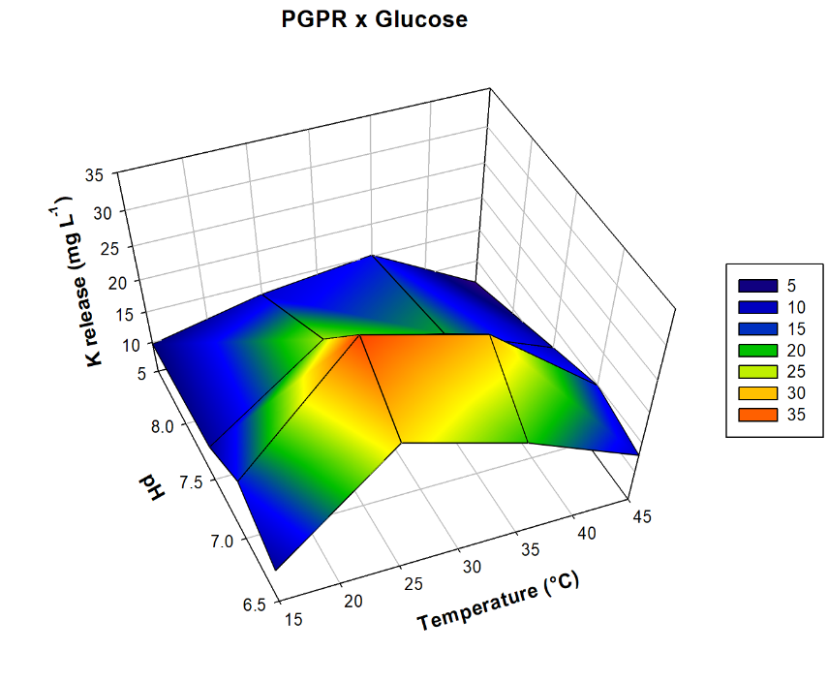
Fig. S1: 3D relationship between glucose (C source), temperature (°C), pH and K release from waste mica (WM) powder 3D Stoichiometric relationships = 3D stoichiometric relationships = Glucose and pH: R² = 7730, p<0001, n = 0032; Glucose and temperature (°C): R² = 7730, p<0001, n= 0002, pH and temperature (°C): R² = 7730, p<0001, n = 0341

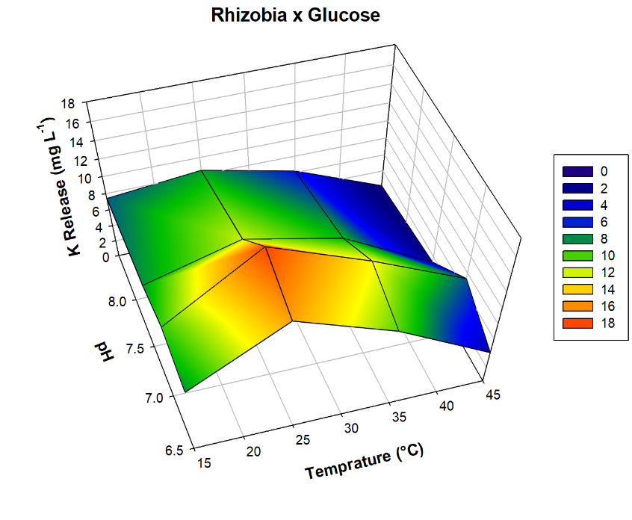
Fig. S2: 3D relationship between glucose (C source), temperature (°C), pH and K release from waste mica (WM) powder 3D Stoichiometric relationships = 3D stoichiometric relationships = Glucose and pH: R² = 7730, p<0001, n = 0032; Glucose and temperature (°C): R² = 7730, p<0001, n= 0002, pH and temperature (°C): R² = 7730, p<0001, n = 0341

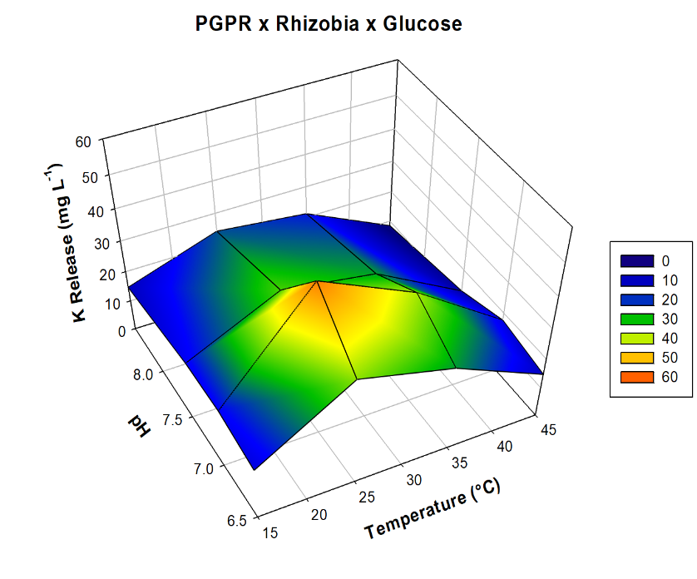
Fig. S3: 3D relationship between glucose (C source), temperature (°C), pH and K release from waste mica (WM) powder 3D Stoichiometric relationships = 3D stoichiometric relationships = Glucose and pH: R² = 7730, p<0001, n = 0032; Glucose and temperature (°C): R² = 7730, p<0001, n= 0002, pH and temperature (°C): R² = 7730, p<0001, n = 0341

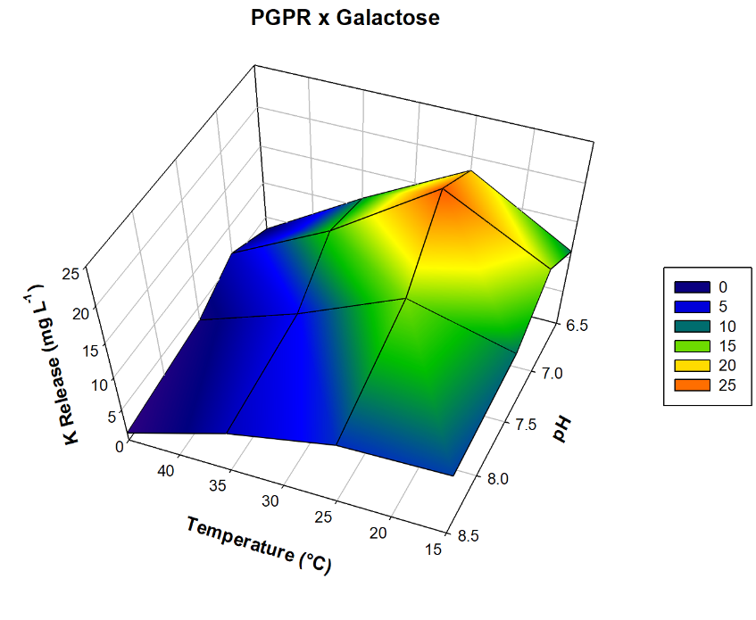
Fig. S4: 3D relationship between glucose (C source), temperature (°C), pH and K release from waste mica (WM) powder 3D Stoichiometric relationships = 3D stoichiometric relationships = Glucose and pH: R² = 7730, p<0001, n = 0032; Glucose and temperature (°C): R² = 7730, p<0001, n= 0002, pH and temperature (°C): R² = 7730, p<0001, n = 0341

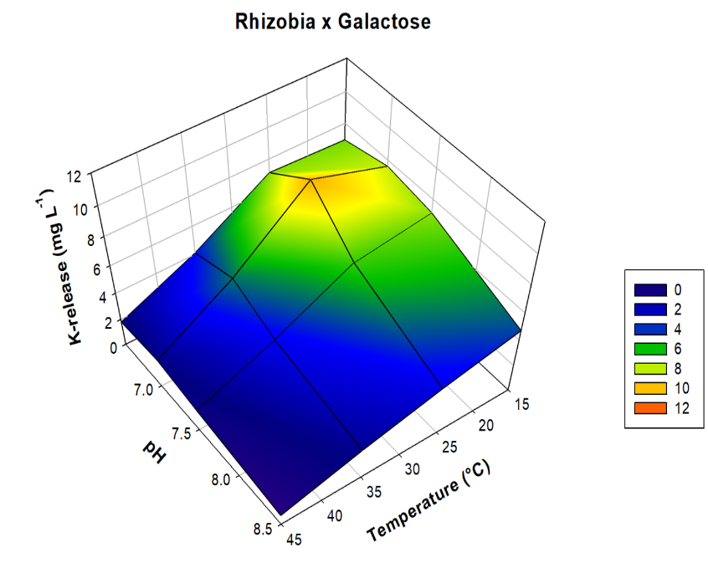
Fig. S5: 3D relationship between glucose (C source), temperature (°C), pH and K release from waste mica (WM) powder 3D Stoichiometric relationships = 3D stoichiometric relationships = Glucose and pH: R² = 7730, p<0001, n = 0032; Glucose and temperature (°C): R² = 7730, p<0001, n= 0002, pH and temperature (°C): R² = 7730, p<0001, n = 0341

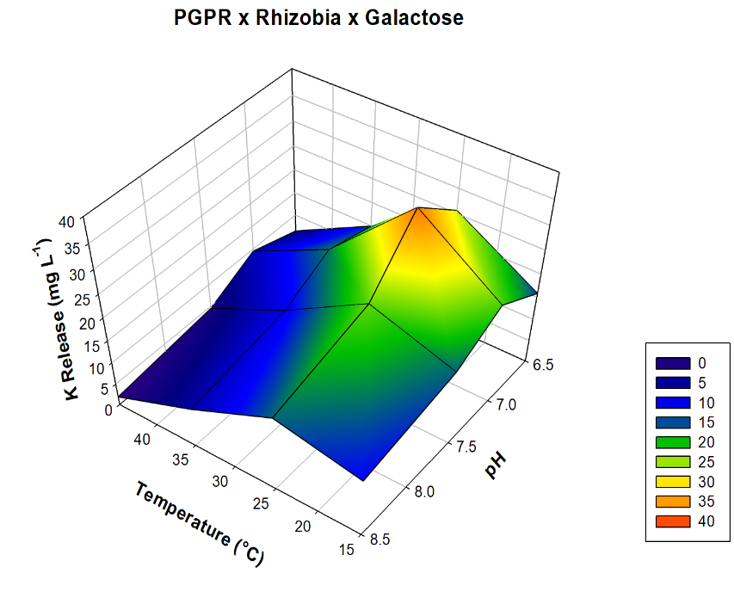
Fig. S6: 3D relationship between glucose (C source), temperature (°C), pH and K release from waste mica (WM) powder 3D Stoichiometric relationships = 3D stoichiometric relationships = Glucose and pH: R² = 7730, p<0001, n = 0032; Glucose and temperature (°C): R² = 7730, p<0001, n= 0002, pH and temperature (°C): R² = 7730, p<0001, n = 0341

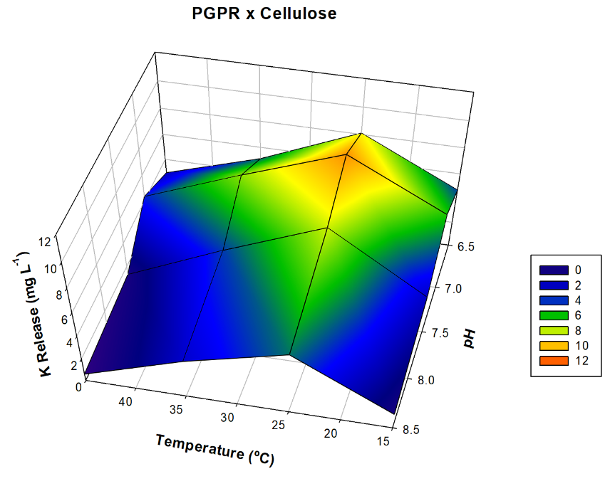
Fig. S7: 3D relationship between glucose (C source), temperature (°C), pH and K release from waste mica (WM) powder 3D Stoichiometric relationships = 3D stoichiometric relationships = Glucose and pH: R² = 7730, p<0001, n = 0032; Glucose and temperature (°C): R² = 7730, p<0001, n= 0002, pH and temperature (°C): R² = 7730, p<0001, n = 0341

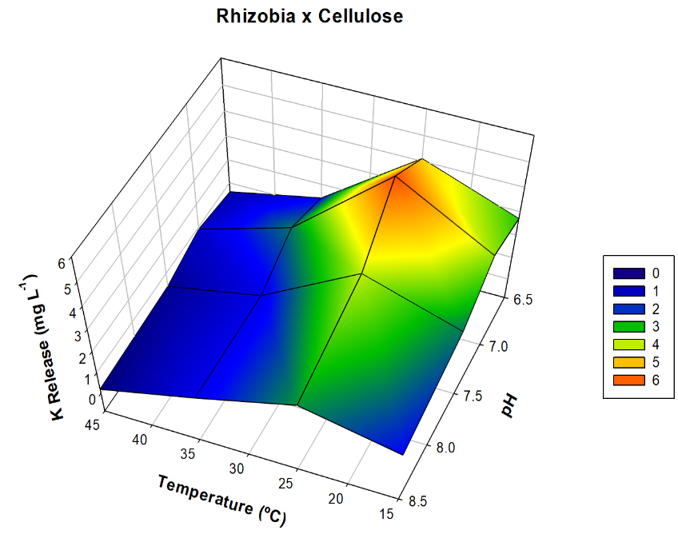
Fig. S8: 3D relationship between glucose (C source), temperature (°C), pH and K release from waste mica (WM) powder 3D Stoichiometric relationships = 3D stoichiometric relationships = Glucose and pH: R² = 7730, p<0001, n = 0032; Glucose and temperature (°C): R² = 7730, p<0001, n= 0002, pH and temperature (°C): R² = 7730, p<0001, n = 0341

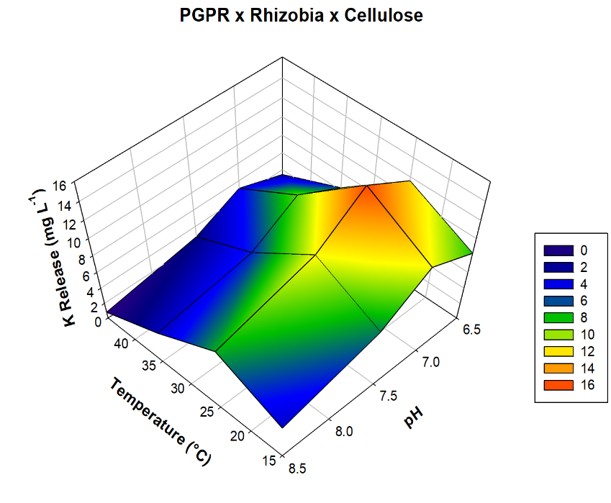
Fig. S9: 3D relationship between glucose (C source), temperature (°C), pH and K release from waste mica (WM) powder 3D Stoichiometric relationships = 3D Stoichiometric relationships = Glucose and pH: R² = 7730, p<0001, n = 0032; Glucose and temperature (°C): R² = 7730, p<0001, n= 0002, pH and temperature (°C): R² = 7730, p<0001, n = 0341

