Running title: Allometric Equations for Estimating Dipterocarp Forest Biomass

Allometric Equations for Estimating Dipterocarp Forest Biomass in the Tropics: Destructive Sampling Approaches

Ika Heriansyah¹, Lutfy Abdulah¹, Joeni Setijo Rahajoe¹, Ruliyana Susanti¹*, Yunita Lisnawati¹, Subarudi², Rosita Dewi¹, Darwo¹, Mawazin¹, Abdurachman¹, Karmilasanti¹, Nur Wakhid¹, Donny Wicaksono¹, Rachman Effendi¹, Andhika Silva Yunianto¹, Nina Mindawati¹, Hazandy Abdul-Hamid³, Shamsudin Ibrahim⁴

¹Research Centre for Ecology and Ethnobiology, National Research and Innovation Agency (BRIN), Bogor, Indonesia
²Research Centre for Population, National Research and Innovation Agency (BRIN), Jakarta, Indonesia
³ Institute of Tropical Forestry and Forest Products (INTROP) Universiti Putra Malaysia, Serdang 43400, Selangor, Malaysia
⁴ Forest Research Institute Malaysia (FRIM), Kepong 52109, Selangor, Malaysia
*For correspondence: ruli001@brin.go.id

Received_____________; Accepted_______________; Published_______________

Novelty statement

The novelty of the research: This research advanced the formulation of an allometric equation based on below-ground biomass, distinguishing itself from the conventional focus on above-ground biomass considerations. The approach is infrequently undertaken in research, as the utilization of destructive methods is typically avoided by researchers. However, this methodology offers precision in data acquisition, yielding more accurate and nuanced insights into the biomass distribution

Abstract
The precision of carbon measurement is essential in convincing potential buyers to invest in carbon stocks. Estimating forest carbon stock using allometric equations can be applied to optimize budget use. Specific allometric equations adapted to different forest types are needed to estimate forest carbon stock accurately from inventory data. We analyzed dipterocarps forests biomass and volume data from tropical forests in Indonesia and Malaysia to ascertain suitable predictor variables to formulate forest type-specific allometric equations. The predictor variables considered were tree diameter at 1.3 m (D), a combination of D and tree height (D2H), and stem volume (V). The data set includes 119 trees, with D ranging from 1.2 cm to 114.6 cm and height (H) ranging from 1.9 m to 59.1 m. The study reveals that applying D alone as a predictor variable produces appropriate relationships in the forest-type specific equations (Model IKA1a). However, incorporating H as a secondary predictor variable significantly improved model performance for stem volume and biomass estimations. We compared our model with four models found in the literature; two were underestimated, and two other models were quite similar with an average deviation value of less than 10%. Even though previous general allometric equations can be accurate for estimating aboveground biomass with diameters between 15 to 115 cm, those equations could have been more precise than the forest type-specific equation, especially for estimation in lowland dipterocarp forests in Indonesia and Malaysia. In addition, the biomass conversion and expansion factor slightly increased with increasing D, from 1.02 to 1.47 (average 1.22) for D 3.2 to 31.8 cm, then effective to estimate total biomass from aboveground biomass data. In conclusion, our study supports using forest-type allometric equations to estimate biomass and stem volume-based inventory data accurately. These results will provide valuable insights for carbon trading stakeholders in Indonesia and Malaysia.
Keywords: Allometric; Biomass conversion and expansion factor; Commercial logs; Dipterocarps; Wood density; South-East Asia

Introduction

The dipterocarp forest is a unique ecosystem distributed in tropical and subtropical regions across Asia (Wohlfart et al., 2014; Huy et al., 2019). In Indonesia and Malaysia, dipterocarp forests dominated lowland forest areas (Rachmat et al., 2021; Whitemore, 1984; Thoumi, 2009). This forest serves a dual function encompassing both conservation and forest production. Dipterocarp forests play essential roles as habitats for many stone species (Huy et al., 2019; Axelsson & Franco, 2023) while also serving as a valuable source of timber and a wide array of non-timber forest products, including medicinal resources, food plants, and a substantial amount of resin derived from species within the dipterocarp family (Huy et al., 2019). Dipterocarp forest also has an essential role as a carbon sink. These forests actively sequester carbon dioxide from the atmosphere, thereby contributing to climate change mitigation (Kumagai et al., 2004).
Accurate measurement of carbon stock is necessary to measure carbon emissions. However, measuring carbon stock using a census of all forest stands can be a burden since it requires a significant budget. Carbon stock within forests can be estimated using allometric equations developed by destructive sampling approaches to overcome limitations. These equations establish relationships specific to forest types, enabling carbon stock estimation by converting forest inventory measurements, such as wood volume (diameter, height, and stem form number) and woody biomass.
Wood volume, woody biomass, and total live biomass are essential indicators to identify the forests' potential to provide various products and services, including carbon sequestration. Participation in international or domestic carbon trading schemes requires the estimation of carbon sequestered in the forests. Because of the monetary value being attached to carbon sequestration, there is increased scrutiny of techniques for estimating aboveground biomass (Brown, 2002; Brown et al., 1989; Brown & Iverson, 1992; Coomes et al., 2002; de Jong, 2001; MacDicken, 1997; Specht & West, 2003). Traditionally, allometric relationships incorporate an easily measured tree variable (e.g., stem diameter) to estimate the aboveground biomass in a large-scale experimental system.
The level of forest biomass differed significantly among forest groups (Wang et al., 2008). Hence, specific volume and allometric equations must be developed for other regions. Many allometric equations have been developed to estimate aboveground biomass in Southeast Asia (Basuki et al., 2009; Hashimoto et al., 2004; Huy et al., 2016; Kato, 1978; Yamakura, 1986; Chave et al., 2009; Chave et al., 2014; Brown, 1997; Chave et al., 2005; Wang et al., 2008) and tropical forests in general (Brown et al., 1997; Chave et al., 2014; Kenzo et al., 2009). However, the adequacy between developed equations for target forest stand and allometric equation to estimate belowground biomass still needs to be improved in the region (Chave et al., 2005; Kenzo et al., 2009; Niiyama, 2010). Some of the established equations have included large canopy trees such as dipterocarp (Hashimoto, 2004; Yamakura, 1986) tropical secondary forests dominated by pioneer species (Huy et al., 2016; Kenzo et al., 2009), mixed secondary forests dominated by human-introduced species, especially rubber trees (Ketterings et al., 2001), logged-over forest (Kenzo et al., 2009; Basuki et al., 2009) plantation forests (Heriansyah et al., 2007; Miyakuni et al., 2004; Komiyama et al., 2005).
Moreover, the number of destructive samples for developing allometric equations for accurate biomass estimation needs higher consideration. However, most existing allometric equations had minimal individuals and species representing tropical forests' original composition. Data from forest inventory can be used to develop volume and total aboveground biomass estimation models. However, such data must be well collected, recapitulated, and trustily analyzed. The diameter at breast height (D) is one of the predictor variables for creating such a model with less work and less cost of measurement. The inclusion of stand height and/or wood density as predictor variables in allometric equations has been suggested to allow and accommodate for the influence of site factors (Kato, 1978; Ketterings et al., 2001; Komiyama et al., 2005) and differences between tree species (Brown & Iverson, 1992).
In addition, we aimed to compare the developed allometric formula obtained from this study with two general allometric models. To the best of our knowledge, the results of the current effort could provide helpful information to make management decisions related to the estimation of biomass and volume for timber companies, district government, and even the national government, especially when dealing with baseline carbon and timber volume data.

Materials and Methods

Study site
The study was conducted within tropical natural production forests across Sumatera, Java, and Kalimantan in Indonesia, as well as Johor, Perak, and Pahang in Peninsular Malaysia (Fig. 1). The topography within these areas is predominantly steep, ranging from 5 to 25%, and elevations ranging from 200 m to 600 m above sea level (asl). However, most of the area comprises highlands and high-altitude plateaus, much of which remains forested. The forest is classified as lowland mixed dipterocarp forests, characterized by individual trees that reach 35 to 60 m in height. The Dipterocarp family dominates the species composition of all trees with a diameter of more than 10 cm, and the dipterocarp forests located within the study sites likely represent some of the last remaining forest formation types in Southeast Asia.
In this study, biomass estimation at the plot level was conducted across eight (8) distinct plots, each characterized by a different structure and composition, yet all belonging to the same forest types. Among all the plots, four (4) plots are located in natural forests, and four (4) other plots are located in planted forests with various stand ages. Detailed information regarding the site names, geographical coordinates, and altitudes for each of the eight plots can be found in Table 1

Destructive sampling

Tree samples for the destructive analysis were taken from all eight plots (Table 2). Tree samples obtained from natural forests were chosen depending on the normality of tree structure during operational felling activities of logging companies. In contrast, the plantation forests were chosen based on diameter distribution.
The destructive sampling technique used in this study did not commence with the felling of trees followed by division into tree components. Instead, it involved uprooting trees using heavy machinery (excavator) for those with a diameter of less than 10 cm. For diameters exceeding 10 cm, the procedure begins with weakening the root structure through manual excavation and spraying with firefighting equipment, followed by utilizing the aboveground weight as a driving force for unearthing the root system.
The destructive samples were collected from tree-log subsequences of 0-0.3 m, 0.3-1.3 m, 1.3-3.3 m, etc., every 2 m to the top. The samples were also divided into living branches and twigs, dead branches and twigs, leaves, and roots. Tree height, diameter, and weight of tree components for destructive samples were measured in the field. Roots samples were collected whenever possible. The subsequent samples were brought to the laboratory to record the oven-dry weight.
In the natural forest, trees with stem diameter (D) more than 30 cm, special procedures were carried out post felling: measurement of stem diameter at both larger and smaller ends of the stump (the lower section of the stem remaining in the field after harvesting), the commercial stem, non-commercial stems (stem sections deemed unsuitable for commercial use due to defects), and at the larger and smaller end of substantial branches exceeding 20 cm in diameter. The volume of stem sections was calculated using Smalian’s formula (Loetsch & Haller, 1973).
Other components, such as small branches, twigs, and foliage, were weighed directly in the field using platform balance. Sub-samples of 200 grams (fresh weight) from each component were taken and weighed using a spring balance. Sub-samples of wood originating from a stump, commercial stem, non-commercial stem, and substantial branches were acquired in block form, measuring 2 cm x 2 cm x 5 cm, and subsequently used for biomass estimation based on their specific wood density. Each sample was carefully placed into a coded paper bag and transported to the laboratory for oven-drying.
The samples were dried at 85oC until a consistent weight was attained, using a drying oven (“Memmert”). The specific drying duration was as follows: i) 48 hours for leaves and wood biomass less than 10 cm in diameter, and ii) 96 hours for wood biomass over 10 cm in diameter (Heriansyah et al., 2007; Miyakuni et al., 2004; Miyakuni et al., 2005). After measurement of the dry weight of each sample, the total dry weights were calculated by multiplying the initial fresh weight of the samples by the dry-to-fresh weight ratio of each respective sample.

Formulating and model fitting of allometric equation

This study assessed the efficacy of linear and non-linear models in log-log space. The linear model is based solely on diameter as the independent variable, implying a linear diameter-biomass relationship in log-log space. While non-linear models involved employing polynomials in diameter and incorporating combinations of both diameter and height as independent variables.
Given that the trees examined in this study were harvested across eight sites spanning two countries. They were situated in two forest types (natural and planted); an investigation was conducted to ascertain whether the intercepts and slope of these models exhibited variations based on the country, the specific harvesting sites, or the type of forest. The significance of the effect of country, site, and forest type was determined through an analysis of variance (ANOVA) test, wherein two nested models were compared: one excluding and another including the effects of these factors alongside those of diameter and/or height.
To estimate the volume and aboveground biomass (AGB), a set of general equations for the allometric model was developed. Specifically, the general model used was an exponential model utilizing diameter at 1.3 m above ground (D) alone or in combination with tree height (H) as independent variables concerning volume and biomass (Huang et al., 2023). Both linear and non-linear regression were employed, and the analysis outcome is presented in Table 3.
The assessment of model fit for allometric equations adhered to specific criteria, including the significance of model coefficient significant at an α of 5%, a low standard error, a high coefficient of correlation (R-squared), high R-adjective and a low root mean square error (RMSE). This methodology aligns with Chicco et al. 2021 and Hooper et al. 2008.

Validation of the allometric equations

A validation analysis was conducted on the dataset comprising 119 sample trees to determine the general applicability of the derived equation. This analysis involved a random, non-replacement dataset division into two subsets, each containing 67% and 33% of the total data. The larger dataset (67%) was utilized for model construction, involving the development of model equation, while the smaller subset (33%) served for model validation.
For the construction process, the 67% subset was employed to ascertain the parameters of the equation linking biomass to diameter, with or without height considerations. Subsequently, the biomass values for the remaining 33% trees were validated based on this equation and compared against the measured biomass. The intercept, slope, R2, and residual standard error of the relationship between the developed model and model validation were recorded during this process.
The validation of the allometric equation is determined by comparing the developed model with the model validation. This comparison involved a t-test validation, wherein equality between the developed model and model validation was assessed at an α of 5% (95% confidence intervals). If the model was found to be statistically equivalent to the model validation, the model was considered to be valid.

Results
Available Dataset
This study successfully collected 119 individuals representing 81 trees of Dipterocarp species in natural forest environments and 38 trees of Shorea leprosula in plantation forest. The diameter and height of trees in natural forest ranged from 1.2 – 114.6 cm and 1.9 - 59.1 m, respectively. In the planted forest, the diameter and height of trees ranged from 3.7 cm to 28.5 cm and from 2.9 to 23.1 m, respectively. Dataset detail is visualized in Fig. 2 and then used to develop the models.

Proportion of biomass

The study results show that the proportion of stem biomass to aboveground biomass (AGB) is higher compared to branches and foliage biomass (Fig. 3). The proportion of stem biomass ranges from 43.6 to 97%, with an average of 71.5%. The range becomes narrower when considering the first quartile (Q1) and third quartile (Q3), which varies between 60.2% to 81.2%. Meanwhile, the proportion of branches biomass to AGB range from 2.09 to 40.1%, with average of approximately 19.5%. The proportion of foliage varies from 0.38 to 29.1%, with an average of 7.8%.
For the root biomass, the results indicate that the proportion root biomass to total biomass ranges from 14.6 to 21.05%, with an average of 17.3%. However, it is noteworthy that for specific trees, this proportion may exhibit a substantial range, spanning 1.7 to 32.1% (Heryati, et al. 2011a; 2011b).

Biomass estimation variables+

The data distribution results for biomass variables indicate a positive relationship between D and H, volume, and biomass (Huy et al. 2019; Manuri et al. 2016). This signifies that as the diameter (D) increases, the total height (H) also increases, leading to larger volume and heavier biomass in the stem, branches, and leaves (Fig. 5).
Fig 5 shows relationship between D and H, stem volume, stem-, branch-, leaves-, and root-biomass. Even though D has positive relationship to H and tree component biomass, D to H and biomass relationship tend to be relative stable ratio for planted forest and natural forest of D less than 20 cm as an effect of similar growing space, but relative scattered for natural forest for D more than 20 cm as result of different growing space and competitions.

Allometric Model for Biomass

The validation results of the models against actual data showed that the models for aboveground biomass (AGB), root biomass (RB), and total biomass (TB) are not significantly different (P-value > 5%) (Table 7). This means that all models developed in this study can be used to estimate the biomass of dipterocarp species, both for AGB, RB, and TB.
Fig 6 shows the validation results of the models against actual data, showing a positive relationship with the diameter (D), which is in line with the research of Huy et al. (2019) on tropical dry dipterocarp forests in Vietnam and the research of Manuri et al. (2016) and Basuki et al. (2009) on tropical dipterocarp forests in Indonesia. This positive relationship indicates that the models developed in the study can accurately estimate the biomass of dipterocarp species.
The allometric equation for stem volume and biomass was validated using the biometric data presented in Fig 6 and Table 7. Concurrently, the model fit of the allometric equations for biomass is illustrated in Tabel 4, 5, and 6 for aboveground-, root- and total biomass, respectively.
In the context of dipterocarp species, the allometric equation utilizing diameter (D) or a combination of diameter and height (H) as predictor variables displayed consistent stability across the thirty dipterocarp species. A similar finding has been reported in several Southeast Asian tropical regions (Chave et al., 2005; Basuki et al., 2009; Hashimoto et al., 2004; Hui et al., 2016; Hui et al., 2019). Figure 5 confirms the congruence between the observed and predicted model, affirming the validity of utilizing the entire dataset to formulate a single (atau unified) allometric equation for dipterocarp in Southeast Asia.
We constructed several equations following scenarios for aboveground, root, and total biomass using parameter D alone and a combination of D and H (Table 4). Based on the criterion of R2 and R2adj, almost all models have high coefficient determination (>90%). However, when considering significance (coefficient less than 5%), models IKA1a, IKA3b, and IKA4b emerged as the best-fitting models, with model IKA1a being the most practical. Consequently, model IKA1a is selected for implementation. Unlike the AGB equation, almost all models for root biomass have moderate coefficient determination. However, when considering significance (coefficient less than 5%), model IKA4a emerged as the best-fitting model and was selected for implementation (Table 5). Based on the criteria of R2 and R2adj, almost all models have high coefficient determination (>94%), except models IKA2a and IKA2b. However, when considering significance (coefficient less than 5%), model IKA4a emerged as the best-fitting model, and then model IKA4a was selected for implementation (Table 6).

Validation Test for Allometric Models

The validation results of the models against actual data showed that the models for aboveground biomass (AGB), root biomass (RB), and total biomass (TB) are not significantly different (P-value > 5%) (Table 7). This means that all models developed in this study can be used to estimate the biomass of dipterocarp species, both for AGB, RB, and TB.
Fig 6 shows the validation results of the models against actual data, showing a positive relationship with the diameter (D), which is in line with the research of Huy et al. (2019) on tropical dry dipterocarp forests in Vietnam and the research of Manuri et al. (2016) and Basuki et al. (2009) on tropical dipterocarp forests in Indonesia. This positive relationship indicates that the models developed in the study can accurately estimate the biomass of dipterocarp species.
The allometric equation for stem volume and biomass was validated using the biometric data presented in Fig 6 and Table 7. Concurrently, the model fit of the allometric equations for biomass is illustrated in Tabel 4, 5, and 6 for aboveground-, root- and total biomass, respectively.

Comparative Biomass Predictions

Comparative analysis was conducted by evaluating the efficacy of the present equation against literature-based models. The plot-level biomasses predicted by the optimum predictive equation derived in this study, employing the composite variable D2H while excluding the effect of Forest Type, were compared with those from various functions found in the literature. The references are listed in Table 7. The analysis results, as illustrated in Figure 8, depict the comparisons made for equations based solely on the log-log linear function of D for Brown (1997); Basuki et al. (2009); Chave et al. (2005); Ketterings et al. (2001), respectively.
The average deviation for individual trees models by Ketterings et al. (2001) and Basuki et al. (2009) is always lower than that of the study model (Fig. 7). When the equation of Ketterings et al. 2001 and Basuki et al. 2009 were applied to our data, the predicted values were underestimated. However, a model developed by Manuri et al. (2016) and Brown (1997) has similar estimates for aboveground biomass at a deviation between 1 to 19% (average 10%) for D 35 to 115 cm and a deviation between 1 to 20% (average 4%) for D 15 to 115 cm, respectively. In addition, the paired t-test presented in Table 8 shows that for one-tailed at α = 0.05, the mean of our model is significantly similar at p-value 0.81 and 0.88 for the model of Manuri et al. (2016) and Brown (1997), respectively. In all four cases, the equation Brown (1997) developed almost precisely estimated the plot aboveground biomass relative to the equation developed here.

Biomass Conversion and Expansion Factor (BCEF)

This study's Biomass Conversion and Expansion Factor (BCEF) is associated with estimating total biomass from Above Ground Biomass (AGB). If AGB is estimated from diameter (D), the resulting estimation, when multiplied by the BEF, provides the total biomass (Schepaschenko, 2018). The definition of BCEF depends on what is being estimated; at times, BCEF is utilized to calculate total biomass in hectares (ha), as demonstrated by Soares and Tomé (2004), which influences its applicability. Soares and Tomé (2004) assert that BEF is valuable for calculating the total biomass of stands based on allometric equations. In cases where the equation is unknown, the BCEF used is based on stand age. BCEF is also expressed as the proportion of CO2 in tree volume, denoted in t.CO2/m3 (Petersson et al. 2012).
The value of BEF is a crucial conversion factor for estimating total biomass from diameter (D) parameters. D is employed to estimate AGB, and the estimation of Total Biomass is derived by multiplying AGB and BCEF. Fig. 8 shows BCEF distribution at different D, with an average of 1.22 at a standard deviation of 8% (Table 9).
As indicated in Table 8, the BCEF is 1.22 for the dipterocarp species, signifying that the Total biomass is approximately 1.22 times the AGB. It is essential to note that this BCEF value is practical within the diameter range of 3.2 to 31.8 cm.

Discussion

The relationship between tree size and biomass is one of the fundamental principles in forest ecology. As a tree's size (height, diameter, volume) grows, its biomass (the total mass of the living tissue it contains) also increases. However, the relationship is sometimes linear. Many factors can affect a tree's overall biomass, including its species, age, health, and environmental conditions like sunlight, soil nutrients, water availability, human disturbances, and the existing management regime (Heriati et al. 2011a& 2011b, Widyatmoko et al. 2013; Wirabuana et al., 2020; Huy et al., 2019; Ma et al., 2021; Laing et al., 2021; Chaudhury et al., 2022; Cabuy et al., 2023). In general, larger trees will have more biomass because they have more living tissue, as research by Chaudhury et al. (2022) stated that the larger the diameter, the greater the biomass. However, the rate at which biomass accumulates might vary at different stages of a tree's life. For example, a tree may gain biomass quickly when it is young and growing rapidly, and then the rate of biomass accumulation might slow down as the tree matures (Brown & Lugo, 1990). The study "Dynamic Allometric Scaling of Tree Biomass and Size" explores this dynamic relationship between tree size and biomass, allowing for more accurate predictions of tree biomass at different stages of growth.
The power model or power law is often used in tree biomass allometry because it provides a very close fit to observational data (Picard et al., 2015). Many growth data empirically align along a straight line when plotted on log-log scales. The power function has the property that the relationship between two quantities is such that one quantity varies as the power of another. In the context of tree biomass, power models imply a proportional relationship between the biomass relative growth and the diameter relative growth. This model type is relatively parsimonious and straightforward, only needing a couple of parameters to estimate a tree's biomass from easily measurable attributes like diameter at breast height (D), height, or wood density. Furthermore, the power model is central to allometry because it aligns well with many biological and ecological systems, often scale-invariant or fractal-like. This, however, includes the applicability and usefulness of other models, with some complex allometric models potentially providing a better fit in some cases.
Allometric equations are used to estimate the biomass of trees and forests. These equations are developed by measuring various tree components, such as diameter, height, and crown width, and then relating them to the biomass of the tree or forest. The accuracy of allometric equations can vary depending on the species, location (Huy et al., 2019; Daba & Soromessa, 2019), and other factors, and it is essential to validate them before using them for biomass estimation.
Despite being expensive, time-consuming, and having limited representation in certain areas, destructive sampling can provide more accurate biomass estimation than non-destructive methods, allowing for a more detailed analysis of the tree's structure and composition (Zaenal et al., 2020). Destructive sampling also allows for component analysis; by cutting down trees, destructive sampling enables the collection and analysis of various components, such as foliage, branches, stems, and roots. On the other hand, non-destructive sampling is less intrusive, cost-effective, and faster, but it may provide a different level of accuracy than destructive testing.
The destructive sampling was applied to collect data on tree diameter (D), height (H), and biomass components such as stem, branch, leaves, and roots. The data collected this way is actual field data, covering various age classes of planted forest and ranging from logged-over forest to primary forest conditions. In building a single equation, the data was divided randomly into 67% for model construction and 33% for validation. With no significant difference in the analysis between the developed model and its validity, we confidently built a single allometric equation for lowland dipterocarp forests.
A single equation was developed based on eight models, using diameter (D) or a combination of diameter and height (D-H). The best model was chosen based on the highest R2 and lowest RMSE values. The t-test results showed a significant difference between the fit model and the actual data, indicating that the built model has high precision in estimating aboveground biomass (AGB), root biomass (RB), and total biomass (TB).
Tree D and the relationship between height are essential elements describing the attributes of forest stands. Although stand D has been applied as a variable in volume and biomass models (Heriansyah et al., 2005) and D with height relationships used to determine volume and biomass estimates (Heriansyah et al., 2005; Gobakken et al., 2008), such relationships may not provide accurate information regarding the entire forest if datasets are not grouped based on life forms or size class for the heterogeneous forest like lowland dipterocarp forest. Furthermore, using general equations may under- or overestimate the forest biomass. The tree biomass in our study was measured destructively using 119 trees of 30 species of dipterocarp from 8 different stand characteristics, and both planted and natural forest, from D 1.2 cm up to 114.6 cm.
Several studies have developed species-specific allometric equations for estimating aboveground biomass in different forest types (Basuki et al., 2009; Heriati et al., 2011a & 2011b; Huy et al., 2019; Spawn et al., 2020). These equations are often more accurate than generalized allometric equations, which can generate great uncertainty of biomass. The development of a generalized allometric equation was approached by measuring multiple tree species, and it was intended to be applied to a broad range of tropical forests. However, a significant error is generated regarding adopting generic pantropical allometric equations for many forests. Allometric equations can be in power relationships or logarithmically transformed power equations. The logarithmic transformation simplifies the allometric equation into a linear equation, making it easier to calculate the values of the constants. Allometric equations are widespread in forestry and forest ecology, and they are used to estimate tree biomass and contribute to the assessment and monitoring of the global carbon cycle.
The fit model developed in this study was then compared to various models for estimating aboveground biomass (AGB) in lowland dipterocarp forests. The study found that the Brown model had the smallest root mean square error (RMSE) and performed better, especially for trees with a diameter at breast height (DBH) between 15 and 115 cm (Brown, 1997). The Manuri model, on the other hand, overestimated AGB and had a higher root mean square error (Manuri et al., 2016). The Brown and Manuri models can estimate AGB for trees with DBH between 15 and 115 cm. However, the Basuki and Ketterings models produced underestimates of AGB with higher deviation, making them unsuitable for estimating AGB in lowland dipterocarp forests (Basuki, 2009; Ketterings, 2001). The study also developed a biomass expansion factor (BCEF) to estimate total biomass (TB) from AGB as an additional study result.
Comparing allometric equations involves examining their accuracy, simplicity, and applicability to different species and regions. Species-specific allometric equations are generally more accurate, but generalized allometric equations can provide a rough estimate when specific equations are unavailable. Transforming allometric equations into logarithmic form can simplify and improve the equation's accuracy. The specific allometric equation for dipterocarp forest developed from our study has a relatively similar result to the model allometric developed by Brown dan Manuri at an average deviation of 4% and 10%, respectively (Brown, 1997; Manuri et al., 2016).
The model developed in the study effectively estimates the biomass of individual trees with a diameter at breast height (D) ranging from 1.2 cm to 114.6 cm. The equation can calculate carbon stocks, including for carbon trading purposes. Carbon stocks can be calculated based on stand density, tree density, and various forest-covered conditions in natural forests (Wirabuana et al., 2021; Li et al., 2023).
Biomass Expansion Factors (BEFs) can vary depending on the forest type, region, and other factors (Brown, 1997; Cabuy et al., 2023). Comparisons of BEFs with individual tree biomass equations and existing biomass allometric equations can help to determine the most accurate method for estimating biomass in each given area. In our study, the biomass conversion and expansion factor (BCEF) is used to estimate the actual productivity of a given land area by expanding the stem biomass to account for total biomass. BEF is calculated by taking the ratio of the total biomass of the tree to the aboveground biomass.
Nowadays, the ability of forests to sequester carbon plays a pivotal role in the economic domain through the mechanism of the carbon market. As part of the carbon market, carbon trading represents a system that facilitates exchanging greenhouse gas (GHG) emissions as economic assets (Kusumajati, 2023). In this context, carbon trading is a market-based mechanism for mitigating GHG emissions through trading carbon emission reduction certificates (Ludeña et al., 2015). Carbon trading resembles conventional commodity trading; however, the commodity being exchanged is in the form of carbon emissions, specifically carbon emission certificates. Certification sellers encompass countries or entities, including state-owned or private companies, that have effectively reduced their carbon emissions below the prescribed target. At the same time, buyers are constituted by countries or entities that exceed the allowable emission limits (Pangaribuan, 2010).
Carbon trading concerning biomass has been a growing market-based system that allows entities to buy and sell carbon credits based on their carbon accumulation in forest trees. However, some limitations and trade-offs are associated with carbon trading concerning biomass, such as assumptions about biomass feedstocks and energy products, energy price assumptions, and carbon storage over the contract period. This study provides a specific equation to estimate the total biomass of lowland dipterocarp forests, which can thus be converted to C-stock.

Conclusion

Forest inventories are highly variable, especially in diverse mosaic landscapes in different forest types or regions. Converting forest inventory into volume, biomass, and carbon measures requires the development of allometric relationships. Several general allometric equations exist, but it is better to develop specific equations. Measurement accuracy is crucial to ensure that volume, biomass, and carbon stocks are well-spent and accounted for and carbon payments are made appropriately. This study provides a specific equation to estimate the total biomass of lowland dipterocarp forests, which can thus be converted to C-stock. The study has demonstrated that, for dipterocarp’s aboveground biomass, the tested two general allometric relationships of Ketterings et al. (2001) and Basuki et al. (2009) are not as accurate as forest type-speciﬁc allometric equation for estimating biomass in the lowland dipterocarp forest in Indonesia and Malaysia. The equation developed by Ketterings et al. (2001) and Basuki et al. (2009) underestimated all D ranges with standard error increased with increasing D of 18% to 76% and 27% to 33%, respectively. The equation developed by Manuri et al. (2016) and Brown (1997) is accurate for estimating aboveground biomass with D between 35 to 115 cm at an average standard error of 10% and between 15 to 115 cm at an average standard error of 4%, respectively. The study concludes that inventory measurements recommend a forest-type allometric equation for estimating biomass and stem volume. Then, total biomass can be estimated from converted aboveground biomass using BCEF value.

Author Contributions

Design and conceptualization of manuscript, I.H.; L.A.; H.A.-H.;J.S.R.; R.S.; Y.L.; S.; D.; M.; A.; S.I.; and R.E.; methodology, I.H.; L.A.; H.A.-H.;J.S.R.; R.S.; Y.L.; S.; D.; M.; A.; and R.E.; software, I.H.and L.A; validation, I.H.; L.A.; H.A.-H.;J.S.R.; R.S.; Y.L.; S.; D.; M.; A.; and R.E.; formal analysis, I.H.; L.A.; H.A.-H.;J.S.R.; R.S.; Y.L.; S.; D.; M.; A.; and R.E.; investigation, I.H; literature reviews, I.H.; L.A.; H.A.-H.;J.S.R.; R.S.; Y.L.; S.; D.; M.; A.; R.E.; R.D.; K.; N.W.; D.W.; A.S.Y.; and N.M.; data curation, I.H.; and L.A.; writing—original draft preparation, I.H.; H.A.-H, L.A.; and R.S.; writing—review and editing, I.H.; L.A.; H.A.-H.;J.S.R.; R.S.; Y.L.; S.; D.; M.; A.; and R.E.; R.D.; K.; N.W.; D.W.; A.S.Y.; S.I.;and N.M All authors have read and agreed to the published version of the manuscript.

Acknowledgement

We would like to thank the Indonesian Forestry and Environment Research, Development, and Innovation Agency (FOERDIA), Forest Research Institute Malaysia (FRIM), and Universiti Putra Malaysia (UPM) staff for field assistance with some components of this work. This work was supported by FOERDIA (Indonesia), FRIM (Malaysia), and UPM (Malaysia).

Conflicts of Interest

The authors declare no conflict of interest.

References
Kassim AR, Md Sabri MD, Kamarudin MF, Birigazz L (2014). Inventory of Tree Biomass and Volume Allometric Equations in Southeast Asia. Southeast Asia. FRIM, Kepong, Food & Agriculture of the United Nations, Rome. Italy.
Axxelson EP and Franco FM (2023). Review: Popular cultural keystone species are also understudied- the case of the camphor tree (Dryobalanops aromatica). Trees forest and people13: 10041
Basuki T, et al. (2009). Allometric equations for estimating the above-ground biomass in tropical lowland Dipterocarp forests. Forest ecology and management) 257: 1684-1694.
Brown S (1997). Estimating biomass and biomass change of tropical forests: a primer. FAO Forestry Paper 134
Brown S (2002). Measuring carbon in forests: current status and future challenges. Environmental pollution 116: pp. 363-372
Brown S and AE Lugo (1992). Aboveground biomass estimates for tropical moist forests of the Brazilian Amazon. Interciencia 17: 8-18
Brown S, A J Gillespie and AE Lugo (1989) Biomass estimation methods for tropical forests with applications to forest inventory data. Forest science 35: 881-902.
Brown IF, et al. (1995). Uncertainty in the biomass of Amazonian forests: an example from Rondonia, Brazil. Forest Ecology and Management 75: 175-189.
Brown S and LR Iverson (1992). Biomass estimates for tropical forests. World Resource Review. 4: 366-384
Chave J, et al. (2005) Tree allometry and improved estimation of carbon stocks and balance in tropical forests. Oecologia 145: 87-99
Chave J, et al. (2009) Towards a worldwide wood economics spectrum. Ecology letters 12: 351-366
Chave J, et al. (2014). Improved allometric models to estimate the aboveground biomass of tropical trees. Global change biology 20: 3177-3190.
Chicco D, Warrens MJ, Jurman G (2021). The coefficient of determination R-squared is more informative than SMAPE, MAE, MAPE, MSE, and RMSE in regression analysis evaluation. PeerJ Comput Sci. 5: e623
Coomes DA, et al. (2002). Designing systems to monitor carbon stocks in forests and shrublands. Forest Ecology and Management 164:89-108.
De Jong, BH (2001). Uncertainties in estimating the potential for carbon mitigation of forest management. Forest Ecology and Management 154: pp. 85-104
Food and Agriculture Organization (2010). Global forest resources assessment 2010: Main report. Food and Agriculture Organization of the United Nations.
Gregoire T, S Zedaker and N. Nicholas (1990). Modeling relative error in stem basal area estimates. Canadian Journal of Forest Research 20: 496-502.
Hashimoto T, et al. (2004). Allometric equations for pioneer tree species and estimation of the aboveground biomass of a tropical secondary forest in East Kalimantan. Tropics 14: 123-130
Heriansyah I, et al. (2007). Growth characteristics and biomass accumulations of Acacia mangium under different management practices in Indonesia. Journal of Tropical Forest Science: 226-235.
Huang Y, Ciais P, Santoro M, Makowski D, Chave J, Schepaschenko D, et al. (2021). A global map of root biomass across the world’s forests. Earth System Science Data. https://doi.org/10.5194/essd-2021-25
Huy B, et al. (2016). Allometric equations for estimating tree aboveground biomass in evergreen broadleaf forests of Viet Nam. Forest Ecology and Management 382: 193-205
Huy B, Tinh NT, Krishna P, Poudel KP, Frank BM (2019). Taxon-specific modeling systems for improving the reliability of tree aboveground biomass and its components estimates in tropical dry dipterocarps forests. Forest Ecology and Management 437:156-174
Hooper D, Coughlan J and Mullen MR (2008). Structural Equation Modelling: Guidelines for Determining Model Fit. The Electronic Journal of Business Research Methods 6: 53 - 60
Kato R (1978). Plant biomass and growth of increment studies in Pasoh Forest Rewerve. Malayan Nature Journal 30: 211-224.
Kenzo T, et al. (2009). Allometric equations for accurate estimation of above-ground biomass in logged-over tropical rainforests in Sarawak, Malaysia. Journal of forest research 14: 365-372.
Kenzo T, et al. (2009). Development of allometric relationships for accurate estimation of above-and below-ground biomass in tropical secondary forests in Sarawak, Malaysia. Journal of Tropical Ecology 25: 371-386
Ketterings QM, et al. (2001). Reducing uncertainty in the use of allometric biomass equations for predicting aboveground tree biomass in mixed secondary forests. Forest Ecology and Management 146:199-209
Komiyama AS, Poungparn and S Kato (2005). Common allometric equations for estimating the tree weight of mangroves. Journal of Tropical Ecology 21: 471-477
Kumagai T, Katul G G, Porporato A, Saitoh TM, Ohashi M, Ichie, T, and Suzuki M (2004). Carbon and water cycling in a Bornean tropical rainforest under current and future climate scenarios. Advances in Water Resources 27: 1136 – 1150
Kusumajati TO (2023). Carbon Trade and Carbon Market. https://www.usd.ac.id/fakultas/ekonomi/daftar.php?id=berita&noid=360
Ludeña C, de Miguel C and Schuschny A (2015). Climate change and carbon markets: implications for developing countries. Cepal Review, 116:.61-84
Loetsch F and K Haller (1973). Forest inventory, Vol I. Munchen. BLV Múnich, Alemania.
MacDicken KG (1997). A guide to monitoring carbon storage in forestry and agroforestry projects.
Madgwick H and T Satoo (1975). On estimating the aboveground weights of tree stands. Ecology 56: 1446–1450.
Manuri S, Brack C, Noorán F, Rusolono T, Anggraini S M, Dotzauer H, Kumara I (2016). Improved allometric equations for tree aboveground biomass estimation in tropical dipterocarp forests of Kalimantan, Indonesia. Forest Ecosystems. 3:28. DOI 10.1186/s40663-016-0087-2
Miyakuni K, et al. (2004). Allometric biomass equations, biomass expansion factors and root-to-shoot ratios of planted Acacia mangium Willd. forests in West Java, Indonesia. Journal of Forest Planning 10: 69-76
Miyakuni K, et al. (2005). Allometric equations and parameters for estimating the biomass of planted Pinus merkusii Jungh. et de Vr. forests. Japanese Journal of Forest Environment 47: 95-104
Nabuurs G, et al. (2008). Comparison of uncertainties in carbon sequestration estimates for a tropical and a temperate forest. Forest Ecology and Management 256: 237-245.
Niiyama K, et al. (2010). Estimation of root biomass based on excavation of individual root systems in a primary dipterocarp forest in Pasoh Forest Reserve, Peninsular Malaysia. Journal of Tropical Ecology 26: 271-284.
Pangaribuan BTF (2010). Perdagangan Karbon; Sudah Siapkah Kita? https://bunghatta.ac.id/artikel-294-perdagangan-karbon-sudah-siapkah-kita.html.
Pinard MA and FE Putz (1996). Retaining forest biomass by reducing logging damage. Biotropica: pp. 278–295.
Schmitt MD and D Grigal (1981). Generalized biomass estimation equations for Betula papyrifera Marsh. Canadian Journal of Forest Research 11: 837-840.
Segura M and M Kanninen (2005). Allometric models for tree volume and total aboveground biomass in a tropical humid forest in Costa Rica. Biotropica: The Journal of Biology and Conservation, 37: 2-8.
Spawn S A et al. (2020). Harmonized global maps of above and belowground biomass carbon density in the year 2010. Scientific data. (2020) 7:112 | https://doi.org/10.1038/s41597-020-0444-4
Specht A and P West (2003). Estimation of biomass and sequestered carbon on farm forest plantations in northern New South Wales, Australia. Biomass and Bioenergy, 25: 363-379
Thoumi G (2009). Indonesia: Kalimantan’s Lowland Peat Forests Explained. https://news.mongabay.com/2009/12/indonesia-kalimantans-lowland-peat-forests-explained.
Wang X, J Fang, and B Zhu (2008). Forest biomass and root–shoot allocation in northeast China. Forest Ecology and Management 255: 4007-4020.
Whitmore TC (1984). Tropical rain forests of the far east. 2nd ed. Oxford (UK): Clarendon Press.
Wohlfart C, Wegmann M, and Leimgruber P (2014). Mapping threatened dry deciduous dipterocarp forest in South-east Asia for conservation management. Tropical Conservation Science 7: 597-613
Xian W, Wang X, Wu Y, Xia X, Fang J (2015). Forest biomass is strong shaped by forest height across boreal to tropical forests in China. Jurnal of Plant Ecology 8: 559-567
Yamakura T, et al. (1986). Aboveground biomass of tropical rain forest stands in Indonesian Borneo. Vegetation 68: 71-82
Yujia H (1997). The dipterocarp forest of Hainan Island, China. Journal of Tropical Forest Science 9:477-498

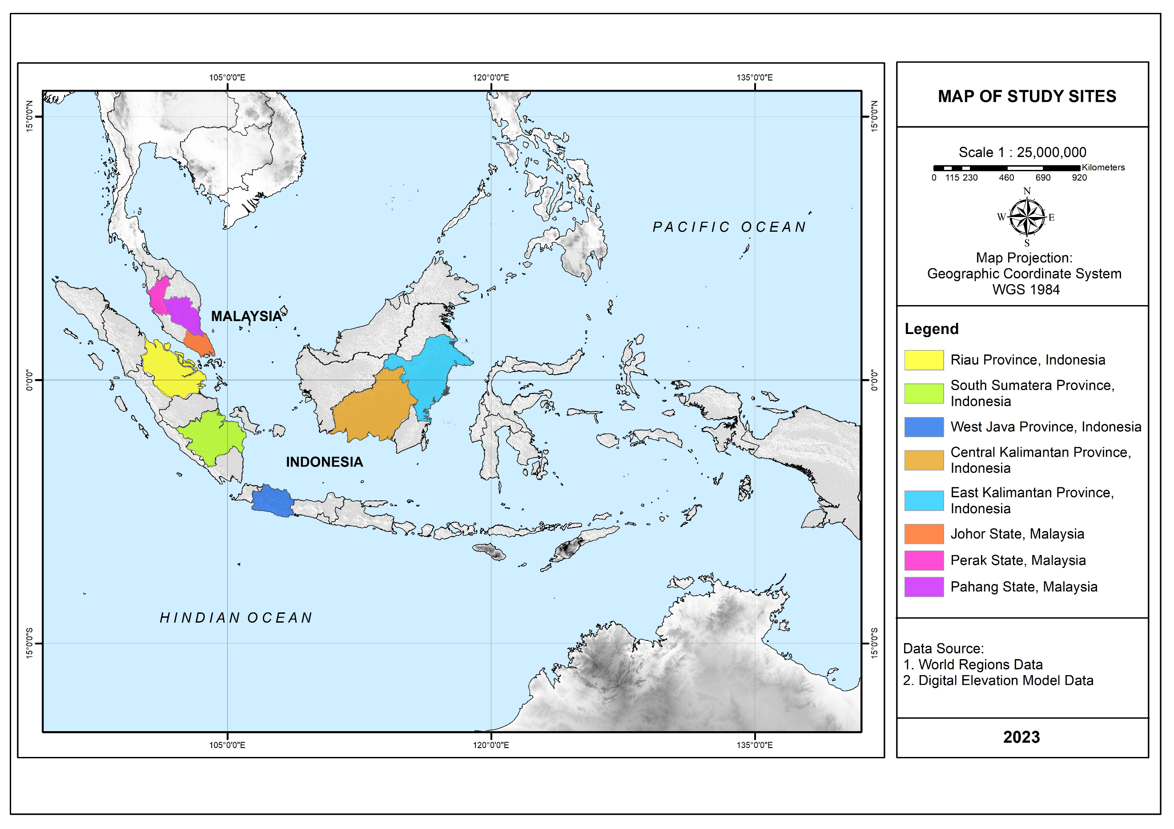
Fig 1. Study sites located in Indonesia and Malaysia

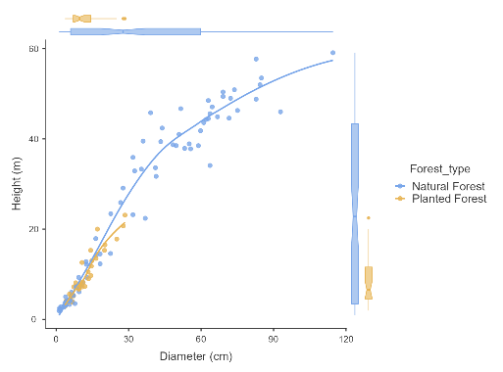

Fig. 2 Diameter and height distribution of tree samples from natural and planted forests

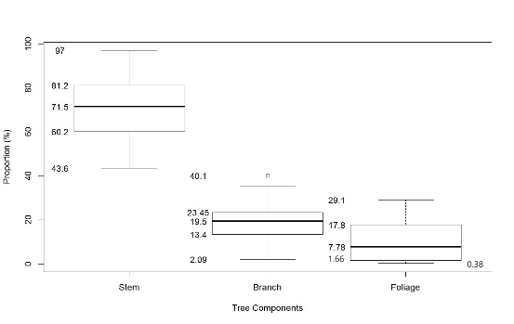
Fig 3. Boxplot of the proportion of tree component biomass: stem, branches, and foliage

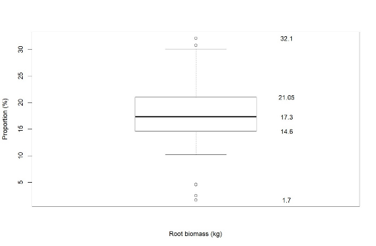
Fig 4. Boxplot of the proportion of root biomass to total biomass

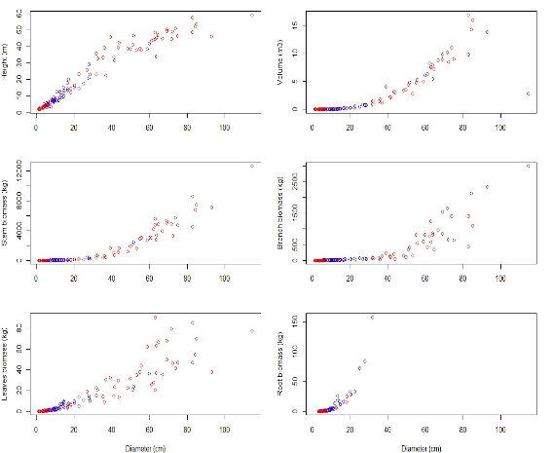
Fig 5. Relationship between D and H, stem volume and biomasses (red color represents natural forest and blue color represents planted forest)

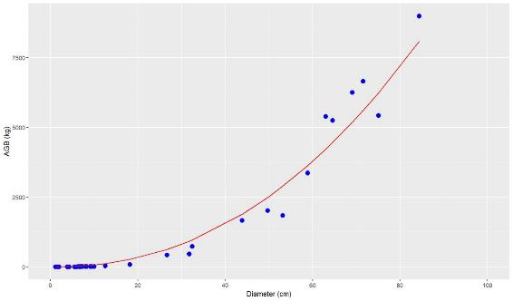

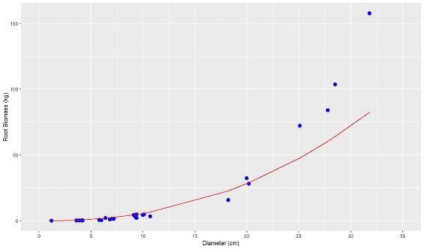

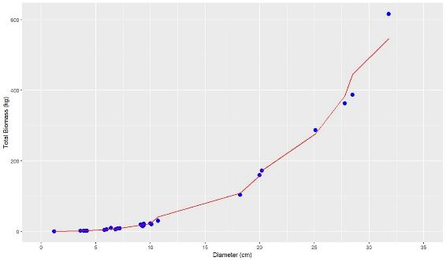

Fig 6. Ratio observed value with model allometric

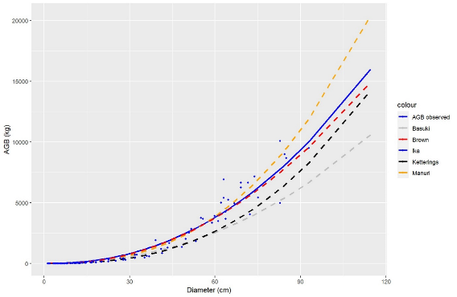

Fig. 7 Comparison of plot-level biomass using alternative equations from the literature

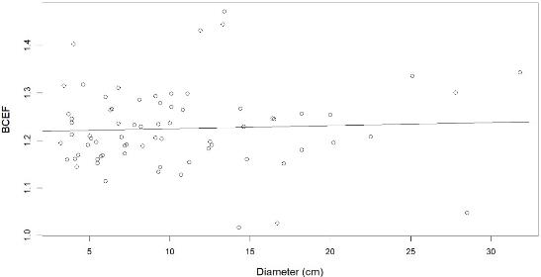
Fig 8. BCEF value distribution at several D of tree

Table 1. Site name, geographical coordinates, and altitudes of study plots.
No | Forest type | Site | Geographical coordinates and altitudes
1 | Primary forest | Bulungan,  East Kalimantan | Lat.  Long.  Alt. | : 02º56’093” - 02º58’057“N  : 116º32’557” - 116º35’101” E  : 200-600 m.asl
2 | 35 y - logged over area | Sei Beruang, Central Kalimantan | Lat.  Long.  Alt. | : 00°52’30” - 01°22’30” S  : 111°30’00” - 112°07’30” E  : 111- 600 m.asl
3 | 15 y - logged over area | Minas, Riau | Lat.  Long.  Alt. | : 00º49’438” – 00º50’138” N  : 101º28’340” – 101º28’499” E  : 8 – 100 m.asl
4 | 10 y - logged over area | Ogan,  South Sumatera | Lat.  Long.  Alt. | : 02º14’212” – 02º14’989” S  : 103º17’182” – 103º17’879” E  : 54 – 96 m.asl
5 | 12 y - Spacing trial | Gunung Dahu,  West Java | Lat.  Long.  Alt. | : 06º36’535” – 06º37’766” S  : 106º33’844” – 106º35’712” E  : 694 – 917 m.asl
6 | 16 y - Plantation | Haurbentes,  West Java | Lat.  Long.  Alt.g. | : 06o32 – 06º33 S  : 106º20 – 106º30 E  : 220 – 280 m.asl
7 | 6.5 y - Provenance trial | Ulu sedili,  Johor | Lat.  Long.  Alt. | : 01º44 – 01º95 N  :103º53 – 103º88 E  : 30 – 60 m.asl
8 | 17 y - Restoration trial | Chikus, Bidor,  Perak | Lat.  Long.  Alt. | : 04º05’338” – 04º05’559” N  : 101º11’328” – 101º11’462” E  : 30 – 60 m.asl
Notes: No. 1-4 are plots in natural forests, and 5-8 plots in planted forests

Table 2. Species and number of harvested trees that were collected from the experiment’s sites
Market Group | Species | Number of samples | Market Group | Species | Number of samples
Red Meranti | Shorea acuminate Dyer ^{R} | 6 | Red Meranti | S. scaberiana ^{R} | 1
 | S. assamica | 1 |  | S. stenoptera ^{R} | 2
 | S. falax ^{R} | 1 |  | S. teysmanniana Dyer | 1
 | S. glauca King | 1 |  | S. virescens ^{R} | 1
 | S. johorensis ^{R} | 3 |  | S. xantophylla ^{R} | 1
 | S. laevis ^{R} | 2 |  | S. bracteolate Dyer ^{R} | 7
 | S. leprosula Miq. ^{R} | 41 (38 ^{P}) |  | S. polyandra | 1
 | S. ovalis Bl. | 2 | Kapur | Dryobalanops fusca V.Sl | 3
 | S. palembanica Miq ^{R} | 3 |  | D. lanceolata Burck | 1
 | S. parvifolia Dyer ^{R} | 20 | Keruing | Dipterocarpus appendiculatus Scheff ^{R} | 5
 | S. patoensis ^{R} | 2 | Majau | Shorea compressa Burck | 4
 | S. pinanga ^{R} | 1 |  | S. seminis V.Sl | 2
 | S. platycarpa ^{R} | 1 | Yellow Meranti | S. gibbosa Brandis | 1
 | S. platyclados V.Sl | 1 |  | S. faguetiana Dyer | 2
 | S. polyandra ^{R} | 1 | White Meranti | S. retinodes V.Sl | 2
Notes: P samples from planted forest
R species with roots unearthing

Table 3. Equation for general allometric models developed in this study
No. | ID Model | Equation | Type Model
1. | IKA1a | $$AGB=aD^{b}$$ | Exponential
2 | IKA1b | $$AGB=a{\left(D^{2}H\right)}^{b}$$ | Self-Developed
3 | IKA 2a | $$AGB= \frac{aD}{\left(1+bD\right)}$$ | Michaelis-Menten
4 | IKA 2b | $$AGB= \frac{a\left(D^{2}H\right)}{\left(1+b\left(D^{2}H\right)\right)}$$ | Self-Developed
5. | IKA 3a | $$AGB=exp \left(a+b*lnD-c*{\left(lnD\right)}^{2}\right)$$ | Brown, 2011
6 | IKA 3b | $$AGB=exp\left(a+b*ln\left(D^{2}H\right)-c*{(ln\left(D\right))}^{2}\right)$$ | Self-Developed
7 | IKA 4a | $$AGB=exp\left(a+b*lnD\right)$$ | Basuki
8 | IKA 4b | $$AGB=exp\left(a+b*ln\left(D^{2}H\right) \right)$$ | Romero et al., 2022

Table 4. Characteristic of allometric models for aboveground biomass
Model | Equation | R² | R²_{adj} | RMSE | a | b | c
IKA1a | $$AGB=aD^{b}$$ | 0.949 | 0.949 | 67.115 | 0.4244** | 2.222***
IKA1b | $$AGB=a{\left(D^{2}H\right)}^{b}$$ | 0.959 | 0.959 | 42.852 | 0.084* | 0.8968***
IKA2a | $$AGB= \frac{aD}{\left(1+bD\right)}$$ | 0.144 | 0.133 | 1063.093 | 5.4028* | 0.8968***
IKA2b | $$AGB= \frac{a\left(D^{2}H\right)}{\left(1+b\left(D^{2}H\right)\right)}$$ | 0.885 | 0.884 | 388.40 | 0.5614 *** | -7.901e-07 ***
IKA3a | $$AGB=exp\left(a+b*lnD-c*{\left(lnD\right)}^{2}\right)$$ | 0.953 | 0.953 | 8.498 | -9.8673* | 6.4095** | -0.4843
IKA3b | $$AGB=exp\left(a+b*ln\left(D^{2}H\right)-c*{(ln\left(D\right))}^{2}\right)$$ | 0.961 | 0.960 | 24.18 | -4.956** | 1.245*** | -0.1
IKA4a | $$AGB=exp\left(a+b*lnD\right)$$ | 0.950 | 0.949 | 67.115 | -0.857* | 2.222***
IKA4b | $$AGB=exp\left(a+b*ln\left(D^{2}H\right) \right)$$ | 0.960 | 0.959 | 42.853 | -2.474*** | 0.897***
Notes: * : significant at 10% significant level
** : significant at 5% significant level
***: significant at 1% significant level

Table 5. Characteristic of allometric models for aboveground biomass (RB)
Model | Equation |  | R² | R² _{adj} | RMSE | a | b | c
IKA1a | $$RB=aD^{b}$$ |  | 0.867 | 0.867 | 0.314 | 0.028* | 2.309***
IKA1b | $$RB=a{\left(D^{2}H\right)}^{b}$$ |  | 0.831 | 0.828 | 0.173 | 0.028 | 0.787***
IKA2a | $$RB= \frac{aD}{\left(1+bD\right)}$$ |  | 0.81 | 0.807 | 0.957 | 0.463*** | -0.032***
IKA2b | $$RB= \frac{a\left(D^{2}H\right)}{\left(1+b\left(D^{2}H\right)\right)}$$ |  | 0.786 | 0.781 | 1.03 | 6.34e-01*** | -8.23e-05***
IKA3a | $$RB=expexp \left(a+b*lnD-c*{\left(lnD\right)}^{2}\right)$$ |  | 0.89 | 0.89 | 0.09 | -14.647** | 10.472** | -1.492*
IKA3b | $$RB=expexp \left(a+b*ln\left(D^{2}H\right)-c*{(ln\left(D\right))}^{2}\right)$$ |  | 0.86 | 0.85 | 19.73 | -1.597 | 0.262 | 0.295**
IKA4a | $$RB=expexp \left(a+b*lnD\right)$$ |  | 0.87 | 0.87 | 0.314 | -3.575*** | 2.309***
IKA4b | $$RB=expexp \left(a+b*lnD^{2}H\right)$$ |  | 0.83 | 0.83 | 0.831 | -3.579*** | 0.787***
Notes: * : significant at 10% significant level
** : significant at 5% significant level
***: significant at 1% significant level

Table 6. Allometric model for Total Biomass (TB)
Model | Equation | R² | R² _{adj} | RMSE | a | b | c
IKA1a | $$TB=aD^{b}$$ | 0.927 | 0.925 | 1.4 | 0.094* | 2.484***
IKA1b | $$TB=a{\left(D^{2}H\right)}^{b}$$ | 0.953 | 0.951 | 0.1 | 0.05** | 0.925***
IKA2a | $$TB= \frac{aD}{\left(1+bD\right)}$$ | 0.86 | 0.857 | 5.326 | 2.391*** | -0.033***
IKA2b | $$TB= \frac{a\left(D^{2}H\right)}{\left(1+b\left(D^{2}H\right)\right)}$$ | 0.19 | 0.17 | 25.11 | 6.34e-01*** | -8.23e-05***
IKA3a | $$TB=expexp \left(a+b*lnD-c*{\left(lnD\right)}^{2}\right)$$ | 0.96 | 0.96 | 1.02 | -15.28*** | 11.85*** | -1.69**
IKA3b | $$TB=expexp \left(a+b*ln\left(D^{2}H\right)-c*{(ln\left(D\right))}^{2}\right)$$ | 0.97 | 0.96 | 0.363 | -2.46*** | 0.79*** | 0.07
IKA4a | $$TB=expexp \left(a+b*lnD\right)$$ | 0.94 | 0.94 | 1.4 | -2.367*** | 2.484***
IKA4b | $$TB=expexp \left(a+b*lnD^{2}H\right)$$ | 0.96 | 0.96 | 0.1 | -3.00*** | 0.925***
Notes: * : significant at 10% significant level
** : significant at 5% significant level
***: significant at 1% significant level

Table 7. Validation Test for Aboveground Biomass (ABG), root, and total biomass
Biomass | Equation | T-Test | P-value
AGB | $$AGB=0.4244{(D)}^{2.222}$$ | 0.017 | 0.986
Root | $$RB= -3.575+2.309(lnD)$$ | 0.60 | 0.55
Total | $$TB=exp⁡(-3.00+0.925*(lnD^{2}H))$$ | -0.016 | 0.987

Table 8. The comparison was carried out for equations based on the log-log linear function of D for Manuri et al. 2016; Basuki et al.2009; Ketterings et al.2001; and Brown 1997.
No. | Equation | t.test | p-value | Reference
1. | $$AGB=0.108*{(DBH)}^{2.562}$$ | 0.244 | 0.81 | (Manuri et al. 2016)
2. | $$AGB=0.318*{(DBH)}^{2.196}$$ | 1.7 | 0.08 | (Basuki et al. 2009)
3. | $$AGB=0.066*{(DBH)}^{2.59}$$ | 1.32 | 0.188 | (Ketterings et al. 2001)
4. | $$AGB = 42.69 – 12.8*D + 1.242*D^{2}$$ | 0.15 | 0.88 | (Brown 1997)

Table 9. BCEF for D ranges of dipterocarp species in the tropics
Diameter (cm) |  | BCEF
Min | Max | Min | Max | Average | Deviation
3.2 | 31.8 | 1.02 | 1.47 | 1.22 | 0.08

