Microbial Assessment of Cow Milk Quality and Production Practices in District Gilgit
Shahnawaz Qasim¹, Sartaj Khalil², Azhar Hussain¹, Khalida Dawar¹
Corresponding Author: Azhar Hussain (Assistant Professor), azhar.hussain@kiu.edu.pk
¹Department of Agriculture and Food Technology Karakoram International University Gilgit, Gilgit-Baltistan Pakistan
²Department of Health, Government of Gilgit-Baltistan
Abstract
To assess the microbial quality of the cow’s raw milk from different villages of district Gilgit Pakistan, a total of 175 respondents were interviewed and 50 samples were collected for laboratory analysis. Methylene blue reduction test (MBRT), total Bacterial count (TBC) and total coliform count (TCC) were conducted for milk quality assessment. The result shows that, the majority of the interviewed personnel didn’t wash their hands, udders/teats of cows and milking utensils before milking. The source of water was tap and stream water for washing purposes. Barn condition of the villages was mostly dusty, and the majority of respondent cleaned the barn daily. Milk was processed and refrigerated by most of the respondents after milking. A few respondents used injections and supplements before milking in the study area. The MBRT result ranges from 1 hour to 8.5 hours, TBC ranging from 2.16x10⁶ to 1.008x10⁷ and TCC ranging from 3x10⁵ to 6.56x10⁶. Most of the milk samples were of fair quality having average MBR time. Both the TBC and TCC have values above the upper limits set 10⁶. As result shows most of the milk consumed in district Gilgit were of low quality. The main causal agent of low milk quality is poor hygienic condition, poor quality water used for cleaning, poor barn condition.
Key Words: Milk quality, Milk borne diseases, Total bacterial count, Total Coliform Count, Methylene Blue Reduction Test.

Introduction:

Due to high nutritional value of milk it is used as an important food by vast population on earth. From public health point of view its hygienic quality is most important. (Muhammad et al., 2009). With respect to foodborne diseases the safety of dairy products is a great concern around the world, especially in third world countries where production of milk and numerous dairy products take place under unhygienic conditions and poor production practices (Ashenafi, 1990; Negash et al., 2012; Asaminew and Eyassu, 2011; Tola et al., 2007).
Instead of its nutritive value, milk is considered as one of the most important diet items among masses. Nutritionally, milk has been defined as “the most nearly perfect food” and it is an outstanding source of calcium and phosphorus for bones and teeth, also contains vitamin B6, A and B1 in significant amounts. (Reta et al, 2015; Marjan et al., 2014). Milk contain almost same chemical constituent but concentrations varies according to its sources, like cow, goat, buffalo, sheep etc. Different factors effects on the composition of milk including species of animals, breed, stage of lactation, frequency of milking, age, seasonal variation, feed, disease, abnormal conditions, and administration of drugs and hormones (Ensminger., 1993). High water content, nearly neutral pH, and variety of available essential nutrients in raw or processed milk is a well-known good growth medium that supports the growth of several microorganisms (Soomro et al., 2002; Teka, 1997).
Quality of raw milk is reduced due to the presence of bacteria in milk and certain bacterial contaminants with their associated enzymes and toxins may even survive after pasteurization and create health risks (Oliver et al., 2005). From the exterior of the udder and from the surface of milk handling and storage equipment microbial contamination can take place. Raw milk Bacterial contamination can originate from different sources: air, milking equipment, feed, soil, feces and grass (Marjan et al., 2014). It is assumed that differences in feeding and housing approaches of cows may also affect the microbial quality of milk (Torkar & Teger, 2008).
The study focused to assess hygienic practices in milking techniques and microbial evaluation of different milk sample.

Materials and methods:

Description of the Study Area:
The study was carried out in District Gilgit, Gilgit Baltistan, Pakistan. The specific towns of study sites were Jalalabad, Oshkandas, Danyore, Sultanabad and Nomal of Gilgit district. The farming system in these study area is mixed crop-livestock farming system.

Study design
A laboratory work was conducted to check the milk hygiene and bacteriological load in the milk while a questionnaire base study will also be conducted to evaluate the hygienic practices in milking by the milk producers.

Data Collection:
The study has divided in to two parts, firstly the questionnaire base; in which, a questionnaire was designed to collect information of possible risk of contamination and extraneous materials. Secondly the laboratory work which was conducted in food microbiology laboratory at Department of Agriculture and Food Technology, Karakorum International University, Gilgit Baltistan, Pakistan.

Sampling:
Raw milk sample was collected from the cattle holders of the study area of Gilgit. A total of 50 milk samples was collected from the study area. From each town 10 samples were collected to determine the milk quality. For the questionnaire survey 150 animal owners are interviewed. The sample was transported to the laboratory according to (ICMSF) rule.

Questionnaire survey:
A questionnaire were designed to evaluate the hygienic practices of dairy farms and gather information about hazard of bacterial contamination in milk. Sanitary condition of milking environment, hygiene of cows’ udder and milk handlers, hygienic status of milking utensils and awareness in milkman on milk’s risk factors were major factors considered.

Microbiological Analysis:

Serial dilution:
One ml from each sample of raw milk was transferred to 9 ml sterile 0.1% peptone water and thoroughly mixed to give 1:10 dilution. Serial dilution were made by transferring 1 ml of the previous dilution in 9 ml of sterile peptone water.

Total Bacterial Count:
Total Bacterial count was measured on nutrient agar plate prescribed by (ISO 6730, 2005). The sample (0.5 ml) from the last dilution was taken in the sterile petridish and poured the nutrient agar. The plate will inoculate for 24 hours at 37⁰C. The total Bacterial count will be measured in CFU/ml.

Total Coliform Count:
Coliform count was done using MacConkey agar medium according to Colins et al. (1989). Typical pink colonies will be counted for determination of Total Coliform after incubation of plates at 37◦C for 24 hours.

Methylene Blue Reduction Test:
Hygienic status of the raw milk samples can be determined using methylene blue reduction (MBR) test (Benson, 2002). One ml of methylene blue solution (1:25000) was transferred to labeled and sterilized 20 ml screw caped test tube containing 10 ml of each of the samples. The tubes were caped and gently inverted three times to mix up the dye with milk sample. Each of the tube will be incubated at 370C and examined after every 2 hours up to 8 hours. The time taken by the methylene blue in milk to become colorless was recorded.

Result and Discussion:
The overall purpose of this study was to assess the hygienic condition, bacterial quality of raw cow milk in selected areas of district Gilgit. In general, the present outcomes showed that, there are numerous practices commenced at farm level such as barn condition, barn cleaning frequency, washing hands and udder/teats before milking, water used for cleanliness (hands and milk equipment’s), and type of storage containers used and milk storage duration under room temperature. Apart from that, it was observed that usage of medicine or injections before milking and purpose of milking.
Utensils mostly metal pots (84%) were used among the respondents whereas plastic and wooden pots were also used by producers as (11.8%) and (4.2%) respectively as shown in (table 1). Depiazzi and Bell (2002), reported that pre-milking udder preparation and teat cleanliness play significant role in the microbial load of milk, mastitis diseases, and environmental contamination of raw milk during milking. Recent study shows that majority of producers (69.4%) wash the cow’s udder/teats before milking while the rest (30.6%) were don’t do that. Similar to this study, Haile et al. (2012) reported that 82.5% of the small size farms holding households in Hawassa city are performing pre milking udder washing. Washing of the udder before milking is vital to remove both detectable dirt and bacteria from the external surface of the udder. Damp teats permit skin and environmental bacteria access to mammary gland easily (Ruegg, 2006). Hand washing practices were also done by the respondents across the study area. The water used for cleaning is of poor quality or they don’t dry their hands, utensils and udder before milking.
Production of milk of good hygienic quality for consumers requires good hygienic practices (clean milking utensils, washing milker’s hands and washing the udder) during milking and handling, before delivery to consumers or processors (Getachew, 2003). In the study area most of the respondent clean their milking utensils before milking however the cleaning water were un-hygienic and cleaning practice is insufficient to remove residues of milk and microbes. Contamination of milk may cause due to surfaces, such as hands coming with contact with milk and milking utensils. Farmers use water for different purposes from different sources (to clean milking equipment and hands) is limited to river and tap water. However, the quality of both river and hand tap waters used for cleaning are of poor quality. According to Zelalem (2009), when non-tap water is used for the purpose of cleaning, than water should be treated with heat or filtered because water quality is responsible for bacterial count. Milking frequency amongst the respondents, mostly (75.6%) milk twice a day but a few (24.4%) milk cows once.
Table 1. Hygienic practices practiced by the farmers in the study area.
Hygienic Practices | Study Areas |  |  |  |  | Total  n=175
 | Jalalabad  n=35 | Oshkandas  n=35 | Danyore  n=35 | Sultanabad  n=35 | Nomal  n=35
Utensils used for milking
Metallic | 91% (32) | 70%(25) | 78%(27) | 100%(35) | 81%(28) | 84%(147)
Plastic | 9%(3) | 20%(7) | 11%(4) | 0%(0) | 19%(7) | 11.8%(21)
Wooden | 0%(0) | 10%(3) | 11%(4) | 0%(0) | 0%(0) | 4.2%(7)
Utensils washing frequency
Daily | 63%(22) | 100%(35) | 74%(26) | 80%(28) | 81%(28) | 79%(139)
Twice a week | 20%(7) | 0%(0) | 21%(7) | 20%(7) | 6%(2) | 13%(23)
Weekly | 17%(6) | 0%(0) | 5%(2) | 0%(0) | 13%(5) | 7%(13)
Wash hands before milking
Yes | 100%(35) | 100%(35) | 89%(31) | 80%(28) | 100%(35) | 94%(164)
No | 0%(0) | 0%(0) | 11%(4) | 20%(7) | 0%(0) | 6%(11)
Source of water for washing
Tap Water | 91%(32) | 100%(35) | 89%(31) | 100%(35) | 94%(33) | 95%(166)
Stream Water | 9%(3) | 0%(0) | 11%(4) | 0%(0) | 6%(2) | 5%(9)
Wash udder and teats before milking
Yes | 54%(19) | 90%(31) | 54%(19) | 80%(28) | 69%(24) | 69%(121)
No | 46%(16) | 10%(4) | 46%(16) | 20%(7) | 31%(11) | 31%(54)
Milking Frequency
Once a Day | 27%(9) | 40%(14) | 16%(6) | 20%(7) | 19%(7) | 24%(43)
Twice a Day | 73%(26) | 60%(21) | 84%(29) | 80%(28) | 81%(28) | 76%(132)
As shown in table 2 there is a significance difference with the five villages having dusty conditions and muddy conditions used for their cattle which is a similar finding of (Gurmessa, 2014). However using clean, dry and dusty bedding is necessary to minimize the growth of pathogenic microorganisms. As Ruegg, (2006) stated that practice that expose the teat end to organic bedding sources, wet and muddy pens increase the risk occurrence of mastitis and milk contamination. Similarly Donald, (1998) stated that maintaining the sanitary condition of the barn is important for the production of good quality milk. As the respondents reported most of (32.6%) clean the barn daily, some of them (20.4%) clean twice a week, 21.8% and 25.2% respondents clean their barn/shed cleans weekly and monthly respectively. production of milk and milk products of acceptable level needs proper and clean housing environment. (Asaminew, 2007).
Table 2. Barn cleaning condition and cleaning frequency of the study area.
Variables | Study Area |  |  |  |  | Total  n=175
 | Jalalabad  n=35 | Oshkandas  n=35 | Danyore  n=35 | Sultanabad  n=35 | Nomal  n=35
Bedding Condition
Dusty | 71%(25) | 80%(28) | 66%(23) | 40%(14) | 63% | 64%(112)
Muddy | 29%(10) | 20%(7) | 34%(12) | 60%(21) | 37% | 36%(63)
Barn cleaning frequency
Daily | 43%(15) | 57%(20) | 17%(6) | 12%(4) | 34%(12) | 32.6%(57)
Twice a week | 25%(9) | 23%(8) | 20%(7) | 14%(5) | 20%(7) | 20.4%(36)
Weekly | 20%(7) | 14%(5) | 23%(8) | 23%(8) | 29%(10) | 21.8(38)
Monthly | 12%(4) | 6%(2) | 40%(14) | 51%(18) | 17%(6) | 25.2%(44)
General milk handling practices are shown in table 3 which indicates the storage condition, medication, purpose of milking, animal feeding regimes and milk processing after milking.
Table 3. General milk handling practices by producers in five villages of district Gilgit.
Variables | Study Areas |  |  |  |  | Total
 | Jalalabad | Oshkandas | Danyore | Sultanabad | Nomal
Storage after milking
Refrigerator | 36%(13) | 60%(21) | 68%(24) | 60%(21) | 69%((24) | 58.6%(103)
Cool place | 64%(22) | 40%(14) | 21%(7) | 20%(7) | 31%(11) | 35.2%(61)
Room temperature | 0%(0) | 0%(0) | 11%(4) | 20%(7) | 0%(0) | 6.2%(11)
Medication before milking
Yes | 9%(3) | 20%(7) | 5%(2) | 20%(7) | 19%(7) | 14.6%(26)
No | 91%(32) | 80%(28) | 95%(33) | 80%928) | 81%(28) | 85.4%(149)
Purpose of Milking
House hold use | 91%(32) | 100%(35) | 79%(28) | 100%(35) | 100%(35) | 94%(165)
Comercial use | 9%(3) | 0%(0) | 21%(7) | 0%(0) | 0%(0) | 6%(10)
Animal feeding frequency
Twice a day | 27%(10) | 50%(18) | 0%(0) | 20%(7) | 6%2) | 20.6%(37)
Thrice a day | 45%(16) | 40%(14) | 37%(13) | 60%(21) | 81%(28) | 52.6%(92)
Four times a day | 18%(6) | 0%(0) | 63%(22) | 20%(7) | 6%(2) | 21.4%(37)
More than above | 9%(3) | 10%(3) | 0%(0) | 0%(0) | 7%(3) | 5.2%(9)
Milk processing
Yes | 91%(32) | 100%(35) | 47%(16) | 100%(35) | 88%(31) | 85.2%(149)
No | 9%(3) | 0%(0) | 53%(19) | 0%(0) | 12%(4) | 14.8%(26)

Methylene Blue Reduction Test (MBRT)
The data obtained from Methylene Blue Reduction Test (MBRT) result are given in Table 4a and 4b. Among 50 raw milk samples 10 from each selected villages of district Gilgit, there were only 1 sample have the excellent quality. 19 samples were found of good quality, 27 found of fair quality and only 3 quality were of poor quality.
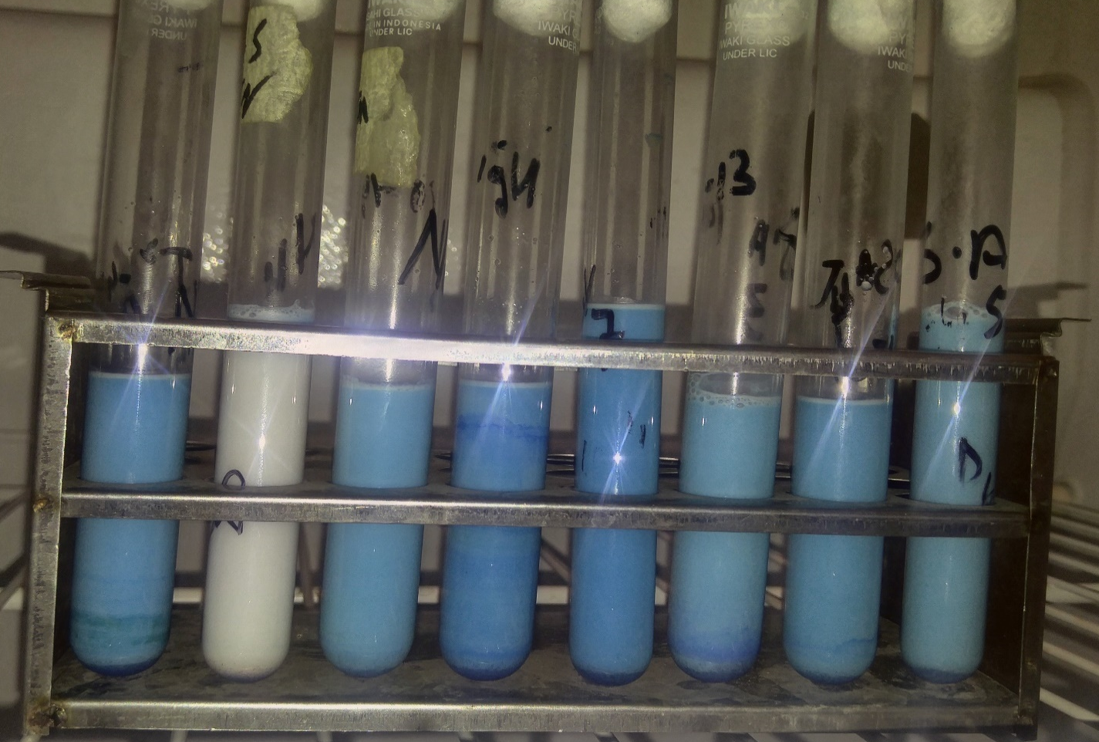
Fig 1. MBRT test result in lab during analysis of milk quality.

Table 4(a). Mean values of MBRT of different milk samples collected from the Study Areas.
Quality | Parameters | MBRT Result
Excelent | >8 Hours | 1
Good | 6-8 Hours | 19
Fair | 2-6 Hours | 27
Poor | < 2 Hours | 3

Quality | Parameters | MBRT Result
Excellent | >8 Hours | 1
Good | 6-8 Hours | 19
Fair | 2-6 Hours | 27
Poor | < 2 Hours | 3

Fig 2. Mean values of MBRT of different milk
Samples collected from the Study Area.
The results obtained from the five different villages of district Gilgit are found highly significant. The mean values of Excellent, Good, Fair, and Poor for Jalalabad were 0, 4, 6, and 0 whereas 1, 4, 5, 0 was recorded for Oshkandas and 0, 2, 6 and 2 in Danyore, respectively. Sultanabad were 0, 3, 7 and 0 and 0, 6, 3 and 1 are recorded for Nomal, respectively. Among these villages Danyore milk samples contains only 2 good quality samples 6 of fair and 2 are poor quality. After Danyore Sultanabad milk samples have only 3 good quality milk among collected samples.
Nomal and Jalalabad milk samples contain 6 and 4 good quality milk samples, 3 and 6 are of fair quality respectively. Amongst all the selected village milk samples Oshkandas have only 1 excellent quality sample, 4, 5 are of good and fair quality respectively. Results shows that Oshkandas have better quality milk than other villages.
Table 4(b). Mean value of Methylene Blue Reduction Test (MBRT) in study area of district Gilgit
Quality | Parameters | Study Area
 |  | Jalalabad | Oshkandas | Danyore | Sultanabad | Nomal
Excellent | >8 Hours | 0 | 1 | 0 | 0 | 0
Good | 6-8 Hours | 4 | 4 | 2 | 3 | 6
Fair | 2-6 Hours | 6 | 5 | 6 | 7 | 3
Poor | < 2 Hours | 0 | 0 | 2 | 0 | 1
Fig 3. Mean value of Methylene Blue Reduction Test (MBRT) in study area of district Gilgit

Total Bacterial Count (TBC)
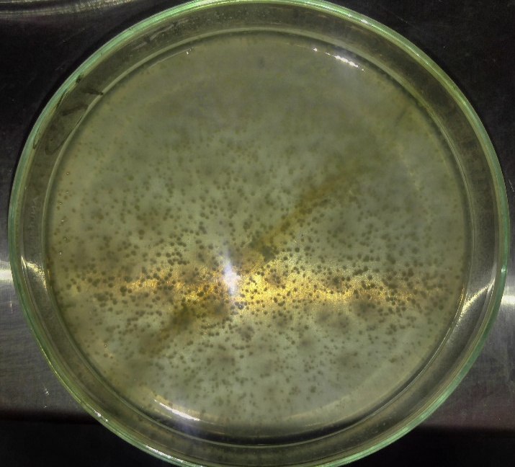
Fig 4. Pictures taken during total bacterial count (TBC) analysis of milk samples
The mean for total Bacterial count of raw milk sampled from five villages of district Gilgit are shown in Table 4. The overall mean TBC was 263, 217, 336, 326 and 275 colonies were counted for milk samples collected from Jalalabad, Oshkandas, Danyore, Sultanabad and Nomal, respectively. Result shows that there is significant difference in different villages.
Table 5. Mean value of total bacterial count (TBC) in study area of district gilgit
Villages | Total Viable Count
Jalalabad | 263
Oshkandas | 217
Dyanore | 336
Sultanabad | 326
Nomal | 275

Total Coliform Count (TCC)
Fig 5. Pictures taken during total Bacterial count analysis of milk samples
Total Bacterial count of bacteria were also been analyzed in the laboratory. The total coliform count in the milk samples tested at laboratory are given in table 5. Total coliform result is same as total Bacterial count as discussed above. Samples collected from Danyore have most no of coliforms as compare to others villages sample, whereas Oshkandas village sample have shown the low count of coliforms. All the results given in the table are mean values of 10 samples which was collected from each specific villages of district Gilgit.
Table 6. Mean value of total coliform count (TCC) in study area of district Gilgit
Villages | Total Coliform Count  1:10,000
Jalalabad | 139
Oshkandas | 129
Danyore | 219
Sultanabad | 205
Nomal | 169

REFERENCES:
Asaminew T. and Eyassu S. 2011. Microbial quality of raw cow's milk collected from farmers and dairy cooperatives in Bahir Dar Zuria and Mecha district, Ethiopia. Agriculture and Biology Journal of North America. 2 (1): 29-33.
Asaminew Tassew, 2007. Production, handling, traditional processing practices and quality of milk in Bahir Dar milk shed area, Ethiopia. M.Sc. Thesis, Haramaya University of Agriculture, Dire Dawa, Ethiopia.
Ashenafi M. 1990. Microbiological quality of ayib, a traditional Ethiopian cottage cheese. International Journal of Food microbiology. 10(3-4): 263-268.
Benson, J. H. (2002). Microbiological applications: Laboratory manual in general Microbiology, 8th Edition. 1 -478 pp.
Collins C. H, P. M. Lyne and J. M. Grange (1989). Counting Microorganisms In “Microbiological Methods”, 6th Edition, Butterworth/Heinemann 127-140 pp
Depiazzi, L.J. and Bell, J.R. (2002): Effect of pre-milking teat sanitation on the quality of raw milk. Department of Agriculture, Government of Western Australia. South Western Highway Bunbury, W.A. 6230, Bulletin 4563.
Donald D.M. (1996): the shelf-life of dart products: 2. Raw milk and fresh product. Inter Jour. of Dairy Technos, 49, 44-48.
Ensminger M. E. (1993). Milk Secretion and Handling in “Dairy Cattle Science, 3rd Edition, Interstate Publishing, Inc., Danville, Illinois 416-422 pp.
Getachew, F. (2003): A Review of the small scale dairy sector in Ethiopia. FAO prevention of food losses programme. Milk and milk products, post-harvest losses and food safety in sub-Saharan Africa and Near East.
Grumessa T., 2014. Physicochemical Properties and Microbial Quality of Raw Cow’s Milk in Ybello District Borena Zone, Southern Ethiopia. MSc Thesis. Haramaya University, Ethiopia.
Haile, W., Zelalem, Y. and Yosef, T.G. (2012): Hygienic practices and microbiological quality of raw milk produced under different farm size in Hawassa, Southern Ethiopia. Agric. Res. and Rev., 1: 132- 142.
ISO 6730. Milk – Enumeration of colony-forming units of psychrotrophic microorganisms – Colony-count technique at 6.5 degrees C. International Organization for Standardization, Genova, Switzerland, 2005, 1–6.
K. Muhammad, I. Altaf, A. Hanif, A. A. Anjum and M. Y. Tipu. (2009). MONITORING OF HYGIENIC STATUS OF RAW MILK MARKETED IN LAHORE CITY, PAKISTAN. Journal of Animal & Plant Sciences 19(2):74-77 pp.
Marjan, S., K. K. Das, S. K. Munshi, and R. Noor. 2014. Drug-resistant bacterial pathogens in milk and some milk products. Nutn. Food Sci. 44 (3):241-248 pp.
Melese Abate Reta, Addisu Hailu Addis. (2015). Microbiological Quality Assessment of Raw and Pasteurized Milk. International Journal of Food Science and Microbiology Vol. 2 (6), pp. 087-091
Negash F., Tadesse E. and Woldu T. 2012. Microbial quality and chemical composition of raw milkin the MidRift Valley of Ethiopia. African Journal of Agricultural Research. 7(29): 4167-4170.
Oliver S.P., Jayarao B.M. and Almeida R.A. 2005. Foodborne pathogens in milk and the dairy farm environment: Food Safety and Public Health Implications. Foodborne Pathogens and Disease. 2(2): 115-129.
Parekh TS and Subhash R (2008) Molecular and bacteriological examination of milk from different milch animals with special references to coliforms. Curr. Res. Bacteriol. 1(2), 56-63.
Ruegg L., 2006. Role of hygienic in efficient milking. WCDS advances in Dairy Technology. Department of Dairy Science, University of Wisconsin, 18: 285-293.
Soomro AH, Arain MA, Khaskheli M, BhutoB(2002). Isolation of E. coli from raw milk and milk products in relation to public health sold under market conditions at Tandonjam, Pakistan. J. Nut. 1 (3): 151 -152.
Teka G (1997). Food Hygiene Principles and Food Borne Disease Control with Special Reference to Ethiopia. 1st Ed, Faculty of Medicine, Department of Community Health, Addis Ababa University Ethiopia. 73-86.
Tola A., Ofodile L.N.and Beyene F. 2007. Microbial quality and chemical composition of raw whole milk from Horro cattle in East Wollega, Ethiopia. Ethiopian Journal of Education and Sciences. 3(1): 1-10.
Torkar KG and Teger SG (2008) The Microbiological quality of raw milk after introducing the two day's milk collecting system. Acta Agri. Slovenica. 92(1), 61–74.

