Running title : Utilization of Fungi Consortium as Biofertilizer
Isolation and a Potential Test of Fungi Consortium from Rice Fields, Forests, Vegetable Gardens, and Residential Lands on The Western Slope of Lawu Mountain as Biofertilizer.
Retno Rosariastuti*, Nanda Mutiara Pradiana Wulandari, Setya Nugraha, Evi Irawan, Siti Maro’ah, Sumani
Department of Soil Science. Faculty of Agriculture, Sebelas Maret University, Surakarta, 57126, Indonesia
* For correspondence: retnobs@staff.uns.ac.id
Received_____________; Accepted_____________; Published____________
Novelty Statement
There is no information on the exploration and utilization of fungi consortia from several land uses on the western slope of Lawu Mountain as biofertilizers. From the exploration results, functional fungi species were obtained that can be used as material for biofertilizers. The test results of the fungi consortium as a biofertilizer were able to increase growth in Pakcoy plants (Brassica rapa L.). The use of fungi consortium four land use on the western slope of Lawu Mountain as a biofertilizer is expected to be used as an alternative to reduce the use of inorganic fertilizers.
Abstract
The mountainside area is one example of an area with potential for agricultural development. The research aimed to explore fungi in paddy fields (LS), forest land (LH), vegetable garden land (LY), and residential land (LP) on the western slope of Lawu Mountain. This research consisted of two types, which were descriptive-exploratory and experimental in the greenhouse with Pakcoy (Brassica rapa L.) as the test plant. Fungi isolation was carried out by culturing soil samples on potato dextrose agar medium with the spread plate method and then observed for morphology, physiology, and molecular identification. Biofertilizer production was done by culturing the fungi consortium in potato dextrose broth medium. Pakcoy planting was done using a randomized complete design (CRD) with regosol soil as the planting medium. Plant height and leaf number were observed. The research was conducted from May 2022 to February 2023. The results of fungi isolation obtained four fungi species, there were Aspergillus flavus, Aspergillus ibericus, Aspergilus aculeatus, and Aspergillus sp. The test results of the potential of the fungi consortium as a biofertilizer showed that the forest land (LH) fungi consortium treatment gave the best average result in Pakcoy plant yields.
Keywords: Lawu Mountain, Land Use, Fungi, Exploration, Biofertilizer
Introduction
Lawu Mountain located on the border of Karanganyar Regency in Central Java, with Ngawi Regency and Magetan Regency in East Java. According to Noviani et al. (2020), most of the soil types on Lawu Mountain are Andisol soils. Vistoso et al. (2021), stated that volcanic soils such as Andisol have low available phosphorus (P) content. According to Poblete-Grant et al. (2020), Andisol soils are rich in minerals such as allophane, iron (Fe), and aluminium (Al) which cause high phosphorus (P) uptake in Andisol soils. Different land use will affect the abundance of microorganisms in the soil. Based on the results of research conducted by Moora et al. (2014), it can be seen that different types of land use will affect the type and abundance of fungi in the soil. This allows the existence of functional fungi such as P-solubilizing fungi, K- solubilizing fungi, and nitrogen fixing fungi in the soil so that the soil is attractive to be used as a source of isolates.
In general one of the efforts made by farmers to increase agricultural products is to prioritize the use of inorganic fertilizers because they are considered easier to apply. Guo et al. (2021). stated that excessive use of inorganic fertilizers over a long time can cause serious problems such as soil degradation, greenhouse gas emissions, and food insecurity. To reduce the use of inorganic fertilizers, specifically explicitly an alternative can be used, specifically biofertilizers that utilize microorganisms such as functional fungi. According to Hammad et al. (2020), of using organic fertilizers can improve soil quality and sustainable crop productivity because has they have many functions in agroecosystems.
The purpose of this research is to obtain biological fertilizer materials in the consortium of fungi obtained through the exploration process in rice fields, forests, vegetable gardens, and residential land. According to Mohsen et al. (2022), a biofertilizer is a fertilizer that one or more microorganisms can convert unavailable nutrients into more available to plants. According to Kumar et al. (2017), fungi in biofertilizers can provide plant-available nutrients through biological processes such as nitrogen fixation, dissolving K, and dissolving P. Raimi et al. (2021), noted that the advantages of natural fertilizers compared to chemical fertilizers are that they are more cost-effective and environmentally friendly and ensure sustainable agricultural production.
The utilization of biological technology made from active microorganisms such as functional fungi is one of the efforts that can be made to support sustainable agriculture. Mitter et al. (2021), stated that biofertilizers are considered an essential component in supporting sustainable agriculture, which provides long-term effects on soil fertility. Therefore, fungi consortia must be explored to obtain functional fungi isolates that can be used as biofertilizers.
Materials and Methods
Methods
The research was divided into two stages, there exploration of fungi consortia and the testing potential of fungi consortia as biofertilizers. The first stage was descriptive-exploratory with a survey method to obtain fungi isolates. The second stage used an experimental method in a greenhouse using pakcoy plants and the design used was a complete randomized design (CRD) consisting of five treatments, which were NPK fertilizer (N) as a control, paddy fields fungi consortium biofertilizer (LS), forest land fungi consortium biofertilizer (LH), vegetable garden land fungi consortium biofertilizer (LY), and residential land fungi consortium biofertilizer (LP). All treatments were replicated three times, so there were 15 experimental units with a spacing of 30 x 30 cm between pots. The observation variables consisted of morphological identification of fungi, physiological identification of fungi, molecular identification of fungi, and chemical analysis of soil consisting of soil pH (Electrometry), C-Organic (Walkey and Black), N-Total (Kjedahl), P-Available (Oslen), K-Available (Flamefotometer).
Time and Location
This study was conducted from May 2022 to February 2023 located on the western slope of Lawu Moutain, Karanganyar Regency, Central Java Province, Indonesia for soil sampling as a source of fungi isolates using the survey method. The survey was conducted on four land uses consisting of paddy fields (7°40 ̍13.58 ̎LS, 111°6 ̍9.45 ̎BT for upper slopes and 7°39 ̍50.07 ̎LS, 111°5 ̍29.72 ̎BT for lower slopes), forest land (7°40 ̍38 ̎LS, 111°8 ̍57.5 ̎BT for upper slopes and 7°40 ̍35.38 ̎LS, 111°8 ̍58. 61 ̎BT for the lower slope), vegetable garden land (7°39 ̍50.42 ̎LS, 111°10 ̍0.87 ̎BT for the upper slope and 7°40 ̍4.68 ̎LS, 111°9 ̍45.93 ̎BT for lower slopes), and residential land (7°40 ̍4.64 ̎LS, 111°7 ̍25.66 ̎BT for upper slopes and 7°39 ̍50.34 ̎LS, 111°5 ̍26.71 ̎BT for lower slopes).
The soil was then brought to the Laboratory of the Faculty of Agriculture, Sebelas Maret University for microbiological analysis and soil chemical analysis. Microbial analysis was conducted at the Soil Biology and Biotechnology Laboratory while chemical analysis was conducted at the Soil Chemistry Laboratory.
Sampling
Sampling was conducted in May 2022. Soil sampling was carried out around the plant rhizosphere, for each type of land use two samples were taken, one from the upper slope and one from the lower slope. For each point, soil samples were taken at an effective depth of about 20 cm from the soil surface and a non-effective depth of up to 50 cm.
Fungi Exploration
Fungi Isolation: Fungi isolation was carried out by growing fungi from four land uses (LS, LH, LY, and LP) on the western slope of Lawu Mountain on potato dextrose agar medium. The next process was to prepare the isolate source by dissolving 5 grams of soil samples in 45 ml of physiological salt and then shaking until homogeneous and settled, then 1 ml of the sedimented solution was taken, put into a reaction tube with 9 ml of physiological salt, and then labeled the reaction tube with the code 10⁻². Serial dilutions were carried out until obtaining a 10⁻⁵ dilution. The results of each dilution were cultured into a petri dish containing PDA medium that had solidified and then incubated at room temperature. After that, a mixed culture was obtained, then purification was carried out by transferring one different fungi colony to a new sterile potato dextrose agar medium until a single culture was obtained.
Identification of Fungi Morphology and Physiology: Morphological identification of fungi which was successfully isolated is carried out using macroscopic and microscopic observations. Macroscopic observations are in the form of colony surface color, colony edge color, and bottom color of fungi colonies. Microscopic observations were made using a microscope including fungi spores and hyphae (Putra et al. 2021). Physiological identification is carried out by growing fungi at different temperature and pH conditions (Sulistiyono, 2017). The temperature used in physiological identification is 4°C for the minimum temperature which is the temperature of the refrigerator, 28°C which is room temperature, and 40°C which is used as the optimum temperature (Putir et al. 2021). According to Hakim et al. (2020), some members of the genus Aspergillus can grow well at 40°C, because at that temperature the fungi biomass generally increases. The pH used is pH 4 for minimum pH, 7 for neutral pH, and 9 for alkaline pH.
Molecular Identification: Molecular identification of each fungal isolate using the polymerase chain reaction (PCR) method using universal primers ITS1-ITS4 which were sent to PT.Genetika Science Indonesia Laboratory. Molecular identification was started with the DNA extraction process using the Quick-DNA fungal Miniprep Kit (Zymo Research, D6005), the DNA extraction results were then amplified with MyTaq HS Red Mix (Bioline, BIO-25048). The amplification results would obtain gene sequences that would later be used as sequencing material. DNA sequencing using a Bi-directional sequencing method then sequencing results were analyzed using the Basic Local Alignment Search Tool (BLAST) program and phylogenetic tree construction.

Testing the Potential of Fungi Consortium as Biofertilizer
Preparation of Liquid Inoculum as Biofertilizer: Liquid inoculum was prepared by growing each fungi isolate from the four land uses on 100 ml potato dextrose broth liquid medium for each land use. PDB media was made by boiling 250 grams of potatoes in 750 ml of distilled water to extract. The extract obtained was then put into an erlenmeyer and dextrose was added 1 gram / 100 ml of potato extract, then sterilized it using an autoclave for 15 minutes at 121˚C. The next step was to put fungi isolates from each land use into PDB media and then put on shaker at 70 rpm for 2 x 24 hours. After that, the spore density was calculated by using a hemocytometer to determine the dose to be given to plants.
Planting: Starting with preparing planting media by drying the soil taken from the Colomadu sub-district area, Regosol soil, then sieved using a 2 mm sieve. The results of the sieve soil were weighed as 3 kg for each pot. Soil that was has sieved, wassterilized first by steaming (steam sterilization) for 3 hours/day for within three consecutive days.
Next, the process of seeding pakcoy seeds as a test plant to determine the ability of the fungi consortium as a biofertilizer. After seven days, the seeds were transferred into pots containing sterile soil. The pots were placed according to the experimental plan with a 30 x 30 cm spacing.
The application of fungi consortium as biofertilizer and NPK fertilizer was done one week after planting to let the plants could adjust to the planting media and environmental conditions so that they could grow well. The application of liquid inoculum of the fungi consortium was given as much as 30 ml with a spore density of 10⁷ spores/ml by pouring around the plant roots. The application of compound NPK fertilizer given as a control is at the recommended dose of 300kg/ha so that the dose for each pot is 0.45 grams given directly around the plant.
Maintenance activities included watering every day, which is carried out twice a day in the morning and evening, weeding and controlling pests or diseases. Plant parameters were observed once a week regarding plant height and number of leaves. Harvesting was done 35 days after planting.
Harvesting was done by pulling the plants from the pots and weighing the plants to get the fresh weight data, then the plants were dried using an oven for 24 hours until they reach the constant weight to get dry weight data. The soil used as planting media analyzed its chemical characteristics before planting and after harvesting. The observation parameters were soil pH, C-Organic, N-Total, P-Available, and K-Available.
Data Analysis
Data were statistically analyzed using ANOVA (Analysis of Variance) followed by DMRT (Duncan's Multiple Range Test) and correlation test.
Results
Fungi Isolation
Based on fungi isolation results from rice fields were 19 fungi isolates, from forest land were 15 fungi isolates, from vegetable gardens were 14 fungi isolates, and from residential land were 13 fungi isolates. The results of fungi isolates from the four land uses were then selected based on the best colony growth marked by clear colony color and the number of colonies that dominate in one petri dish.
Based on the screening results, two fungi isolates from paddy fields, four fungi isolates from forest lands, two fungi isolates from vegetable gardens, and two fungi isolates from residential lands were obtained. (Table 1)
Morphological Identification of Fungi Colonies
Physiological Identification of Fungi Colonies
According to the identification results of fungi physiology in Table 4, it can be seen that the fungi isolates found can grow in all pH conditions, but are only able to grow in temperature conditions of 28°C and 40°C.
Molecular Identification of Fungi Colonies

Figure 1 and Figure 2 above show the gene amplification results of isolates A1, S2b(2), H2a, and Y1b. The letter M in the amplification results above is a marker. Figure 1 is a DNA band owned by isolate A1 with a DNA molecular weight of about 600 bp. Figure 2 is a DNA band belonging to isolates S2b (2), Y1b, and H2a with a DNA molecular weight of about 700 bp.
Based on the sequencing results shown in Figure 3, isolate A1 has a DNA length of 589 bp. Based on the results of BLAST analysis and phylogenetic tree construction, it can be concluded that isolate A1 has the most similarity with Aspergillus flavus.
Based on the sequencing results shown in Figure 6, isolate S2b(2) has a DNA length of 615 bp. Based on the results of BLAST analysis and phylogenetic tree construction, it can be concluded that isolate S2b(2) has the most similarity with the species Aspergillus ibericus.
Based on the sequencing results shown in Figure 9, isolate Y1b has a DNA length of 562 bp. The results of phylogenetic tree construction in Figure 11 show that isolate Y1b has the closest kinship with Aspergillus aculeatus.
Based on the sequencing results shown in Figure 12 isolate H2a has a DNA length of 503 bp. Based on the results of BLAST analysis and phylogenetic tree construction, it can be concluded that isolate H2a has the most similarity with the species Aspergillus sp.
Based on the results of BLAST analysis and phylogenetic tree construction, it can be concluded that the fungi consortium from each land use is obtained as follows: Table 5
Initial Soil Characteristics of Planting Media
The initial soil analysis (Table 6) showed that the soil had a pH that was classified as slightly acidic, which is 6.19. The C-Organic content of the soil is low at 1.92%. The content of nitrogen (N) and phosphorus (P) according to the results of the analysis is in the very low category, which is 0.06% for soil N-Total and 1.72 mg/kg for soil P-Available. The K-available content is low at 0.13 me/100g. From the preliminary analysis, it can be concluded that the soil still has a low fertility level.
Effect of Treatment on Final Soil Characteristics
pH
In general, the treatment can increase soil pH compared to the initial soil with a range of 4.6% to 10.3%. ANOVA results (Table 7) showed that the application of fungi consortium as biofertilizer significantly affected soil pH (p<0.05). Table 7 shows that the LH fungi consortium treatment could increase pH highest compared to the control and other treatments which was 10.3%. The soil pH value in the LH fungi consortium treatment was 6.83 (5.6% higher than the control). The results of DMRT analysis showed that the LH fungi consortium treatment was significantly different from the control and other treatments.
C-Organic
In general, the treatment of fungi consortium caused a decrease in C-Organic content compared to the initial soil with a range of 41.6% to 44.8%. ANOVA results (Table 7) showed that the application of fungi consortium as biofertilizer interaction significantly affected to soil C-Organic (p<0.05). The study results showed that the highest decreased C-Organic occurred in the treatment of LH fungi consortium which amounted to 44.8%, and the value of C-Organic was 1.06%. The results of DMRT analysis showed that the LH fungi consortium treatment was significantly different from the control and other treatments.
N-Total
In general, the fungi consortium treatment increased soil N-Total content compared to the initial soil with a range of 50% to 100%. The ANOVA results (Table 7) showed that the application of fungi consortium as biofertilizer significantly affected soil N-Total (p<0.05). Table 7 reveals the highest results were found in the treatment of LY fungi consortium. The N-Total value in the LY fungi consortium treatment was 0.12% (33.3% higher than the control) and the increase was 100%. DMRT results showed that the LY fungi consortium treatment was not significantly different from the LH fungi consortium treatment, but the difference was significant with the control and the other two treatments.
P-Available
In general, the treatment of fungi consortium was able to increase the soil P-available content compared to the initial soil with a range of 25.6% to 48.3%. The results of ANOVA (Table 7) showed that the application of fungi consortium as biofertilizer had a significant interaction on soil P-availability (p<0.05). The highest was found in the LY fungi consortium treatment. The value of P-Available in the treatment of LY fungi consortium is 2.55 mg/kg (18.1% higher than the control) and the increase was 48.3%. The results of DMRT analysis showed that the treatment of LY fungi consortium significantly differed from the control and other treatments.
K-Available
In general, the fungi consortium treatment was able to increase the soil K-available content compared to the initial soil with a range of 61.5% to 130.7%. ANOVA results (Table 7) showed that fungi consortium as biofertilizer application had a significant effect to soil K-available (p<0.05). Based on the analysis, the increase in K-available was highest in the LH fungi consortium treatment, which amounted to 130.7% and the value of K-Available was 0.30 me/100g which means 42.9% higher than the control. The DMRT analysis showed that the treatment of LH fungi consortium showed a significant difference with the control, but the difference was not significant with the treatment of LY fungi consortium and LP fungi consortium.
Effect of Treatment on Plants Growth
Plant Height
ANOVA results (Table 8) showed that the treatment of fungi consortium as biofertilizer had a significant effect on plant height (p<0.05). The results showed that the treatment of LH fungi consortium had the highest average value of 27 cm (35% higher than the control). The plant height by the LH fungi consortium treatment was not significantly different from the LY fungi consortium treatment, but the difference was significant with the control and the other two treatments.

Number of Leaves
ANOVA results (Table 8) showed that the provision of fungi consortium as biofertilizer significantly affected the number of leaves (p<0.05). The results of this study revealed that the LY fungi consortium treatment resulted in the highest average leaf number. The treatment of LY fungi consortium had 11 leaves (57% higher than the control). The number of leaves by LY fungi consortium treatment was not significantly different from the LH fungi consortium treatment, but the difference was significant with the control and the other two treatments.
Plant Dry Weight
ANOVA results (Table 8) showed a significant effect on plant dry weight by the treatment of fungi consortium as biofertilizer (p<0.05). The highest results were found in the treatment of LH fungi consortium. The treatment of LH fungi consortium obtained a dry weight of 0.42 grams (50% higher than the control), the dry weight of plants by LH fungi consortium was significantly different from the control and other treatments.
Discussion
Soil pH (Table 7) is one of the factors that can support the growth of soil microorganisms. According to Rukmana et al.( 2019), in conditions of pH 5.5 to pH 7 fungi and bacteria that are functional, namely as decomposers of organic matter in the soil, will grow well. Wan et al. (2021), stated that soil pH is considered a major factor affecting microbial diversity and activity in the soil.
The treatment of LH fungi consortium had the highest pH increase value than the other treatments (Table 7), because the LH fungi consortium has the most combined fungi species compared to the fungi consortium from other land uses (Table 5). Increasing the pH of the soil to neutral can be caused by the decomposition process of soil organic matter carried out by soil microorganisms such as fungi. According to Li et al. (2022), fungi contribute to the decomposition of organic matter and the carbon cycle. Kaya et al. (2017), stated that the decomposition of organic matter will produce basic cations such as Ca, Mg, K, and Na which cause the concentration of OH¯ ions to increase which results in soil pH also increasing. The concentration of OH¯ ions increases due to the exchange of alkaline cations with other cations on the soil surface such as H+. For example, the reaction between calcium (CaCO₃) and water (H₂O) from the hydrolysis reaction will release OH¯ ions so that the soil pH increases (Rini et al., 2009).
Based on the results of the study, it can be seen that there is a decrease in the C-Organic content of the initial soil after being treated (Table 7). The reduction in C-Organic content can occur because fungi use carbon as an energy source to support the decomposition process of organic matter. Macias-Benitez et al. (2020), stated that soil microorganisms use carbon as an energy source. Nurrohman et al. (2014), stated that the decomposition process will produce minerals that are a source of nutrients for plants that would be released by the mineralization process to be used by plants to support their growth. The decrease in C-Organic content can also be caused by the respiration process in plants and soil. The process of plant respiration and soil respiration will cause the release of organic carbon in the form of carbon dioxide (CO₂) so that the soil C-Organic content will decrease.
The LY fungi consortium treatment which is a combination of Aspergilus aculeatus and Aspergillus flavus species has the highest N-Total value compared to other treatments. Hastuti (2011), stated that the fungus Aspergillus flavus is included in heterotrophic microorganisms that can produce nitrate. According to Al-Maadhidi & Henriksson (1980), their research stated that Aspergillus flavus can increase nitrogen fixation but its ability is not better than Trichoderma fungi because Aspergillus fungi produce more inhibitory substances than Trichoderma fungi. This is in line with the results of this study which showed that soil N-total after being treated increased from the initial soil but the results were still relatively low (Table 7).
The treatment of LY fungi consortium also gave the highest increase in available P compared to other treatments. Omomowo et al. (2020), stated that Aspergillus flavus has the potential to increase plant growth when used as a biological fertilizer. Aspergilllus flavus can dissolve phosphate in the soil. The increase in available P is also influenced by pH. According to Balogun et al. (2022), usually acidic pH causes high phosphate dissolution due to the presence of acids that ionize bound phosphate, but this species of Aspergillus fungi can grow well in neutral soil conditions, so it tends to dissolve more phosphate in neutral conditions. It is shown from the research results that the control treatment with pH 6.47 (slightly acidic) (Table 7) has the lowest P-available value compared to other treatments with soil conditions that have a neutral pH
(Table 7).
According to Ristiari et al. (2018), soil microbes such as fungi that can dissolve P, generally also can dissolve potassium. The fungI species found in the LH fungi consortium treatment, namely Aspergillus flavus, Aspergillus aculeatus, and Aspergillus sp. can dissolve P, which means they can dissolve K. According to Li et al. (2019), Aspergillus aculeatus can dissolve insoluble forms of P to become available to plants. Li et al. (2023), stated that Aspergillus aculeatus also can dissolve K in the soil which can encourage plant growth. According to Sattar et al. (2019), fungi dissolve potassium by producing organic acids such as oxalic acid, citric acid, and gluconate which can cause damage to silicate clay, mica, and feldspar. Based on the results of the study, it can be seen that the application of fungi consortium is able to increase K-available in the soil (Table 7).
Plant height is a parameter used to determine the effect of treatment on plant growth. The treatment of LH fungi consortium was able to provide the highest plant height compared to other treatments (Table 8). Benu et al. (2020), stated that the number of biota in the soil affects the physical and chemical properties of the soil and affects plant growth. According to Aulia et al. (2016), the application of biological fertilizers to plants will cause the formation of functional microbial colonies at the roots to protect the roots from pathogen attacks and break down organic matter, to encourage plant growth by increasing the supply of nutrients for plants.
The treatment of LY fungi consortium provided the highest number of leaves compared to other treatments (Table 8). Andriani (2017), stated that observations on the number of leaves showed that as the age of the plant increases, the number of leaves increase. The number of leaves that grow along with the age of the plant indicates the activity of vegetative growth in plants.
The highest results were found in the LH fungi consortium treatment. The LH fungi consortium treatment obtained a dry weight of 0.42 grams (Table 8). Anjani et al. (2022), stated that the number of leaves influences the dry weight of plants because the leaves are the storage of photosynthetic products of plants. The large number of leaves will cause an increase in the photosynthesis process which will be translocated to the plant body. Plant dry weight is also influenced by plant height, according to Pane et al. (2014), an increase in plant height will directly affect plant weight.
Conclusion
The results of fungi isolation from four land uses on the western slope of Lawu Mountain obtained four fungi species which were Aspergillus flavus, Aspergillus ibericus, Aspergilus aculeatus, and , Aspergillus sp. The potential test results of the fungi consortium as a biofertilizer showed that the forest land (LH) fungi consortium treatment gave the best average results on the yield of Pakcoy (Brassica rapa L.) plants, there were the plant growth and the dry weight.
Reference :
Al-Maadhidi, & Henriksson, E (1980). Nordic society oikos effects of the fungi trichoderma harzianum and aspergillus flavus on the nitrogen fixation and growth of the alga anabaena variabilis.. Nordic Society Oikos 35: 115–119
Andriani, V (2017). Pertumbuhan dan kadar klorofil tanaman pakcoy (Brassica rapa L.) terhadap cekaman NaCl. STIGMA: Jurnal Matematika Dan Ilmu Pengetahuan Alam Unipa 10: 58–67
Anjani, B. P. T., Bambang Budi Santoso, & Sumarjan (2022). Pertumbuhan dan Hasil sawi pakcoy (Brassica rapa L.) sistem tanam wadah pada berbagai dosis pupuk kascing. Jurnal Ilmiah Mahasiswa Agrokomplek 1: 1–9
Aulia, F., Susanti, H., & Fikri, E. N (2016). Pengaruh pemberian pupuk hayati dan mikoriza terhadap intensitas serangan penyakit layu bakteri (Ralstonia solanacearum), pertumbuhan, dan hasil tanaman tomat.. Jurnal ZIiraa’ah 41: 250–260
Balogun, D. A., Oke, M. A., Rocha-Meneses, L., Fawole, O. B., & Omojasola, P. F (2022). Phosphate solubilization potential of indigenous rhizosphere fungi and their biofertilizer formulations. Agronomy Research 20: 40–55
Benu, M. M. M., Tae, A. S. J. A., & Mukkun, L (2020). Dampak residu insektisida terhadap keanekaragaman jamur tanah pada lahan sayuran sawi. Jurnah Ilmu Tanah Dan Lingkungan 22: 80–88
Guo, L., Li, H., Cao, X., Cao, A., & Huang, M (2021). Effect of agricultural subsidies on the use of chemical fertilizer. Journal of Environmental Management 299: 113621
Hakim, L., Kurniatuhad, R., & Rahmawati (2020). Karakteristik fisiologis jamur halofilik berdasarkan faktor lingkungan dari sumur air asin di Desa Suak, Sintang, Kalimantan Barat.. Jurnal Biologi Makassar 5: 227–232
Hammad, H. M., Khaliq, A., Abbas, F., Farhad, W., Fahad, S., Aslam, M., Shah, G. M., Nasim, W., Mubeen, M., & Bakhat, H. F (2020). Comparative effects of organic and inorganic fertilizers on soil organic carbon and wheat productivity under arid region. Communications in Soil Science and Plant Analysis 51: 1406–1422
Hastuti, Y. P (2011). Nitrifikasi dan denitrifikasi di tambak. Jurnal Akuakultur Indonesia, 10: 89–98
Kaya, E., Silahooy, & Risambessy (2017). Pengaruh pemberian pupuk organik cair dan mikroorganisme terhadap keasaman dan P-tersedia pada tanah ultisol. Jurnal Mikologi Indonesia 1: 91–99
Kumar, R., Kumawat, N., & Sahu, Y. K (2017). Role of biofertilizer in agriculture. Popular Kheti 5: 63–66
Li, X., Qu, Z., Zhang, Y., Ge, Y., & Sun, H (2022). Soil fungal community and potential function in different forest ecosystems. Diversity 14: 1–12
Li, X., Sun, X., Wang, G., Amombo, E., Zhou, X., Du, Z., Zhang, Y., Xie, Y., & Fu, J (2019). Inoculation with aspergillus aculeatus alters the performance of perennial ryegrass under phosphorus deficiency. Journal of the American Society for Horticultural Science 144: 182–192
Li, X., Zhang, T., Xue, Y., Xu, X., Cui, X., & Fu, J (2023). Aspergillus aculeatus enhances nutrient uptake and forage quality in bermudagrass by increasing phosphorus and potassium availability. Frontiers in Plant Science 1: 1–10
Macias-Benitez, S., Garcia-Martinez, A. M., Caballero Jimenez, P., Gonzalez, J. M., Tejada Moral, M., & Parrado Rubio, J (2020). Rhizospheric Organic acids as biostimulants: monitoring feedbacks on soil microorganisms and biochemical properties. Frontiers in Plant Science 11: 1–16
Mitter, E. K., Tosi, M., Obregón, D., Dunfield, K. E., & Germida, J. J (2021). Rethinking crop nutrition in times of modern microbiology: innovative biofertilizer technologies. Frontiers in Sustainable Food Systems 5: 1–23
Mohsen, B., Asadzadeh, F., Masoumeh, H., Edith, C. H., Ramesh, R. V., & Vahedi, R (2022). Optimization of biofertilizer formulation for phosphorus solubilizing by pseudomonas fluorescens Ur21 via response surfance methodology. Process 10: 1–12.
Moora, M., Davison, J., Öpik, M., Metsis, M., Saks, Ü., Jairus, T., Vasar, M., & Zobel, M (2014). Anthropogenic land use shapes the composition and phylogenetic structure of soil arbuscular mycorrhizal fungal communities. FEMS Microbiology Ecology 90: 609–621
Noviani, N., Sugiyarto, & Sunarto (2020). Berbagai penggunaan lahan di Lereng Gunung Lawu. Biological Journal of Indonesia 01: 7–10
Nurrohman, M., Suryanto, A., & Puji, K (2014). Kotoran kelinci cair sebagai sumber hara pada budidaya sawi ( Brassica Juncea L .) secara hidroponik rakit apung. Produksi Tanaman 2: 649–657
Omomowo, I. O., Shittu, O. E., Omomowo, O. I., & Majolagbe, O. N (2020). Influence of phosphate solubilizing non-toxigenic Aspergillus flavus strains on maize (Zea mays L.) growth parameters and mineral nutrients content. AIMS Agriculture and Food 5: 408–421
Pane, M. A., Damanik, M. M. B., & Sitorus, B (2014). pemberian bahan organik kompos jerami padi dan abu sekam padi dalam memperbaiki sifat kimia tanah ultisol serta pertumbuhan tanaman jagung. Jurnal Online Agroekoteknologi 2: 1426–1432
Poblete-Grant, P., Suazo-Hernández, J., Condron, L., Rumpel, C., Demanet, R., Malone, S. L., & Mora, M. de L. L (2020). Soil available P, soil organic carbon and aggregation as affected by long-term poultry manure application to Andisols under pastures in Southern Chile. Geoderma Regional 21: 1–10
Putir, P. E., Penyang, & Fetriasie (2021). Jamur Makro Basidiomycetes di Hutan Rawa Ganbut Taman Nasional Sebangau Kabupaten Katingan Kalimantan Tegah. Jurnal Hutan Tropika 16: 175–185
Putra, I., Sudiarta, 1, & Suniti, N (2021). Identifikasi morfologi jamur kontaminan pada naskah lontar. Jurnal Agroekoteknologi Tropika Lembab 10: 448–455
Raimi, A., Roopnarain, A., & Adeleke, R (2021). Biofertilizer Production in Africa: current status, factors impeding adoption and strategies for success. Scientific African 11: e00694
Rini, Nurdin, H., Suyani, H., & Prasetyo, T. B (2009). Pemberian fly ash (abu sisa boiler pabrik pulp) untuk meningkatkan pH tanah gambut. Riset Kimia 2: 132–139
Ristiari, N. P. N., Julyasih, K. S. M., & Suryanti, I. A. P (2018). Isolasi dan identifikasi jamur mikroskopis pada rizosfer tanaman jeruk siam (Citrus nobilis Lour.) di Kecamatan Kintamani, Bali. Jurnal Pendidikan Biologi Undiksha 6: 10–19
Rukmana, A., Susilawati, H., & Galang (2019). Pencatatan pH tanah otomatis. Jurnal Penelitian Dan Pengembangan Teknik Elektro Telekomunikasi Indonesia 10: 25–32.
Sattar, A., Naveed, M., Ali, M., Zahir, Z. A., Nadeem, S. M., Yaseen, M., Meena, V. S., Farooq, M., Singh, R., Rahman, M., & Meena, H. N (2019). Perspectives of potassium solubilizing microbes in sustainable food production system. Applied Soil Ecology 133: 146–159
Sulistiyono, F. D (2017). Karakteristik fisiologi empat antagonis isolat Trichoderma sp. sebagai agensia hayati. Jurnal Sains Natural 5: 24-29
Vistoso, E., Iraira, S., & Sandaña, P (2021). Phosphorus use efficiency in permanent pastures in Andisols. Journal of Soil Science and Plant Nutrition 21: 2587–2599
Wan, W., Hao, X., Xing, Y., Liu, S., Zhang, X., Li, X., Chen, W., & Huang, Q (2021). Spatial differences in soil microbial diversity caused by ph-driven organic phosphorus mineralizatio. Land Degradation and Development 32: 766–776

Table 1. Fungi Isolates from Rice Field, Forest, Vegetable Garden, and Residential Land Use
Type of Land Use | Code of Dominant Fungi Isolate
Agricultural Land Use (LS) | S1, S2
Forest Land Use (LH) | H1a, H1b , H2a , H2b
Vegetable Garden Land Use (LY) | Y1, Y2
Residential Land Use (LP) | P1 , P2
Source: Primary Data
Table 2. Macroscopic Observation of Fungi Colony Morphology
No | Isolate Code | Colony Surface Color | Colony Edge Color | Colony Bottom Color
1. | A1 | Yellow-Green | White | Pale
2. | S2b(2) | Black | White | Pale-yellow
3. | Y1b | Brownish-Black | White | Brownish-White
4. | H2a | Orange-Red | White | Reddish
Source: Primary Data
Description :
A1 (Isolate S1, H1a, Y1, P2); S2b(2) (Isolate S2, H2b); Y1b (H1b, Y2, P1), H2a

Table 3. Microscopic Observation of Fungi Colony Morphology
No | Isolate Code | Spores | Hyphae
1. | A1 | Round green | Has septum
2. | S2b(2) | Round blackish green | Has septum
3. | Y1b | Round yellowish green | Has septum
4. | H2a | Round green | Has septum
Source: Primary Data
Description :
A1 (Isolate S1, H1a, Y1, P2); S2b(2) (Isolate S2, H2b); Y1b (H1b, Y2, P1), H2a

Table 4. Identification Results of Fungi Isolates at Different Temperature and pH
No. | Isolate Code | Temperature |  |  | pH
 |  | 4°C | 28°C | 40°C | 4 | 7 | 9
1. | A1 | - | + | + | + | + | +
2. | S2b(2) | - | + | + | + | + | +
3. | Y1b | - | + | + | + | + | +
4. | H2a | - | + | + | + | + | +
Source: Primary Data
Description: (+) sign can grow
(-) sign cannot grow
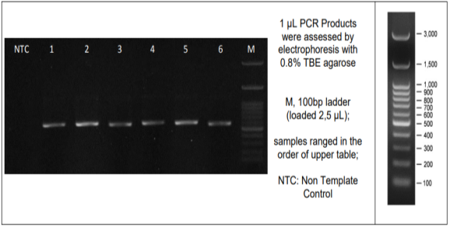
Figure 1. Amplification Results of Isolate A1
Description: Number 1 is a DNA band owned by isolate A1
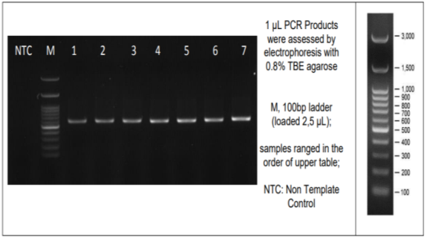
Figure 2. Amplification Results of Isolates S2b(2), Y1b, and H2a
Description: number 2 is a DNA band belonging to isolate S2b (2), number 5 belongs to isolate Y1b, and number 7 belongs to isolate H2a.

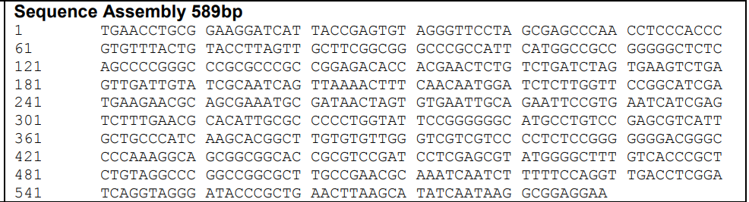
Figure 3. Nitrogen Base Sequence of Isolate A1
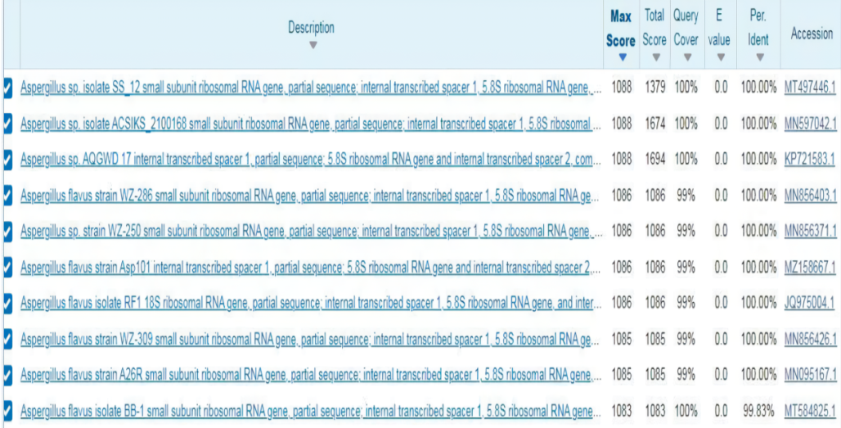
Figure 4. BLAST Analysis of Isolate A1
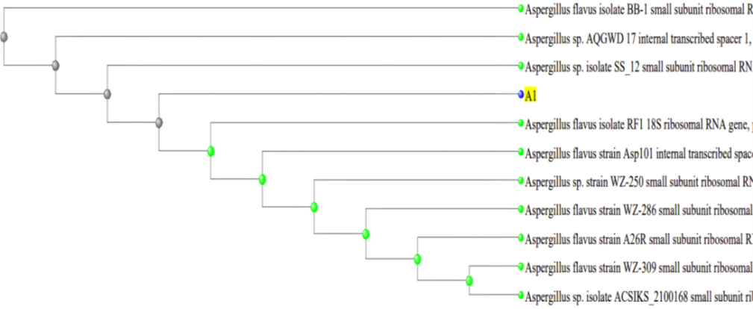
Figure 5. Phylogenetic Tree of Isolate A1
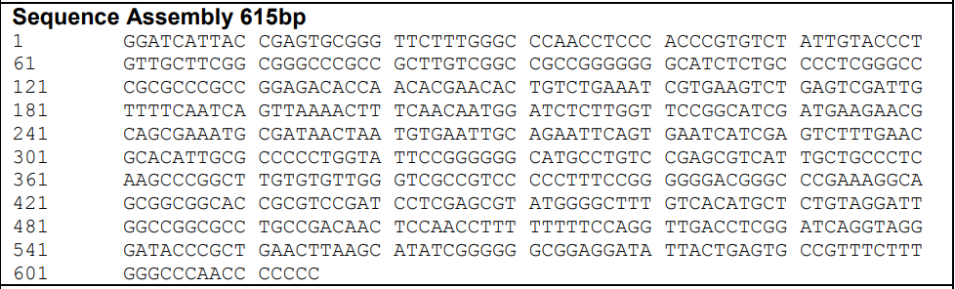
Figure 6. Nitrogen Base Sequence of Isolate S2b(2)
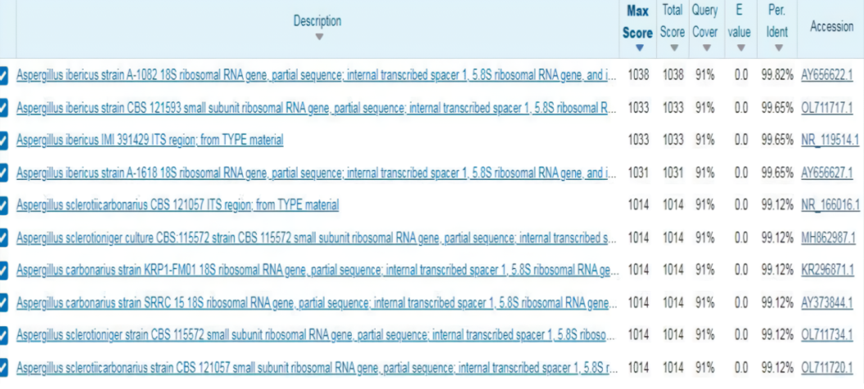
Figure 7. BLAST Analysis of Isolate S2b(2)
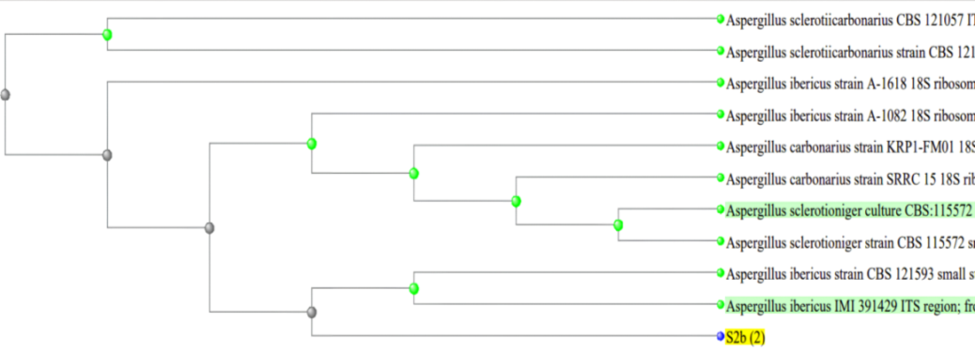
Figure 8. Phylogenetic Tree of Isolate S2b(2)
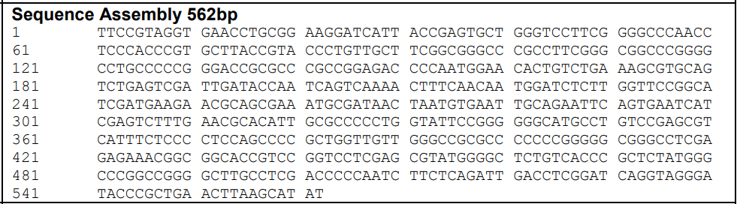
Figure 9. Nitrogen Base Sequence of Isolate Y1b
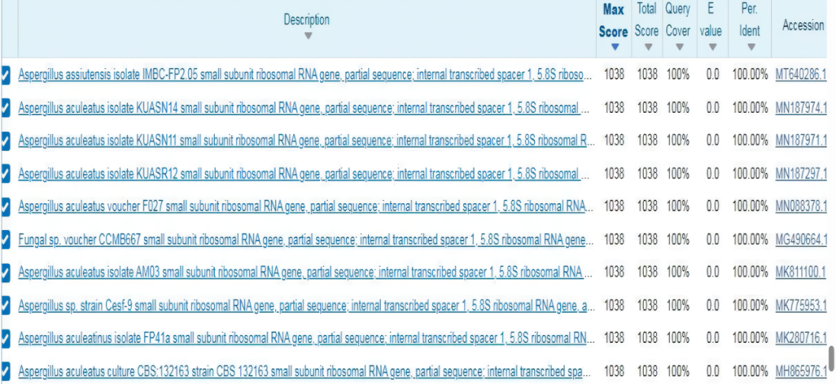
Figure 10. BLAST Analysis of Isolate Y1b

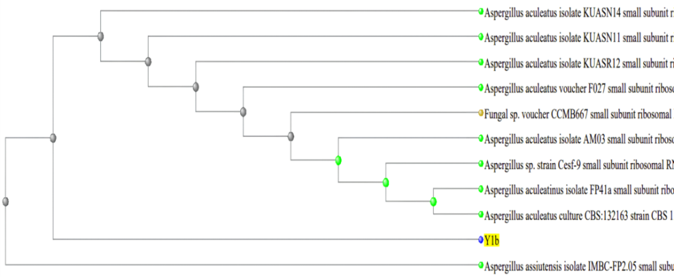
Figure 11. Phylogenetic Tree of Isolate Y1b
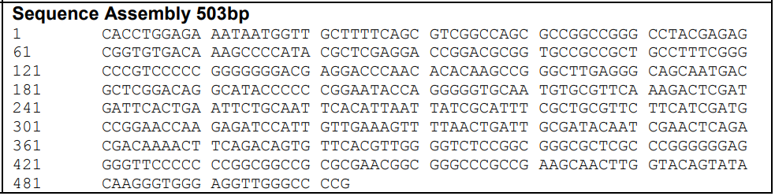
Figure 12. Nitrogen Base Sequence of Isolate H2a
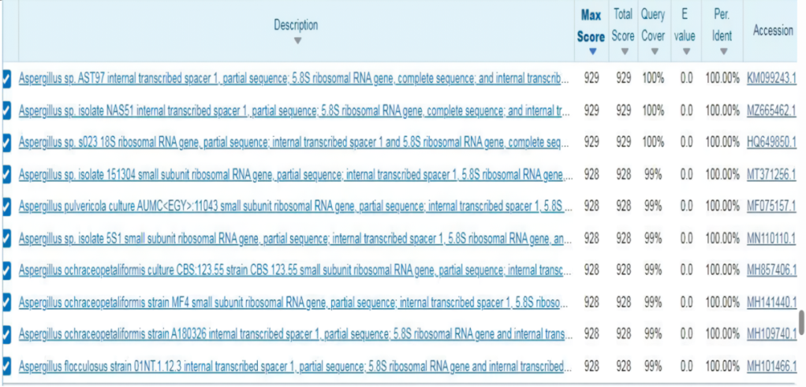
Figure 13. BLAST Analysis of Isolate H2a
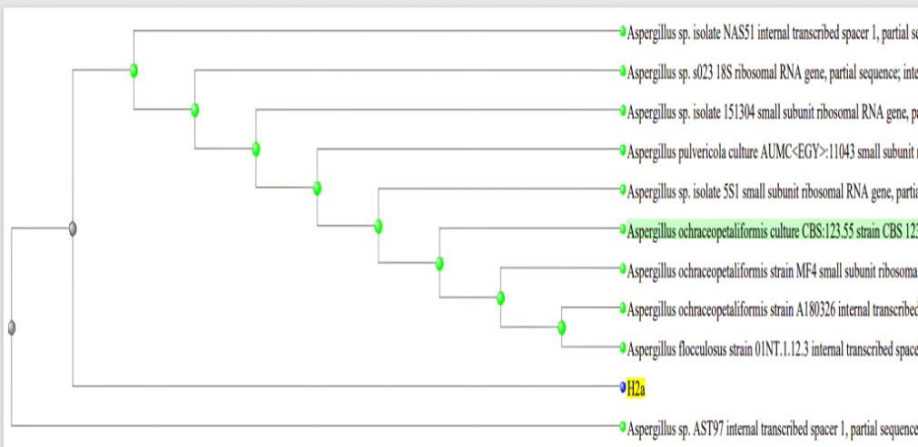
Figure 14. Phylogenetic Tree of Isolate H2a
Table 5. Fungi Consortium from Each Land Use
No | Land Use | Species
1. | Rice Field (LS) | Aspergillus ibericus dan Aspergillus flavus
2. | Forest Land (LH) | Aspergillus sp., Aspergillus ibericus, Aspergilus aculeatus, dan Aspergillus flavus
3. | Vegetable Garden Land (LY) | Aspergilus aculeatus dan Aspergillus flavus
4. | Residential Land (LP) | Aspergilus aculeatus dan Aspergillus flavus
Source: Primary Data

Table 6. Results of Initial Soil Characteristics Analysis of Planting Media
No | Parameter | Unit |  | Result | Classified
1. | pH | - |  | 6.19 | Slightly acidic
2. | C-Organic | % |  | 1.92 | Low
3. | N-Total | % |  | 0.06 | Very low
4. | P-Available | mg/kg |  | 1.72 | Very low
5. | K-Available | me/100g |  | 0.13 | Low
Source: Primary Data
Table 7. Effect of Treatment on Final Soil Characteristics
No | Treatments | Parameters
 |  | pH | C-Organik (%) | N-Total (%) | P-Available (mg/kg) | K-Available (me/100g)
1. | N | 6.47a | 1.09b | 0.09a | 2.16a | 0.21a
2. | LS | 6.50a | 1.10b | 0.09a | 2.25b | 0.25b
3. | LH | 6.83c | 1.06a | 0.11bc | 2.32b | 0.30c
4. | LY | 6.63b | 1.12c | 0.12c | 2.55d | 0.27bc
5. | LP | 6.61b | 1.11bc | 0.10ab | 2.33c | 0.28bc
Source : Primary Data
Description : N = NPK fertilizer as a control; LS = paddy fields fungi consortium biofertilizer; LH = forest land fungi consortium biofertilizer; LY = vegetable garden land fungi consortium biofertilizer; LP = residential land fungi consortium biofertilizer

Table 8. Effect of Treatment on Plants Growth
No | Treatments | Parameters
 |  | Plant Height (cm) | Number of Leaves (strands) | Plant Dry Weight (g)
1. | N | 20a | 7a | 0.28a
2. | LS | 20a | 8a | 0.33b
3. | LH | 27c | 10b | 0.42c
4. | LY | 25bc | 11b | 0.33b
5. | LP | 22ab | 8a | 0.34b
Source : Primary Data
Description : N = NPK fertilizer as a control; LS = paddy fields fungi consortium biofertilizer; LH = forest land fungi consortium biofertilizer; LY = vegetable garden land fungi consortium biofertilizer; LP = residential land fungi consortium biofertilizer

